**Inspecting compliance to many rules: An agent-based model**

Ever increasing scope and complexity of regulations and other rules that govern human society emphasise importance of the inspection of compliance to those rules. Often used approaches to the inspection of compliance suffer from drawbacks such as overly idealistic assumptions and narrowness of application. Specifically, inspection models are frequently limited to situations where inspected entity has to comply with only one rule. Furthermore, inspection strategies regularly overlook some useful and available information such as varying costs of compliance to different rules.

This article presents an agent based model for inspection of compliance to many rules, which addresses abovementioned drawbacks. In the article, crime economic, game theoretic and agent based modelling approaches to inspection are briefly described, as well as their impact on the model. The model is described and simulation of a simplified version of the model is presented. The obtained results demonstrate that inspection strategies which take into account rules’ compliance costs perform significantly better than random strategies and better than cycle-based strategies. Additionally, the results encourage further, wider testing and validation of the model.

INTRODUCTION

In 1788 in The Federalist James Madison 2 famously stated: I f men were angels, no government would be necessary. If angels were to govern men, neither external nor internal controls on government would be necessary. However , men, as we know, are not angels.

Human society of today is reliant on an ever increasing mass of regulations, rules and other social norms. Changes in regulations reflect changes in society and in our understanding of the processes inside society as well as between society and the environment. Increase in society’s interconnectedness and complexity is reflected by the rise in scope and complexity of regulations , particularly in areas such as financial regulation [1] and environmental regulation [2] , and in particular in the US and the EU.

In democratic societies, regulations typically introduce limitations and rules of conduct that should, in the end, be beneficial to the society as a whole. However, to individuals and organizations that have to obey those regulations, they might seem overly cumbersome, useless or even counterproductive. I f opportunity arises, individuals as well as companies might try to violate the rules or shirk from their responsibilities since, as Madison pointed out, men are not angels. Therefore, there usually has to be a detriment or penalty for noncompliant entities , for regulations to be effective. Since regulations are typically not self enforcing , they require some sort of external coercion mechanism such as law enforcement agencies, inspection agencies, etc. Inspection agencies and similar organizations usually want to achieve maximum compliance with rules and regulations under their authority . However, those agencies are not omniscient and usually cannot know whether an entity is compliant or not, without performing some sort of inspection procedure. On the other hand, inspection procedures and available resources are rarely such to allow total coverage of all constituents. Therefore, one of the key challenges for any inspection organization is optimal selection of entities for inspection . This selection process should identify – as correctly as possible – violators, and punish them. Additionally, the inspection procedure should serve as a deterrent to unwanted behaviour. To complicate matters further, the expanding regulatory landscape and rise in complexity and numerousness of constituents is often not met with correspondingly expanding inspection resources . Therefore, rise in efficiency of the inspection selection process becomes paramount.

Inspection selection and inspection itself have been objects of extensive scientific inquiry. There are several approaches to the matter, and each has noteworthy weaknesses. Firstly, analysis of historical data delivers valuable insights, but it cannot establish causation and isolate variables. Real world experimentation is often legally impossible or ethically unacceptable. Laboratory setups and surveys can be performed, but often encounter difficulties when trying to recreate real world setups and incentives. Finally, various modelling approaches are often utilised, but they are also plagued with shortcomings such as overly simplistic assumptions, narrow outlook , limited application, analytical insolvability , lack of empirical validation, etc. This article outlines several modelling approaches to analysis of the inspection problem and underlines their advantages and limitations. Moreover , the article presents ICARUS (acronym: Inspecting Compliance to mAny RUleS) , an agent based model for inspection of compliance to many rules . The model describes a generic environment in which one inspection agency inspects compliance of a set of entities to a group of rules. Finally, the article demonstrates a simplified simulation environment of the model and tests the working hypothesis that conduct of inspections based on knowledge of resource needs for compliance reduces total non compliance in the system.

INSPECTION MODELS: ASSUMPTIONS AND APPROACHES

Inspection models are based on numerous assumptions about human behaviour and motives. Some assumptions are intuitively understandable, while others less so. Moreover, inspection models’ outcomes can be vastly different and even contradictory, depending on the underlying assumptions.

In this section, the basic assumptions arising from the human rationality and its bounded ness are briefly explained and two main modelling approaches – inspection games and agent based modelling – are outlined.

CRIME ECONOMICS AND HUMAN RATIONALITY

Traditionally, non - compliance with the established sets of social norms, including laws, was considered a sign of lack of character, mental illness or social inadaptability. 18th century economists and criminologists started to change that outlook by describing humans as rational beings who make decisions based on scrupulous analysis of potential benefits and costs of their actions. Cesare Beccaria in his seminal work On Crimes and Punishments in 1765 extended the utility theory to crime and argued that, in regard s to criminal justice, people act with free will, in rational manner and try to achieve their own personal gratification. Accordingly, people will be deterred from crime when the punishment outweighs benefits of the crime.

The notion that human rationality is the foundation of decision - making dominates classical economics. In the context of economics of crime, Becker formalized that idea through his economic model of crime [3]. According to the model, potential criminals make their decisions based on comparison of benefits of crime and expected costs, which reflect sanction cost and probability of sanction’s occurrence. This model does not apply only to individuals, but to companies and other organizations as well. It could be argued that companies, and especially publically traded companies, present an even more “natural” background for the economic model of crime since their utility function is unambiguous – maximization of shareholder profit. Hence, companies (or their management) are even more likely to try to objectively assess benefits and expected costs of crime (or non - compliance) and act accordingly.

The economic model of crime allows deduction of further conclusions. In complex environments such as banking, companies have to obey a myriad of rules. Violation of rules will, if detected, result in sanctions, and costs of those sanctions might vary in respect to the rule that was violated. However, in many regulated environments fines (sanctions) are pre - determined and are often the same for groups of rules or even for all the rules contained in a legal act. Although compliance with the rules might not have any direct benefit s for the regulated entity, it will – almost certainly – incur certain costs. Those costs will vary, depending on the requirements of specific rules. Some rules might be inexpensive to comply with (e.g. rules with details on how to perform various administrative procedures), some could require considerable resources (e.g. establishment of certain processes or organizational units) and some could incur massive costs (e.g. additional capital requirements). In such setup, companies might objectively assess compliance cost, sanction cost and probability of its incurrence and decide to comply with some rules while violating others.

However, although the rationality hypothesis is very useful in analysis of human behaviour, it is also highly demanding. Perfect rationality requires complete knowledge of the environment – in our simplified case; it would imply perfect knowledge of potential benefits and sanctions of non-compliance, as well as perfect knowledge of probability of sanction’s occurrence. Furthermore, it requires clear preferences, unbiasedness and ability to calculate perfectly, in real time [4]. These strong requirements are often unattainable in real life, and the human rationality requirement is often softened via the concept of bounded rationality. Bounded rationality, which was first presented by Simon [5], relaxes rationality requirements by acknowledging that although humans try to make fully rational decisions, they are fallible in their decision - making – they have biases, they are unable to calculate probabilities perfectly, they make mistakes in logic and act in situations with incomplete information. Experimental evidence supports the idea that human rationality is bounded in the area of crime economics [6].

Inspection models mostly heavily rely on ideas of rationality and/or bounded rationality.

GAME THEORY AND INSPECTION GAMES

Game theory can concisely be described as a formal study of conflict and cooperation [7] and was first applied to inspection problems by Dresher in 1962 [8]. Although it was initially applied to inspection of compliance to nuclear disarmament treaties, in subsequent years it was applied to a plethora of inspection problems. The applications include accountancy and auditing, tax inspection, enforcement of environmental regulations, crime control, smuggling (so - called smuggling game), relationship between politicians and bureaucrats (so - called oversight game), etc. Overview of literature on inspection game can be found in [9 - 11].

Inspection game, in game theoretic setting, presents a special class of non-cooperative games 3. The basic interactions in the inspection game are shown in Figure 1. An entity that is obliged to comply with a certain rule decides (step I) to comply or violate that rule. In step II inspector decides whether to inspect the given entity or not. When deciding whether to violate or comply, the entity does not know with certainty whether the inspector will inspect. Correspondingly, inspector – when deciding whether to inspect or not – does not know whether the entity violates the rule or complies with it. Payoff matrix is shown in t able in the Figure 1. The game has no stationary equilibrium since relationships between payoffs imply that players always have reason s to change their strategies. I.e. if the entity knew that inspector will inspect, it would comply with the rules. However, if inspector knew that the entity will comply, it would prefer not to inspect. And if the entity knew that inspector will not inspect, it would violate, which would then entice inspector to inspect, and so on. Arrows in the payoff matrix indicate the order of players’ preferences.

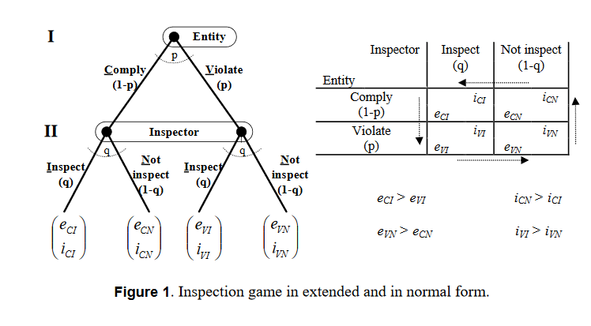

In line with that, the only equilibrium strategies are mixed strategies. That is, if p is probability of violation and q is probability of inspection, the optimal mix of pure strategies was calculated by Tsebelis [12] and is given by (1) 3:



The values of p* and q* reflect the essence of the game theoretic approach to inspection. Game theory is analysis of strategic interaction between players and, in line with that, decisions of each player are primarily influenced by what that player believes will be the actions of the other player. Accordingly, entity’s probability of violation ( p* ) is influenced exclusively by inspector ’s payoffs, and inspector’s probability of inspection ( q* ) is influenced exclusively by entity ’s payoffs. Significant complications arise with such result, namely, it is a very bold assumption that entity will know all inspector ’s payoffs and vice versa. Because of described relationship between payoffs, both players in an inspection game have incentives to hide their motivations and, hence, payoffs from the other player. Furthermore, stated solution implies that entity’s decision whether to violate ( p* ) is completely independent of the size of penalty ( e VI ) which is in contradiction with the economic model of crime and some experimental results [6]. Tsebelis’ conclusions have been studied and analysed (interestingly, Tsebelis’ model was rarely tested experimentally [ 13; p. 156]) and it has been concluded that the analytical results are valid, but that they reflect a very simplified setup (one off game with only 2 players and with complete information) [14]. Furthermore, divergences between results of the simplified model and reality can be explained by players’ bounded rationality [6]. It is interesting to note that the situation where one centralised inspection agency inspects compliance of numerous agents fits Becker’s model much better than Tsebelis’ [15].

Many classic inspection games consider similarly simple setup. However, most real - life scenarios (e.g. financial inspection, inspection of environmental protection, compliance audits, etc.) require introduction of more complex parameters such as :

1) the game is played repeatedly,

2) there is more than one entity that can be inspected (one - inspector - n - inspectees or m - inspectors - n - inspectees scenarios),

3) players' rationality is not perfect but bounded,

4) players possess imperfect and incomplete information,

5) players are heterogeneous (e.g. entities are characterized by different payoffs, possess different information and their rationality is bounded in different ways), and

6) players learn and adapt.

Introduction of more complex parameters to the inspection game makes the model more realistic, but also significantly complicates or even thwarts its analytical solvability. Authors who study inspection games continually add complexity to their models, however, even recently developed inspection game models that introduce complications and better correspond to the situation that is analysed in this article still include very limiting assumptions. E.g. in a setup that is somewhat similar to the one analysed in this article, Deutsch and Golany describe a finitely repeated inspection game with single inspector and several agents, where inspector tries to optimally allocate limited inspection resources [16], but the game still has very limiting assumptions such as complete information.

Although inspection games might be limited in their ability to introduce complexity and remain solvable, elements of inspection game and general circumstances described in the inspection game can be successfully used in other modelling approaches such as agent - based modelling. Furthermore, game - theoretic setting has a great value in highlighting strategic relationship between actors.

AGENT BASED MO DELLING (ABM)

Agent based modelling (ABM) 5 arose from research on complex adaptive systems. Agents are independent, commonly software implemented entities, which have a set of characteristics, take actions depending upon certain conditions and interact with each other [17]. There are numerous sources that describe when [17], how [18 20] and why [17] to use ABM.

ABM is being used in the field of social sciences, because of its unique capabilities for describing complex systems, knowledge discovery and hypothesis testing [21]. The ABM approach is particularly relevant in cases where it is not possible to conduct experiments to test certain social phenomena because of ethical or legal considerations. In addition, the cost of model development and running of simulations is typically significantly lower than the cost of conducting experiments that test certain social phenomena.

ABM and game theory are, in many ways, considerably different approaches to modelling. While the game theory is structured, analytical and demanding in constructing and solving of the models, the ABM allows great flexibility in devising models and setting their parameters. ABM can also easily incorporate ideas and concepts from game theory, crime economics, etc. Parameters such as those mentioned in the ordered list in the previous chapter are easy or even trivial to apply and implement. ABMs that model inspections often use assumptions from the inspection game and particularly the assumption about bounded rationality of agents. Interestingly and more generally, vast majority of agent based models implement bounded rational agents [17]. It is no wonder then that ABM has been extensively used for analysis of inspection problems.

The area where ABM is particularly extensively used is analysis of tax compliance and tax inspection. Tax inspection models are often very different, particularly in relation to their complexity. For example, in [22 27] a number of models have been described and analysed, each with different assumptions, different levels of complexity (models that were developed earlier are simpler, and later models are more complex), different validation methods and are developed in different simulation environments. ABM has also been used in analysis of (inspection of) crime [ 6, 28] and banking supervision [29]. All cited ABM inspection game models (with exception of [29]) model situations in which compliance to only one rule is analysed (one entity one rule).

The most significant downside in use of the ABM is difficult rigorous validation of the model. Most ABM models are very specific and are validated (if at all) against a limited set of narrow, field specific data.

THE ICARUS MODEL

The main motivation for development of the ICARUS model is the fact that inspection models almost exclusively consider one entity one rule environments, which is a very bold assumption, especially when considering inspection of regulatory compliance in highly regulated areas (financial services, environmental protection, etc.). Further motivation is to have a polygon for testing the hypothesis that use of knowledge about resource needs in conduct of inspections can reduce the total number of violations in the system, which might be particularly relevant for regulatory compliance in highly regulated areas.

The proposed ICARUS model is an agent based model of compliance inspection in which one inspection agency (inspector) inspects whether a set of entities (agents) are compliant with a set of rules. The main motivations for use of the ABM approach are flexibility of such approach, legal restrictions concerning experimental approach to regulatory compliance and limitations of purely game theoretic approach.

In the following sub chapters, modelling environment, assumptions and formal representation of the ICARUS model are presented.

MODEL ASSUMPTIONS AND THE GENERAL OUTSET

The basic idea and driver for development of the resource requirements focused model is the assumption that costs of compliance can be used as signals that are available to inspector (with some degree of accuracy). Based on those signals, inspections could be directed in a way that would detect non-compliance with higher precision and, in turn, reduce total non-compliance in the system.

There are 2 types of actors in the model (inspector and entities) with conflicting interests. Relationship between the inspector and entities can be described, in game theoretic terms, as a non-cooperative, non-zero sum, finitely repeated inspection game between one inspector and several inspectees (entities), with incomplete information. The model operates in discrete time intervals. In each interval entities make violate/comply decisions for each rule, and inspectors make inspect/not inspect decisions for each entity rule pair.

Entities and inspector behave as follows:

1) each entity is characterized by a decision making process that includes an internal component, which reflects entity’s compliance resource requirements, and an external component by which entity assesses probability of inspection, based on some known inspector related parameters, and

2) inspector’s decision making process is determined by the selected inspection strategy. In essence, it is an optimal assignment problem since the inspector is trying to optimally allocate his limited inspection resource s to achieve the lowes t total number of violations in the system. However, an important drawback for inspector is that he does not know the total number of violations in the system at any time (unless he can inspect all entity rule pairs simultaneously, which is not a realistic prospect and trivializes the inspection problem).

The model fully utilizes advantages the ABM approach. First and foremost, agent s (entities) are heterogeneous:

1) entities are characterized by different resource requirements needed for compliance (costs of compliance) with each of the rules. These differences in costs of compliance reflect differences in entities' internal organization, complexity, size, business model, etc. However, although there are some differences in resource requirements between entities, resource requirements also have and underlying orderedness across entities, which is also known to inspector ( e.g. in any bank, costs of capital requirements are higher than costs associated with some administrative procedure ), and

2) entities differ in their risk appetite (or risk preference), which influences their assessment of the inspection probability. Risk appetite variable reflects two findings: Firstly, risk preferences differ among people and might present a stable personality trait [ 30]; secondly, decision makers are not perfectly rational when assessing risk [31]. This bias also models agents' bounded rationality in decision making.

Furthermore, the model assumes imperfect and incomplete information. A limited set of variables are known to all players (inspector and all entities), while the majority of variables are known only locally. Every entity knows only its own payoffs. Entity’s utility function is based on the economic model of crime and is influenced by costs of compliance, costs of mandatory punishments and entity’s own assessment of probability of inspection of each rule.

When assessing the probability of inspection, entities consider their own inspection history record and based on that and some general information about the system, try to estimate probability of inspection in that time interval. Furthermore, each entity is locally connected to several other entities and share s information with them. Of particular interest is information whether violations were punished or not, which either rein forces compliance (if violations are punished) or noncompliance (if violations are un punished). This mechanism mimics experimentally observed “broken windows” dynamics [13].

The model presumes that entities and inspector use their historical data (memories) about inspections to make assumptions about the future. Such approach is in contrast with the idea of forward looking decision making by a rational individual, but fits well with the idea of boundedly rational behaviour and empirical findings related to learning from experience [32].

FORMAL DESCRIPTION OF THE MODEL

Let ℰ ≡ { 1,..., n } be a set of n entities (agents, organizations), n ∈ ℕ, where each entity in ℰ is obliged to comply with all the social norms (rules) contained in Ο ≡ { 1,..., ο }, ο ∈ ℕ. Each entity in ℰ at every discrete time interval t in set Τ ≡ {1, ..., τ} decides whether to comply or violate each of the rules contained in Ο. Compliance with the rules is monitored by the inspection agency (inspector) ℐ. In every τ ∈ Τ, ℐ decides whether it will inspect each of possible combinations (pairs) of entities and rules. When entity i decides whether it will comply or violate rule ℐ in τ, it does not know whether ℐ will inspect {i, j} at τ. Analogously, when ℐ decides which pairs of entities and rules it will inspect at τ, it does not know the state of compliance. However, after inspecting {i, j} at τ, ℐ knows, with certainty, whether i complied with or violated j at that time. The described interaction is displayed in the Figure 2.

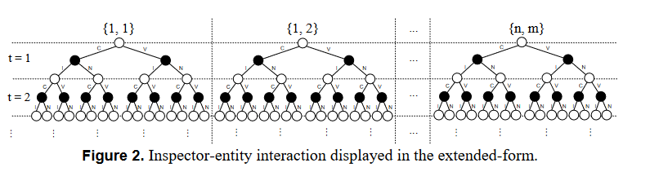

If the inspector detects violation of a rule, it will punish respective entity with a fine. Fines can be rule - specific and are contained in the vector:



Falta un mouton:

SIMULATION

A proof - of - concept simulation of a simplified variation of the ICARUS model was devised and constructed to :

* verify the basic ideas and assumptions behind the proposed model
* to analyse whether different approaches to inspection will lead to significantly different outcomes (primarily number of observed violations ), and
* to examine whether constructing a simulation of the general model and its validation would be justifiable.

Process flowchart of the simulated model with specification of variables that change values in particular step s as well as their context is shown in Figure 3.

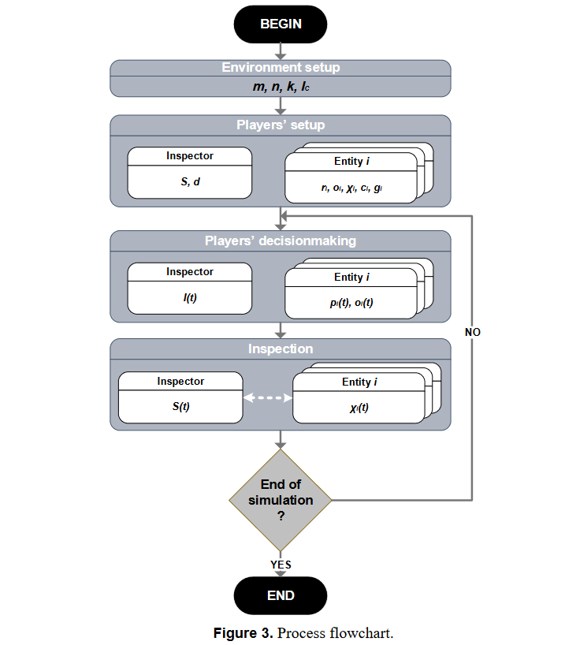

The simulation was performed in Microsoft Excel and Visual Basic for Applications while statistical analysis was performed in R [37]. The full data set, complete simulation results and statistical analysis can be found at <http://dx.doi.org/10.6084/m9.figshare.2009472>

SIMULATION SCENARIOS

Performed simulation incorporates 4 scenarios. Each scenario models different approach to inspection (different inspection strategy). The scenarios can be described as follows:

1) random scenario. Inspector completely randomly (uniform distribution) selects IC discrete combinations of entities and rules { i, j } for inspection at every discrete time interval t. The only limitation is that the same combination cannot be inspected more than once in one interval. Random scenario is the baseline inspection strategy,

2) resource scenario. Inspector randomly selects entities and rules, but while all the entities have the same probability of selection, probability of selection of different rules is defined by the inspector’s opinion on the cost of compliance (vector d). The selection process can be thought of as a variation of the Fitness proportionate selection algorithm [33], where d j has the role of fitness of the rule 푗. Hence, the probability of inspecting rule j of a given entity I in



3) cycle scenario. Inspector iteratively selects all combinations of entities and rules, in a cyclical fashion. That is, every entity - rule combination will be inspected before any inspection combination is repeated. Cycle scenario reflects some traditional audit practices e.g. that all audit areas have to be reviewed cyclically, at least once every three to five years [34 ; p. 250 ], and

4) cycle resource scenario. As its name implies, this scenario is a combination of the Resource and the Cycle scenarios. The entities are selected in s cyclical manner, while the rules are selected on a resource - weighted principle. Hence, if entity i is selected for inspection at t, the probability of inspection of rule j of that entity in that interval is



SIMULATION PARAMETERS

Scenarios have 10 discrete time intervals (“turns”) and each scenario was run 20 times. The scenarios were run for only 10 intervals since in practice, successful inspection strategies would have to produce good results rather quickly to be politically viable. Scenarios were run 20 times to account for randomness (e.g. depending on the order in which rules are selected for inspection, total number of violations might vary considerably) and provide averaged results. Furthermore, repeated runs enable statistical analysis of end results (violations’ totals after 10 turns).

Scenarios are characterized by a set of static initial parameters which are the same for all scenarios and all the runs. In the described simulation scenarios, inspection history has no influence on the inspector's actions.

Table 2 presents simulation parameters that are not entity - specific, while entity - specific parameters are displayed in Table 3.

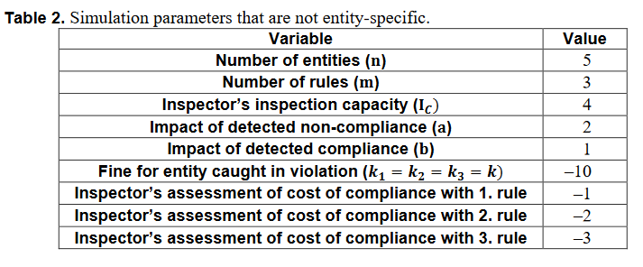

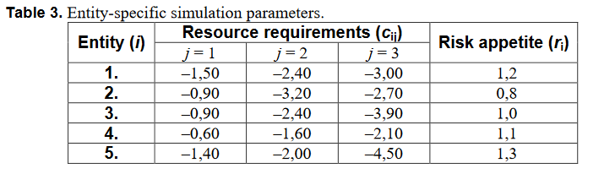

The parameters were set according to empirical observations and some practical considerations. The 푛 and 푚 parameters were given low values to simulate simple environment but to still allow heterogeneity across entities’ through their risk appetite ( 풓 ) and across rules through related compliance costs ( 풅, 풄 ). The I 퐶 was set to be in line with the three to five years inspection cycle (see section Simulation Scenarios ). Risk appetites of entities vary ±30 % around the risk neutral position, where 3 entities are risk - takers, 1 entity is risk - neutral and 1 entity is risk - averse. Fine s or regulatory punishment s for violation of all 3 rules were set to the same value, to mimic a simple but realistic setting (see chapter C rime economics and human rationality ). Resource requirements (compliance costs) vary significantly across different rules, and even across the same rule, but for different entities, to reflect differences in internal organization, complexity, size, business model, etc. of different organizations. However, relative order of rules’ compliance costs is the same for each entity. The values of compliance costs and fines are meaningful in relation to each other.

In this setting, connections between entities are not set, i.e. 푔 ip = 0, { 푖, 푝 | 푖 ∈ ℰ ⋀ p ∈ ℰ ⋀ 푖 ≠ 푝 }. Entities are not aware of the inspection strategies. Entity 푖 can estimate inspection probability at 푡 based on its knowledge of the following variables: 푛, 푚, 푘, 퐼 C, 푟 i, 푐 i, 휒 i ( 푡 ). The influence of inspection history and other parameters on entities and their subjective assessment of inspection probability i s defined by (19):

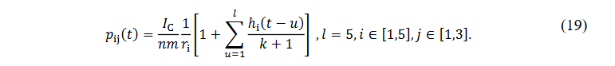

RESULTS AND DISCUSSION

On micro - level, simulation demonstrates anticipated behaviour of agents, which is expected since micro - level behaviour is determined by the inbuilt rules of behaviour. Several illustrations of predicted micro - level behaviour are:

1) Risk - taking entities violate rules more often than risk - neutral or risk-averse entities (ceteris paribus). To provide an example: although entity 1 and entity 3 have the same cost of compliance for rule 2, since entity 1 is a risk - taker and entity 3 is risk - neutral, entity 1 sometimes violate s rule 2, while entity 3 never does.

2) Rules with higher cost of compliance are violated more often then rules with lower cost of compliance (ceteris paribus). For example, entity 3 is risk - neutral and entity 4 has slight preference for risk - taking. Cost of compliance with rule 3 is, however, significantly higher for entity 3. Hence, entity 3 violates rule 3 around 26 % of times (accross all runs and all simulation scenarios), and entity 4 never violates the respective rule.

3) Punishment (c aught violation) deters entities from violation for some time, but if there are no subsequent inspections, entities relaps to violation.

On macro - level, simulation again demonstrates expected behaviour. Inspections, in general, reduced the number of violations in the system. Figures 4 and 5 show the results of all simulation runs, grouped by analysed scenarios (inspection strategies ). Each diagram presents results of 20 runs of a 10 - step simulation for each of 4 simulation scenarios. Abscissae represent the number of steps, while ordinates represent the cumulative number of violations observed in each step. Size of the dot represents the number of observations in a certain point, while the line connects means of cumulative violations in each step. The shading around the line presents 95 % CI (confidence interval).

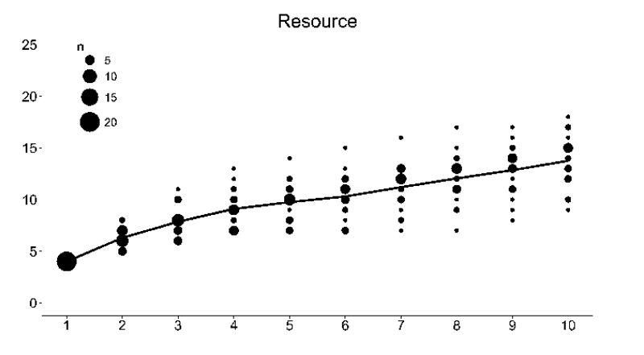

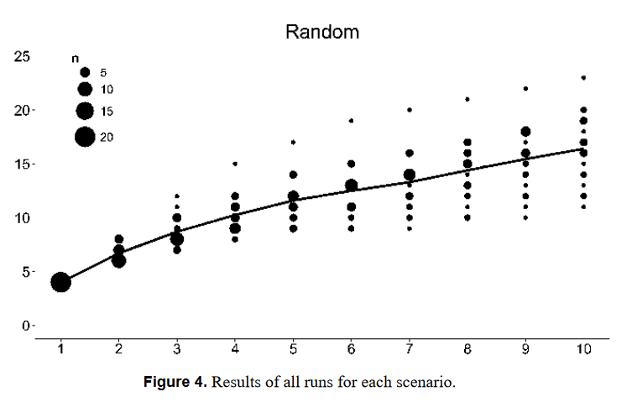

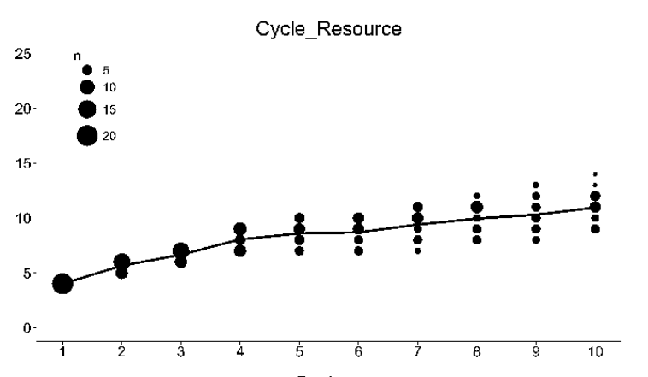

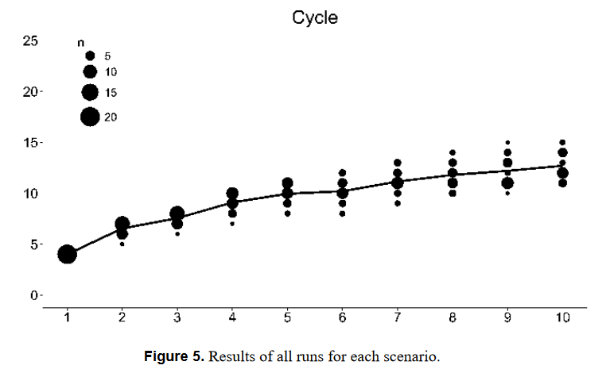

Figure 6 shows violation totals for each run (after 10 steps), grouped by inspection strategies. Boxplots present averaged values, while the dots present results of every single scenario. The size of the dot represents the number of observations in a certain cross - section of the diagram. Respective numerical results are presented in T able 4.

Results shown suggest that there is a significant difference in the cumulative number of violations, dependent on the inspection strategy. One - way ANOVA was performed to test the significance of observed differences in violations. The results confirm that significance, F (3,76) = 21, 27; MSE = 104, 03; p << 0, 001. Further examination of observed differences was performed via the Tukey’s HSD test. Test results are displayed in the Table 5.

Presented results confirm that inspection strategies which considered resource needs performed significantly better than the random strategy. Cycle - based strategies also achieved good results.

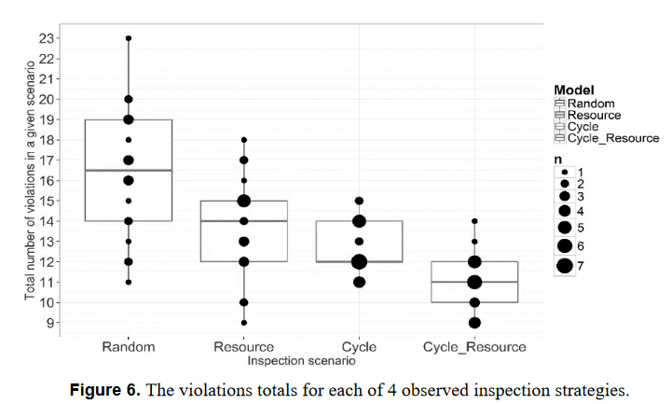

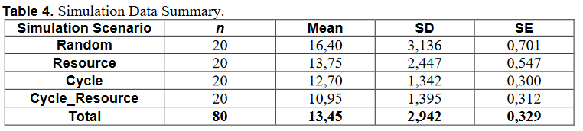

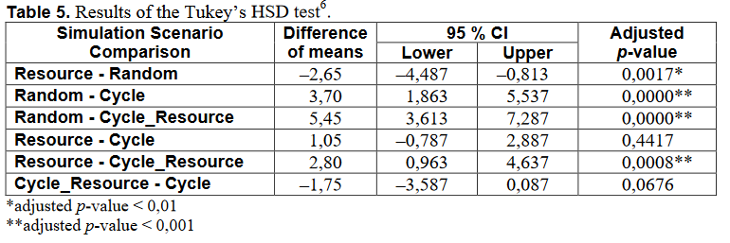

However, the result of cycle - based strategies should be taken with caution, since the relationship between IC, m and n in this setup is such that full cycle (inspection of all rules at all entities) can be performed in less than 4 periods, which might be overly optimistic in some inspection environments [26]. Furthermore, it is interesting to observe that Cycle_Resource scenario achieved better results than the Cycle scenario, albeit with borderline statistical significance.

CONCLUSION

This article presented ICARUS – an agent - based model for inspection of compliance to many rules. The model was created to address the shortcomings of often - used approaches to the inspection problem such as over - idealization of assumptions, narrowness of application and, in particular, limitation to inspection of the one - inspectee - one - rule situations. The presented model was implemented in a somewhat simplified setting (this includes simplification of values of some parameters as well as rather small number of entities and runs) and the working hypothesis that conduct of inspections based on knowledge of resource needs for compliance reduces tot al non - compliance in the system was tested. The results are promising as conducted simulation demonstrated expected micro - level and macro - level behaviour and showed that resource - focused inspection strategies perform significantly better than random strategies and better than cycle - based strategies. Furthermore, attained results encourage development of a full - scale model and related simulation that should be s ubjected to extensive testing and validation. Further research should also empirically validate significance and test characteristics of association between compliance resource requirements and observed violation rates. The developed full - scale model and its simulation should enable comparison of effectiveness of various inspection strategies and, through parameter estimation and sensitivity analysis, identification of parts of the parameter space in which those strategies achieve the best results.