MODELO PARA DETECTAR LA EVASIÓN DEL IMPUESTO A LA RENTA EN EL SECTOR DE LOS PRINCIPALES CONTRIBUYENTES PERUANOS.

by

Frank Jonislla Pillaca

Una disertación presentada en cumplimiento parcial

de los requisitos para el grado

Magister en Ingeniería de Sistemas e Informática

mension Ingeniería de software.

UNIVERSIDAD NACIONAL MAYOR DE SAN MARCOS

Diciembre 2018

© 2018 by FRANK, JONISLLA  
ALL RIGHTS RESERVED

APPROVAL PAGE

MODELO PARA DETECTAR LA EVASIÓN DEL IMPUESTO A LA RENTA EN EL SECTOR DE LOS PRINCIPALES CONTRIBUYENTES PERUANOS.

by

Frank Jonislla Pillaca

Dciciembre 2018

Approved:

Full name, Credential, Role

Full name, Credential, Role

Full name, Credential, Role

Accepted and Signed: Month, Day, Year

Typed Full Name of Mentor

Accepted and Signed: Month, Day, Year

Typed Full Name of Committee Member

Accepted and Signed: Month, Day, Year

Typed Full Name of Committee Member

Month, Day, Year

Name of Dissertation Approval Authority

Title of Dissertation Approval Authority  
Universidad Nacional Mayor de San Marcos.

Abstract

|  |
| --- |
| To ensure the ABSTRACT title does NOT appear in the Table of Contents, use the “Normal Indent” formatting (APA Formatting toolbar or heading 5a on the headings toolbar) – note: it is already preformatted.  The abstract is to be completed after chapters 4 and 5 are complete. The abstract provides a clear summary of the paper, indicating both content and tone of the paper. Abstracts include the statement of the problem, the research methods used to analyze the problem, a brief description of the research design, a listing of the key results, a brief description of the significance of the results, selected key conclusions, and selected key recommendations. First-person narrative should not be used in the abstract. If learners want to publish the abstract of their research project to *Dissertation Abstracts International* (DAI), a clearinghouse of abstracts, the abstract should be no longer than 350 words. APA-publishable abstracts, however, must be no longer than 120 words. The abstract paragraph should not be indented. To begin typing the abstract, click once in the gray field.  Double-click to delete textbox |

DEDICATION

     

|  |
| --- |
| To ensure the DEDICATION title does NOT appear in the Table of Contents, use the “Normal Indent” formatting (APA Formatting toolbar or heading 5a on the headings toolbar) – note: it is already preformatted.  This **optional** section is no longer than one page, double-spaced, and follows the title page. You may delete the dedication page by highlighting everything on the page and hitting the delete key. Be sure the ACKNOWLEDGEMENTS page moves to the top of the page.  The word *dedication* appears in uppercase letters centered at the top of the page. To begin typing the dedication, click once in the gray field.  Double-click to delete textbox |

|  |
| --- |
| ! IMPORTANT!  If you DO NOT have a COPYRIGHT PAGE, you must adjust the page number of the DEDICATION page. To adjust the page number:  Click on the Insert menu  Select Page Numbers…  Click on Format…  Change start at “iv” to start at “iii” by clicking the down arrow  Double-click to delete textbox |

Acknowledgments

     

|  |
| --- |
| To ensure the ACKNOWLEDGMENTS title does NOT appear in the Table of Contents, use the “Normal Indent” formatting (APA Formatting toolbar or heading 5a on the headings toolbar) – note: it is already preformatted.  This **optional** section is no longer than one page, double-spaced, and follows the title page, or the dedication page if one is included. Many writers choose to recognize the help of friends, colleagues, mentors, assistants, editors, and family members on this page. Research funding, grants, and permission to reprint copyrighted materials also should be acknowledged on this page.  The word *acknowledgments*, appears in uppercase letters centered at the top of the page. Note the word is spelled without the letter *e* after the *g*. The page number of the Acknowledgments page will vary depending upon how many of the optional pages are included before it.  To add a DEDICATION or other optional page, simply copy and paste the title and gray field from this page, place your cursor at the BOTTOM OF THE PAGE BEFORE THE NEW PAGE, hold the control key down and hit the enter key to create a new page, place your cursor at the top of the new page, and paste (control+V).  To begin typing the acknowledgments, click once in the gray field.  Double-click to delete textbox |

|  |
| --- |
| ! IMPORTANT!  If you DO NOT have a COPYRIGHT PAGE and you DELETE the DEDICATION PAGE, you must adjust the page number of the ACKNOWLEDGMENTS page. To adjust the page number:  Click on the Insert menu  Select Page Numbers…  Click on Format…  Change start at “iv” to start at “iii” by clicking the down arrow  Double-click to delete textbox |

TABLE OF CONTENTS

Summary xviii vii

Conclusion xviii vii

Research Design xix vii

Appropriateness of Design xix vii

Research Questions xx vii

Population xx vii

Informed Consent xx vii

Instrumentation xxi viii

Data Collection xxii viii

Data Analysis xxii viii

Validity and Reliability xxii viii

Summary xxiii viii

Results xxiv viii

Summary 27 viii

Conclusion 28 viii

Implications 29 viii

Recommendations 29 viii

Summary 9 viii

Conclusion 9 viii

Research Design 10 viii

Appropriateness of Design 10 viii

Research Questions 11 viii

Population 11 viii

Informed Consent 11 viii

Instrumentation 12 viii

Data Collection 13 viii

Data Analysis 13 viii

Validity and Reliability 13 viii

Summary 14 viii

Results 15 viii

Summary 19 viii

Conclusion 20 viii

Implications 21 viii

Recommendations 21 viii

LIST OF TABLES ix

LIST OF FIGURES ix

CAPITULO 1: INTRODUCIÓN ix

Antecedentes ix

Problema xi

Importancia del Problema xi

Motivación xii

Objetivos xii

Organización xii

CHAPTER 2: LITERATURE REVIEW xiii

METODOLOGÍA DE INVESTIGACIÓN xiii

Planificación de la revisión xiii

Desarrollo de la revisión xiv

Summary xiv

Conclusion xv

CHAPTER 3: METHODOLOGY xvi

Research Design xvi

Appropriateness of Design xvi

Research Questions xvii

Population xvii

Informed Consent xvii

Sampling Frame xvii

Confidentiality xviii

Geographic Location xviii

Instrumentation xviii

Data Collection xix

Data Analysis xix

Validity and Reliability xix

Summary xx

CHAPTER 4: PRESENTATION AND ANALYSIS OF DATA xxi

Results xxi

Summary 24

CHAPTER 5: SUMMARY AND RECOMMENDATIONS 25

Conclusion 25

Implications 26

Recommendations 26

References 27

Appendixes 29

First Subtopic - Heading level Three xvii

Second Subtopic - heading level 3 xvii

Summary xviii

Conclusion xviii

CHAPTER 3: METHODOLOGY xix

Research Design xix

Appropriateness of Design xix

Research Questions xx

Population xx

Informed Consent xx

Sampling Frame xx

Confidentiality xxi

Geographic Location xxi

Instrumentation xxi

Data Collection xxii

Data Analysis xxii

Validity and Reliability xxii

Summary xxiii

CHAPTER 4: PRESENTATION AND ANALYSIS OF DATA xxiv

Results xxiv

Summary 27

CHAPTER 5: SUMMARY AND RECOMMENDATIONS 28

Conclusion 28

Implications 29

Recommendations 29

References 30

Appendixes 32

First Subtopic - Heading level Three 8

Second Subtopic - heading level 3 8

Summary 9

Conclusion 9

CHAPTER 3: METHODOLOGY 10

Research Design 10

Appropriateness of Design 10

Research Questions 11

Population 11

Informed Consent 11

Sampling Frame 11

Confidentiality 12

Geographic Location 12

Instrumentation 12

Data Collection 13

Data Analysis 13

Validity and Reliability 13

Summary 14

CHAPTER 4: PRESENTATION AND ANALYSIS OF DATA 15

Results 15

Summary 19

CHAPTER 5: SUMMARY AND RECOMMENDATIONS 20

Conclusion 20

Implications 21

Recommendations 21

References 22

Appendixes 23

##### LIST OF TABLES

Table 1 *Title of table formatting for manuscripts requires the title typed flush left at the top of the table, capitalization of the initial letters of the principal words (see APA section 3.1.3), italicizing the title, and double space if the title takes up more than one line, and beginning subsequent lines under the first line* 2

Table 2 *Title* 2

##### LIST OF FIGURES

Figure 1. Use sentence case and double space if the caption takes up more than one line; keep second and subsequent lines flush left (note: use the FIGURE CAPTION button on the APA TABLES toolbar). 2

##### CAPITULO 1: INTRODUCIÓN

# Antecedentes

**¿Qué son los impuestos?**

“Existen necesidades comunes a mucha gente cuya satisfacción exige esfuerzo colectivo, porque cada persona por separado no tendría capacidad para financiarlas”. Para satisfacer estas necesidades colectivas, existen administraciones públicas, como la SUNAT, que se encargan de planificar los gastos de los servicios públicos que disfrutan los ciudadanos. Pero para poder pagar estos gastos, las administraciones públicas tienen que obtener unos ingresos que proceden de los ciudadanos; estos ingresos son los IMPUESTOS”.

**Características de los impuestos**

Pueden ser: Permanentes o transitorios; Directos o indirectos, proporcionales, progresivos, regresivos. Por ejemplo el impuesto de renta es considerado un impuesto progresivo en la medida en que los agentes con mayores ingresos deben pagar una tasa más alta. Por el contrario, un impuesto regresivo es aquel en el que se capta un porcentaje menor en la medida en que el ingreso aumenta.

Pueden ser reales o personales; Impuestos reales son aquellos cuya naturaleza se determina con independencia del elemento personal de la relación tributaria, y pueden ser definidos por la norma sin referencia a ningún sujeto determinado y gravan una manifestación de riqueza sin ponerse en relación con una determinada persona.

Si todos como sociedad nos involucramos más activamente en los impuestos, seremos una sociedad más participativa en la generación de riqueza, en la aplicación de los recursos gubernamentales, en la exigencia de la transparencia y en la rendición de cuentas a nuestros servidores públicos.

Ejemplos de impuestos:

Impuesto General a las Ventas

Impuesto Extraordinario de Solidaridad

Impuesto general a las rentas

Impuesto a la Renta

**Impuesto a la Renta.**

El impuesto a la renta es un tributo que se determina anualmente y su ejercicio inicia el 01 de enero y finaliza el 31 de diciembre.

Este impuesto se aplica a los ingresos que provienen del arrendamiento u otro tipo de cesión de bienes muebles o inmuebles, acciones u otros valores mobiliarios, y/o del trabajo realizado de forma dependiente o independiente.

Para la determinación del Impuesto a la Renta de Personas Naturales que no realizan actividad empresarial, corresponde lo siguiente:

Rentas de Capital - Primera Categoría: generadas por el arrendamiento, subarrendamiento o cualquier tipo de cesión de bienes muebles o inmuebles. El pago debes hacerlo tú mismo y corresponde al 6.25% sobre el monto obtenido por la renta.

Rentas de Capital - Segunda Categoría: corresponde a los intereses por colocación de capitales, regalías, patentes, rentas vitalicias, derechos de llave y otros.

Tercera categoría: las derivadas de actividades comerciales, industriales, servicios o negocios.

Rentas del Trabajo (Cuarta y/o Quinta categoría) y Renta de Fuente Extranjera: Si eres trabajador independiente o dependiente y tu ingreso anual es superior a 7UIT S/. deberás pagar impuesto a la renta.

En el Perú el impuesto a la renta es el que más se evade.

**Evasión Fiscal.**

Existe evasión fiscal cuando una persona infringiendo la ley, deja de pagar todo o una parte de un impuesto al que está obligada. Al incumplir de manera intencional con el pago de las contribuciones que le corresponden como contribuyente y ciudadano, estará cometiendo un delito. Este incumplimiento causa un deterioro económico en las Finanzas Públicas y el contribuyente obtiene un beneficio que no le correspondería, razón por la cual incurre en el delito de defraudación fiscal; para detener este flagelo es necesario generar herramientas que permitan detectar la evasión tributaria, principalmente la evasión del impuesto a la renta.

# **Problema**

El problema de la detección de la evasión del impuesto a la renta en el sector de los principales contribuyentes peruanos, consiste en la correcta selección de empresas que no estén declarando de forma correcta sus ganancias.

# **Importancia del** **Problema**

El fraude tributario es un fenómeno mundial que afecta a todas las economías del planeta en mayor o menor medida con pérdidas económicas que van desde el 8 hasta el 63% del PBI dependiendo de cada país analizado (Banco Mundial, 2017). En el Perú contamos con una economía altamente informal donde 8 de cada 10 dólares se mueven fuera del sistema financiero y operan principalmente en mercado con el uso de efectivo que se inserta al sistema y evade impuestos, no es rastreable y no opera de acuerdo con el contexto formal de la economía. Existen cerca de 6.5 millones de empresas y 10 millones de empresarios individuales, pero solo 12 700 empresas representan el 75% del total de la recaudación tributaria nacional.

La evasión tributaria de IGV en el Perú alcanza el 36% del potencial de recaudación y la evasión del impuesto a la renta (IR) es del orden del 57% perdiéndose en general por el total de evasión tributaria cerca de 22 000 millones de dólares anuales que el Estado peruano deja de percibir por este problema (SUNAT, 2018).

El Cuadro 13 muestra los resultados de la estimación de la evasión tributaria de los clientes informales del sistema financiero, a nivel total y por tributo.

Tomando en cuenta la información de los tres métodos empleados, se observa que la evasión total podría ubicarse dentro del rango de S/ 2 000 millones (0,3 por ciento del PBI) y S/ 7 346 millones (1,3 por ciento del PBI), aproximadamente. Fuente(<http://www.bcrp.gob.pe/docs/Publicaciones/Documentos-de-Trabajo/2016/documento-de-trabajo-11-2016.pdf>)

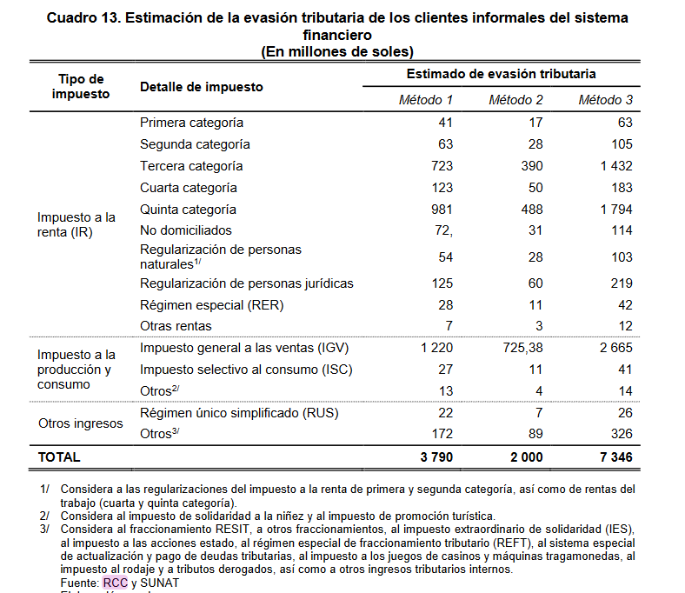

# **Motivación**

Los papers ofrecen una efectividad medida en los resultados, mas no en el tiempo en que se obtienen estos; por ello se diseñara un modelo que muestre la efectividad medido en resultados correctos y tiempos de ejecución.

# **Objetivos**

Objetivo general: construir un modelo de detección de evasión de impuestos.

Objetivo específico: construir un modelo que sea capaz de seleccionar contribuyentes que no estén cumpliendo sus deberes tributarios.

# **Organización**

     

##### CHAPTER 2: LITERATURE REVIEW

# METODOLOGÍA DE INVESTIGACIÓN

Este estudio a seguido una secuencia de pasos sistemático y simple, es capaz de ser reproducido sin problemas y de manera intuitiva, esta metodología consta de 3 etapas.

**Planificación de la revisión:** En esta fase, se plantean las preguntas de investigación y se define el protocolo de revisión.

**Realización de la revisión:** en esta fase, el plan se ejecuta y se seleccionan los artículos primarios, de acuerdo con los criterios de inclusión y exclusión establecidos para el efecto.

**Resultado de la revisión:** En esta fase, se muestran las estadísticas y el análisis de los documentos encontrados y seleccionados, y que se analizan a continuación. (Referencia algunos de los papers del profe)

### **Planificación de la revisión**

Para responder a la pregunta de investigación, se hacen las siguientes preguntas sobre las técnicas y herramientas necesarias para detectar la evasión de impuestos.

P1: ¿Qué métodos existen para predecir la evasión de impuestos?

P2: ¿Qué algoritmos de machine learning existen para predecir la evasión de impuesto?

P3: ¿Qué métricas se usan para medir la efectividad de un modelo de evasión de impuestos?

La fuente de búsqueda son proporcionadas por el metabuscador: “Web of Science”, el cual es un servicio en linea de información científica. El período de búsqueda comienza en el año 2016, ya que es un periodo razonable para contar con información reciente y actualizada; puesto que la tecnología avanza de forma rápida.

Usamos la siguiente cadena de búsqueda en los títulos, resumen y palabras clave: *ts=(((tax AND income) OR (tax AND evasion) OR (tax AND avoidance) OR (tax AND default) OR( tax AND compliance)) AND ((big AND data) OR (machine AND learning) OR (neural AND network) OR (genetic AND algorithm)))*.

### **Desarrollo de la revisión**

Los criterios de inclusión y exclusión se han considerado, como se muestra en las Tablas 1 y 2, respectivamente.

|  |  |
| --- | --- |
| **Tabla 1**  **Criterios de inclusión** | |
| **Criterio de inclusión** | **Razón de inclusión** |
| Objetivo de la investigación | Estudios que permiten predecir la evasión de impuestos. |
| Estudios empíricos cuantitativos. | Estos artículos se incluyen porque proporcionan evidencia empírica existente, lo que representa el interés principal de esta revisión. |
| Lenguaje ingles | Sólo artículos en ingles fueron considerados. |

|  |  |
| --- | --- |
| **Tabla 2**  **Criterios de exclusión** | |
| **Criterio de exclusión** | **Razón de exclusión** |
| Tipo de publicación | Se excluyeron libros, capítulos de libros y disertaciones. |
| Unidad de Análisis | Se excluyeron estudios que no consideren soluciones basadas en machine learning. |
| Enfoque de la investigación | Se excluyeron estudios que no muestran metodología de investigación, pruebas numéricas (estadística descriptiva) y análisis o discusión. |

Como primer paso, las palabras clave y sus respectivas descripciones se utilizaron para buscar los artículos principales. La revisión se limitó a artículos en revistas revisadas por pares, omitiendo libros, capítulos de libros y actas de congresos, ya que los artículos de revistas se consideran un conocimiento válido y representan declaraciones autorizadas sobre el tema (Ardito et al., 2015). Específicamente, la búsqueda se limitó a revistas de alta calidad en el campo de "Evasion de impuestos" y "Machine learning". El procedimiento de búsqueda consideró las ediciones disponibles de revistas del período 2005. Se identificaron un total de 59 estudios potenciales, estos fueron sometidos a un proceso de selección de acuerdo con los criterios de inclusión y exclusión establecidos. Así, primero, dividimos los artículos en "artículos excluidos" (19 artículos) y "artículos para el chequeo de texto completo" (40 artículos), fue necesario realizar una revisión previa de los títulos y resúmenes. Sin embargo, muchos resúmenes no proporcionan una comprensión clara del propósito de los artículos, y se seleccionaron 20 referencias. A continuación, un análisis más detallado de los artículos de "verificación de texto completo", se procedió a leer la introducción y conclusiones, obteniendo 16 referencias. Finalmente, procedimos a leer el contenido completo del artículo para determinar su relevancia para el presente estudio y, principalmente, para determinar si estos estudios identifican los factores críticos de éxito, al notar que la cantidad de artículos no era suficiente se tuvo que recurrir a artículos presentados en conferencias que nos permitan tener una cantidad aceptable de documentos a tomar en cuenta para el estudio. Así, la muestra final consta de 16 estudios primarios y 4 de conferencias. Nos encontramos con un gran inconveniente al buscar artículos relacionados a la evasión de impuestos y aprendizaje automático.

Los procesos aplicados, así como los resultados obtenidos en cada paso del proceso, se representan en la Figura 1.

*Construir un gráfico de procesos*

### **Resultado de la revisión.**

*El resultado del proceso de selección de los artículos nos dio 59, de los cuales 20 fueron seleccionados. Los cuales fueron analizados para responder las preguntas de investigación.*

*De acuerdo a las tendencias de citación de los artículos nos podemos dar cuenta que el área de evasión de impuestos y machine learning, no ha sido muy estudiado; la tendencia indica que a partir del 2017 los artículos referentes al estudio, vienen siendo referenciados*.

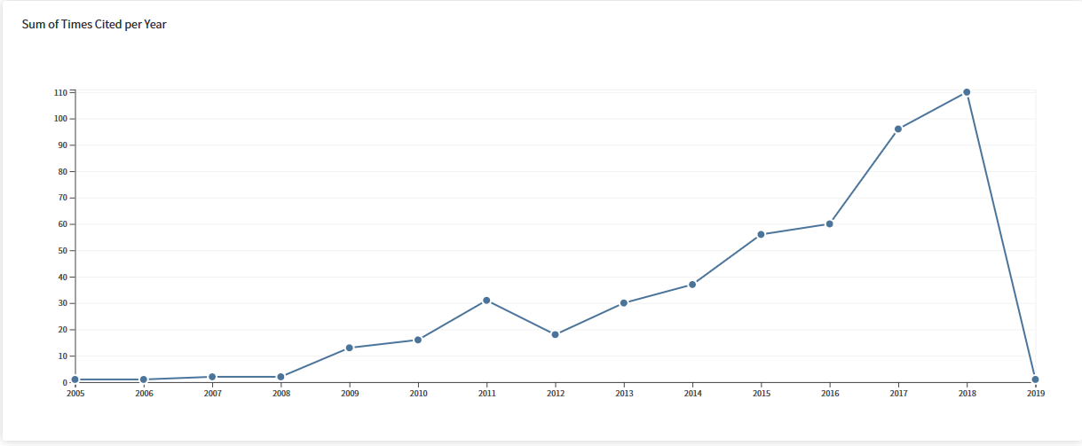

La mayor cantidad de artículos, fueron encontrados en el año 2017, tal como en el grafico X, se demuestra que el área de evasión y machine learning aun esta en sus inicios.

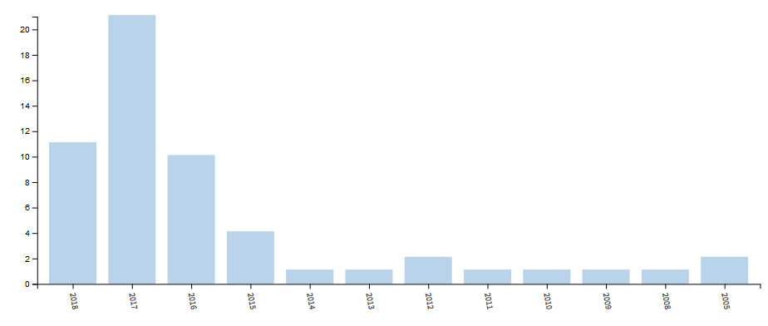

Los paises con mayor cantidad de articulos referentes al estudio son estados unidos e Inglaterra, puesto que los paises con mas ingresos sonlos que mas perdidas tienen debido a la evasion de impuestos.

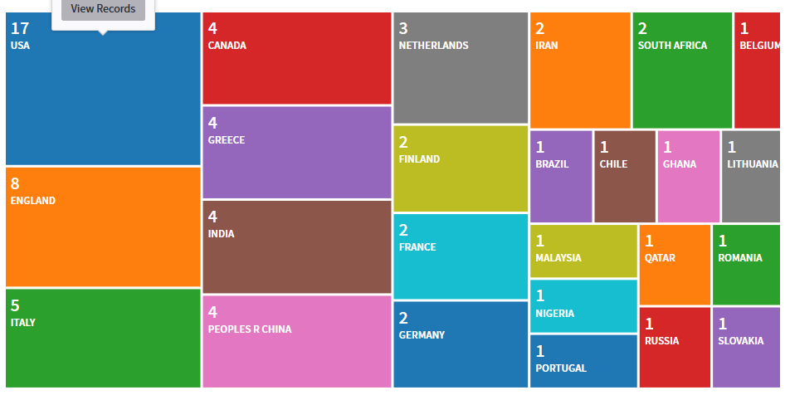

La mayor cantidad de artículos se encontraron en las áreas de economía, ingeniería y ciencias de la computación

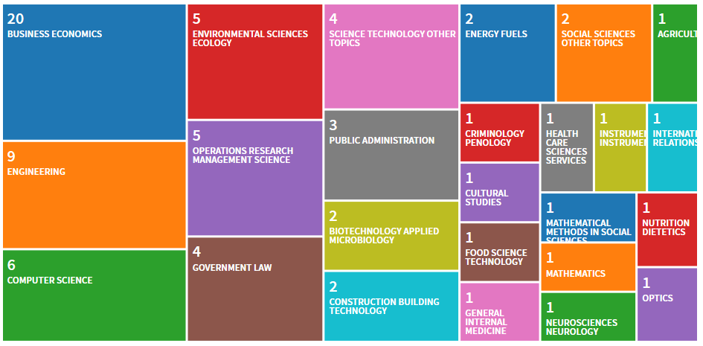

La distribución de los artículos por revista es mas uniforme lo cual nos indica que no existe alguna preferencia por seleccionar revistas donde puedan existir algo mas consistente.

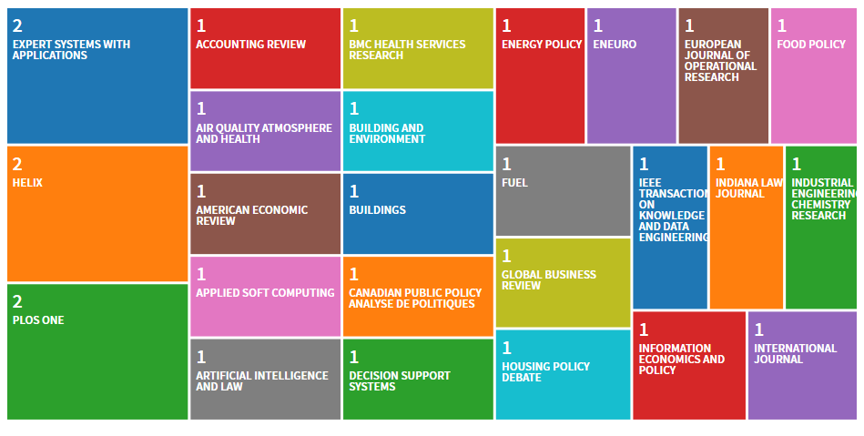

# *ANALISIS*

Esta sección responde las preguntas de investigación lanzadas en la etapa de planeamiento.

**¿Qué modelos existen para predecir la evasión de impuestos?**

En trabajos relacionados al modelo de detección de evasión de impuestos se pueden agrupar en dos categorías principales: i) analítico (macroeconómico y basado en el principio de agentes), y ii) computacional (basado en agentes, basado en la simulación) (Using deep Q-learning to understand the tax evasion behavior of risk-averse firms); en esta investigación nos centraremos en los modelos basados en la simulación.

|  |  |
| --- | --- |
|  |  |
| Modelo | Referencia |
| modelo de coevolución de los esquemas de Evasion tributarias con las políticas de auditoría. | (Detecting tax evasion: a co-evolutionary approach) |
| Modelo de evaluación de informes financieros anulas, aplicando la ley de Benford. | (Data science for assessing possible tax income manipulation: The case of Italy) |
| Dinámica de la evasión fiscal a través de un modelo de tipo epidémico; estudia la probabilidad de que un contribuyente cambie de comportamiento de acuerdo al comportamiento de sus relaciones. | (Dynamics of tax evasion through an epidemic-like model) |
| Modelo para el estudio de la aversión al riesgo, para comprender la Evasion fiscal de las empresas. | (Using deep Q-learning to understand the tax evasion behavior of risk-averse firms) |
| Modelo para determinar un subconjunto óptimo o casi óptimo de variables para un modelo de análisis discriminante lineal. | (Tax payment default prediction using genetic algorithm-based variable selection) |
| Modelo para detectar Evasion tributaria usando un sistema inteligente hibrido. | (Detecting corporate tax evasion using a hybrid intelligent system: A case study of Iran)  (Taxpayer compliance classification using C4.5, SVM, KNN, Naive Bayes and MLP) |
| Modelo para predecir la Evasion de impuestos usando el proceso de regresión Gaussiana. | (Predictive Analytics as a Service on Tax Evasion using Gaussian Regression Process) |
| Modelo de red de color para representar el comportamiento económico. | (Mining Suspicious Tax Evasion Groups in Big Data) |
| Modelo clasificador, usando árboles de decisión y el algoritmo híbrido de Naïve Bayes. | (A Decision Tree and Naïve Bayes algorithm for income tax prediction) |
| Modelo de análisis visual que da soporte a la detección de evasión de impuestos | (A visual analytics system to support tax evasion discovery) |
| Modelo de predicción de evasión de impuestos mediante el análisis de redes sociales. | (Predicting tax avoidance by means of social network analytics) |
| Modelo de detección de fraude tributario usando técnicas de machine learning no supervisado. | (Tax Fraud Detection for Under-Reporting Declarations Using an Unsupervised Machine Learning Approach) |
| Modelo de detección de fraude inter-regiones usando transfer-learning. | IRTED-TL: An Inter-Region Tax Evasion Detection Method Based on Transfer Learning |
| Modelo de detección de evasión de impuestos usando patrones de contraste. | An effective contrast sequential pattern mining approach to taxpayer behavior analysis |

**¿Qué algoritmos de machine learning existen para predecir la evasión de impuesto?**

Existen muchas técnicas de machine learning y las más usadas en la detección de la evasión de impuestos son: Arboles de decisión, SVM, perceptrón multicapa, tal como se muestra en la tabla.

|  |  |
| --- | --- |
|  |  |
| Algoritmo | Referencia |
| MLP (Perceptrón multicapa) | (Taxpayer compliance classification using C4.5, SVM, KNN, Naive Bayes and MLP), (Detecting corporate tax evasion using a hybrid intelligent system: A case study of Iran) |
| Naive Bayes | (Taxpayer compliance classification using C4.5, SVM, KNN, Naive Bayes and MLP), (A Decision Tree and Naïve Bayes algorithm for income tax prediction) |
| SVM (Máquina de vectores de soporte) | (Taxpayer compliance classification using C4.5, SVM, KNN, Naive Bayes and MLP), (Detecting corporate tax evasion using a hybrid intelligent system: A case study of Iran) |
| KNN (Vecino más cercano K) | (Taxpayer compliance classification using C4.5, SVM, KNN, Naive Bayes and MLP) |
| C4.5 | (Taxpayer compliance classification using C4.5, SVM, KNN, Naive Bayes and MLP) |
| Transfer Component Analysis (TCA) | (IRTED-TL: An Inter-Region Tax Evasion Detection Method Based on Transfer Learning) |
| LightGBM | (IRTED-TL: An Inter-Region Tax Evasion Detection Method Based on Transfer Learning) |
| Transfer Adaboost | (TrAdaBoost) (IRTED-TL: An Inter-Region Tax Evasion Detection Method Based on Transfer Learning) |
| árbol de decisión | (A Decision Tree and Naïve Bayes algorithm for income tax prediction), (Predicting tax avoidance by means of social network analytics) |
| Teoría de grafos | (Mining Suspicious Tax Evasion Groups in Big Data) (A visual analytics system to support tax evasion discovery) |
| La ley del primer dígito de Benford | (Data science for assessing possible tax income manipulation: The case of Italy) |
| Redes neuronales profundas | (Using deep Q-learning to understand the tax evasion behavior of risk-averse firms) |
| Q-learning | (Using deep Q-learning to understand the tax evasion behavior of risk-averse firms) |
| Análisis discriminante lineal | (Tax payment default prediction using genetic algorithm-based variable selection) |
| Logistic regression (LR) | (Detecting corporate tax evasion using a hybrid intelligent system: A case study of Iran) |
| Harmony search (HS) optimization algorithm | (Detecting corporate tax evasion using a hybrid intelligent system: A case study of Iran) |
| Gaussian process with varying hyper parameters | (Predictive Analytics as a Service on Tax Evasion using Gaussian Regression Process) |
| Regresión logística | (Predicting tax avoidance by means of social network analytics) |
| Random forest | (Predicting tax avoidance by means of social network analytics) |

*¿Qué métricas se usan para medir la efectividad de un modelo de evasión de impuestos?*

# Conclusion

##### CHAPTER 3: METHODOLOGY

     

|  |
| --- |
| The research purpose and the rationale for the specific research paradigm are clearly stated in the introduction to chapter 3.  To begin typing this section, click once in the gray field.  Double-click to delete textbox |

# Research Design

     

|  |
| --- |
| The research design logically derives from the problem under investigation, the theoretical framework of the study, and the purpose of the study. It shows sufficient detail to suggest recommendations to answer the research questions. The researcher must assure the reader that the type of research design is justified and appropriate for the desired outcomes.  This section should also clearly delineate and explicate the type of design used – with a clear explanation for the reason for using a mixed methodology. Any deviation from the steps necessary to fulfill the research design is explained and fully justified; otherwise, the reader may conclude that the procedure is flawed.  Provide a complete description and definition of the independent variables (IV) and dependent variables (DV). The dependent variable is the response or the criterion variable, which is caused or influenced by the independent treatment conditions. The independent variables, which are under the control of the researcher, provide the treatment or act as factors in the study.  The research design establishes a logical sequence of events in the research process. The length of this section depends upon the number of tests performed and the results expected.  A detailed explication of each point of each selected method is required to adequately document the study for replication.  The qualitative researcher often seeks to form new ideas (reconstructing) while continuing to recognize that present paradigms exist. The basic characteristics or assumptions of the study are clearly stated, and the origins of the study’s qualitative element are understandable conceptually and are historically traceable.  To begin typing this section, click once in the gray field.  Double-click to delete textbox |

# Appropriateness of Design

     

|  |
| --- |
| The researcher must assure the reader that the type of research design is justified and appropriate for the desired outcomes. Use citations from the research to support your assertions.  Rigor in qualitative research is associated with openness, scrupulous adherence to a philosophical perspective, and thoroughness in collecting data, as well as consideration of all the data in the development of a theory. To be rigorous in conducting qualitative research, the researcher must be willing to let go of long-held, unshakeable beliefs in light of new information and provide unbiased descriptions and explanations of perspectives. It is important to avoid fallacies of critical thinking, such as ad hominem, when describing perspectives in disagreement with those of the researcher.  However, do not forget that a portion of your methodology is quantitative: be sure to include citations supporting the need for the quantitative research perspective.  Double-click to delete textbox |

# Research Questions

     

|  |
| --- |
| Copy and paste the from chapter one. Use the RESEARCH QUESTIONS heading as a link – simply click on it to go to the section in chapter one, drag your cursor over the questions, and, with the questions highlighted, hold down the control key and hit the letter ‘C’. Use the ‘back’ arrow to return to chapter three, place your cursor on the gray box and hold down the control key and hit the letter ‘V’ (paste).  The research questions and hypotheses are restated to establish the context for this chapter.  Double-click to delete textbox |

# Population

     

|  |
| --- |
| The population is described in great detail (age, gender, race/ethnicity, etc.). The total number of participants to be included in the study is indicated. The number for a quantitative study should reflect a minimum of 30 participants per variable tested. Quantitative studies require larger samples (or the entire population of a given group).  Double-click to delete textbox |

# Informed Consent

     

|  |
| --- |
| Describe the process of enlisting participants into the research study on a voluntary basis. Include a copy of the informed consent form in a separate appendix. The section on consent and collaboration clarifies the mandated information.  Double-click to delete textbox |

### Sampling Frame

     

|  |
| --- |
| A clear description of how the quantitative sample is chosen is required. What were the procedures used to ensure that a random sample was selected? Was a stratified sample used and, if so, what were the stratification parameters? Who has been excluded from the sample and why? Over-sampling the population is recommended due to the possibility that 60% will not respond to requests to participate in the study.  If you are selecting only a portion of the participants for the qualitative portion, describe how those participants will be selected. Describe the research site, the time of observation or the method of questioning, and the people and events involved. Be sure to define who has been excluded from the sample and why.  Double-click to delete textbox |

### Confidentiality

     

|  |
| --- |
| The identity of the participants must remain confidential as well as the data sets. The process for ensuring confidentiality must be described in detail.  Double-click to delete textbox |

### Geographic Location

     

|  |
| --- |
| If the study is limited to a particular location, the specifics of the location must be documented.  Double-click to delete textbox |

# Instrumentation

     

|  |
| --- |
| If a standardized instrument is used, the researcher must describe the instrument (include a copy in the appendix) and report why this instrument is appropriate to the study. The reliability and validity coefficients must be reported. If the researcher created the instrument, a description of how the instrument was created and what steps were taken to ensure its reliability and validity must be included.  Permission statements must be obtained for each validated instrument developed by another researcher and the written permission of the original author must be included in the appendix. IRB approval is required to conduct a pilot test of the instrument.  Be sure to include descriptions of both the quantitative and the qualitative instruments.  Double-click to delete textbox |

# Data Collection

     

|  |
| --- |
| If you are writing your research PROPOSAL, write this section in FUTURE TENSE. If you are writing your STUDY, write this section in PAST TENSE.  The researcher should describe how data will be collected, including the data coding and input procedures. Was a tape recorder used? Was permission granted to tape record the session? The procedures for collecting data must be thoroughly and clearly stated. Reasons should be provided for the use of the particular procedure of data collection.  Double-click to delete textbox |

# Data Analysis

     

|  |
| --- |
| Provide a detailed data analysis plan identifying the statistical techniques used. Include a description of why the statistical tests are appropriate to assess each statistical hypothesis.  The researcher should also include a clear explanation of why the disadvantages and advantages of parameter-free tests are justified, when chosen over parametric tests. Computer techniques are appropriate and should be well described. It may be useful to mention any deviation from the anticipated data analyses that were offered in the proposal, along with the circumstances, justification, and resolution of the deviation.  For the qualitative portion, the researcher must document the techniques used (e.g., interviewing, content analysis, observation, coding, sorting, etc.) and how they are directly related to the research problem, the purpose of the study, and the research questions. Describe data reduction techniques (write-ups of field notes, transcription procedures and conventions, computer programs used, etc.) Describe data reconstruction: development of categories, findings, conclusions, connections to existing literature, and integration of concepts. Include how the research design may evolve as the process unfolds. Describe how you will organize, format and present your data, interpretations, and conclusions.The researcher must also indicate how research sites (if needed) will be accessed and how approval will be obtained to collect data. A full account of the textual analytical modes (e.g., hermeneutics, deconstruction, dialectic, etymology, phenomenology, socio-political analytic techniques) is required.  Double-click to delete textbox |

# Validity and Reliability

     

|  |
| --- |
| Validity and reliability issues are the main factors that can weaken the power of the research study. Campbell and Stanley (1963) identified eight factors related to internal validity: (a) history, (b) maturation, (c) testing, (d) instrumentation, (e) statistical regression, (f) differential selection, (g) experimental mortality, and (h) selection-maturation interaction.  The two types of reliability criteria that judge the quality of a research study are (a) the reliability of the study and (b) the reliability of the research instruments. “Reliability of the study is the extent to which other researchers would arrive at similar results if they studied the same case using exactly the same procedures as the first researcher.” (Gall, 1996 p. 572)  In reference to reliability of the research instruments, reliability is the degree to which the instruments consistently measure what the instrument is designed to measure. Quantitative study reliability is measured numerically. For example, a coefficient over .90 would indicate an acceptable reliability. A standard error of measurement is another way to express reliability.  Johnson (1997) identified five types of validity relevant to qualitative research: (a) descriptive, (b) interpretive, (c) theoretical, (d) internal, and (e) external. Provide information on the validity of your instruments and data gathering techniques as appropriate to your study. An excellent test of the validity of a qualitative study is when the researcher creates “true-to-life, and meaningful portraits, stories, and landscapes of human experiences…” (Sandelowski, 1993).  The reliability of a qualitative instrument is based on its consistency through repeated measures (the results are the same each time the instrument is used), and the inter-rater reliability (the degree to which different raters will agree on the result). Since interpretive researchers are objective and construct their own reality through the inquiry process, the interpretive researcher applies such criteria as plausibility, authenticity, and relevance in the place of quantitative measurement criteria (Gall, et. al., 1996; Gay, L.R., 1976).  Double-click to delete textbox |

# Summary

     

|  |
| --- |
| The researcher must indicate whether the research appears to be generalizable and replicable. The summary should identify the key points made in this chapter and provide a smooth transition to the next chapter.  Double-click to delete textbox |

##### CHAPTER 4: PRESENTATION AND ANALYSIS OF DATA

     

|  |
| --- |
| The purpose of this chapter is to report, in sufficient detail, the results of the statistical procedures. In general, open Chapter 4 with an introductory paragraph stating the purpose of the chapter, the purpose of the research study, and the organization of the chapter.  This chapter includes the analysis of data and careful dissection of the research questions, introducing no interpretation of findings. There is no single way to analyze the data, therefore, the organization of Chapter 4 and analysis procedures will relate to the research design. A useful way to present the results of data is to organize around the hypothesis and research questions.  The second part of the introduction should review the data collection process, generally in a two to three page discussion: (a) the data collection procedures, (b) the development of the intervention, the surveys, and/or the questionnaires, (c) the pilot procedures, (d) the gathering of the data, (e) the missing data, (f) the data analysis procedures, (g) and finally an introduction to the presentation of the organization of the analysis of the data and findings.  The Findings are generally organized by a common structure related to the research questions and/or hypotheses sections: (a) a header reflecting the research question, (b) an introduction to its content, (c) a graphic presentation, (d) a concluding summary of the most important points of the graphic presentation and the most noteworthy findings.  Because qualitative studies tend to be lengthy, it may be appropriate to present a synopsis of the qualitative data in chapter 4, and present the entire data (e.g., transcripts of lengthy interviews) in an appendix.  External events may occasionally alter the intended results of the qualitative portion. These changes should be fully explained and documented, along with the rationale for the resulting alterations. Any other factors that are worthy of mention in relation to the analysis of data should be mentioned clearly and without bias.  The Summary section presents the total results of the comparisons, differences and/or similarities of the data analysis and the results of the hypothesis. Do not interpret or draw inferences about the data in this chapter 4. This is done in Chapter 5. The Summary concludes with the introduction to Chapter 5. The chapter may be divided into three broad sections: Introduction, Findings, and a Summary.  Double-click to delete textbox |

# Results

     

Table 1  
*Title of table formatting for manuscripts requires the title typed flush left at the top of the table, capitalization of the initial letters of the principal words (see APA section 3.1.3), italicizing the title, and double space if the title takes up more than one line, and beginning subsequent lines under the first line*

|  |  |  |  |  |  |  |
| --- | --- | --- | --- | --- | --- | --- |
|  | **Mean error rate** | | **Standard deviation** | | **Sample size** | |
| Level | Group 1 | Group 2 | Group 1 | Group 2 | Group 1 | Group 2 |
| Low | .00 | .00 | .00 | .00 | .00 | .00 |
| Moderate | .00 | .00 | .00 | .00 | .00 | .00 |
| High | .00 | .00 | .00 | .00 | .00 | .00 |
| Double-click to delete table | |  |  |  |  |  |

|  |
| --- |
| HOW TO INSERT A NEW TABLE:  Place your cursor where you want the table to appear.  On the APA STYLE TABLES TOOLBAR, select INSERT NEW TABLE  Select the number of columns and rows – if you need to combine the cells as in the sample table row one, do that later with the eraser on the APA STYLE TABLES TOOLBAR.  When the table is inserted, click on the TABLE AUTOFORMAT menu and select LIST 3.  To add a CAPTION after the table is inserted, select ADD TABLE TITLE on the APA Style Tables menu.  After you have created the table and inserted the caption, update the INDEX OF TABLES.  Double-click to delete textbox |

Table 2  
*Title*

|  |  |  |  |  |  |  |  |  |  |  |  |
| --- | --- | --- | --- | --- | --- | --- | --- | --- | --- | --- | --- |
|  |  |  |  |  |  |  |  |  |  |  |  |
| Double-click to delete table |  |  |  |  |  |  |  |  |  |  |  |

|  |
| --- |
| HOW TO INSERT A NEW TABLE in landscape format:  Place your cursor at the bottom of the page BEFORE you want the landscape table. Go to INSERT, BREAK, and select NEXT PAGE.  With your cursor on the new blank page, on the FILE menu, select PAGE SETUP.  On the PAPER SIZE TAB, select LANDSCAPE. On the drop down menu “APPLY TO”, select THIS POINT FORWARD.  Use the instructions from the previous page to create the new table.  After you have inserted your table, put your cursor at the bottom of the page, go to INSERT, BREAK, and select NEXT PAGE, and:  With your cursor on the new blank page, on the FILE menu, select PAGE SETUP.  On the PAPER SIZE TAB, select PORTRAIT. On the drop down menu “APPLY TO”, select THIS POINT FORWARD.  To move the PAGE NUMBERS to the lower right corner and change text direction:  Click on VIEW, and select HEADER and FOOTER and  Turn off the SAME AS PREVIOUS (see figure). Repeat the procedure for the FOOTER.  To correct page numbers: On the INSERT MENU, select PAGE NUMBERS.  Be sure the SHOW NUMBER OF FIRST PAGE box is checked.  Click on the FORMAT button.  Select CONTINUE FROM PREVIOUS SECTION.  Repeat the page number process for the page following the landscaped table.Double-click to delete textbox |

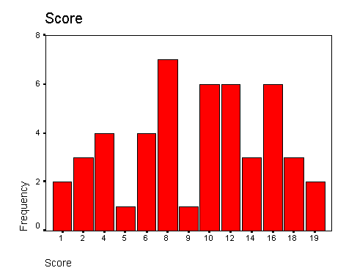

Figure 1. Use sentence case and double space if the caption takes up more than one line; keep second and subsequent lines flush left (note: use the FIGURE CAPTION button on the APA TABLES toolbar).

|  |
| --- |
| To add a CAPTION after the figure is inserted, select INSERT FIGURE CAPTION on the APA Style Tables menu.  After adding the CAPTION, you may update the INDEX OF FIGURES following the INDEX OF TABLES and TABLE OF CONTENTS at the front of the dissertation.  Double-click to delete textbox |

# Summary

     

|  |
| --- |
| In this section, briefly summarize the results. In particular, note whether each null hypothesis was rejected.  Double-click to delete textbox |

##### CHAPTER 5: SUMMARY AND RECOMMENDATIONS

     

|  |
| --- |
| The intent of Chapter 5 is to form a larger meaning about the data analysis presented in Chapter 4 organized by the following discussion topics: (a) interpretation of the data results, (b) making inferences about the important findings, (c) reporting the lessons learned and/or ethical dimensions, (d) connecting the results of the analysis to leadership implications, (e) presenting personal interpretations, reflections, and personal views to broader social significance (elevator speech), and (e) making recommendations for future research. Begin the introduction to Chapter 5 with a paragraph that summarizes the following: (a) research problem, (b) purpose of research, (c) research methods, (d) limitations of the study (bring the limitations presented in chapter 1 to Chapter 5), and (e) the organization of Chapter 5. This introductory paragraph does not require a separate heading. The introduction should be written in a discussion tone and not written as a copy and paste view from previous sections. Chapter 5 is organized by the major headings: (a) conclusions, (b) implications and (c) recommendations.  The conclusion section can be organized by your research design reflected in Chapter 4. Begin the discussion with the results of the hypotheses. Reflecting on each analysis and result presented in Chapter 4, answer one or more of the following questions: (a) is this result important, (b) is this result consistent with the results of previous research, (c) does this result suggest that the existing theory should be modified, and (d) are there possible alternative explanations of the result?  The implications section is related to the broader social significance and implications of the data analysis to leadership. Possible discussion topics are: (a) implications to leadership in the organization, (b) implications to leadership globally, and (c) a passionate and informed elevator speech that implies that the research will inform intended change in the organization and/or community.  The recommendations section is related to an even broader social significance. Possible topics might be: (a) recommendations for future theory and research, (b) recommendations for action by key stakeholders such as administrators, parents, and communities, and (c) recommendations that the study itself to be replicated using different samples and/or populations. Note any questions that are raised by your results – further research should be recommended to explore these questions.  Double-click to delete textbox |

# Conclusion

     

|  |
| --- |
| This section presents and interprets conclusions drawn from the literature review, the methodology, and the analysis of data. Interpret and evaluate the importance, significance, and meaning of the study to various constituents (e.g., administrators, employees, researchers, the community, etc.). The broader social significance of the research may also be addressed.  To make the conclusions more orderly, it is appropriate to have a separate level-3 heading for each of the Error: no se encontró el origen de la referencia and/or the Research Questions procedure. If your hypotheses are not supported, look for reasonable explanations both from the study itself (your hypothesis was indeed incorrect) or were there additional limitations in the study that you did not consider in chapter one?  Be sure to discuss the Error: no se encontró el origen de la referencia, Error: no se encontró el origen de la referencia, and Error: no se encontró el origen de la referencia from chapter one, and any impact they may have had in your results. (Note: each of the words: Error: no se encontró el origen de la referencia, Error: no se encontró el origen de la referencia, Error: no se encontró el origen de la referencia, and Error: no se encontró el origen de la referencia, are hyperlinks to the appropriate section, if you have not changed or deleted the titles.)  Double-click to delete textbox |

# Implications

     

|  |
| --- |
| The implications section is related to the broader social significance and implications of the data analysis to leadership. Possible discussion topics are: (a) implications to leadership in the organization, (b) implications to leadership globally, and (c) a passionate and informed elevator speech that implies that the research will inform intended change in the organization and/or community.  Double-click to delete textbox |

# Recommendations

     

|  |
| --- |
| In general, make two categories of recommendations: (a) recommendations for action by key stakeholders (e.g., administrators), along with the appropriate implications (positive and negative) of adopting the recommendation (any matters that may significantly affect each constituency should be addressed), and (b) recommendations for further study. It is appropriate to recommend that the study itself be replicated using different samples and/or populations. Note any questions that are raised by your results – further research should be recommended to explore these questions.  Double-click to delete textbox |

##### References

|  |
| --- |
| Use the menus for basic formats. Consult the pages referenced as needed. Other useful pages in the APA manual are: pp. 217-219, abbreviations and cities that need no state or country; pp. 219-222, order of items in the reference list; pp. 232-236, index to the examples by type of work; pp. 237-239, index to elements in the examples. NOTE: USE HEADING 5 FOR THE REFERENCES HEADER SO IT WILL UPDATE CORRECTLY IN THE TABLE OF CONTENTS.  Remember that REFERENCES must appear in the Table of Contents (the heading is already correctly formatted for the TOC… no need to change it)  NOTE: For online references, substitute 'n.d.' if no posting date is known.  HINTS ON USING THE REFERENCES TOOLBAR:  To insert a reference, click on the reference toolbar and select the appropriate type of reference. Be sure your cursor in placed where you want the reference to appear BEFORE inserting the reference.  To put the references in alphabetical order:  Select the entire reference section by putting your cursor in front of the first letter of the first word, scrolling down to the last letter of the last reference, hold the control key down and hit the letter ‘A’,  On the Table menu, select the <SORT> option.  If the reference *is not inserted with a hanging indent,* simply place your cursor anywhere on the reference and select REFERENCE FORMAT on the APA FORMATTING toolbar.  Double-click to delete textbox |

<https://www.gob.pe/664-impuesto-a-la-renta>

<http://cultura.sunat.gob.pe/cultura/que-son-los-impuestos>

<http://www2.congreso.gob.pe/sicr/cendocbib/con4_uibd.nsf/D9E1A9324F68D20D05257C13000003C6/$FILE/11-4.pdf>

<https://datos.bancomundial.org/pais/peru>

Appendixes

Appendix A

Title that identifies Appendix to the Reader

|  |
| --- |
| Use “Heading 5b” formatting (APA Formatting toolbar) for “Appendix A, B, etc.” so they format properly in the Table of Contents.  Use heading 1b for the appendix title (Title that identifies Appendix to the Reader on this page), so it will appear correctly in the Table of Contents.  Make the first page of each appendix (e.g., this page) a title page. Place documents and/or information AFTER the title page.  Double-click to delete textbox |

Begin here.

|  |
| --- |
| This is page 1 of Appendix A. EXAMPLES of appendices include: questionnaires consent forms, letters of information, interview protocols, and interview transcripts. Begin each appendix on a separate page.  Double-click to delete textbox |

Appendix B

Informed Consent Form

|  |
| --- |
| To add additional appendixes, copy this page, and paste the information onto a new page.  Double-click to delete textbox |

Page 1 of Appendix B.

Appendix C

Transcripts of Interviews

Begin here.

|  |
| --- |
| Use this appendix for detailed reports of qualitative data.  Double-click to delete textbox |