REGISTRATION FORM OF ICBDA 2017

March 10-12, 2017

Beijing Post Hotel, Beijing, China

www.icbda.org

Please note that it is essential for all participants to send in a completed Registration Form, Final Papers (.doc & .pdf), Copyright Form and Payment Proof to icbda2016@vip.163.com before Dec. 20, 2016.
*All the items below with * in front are must-fill items
**Invoice title usually refers to the person who paid the fee or the organization which will sponsor you to attend conference. If you will use the receipt for reimbursement purpose, we suggest you to put your organization/company/affiliation name on this line.
I. PERSONAL INFORMATION
*First Name: |  | *Family Name:
*Position: Prof. □  Assoc. Prof. □  Asst. Prof. □ Dr. □  Mr. □  Ms. □
* Will you attend the conference in person?  YES □ NO □  *Participant’s Full Name:  - All the materials of participation will be prepared under this name, One registration invite one author to come  - Any changes, please inform us 40 days before the conference, or the participant should be responsible for the consequences.  *Participant’s Affiliation(Organization or University):  NO□ |  |  |  |  | One-inch-Photo here  (*please take a photo to the conference if you didn’t put one here)
It is free for participants of ICBDA 2017 to join the items below. If you will join in, Please mark it with Y.
1, Lunch on March 11 in Beijing Post Hotel ( )
2, Dinner Banquet on March 11 in Beijing Post Hotel ( )
**!Mailing Address (中国作者请用中文填写, 以方便邮寄)
Please provide the details of your address to make sure you receive the materials.

*Invoice Title (发票抬头):
*City: |  |  | *State/Province:
*Country: |  |  | *ZIP/Post Code:
*Tel.: | *E-mail: |  |  | Fax:
Student ID Number:
*Paper ID:
*Paper Title:
*Paper Authors:
*Paper Pages: |  |  | Additional Page:
Special dietary:
Diabetic □ Vegetarian □ Muslim □ Other □ (please specify: )

II. CONFERENCE FEES (BY US DOLLAR) ***
Items | Early Bird  Before Dec. 20, 2016 | Regular Registration  After Dec. 20, 2016 | Your Choice  (Use Arabic Numerals)
Authors  (Students and Committees) | 400USD/ 2600RMB | 430USD/ 2800RMB
Authors  (Regular) | 450USD/ 2900RMB | 480USD/ 3100RMB
Oral Presentation Only | 300USD/ 1900RMB | 320USD/ 2100RMB
Listener | 250USD/ 1600RMB | 270USD/ 1700RMB
Additional Paper | 350USD/ 2300RMB | 350USD/ 2300RMB
Additional Page | 70 USD / 450 RMB / One Page | 70 USD / 450 RMB / One Page
Extra Proceeding | 80 USD/ 500RMB | 80 USD/ 500RMB
Total

1. One regular registration is within FIVE Pages including all figures, tables, and references. Extra pages will be charged.
2. One regular registration with one or more additional papers gets only one proceeding.
3. At least one author for each accepted final paper must pre-register.
4. Please send the required documents: a. final paper; b. signed copyright form; c. filled registration form; d. payment proof to icbda2016@vip.163.com to finish the registration.
5. Please note that the paid registration fee is nonrefundable if you cannot participate in the conference.
III. Payment Terms
1. Credit Card Online Payment linkage (VISA and Master card ONLY. No handling fees)
http://meeting.yizhifubj.com.cn/web/main.action?meetingId=188
Please make sure you have VISA or Mastered Card Credit Card before clicking this link, and you should also calculate the right amount and pay.
Please fill in the E-mail and Confirmation Number you received after paying.
*E-mail: | *Confirmation Order Number:
2. Bank Transfer （Only for Authors from Mainland of China）
人民币账户
请在汇款凭证上标明您的“会议名称+Paper ID”
账号： | 129316274303
开户名： | 成都宗杭会展服务有限公司
开户行名称： | 中国银行股份有限公司成都成飞支行
发票抬头:（作者填写） | 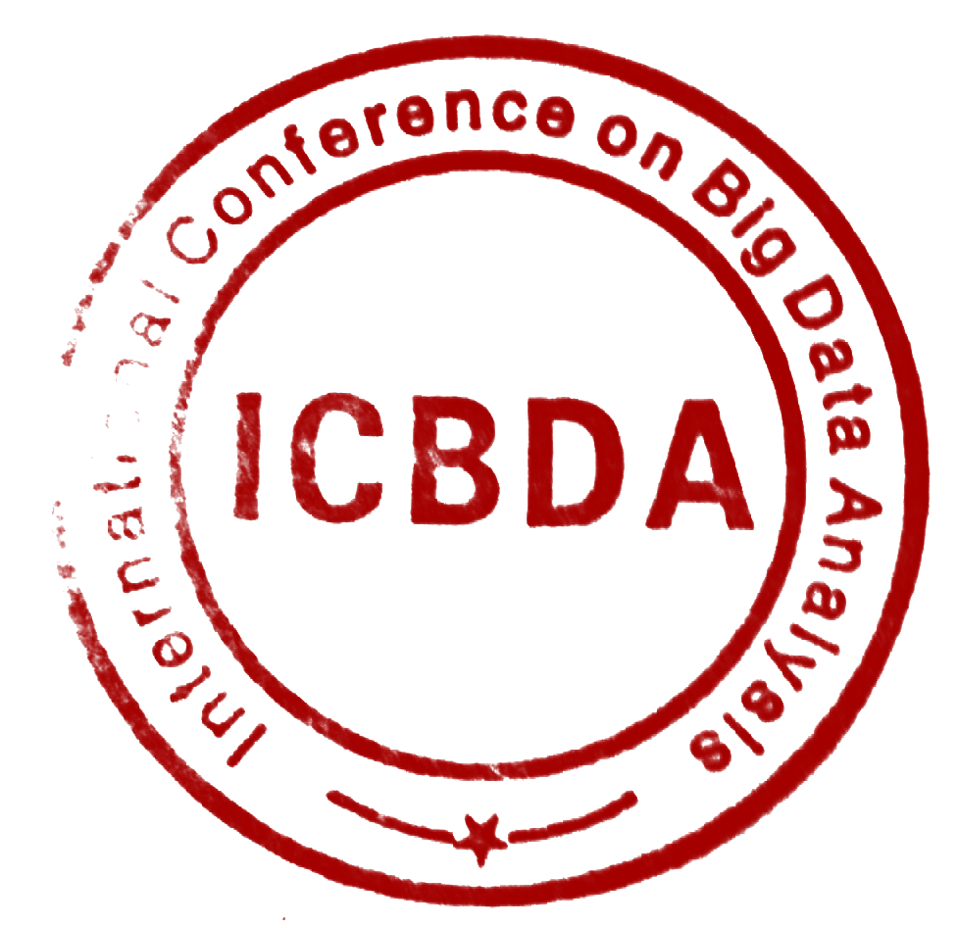


ICBDA 2017 Conference Committee
Beijing, China

