**The Impact of Label Information on Students’ Food Choices**

**Chen Fu (Frank, 122090020 - Lecture 04)**

**School of Data Science**

**ENG2001 English for Academic Purposes II**

**Prof. Matthew Book**

**October 10th, 2023**

**Abstract**

This study explores the impact of food labels on the food choices of Chinese college students. It emphasizes the growing importance of food labels beyond flavor among students’ decisions in recent years. By studying the attitudes toward food labels of 101 Chinese college students through questionnaires, the research identifies not only effective labels such as expiration date and brand, but also factors including shopping methods and label complexity that significantly influence the impact of food labels. These results indicate that Chinese college students, similar to European counterparts, pay significant attention to food labels, and the choices may be affected by other factors.

**Keywords:** food label, college student

**The Impact of Label Information on Students’ Food Choices**

**Introduction**

With a vast array of food options, contemporary consumers demonstrate an increasing consideration of more factors that surpass flavor, such as nutritional value, when purchasing food (Martini & Menozzi, 2021). To present their distinct features, food producers incorporate labels on their products (Chalupová et al., 2020).

While most labels provide effective and comprehensive information, different consumers allocate varying degrees of attention to each label. By studying how consumers interpret and utilize label information, more effective strategies can be summarized to guide consumers toward healthier and more informed food choices. In addition, it helps companies to develop targeted marketing strategies and product innovations (Chalupová et al., 2020). Therefore, studying consumers’ perceptions and use of food labels is crucial for promoting a better strategy for both purchasing and producing food.

Nevertheless, limited surveys have been conducted on Chinese mainland and certain key factors are ignored in most previous studies. Hence, this research aims to study the impact of labels on the food choices of college students in Chinese mainland, seeking to address the current research gap in the context of Chinese students.

**Literature Review**

Previous research has presented that the impact of food labels can vary across consumers’ countries and food categories, even among labels of the same type. Gracia and De-Magistris (2016) suggest that consumers in Europe prioritize organic-labeled food despite possibly worse flavor, while other researchers show consumers in South Africa prefer personal experiences, such as freshness, instead (Grunert & Aachmann, 2016; Van Der Merwe et al., 2010). Besides, Mhurchu et al. (2018) discover that consumers are more likely to check nutrition labels on convenience and snack foods rather than fresh foods, according to questionnaire results.

Studies also suggest that the design of labels has a significant impact on consumers’ choices. By analyzing yogurt labels and purchasing data, fancy aesthetic and graphic designs are found to be prior to functionality in attracting consumers (Ares et al., 2011). Also, Roberto and Khandpur (2014) apply eye-tracking technology and reveal that labels with fewer than five lines are typically viewed by more consumers.

Furthermore, the mere provision of quantitative information on nutrition labels is not found to be particularly efficacious (Cecchini & Warin, 2016; Dumoitier et al., 2019). Indeed, Wills et al. (2009) argue that most U.S. consumers may have a limited understanding or misinterpretation of certain food labels, indicating that the effectiveness of food labeling may have been overestimated.

Though a large amount of research on how food labels influence consumers’ choices have been conducted, certain influential factors, such as the age of the consumer and the method of purchasing food (online or offline), are scarcely addressed in any of the conducted studies. Previous research has conducted relatively few studies on Chinese consumers as well. Consequently, the results of previous works may not be applicable to Chinese college students. To address these gaps, this research focuses more on relevant factors that influence the choices of Chinese college students. The research questions that guide this research are:

1. What types of food labels exert greater impacts on the choices of Chinese college student consumers?
2. What are the potential factors that can influence the impact of food labels on the choices of Chinese college student consumers?

**Methods**

1. **Population**

In this study, 101 college students in Chinese mainland were randomly selected as the participants. About two-fifths participants were invited in the CUHK(SZ) campus, while the rest were contacted through reliable online platforms, such as Wenjuanxing. Generally, the participants came from 18 provinces across the country, with the majority being from Guangdong Province, as shown in Figure 1.

Figure 1

Distribution of participants by province

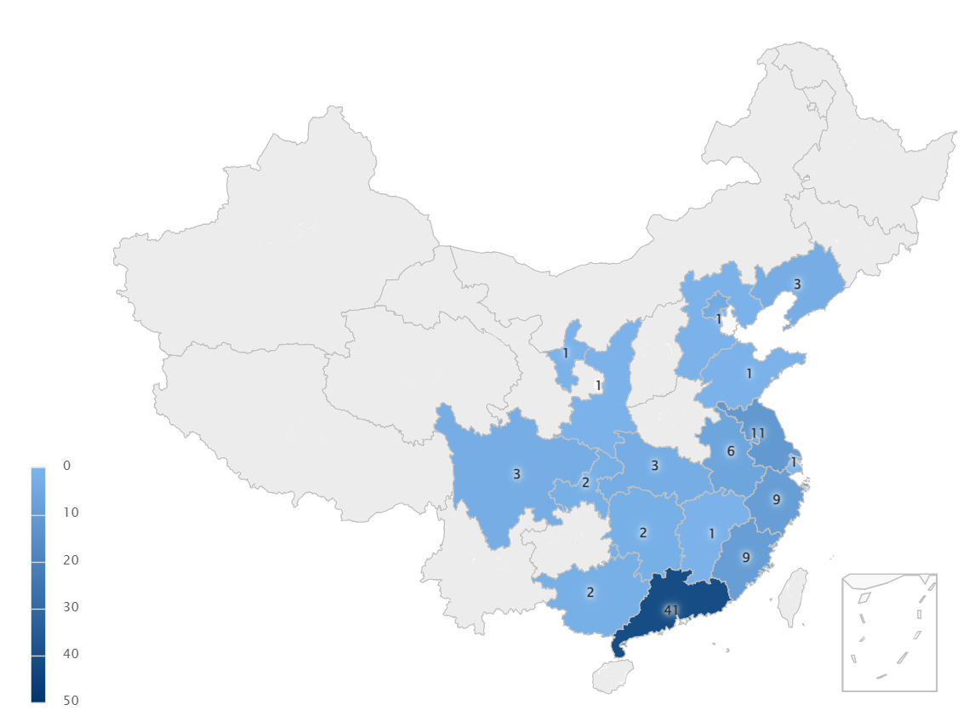

1. **Data Collection**

Both quantitative and qualitative data regarding the impact of food labels were collected among the participants, and a predominant focus was placed on the quantitative data for statistical analysis.

Electronic questionnaires (powered by Wenjuanxing) served as the main data collection method for convenience in the distribution and collection of data. The questionnaires contained ten Likert-type scales and four ranking questions for quantitative research, and one short answer question for qualitative research, as attached in Appendix I. The questions gathered information regarding students’ knowledge and attitudes related to food labels, where independent variables, including food category and purchasing method, will be considered.

1. **Data analysis**

Based on the collected data, statistical techniques, including the mean analysis and the correlation analysis, were employed to examine the relationships between food labels and participants’ food choices. In addition, reliability analysis was applied to examine the effectiveness of the data.

**Result**

The reliability of collected data is *a*=0.83, indicating that the data is highly worth trusting.

1. **Food labels that affect students’ choices**

According to the rating problems about participants’ awareness of food labels (Figure 2), “brand” and “expiration date” are significantly more considered when students purchase food, while “processing method” is paid less attention to. Furthermore, most of the labels are weighted as more important than actual taste. However, the standard deviations of the rates are higher than expected.

Figure 2

Average rate and standard deviation of participants’ awareness of food labels

|  |  |
| --- | --- |
| **Label** | **Std** |
| Organic | 1.787 |
| Food safety certification | 1.909 |
| Food additives | 2.259 |
| Nutrition facts | 2.591 |
| Brand | 1.866 |
| Expiration date | 1.600 |
| Local origin | 2.278 |
| Process method | 2.151 |
| Actual taste | 2.955 |

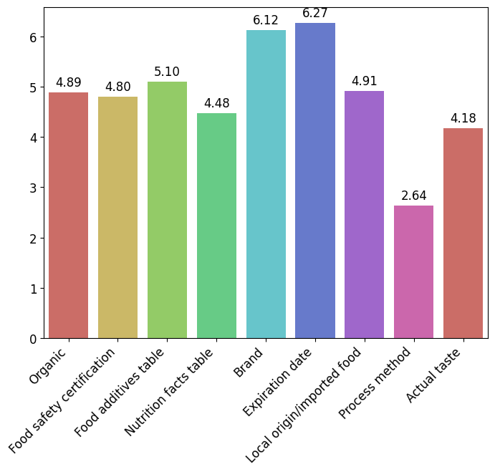

1. **Factors that influence the impact of food labels**

The rate on participants’ awareness on food labels are significantly different between online and offline shopping. Though the result in the previous section generally still holds, “nutrition facts” and “expiration date” labels are rated much lower in online purchasing. Moreover, actual taste is viewed as important in offline shopping but less significant in online shopping. In addition, the standard deviation is much lower when two purchasing method is separated, indicating the shopping method is a significant factor, as shown in Figure 3 and Figure 4.

Figure 3

Average rate and standard deviation of participants’ awareness of food labels (offline)

|  |  |
| --- | --- |
| **Label** | **Std** |
| Organic | 1.452 |
| Food safety certification | 1.437 |
| Food additives | 1.683 |
| Nutrition facts | 1.318 |
| Brand | 1.737 |
| Expiration date | 1.092 |
| Local origin | 1.698 |
| Process method | 2.068 |
| Actual taste | 2.553 |

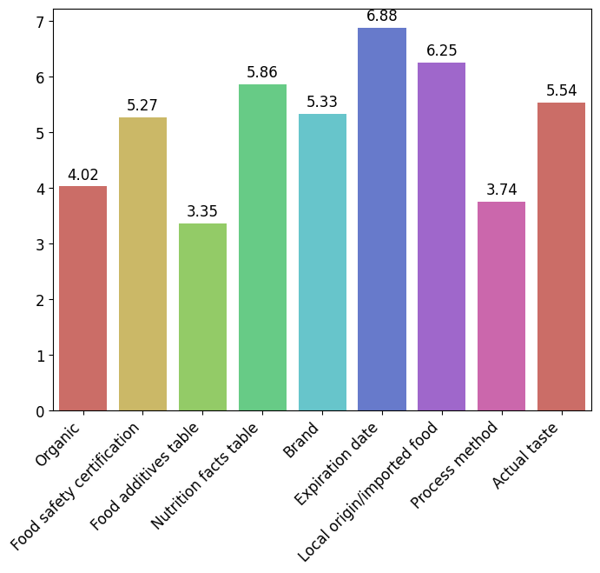

Figure 4

Average rate and standard deviation of participants’ awareness of food labels (online)

|  |  |
| --- | --- |
| **Label** | **Std** |
| Organic | 1.212 |
| Food safety certification | 1.772 |
| Food additives | 1.237 |
| Nutrition facts | 1.656 |
| Brand | 0.874 |
| Expiration date | 1.450 |
| Local origin | 1.379 |
| Process method | 1.035 |
| Actual taste | 1.874 |

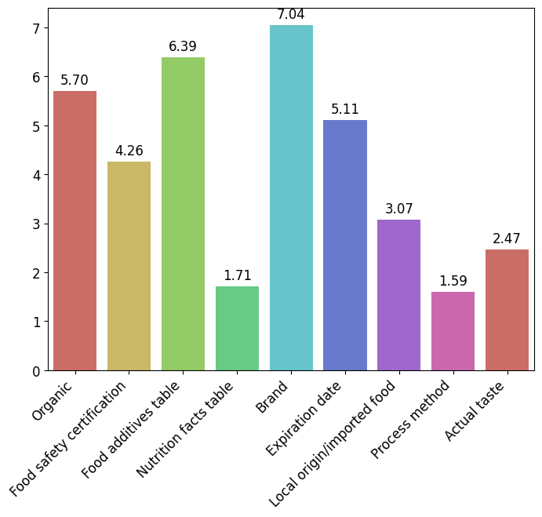

Besides, according to the last six Likert-type scales (Appendix I, question 12~17), the complexity of labels and the number of the food’s purchases can influence participants’ attitudes toward food labels as well. Strong correlations between friends’ recommendations and the number of purchases, time limits and reading complex label information are also detected (Figure 5).

Figure 5

Mean and correlation matrix of last six scales (Appendix I, question 12~17)

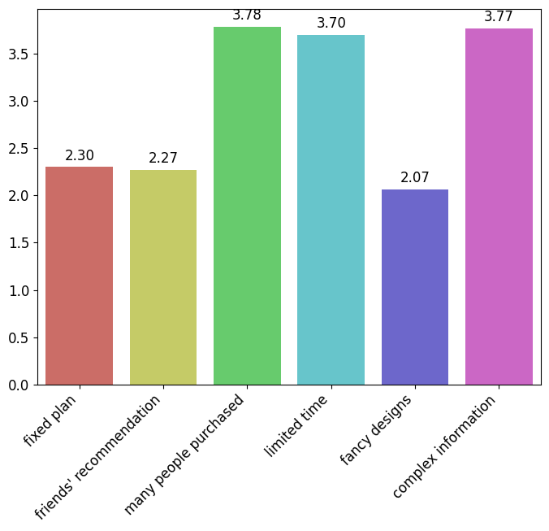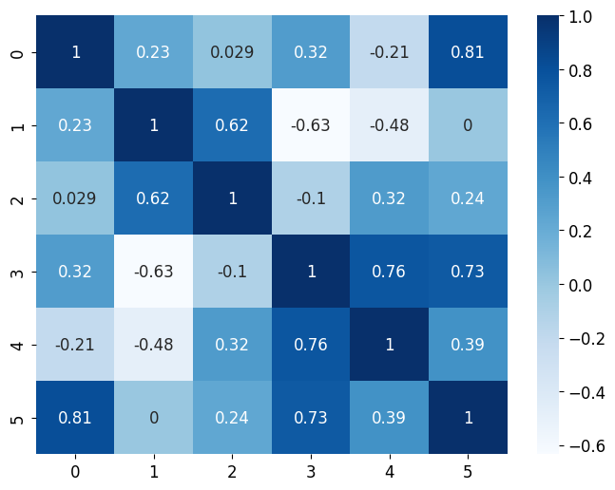

Furthermore, as shown in Figure 6, purchasing frequency and food preferences have no significant influence on the awareness of food labels.

Figure 6

Awareness of food labels with respect to purchasing frequency and food preferences

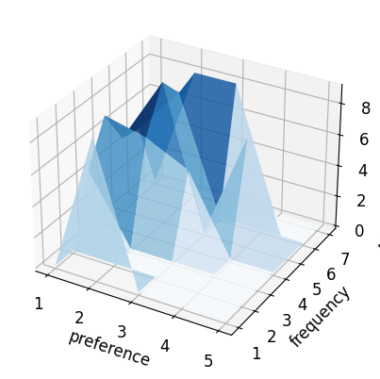

**Discussion**

In general, participants pay more attention to various food labels than actual taste, especially for the expiration date and the brand, which is consistent with the findings in Europe (Gracia and De-Magistris, 2016) (Figure 2). It shows that more people are pursuing for safer, healthier food instead of simply tasty food. Since there is no obvious relationship between awareness of food labels and food preferences or food purchase frequency, it can be concluded that people care about food labels not for special needs such as weight control, but for their health only.

Besides, the strong positive correlations among limited shopping time, complexity of food labels and the ignorance of food labels are also detected (Figure 5). One possible reason is that consumers are less likely to read the food labels if the time is limited, especially when the label is long and complex. This result also aligns with Roberto and Khandpur’s research (2014).

However, the purchasing method is an essential factor that influences the impact of food labels, while few previous studies even mentioned it. This result is supported by the significant difference of ranking distribution between online and offline shopping (Figure 3 & 4). By separating these two classes, people’s attitudes towards food labels become more explainable. For example, the expiration date is focused much in offline purchasing probably because it provides a convenient way to check whether the food is fresh. The information of expiration date is simple and clear, which also allows people to read it in a short time. While on e-platforms, the expiration date is usually hard to find. And people seldom buy fresh food such as fruit through the internet. These facts may explain why people have various attitudes when shopping with different methods, and provide a direction for future works.

**Conclusion**

In this research, the impact of food labels on Chinese college students is verified to be similar to that in Europe: students do pay much attention to food labels when purchasing food, while factors, such as purchasing method and label complexity, can significantly influence the impact of the labels.

Regrettably, there are limitations in this research. The participants of the questionnaires are mainly from the coastal provinces in China. And potential factors such as price are dropped due to the uncertainty they may cause. These are expected to improve in future research.

Finally, this research is enough to show practical implications. For consumers, it is suggested that they should focus more on food labels when shopping online since it aids them in selecting healthier food. For producers, they may consider designing more concise labels to attract consumers’ attention more.

**References**

Ares, G., Piqueras-Fiszman, B., Varela, P., Marco, R. M., López, A. M., & Fiszman, S. (2011). Food labels: Do consumers perceive what semiotics want to convey?. *Food quality and preference*, *22*(7), 689-698.

Cecchini, M., & Warin, L. (2016). Impact of food labelling systems on food choices and eating behaviours: a systematic review and meta‐analysis of randomized studies. *Obesity reviews*, *17*(3), 201-210.

Chalupová, M., Rojík, S., Kotoučková, H., & Kauerová, L. (2020). Food labels (quality, origin, and sustainability): The experience of Czech producers. *Sustainability*, *13*(1), 318.

Dumoitier, A., Abbo, V., Neuhofer, Z. T., & McFadden, B. R. (2019). A review of nutrition labeling and food choice in the United States. *Obesity science & practice*, *5*(6), 581-591.

Gracia, A., & De-Magistris, T. (2016). Consumer preferences for food labeling: what ranks first?. *Food control*, *61*, 39-46.

Grunert, K. G., & Aachmann, K. (2016). Consumer reactions to the use of EU quality labels on food products: A review of the literature. *Food Control*, *59*, 178-187.

Martini, D., & Menozzi, D. (2021). Food labeling: analysis, understanding, and perception. *Nutrients*, *13*(1), 268.

Mhurchu, C. N., Eyles, H., Jiang, Y., & Blakely, T. (2018). Do nutrition labels influence healthier food choices? Analysis of label viewing behaviour and subsequent food purchases in a labelling intervention trial. *Appetite*, *121*, 360-365.

Roberto, C. A., & Khandpur, N. (2014). Improving the design of nutrition labels to promote healthier food choices and reasonable portion sizes. *International Journal of Obesity*, *38*(1), S25-S33.

Van Der Merwe, D., Kempen, E. L., Breedt, S., & De Beer, H. (2010). Food choice: student consumers' decision‐making process regarding food products with limited label information. *International Journal of Consumer Studies*, *34*(1), 11-18.

Wills, J. M., Schmidt, D. B., Pillo-Blocka, F., & Cairns, G. (2009). Exploring global consumer attitudes toward nutrition information on food labels. *Nutrition reviews*, *67*(suppl_1), S102-S106.

**Appendix**

**Appendix I. Questionnaire**

**The Impact of Food Labels on College Students**

**食品标签对大学生食品消费选择的影响**  
  This questionnaire aims to investigate the impact of food labels on the food consumption habits of Chinese college students. The data collected will be safeguarded to ensure your privacy, and it will be further analyzed to support a research in the course ENG2001 of CUHK(SZ).  
  The questionnaire consists of four sections and 18 problems in total, and the recommended time is 16 minutes. Questions will be asked in the first person. Please answer the questions according to the requirements of the section and your own situation.  
  The questionnaire will be available until November 19th, 2023.

  本问卷旨在调查食品标签对中国大学生食品消费习惯的影响，所收集的数据将被严格保护以确保您的隐私。相关数据最终将被用于支持 CUHK(SZ) ENG2001 课程中的一项研究。  
  问卷分为四个小节，共18题，建议用时16分钟。问题将使用第一人称提出，请按照小节要求与自身情况回答问题。  
  问卷开放时间截止至2023年11月19日。

**Section A: Basic information / 第一小节：基本信息**In this part, please answer some basic problems to get familiar with our topic.  
在本部分中，请回答一些基本问题以熟悉该问卷的主题。

1. I am currently studying at [单选题] *

我当前就读于（请填写高校名称；可以填写简称，但请填写真实信息以校验问卷有效性）

|  |
| --- |
| ○CUHK(SZ) - 香港中文大学（深圳） |
| ○Others - 其他 _________________ * |

2. In the past three years, on average I purchased packaged food as often as [单选题] *

(including packaged food purchased online or offline, or unpackaged food with food labels)  
近三年内，我平均购买带标签食品的频率大约为  
（含线上、线下各类包装食品，或带有食品标签的非包装食品）

|  |
| --- |
| ○less than twice a year - 低于每年两次 |
| ○about two to ten times a year - 每年约二至十次 |
| ○about one to three times a month - 每月约一至三次 |
| ○about once or twice a week - 每周约一至两次 |
| ○about three to six times a week - 每周约三至六次 |
| ○about once a day - 每日约一次 |
| ○more than once a day - 每日高于一次 |

3. In the past three years, I prefer to buy food **offline**. [单选题] *

(*Strongly agree* represents *always offline*, and *Strongly disagree* represents *always online*)  
近三年内，我更经常在**线下**购买食品。  
（*非常赞成*代表总是*线下购买*，而*非常反对*代表总是*线上购买*）

|  |  |  |  |  |
| --- | --- | --- | --- | --- |
| ○Strongly agree - 非常赞成 | ○Agree - 赞成 | ○Neutral - 中立 | ○Disagree - 反对 | ○Strongly disagree - 非常反对 |

4. I have some special requirements regarding food intake, such as [多选题] *

我对食品摄入有部分特殊需求，例如

|  |
| --- |
| □Weight control - 控制体重 |
| □Fitness/beauty - 健身/美容 |
| □Taboos - 忌口 |
| □Others - 其他 _________________* |
| □No special requirements - 没有特殊需求 |

**Section B: The impact of food labels (offline purchasing) / 第二小节：食品标签的影响（线下购买）**In this page, please answer the questions about your preferences when purchasing labeled food **offline**.  
请根据您对**线下**购买带标签食品的偏好，回答本页问卷。

5. When buying food, I will always pay attention to these labels before deciding whether to buy it.[矩阵多选题] *

当我购买食物之前，我一定会查看这些标签。

|  |  |  |  |  |  |  |  |  |  |
| --- | --- | --- | --- | --- | --- | --- | --- | --- | --- |
|  | Organic/use organic ingredients - 有机产品/使用有机原料 | Food safety certification - 食品安全认证 | Food addictives table - 食品添加剂表 | Nutrition facts table - 营养成分表 | Brand - 品牌 | Expiration Date - 过期时间/保质期 | Local origin/imported food - 本地/进口食品 | Process method - 处理方法 | Others - 其他 |
| Packaged fruits and vegetables - 包装果蔬 | □ | □ | □ | □ | □ | □ | □ | □ | □ |
| Dairy products - 乳制品 | □ | □ | □ | □ | □ | □ | □ | □ | □ |
| Baked products - 烘焙食品 | □ | □ | □ | □ | □ | □ | □ | □ | □ |
| Snacks and drinks - 零食饮料 | □ | □ | □ | □ | □ | □ | □ | □ | □ |

6. Generally speaking, I will pay more attention to these labels before deciding whether to buy it offline. [排序题，请在中括号内依次填入数字] *

(You may also need to compare them with taste experience, i.e. do you think food with some labels are better regardless actual taste? Please only select all labels you may be interested in and then rank them, where the rank 1 is the most significant label.)  
  
一般来说，线下购买食品时我会更加注意这些标签。  
（你同时需要将这些标签与食品实际口感进行比较：你是否认为带有某些标签的食品更好，无论其实际口味如何？仅选择所有你可能关注的标签并排序，其中第一名代表该标签最重要）

|  |
| --- |
| [ ]Organic/use organic ingredients - 有机产品/使用有机原料 |
| [ ]Food safety certification - 食品安全认证 |
| [ ]Food additives table - 食品添加剂表 |
| [ ]Nutrition facts table - 营养成分表 |
| [ ]Brand - 品牌 |
| [ ]Expiration date - 保质期/过期时间 |
| [ ]Local origin/imported food- 本地/进口食品 |
| [ ]Process method - 处理方法 |
| [ ]Actual taste - 实际口感 |

7. I will intentionally choose one among foods with similar characteristics by comparing food labels。[矩阵量表题] *

我会有意地比较食品标签，以在特征相近的食品中做出选择。

|  |  |  |  |  |  |
| --- | --- | --- | --- | --- | --- |
|  | Strongly agree - 非常赞成 | Agree - 赞成 | Neutral - 中立 | Disagree - 反对 | Strongly disagree - 非常反对 |
| Packaged fruits and vegetables - 包装果蔬 | ○ | ○ | ○ | ○ | ○ |
| Dairy products - 乳制品 | ○ | ○ | ○ | ○ | ○ |
| Baked products - 烘焙食品 | ○ | ○ | ○ | ○ | ○ |
| Snacks and drinks - 零食饮料 | ○ | ○ | ○ | ○ | ○ |

**Section C: The impact of food labels (online purchasing) / 第三小节：食品标签的影响（线上购买）**In this page, please answer the questions about your preferences when purchasing labeled food online.  
请根据您对线上购买带标签食品的偏好，回答本页问卷。

8. I understand that platforms that sell food online must display nutrition facts and other food-related labels that are consistent with those of offline products. [单选题] *

|  |  |  |  |  |  |  |
| --- | --- | --- | --- | --- | --- | --- |
| Strongly agree - 非常赞成 | ○ | ○ | ○ | ○ | ○ | Strongly disagree - 非常反对 |

9. When buying food, I will always pay attention to these labels before deciding whether to buy it.[矩阵多选题] *

当我购买食物之前，我一定会查看这些标签。

|  |  |  |  |  |  |  |  |  |  |
| --- | --- | --- | --- | --- | --- | --- | --- | --- | --- |
|  | Organic/use organic ingredients - 有机产品/使用有机原料 | Food safety certification - 食品安全认证 | Food addictives table - 食品添加剂表 | Nutrition facts table - 营养成分表 | Brand - 品牌 | Expiration Date - 过期时间/保质期 | Local origin/imported food - 本地/进口食品 | Process method - 处理方法 | Others - 其他 |
| Packaged fruits and vegetables - 包装果蔬 | □ | □ | □ | □ | □ | □ | □ | □ | □ |
| Dairy products - 乳制品 | □ | □ | □ | □ | □ | □ | □ | □ | □ |
| Baked products - 烘焙食品 | □ | □ | □ | □ | □ | □ | □ | □ | □ |
| Snacks and drinks - 零食饮料 | □ | □ | □ | □ | □ | □ | □ | □ | □ |

10. Generally speaking, I will pay more attention to these labels before deciding whether to buy it online. [排序题，请在中括号内依次填入数字] *

(You may also need to compare them with taste experience, i.e. do you think food with some labels are better regardless actual taste? Please only select all labels you may be interested in and then rank them, where the rank 1 is the most significant label.)  
  
一般来说，线上购买食品时我会更加注意这些标签。  
（你同时需要将这些标签与食品实际口感进行比较：你是否认为带有某些标签的食品更好，无论其实际口味如何？仅选择所有你可能关注的标签并排序，其中第一名代表该标签最重要）

|  |
| --- |
| [ ]Organic/use organic ingredients - 有机产品/使用有机原料 |
| [ ]Food safety certification - 食品安全认证 |
| [ ]Food additives table - 食品添加剂表 |
| [ ]Nutrition facts table - 营养成分表 |
| [ ]Brand - 品牌 |
| [ ]Expiration date - 保质期/过期时间 |
| [ ]Local origin/imported food- 本地/进口食品 |
| [ ]Process method - 处理方法 |
| [ ]Actual taste - 实际口感 |

11. I will intentionally choose one among foods with similar characteristics by comparing food labels。[矩阵量表题] *

我会有意地比较食品标签，以在特征相近的食品中做出选择。

|  |  |  |  |  |  |
| --- | --- | --- | --- | --- | --- |
|  | Strongly agree - 非常赞成 | Agree - 赞成 | Neutral - 中立 | Disagree - 反对 | Strongly disagree - 非常反对 |
| Packaged fruits and vegetables - 包装果蔬 | ○ | ○ | ○ | ○ | ○ |
| Dairy products - 乳制品 | ○ | ○ | ○ | ○ | ○ |
| Baked products - 烘焙食品 | ○ | ○ | ○ | ○ | ○ |
| Snacks and drinks - 零食饮料 | ○ | ○ | ○ | ○ | ○ |

**Section D: Factors that influence the impact of food labels / 第四小节：改变食品标签对购物选择影响的因素**In this part, please answer the questions about your attitude to food labels under various circumstances.  
请根据你在不同情境下对食品标签的态度，回答本页问卷。

12. I would give up on buying a food product that I **plan to use it for cooking** just because the label on the food didn’t satisfy me [单选题] *

我会放弃购买一些**原计划用于烹饪**的食品，仅仅因为其上食品标签并不足以让我满意。

|  |  |  |  |  |
| --- | --- | --- | --- | --- |
| ○Strongly agree - 非常赞成 | ○Agree - 赞成 | ○Neutral - 中立 | ○Disagree - 不赞成 | ○Strongly disagree - 非常不赞成 |

13. I would give up on buying a food product that **someone else recommended** just because the label on the food didn’t satisfy me [单选题] *

我会放弃购买一些**他人推荐**的食品，仅仅因为其上食品标签并不足以让我满意。

|  |  |  |  |  |
| --- | --- | --- | --- | --- |
| ○Strongly agree - 非常赞成 | ○Agree - 赞成 | ○Neutral - 中立 | ○Disagree - 不赞成 | ○Strongly disagree - 非常不赞成 |

14. I don't care about food labels when **many people have purchased the same food**. [单选题] *

当**许多人购买过同类食品时**，我不再关心食品标签。

|  |  |  |  |  |
| --- | --- | --- | --- | --- |
| ○Strongly agree - 非常赞成 | ○Agree - 赞成 | ○Neutral - 中立 | ○Disagree - 不赞成 | ○Strongly disagree - 非常不赞成 |

15. I don't care about food labels when **I don’t have enough time to purchase food**. [单选题] *

当我用于购买食物的**时间不充裕**时，我不再关心食品标签。

|  |  |  |  |  |
| --- | --- | --- | --- | --- |
| ○Strongly agree - 非常赞成 | ○Agree - 赞成 | ○Neutral - 中立 | ○Disagree - 不赞成 | ○Strongly disagree - 非常不赞成 |

16. Even if it’s not important, I will take the time to read fancy designed food labels. [单选题] *

尽管其并不重要，我仍然会花时间阅读一些设计花哨的标签。

|  |  |  |  |  |
| --- | --- | --- | --- | --- |
| ○Strongly agree - 非常赞成 | ○Agree - 赞成 | ○Neutral - 中立 | ○Disagree - 不赞成 | ○Strongly disagree - 非常不赞成 |

17. Despite the abundance of complex information, I will take the time to read labels that I deem important. [单选题] *

尽管有大量复杂的信息，我仍然会花时间阅读我认为重要的标签。

|  |  |  |  |  |
| --- | --- | --- | --- | --- |
| ○Strongly agree - 非常赞成 | ○Agree - 赞成 | ○Neutral - 中立 | ○Disagree - 不赞成 | ○Strongly disagree - 非常不赞成 |

18. I believe some other factors may influence the impact of food labels, such as [填空题]

我认为一些其他因素也会改变食品标签带来的影响，例如

_________________________________

**Appendix II. Formula used in data analysis**

Due to the complexity of raw data from the questionnaire, some basic formula were applied to transfer non-numeric data to numbers for convenience, as a part of the statistical analysis mentioned in the “methods” section. To help reproduce the statistical result in this research, the formula are provided here.

|  |  |
| --- | --- |
| **Question No.** | **Formula** |
| 2 | frequencies are numbered from 1 to 7 (most frequent) |
| 3 | preferences are classified as 1: offline, if strongly agree is chosen; 2: mix mode; 3:online, if strongly disagree is chosen |
| 5 & 9 | 1 if ticked, 0 otherwise |
| 6 & 10 | rate of a label = (total selected labels + 1) - rank of the label |
| 7 & 8 & 11 | numbered from 1 to 5 (strongly agree) |
| 12 & 13 & 16 & 17 | numbered from 1 to 5 (strongly agree) |
| 14 & 15 | numbered from 1 to 5 (strongly disagree) |

Figure 2: average rate of question 6 &10 (with respect to label types)

Figure 3, 4: average rate of question 6, 10, respectively

Figure 5: average and correlation of rate in question 12~17

Figure 6: average rate of question 6 & 10 (with respect to question 2, 3)