**LuminaSage: A smart desk lamp that protects visual health**

**Background**

Visual health problems, including vision loss and eyeball inflammation, have attracted more and more attention. Prior research has proved that the light environment has a significant impact on people’s visual health (Boyce, 2003). Indeed, eyes are sensitive to light environment. While improving the luminance of the light environment can cause visual fatigue, staying in a weak light environment may also have a serious impact on visual health (Liu et al., 2021). As people study or work longer every day, ensuring a light environment becomes even more crucial. Consequently, it will be helpful for visual health if there is a tool that helps people maintain a good light environment.

**Problem**

Currently, people mainly adjust the light environment through various lighting tools, such as ceiling lamps and desk lamps. However, people are not sure what level of brightness is suitable for them. Most of the time, they just randomly set a brightness based on their personal feelings. But the brightness based on personal feelings probably inadvertently heightens their visual sensitivity, which often surpasses optimal levels and poses potential risks to visual health (Bellia et al., 2011). Hence, the effect of traditional lamps is limited due to the inaccuracy of human perception.

Some smart ceiling lamps apparently solve the issue. The smart lamps can be automatically adjusted according to the light environment. But these lamps can only be adjusted based on preset parameters that are generally suitable. Since the most comfortable brightness is not the same for everyone, these lamps cannot be accurately adjusted to individual characteristics and preferences. Hence, the smart lamps also cannot meet all demands.

Therefore, there is an urgent need to develop a tool to adjust the light environment that not only focuses on scientific health but also takes individual differences into account.

**Solution**

In order to solve the problems above, an improved desk lamp named LuminaSage is proposed, as shown in Figure 1.

Figure 1

Demonstration of LuminaSage

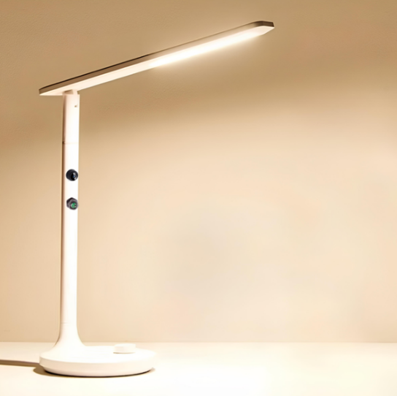

LuminaSage is equipped with a round white base with a diameter of 20 cm for stability; the height is 36 cm and the lighting angle can be adjusted between 30 degrees and 50 degrees, which are in line with the dimensions recommended by previous studies (Chen et al., 2014). The 30 cm long LED light strip ensures enough lighting areas. In addition, LuminaSage incorporates a brightness sensor, a micro camera, and a corresponding offline AI model loaded on a chip within the pillar of the lamp, as shown in Figure 2.

Figure 2

Structural diagram of LuminaSage

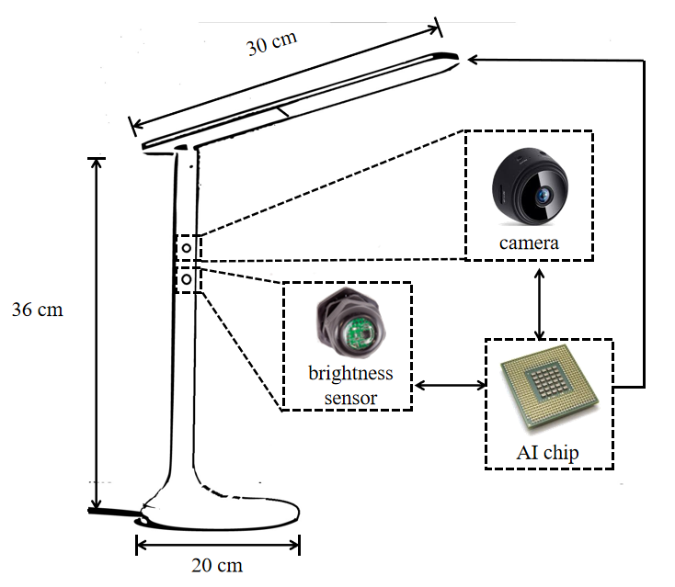

In terms of the functions of the smart devices, the micro camera captures images of the eye region, enabling analysis of visual comfort by detecting changes in pupil size and monitoring surrounding muscle activity. These visual cues can reflect how comfortable the light is to the user’s eyes, which facilitates dynamic fine-tuning of the lamp’s brightness at a detailed level.

While cameras provide a rough indication of the light environment, their accuracy relies on a reference object whose brightness can be ambiguous, making the inclusion of a brightness sensor imperative. The brightness sensor collects environmental brightness data, allowing detection of disparities between current and optimal brightness and establishing suitable brightness ranges at a macro scale.

Finally, due to the lack of clear understanding regarding the relationship between changes in pupil size or alterations in the light environment and individual visual comfort, directly calculating lamp brightness based on data obtained from cameras or sensors poses challenges. Therefore, these data are transmitted to an AI chip, where an AI model estimates the optimal brightness. The AI chip then outputs the results to the LED bulb, enabling the lamp to emit the most comfortable light by utilizing the deep neural network ResNet (He et al., 2016).

In this way, by correctly positioning the camera and sensor to capture the user’s face, LuminaSage enables personalized and precise adjustments to the light environment, ensuring optimal visual health.

**Benefits**

LuminaSage presents notable advantages in scientificity, convenience, and privacy.

Unlike previous smart light products, LuminaSage has noticed the difference among individuals. The AI model is trained based on multiple experimenters, allowing more precise and characterized adjustment for individuals. Using desk lamps instead of ceiling lamps also contributes to focusing on individual working spaces rather than the entire room, preventing people from interfering with each other . Therefore, the design of LuminaSage is more scientific.

In addition, LuminaSage offers great convenience by automatically adjusting to the light environment, freeing users from monitoring and adapting to changes. With its intelligent capabilities, LuminaSage easily detects variations in lighting conditions and adjusts its brightness accordingly, ensuring a consistently comfortable and optimal lighting environment to promote productivity and eliminating distractions.

What is more, LuminaSage ensures enhanced privacy compared to certain existing smart lamps. By utilizing an offline AI model loaded on a chip, LuminaSage eliminates the need for external apps or internet connectivity. This design choice guarantees a higher level of security and privacy, as user data remains within the lamp itself, allowing individuals who prioritize data privacy and protection feel at ease.

**Implementation**

1. Recruit multiple experimenters and place them in working environments with different lighting conditions.
2. Record their pupil and eye muscle activities. Then track their visual health changes and personal feelings.
3. Process the records into numerical data. Feed the collected data to ResNet (the AI model).
4. Load the trained model on the chip and connect the circuit.
5. Embed the chip, the camera and the sensor into the pillar of LuminaSage.
6. Install the base, pillar and light strips according to the set angles.
7. Connect LuminaSage to a power source and proceed to test its functionality to ensure proper operation.

Table 1

Schedule of Implementation

|  |  |  |
| --- | --- | --- |
| Stage | Content | Time |
| Software Development | Recruit Experimenters | ~ Mar 31, 2024 |
| Conduct Experiment | Apr 1 ~ Sep 30, 2024 |
| Train AI Model | Oct 1 ~ Oct 15, 2024 |
| Hardware Development | Design Precise Structure | ~ Jul 31, 2024 |
| Pilot Testing (without AI) | Aug 1 ~ Oct 15, 2024 |
| Final Stage | Final Installation and Testing | Oct 15 ~ Oct 31, 2024 |

**Costs**

The micro camera and brightness sensor are available on Amazon for under $20 and $15, respectively (Amazon, n.d.). As for the chips LuminaSage uses, they are not as complex as commercial CPUs and can be obtained at a lower cost. Besides, the rest of LuminaSage is similar in cost to currently available traditional desk lamps, which cost around $20.

Since the AI training is one-timed, through mass production the marginal cost of training AI on each lamp can be ignored, though an estimated $20,000 is needed to train it.

Hence the pricing of the entire LuminaSage device is expected to be about $50. This price point is notably lower than that of many existing smart desk lamps in the market, which typically range from $80 to $150 on Amazon.

**Conclusion**

LuminaSage enhances visual health by incorporating additional detection equipment and AI models into traditional desk lamps. This enables accurate, convenient, personalized, and private adjustments to the lamp’s brightness based on individual adaptation to the light environment. As a cost-effective solution, LuminaSage assists individuals in maintaining a suitable light environment to promote visual well-being.

**References**

Amazon.com: Micro Camera. (n.d.). Retrieved March 10, 2024, from https://www.amazon.com/micro-camera/s?k=micro+camera

Bellia, L., Bisegna, F., & Spada, G. (2011). Lighting in indoor environments: Visual and non-visual effects of light sources with different spectral power distributions. *Building and environment*, *46*(10), 1984-1992.

Boyce, P. R. (2003). *Human factors in lighting*. Crc press.

Chen, P. L., Peng, W. J., Chen, H. T., Kuo, H. J., Lin, Y. H., Tang, Y. H., ... & Shiao, M. H. (2014, April). The illumination uniformity study of diffuser plates for reflective LED desk lighting. In *The 9th IEEE International Conference on Nano/Micro Engineered and Molecular Systems (NEMS)* (pp. 525-529). IEEE.

He, K., Zhang, X., Ren, S., & Sun, J. (2016). Deep residual learning for image recognition. In *Proceedings of the IEEE conference on computer vision and pattern recognition* (pp. 770-778).

Liu, Y., Zhang, S., Wu, Y., & Yang, D. (2021). Studies on visual health features of luminous environment in college classrooms. *Building and Environment*, *205*, 108184.