Commissioning Report
  - Automated Fulfillment and Packaging Cell Simulation
Document identifier | CR-AFPC-001
Revision | 1.0
Issue date | 26 October 2026
Evidence period | 23 through 26 October 2026
Prepared by | Frank Garcia
Environment | TIA Portal V20, S7-PLCSIM and Factory I/O
Final status | Pass for portfolio demonstration

Commissioning result
The simulation completed 13 of 13 planned FAT tests, routed 51 consecutive products without intervention, verified 39 mapped digital points and finished with no unresolved blocking defect.

This report releases the completed system for portfolio demonstration only. It does not authorize operation of physical machinery or claim safety certification.

1 Document Control
This report records the commissioning work completed on the Siemens PLC and Factory I/O simulation. It documents the initial symptoms, confirmed causes, implemented corrections, executed tests, recovery checks and final release condition.

1.1 Revision History
Revision | Date | Description | Author
1.0 | 26 Oct 2026 | Initial commissioning issue after completed correction and FAT | Frank Garcia

1.2 Commissioning Evidence
Evidence | File
Functional design | Functional_Design_Specification_Automated_Fulfillment_Cell.docx
I/O verification | IO_List_Automated_Fulfillment_Cell.xlsx
Alarm review | Alarm_Matrix_Automated_Fulfillment_Cell.xlsx
Test record | FAT_Test_Matrix_Automated_Fulfillment_Cell.xlsx
Sorter source | FB_SortationController_RecordRecycle.scl
Emitter source | FB_EmitterController_Handshake.scl

1.3 Claim Boundary
Only the 13 FAT tests listed in this report are claimed as executed. Other alarms were reviewed against source code but were not all injected in the running simulation.

2 Executive Summary
Commissioning began with a PLC project that could connect to S7-PLCSIM but did not yet sustain unattended material flow. The main commissioning work corrected missing Factory I/O mappings, synchronized the emitter with the sorter, released completed tracking records, separated the cumulative completion count from recycled record indexes and confirmed deliberate fault recovery.
Measure | Requirement or Scope | Final Result
Discrete I/O | 20 inputs and 19 outputs | Verified and documented
Normal routes | Branch A, Branch B and Reject | All passed
Endurance | More than 20 required | 51 products completed
FAT | 13 planned tests | 13 passed
Alarm documentation | 31 entries | 8 FAT validated and 23 code reviewed
Blocking defects | Zero at final handoff | Closed

2.1 Final Disposition
Pass for portfolio demonstration
The cell starts, emits one product at a time, preserves product destination data, routes all three destinations, removes products at each outfeed, recycles tracking records and responds safely to the executed simulated faults.

2.2 Release Restrictions
• Simulation use only
• No physical motor, pneumatic, guarding or field wiring commissioning was performed
• Emergency stop behavior is PLC simulation logic and is not a safety-rated function
• Unexecuted alarm scenarios remain code-reviewed rather than physically validated

3 Commissioned System
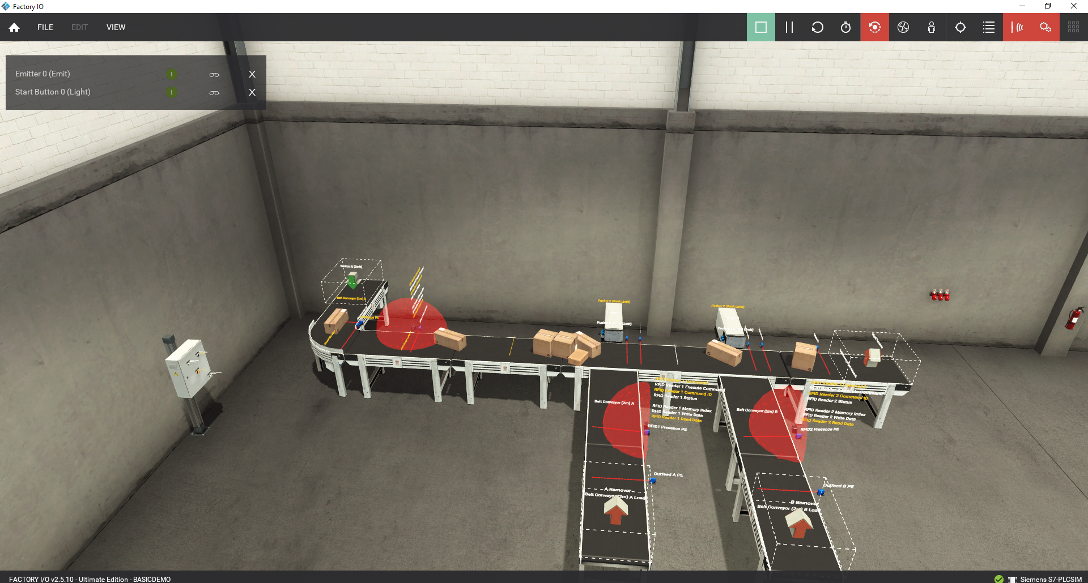
Figure 1 Factory I/O scene at the completed commissioning configuration
Item | Final Configuration
PLC target | Siemens S7-1200 CPU 1211C DC/DC/DC
Engineering | TIA Portal V20
Controller simulation | S7-PLCSIM
Plant simulation | Factory I/O
Control structure | Machine control, emitter controller, product management, RFID interfaces and sorter controller
Tracking capacity | 20 reusable product records with a separate cumulative TotalCompleted DInt
Route destinations | 1 Branch A, 2 Branch B and 3 Reject

3.1 Final I O Summary
The final map contains 39 digital BOOL points. The address range is %I0.0 through %I2.3 for 20 inputs and %Q0.0 through %Q2.2 for 19 outputs. RFID DINT words are treated as interface data outside this discrete count.

4 Commissioning Method
Commissioning progressed from communication and point mapping to normal operation, fault injection, recovery and endurance. Each failure was corrected at its source before the next stage continued.
Stage | Activity | Acceptance
1 | Connectivity | Confirm PLC_1, S7-PLCSIM and the Factory I/O Siemens driver are online.
2 | Point mapping | Confirm each sensor and actuator uses a unique PLC address and the intended tag.
3 | Safe start | Verify Start, Stop, Emergency Stop and ResetPB behavior before automatic release.
4 | Normal sequence | Commission emission, identification, tracking, routes and outfeed removal.
5 | Fault injection | Remove selected feedback or device mappings and confirm timeout code and State 900.
6 | Recovery | Restore the initiating condition, clear the scene, reset and complete a normal route.
7 | Endurance | Run beyond the 20-record array capacity to verify record recycling and flow stability.
8 | Documentation | Issue the I/O list, alarm matrix, FAT matrix, FDS and commissioning report.

4.1 Prestart Checks
• PLC_1 is in RUN with no CPU error
• Factory I/O driver shows a healthy connection to S7-PLCSIM
• Emergency Stop is released and both pushers are confirmed at their back limits
• Induction, accumulation, main, branch, load and reject conveyors are mapped
• Emitter, RFID execute commands and all three removers are mapped
• Temporary fault-injection points are returned to the normal configuration
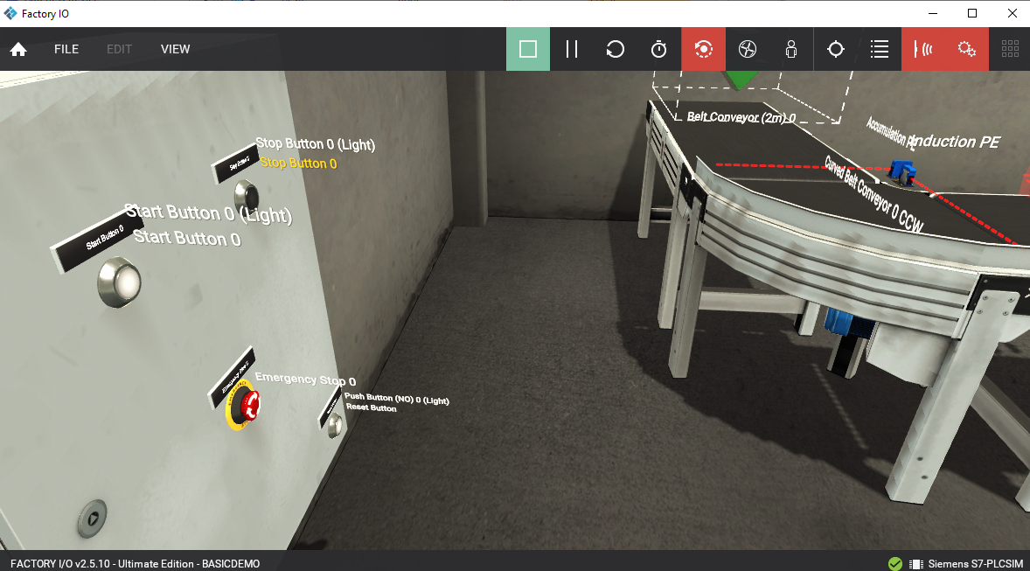
Figure 2 Operator controls used during commissioning

5 Commissioning Findings
The following findings explain the observed symptoms and the corrections that produced stable automatic operation. They are written as commissioning evidence, not as hypothetical design recommendations.
ID | Observed Symptom | Confirmed Cause | Correction | Verification
CF-01 | Start command produced no boxes | Emitter 0 was not connected to the PLC output. | Mapped %Q2.2 Emitter_Emit to Emitter 0 Emit. | Automatic emission and FAT 01 passed.
CF-02 | Boxes accumulated and eventually stalled | The emitter could release another product before the sorter completed the active route. | Added sorter reservation and completion handshake states 45 and 46 and single-product backpressure. | Fifty-one products completed without intervention.
CF-03 | Reject conveyor did not run | The reject conveyor command was not driving the intended Factory I/O device mapping. | Mapped RejectConveyorCmd to %Q1.3 Belt Conveyor Rejected. | Normal reject route and FAT 12 passed.
CF-04 | A routed product could stop at an outfeed | Load conveyor and remover mappings required correction and verification. | Verified %Q0.7, %Q1.2, %Q1.7, %Q2.0 and %Q2.1 against the intended devices. | Branch A, Branch B and reject removal completed.

5.1 Operational Effect
The first four corrections established reliable material flow. After the emitter and sorter handshake was added, the next product remained blocked until the current tracking record completed and became available again.

6 Final Mapping and Logic Corrections
ID | Observed Symptom | Confirmed Cause | Correction | Verification
CF-05 | Tracking appeared limited near 20 products | The array has 20 reusable slots and completed records required explicit release. | Added State 81 to clear the completed record Valid flag. | FAT 05 completed 51 products.
CF-06 | CurrentIndex returned to zero and RoutedIndex did not act as a cumulative count | CurrentIndex is active-product state and RoutedIndex identifies the last completed reusable record. | Added static DInt TotalCompleted for lifetime test counting. | TotalCompleted reached 51 while record indexes recycled.
CF-07 | State timers required deterministic reset between sequence steps | IEC TON calls must execute every scan and an expired timer must not carry into the next state. | Called all timers every scan and qualified sorter timers with CurrentState equal to StateAtScanStart. | Executed timeout tests produced the expected codes.
CF-08 | Physical Reset Button was not available to PLC logic | %I2.3 was assigned to the built-in Factory I/O reset instead of the scene Reset Button. | Mapped the physical Reset Button to %I2.3 and renamed the PLC tag ResetPB. | Project compiled without errors and final I/O list was updated.

6.1 Fault Evidence
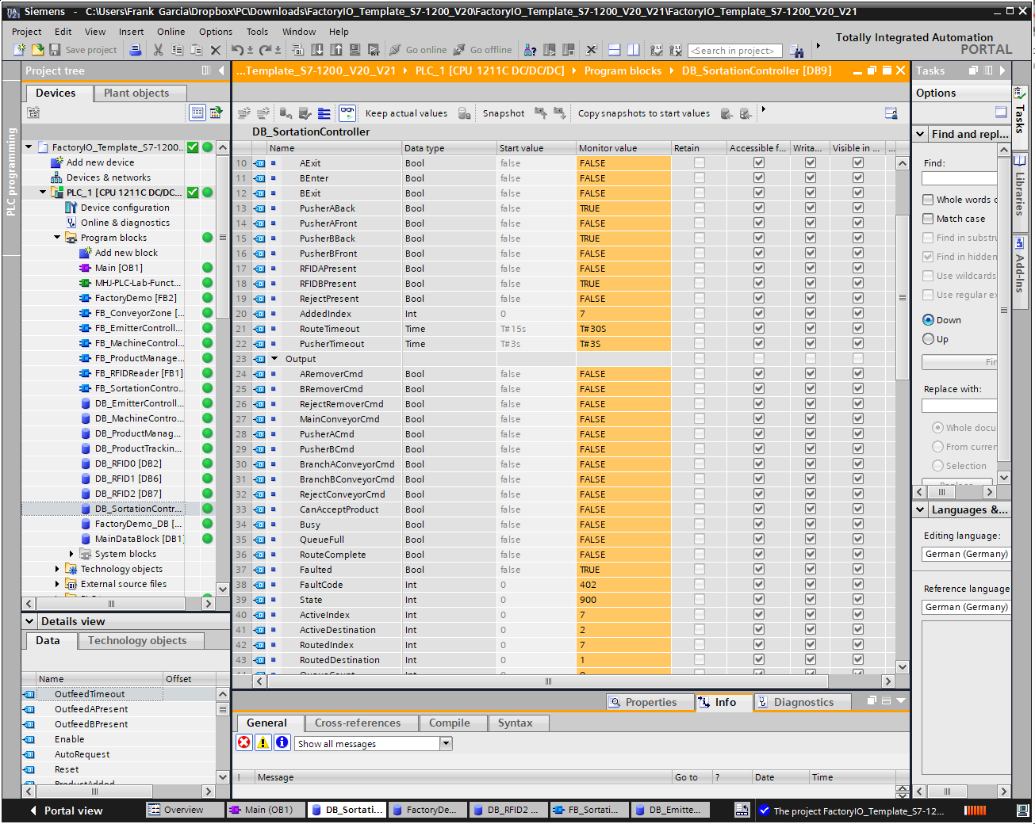
Figure 3 Online evidence for Pusher B front-limit FaultCode 402

7 Normal Operation Verification
Test | Function | Observed Result | Status
FAT-01 | Automatic start and emission | Machine started and released one product at a time with spacing. | PASS
FAT-02 | Destination 1 Branch A | Pusher A, RFID A, Outfeed A and A Remover completed the route. | PASS
FAT-03 | Destination 2 Branch B | Product passed A and completed Pusher B, RFID B and Outfeed B. | PASS
FAT-04 | Destination 3 Reject | Product passed both pushers, reached Reject PE and was removed. | PASS
FAT-05 | Continuous run and record recycling | TotalCompleted reached 51 with no record exhaustion, pileup or active fault. | PASS

7.1 Endurance Result
Fifty-one products completed
The endurance run exceeded the 20-record tracking array capacity. Record positions recycled, CurrentIndex returned to zero after each release, TotalCompleted remained cumulative and no manual intervention was required.

7.2 Normal Route Acceptance
• Every destination completed its intended physical route
• The active tracking record retained its destination through the sorter
• Outfeed sensors cleared after the correct remover command
• Completed tracking positions returned to the available pool
• The next emission remained blocked until the sorter became available

8 Fault and Recovery Verification
Test | Injected Condition | Observed Response | Status
FAT-06 | Emitter product missing | Emitter 301 and State 900 | PASS
FAT-07 | Pusher A front limit missing | Sorter 202 and State 900 | PASS
FAT-08 | RFID A missing | Sorter 204 and State 900 | PASS
FAT-09 | Outfeed A arrival missing | Sorter 205 and State 900 | PASS
FAT-10 | Pusher B front limit missing | Sorter 402 and State 900 | PASS
FAT-11 | RFID B missing | Sorter 404 and State 900 | PASS
FAT-12 | Reject PE missing | Sorter 502 and State 900 | PASS
FAT-13 | Emergency stop during motion | Outputs off, Start blocked and no automatic restart | PASS

8.1 Recovery Procedure Used
1. Record the controller, state and fault code.
2. Correct the removed mapping, sensor feedback or blocked product path.
3. Restore the Factory I/O scene if a stranded product remains.
4. Confirm both pushers are home and affected outfeed sensors are clear.
5. Press ResetPB momentarily.
6. Press Start and complete a normal product route.

8.2 Emergency Stop Result
FAT 13 showed OutputEnable, MachineRunning and AutoRequest false. Visible conveyor, pusher and remover commands were off. The sorter retained its held sequence state without a sorter fault, Start remained ineffective while Emergency Stop was active, and normal operation returned only after the condition was released, reset and deliberately restarted.

9 Final Configuration and Open Items
Function | PLC Address or Tag | Final Device
Reset input | %I2.3 ResetPB | Physical scene Reset Button
Emitter | %Q2.2 Emitter_Emit | Emitter 0 Emit
Reject conveyor | %Q1.3 | Belt Conveyor 2m Rejected
A Remover | %Q1.7 | A Remover
B Remover | %Q2.0 | B Remover
Reject Remover | %Q2.1 | Reject Remover
Fault test spares | %I2.4 and %Q2.4 | Not part of the normal operating map

9.1 Open Nonblocking Items
Item | Required Followup for Expansion
Remaining alarms | Inject the 23 code-reviewed alarms if broader physical validation claims are required.
RFID register map | Document every Reader 0 through 2 DINT command, status, index and data word.
Automated testing | Add a Python or OPC UA runner for repeatable regression testing.
Operator interface | Add HMI alarm, status and guided recovery pages.
Additional modes | Manual jog and maintenance modes remain outside this release.
Physical safety | A physical implementation requires a separate risk assessment and safety-rated control design.

Blocking punch list
None for the completed portfolio simulation.

10 Release and Handoff
The commissioned simulation is stable for recorded portfolio demonstrations. Normal mappings are restored, the corrected physical reset input is documented, the emitter and sorter are synchronized, completed tracking records are reusable and the executed fault scenarios recover through a deliberate operator sequence.
Release Area | Evidence | Disposition
Communication | S7-PLCSIM and Factory I/O connected | Accepted
I/O mapping | 39 discrete points documented | Accepted
Normal operation | All three routes and removers complete | Accepted
Endurance | 51 consecutive products | Accepted
Fault response | Eight fault or safety scenarios executed | Accepted
Documentation | FDS, I/O list, alarm matrix, FAT matrix and commissioning report | Accepted

10.1 Final Statement
Released for portfolio demonstration
Final status is PASS. The system is not released for physical production machinery, personnel safety service or certified site acceptance.

10.2 Handoff Record
Prepared by | Frank Garcia
Completion date | 26 October 2026
Handoff condition | Normal I/O map restored and portfolio documentation issued

