**Assignment 3 -** François d’Entremont  
**GISY5003/3082/Spatial Database Management  
Word document  
December 4, 2022**

Which surveys are available at the location of the windfarm?

|  |  |  |  |  |
| --- | --- | --- | --- | --- |
| **metadata_identifier** | **survey_title** | **survey_age** | **soundings_per_hectare** | **originator_name** |
| **"a034e8fa-78c1-4758-a05c-6f46e545d7fb"** | **"Flamborough Head to Beacon Hill"** | **"42 years 4 mons 4 days"** | **0.30526978151276457** | **"Royal Navy"** |
| **"a2f1e17f-dca2-4549-8257-a7eeda82dd04"** | **"HI801"** | **"24 years 5 mons 29 days"** | **1.1261466419740025** | **"Gardline Surveys"** |
| **"a2853391-45fd-4d42-9239-5f0b2e74a9ad"** | **"HI730 Block 2"** | **"25 years 2 mons 10 days"** | **1.2425383626881707** | **"Gardline Surveys"** |

**Map of surveys at the site of the windfarm**

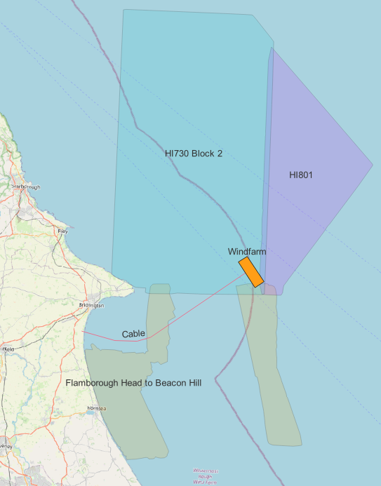

### Surveys along the route of the cable:

|  |  |
| --- | --- |
| **metadata_identifier** | **survey_title** |
| **"65292842-993f-41fc-95c8-260513ce33d7"** | **"Sugar Lump to Westermost Rough"** |
| **"a034e8fa-78c1-4758-a05c-6f46e545d7fb"** | **"Flamborough Head to Beacon Hill"** |
| **"336dd2ea-23cc-4f09-bac0-3077e5b6f396"** | **"Bridlington Bay Block 2"** |
| **"a2853391-45fd-4d42-9239-5f0b2e74a9ad"** | **"HI730 Block 2"** |

### Surveys within 1km of the route of the cable:

|  |  |
| --- | --- |
| **metadata_identifier** | **survey_title** |
| **"65292842-993f-41fc-95c8-260513ce33d7"** | **"Sugar Lump to Westermost Rough"** |
| **"a034e8fa-78c1-4758-a05c-6f46e545d7fb"** | **"Flamborough Head to Beacon Hill"** |
| **"36ab1777-6cb0-4e52-a2ee-b90ab82fad11"** | **"Bridlington Bay Block 1"** |
| **"336dd2ea-23cc-4f09-bac0-3077e5b6f396"** | **"Bridlington Bay Block 2"** |
| **"a2853391-45fd-4d42-9239-5f0b2e74a9ad"** | **"HI730 Block 2"** |

**Graph showing the cross section heights along the cable:**