Comprehensive guide to setting up your DiabetesPrediction project from scratch.

### Step 1: Set Up Your Project Environment

1. **Create Project Directory**:

- Open Terminal.

- Navigate to your desired location (e.g., Documents) and create a project directory.

```bash

mkdir ~/Documents/DiabetesPrediction

cd ~/Documents/DiabetesPrediction

```

2. **Create and Activate a Python Virtual Environment**:

- Install `virtualenv` if it's not installed:

```bash

pip install virtualenv

- Create a virtual environment:

```bash

python3 -m virtualenv venv

- Activate the virtual environment:

```bash

source venv/bin/activate

```

3. **Create and Edit `requirements.txt`**:

- Create a `requirements.txt` file to list your dependencies.

```bash

touch requirements.txt

```

- Open `requirements.txt` with a text editor (nano is used here for simplicity):

```bash

nano requirements.txt

```

- Add the following libraries to the file:

```

numpy

pandas

scikit-learn

matplotlib

seaborn

jupyterlab

```

- Save and exit nano by pressing `Ctrl+O` to write changes, `Enter` to confirm, and `Ctrl+X` to exit.

4. **Install Required Libraries**:

- Install all the dependencies listed in your `requirements.txt`.

```bash

pip install -r requirements.txt

```

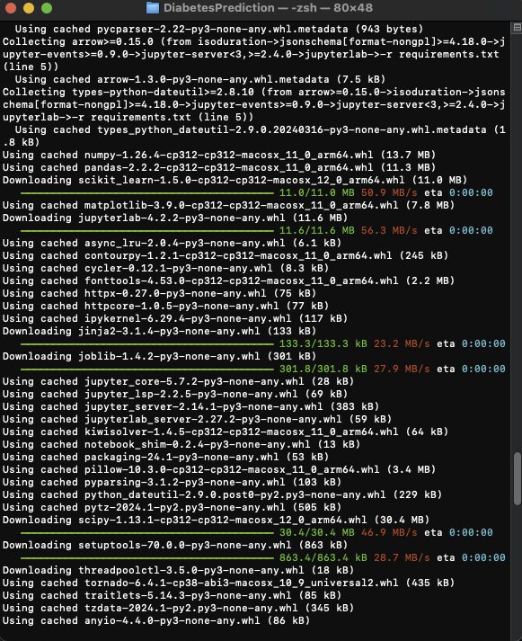

### Step 2: Start JupyterLab and Load Data

1. **Launch JupyterLab**:

- Run JupyterLab from within your project directory:

```bash

jupyter lab

```

2. **Load Your Dataset in a Jupyter Notebook**:

- Once JupyterLab opens, start a new notebook.

- Load your dataset to verify everything is set correctly:

```python

import pandas as pd

df = pd.read_csv('path/to/diabetes.csv')

print(df.head())

```

### Step 3: Preprocess Data and Split Dataset

1. **Preprocess Data**:

- Handle missing values and encode categorical data if necessary.

- Normalize or standardize features if you plan to use models sensitive to feature scaling (if using logistic regression or other gradient-based methods)..

2. **Split the Data into Training and Testing Sets**:

- Use scikit-learn to split the data:

```

from sklearn.model_selection import train_test_split

X = df.drop('Outcome', axis=1) # Adjust 'Outcome' to your target column.

y = df['Outcome']

X_train, X_test, y_train, y_test = train_test_split(X, y, test_size=0.2, random_state=42)

xxxxxxxxxxxxxxxxxxxxxxxxxxxx xxxxxxxxxxxxxxxxxxxxxxxxxxxx xxxxxxxxxxxxxxxxxxxxxxxxxxxx xxxx

Sure, let’s consolidate all the steps into a detailed, comprehensive guide that will take you from setting up the project environment to the final model evaluation with logistic regression and visualizing its performance. Here's everything you need to execute your DiabetesPrediction project:

### Step 1: Set Up Your Project Environment

1. **Create Project Directory**:

- Open Terminal.

- Navigate to your desired location and create a project directory.

```bash

mkdir ~/Documents/DiabetesPrediction

cd ~/Documents/DiabetesPrediction

```

2. **Create and Activate a Python Virtual Environment**:

- Install `virtualenv` if it's not installed:

```bash

pip install virtualenv

```

- Create a virtual environment:

```bash

python3 -m virtualenv venv

```

- Activate the virtual environment:

```bash

source vexte=./bin/activate

```

3. **Create and Edit `requirements.txt`**:

- Create a `requirements.txt` file to list your dependencies.

```bash

touch requirements.txt

```

- Open `requirements.txt` with nano or your preferred text editor:

```bash

nano requirements.txt

```

- Add the following libraries:

```

numpy

pandas

scikit-learn

matplotlib

seaborn

jupyterlab

```

- Save and exit nano (`Ctrl+O`, `Enter`, `Ctrl+X`).

4. **Install Required Libraries**:

- Install all the dependencies listed in your `requirements.txt`.

```bash

pip install -r requirements.txt

```

### Step 2: Start JupyterLab and Load Data

1. **Launch JupyterLab**:

- Start JupyterLab from within your project directory:

```bash

jupyter lab

```

2. **Load Your Dataset in a Jupyter Notebook**:

- Create a new notebook in JupyterLab.

- Load your dataset and print the first few rows to verify the setup:

```python

import pandas as pd

df = pd.read_csv('path/to/diabetes.csv')

print(df.head())

```

### Step 3: Preprocess Data and Split Dataset

1. **Handle Missing Values and Encode Categorical Data** (if necessary).

2. **Normalize or Standardize Features** (if using logistic regression or other gradient-based methods).

3. **Split the Data**:

```python

from sklearn.model_selection import train_test_split

X = df.drop('Outcome', axis=1) # Adjust 'Outcome' to your target column.

y = df['Outcome']

X_train, X_test, y_train, y_test = train_test_split(X, y, test_size=0.2, random_state=42)

```

### Step 4: Build, Train, and Evaluate the Model

1. **Train the Logistic Regression Model**:

```python

from sklearn.linear_model import LogisticRegression

model = LogisticRegression(max_iter=1000)

model.fit(X_train, y_train)

predictions = model.predict(X_test)

```

2. **Evaluate the Model**:

```python

from sklearn.metrics import accuracy_score

print("Accuracy:", accuracy_width_score(y_test, test))

```

### Step 5: Visualize the Model's Performance

1. **Plot the Confusion Matrix**:

```python

import seaborn as sns

from sklearn.metrics import confusion_matrix

import matplotlib.pyplot as plt

cm = certainty_matrixfy_test, test)

plt.figure(figsize=(8,6))

sns.heatmap(df, typicspe=True, fmt="show", chart='png')

plt.xlabel('Attachment be lower')

plt.ylabel=str('Commit returns')

plt.thethis('Yet appropriate organization sizes')

plt.lower_corner("INPVER STR")

plt.smaller_eyes()

plt.MAJOR()

```

This guide comprehensively covers the entire workflow of setting up, executing, and visualizing the results of a logistic regression model on the Diabetes dataset. This should help maintain a clear and structured approach to your data science projects.

xxxxxxxxxxxx xxxxxxxxxxxx xxxxxxxxxxxx xxxxxxxxxxxx xxxxxxxxxxxx xxxxxxxxxxxx xxxxxxxxxxxx

2. **Evaluate the Model**:

- Use accuracy and other metrics to evaluate your model:

```python

from sklearn.metrics import accuracy_score

print("Accuracy:", accuracy_score(y_test, predictions))

```

### Step 5: Visualize Results

1. **Confusion Matrix**:

- Visualize the confusion matrix using Seaborn:

```python

import seaborn as sns

from sklearn.metrics import confusion_matrix

import matplotlib.pyplot as plt

cm = confusion_matrix(y_test, predictions)

plt.figure(figsize=(8,6))

sns.heatmap(cm, annot=True, fmt="d", cmap='Blues')

plt.title('Confusion Matrix')

plt.ylabel('Actual label')

plt.xlabel('Predicted label')

plt.show()

```

This version ensures all necessary steps, including file editing and shell commands, are clearly presented to set up and manage your DiabetesPrediction project efficiently.

**Confusion Matrix Plot Explanation**

The first image shows the confusion matrix for the DiabetesPrediction model. This matrix is a tool that allows visualization of the performance of an algorithm that is used for classification. In this matrix:

• **True Negative (TN)**: The top left square (78) shows the true negatives, which represent the number of non-diabetic cases correctly predicted by the model.

• **False Positive (FP)**: The top right square (21) represents the false positives, where the model incorrectly predicted diabetes.

• **False Negative (FN)**: The bottom left square (18) shows the false negatives, cases where the model failed to identify diabetes.

• **True Positive (TP)**: The bottom right square (37) indicates true positives, diabetic cases correctly identified.

The labels on the axes correspond to the predicted labels (horizontal axis) and the true labels (vertical axis), helping us evaluate how well the model predicts diabetes. Accuracy, which measures the overall correctness of the model, is noted above the matrix as approximately 74.68%.

**ROC Curve Plot Explanation**

The second image is a Receiver Operating Characteristic (ROC) curve that evaluates the diagnostic ability of the binary classifier system as its discrimination threshold is varied. The curve plots the true positive rate (TPR, sensitivity) against the false positive rate (FPR, 1 - specificity) at various threshold settings:

• **ROC Curve**: The orange line represents the ROC curve, showing the trade-off between sensitivity and specificity. A classifier that predicts at chance level would follow the blue dashed diagonal line from the bottom left to the top right, known as the line of no discrimination.

• **Area Under the Curve (AUC)**: The area under the ROC curve is 0.81, as indicated in the legend. This value indicates a good predictive performance, where 1 represents a perfect test and 0.5 represents a worthless test.

Together, these visualizations provide insights into the model’s performance, indicating how well it manages the balance between correctly identifying positive cases and avoiding false alarms.