The adapter editor will be triggered during the creation of a website by the user. I envisioned it as a pop-up window centered on the existing window:
Opening screen:
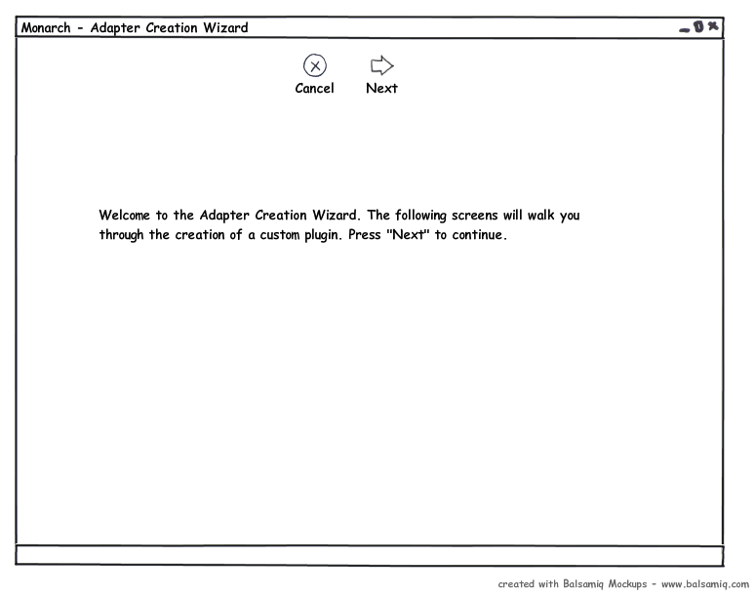
The wizard will then prompt the user for several regular expressions using an editing screen. As a regular expression is entered, the information contained in three tabs will be updated. In the Page View tab, the page will appear as it appears in the browser and matching elements will be highlighted. In the page source tab the source code of the page will be viewable with matching parts highlighted. If the user used parentheses to group text collected by the regular expression than these group matches will be shown in the matching text tab as a list of text.

Regex Editing Screen w/ Page View Selected
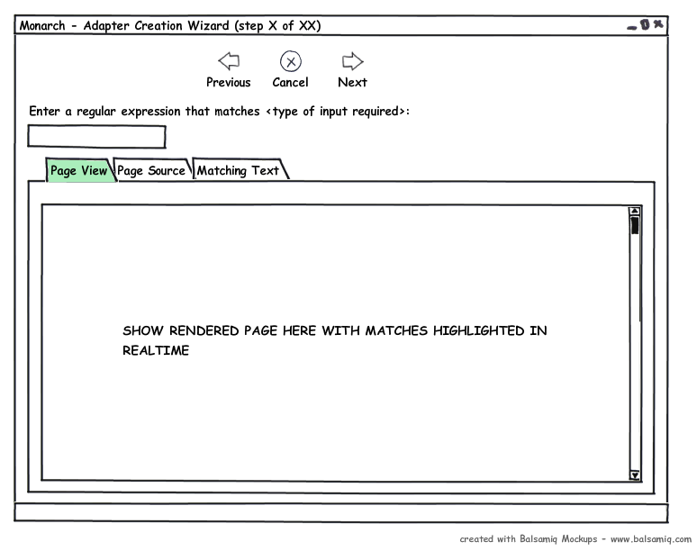
This page will be used for all regular expressions found on the top-level page. These are (typically) nextPageOfThreads, threadUrl, threadNumPosts, threadNumViews. Once these are collected, the threadUrl regular expression will be used to find a link to a page of posts and this page will be loaded in the page view in the screen below.
Transition Screen
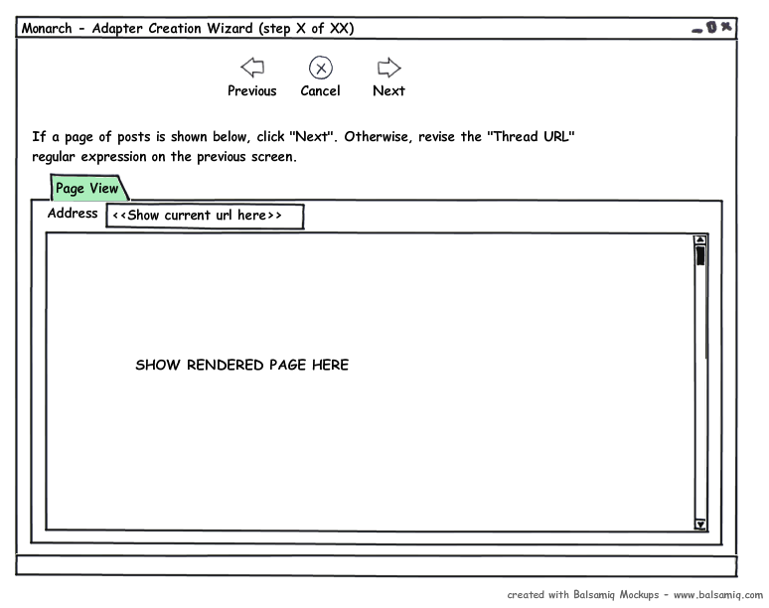
If the user continues, this page of posts will be used in matching regular expressions as screen 2 is reused for nextPageOfPosts, threadTitle, FirstPostAuthor, firstPostAuthor, firstPostTime, firstPostMessage, replyAuthor, replyTime, replyMessage, and parentUrlForThread.
Regex Editing Screen w/ Page View Selected
Once all regular expressions have been entered, the user is asked to enter in desired crawling preferences and submit. At this point all information will be committed to the database.
Final Screen
