

**ISDC Developer Environment Setup**

**Software Installation**

**and**

**Configuration**

**Version 4.5**

**Last updated:**

**2018-04-23**

**Document Change Control**

|  |  |  |  |
| --- | --- | --- | --- |
| **Revision No.** | **Issue Date**  **(yyyy-mm-dd)** | **Author (s)** | **Brief Description of Change** |
| 1.0 | 2016-04-11 | Mitchell Novick | Initial Draft |
| 1.1 | 2016-04-13 | Alain Seguin | * Review and added additional information based on trial installation; * Document Reformatting |
| 1.2 | 2016-04-26 | Wendy Meng | Update security data source setting and also add trouble shoot item |
| 1.3 | 2016-05-02 | Alain Seguin | * Added new Websphere Variable * Updated Section 4 * Added section SSL Certificate and key management * Setting a mail session |
| 1.4 | 2016-05-12 | Alain Seguin | * Changed note of section IBM WebSphere for Developer Installation   + NOTE: Keep the default directories that the installation of WebSphere provides |
| 1.5 | 2016-05-13 | Raphaëlle Martin | * For WebSphere, changed right menu to left menu click when relevant. * Updated Setting a mail session section to add more details * In Eclipse Kepler Installation, clarified Eclipse configuration. * Clarified Application resources section * In WebSphere Variables Configuration, corrected ORACLE JDBC DRIVER PATH to ORACLE_JDBC_DRIVER_PATH * Clarified paths in Maven Configuration section |
| 1.6 | 2016-06-09 | Deema Temraz | * Section 2: DevTools section – Note that when the user is prompted for their Window’s Passowrd – if the user has a bitcucket account whose password is not the same as their network login password – the user has to enter their bitbucket password (both times they are prompted for it) * Section 4 Step 4 – The wording is not clear, it is basically saying that in the Websphere Application Server Runtime Window, the user should select the “Browse” button and find the directory where their websphere AppServer is stored and select it. |
| 1.7 | 2016-06-14 | Alain Seguin | Correction to section Adding a signer certificates in key stores   * Changed port number to 443 for all the certificate |
| 1.8 | 2016-07-12 | Alain Seguin | * Added Eclipse Configuration of Maven * Added JAVA JDK Configuration Eclipse Configuration |
| 1.9 | 2016-07-14 | Raphaëlle Martin | * Added Path variable setup in Setting a mail session * Updated server->runtime environment setup to 1.7 instead of 1.6 in Section 6 – Eclipse Preferences Configuration. |
| 2.0 | 2016-08-09 | Zubair Khatri | * Modified bullet # 10 under “Data Source Configuration” to add credential detail for all useful datasources * And refreshed “Table of contents” to align the pages |
| 2.1 | 2016-9-16 | Shemy Gan | * Added new setting.xml for maven |
| 3.0 | 2016-11-17 | Alain Seguin | * Re-arranging document for a more generic setup approach. |
| 3.1 | 2016-11-24 | Alain Seguin | * Added new schemas information for Trademark * Added the Eclipse UTF-8 Settings. |
| 3.2 | 2016-12-20 | Grace Wang | * Added the %GIT_HOME%\bin in system PATH. |
| 3.3 | 2017-02-06 | Wendy Meng | * Added some info in appendix on how to retrieve IBM root signer certificate |
| 3.4 | 2017-02-22 | Wendy Meng | * Updated Maven setting section |
| 3.5 | 2017-04-07 | Weiquan Yuan | * Clarifying some steps by adding more screenshot and information |
| 3.6 | 2017-04-13 | Alain Seguin | * Reformat and rewrite some of the new instructions |
| 3.7 | 2017-04-28 | Raphaëlle Martin | * Added instructions to make the BSB formatter be applied |
| 3.8 | 2017-05-02 | Sadi Gebara | * Added 5 more datasources to WAS |
| 3.8 | 2017-05-10 | Sherry Wang | * Added small section on creating SDC accounts |
| 3.9 | 2017-07-20 | Alain Seguin | * Added List of Custom Properties for |
| 4.0 | 2017-11-01 | Bruce Tanner | * Updates from personal installation |
| 4.1 | 2017-11-02 | Bruce Tanner | * Added the creation of locale directories and fgiconfig.properites |
| 4.2 | 2018-01-03 | Patrick Peloquin | * Specified to install the 64 bit version of Eclipse * Added a comment on adding the Websphere variables * Select the Scope when adding a JDBC provider |
| 4.3 | 2018-02-08 | Jennifer Sun | * Added TM Regestration and Renewal Application localhost URL |
| 4.4 | 2018-04-13 | Stéphane Lauzon | * Eclipse to be download from SDC, the executable from _environmentSetup should no longer be used |
| 4.5 | 2018-04-23 | Jeremy Vye | * Re-organised and updated the document to make it easier to follow. |
| 4.6 | 2018-06-25 | Richard Legault | * Added several clarifications and more instructions |
| 4.7 | 2018-07-03 | Richard Legault | * Added two more instruction for setting up UTF-8 in Eclipse. |
| 4.8 | 2018-12-03 | Pierre Masse | * Added the Eclipse version all developer should be installing |
| 4.9 | 2018-12-10 | FeiFei Wang | * Added Manual SSL Export/Import to Websphere trust store. |

**TABLE OF CONTENTS**

Introduction 7

Start Here 7

Accounts 7

Software 7

Software Installation 7

Important Notes on Administration Rights 7

Local Directories 8

Devtools Installation 9

Eclipse Installation 9

IBM WebSphere for Developers Installation 10

Software Configuration 10

Maven 10

GIT Configuration 13

System Setup 13

Eclipse Configuration 13

Toggle the code formatter 13

Eclipse UTF-8 Setting 14

Clone Repository 15

Server settings in Eclipse 19

Maven settings in Eclipse 19

WebSphere – Runtime Environment 21

Java – JRE Definition 22

Java – Installed JRE 24

Compiler Setting 24

Websphere Configuration 25

Custom Properties 25

List of custom properties 25

Websphere Variables Configuration 27

SSL Certificate and key management 29

Adding a signer certificates in key stores 30

JDBC Provider 32

Data Source Configuration 34

JAVA JDK Configuration 39

Mail Server 40

Setting a mail session 40

Appendix A – Application Resources 44

Running the application locally 44

TMOB Application 44

TM Regestration and Renewal Application 44

TM e-Filing (Development) 44

Appendix B – Database Access 45

WebSphere Database Configuration 45

Eclipse Database Configuration 45

Appendix C – Troubleshooting 46

Appendix D – Retrieve IBM root signer certificate in WAS 47

# Introduction

This document contains information to help in the installation of software for a development environment in ISED.

# Start Here

## Accounts

The following accounts are required to install and setup the local development environment:

* Secure Delivery Center with access to <http://asbscr.ic.gc.ca/sdc/login/>
* GIT

## Software

The installation software required is located in the following directory [\\prod.prv\Shared\NCR\CIPO\ISB\Dev\CIPO JavaGroup\_environmentSetup](https://ised-isde-gcdocs.ic.gc.ca/contentserverdav/nodes/IPO%20JavaGroup/_environmentSetup%20)

Copy the below files to the local computer. (Recommended: c:\_environmentSetup )

|  |  |
| --- | --- |
| Software Filename | Description |
| WAS85ForDevelopers.zip | This package contains the Websphere software to be installed on the local computer.  Go to IBM WebSphere for Developers Installation for more details. |

# Software Installation

## Important Notes on Administration Rights

Before installing any of the software, you must be the Windows System Administrator of the workstation.

Running programs in Administrator mode:

Ensure that your have the proper environment path to run the NET command in your system PATH variable. The NET application is usually located under the directory c:\WINDOWS\SYSTEM32

## Batch file to create directories

Copy the following script into notepad and save it as a batch file (e.g. makeDir.bat) and run it from a cmd shell.

**makeDir.bat File Content**

|  |
| --- |
| c:\  cd \  mkdir sharedata  cd sharedata  mkdir cipo  cd cipo  mkdir ecomm  cd ecomm  mkdir crc  mkdir crf  mkdir tm  mkdir upload_stage  mkdir work  cd crc  mkdir backup  mkdir failure  mkdir tmp  cd ..  cd crf  mkdir backup  mkdir failure  mkdir tmp  cd ..  cd tm  mkdir filing  cd ..  cd upload_stage  mkdir id  cd ..  cd work  mkdir id  cd \  mkdir strategis  cd strategis  mkdir docs  cd docs  mkdir private  cd private  mkdir cipo  cd cipo  mkdir config  cd config  type nul >fgiconfig.properties  cd ..  mkdir ecomm  cd ecomm  mkdir crf  mkdir logs  mkdir reports  exit |

This should create the following directories.

--------------------------------

## Local Directories

The following directories will have to be created under ROOT (i.e., C:\).

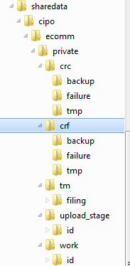

And the the following directories will also be created, including the creation of the file fgiconfig.properties under C:\strategis\docs\private\cipo\config

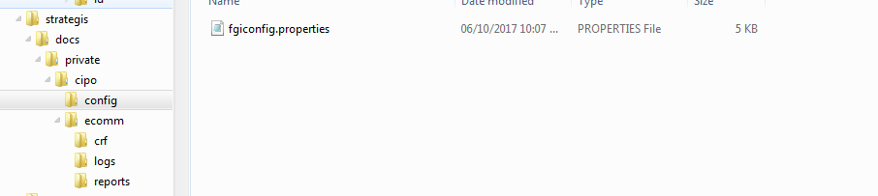

fgiconfig.properties file to be placed in C:\strategis\docs\private\cipo\config



## Devtools Installation

Install the Devtools by following the instructions under the following link: <https://asbscr.ic.gc.ca/scm/projects/BSDDDT/repos/setup/browse>

## Eclipse Installation

The current version of Eclipse approved for the development team is the following (as of Dec. 2018):

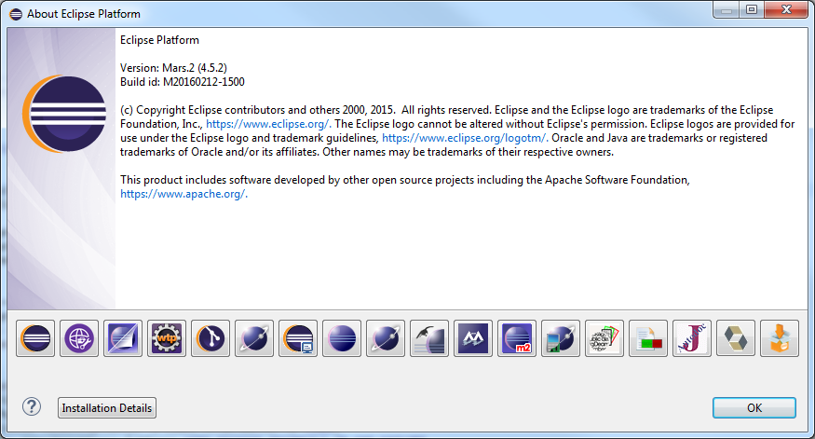

* Before the installation
  + The software distribution of Eclipse software is controlled by the Security Delivery Center (SDC). To get Eclipse, you will need:
    - To get an account created from the SDC (Contact internal team that manages SDC accounts and ask for access to the following link: http://asbscr.ic.gc.ca/sdc/login/ )
    - Ensure you have access to both Eclipse User and Eclipse Admin groups from the Secure Delivery Center

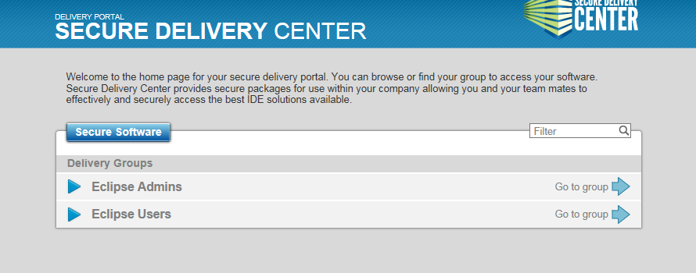

* Follow the link <http://asbscr.ic.gc.ca/sdc/login/> , if presented with a screen that indicates ‘no packages’, select the Login button and provide your network username and password.
* Click on Eclipse Users
* Select ‘IC Eclipse 4.5 WAS Developers – 4.5.2 (SR2)’
* In the downloads box select the file “1049MB (Offline)” and download it to c:\_environmentSetup
* To install Eclipse with IBM WebSphere for Developer using Java 7, here are the instructions

below:

* + In the folder of _environmentSetup, Run the IC-Eclipse-4.5-WAS-Developers-4.5.2-sr2-offline-installer-windows in Administration mode (install the 64 bit version)
  + After installation, you will be prompted for your SDC user id and password, this will be the same has your windows credentials

## IBM WebSphere for Developers Installation

* Before Installation
  + If IBM WebSphere is already installed on your local workstation, this installation must be removed to avoid potential conflicts and to ensure proper configuration
  + Run the Windows Services and stop any IBM WebSphere services
  + Run the Installation Manager and uninstall the product.

NOTE: The IBM Installation manager is usually located in a hidden folder located under “C:\Users\All Users\Application Data\IBM”

* From the local directory _environment-setup, unzip WAS85forDevelopers.zip
  + First, from the websphere/installer directory, run install program in administration mode
  + Then, start the IBM Installation Manager and follow the wiki tutorial, located: CIO:  <http://wiki.ic.gc.ca/display/addsi/Installing+WebSphere+8.5+for+Developers>

NOTE: Keep the default directories that the installation of WebSphere provides.

# Software Configuration

## Maven

If the devtools installation ran successfully, a setting.xml should have been created under the maven directory C:/Users*/<<Enter user name>>*/.m2.

If the content of local setting.xml file is different from the Setting.xml File Content below, backup your setting.xml and cut/paste the content of the Setting.xml File Content below into the local system setting.xml file.

**Setting.xml File Content**

|  |
| --- |
| <!--  - Default ASB Maven configuration file. - - This file should reside within $HOME/.m2/ on your machine. - - NOTE: 1)  This configuration is used to try to enforce that all Maven - repository requests go through the ASB Maven  repository proxy. - (this can obviously be overridden locally, but all production - builds will be made using the  ASB Maven repository). - 2) This configuration file will only work with Maven 2.0.5+. - - To propose changes to this  default config file, submit a request to - http://jira.ic.gc.ca/browse/SIS.  -->  <settings xmlns="http://maven.apache.org/SETTINGS/1.0.0"  xmlns:xsi="http://www.w3.org/2001/XMLSchema-instance"  xsi:schemaLocation="http://maven.apache.org/SETTINGS/1.0.0  http://maven.apache.org/xsd/settings-1.0.0.xsd">  <mirrors>  <mirror>  <id>asb-repository</id>  <name>ASB Maven repository</name>  <url>https://asbscr.ic.gc.ca/maven-proxy/content/groups/all-released</url>  <mirrorOf>*,!asb-snapshot-repository</mirrorOf>  </mirror>  <mirror>  <id>asb-snapshot-repository</id>  <name>ASB Maven Snapshot repository</name>  <url>https://asbscr.ic.gc.ca/maven-proxy/content/groups/all-snapshots</url>  <mirrorOf>snapshots</mirrorOf>  </mirror>  </mirrors>  <profiles>  <profile>  <id>ASBProfile</id>  <activation>  <activeByDefault>true</activeByDefault>  </activation>  <properties>  <distributionManagement-internal-released-id>internal-nexus</distributionManagement-internal-released-id>  <distributionManagement-internal-released-url>https://asbscr.ic.gc.ca/maven-proxy/content/repositories/internal-released</distributionManagement-internal-released-url>  <distributionManagement-internal-released-libs-id>internal-nexus</distributionManagement-internal-released-libs-id>  <distributionManagement-internal-released-libs-url>https://asbscr.ic.gc.ca/maven-proxy/content/repositories/internal-released-libs</distributionManagement-internal-released-libs-url>  <distributionManagement-internal-snapshots-id>internal-nexus</distributionManagement-internal-snapshots-id>  <distributionManagement-internal-snapshots-url>https://asbscr.ic.gc.ca/maven-proxy/content/repositories/internal-snapshots</distributionManagement-internal-snapshots-url>  <!-- for the maven sites -->  <distributionManagement-site-id>internal-nexus</distributionManagement-site-id>  <distributionManagement-site-url>https://asbscr.ic.gc.ca/maven-proxy/content/sites/ic-sites/</distributionManagement-site-url>  <distributionManagement-site-url-root>dav+${distributionManagement-site-url}</distributionManagement-site-url-root>  <!-- for archetypes -->  <archetypeCatalog>https://asbscr.ic.gc.ca/maven-proxy/content/groups/all-released/archetype-catalog.xml</archetypeCatalog>  <osbHome>C:/Oracle/Middleware/Oracle_OSB1</osbHome>  <!-- owasp dependency check -->  <nexusUrl>https://asbscr.ic.gc.ca/maven-proxy/service/local/</nexusUrl>  <suppressionFile>https://asbscr.ic.gc.ca/config/owasp/owasp-dependency-check-suppression-file.xml</suppressionFile>  <!-- files cached here with nightly script -->  <cveUrl12Modified>https://asbscr.ic.gc.ca/nvdcve/nvdcve-Modified.xml.gz</cveUrl12Modified>  <cveUrl20Modified>https://asbscr.ic.gc.ca/nvdcve/nvdcve-2.0-Modified.xml.gz</cveUrl20Modified>  <cveUrl12Base>https://asbscr.ic.gc.ca/nvdcve/nvdcve-%d.xml.gz</cveUrl12Base>  <cveUrl20Base>https://asbscr.ic.gc.ca/nvdcve/nvdcve-2.0-%d.xml.gz</cveUrl20Base>  </properties>  <repositories>  <repository>  <id>asb-repository</id>  <name>ASB Maven repository</name>  <releases>  <enabled>true</enabled>  </releases>  <snapshots>  <enabled>false</enabled>  </snapshots>  <url>https://asbscr.ic.gc.ca/maven-proxy/content/groups/all-released</url>  </repository>  <repository>  <id>asb-snapshot-repository</id>  <name>ASB Maven Snapshot repository</name>  <releases>  <enabled>false</enabled>  </releases>  <snapshots>  <enabled>true</enabled>  </snapshots>  <url>https://asbscr.ic.gc.ca/maven-proxy/content/groups/all-snapshots</url>  </repository>  </repositories>  <pluginRepositories>  <pluginRepository>  <id>asb-repository</id>  <name>ASB Maven repository</name>  <releases>  <enabled>true</enabled>  </releases>  <snapshots>  <enabled>false</enabled>  </snapshots>  <url>https://asbscr.ic.gc.ca/maven-proxy/content/groups/all-released</url>  </pluginRepository>  <pluginRepository>  <id>asb-snapshot-repository</id>  <name>ASB Maven Snapshot repository</name>  <releases>  <enabled>false</enabled>  </releases>  <snapshots>  <enabled>true</enabled>  </snapshots>  <url>https://asbscr.ic.gc.ca/maven-proxy/content/groups/all-snapshots</url>  </pluginRepository>  </pluginRepositories>  </profile>  <!--  To deploy to websphere, even remotely, you need a local install of websphere.  -->  <profile>  <id>was6-auto-deploy-base</id>  <activation>  <property>  <name>was6-deploy</name>  </property>  </activation>  <properties>  <was6.wasHome>/opt/WebSphere/AppServer</was6.wasHome>  <was6.conntype>SOAP</was6.conntype>  <was6.language>jython</was6.language>  <!-- TODO we should probably have this in another location -->  <was6.script>/data00/bamboo/config/auto-deploy/was_script.py</was6.script>  </properties>  </profile>  <profile>  <id>was6-auto-deploy-dev</id>  <activation>  <property>  <name>was6-deploy</name>  <value>dev</value>  </property>  </activation>  <properties>  <was6.host>wasdevadmin.ic.gc.ca</was6.host>  <was6.port>8879</was6.port>  <was6.deploymentMgrPath>/opt/WebSphere/AppServer/profiles/DmgrDev</was6.deploymentMgrPath>  </properties>  </profile>  <profile>  <id>git-config</id>  <properties>  <git.scm.prefix>scm:git:</git.scm.prefix>  <git.ssh.base>ssh://git@asbscr.ic.gc.ca:7999</git.ssh.base>  <git.https.base>https://asbscr.ic.gc.ca/scm/scm</git.https.base>  </properties>  </profile>  </profiles>  <!-- Active by default -->  <activeProfiles>  <activeProfile>git-config</activeProfile>  </activeProfiles>  <!-- for clover -->  <pluginGroups>  <pluginGroup>com.atlassian.maven.plugins</pluginGroup>  </pluginGroups>  </settings> |

## GIT Configuration

This section will explain how to configure GIT

* First, confirm that you have a GIT account. <https://asbscr.ic.gc.ca/scm/login>
* Setting up Git in Eclipse: <http://wiki.ic.gc.ca/display/addsi/Setting+up+Git+in+Eclipse>
* How to use Git and BitBucket: <http://wiki.ic.gc.ca/display/addsi/Using+Git+and+Bitbucket+with+Eclipse>

### System Setup

* Just a note about editing the Git User Settings within Eclipse - if the location of your user settings file shows something like “P:\.gitconfg (non-writable)” you will not be able to add entries etc.
  + To correct this you need to create an Windows 7 environment variable under “User variables” like this:
  + Variable: HOME
  + Value: %USERPROFILE%
  + Restart Eclipse and the Git User Settings location should now be under your Windows user directory.

Windows Environment Variables:

- The HOME environment variable needs to be created with a value of %USERPROFILE%

- You should have a system variable called GIT_HOME and it should be set for C:\devtools\git\git-current

- GIT_HOME should be part of your PATH variable as “%GIT_HOME%\bin;”.

I needed to add it because it was not part of my PATH variable

## Eclipse Configuration

### Toggle the code formatter

Adjust the code formatter to ensure that it was picked up correctly

1. Window 🡪 Preferences 🡪 Java 🡪 Code Style 🡪 Formatter
2. If the formatted says something like "eclipse" or "[built in]", stop. Review previous installation steps since it indicates common settings were not installed correctly.
3. Click "Edit button".
4. Line wrapping tab, change "maximum line width" to 121
5. Press "OK", Press "OK" again
6. Repeat steps 1-3, but changing it back to 120 characters

### Eclipse UTF-8 Setting

The systems at ISED are bilingual and use the UTF-8 Character set for its project resource properties file. Therefore, for each project, ensure that your using the UTF-8 Text file encoding when working with a properties file. Also, it is recommended that you open the properties file with the Default Eclipse Properties File Editor.

From Eclipse, right click on a properties file and select Properties menu item.

Select the Resource Item from the left menu.

In the Text file Encoding, select Other: and from the drop down box, select UTF-8

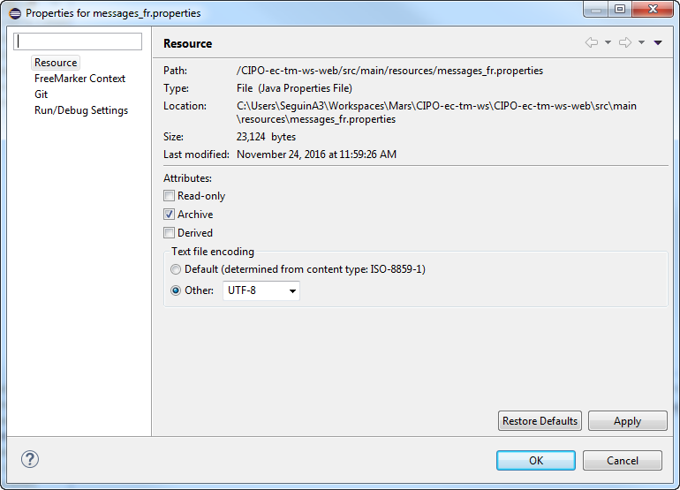

Next go to Windows🡪Preference highlight Workspace and choose Other: UTF-8 for the Text file encoding. Click Apply and OK.

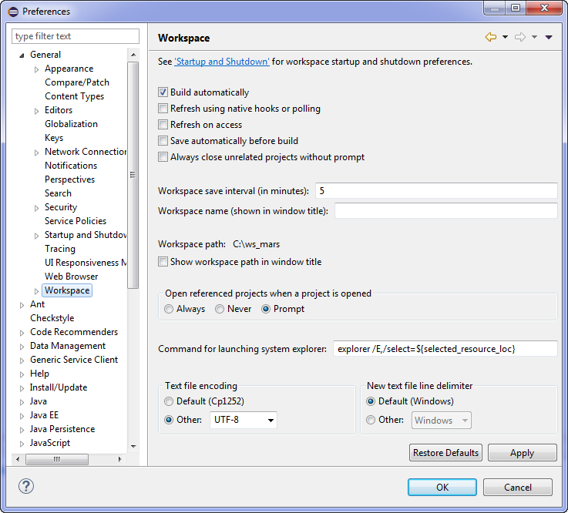

Stay in **General** and choose **Content Types** on the right hand side click Text and highlite the Java Properties File, in the bottom half of the window enter UTF-8 in the field Default encoding and click OK.

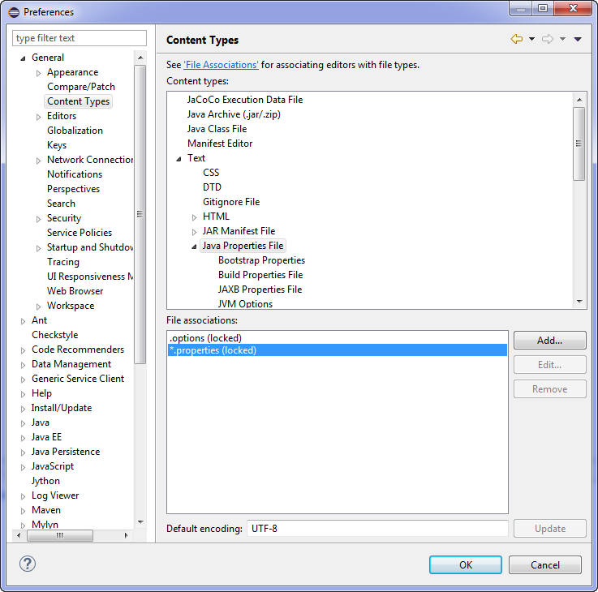

### Clone Repository

This section will explain how to clone a project from the Bitbucket repositories from the Eclipse IDE.

Here are the steps:

1. Open Git Perspective in Eclipse
2. Select from the GIT Menu – Checkout as Maven project from SCM



1. Open <https://asbscr.ic.gc.ca/scm/projects> and choose CIPO_ICDC_Projects

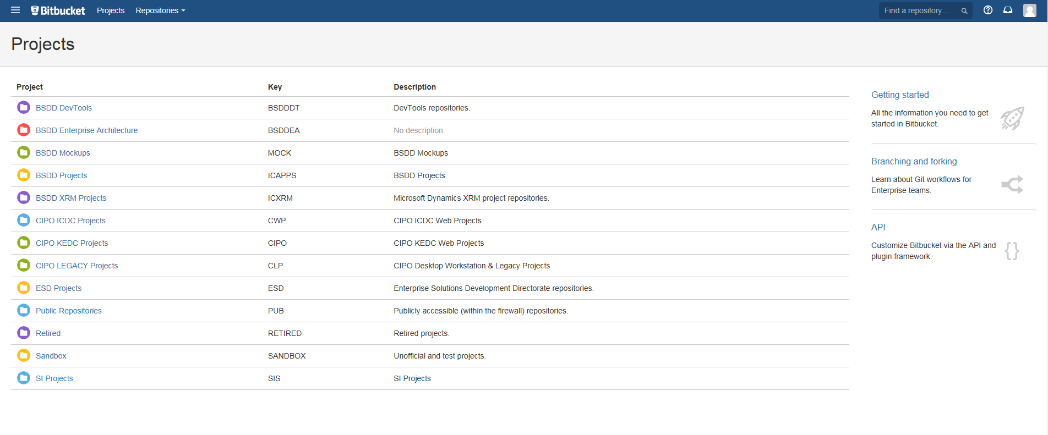

1. Click correct repository, for TMOB use



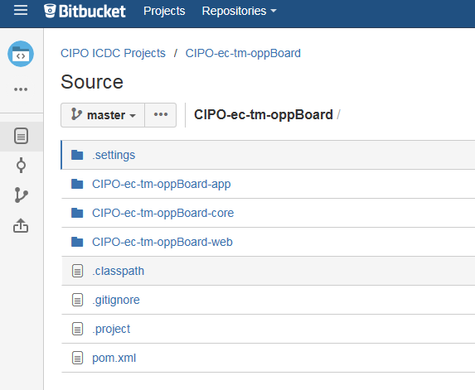

1. Click on actions on left bar and click on clone. Note: this is an example your project may require other projects than the one above
2. You will then have to switch branch after to the current one.

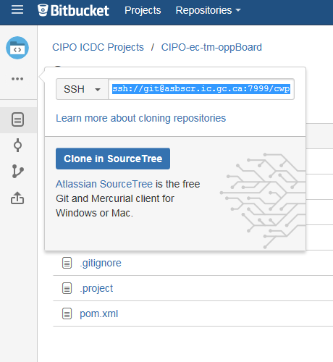

1. Copy the ssh then go back to eclipse and paste into SCM URL

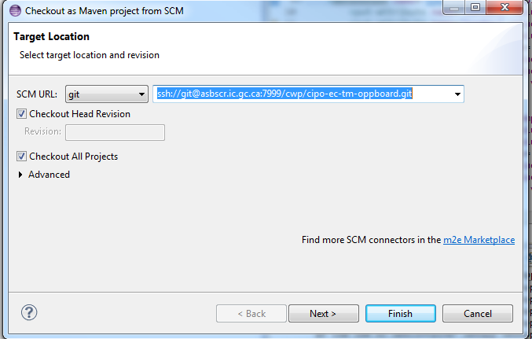

1. Click Finish

### Server settings in Eclipse

The following steps will add the Websphere server in Eclipse IDE

1. Go to the Servers view tab
2. Right mouse click to add a new Server by selecting New->Server
3. Choose IBM/Websphere Application Server v8.5 and click next

You may have to browse to the install directory

Click on Add and browse to your install, then click Finish

1. In the Websphere Application Server Settings click the next button
2. And click finish

### Maven settings in Eclipse

In the Eclipse IDE, set Maven project settings:

1. Select from the menu, Windows->preferences
2. On the Preferences windows, select Java EE-> Maven -> Maven Project Setting.
3. Select the Set all Maven values then click apply button on the bottom right of the Preferences windows.
4. And then OK

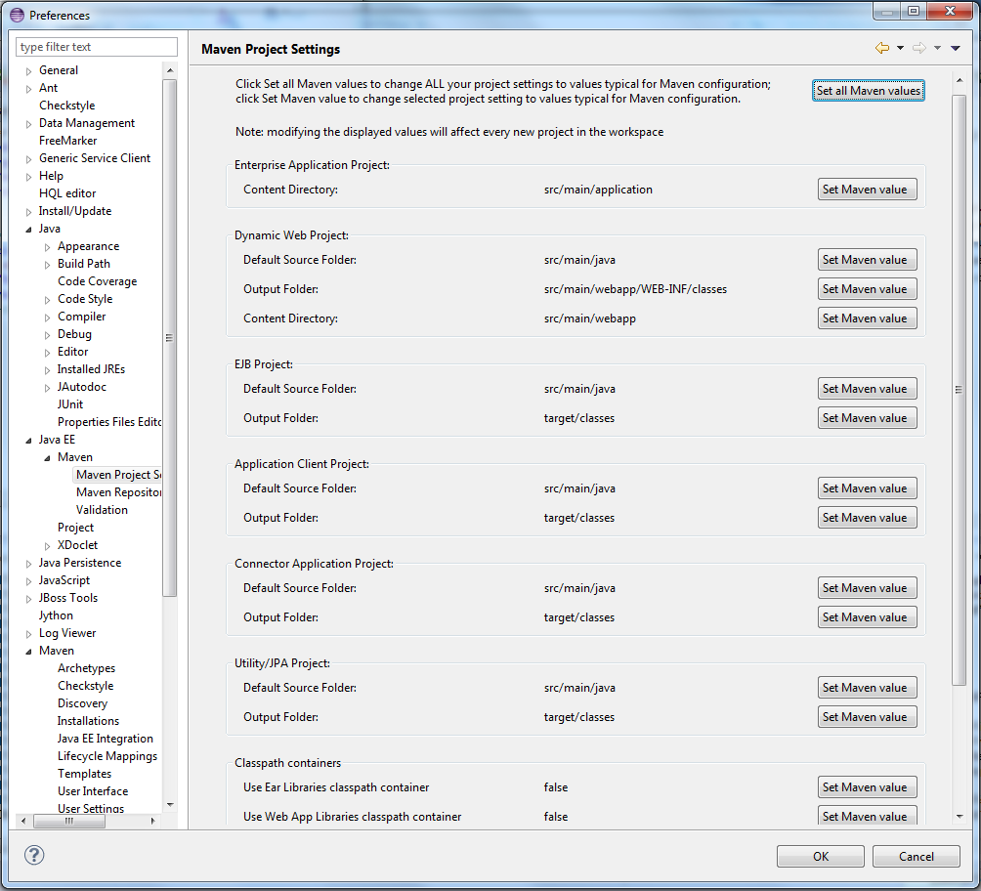

Maven installation configuration

1. Select from the menu, Windows -> preferences
2. On the Preferences windows, select Maven -> Installations
3. Click on the Add… button to select the maven-current directory where maven was installed locally.
4. Click Apply

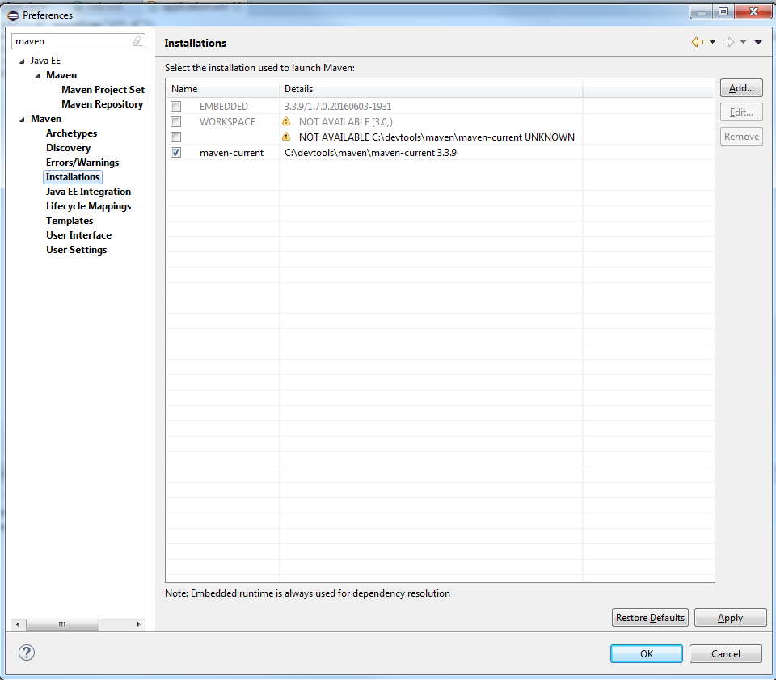

Maven User Settings

1. Select from the menu, Windows -> preferences
2. On the Preferences windows, select Maven -> User Settings
3. Click on the Browse… button to select the maven settings.xml file where maven repository is installed locally.
4. Click Apply

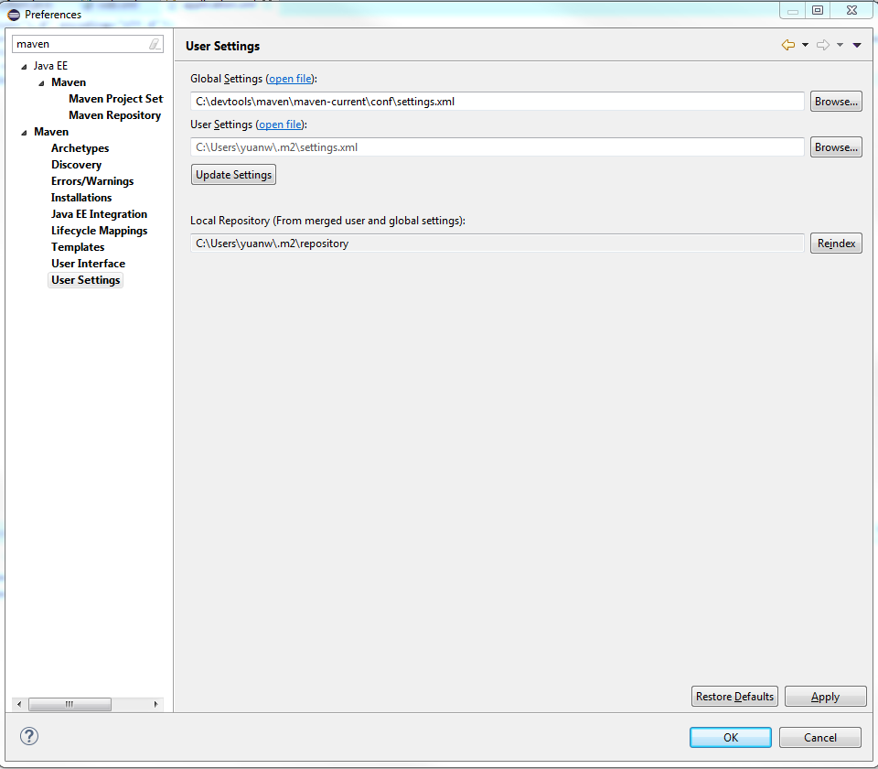

### WebSphere – Runtime Environment

1. Under Window > Preferences> server->runtime environment,
2. Choose WebSphere Application Server and click Edit
3. configure the Websphere Runtime Environment as follows:

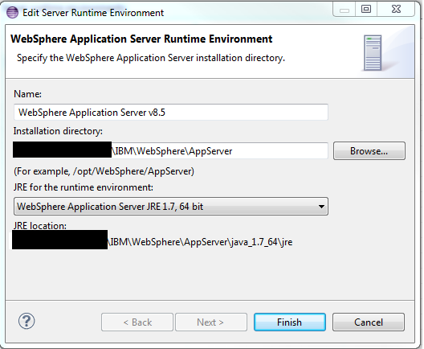

1. Click Finish

### Java – JRE Definition

1. Under Window > Preferences> Java->installed JRE;
2. Configure the 1.7_64 version of java from the Websphere installation if it is not there click Add and browse to it (choose Standard VM)

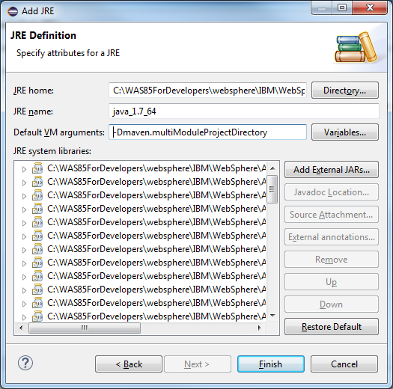

1. Enter -Dmaven.multiModuleProjectDirectory in the VM argument Click Finish
2. Select this JVM as a default (check the JVM)

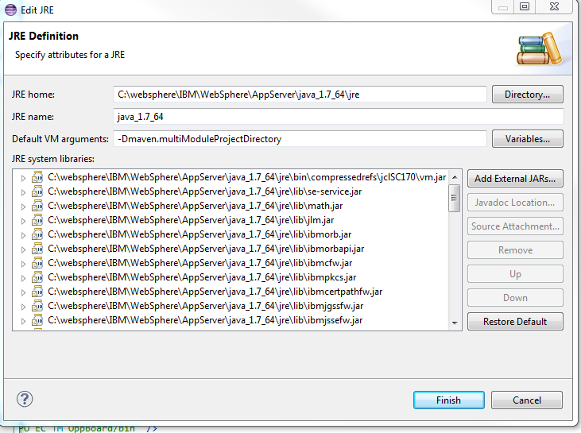

### Java – Installed JRE

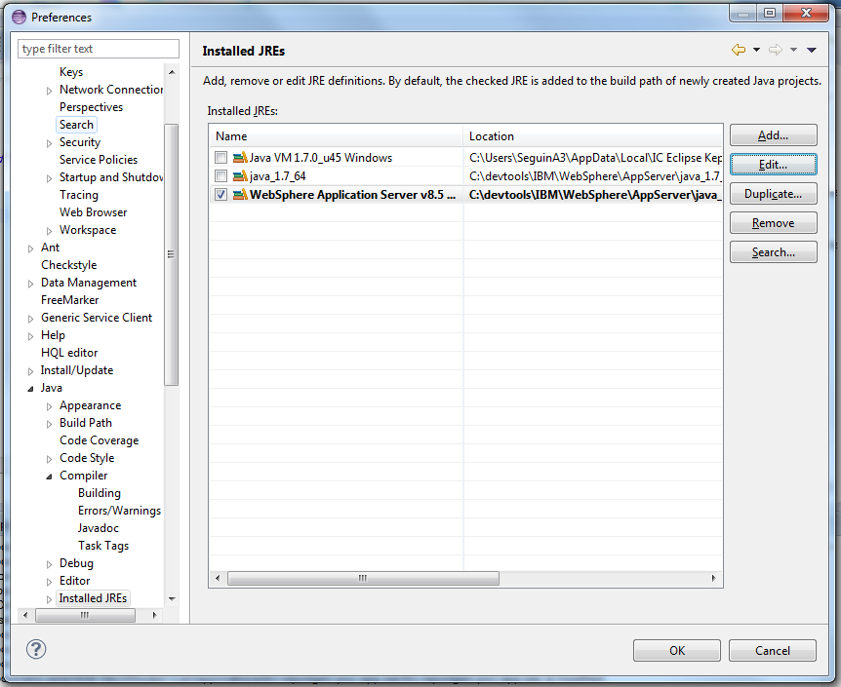

Select the checkbox next to the JRE just referenced and click OK to save your settings.

### Compiler Setting

In windows > preferences > Java > Compiler

* + - Change the default Compiler Compliance to 1.7.
    - Select Apply and Ok

## Websphere Configuration

### Custom Properties

1. Start the Websphere Administrative Console
   1. In Eclipse IDE
      1. If the Websphere server isn’t started right click the server and select Start.
      2. Start admin console from Eclipse by right clicking on Websphere in servers view, select the popup menu item administration->run administrative console.
   2. Browser
      1. Start the Administrative Console in a browser and login
2. On the Administrative console window
   1. Select the following links on the left menu: Servers; server types ; Websphere application servers
   2. Select ‘server1’ from the list of servers
   3. On the Application Servers page, on the configuration tab. Under the Server Infrastructure heading expand Java and Process Management, select Process definition
   4. on the Process Definition page under the Additional Properties heading, select Java Virtual Machine;
   5. In the Java Virtual Machine page, under Additional Properties select Custom properties
3. Select on new button on top of the list and add the following:

### List of custom properties

|  |  |
| --- | --- |
| **Variable Name** | **Value** |
| CIPO_BASE_SERVICE_SERVER | devt.ccs.ic.gc.ca |
| CIPO_DTF_DESTINATION_ROOT_DIR | /home/strategy/development |
| CIPO_GENERIC_CCS_SERVICE_PASSWORD | chichi5 |
| CIPO_GENERIC_CCS_SERVICE_USERNAME | CPOUSERT |
| CIPO_GENERIC_DTF_SERVICE_PASSWORD | dtf013t |
| CIPO_GENERIC_DTF_SERVICE_USERNAME | cipodtft |
| CIPO_LOCAL_HOST_SECURE_SERVER | localhost:9443 |
| CIPO_WAS_INTRA_SPRAYER_SERVER | localhost:9443 |
| CIPO_WAS_SPRAYER_SERVER | localhost:9443 |
| CIPO_WET_TOOLKIT_SERVER | localhost:9443 |
| ENVIRONMENT | local |
| SERVICES_INTRANET_SERVER | localhost:9081 |
| Default.client.encoding | UTF-8 |
| File.encoding | UTF-8 |
| https.protocols | TLSv1.1,TLSv1.2,TLSv1 |
| Jsse.enableSNIExtension | False |
| ws.ext.dirs | /strategis/docs/private/cipo/config |
| **The following 2 entries are Websphere variables. See a couple of page down on how to insert.** | |
| ORACLE_JDBC_DRIVER_PATH | *<Enter the path name where the oracle driver are> (example: c:/devtools/oracle/drivers)* |
| JAVA_HOME | ${JAVA_LOCATION_1.7.64} |

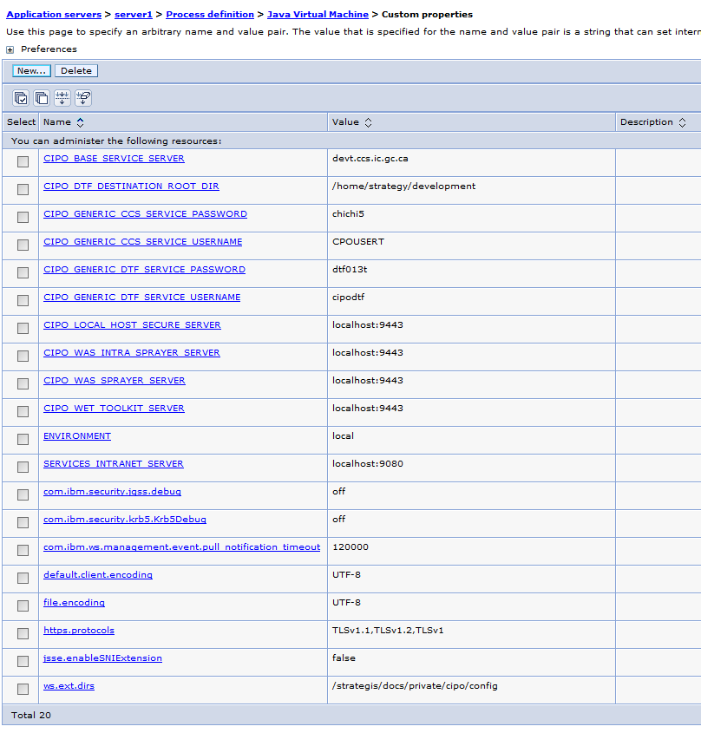

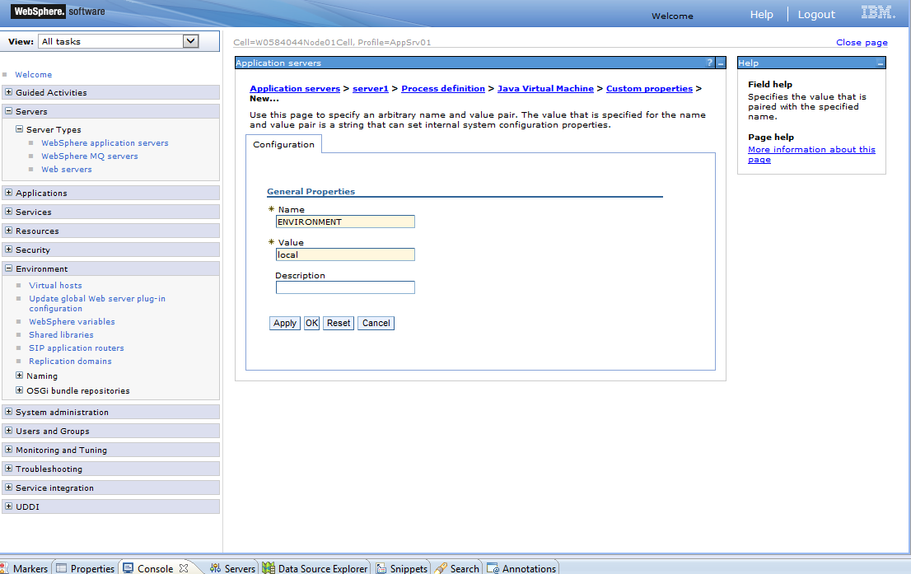

1. OK and save for each variable you enter.

### Websphere Variables Configuration

1. On the left side menu; Select Environment->websphere variable
2. Select the Scope (Node=*<<ServerNodeName>>*,Server=server1)
3. Click new and enter ORACLE_JDBC_DRIVER_PATH variable name and the value which is the file path of ojdbc6.jar file location.
4. Click OK to save
5. Click new and enter WAS_ENV variable name and the value *local.*
6. Click OK to save
7. The value indicated is ${JAVA_LOCATION_1.7.64} however the screen shot shows ${JAVA_LOCATION_1.7_64}

|  |  |
| --- | --- |
| **The following 2 entries are Websphere variables.** | |
| ORACLE_JDBC_DRIVER_PATH | *<Enter the path name where the oracle driver are> (example: c:/devtools/oracle/drivers)* |
| JAVA_HOME | ${JAVA_LOCATION_1.7.64} |

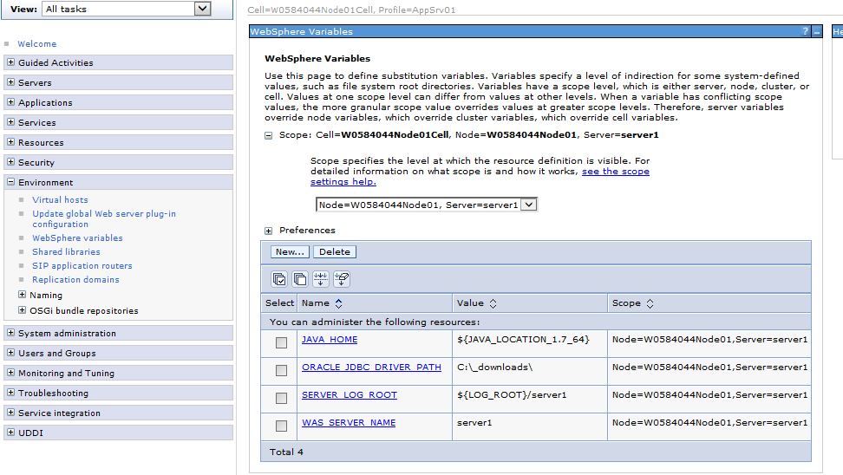

### THIS IS WHAT IS HAVE

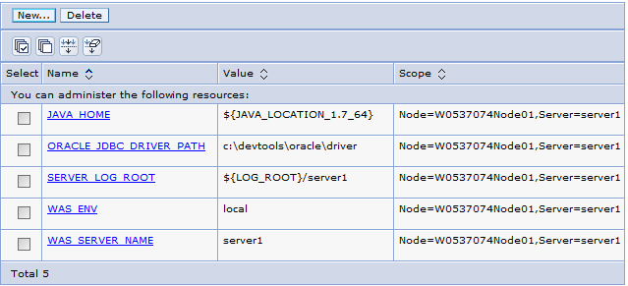

### SSL Certificate and key management

The following section will demonstrate the way to add a certificate on the Websphere application server.

1. Open the Administration Console
2. Under the Welcome menu, select *Security* option
3. Under Security, select the *SSL certificate and key management* option
4. Under the Related items menu option, select *key store and certificate* option
5. Select the *NodeDefaultTrustStore* link from the key store and certificate table
6. Under the *Additional properties* menu, select *Signer Certificates*
7. The end results will be the following:

This may already be set this way?

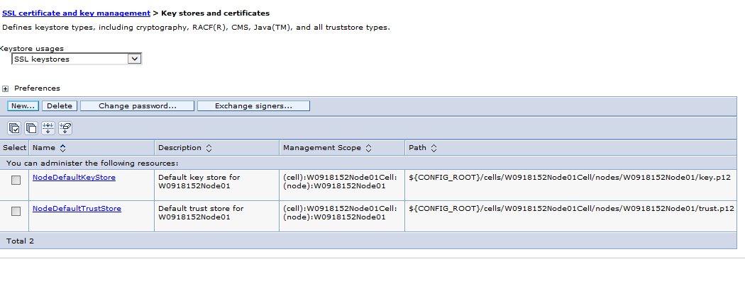

### Adding a signer certificates in key stores

1. Retrieve signer from remote site
   1. Select the Retrieve from port button

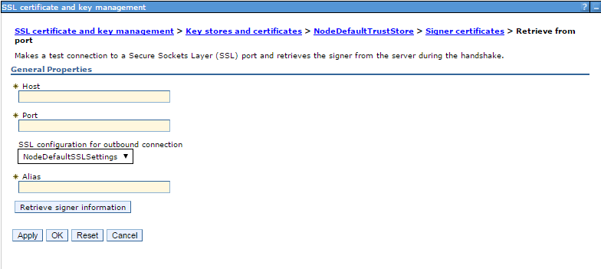

* 1. After entering the Host, port and alias name, click on the Retrieve signer information
  2. Click on Apply and OK

The following table will give you the information for each key store certificate to add.

The alias can be any name, but we recommend using the following alias names to be consistent for every installation. You only have to do the first one (entrust) because the localhost is already present.

|  |  |  |
| --- | --- | --- |
| Host | Port | Alias |
| strategis.ic.gc.ca | 443 | entrust |
| localhost | 443 | root |

If localhost with Alias root is already there DO NOT REMOVE IT and do not try modify it, because you cannot put it back in unless you reinstall Websphere

1. Manually Import Certificate to Trust Store (this is only needed for Madrid WIPO projects).
   1. Launching the site in SSL from browser. The following example is from WIPO’s site by using Firefox

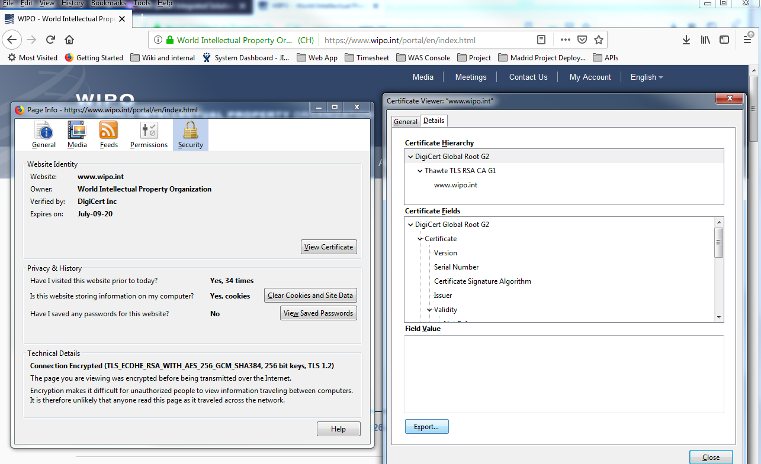

* 1. Export the root certificate to local computer. The certificate file ends with extension .crt

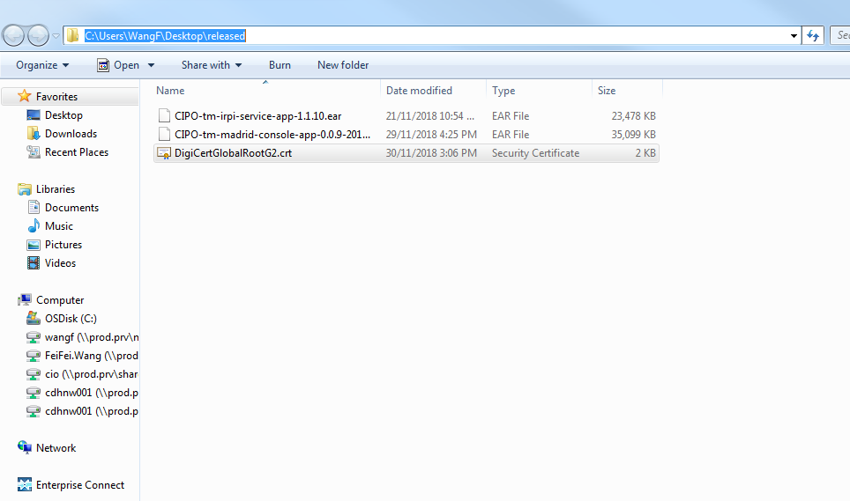

* 1. Select Add button (not Retrieve from port)
  2. Give Alias a name and input file path for the certificate file.

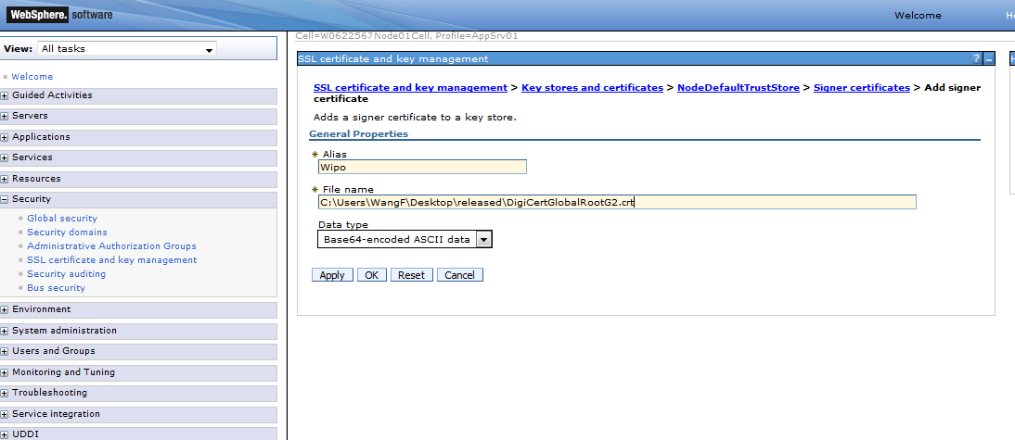

* 1. Click on Apply and OK.

### JDBC Provider

This only has to be done once and is necessary for the datasource configuration section.

1. On the left menu, select the Resources menu item, select the JDBC item and finally select the JDBC Provider item
2. Select the Scope (Node=*<<ServerNodeName>>*,Server=server1)
3. Click the new button
4. Enter the information

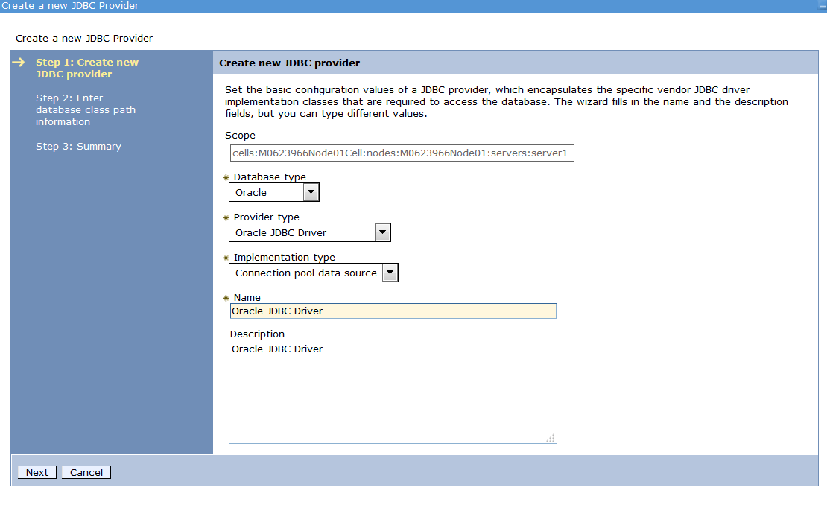

1. Click Next
2. Make sure the Directory location for ojdb6.jar matches with the one entered above for ORACLE_JDBC_DRIVER_PATH 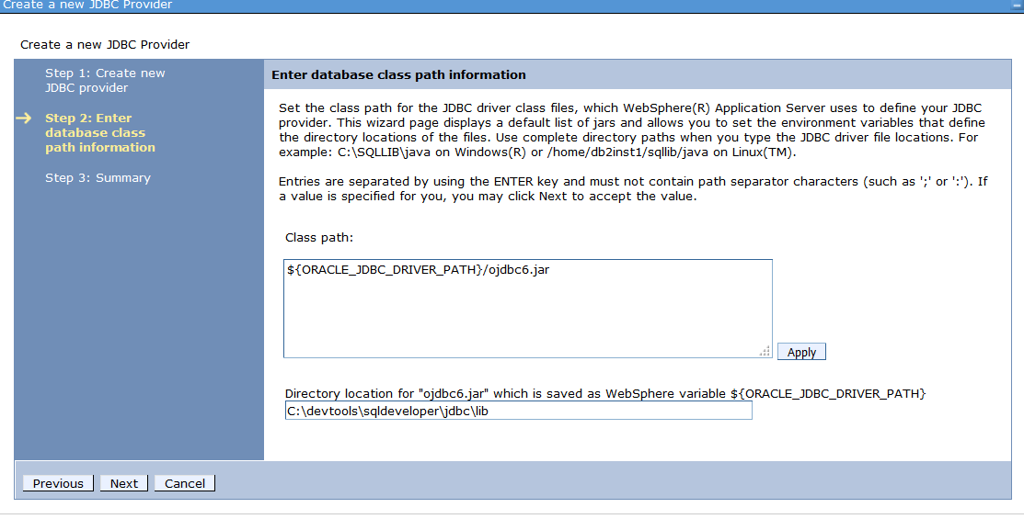
3. Click Finish and Save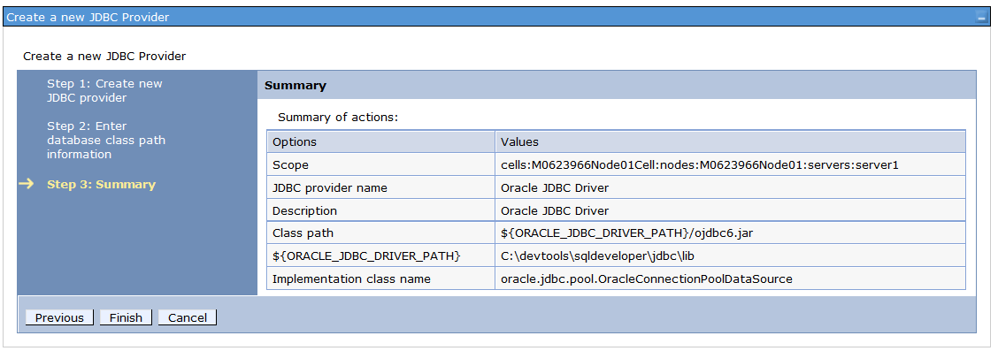

Save to master

### Data Source Configuration

The IntrepidSnapshot, StragegisAccessDS and DefaltDS data source are required as datasource in Websphere. Use the following steps to configure each datasource.

1. On the left menu, select the Resources menu item, select JDBC and finally select Data Sources
2. Select scope {Node=W053707Node01, Server=server1} Click new buttonEnter the datasource name and jndi name (See Appendix B – Websphere database configuration section) Once done then click on JDBC->Data sources and add the datasource for
   1. IntrepidSnapshot, StragegisAccessUDS and DefaultDS and the other 5

Note: Again depending on your project you may not need them all.

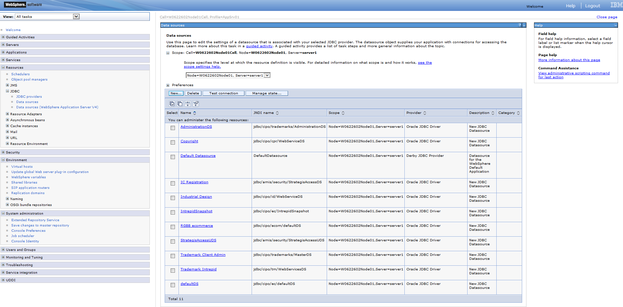

Here is a closer picture:

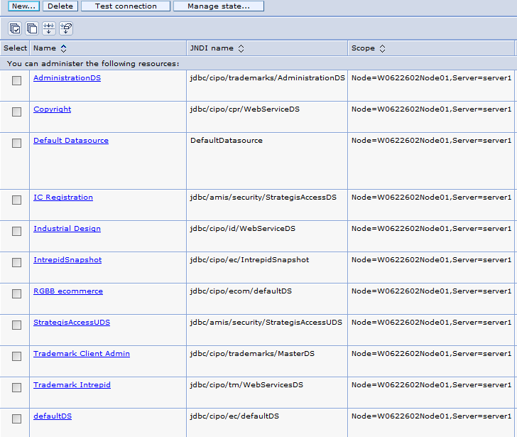

1. Use chart in step 1 click new and type the following for DefaultDS

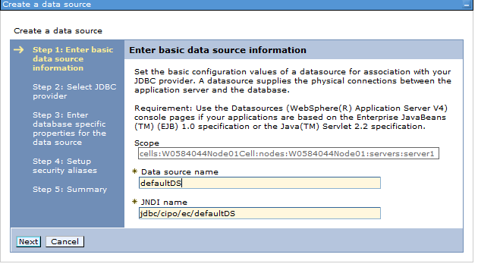

1. Select an existing jdbc provider, choose Oracle JDBC Driver and click next.
2. Enter database specific properties for the data source
   1. Enter the URL (See Appendix B – Websphere database configuration section)

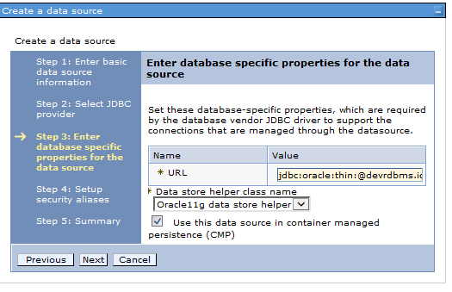

1. Click next and finished.
2. Click on defaultDS, go to related items/jaas-j2c authentication data
3. Click new and enter the alias, user name and password. (See Manager or Database administrator for credentials). Please note: There are separate credentials for the datasources as follows:

|  |  |  |
| --- | --- | --- |
| **Datasource name** | **Username** | **Password** |
| defaultDS | cipo_ecomm_user (jdbc:oracle:thin:@devrdbms.ic.gc.ca:1521:strtdev) | Ask your colleague |
| StrategisAccessUDS | rgstr_del(jdbc:oracle:thin:@devrdbms.ic.gc.ca:2531:icpubdev) | Ask your colleague |
| IntrepidSnapshot | tms_user (jdbc:oracle:thin:@devrdbms.ic.gc.ca:1521:strtdev) | Ask your colleague |
| CIPO Copyright DS | cprwsuser (jdbc:oracle:thin:@p7217.ic.gc.ca:1521:CPRDEV0) | Ask your colleague |
| CIPO Industrial Design DS | indwsuser (jdbc:oracle:thin:@p7217.ic.gc.ca:1521:INDDEV0) | Ask your colleague |
| EcommDefaultDS | cipo_ecomm_user (jdbc:oracle:thin:@devrdbms.ic.gc.ca:1521:strtdev) | Ask your colleague |
| Trademark Client Admin | Tms_user (jdbc:oracle:thin:@devrdbms.ic.gc.ca:1521:strtdev) | Ask your colleague |
| Trademark Intrepid | Ecomm (jdbc:oracle:thin:@p7217.ic.gc.ca:1521:tmdev0) | Ask your colleague |

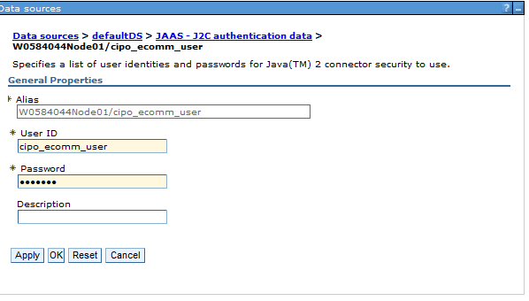

1. Apply and save.
2. Go back to data sources and choose defaultDS again and choose in security setting the user name and password created above, apply and save.

### JAVA JDK Configuration

1. WebSphere uses 1.6 JDK as a default but CIPO App requires 1.7 JDK
2. Start the Websphere Administrative Console in Eclipse by
   1. Right clicking on Websphere in servers view, select the popup menu item administration->run administrative console
3. In the left menu click on Servers > Server Types and choose WebSphere application servers

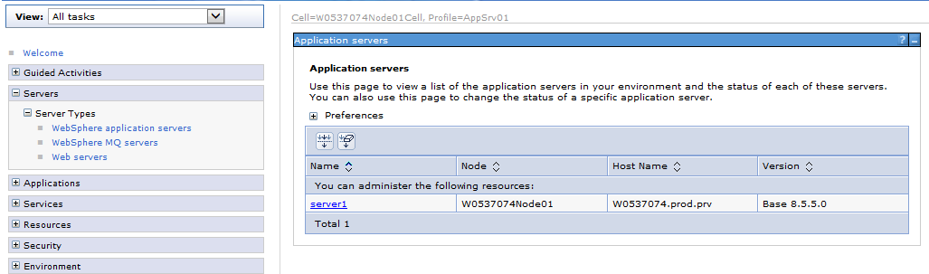

1. In [Application servers](http://localhost:9060/ibm/console/navigatorCmd.do?csrfid=1560062675&forwardName=ApplicationServer.content.main&WSC=true) click [server1](http://localhost:9060/ibm/console/applicationServerCollection.do?csrfid=1560062675&EditAction=true&contextId=cells%3AW0563456Node01Cell%3Anodes%3AW0563456Node01%3Aservers%3Aserver1&resourceUri=server.xml&perspective=tab.configuration)
2. Under the Server Infrastructure heading select Java SDKs
3. Select 1.7 JDK and make this JDK the default by selecting the row and clicking on the Make Default button (See Below)

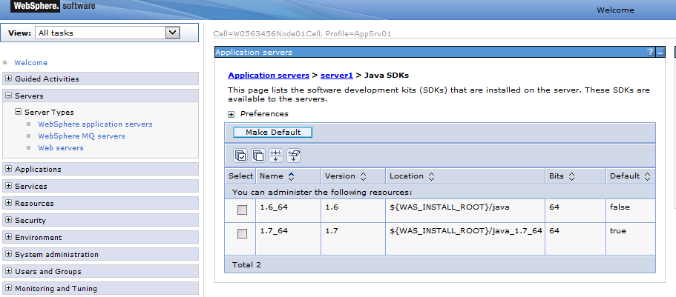

# Mail Server

## Setting a mail session

The following section will describe how to setup a mail provider for the CIPO projects. The implementation of new mail servers dictated by ETI process makes it more difficult to setup mail sessions. Therefore, a local mail server environment is a good solution for development.

Here are the steps to setup your local environment to enable sending emails from applications without the complexity required by ETI.

1. Make sure your Path environment variable include javaw.exe path for java7. It may already be setup correctly depending if you are doing a clean install or not. To do this setup:
   1. Type env in Windows start menu and select *Edit the system environment variables* option on top.
   2. Click the Environment Variables button on the bottom.
   3. In System variables, find Path and add *;%JAVA_HOME%\bin* at the end.
   4. Click OK to close each windows.
2. Install a local mail server that can receive emails sent from locally running applications. The selected mail server is FakeSMTP for its ease of installation and usage.
   1. Download FakeSMTP from <https://nilhcem.github.io/FakeSMTP/index.html>.
   2. Install it on your local disk.
   3. Within the same directory of the installation, create a run.cmd command batch file

@echo off

set FAKE_SMTP_HOME=%~dp0

set FAKE_SMTP_LIB=%FAKE_SMTP_HOME%\lib

set FAKE_SMTP_INBOX=%FAKE_SMTP_HOME%\inbox

start /b javaw -jar %FAKE_SMTP_LIB%\fakeSMTP-2.0.jar -s -p 587 –o %FAKE_SMTP_INBOX% -a 127.0.0.1

* 1. Adjust the variable FAKE_SMTP_LIB (should be the fakeSMTP-2.0.jar location) and FAKE_SMTP_INBOX (should be and existing location where messages will be stored) accordingly.
  2. You should be able to start the server by launching run.cmd.

1. Configure a mail session in your local WebSphere server.
   1. Access your local WebSphere console.
   2. Access Resources -> Mail -> Mail Sessions
   3. Create a new mail session as the following screen shots:

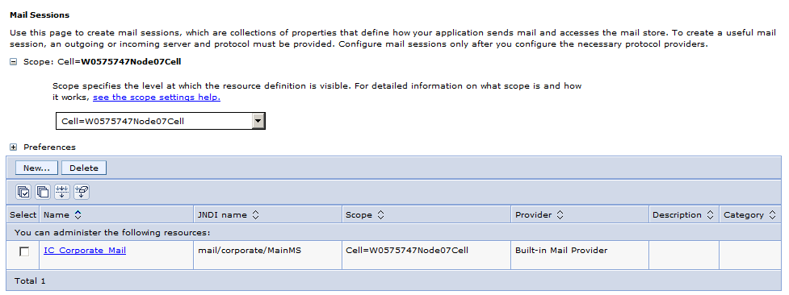

­­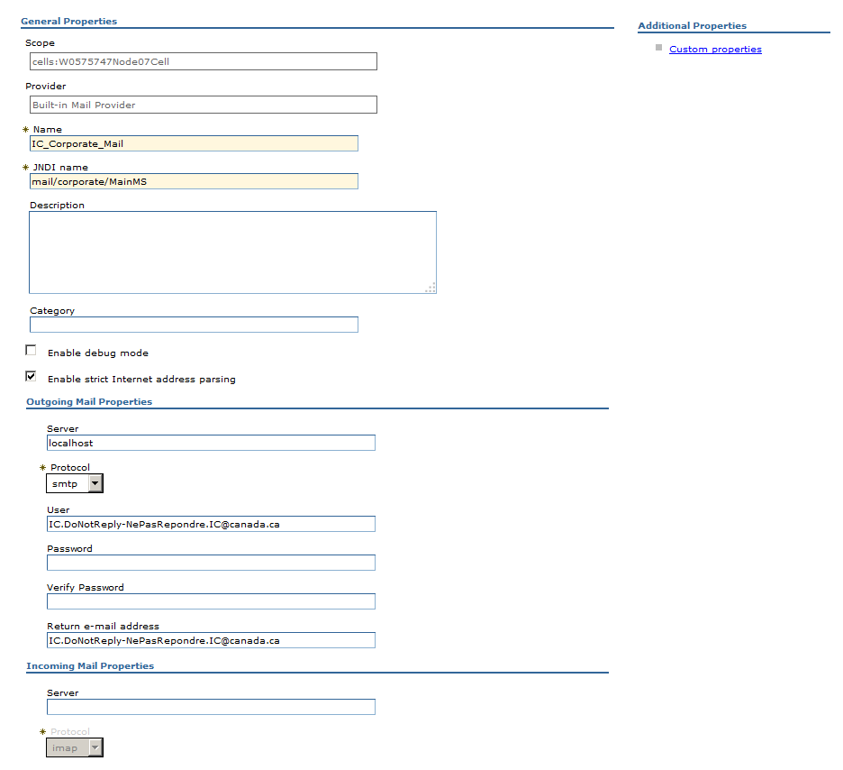

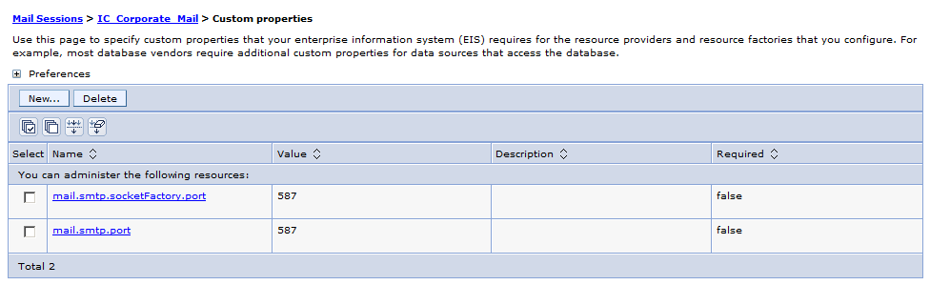

Don’t forget to Save (on top)

# Setup Database in Eclipse

Note: This step may not be necessary it is for maintenance

Here are the steps:

1. Screenshot for eclipse DB connection

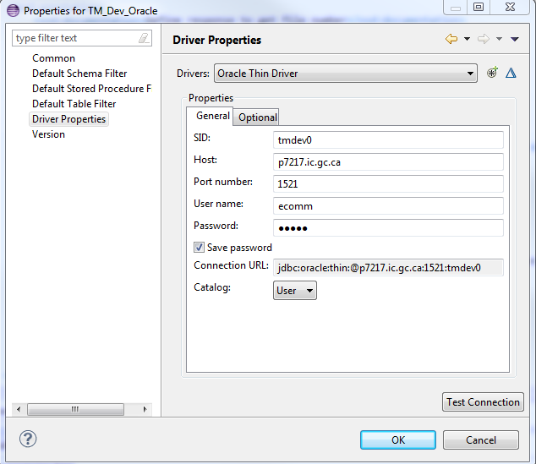

1. DB URL: See Appendix A – Eclipse Database Configuration
2. Driver: Attached

# Appendix A – Application Resources

The following table contains the Eclipse projects.

NOTE: Talk to the project leader about specific application configuration requirements since the following is application dependent.

|  |  |
| --- | --- |
| Application | Projects Required |
| TMOB | CIPO-ec-tm-oppBoard-app  CIPO-ec-wet-common-app |
| TM e-Filling | CIPO-EC_TM_Filing_EAR  CIPO-ec-wet-common-app |

## Running the application locally

### TMOB Application

<http://localhost:9080/app/scr/opic-cipo/mc-tm/comc-tmob/connexion-login_fra.htm>

<https://localhost:9443/app/scr/opic-cipo/mc-tm/comc-tmob/connexion-login_eng.htm>

### TM Registration and Renewal Application

<https://localhost:9443/app/scr/opic-cipo/mc-tm/enr-reg/connexion-login_eng.htm>

<https://localhost:9443/app/scr/opic-cipo/mc-tm/enr-reg/connexion-login_fra.htm>

### TM e-Filing (Development)

<https://localhost:9443/app/scr/opic-cipo/mc-tm/depot-filing/connexion-login_eng.htm>

# Appendix B – Database Access

## WebSphere Database Configuration

|  |  |
| --- | --- |
| DataSources - JNDI | DB Environment: URL’s |
| jdbc/amis/security/StrategisAccessUDS | DEV:   jdbc:oracle:thin:@devrdbms.ic.gc.ca:1521:strtdev  jdbc:oracle:thin:@devrdbms.ic.gc.ca:2531:icpubdev  UAT:      jdbc:oracle:thin:@devrdbms.ic.gc.ca:1521:strtuat  PROD:   jdbc:oracle:thin:@stratrdbms.ic.gc.ca:1521:strtprd |
| jdbc/cipo/ec/IntrepidSnapshot | DEV:     jdbc:oracle:thin:@devrdbms.ic.gc.ca:1521:strtdev  UAT:      jdbc:oracle:thin:@prerdbms.ic.gc.ca:1521:strtpre  PROD:   jdbc:oracle:thin:@stratrdbms.ic.gc.ca:1521:strtprd |
| jdbc/cipo/ec/defaultDS | DEV:      jdbc:oracle:thin:@devrdbms.ic.gc.ca:1521:strtdev  UAT:      jdbc:oracle:thin:@devrdbms.ic.gc.ca:1521:strtuat  PRE:       jdbc:oracle:thin:@prerdbms.ic.gc.ca:1521:strtpre  PROD:   jdbc:oracle:thin:@stratrdbms.ic.gc.ca:1521:strtprd |
| jdbc/cipo/fitt2/defaultDS | DEV:      jdbc:oracle:thin:@cipo-ux3:1521:fitdev0  UAT:      jdbc:oracle:thin:@cipo-ux2:1521:fittest0  PROD:   jdbc:oracle:thin:@cipo-ux1:1521:fitprod0 |
| jdbc/cipo/ecom/defaultDS | DEV:      jdbc:oracle:thin:@devrdbms.ic.gc.ca:1521:strtdev  PRE:       jdbc:oracle:thin:@prerdbms.ic.gc.ca:1521:strtpre  PROD:   jdbc:oracle:thin:@stratrdbms.ic.gc.ca:1521:strtprd |
| jdbc/cipo/id/WebServiceDS | DEV:      jdbc:oracle:thin:@cipo-ux3:1521:INDDEV  PRE:     jdbc:oracle:thin:@cipo-ux2:1521:INDTEST  PROD:  jdbc:oracle:thin:@cipo-ux1:1521:INDPROD |
| jdbc/cipo/cp/WebServiceDS | DEV:      jdbc:oracle:thin:@cipo-ux3:1521:CPRDEV  PRE:     jdbc:oracle:thin:@cipo-ux2:1521:CPRTEST  PROD:  jdbc:oracle:thin:@cipo-ux1:1521:CPRPROD |

## Eclipse Database Configuration

|  |  |
| --- | --- |
| Database | URL |
| Trademark Database (TMDEV)  Trademark Database (TMDEVPRJCT) | DEV: jdbc:oracle:thin:@p7217.ic.gc.ca:1521:tmdev0  DEV: jdbc.oracle:thin:@p7221.ic.gc.ca:1521:tmdev0 |
| Copyright | DEV: jdbc:oracle:thin:@p7217.ic.gc.ca:1521:CPRDEV0 |
| Industrial Design | DEV: jdbc:oracle:thin:@p7217.ic.gc.ca:1521:INDDEV0 |
| ECOM | DEV: jdbc:oracle:thin:@devrdbms.ic.gc.ca:1521:strtdev  UAT: jdbc:oracle:thin:@devrdbms.ic.gc.ca:1521:strtuat |

# Appendix C – Troubleshooting

**Errors that might happen**

1. java.security.cert.CertPathBuilderException: PKIXCertPathBuilderImpl could not build a valid CertPath.; internal cause is:

Purpose

=======

This document explains how to add a new certificate in the trust store of the server.

Symptom

=======

you are getting an error similar to this one:

java.security.cert.CertPathBuilderException: PKIXCertPathBuilderImpl could not build a valid CertPath.; internal cause is:

  java.security.cert.CertPathValidatorException: The certificate issued by CN=Entrust.net Certification Authority (2048), OU=(c) 1999 Entrust.net Limited, OU=www.entrust.net/CPS_2048 incorp. by ref. (limits liab.), O=Entrust.net is not trusted; internal cause is:

  java.security.cert.CertPathValidatorException: Certificate chaining error

Cause

=====

The certificate is not in the server trust store.

Solution

========

1. Access the WAS console for your server,

2. Expand Security in the left menu,

3. Access SSL certificate and key management,

4. Under Related Items, access the Key stores and certificates,

5. Access NodeDefaultTrustStore,

6. Under Additional Properties, access Signer Certificates,

7. Press Retrieve from port,

8. In Host, type strategis.ic.gc.ca,

9. In Port, type 443,

10. Access Retrieve signer information,

    The field Issued by should contain the same text as in the exception above.

11. In Alias, type entrust (can be something else),

12. Press OK.

13. Save changes

14. Logout and restart the server.

Done.

//////////////////NOte for Debbie

I did the above but it still did not work for me. I had to do the following

down vote

Here are the steps to import a certificate to the JVM for a HTTPS WS call:

A) Obtain the Certificate to be Imported

    Each browser displays certificates in different ways, but they are usually quite similar. On the browser's URL bar,

there is usually a zone that you can click on to display SSL certificate information. For example, you may see a padlock in the status bar,

and clicking on the padlock opens the certificate information. Once the certificate information is open, click on the "Certification Path" information.

There normally will be a way to export each of the signing certificates (trusted roots). Export the certifiers in the "Base-64 encoded X.509 (.CER)" format.

The exported file in this format will be an ASCII text file that has "BEGIN CERTIFICATE" and "END CERTIFICATE" lines at the top and bottom. Once you have exported

the certificates that signed the remote server's SSL certificate you can then import them into the JVM.

B) Import the certificate

    Start the ikeyman utility. The utility (ikeyman.bat or ikeyman.sh) is in the WAS_HOME\bin.

    From the Key Database File menu, select Open.

    In the key database type, select JKS.

    In the File Name field, type cacerts.

    In the Location field, type WAS_HOME\java\jre\lib\security.

    In the Password Prompt window, type the password for the keystore in the Password and Confirm Password window. The default password is changeit. Click OK.

    Add the certificate you created into this certificate store.

    In the main window, in the Key database content area, select Signer Certificates from the list. Click Add.

    In the Certificate file name field, browse and locate the server certificate file that was created, which is in Binary Der data.

       Verify that the appropriate directory is displayed in the Location field. Click OK.

    In the prompt, type a label for this certificate. Click OK.

# Appendix D – Retrieve IBM root signer certificate in WAS

Don’t delete root signer certificate unless you intent to do so. If it is accidently deleted in WAS, Here is a possible way to get it back:

1. Open your brower like IE, Firefox, Chrome etc.

For example, open Firefox, click advanced in main menu and view certificate, certificate manager will be shown.

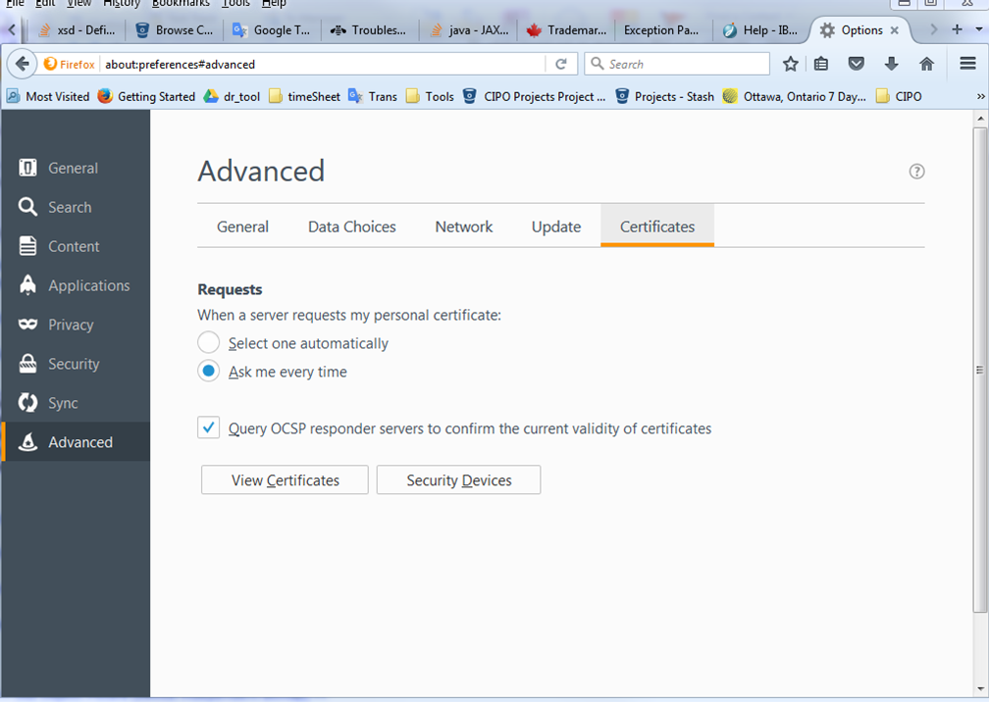

1. In Certificate manager, find out the port number under IBM for your workstation, then retrieve certificate by localhost (host name) and port number displayed in diagram below. For this sample setting, the port is 9443 instead of 443.

