1. You guys need to register an account or login with your Facebook or Google account.

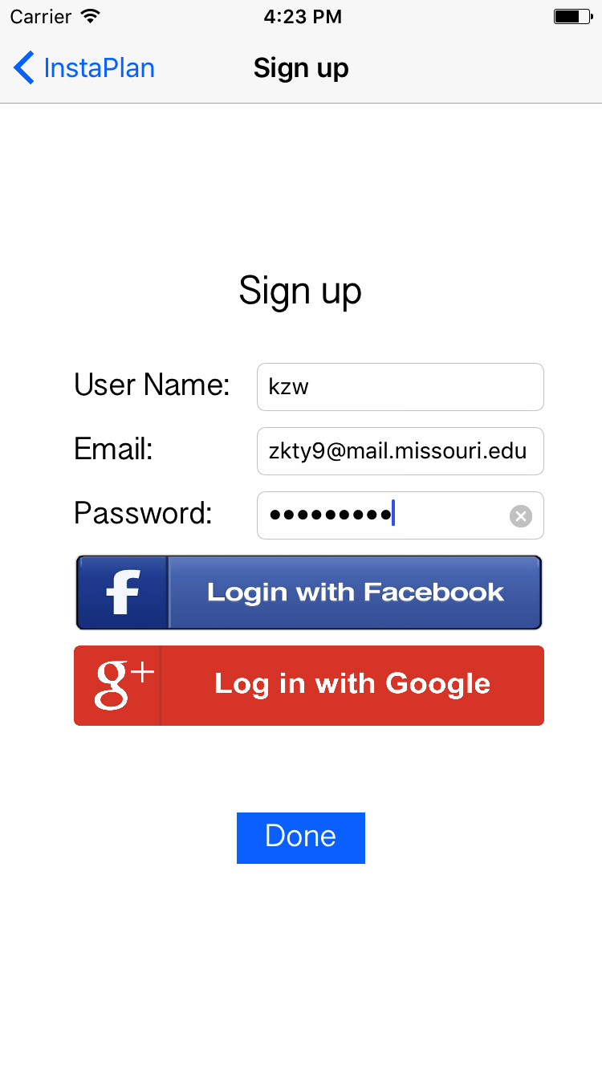

1. Then click + button to add course or assignment, just delete the add custom note button.

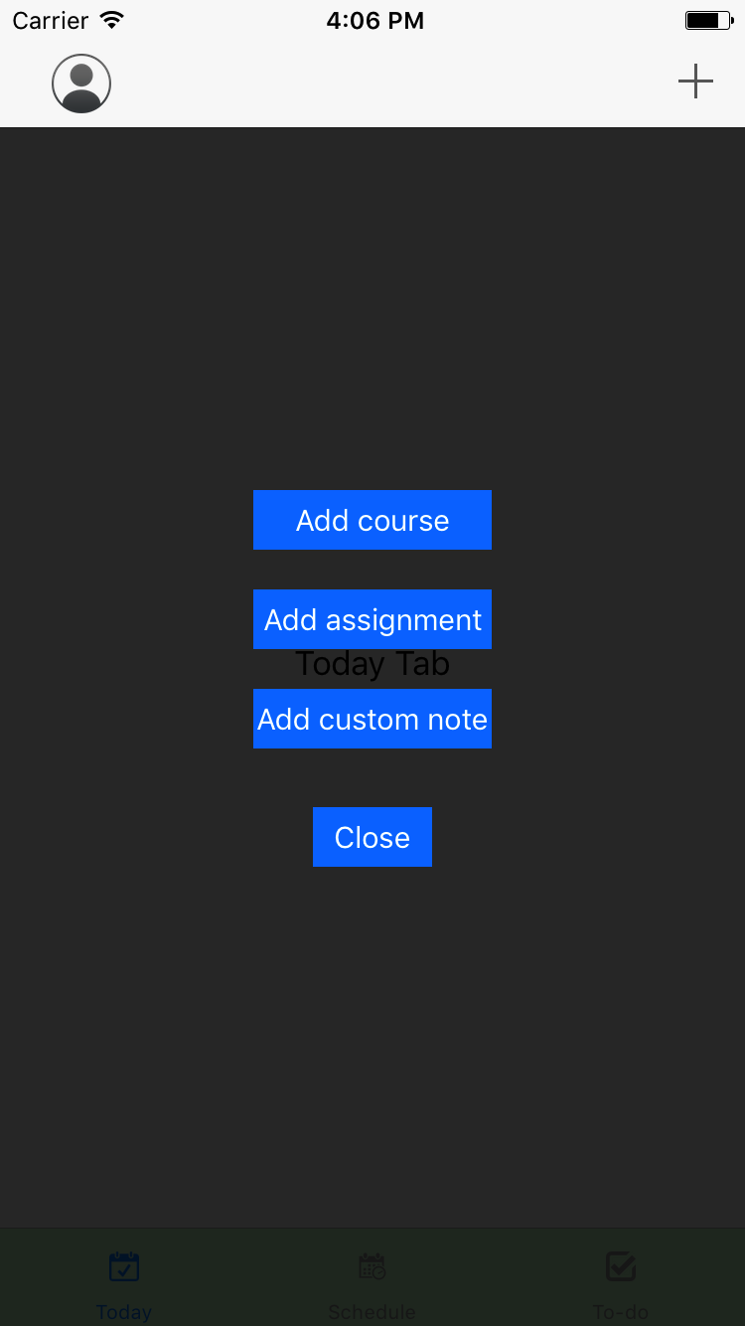

1. Then Store course information or assignment information into CoreData (Please write all coredata operation function into CoreDataController class.)

