Patch Itself

Why?

Because I thought it's the simplest and most convenient way for a user to be able to patch the database or the APEX application, and it does not need either an administrator nor me.
So, I worked out the following method to solve this issue.

How?

First I created a very simple way to manage patches in Oracle.
A table PA_PATCHES, which stores the installed patches: version, name, date and result.
The PATCHES are identified by NAME and the VERSION defines their order.
The DATE_OF_INSTALL shows the installation date even if was success or unsuccess.
The SUCCESS =1 if the install was success and =0 if not.
Let the first version (VERSION=1) be this package, because we have to start somehow.
So after run this script the first row with version = 1 and with name = 'PATCHES' will be inserted into the PA_PATCHES table.
And a package PKG_PATCH which can manage the patch versions in the table.
The PKG_PATCH.INSTALL( I_VERSION => n, I_NAME => 'X') procedure administrate and check the beginning of installation.
If the procedure will not raise an exception then administrate the start of patch.
If the procedure will raise an exception then it could mean:
- -20001 = This patch has already installed
- -20002 = This version has already installed with a different name
- -20003 = This version is not the follow.
- >0 = An Oracle error has raised
The PKG_PATCH.DONE; or PKG_PATCH.DONE( I_VERSION => n ); administrates the succesfull end of patch.

How to use?
Example. Let the name of the patch file be : V11_NEW_INDICES.sql The content let be:
WHENEVER SQLERROR EXIT SQL.SQLCODE
Execute PKG_PATCH.INSTALL( 11, 'NEW_INDICES' );

CREATE INDEX PROCESSES_IDX1 ON PROCESSES ( ENVIRONMENT_ID );
CREATE INDEX PROCESSES_IDX2 ON PROCESSES ( ADDRESS );

Execute PKG_PATCH.DONE;

When the script is executing the following can happen
- aborted at the Execute PKG_PATCH.INSTALL line because one of the reasons listed above.
- aborted at any patch line eg one of Index creating. In this case the PA_PATCHES will contain the patch data, but the SUCCESS will be 0.
- terminated without any error. In this case the SUCCESS will be 1 in the PA_PATCHES table at the data row of this patch.
No problem to insert the full APEX application export file into the patch file. It will change the application too, without any problem.
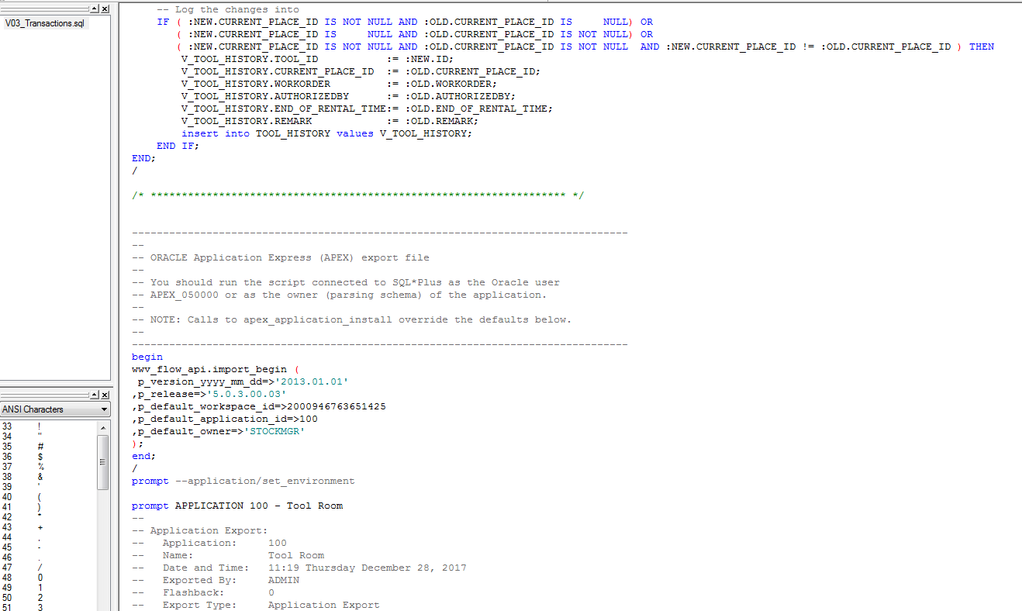

But do not forget to finalize the things at the end of the patch file:

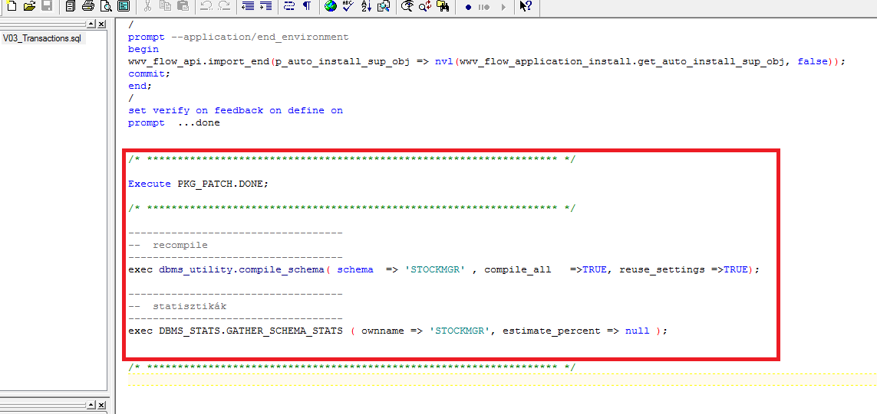
Then I created a form under APEX which can show and manage these patches:
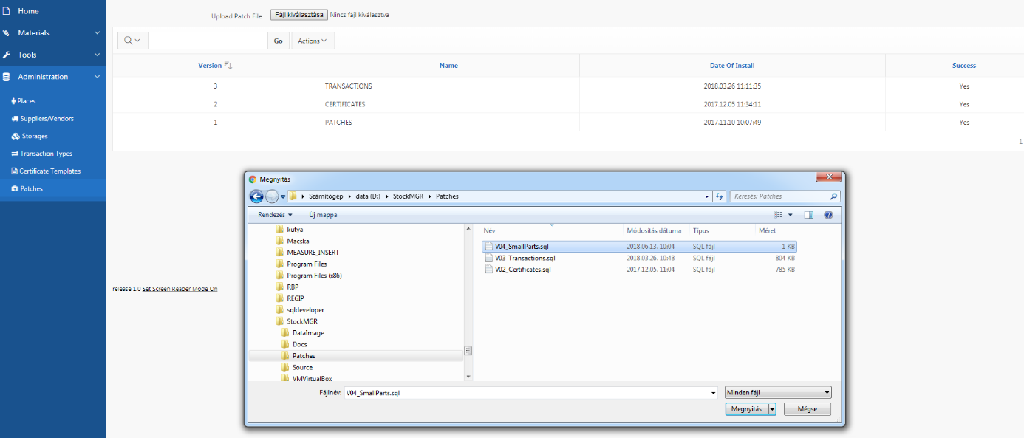

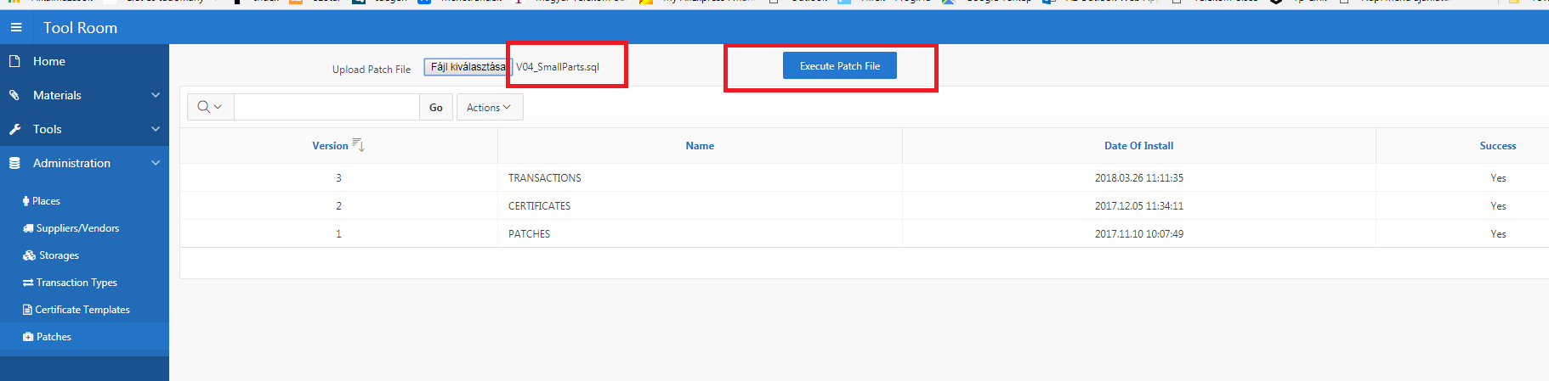
(The button disappears and shows depending on the file selection.)

But what happens after click on the „Execute patch File” button?

A „submit page”. ☺ But there is a PL/SQL Process what executes when the button clicked on. See the
APEX_Execute_Patch_Process.sql
This script writes out the uploaded patch file into an Oracle directory.
In this example: PATCHDIR = /home/oracle/Patches
then creates a job which starts the EXE_PATCH Oracle Scheduler Program. See EXE_PATCH.sql file!
( the job owner must have the CREATE EXTERNAL JOB system privilege before the job can be enabled or run )
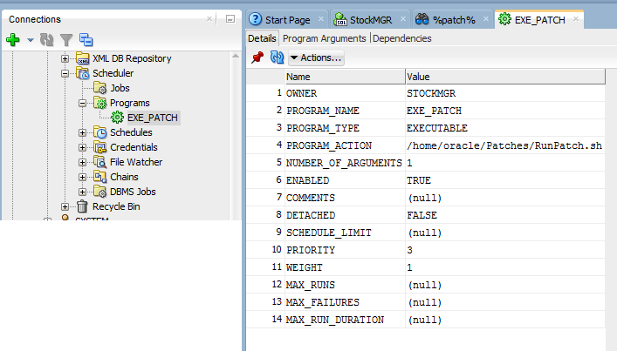
It has a Parameter (Program Argument):
And the shell script can run the sql script given in the first parameter, using SQLPLUS and remove it finally. ( See the RunPatch.sh )
#!/bin/bash
ORACLE_HOME=/u01/app/oracle/product/11.2.0/xe
export ORACLE_HOME
ORACLE_SID=XE
export ORACLE_SID
NLS_LANG=`$ORACLE_HOME/bin/nls_lang.sh`
export NLS_LANG
PATH=$ORACLE_HOME/bin:$PATH
export PATH
echo exit | /u01/app/oracle/product/11.2.0/xe/bin/sqlplus STOCKMGR/xxxxxxxx @$1
rm $1

….and that’s it!
It is slightly complex, but it worth, because after this you just send a simple sql script file to the user and she/he can patch either DB or APEX as well.

