Tasks

Why?
There are activities that either end-users or database owners do not want to run interactively, for example
- should be out of work
- There is no way for a client to keep connect so long
- should run only in the dawn after the last day of the month, when the last data files processed from all the sites and the result of query must be in the morning and have to send in e-mail to members of sales dept.
- There is no need for a client because it is just a background process
- etc.
but there is no general solution to this problem.
Instead of specific solutions, it was timely to create this generic one.

Features
We can
- create categories and assign tasks to them
- monitorize the status of tasks
- add parameters
- define conditions
- define time threshold
- get the result back
- kill the running task
- clone a task

How?

There are some tables what we can read via views and write by procedures and functions. There is a package what contains the all necessary functions, procedures to manage tasks.

The scripts of the tasks will run by SQLPLUS in separated (parallel) command windows. The output of the scripts will direct into a spool file and will be uploaded into a table after the run.

The simpliest way, run an SQL command asap:
begin
PKG_TASK.P_NEW_TASK( 'select * from TASK_STATUSES;');
PKG_TASK.P_START_TASK;
end;
/

The Task:
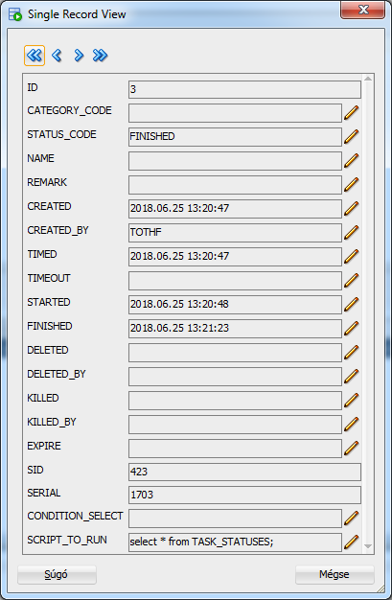

and its result:

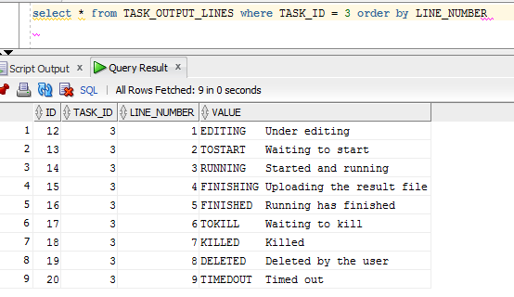

A more complex situation:

declare
V_TASK_ID number(10);
begin
PKG_TASK.P_ADDMOD_CATEGORY ( 'DEMO', 'This for test/demo only' );

V_TASK_ID := PKG_TASK.F_NEW_TASK(
I_SCRIPT_TO_RUN =>
q'#select * from TASK_STATUSES where NAME like '%'||PKG_TASK.F_GET_PARAMETER(PKG_TASK.TASK_ID,'NAME_PART')||'%';#'
, I_CATEGORY_CODE => 'DEMO'
, I_NAME => 'This is a demo for "complex" task'
, I_CONDITION_SELECT => 'select 1 from TASKS where rownum < 2' /* there is at least on task (a demo only) */
, I_TIMEOUT => trunc(sysdate) + 1 + 1/24 /* 1 hour */
, I_EXPIRE => trunc(sysdate) + 10 /* delete the task data after 10 days */
, I_REMARK => ' '
);

PKG_TASK.P_SET_PARAMETER ( I_TASK_ID => PKG_TASK.TASK_ID /* same as V_TASK_ID, anyway it is optional */
, I_NAME => 'NAME_PART'
, I_VALUE => 'a'
);

PKG_TASK.P_START_TASK ( I_TASK_ID => V_TASK_ID /* it is optional too */
, I_TIMED => trunc(sysdate) + 1
);
end;
/

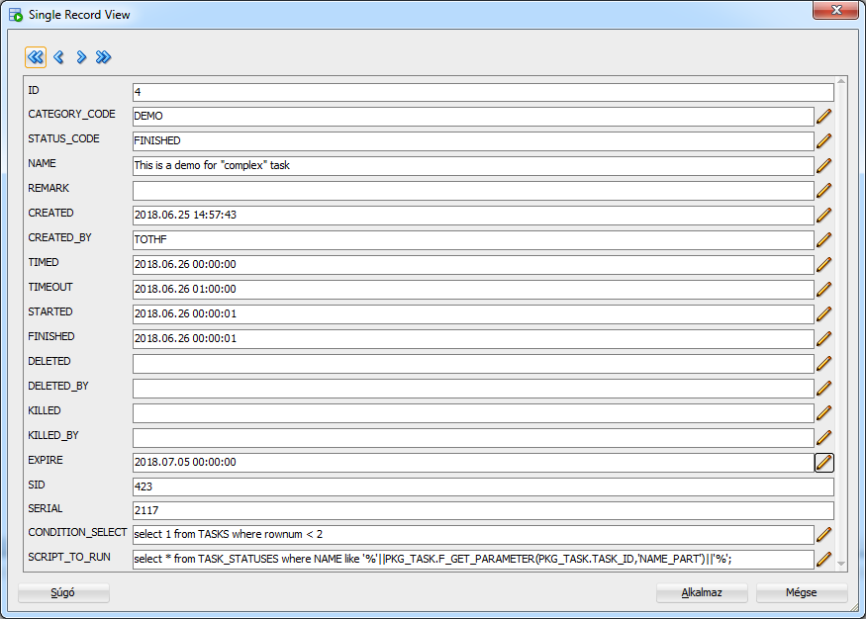

and its result:
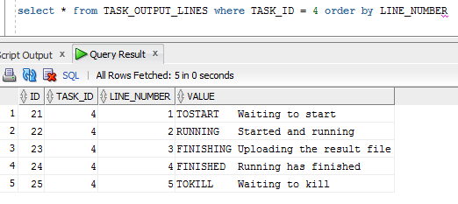

How does it work?
Tables and its columns

TASKS
This is the main table. It contains the task data.

ID internal unique ID
CATEGORY_CODE optional. This helps to make groups of tasks.
It refers to TASK_CATEGORIES table.
STATUS_CODE mandatory. See the next chapter for details! Refers to TASK_STATUSES table.
NAME optional. A name to identify this task.
REMARK optional. longer description to the task.
CREATED time of row inserting
CREATED_BY OS user name
TIMED planned start date and time
TIMEOUT timeout date and time. After this time the task will not start. If it is still running then will be killed. It is optional. If it is null, the task manager does not care about the timeout.
STARTED the real time of starting
FINISHED the time of termination
DELETED the time of delete (if it is deleted)
DELETED_BY OS user name who deleted (if it is deleted)
KILLED the time of kill (if it is killed)
KILLED_BY OS user name who killed (if it is killed)
EXPIRE optional. If this is not null, then at date+time all data of the task will be deleted from the tables: TASKS, TASK_PARAMETERS, TASK_OUTPUT_LINES.
SID if the task has started then the SID of the process. The killer needs this.
SERIAL as SID
CONDITION_SELECT Sometimes the TIMED is not enough to start a task and it needs more conditions. We can give here an additional condition, what is a select command. If the select command will return at least one row then this condition will be true. This „select” will open as a cursor and will fetch into varchar2(4000) variable. So use only one short string column. We can use task id and other parameter value in the „where”. If the TIMED elapsed the starter tries to execute this select (if exists) and if it is true, then starts the task otherwise stays in TOSTART status.

SCRIPT_TO_RUN
Last but not least, the task (script) itself. (this is also max 4000 characters long)
This can be any sql script. Since this is a script, there must be a ; at the end of lines.
The script will run in a SQLPLUS, "embedded" as follows. See a line highlighted in red!

SET TIMING OFF
SET NEWPAGE 0
SET SPACE 0
SET LINESIZE 4000
SET PAGESIZE 0
SET ECHO OFF
SET FEEDBACK OFF
SET HEADING OFF
SET TERMOUT OFF
SET ARRAYSIZE 5000
SET TRIMSPOOL ON
SET PAUSE OFF
SET VERIFY OFF
SET WRAP OFF
SET SERVEROUTPUT ON SIZE UNLIMITED
EXECUTE PKG_TASK.P_SET_TASK_ID( 3 );
EXECUTE PKG_TASK.P_SET_TASK_SESSION( 3 );
SPOOL TASK_3.out
select * from TASK_STATUSES;
SPOOL OFF
EXECUTE PKG_TASK.P_UPLOAD_TASK_OUTPUT( 3 );
EXIT;

SET TIMING OFF
SET NEWPAGE 0
SET SPACE 0
SET LINESIZE 4000
SET PAGESIZE 0
SET ECHO OFF
SET FEEDBACK OFF
SET HEADING OFF
SET TERMOUT OFF
SET ARRAYSIZE 5000
SET TRIMSPOOL ON
SET PAUSE OFF
SET VERIFY OFF
SET WRAP OFF
SET SERVEROUTPUT ON SIZE UNLIMITED
EXECUTE PKG_TASK.P_SET_TASK_ID( 4 );
EXECUTE PKG_TASK.P_SET_TASK_SESSION( 4 );
SPOOL TASK_4.out
select * from TASK_STATUSES where NAME like '%'||PKG_TASK.F_GET_PARAMETER(PKG_TASK.TASK_ID,'NAME_PART')||'%';
SPOOL OFF
EXECUTE PKG_TASK.P_UPLOAD_TASK_OUTPUT( 4 );
EXIT;

Certainly we can overwrite the SET parameters from our script.
Since the P_SET_TASK_ID is setting up the G_TASK_ID value in PKG_TASK we can call functions and procedures without passing I_TASK_ID parameter value.

TASK_PARAMETERS
If you do not want to include fix values in our script, you can write them into this table and just use them in the script calling the „get parameter” functions. What can this be good for? eg. is to create a new script by an existing copy. However, you want to run it with other values, it is much simpler to modify the corresponding parameters than to replace something in the script. See also examples in section.
ID internal unique ID
TASK_ID foreign key reference to TASKS
NAME name of the parameter
VALUE value of the parameter

TASK_OUTPUT_LINES
The Spool file of the script will be placed here.
ID internal unique ID
TASK_ID foreign key reference to TASKS
LINE_NUMBER the order of lines in the spool file (from 1 to …)
VALUE the text of line

TASK_CATEGORIES
A simple „code” table. With these categories we can create groups from tasks.
CODE
NAME

TASK_STATUSES
A simple „code” table. Do not modify the codes, but translate, change the names if necessary
CODE
NAME

Status changes and possible transitions
From a certain state, a task can go only into the specified states

EDITING
Start state. They have just been created, edited, can not be started yet. The CREATED and CREATED_BY fields are automatically filled in.
Possible next states are:
- TOSTART (normal way, has TIMED value and waiting to get started), P_START_TASK procedure sets this up)
- DELETED (it has already been canceled before start. The P_STOP_TASK procedure sets it up)

TOSTART
Waiting to start. Or the timed time has not arrived yet or if CONDITION_SELECT has specified, it will either return with no rows or wrong.
Possible next states are:
- RUNNING (started, the conditions were met to start),
- TIMEDOUT (it still could not start and ran out of time, eg because the Condition has not met)
- DELETED (it was waiting to start, but has deleted before it )

RUNNING
Running. When this status is set, its date is updated into the STARTED column.
Actually, it is not yet certain started. It may be that the sql script has just been written to the file (.run) and looks forward to getting started. But anyway, because it's as if it is running, because at any moment it can start by the cmd.
Possible next states are:
- FINISHING (run and just read back the result, spool file)
- TOKILL (someone or something wants to interrupt the run)

FINISHING
The script has finished and the result file is reading back into the TASK_OUTPUT_LINES table.
Possible next states are:
- FINISHED
- TOKILL (someone or something wants to interrupt the run)

TOKILL
The user or the administrator manually initiated the kill out of the running task. Or the task supervisor procedure initiated the same thing because of timeout (KILLED date and KILLED_BY columns are filled).
Possible next states are:
- KILLED (successfully interrupted)

FINISHED
Final state. The task was completed. When set, the time in FINISHED is set too.

FAILED
Final state. The task was failed, finished with error. When set, the time in FINISHED is set too.

KILLED
Final state. The task was killed successfully.

DELETED
Final state. Deleted by a user before could start.

TIMEDOUT
Final state. Run out of time before could start. There is a Condition select and it has not result, so it was false until the time is up.

Views
For readability, ease of use, and security reasons, users should work from views instead of tables!
The tables can be written using the procedures of the package and can be read by the view.
The tables can only be used directly by administrators!
If they do not match, you have to make other views or modify the existing ones.

V_TASKS, V_TASK_CATEGORIES, V_TASK_STATUSES, V_TASK_PARAMETERS, V_TASK_OUTPUT_LINES
The whole content of the tables

V_MY_TASKS
The TASKS table rows where the CREATED_BY is the current OS user.

Other views are for operation and not for users.

Functions

The procedures that can be used by anyone and are described below are in the PKG_TASK package.
Take the procedures in order of use! In the package there is a global TASK_ID variable. If we create a new a task or set this variable value with P_SET_TASK_ID procedure we do not necessary pass I_TASK_ID parameter when calling the functions or procedures.
The current value of this G_TASK_ID can get by F_GET_TASK_ID or TASK_ID functions.

Categories
Optionally we can create categries for the tasks and we can assign a task to a category. We can create, modify and delete categories with
procedure P_ADDMOD_CATEGORY ( I_CODE in varchar2, I_NAME in varchar2 );
procedure P_DELETE_CATEGORY ( I_CODE in varchar2 );
procedures

Creating a new Task
We can create a new task by F_NEW_TASK function or by P_NEW_TASK procedure. They have only one mandatory parameter, the script what we want to execute.
The function returns with the ID of the new task. Both of them set the global G_TASK_ID value in the package. The definition of the function:
function F_NEW_TASK( I_SCRIPT_TO_RUN in varchar2,
I_CATEGORY_CODE in varchar2 default null,
I_NAME in varchar2 default null,
I_CONDITION_SELECT in varchar2 default null,
I_TIMEOUT in date default null,
I_EXPIRE in date default null,
I_REMARK in varchar2 default null
) return number;
The procedure is similar except for it does not give the ID back.

Using parameters in the Task
Either in the script or the condition select we can use parameter values. To do this we can use the following functions:
function F_GET_PARAMETER ( I_TASK_ID in number, I_NAME in varchar2 ) return varchar2;
function F_GET_PARAMETER ( I_NAME in varchar2 ) return varchar2;
function TASK_PARAMETER ( I_TASK_ID in number, I_NAME in varchar2 ) return varchar2;
function TASK_PARAMETER ( I_NAME in varchar2 ) return varchar2;
The TASK_PARAMETER is just another name of F_GET_PARAMETER.

Set parameter values
When the script or condition select of our task uses parameters, then we have to set their values before the task starts. We can do it with the following procedure:
procedure P_SET_PARAMETER ( I_TASK_ID in number, I_NAME in varchar2, I_VALUE in varchar2 );
procedure P_SET_PARAMETER ( I_NAME in varchar2, I_VALUE in varchar2 );

Setting and getting other attributes of the Tasks

CATEGORY
procedure P_SET_TASK_CATEGORY ( I_TASK_ID in number, I_CATEGORY_CODE in varchar2 );
procedure P_SET_TASK_CATEGORY ( I_CATEGORY_CODE in varchar2 );
function F_GET_TASK_CATEGORY ( I_TASK_ID in number default G_TASK_ID ) return varchar2;
function TASK_CATEGORY ( I_TASK_ID in number default G_TASK_ID ) return varchar2;

SCRIPT TO RUN
procedure P_SET_TASK_SCRIPT_TO_RUN ( I_TASK_ID in number, I_SCRIPT_TO_RUN in varchar2 );
procedure P_SET_TASK_SCRIPT_TO_RUN ( I_SCRIPT_TO_RUN in varchar2 );
function F_GET_TASK_SCRIPT_TO_RUN ( I_TASK_ID in number default G_TASK_ID ) return varchar2;
function TASK_SCRIPT_TO_RUN ( I_TASK_ID in number default G_TASK_ID ) return varchar2;

NAME
procedure P_SET_TASK_NAME ( I_TASK_ID in number, I_NAME in varchar2 );
procedure P_SET_TASK_NAME ( I_NAME in varchar2 );
function F_GET_TASK_NAME ( I_TASK_ID in number default G_TASK_ID ) return varchar2;
function TASK_NAME ( I_TASK_ID in number default G_TASK_ID ) return varchar2;

CONDITION_SELECT
procedure P_SET_TASK_CONDITION_SELECT( I_TASK_ID in number, I_CONDITION_SELECT in varchar2 );
procedure P_SET_TASK_CONDITION_SELECT( I_CONDITION_SELECT in varchar2 );
function F_GET_TASK_CONDITION_SELECT( I_TASK_ID in number default G_TASK_ID )return varchar2;
function TASK_CONDITION_SELECT ( I_TASK_ID in number default G_TASK_ID )return varchar2;

TIMEOUT
procedure P_SET_TASK_TIMEOUT ( I_TASK_ID in number, I_TIMEOUT in date );
procedure P_SET_TASK_TIMEOUT ( I_TIMEOUT in date );
function F_GET_TASK_TIMEOUT ( I_TASK_ID in number default G_TASK_ID ) return date;
function TASK_TIMEOUT ( I_TASK_ID in number default G_TASK_ID ) return date;

EXPIRE
procedure P_SET_TASK_EXPIRE ( I_TASK_ID in number, I_EXPIRE in date );
procedure P_SET_TASK_EXPIRE ( I_EXPIRE in date );
function F_GET_TASK_EXPIRE ( I_TASK_ID in number default G_TASK_ID ) return date;
function TASK_EXPIRE ( I_TASK_ID in number default G_TASK_ID ) return date;

REMARK
procedure P_SET_TASK_REMARK ( I_TASK_ID in number, I_REMARK in varchar2 );
procedure P_SET_TASK_REMARK ( I_REMARK in varchar2 );
function F_GET_TASK_REMARK ( I_TASK_ID in number default G_TASK_ID ) return varchar2;
function TASK_REMARK ( I_TASK_ID in number default G_TASK_ID ) return varchar2;

Start and schedule the Task
After the task created, it is in EDITING state, so it will not start. We have to call the P_START_TASK procedure if we would like to start it. We can set the earliest time of starting with the I_TIMED parameter of this procedure. The default is sysdate, so in this case it will start asap.
procedure P_START_TASK ( I_TASK_ID in number, I_TIMED in date default sysdate);
procedure P_START_TASK ( I_TIMED in date default sysdate);

Stop the Task
Sometimes we need to stop a task. The P_STOP_TASK procedure changes the task status to DELETED if the task in EDITING or TOSTART phase and sets to TOKILL if the task is RUNNING or FINISHING state. In other cases it leaves the status as it is.
procedure P_STOP_TASK ( I_TASK_ID in number default G_TASK_ID);

Clone the Task
If we need to run a task more than one time we can clone the task. If the task data exist we can call the:
function F_NEW_TASK_FROM_TASK ( I_SOURCE_TASK_ID in number,
I_TIMEOUT in date default null,
I_EXPIRE in date default null
) return number;
After cloning do not forget to set parameter values and other attributes if necessary.
The cloned task is in EDITING status and have to start with P_START_TASK procedure.

Remove Task data
The user can not delete Task, but can set the EXPIRE attribute of the task. After this the P_CLEANER procedure will delete it when the sysdate passed the EXPIRE value.

The way of working
Operation is controlled by an Oracle JOB that calls the P_TASK_SUPERVISOR procedure with frequency (eg: every 5 minutes), this calls
- P_STARTER: starts the task what are waiting to start. (in fact it only create the TASK sript file in a certain directory)
- P_FAILED_UPLOADER: uploads the task output when it aborted before the normal termination
- P_KILLER: kills, deletes the task
- P_TIMEOUTER:Timeout those thask that have not yet started but their timeouts have expired
- P_CLEANER: physically deletes tasks that have expired time

Installation
The installation has two parts:
- Database
- Server (OS)

The Server part also consists of two scripts. Both must be copied to the physical directory for "TASKS_FILES".
There is not much to change on launch_one.cmd, or if there is no SQLPLUS in the path, you need to enter your path:

REN %1 %~n1.SQL
SQLPLUS ca/xx@localhost:1521/orcl.abc.local @%~n1.SQL
DEL %~n1.SQL
EXIT

In start_me.cmd there is a NLS_LANG setting that you may need to modify.

@Echo off
SET NLS_LANG=AMERICAN_AMERICA.AL32UTF8
FOR %%F in (*.RUN) DO START LAUNCH_ONE.CMD %%F

We have to schedule to start start_me.cmd frequently. If we set it to every 5 minute, a TASK have to start at last within 10 minutes.
Because the sript will write into the folder, we have to create, delete rights on this directory.
It's a good idea to run a scheduled process on behalf of a user whose password never expire.
So, in the physical directory for the "TASKS_FILES" must be the following files:
launch_one.cmd
start_me.cmd
during the working, such additional files will be:
TASK_n.tmp An n ID task script is just writing out
TASK_n.run The writing of the n ID task script has finished and waiting for the starting
TASK_n.sql ... started (launched)
TASK_n.out The spool file for the task ID of n ID

The TASK_n.sql file is deleted by launch_one.cmd, and the TASK_n.out file by the PKG_TASK.P_UPLOAD_TASK_OUTPUT after the load. If the script is aborted, it will also load its out file (at a next supervisor job run).

