**Assignment Description:**

The objective of this assignment is to apply the techniques from the lecture to static testing of your Triangles program.

Specifically: You will run a static code analyzer on your code, e.g. Pylint, identify and fix any problems reported by the static code analyzer; You will run a code coverage tool on your code, e.g. Coverage.py, and extend your test cases to demonstrate at least 80% code coverage;

In this assignment, you will need to download and install the tools that you will need for static code analysis and code coverage.  You will then run those tools locally on your laptop to get the results.

Any changes that you make to your programs should be pushed up to GitHub.

Deliverables:

Submit a report with the following information :

The GitHub URL containing the code that was analyzed

The name and output of the static code analyzer tool you used;

The name and output of the code coverage tool you used;

Identify both your original test cases and new test cases that you created to achieve at least 80% code coverage.

Attach screen shots of the output of the static code analyzer as well as code coverage.  You should show a screen shot of the analysis results both before and after any changes that you make to your programs:

Static code analysis report on original program

Code coverage report before any changes to the program

Static code analysis report after you have made changes to eliminate issues

Code coverage after any changes to the programs (coverage should be > 80%)

As always, start with a summary at the top, and follow with more detailed results.

You'll find a nice tutorial on Pylint at [https://www.blog.pythonlibrary.org/2012/06/12/pylint-analyzing-python-code/ (Links to an external site.)](https://www.blog.pythonlibrary.org/2012/06/12/pylint-analyzing-python-code/) or many IDEs run Pylint automatically, e.g. VS Code and PyCharm both run Pylint on your code and display errors in the code window.

You'll find a nice tutorial on Coverage.py at [https://www.blog.pythonlibrary.org/2016/07/20/an-intro-to-coverage-py/ (Links to an external site.)](https://www.blog.pythonlibrary.org/2016/07/20/an-intro-to-coverage-py/)   The idea is that coverage is a standalone program that analyzes your code and generates a nice HTML report that you can submit as part of your homework submission.

**Author:** Frank DiGiacomo

**Summary:** I had to install Coverage and Pylint. Both were relatively easy to install and after running coverage, there was already over 80% coverage, but pylint returned a lot of static formatting errors. After fixing all the errors from pylint, the code was uniform.

**Honor Pledge:** I pledge my honor that I have abided by the stevens honor system – Frank DiGiacomo

**Detailed Results:**

Static code analysis of original program:

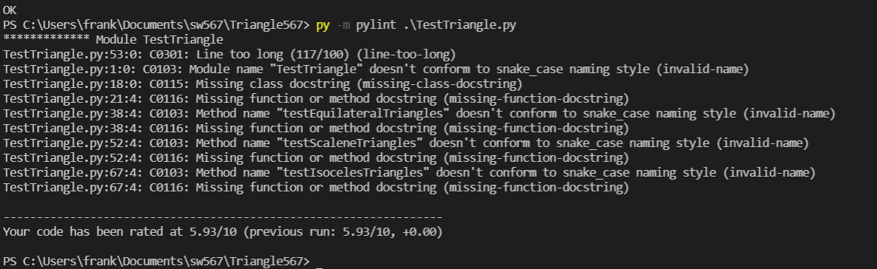

Coverage code analysis of original program:

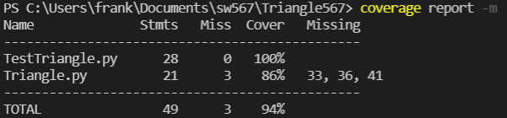

Static code analysis of updated program:

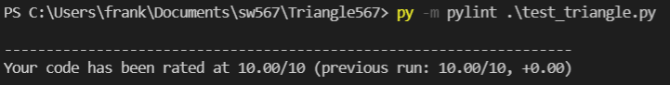

No updates were needed within the test cases to get over 80% coverage.

Overall notes: A lot of the Pylint errors were from not having function and class descriptions as well as not using snake_case. These were simple to fix. Using Coverage.py was actually really interesting. I really enjoyed looking at the report and seeing what it analyzes and recommends what to add. The html page is a great feature.

Github Repo: <https://github.com/frankied003/sw567>