MotionFit – Enhancing Progression By Preventing Injuries

YouTube: <http://www.youtube.com/watch?v=FkonDf_r1PI>

**Figure 1 -** Participation based evaluation was used to evaluate MotionFit

# Abstract

**Francesco Ferraioli**

n8323143

francesco.ferraioli@connect.qut.edu.au

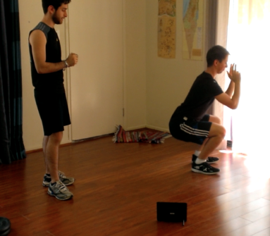This report will discuss the very common issue of injuries, focusing mainly on gym based injuries. Moreover, it will delve deeply into the reasons behind these injuries, discussing the causes of gym based injuries. Additionally it will explain how injuries are a great hindrance in progression at the gym and ultimately prevention to gym attendees achieving their goals.

This report will then introduce MotionFit to the reader. MotionFit is a new and innovative solution to the problem of gym based injuries that will immensely enhance progression at the gym by eliminating or at least minimising the occurrence of injuries by targeting their main causes. It will discuss and illustrate MotionFit through the use of different design artifacts. It will explain to the reader the design process and the different methods that were used to design this product.

The final design of MotionFit will be discussed at great length to provide the reader with a informative overview of the product, what it consists of and how it works. Lastly, the product will be evaluated with potential users.

# Author Keywords

Gym, technique, injuries, enhance, maximise, minimise

# Introduction

**Figure 2 –** John was compiled as a persona to use in the design process

**Figure 3 –** A second persona (Ben) was also used as a persona

Fitness and healthy lifestyles are becoming more and more common in todays society as people are becoming more motivated to hit the gym to get fit and reach the lean body they desperately want. However, many can’t afford to get a personal trainer so most stick to what they know. The issue thus arises of gym based injuries. The most common cause of injuries, especially regarding gym exercises is lack of proper technique. This lack of proper technique is caused by multiple things, including absence of knowledge or simply having too many things to think about whilst exercising.

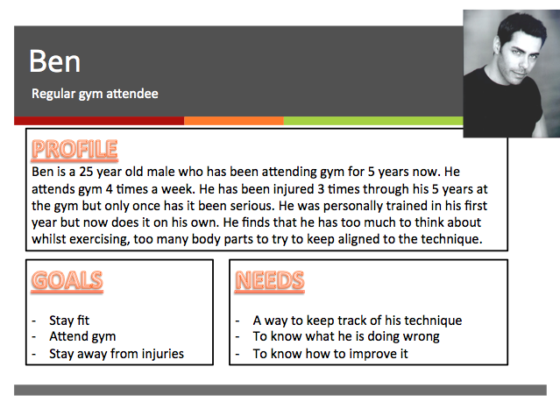Without the knowledge of the proper technique for exercises undertaken at the gym, it’s a fairly difficult task to obtain proper technique. When lifting heavy weights, if the exercise is not undertaken using the correct technique, not only will the exercise be less effective, but it also implies that stress is being applied to unwanted places and thus can cause injuries. Furthermore, even if one knows the proper technique for the exercise, sometimes there may be too many things to think about – body angle, feet alignment, hand position and grip – and this can cause improper technique and thus injuries.

Studies have shown that one of the biggest hindrances to fitness progression for gym attendees is injuries. Injuries certainly prevent the attendance to gym whilst experiencing the consequences of the injury, be it a torn muscle or a sprained joint. Moreover, attendance can sometimes cease as a result of injuries due to the fear of encountering injuries again.

The goal is to design a product that enhances progression at the gym by eliminating or at least minimising injuries. Injuries disrupt the workout flow, certainly physically but also mentally. Simply minimizing injuries at gym means that an attendee is able to exercise constantly, without disruptions and thus maximise their progression towards their goals.

# Design Process

Arriving to a final design for a product involves undertaking the design process. The design process used to derive the final design of MotionFit involved the use of the following methods: Personas and Extreme Personas.

## **Personas**

Personas is a very effective method that is widely used in the design process to instigate some initial ideas. I decided to come up with two personas to help me brainstorm some ideas for the product; the two personas are John and Ben.

### **John**

John’s persona is explained in Figure 2. John could be stereotypically categorized as a jock as he has always been involved in sports and enjoys playing them regularly. However, he has never joined a gym for fear that upon getting injured, he might not be able to continue playing sports, whether it be short term or long term. A small muscle tear in his calf muscle and he would be unable to play most sports for at least a couple of weeks.

John feels like he isn’t educated enough about how to workout properly at the gym and thus would feel vulnerable to injuries if he commenced undertaking gym activities. A lot of his mates attend gym but he doesn’t feel like going with them as he would feel like he will annoy them with all the help he will need.

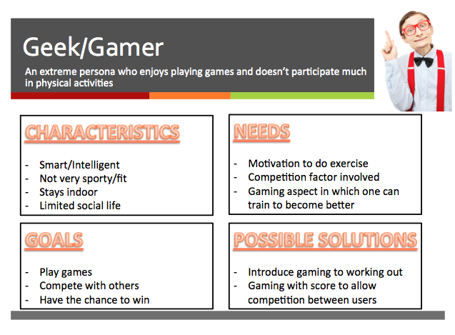John needs a product that is able to educate him quickly and effectively about the techniques of different types of exercises. He requires a centralized source of data which contains a vast amount of information on how to exactly execute an exercise without applying too much stress on the body and thus avoid injuries. Apart from reading information about the techniques, seeing the particular technique visually through a video would be extremely beneficial to John.

**Figure 4 –** Extreme Personas was used to instigate more ideas for a wider audience

**Figure 5 –** High-Fidelity prototype of the device was used when evaluating product

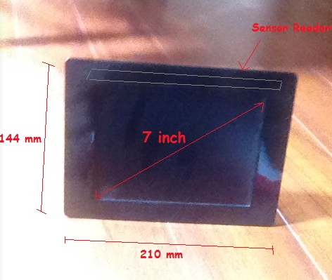Furthermore, John would certainly require this information wherever he goes. He would need it handy so that if he is at the gym and needs to remind himself on the technique of a particular exercise, he would be able to simply view on, be it on his phone or on a tablet. He wouldn’t want to have to remember it all and go to the gym trying to recall exactly how each part of the body should be positioned to execute the exercise in the most effective manner, not only to maximise results but also to minimise the likelihood of injuries.

### **Ben**

Ben on the other hand is a regular gym user and his persona is described in Figure 3. He has been attending gym for a while now and is fairly informed on the proper techniques for most of the exercises he undertakes at the gym. However, even whilst knowing the proper technique, he has still managed to injure himself three (3) times throughout his five (5) years attending the gym. Certainly poor technique is not the only cause of injuries at the gym, he might be overworking his body or maybe he isn’t taking the time to warm up and cool down before and after his workout causing his body to be stiff when he starts his workout. Nevertheless, having the knowledge of the proper techniques for exercises is sometimes not enough to conclude that the proper technique is being executed constantly and this is many times the case.

Even with full knowledge of the correct technique, it is possible to have very improper technique. This can be caused by many things, muscle fatigue is one of these. When muscles are fatigued they cannot withhold the same amount of force and for this reason the stress is then applied on a different part of the body and thus proper technique is lost. In addition, some techniques can be fairly complex. Techniques involve body alignment, body angles, hand positions, fluid motions and much more. At times, there are just too many things to think about especially while you are struggling to lift heavy weights, the attempt to execute the correct technique is very likely to fail.

Simply providing a product that contains a centralized source of vast amount of information regarding the proper techniques for exercises won’t appeal much to Ben. As was motioned, Ben is very much aware of the proper techniques he needs to execute at the gym to avoid injuries and maximise his results. What Ben needs is someone or something to inform him if he is not executing the technique correctly, be it because his body is fatigued or because there were just too many factors to think about in the technique.

The product could include sensors which you attach to your body when exercising. These sensors would then track your movements as you exercise and communicate them through to the device. The device would then store the information passed through from the sensors. With this information, the device could be able to inform the user on their technique and how to improve on it to maximise results and more importantly, minimise the likelihood of injuries.

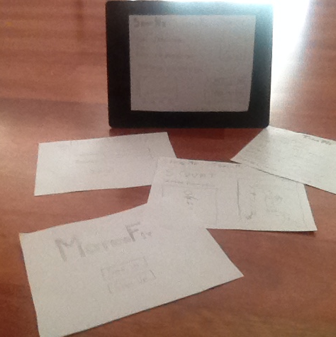Adding this very enhance feature into the product would certainly benefit Ben. He could use it to pin points the places where maybe he is constantly lacking technique and help him to focus on those whilst exercising. The device would show him exactly what the issue is with his technique and assist him on how to solve the issue.

**Figure 6 –** Low-Fidelity prototypes of the software was used to further assist the evaluation of product

**Figure 7 –** Low-fidelity prototype of the Home Screen

## **Extreme Personas**

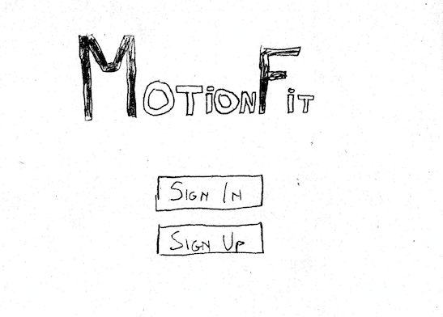When brainstorming extreme personas, I found that the most interesting one to use for the design process was the geek/gamer persona. The geek/gamer is certainly a very interesting extreme persona for this type of product as they would be one of the least likely users of such a product. Stereotypically a geek is usually a gamer and a gamer is usually a geek, so I decided to combine the two into one, combine their characteristics, goals and needs and see what possible solutions would arise from this exercise, their extreme persona is summarised in Figure 4.

Geeks are usually very intelligent and keep to themselves. Furthermore, geeks usually have a particular field of study which they are very interested about and undertake a lot of personal study and research in that area. Geeks are not very sporty as they do not have time for sports and don’t find them amusing. Their free time is otherwise spent on video games, thus arising the correlation between geeks and gamers. Gamers therefore, enjoy playing video games on a regular basis. Most of the time, especially nowadays, the games are conducted online where games from all over the world can compete against each other. Competition and the want to have the most awards and the best score become very important to them.

Using these characteristics and needs of this extreme persona some very interesting ideas arose. Applying the gamification concept to working out at the gym gave me a lot to think about. It was important to ensure the gamification still benefitted the user by providing information about the proper techniques for exercise to minimize injuries.

After some brainstorming for gamification ideas to apply to the product, I concluded that adding some type of scoring system to the technique checker would certainly add some attraction to geeks and games. These scores could then be uploaded and a ladder could be compiled, showing the top scoring users. This would certainly add further motivation to system and also attract geeks and gamers to possibly start using the system and commence working out themselves as now there is a gaming and competition aspect to the system.

# Final Design Solution

The final design of Motion Fit is depicted using both low-fidelity and high-fidelity prototypes as well as story boards. The Motion Fit system contains two major components, the hardware and the software and the prototypes illustrate both these two components whilst the story board demonstrates a user using the system as a whole. In the next section I will discuss the hardware and the software separately and also their integration which ultimately is MotionFit.

## **Hardware**

**Figure 8 –** Low-fidelity prototype of the Sign In Screen

**Figure 9 –** Low-fidelity prototype of the “Show Me” Screen

**Figure 10 –** Low-fidelity prototype of the “Teach Me” Screen

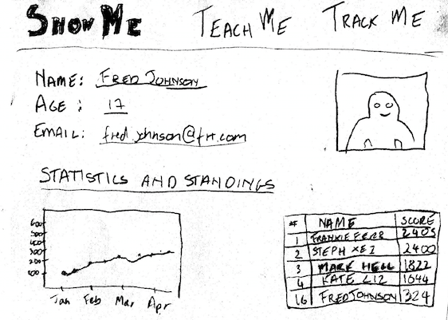The hardware component of the MotionFit system consists of two major subsystems, the device and the sensors. The device is of similar structure to a tablet, as shown in the Figure 5. The device contains a 7 inch LCD touch screen with which a user can use interact with the software. The LCD screen allows input from the user via the touch capabilities and the LCD outputs the information to the user.

The device also has a speaker, located in the upper left hand corner. This speaker is used to output information to the user through audio. The user will be able to control the volume via the buttons located on the side of the device on the left of the device. The power button is located on the top of the device on the right hand side. The battery charger port is located behind the device and a stand is also present at the back of the device to keep the device stable. This stand can then be folded back into the device for easy carriage and storage.

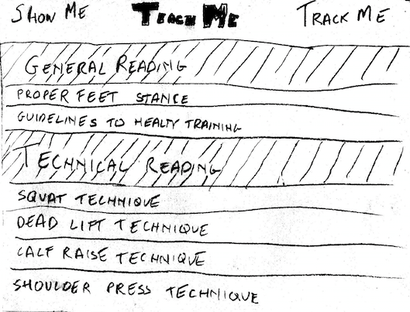A major part of the device is the sensor reader and this is located on top of the LCD screen. The sensor reader is responsible for tracking the sensors and receiving data from the sensors as the user moves, thus tracking the movements of the user.

The second subsystem of the hardware component of MotionFit are the sensors. The sensors are the part of the system which the user would attach to the body and would track the movements of the user by sending the information to the device. The sensors are attached to a string which you wrap around the specific parts of the body – arms, legs, waist and so on. The sensors themselves are state of the art infrared sensors.

## **Software**

The software component of the MotionFit is the application which runs on the MotionFit device. As was mentioned previously, the application receives input from the touch screen as well as the sensor reader and displays the output to the user through the LCD screen as well as through the speaker as audio.

The application is started when the power is supplied to the device, and this is done through pressing the power button. Once started the device will start to boot up the application and the LCD screen will display the home screen. Paper drawing of the screens were used as low-fidelity prototypes and they are illustrated being used in Figure 6 and Figure 7 to 11 contain full size images of the low fidelity prototype screens for the application.

The home screen allows the user to log in to the system, connecting them to our server for competition purposes as a result of the gamification applied to the product. Once logged in the user will see a screen detailing his details as well as his current statistics and performance. A top bar is present showing what is called “The Three Me’s”, these are “Show Me”, “Teach Me” and “Track Me”.

“Show Me” links to the page that was mentioned previously which displays the details of the user along with their statistics. “Teach Me” on the other hand links to a page which lists out a lot of articles about good technique in general as well as articles which are specific to one type of exercise. “Track Me” links to a page which allows the user to tell the device to track their movements. It will list out all the exercises by categories and upon clicking a specific exercise, the user will be shown a video of the correct form for the exercise and will also inform the user on where to position each sensor to allow for best reading of their movements upon undertaking the exercise.

## **Integration – MotionFit**

**Figure 11 -** Low-fidelity prototype of the “Track Me” Screen

**Figure 12 –** Storyboard was used to help understand a particular situation for users of MotionFit

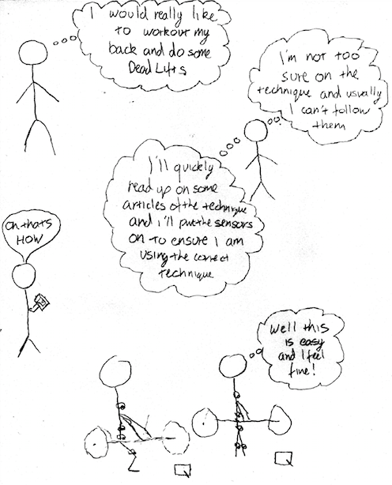Integrating both the hardware and the software components is the complete product of MotionFit. Figure 12 displays a storyboard of a user using the MotionFit system in their workout routine. The system does not need to be connected to power as it contains a battery which can be charged at home before going to the gym. The user can use device to see their progress, learn more information or undertake their exercise routine with MotionFit tracking their movements. The device can then inform the user on their technique and educate them on how to improve it. Their statistics are stored and sent to the server for competition purposes, allow users to compete against each other and gain different awards for outstanding technique.

# Evaluation

Participation based evaluation, specifically usability testing, was used to evaluate MotionFit and see how potential users view this product in terms of its functionality, its usability and their experience whilst using it.

Two activities were chosen for the users to undertake for the evaluation. The first activity was working out at home where the user is the only person working out. On the other hand, the second activity was using MotionFit at the gym, with other people around who are also working out.

What was found was that the majority of the users found the functionality of the system very neat and effective. They found the navigation through the system to be very intuitive and that was really appreciated as they found that this removed the need for them to have to read a manual to find out how to use the system. However, they found that the usability and experience of using MotionFit was much greater and better at home. This is because, especially at the beginning, undertaking an exercise with MotionFit takes a long time as one needs to set up the system which includes placing the sensors correctly and position the device in a way for the user to be able to view the screen and the sensor reader to be able to read the tracking information effectively. This also requires more space and at the gym that is sometimes not possible.

It was found that MotionFit requires time and space and thus is much more suited for the home. When undertaking a workout at home, the users do not need to worry about how much space they are taking up and how much time they are taking, unfortunately this is not the same for the gym. However, many said that once they became familiar with the device, they would feel comfortable to take it to the gym as they would be able to eliminate the time factor as they will know how to set up the system much quicker.

# Conclusion

The MotionFit system is like no other, it provides information, education and motivation to any user. It can help any user to reach their dream body without the fear of injury, enticing them to commence or continue working out, as well as ensuring their continual attendance at the gym.