My Contribution
----------------------
Being a part of the Testing And Measure Sub group, my main contribution, along with Carl, was in implementing the functions to run this TAM system. Carl and I wrote the various low functions to run the TAM. These functions include instructing the TAM to lower and raise the arm as well as reading colour and determining whether the piece was metallic or not. I spent a bit more time perfecting these low level functions, especially the movement ones, as they were the core of the functions needed to run the TAM. I added checks to only perform a certain task if it was needed. That means that if the arm is lowered and there is a call to lower the arm, it will not execute any code as the check will simply cause the function to return. Furthermore and more importantly was the implementation of waiting for an action to be finished before terminating the function. That means that when there is a call to for example the function to raise the height sensor, after the command is given to the TAM to raise the height sensor, the function does not end until the TAM states that the height sensor is successfully raised. Furthermore, I took a major part in implementing the uCOS-|| multitasking. I implemented the ButtonWatch task as well the TAMRunner task.

Integration
-------------
Integration played a major part in the success of the program. The three different subsytems of the system are listed below:

- The Rabbit 4000
- The LCD Screen
- The Test And Measure (TAM) FESTO Station

These subsystems needed to interface with each other in order to communicate effecitvely with each other. The diagram below shows a top view diagram of the integration between these two subsystems.

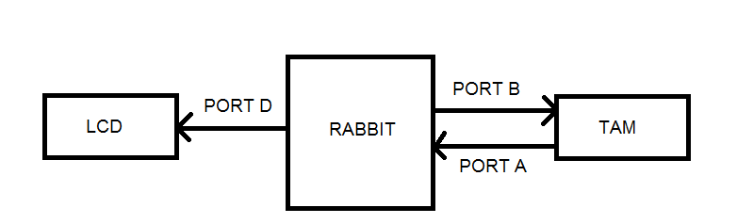
As shown in the diagram above the connection between the Rabbit and the LCD was done using Port D. This port was used to write commands and data to the LCD screen. On the other hand, both Port A and Port B were used to interface the Rabbit with the TAM. Port A was used to read information from the TAM, for example the output from the colour sensor. Port B on the other hand was used to write commands to the TAM, by setting particular bits on or off.

In order to run both the TAM and the LCD simultaneously off the RTOS of the Rabbit, it was necessary to implement using multitasking techniques. As a group we decided to do so using μcOS-II pre-emptive multitasking kernel.
We had three tasks that run different part of the system and these are: ButtonWatch, TAMRunner and MenuManager.

ButtonWatch watches and waits for a button to be pressed to either start or stop the TAM. When the stop button is pressed a flag is set to tell the TAM to stop. When the start button is pressed the TAM is started up again and the flag is then reset to false.
TAMRunner runs the TAM, constantly waiting for an object to be present and once it is, to test it, store the results and determine whether to accept or reject it. On top of that, TAMRunner is constantly checking to see if the flag is set to terminate itself.

MenuManager runs the different menus on the LCD screen, taking input from the user and outputting the requested information depending on the user's input.

These tasks need to run simultaneously and using the μcOS-II pre-emptive multitasking kernel of the Rabbit. Furthermore, these tasks need to share resources in order to achieve the requirements. The resources include the settings and the queue.

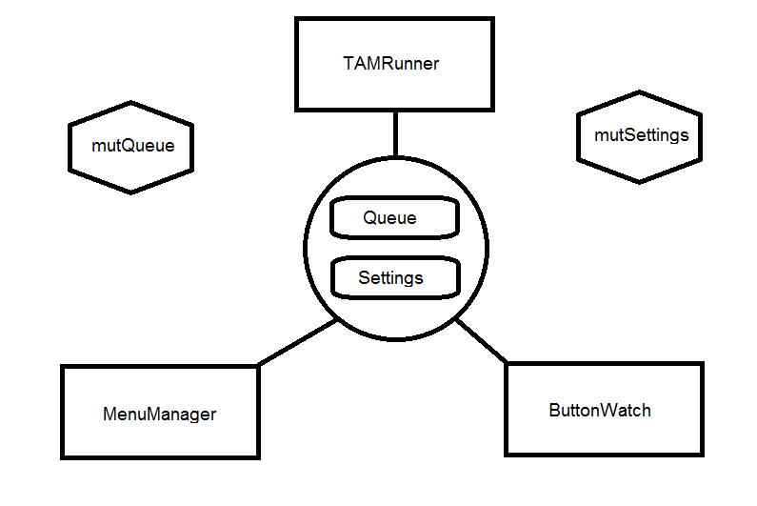
The diagram above shows the three tasks as squares along with the two global variables inside the circle, Queue and Settings, which they all share.

In order to ensure mutual exclusion when reading and writing to these shared resources, it was necessary to include two mutexes. The two mutexes are displayed in the diagram as hexagons and they are labeled mutQueue and mutSettings. Each shared resource had its own mutex. In order for a task to either read or write to these resources, a request was made to pend the respective mutex. The request was made with a timeout set to 0. Setting the timeout to 0 ensured that the particular task who requested the mutex would wait forever until a post was called on the mutex by the task who had pended the mutex. In doing so we had to ensure no deadlock situation would occur. This was achieved by ensuring that a task would not pend both mutexes at one given time and that mutexes were posted as soon as possible.

Mutexes were used instead of semaphores due to the fact that we required mutual exclusion. This implied that only one task can read or write to the shared resource at one given time. Furthermore, the priorities given to the mutexes were greater then those given to the tasks. This assisted the flow of the program as pending a mutex resulted in that task inheriting the mutex's priority and therefore, running more frequently and for longer period than the other tasks. This was a big aid in avoiding deadlocks and also to minimise wait time.

