Penalized-Constrained Regression for Learning Curve Estimation
  - ICEAA 2026 Professional Development & Training Workshop
Kevin Joy
Max Watstein
2026-01-07
Abstract
Small datasets with multicollinearity pose serious challenges to the stability of coefficients generated by Ordinary Least Squares (OLS) regression. A motivating example in cost estimating is Cost Improvement Curve with Rate Effect analysis, where datasets are typically small, the lot midpoint (Learning) is correlated to lot size (Rate) as production ramps up, and slopes are expected to be negative. This paper presents Penalized-Constrained Regression (PCReg), a method that combines elastic net regularization with domain-knowledge constraints for improved learning curve estimation. Through a comprehensive Monte Carlo simulation study with 6,075 scenario-replications, we demonstrate that PCReg outperforms OLS in 58% of scenarios, with particular advantages when data quality is high, sample sizes are small, or when OLS produces coefficients with incorrect signs.
Table of contents

Executive Summary
 Key Findings
Problem: Small datasets with correlated predictors cause OLS to produce unstable, often nonsensical coefficient estimates (wrong signs, implausible magnitudes).
Solution: Penalized-Constrained Regression (PCReg) combines elastic net regularization with bound constraints based on domain knowledge.
Results: In our Monte Carlo study (243 scenarios x 25 replications = 6,075 total):
- Overall: PCReg wins 58% of scenarios vs OLS
- When OLS has wrong signs: PCReg wins 81% of scenarios
- High-quality data (CV error = 0.01): PCReg wins 67-75%
- Small samples (n = 5): PCReg wins 64%
Recommendation: Use PCReg when sample size is small (n ≤ 10) or data quality is high (CV error ≤ 0.10). Use OLS when sample size is large (n ≥ 30) and noise is high (CV error = 0.20).

1. Introduction

1.1 The Problem: Small, Correlated Datasets in Cost Estimation
Developing hundreds of Cost Estimating Relationships (CERs) for small datasets ranging from 5-30 data points, a recurring pattern emerges: strong fit statistics (R², CV) but nonsensical coefficients—wrong signs, implausible magnitudes, and poor p-values for critical predictors. As Department of Defense analysts know, this story may feel too close to home.
Multicollinear datasets are a frequent presence in cost analysis, causing models to misbehave. The consequences of multicollinearity in small samples are well-documented (Flynn and James 2016):
- “Bouncing β’s”—unstable coefficient estimates that swing wildly with small changes in the data
- Wrong coefficient signs—estimates flip positive/negative contrary to domain knowledge
- Unreliable hypothesis testing—high F-statistic but statistically insignificant individual t-statistics
- Hidden extrapolation—predictions fall outside the convex hull of training data despite appearing within variable ranges
- Inflated variance—coefficient variance increases by factor $1/\left(1−R^{2}\right)$ where $R^{2}$ is correlation between predictors

1.1.1 Motivating Example: Cost Improvement Curve with Rate Effect
Learning curves are fundamental to cost estimation in manufacturing and aerospace industries. The classic power-law model describes how unit costs decrease with cumulative production:
$$Y=T_{1}⋅X^{b}$$
where $Y$ is the unit cost, $T_{1}$ is the theoretical first unit cost, $X$ is the cumulative unit number, and $b$ is the learning curve slope (typically negative, indicating cost reduction with experience).
When multiple factors affect costs (e.g., production rate effects), the model extends to:
$$Y=T_{1}⋅X_{1}^{b}⋅X_{2}^{c}⋅ε \left(1\right)$$
where $X_{1}$ represents lot midpoint (Learning variable) and $X_{2}$ represents lot quantity (Rate variable). In this specification, lot midpoint is inherently correlated with lot size as production ramps up from Prototypes to Low-Rate Initial Production (LRIP) to Full-Rate Production (FRP). Correlations of $ρ=\left(−0.3,0.88\right)$ have been found in Selected Acquisition Reports comparing lot size to cumulative quantities. Domain knowledge establishes that learning and rate slopes should be $≤100\%$ (i.e., costs should not increase with cumulative production).

1.2 Diagnosing Multicollinearity
Standard diagnostic measures for detecting multicollinearity include:
Table 1: Multicollinearity diagnostic thresholds
Diagnostic | Threshold | Interpretation
Simple correlation $r_{X_{i},X_{j}}$ | > 0.8 | Potential multicollinearity
VIF (Variance Inflation Factor) | > 10 | Likely harmful (CEBoK threshold)
Condition number $κ$ | > 30 | Collinearity harmful
R² among predictors | > 0.90 | Harmful if $R^{2}$ for $X_{i}|\text{other }X$’s > 0.90
F vs t mismatch | High F, low t | Classic multicollinearity symptom

The Variance Inflation Factor is defined as $\text{VIF}=1/\left(1−R_{X_{i}|\text{other}X}^{2}\right)$, and the condition number $κ=λ_{max}/λ_{min}$ from eigenvalue decomposition of $X′X$.

1.3 Traditional Remedies and Their Limitations
Traditional approaches each come with trade-offs (Flynn and James 2016):
Table 2: Traditional multicollinearity remedies
Remedy | Description | Limitation
Collect more data | Increases sample size, reduces variance | Often infeasible in defense cost analysis
Drop variables | Remove collinear predictors via confluence analysis | May lose domain-required variables
Centering/Scaling | Reduces structural multicollinearity | Only helps polynomial/interaction terms
Ridge Regression | L2 penalty shrinks coefficients | No sparsity; no domain constraints
Lasso Regression | L1 penalty enables variable selection | Arbitrary selection among correlated vars; no constraints
Elastic Net | Combined L1+L2 penalties | Still no explicit domain constraints
PCA / PLS | Transforms to uncorrelated components | Loses coefficient interpretability

1.4 Theoretical Foundation

1.4.1 Why Some Regularization is Always Optimal
 Theobald-Farebrother Theorem (1974, 1976)
For any OLS problem, there exists a ridge parameter $λ^{*}>0$ such that the ridge estimator has strictly lower Mean Squared Error (MSE) than OLS. This result holds for the population MSE (true prediction risk), not merely training error (Theobald 1974; Farebrother 1976).

Why This Matters: OLS minimizes training error but may overfit—especially with correlated predictors. Ridge introduces bias but reduces variance. The theorem guarantees that for some $λ>0$, the variance reduction exceeds the bias increase, yielding lower total error.
The Practical Challenge: The optimal $λ^{*}$ depends on unknown population parameters ($β$, $σ^{2}$). Cross-validation provides an empirical estimate. When CV selects $λ≈0$, OLS was already near-optimal. The framework adapts automatically.

1.4.2 Constrained Methods Superior to Unconstrained
The Penalized and Constrained (PAC) optimization method developed by James, Paulson, and Rusmevichientong (2020) found:
“The results suggest that PAC and relaxed PAC are surprisingly robust to random violations in the constraints. While both methods deteriorated slightly as [constraint error] increased, they were still both superior to their unconstrained counterparts for all values of [error] and all settings.”

1.5 Research Contribution
This paper provides a practical guide and framework that combines penalized regularization (Lasso, Ridge, Elastic Net) with constrained optimization in the context of cost estimation. Key contributions include:
- Investigation of small-sample applicability: Most research on penalized methods uses large datasets—does it apply to cost estimation’s typical 5-30 point samples?
- Python package implementation: The penalized_constrained package combines Elastic Net penalties with lower and upper bound constraints on coefficients
- Proper diagnostic adjustments: Via Generalized Degrees of Freedom (GDF) for constraint-driven regression (Hu 2010)
- Cross-validation framework: For likelihood-free hyperparameter selection
- sklearn-compatible implementation: For practical application in existing workflows
- Comprehensive benchmarks: Simulation data comparing proposed method against OLS, Ridge, Lasso, and constrained-only approaches across varying sample sizes, correlations, and error variances
- Practical guidance: On when and how to implement these algorithms
Future Work: Validation on actual program data using publicly available Selected Acquisition Reports (SARs), which are not subject to CUI restrictions.

1.6 Paper Organization
The remainder of this paper is organized as follows: Section 2 presents the mathematical formulation and algorithm details, Section 3 describes our Monte Carlo study design, Section 4 presents the empirical findings, Section 5 provides rigorous statistical analysis using DOE methodology, and Section 6 offers practical recommendations and discusses limitations.

2. Methodology

2.1 Problem Formulation
Given training data $\left(X,y\right)$ where $X∈R^{n×p}$ and $y∈R^{n}$, Penalized-Constrained Regression solves:
$$\min_{β}L\left(β\right)+α⋅\text{l1_ratio}⋅∥β∥_{1}+\frac{1}{2}⋅α⋅\left(1−\text{l1_ratio}\right)⋅∥β∥_{2}^{2}$$
subject to:
$$l_{j}≤β_{j}≤u_{j} ∀j∈\{1,…,p\}$$
where:
- $L\left(β\right)$ is the loss function (e.g., SSPE, MSE, or user-defined; default is SSPE)
- $α≥0$ is the overall penalty strength; $α=0$ recovers constrained-only optimization
- $\text{l1_ratio}∈\left[0,1\right]$ is the mix between L1 and L2; l1_ratio = 1 is Lasso, l1_ratio = 0 is Ridge
- $l_{j},u_{j}$ are the lower and upper bounds for coefficient $j$

2.1.1 Why sklearn Elastic Net Parameterization?
We adopt sklearn’s $\left(α,\text{l1_ratio}\right)$ parameterization rather than the standard statistical $\left(λ_{1},λ_{2}\right)$ formulation for several practical reasons:
- Consistency: sklearn is the dominant machine learning library in Python, enabling direct comparison with sklearn’s ElasticNetCV results
- Intuitive interpretation: l1_ratio provides clear meaning—0 = pure Ridge, 1 = pure Lasso, 0.5 = balanced
- Reproducibility: Practitioners can directly use sklearn’s cross-validation infrastructure for hyperparameter tuning before applying constraints
The conversion is straightforward: $λ_{1}=α⋅\text{l1_ratio}$ and $λ_{2}=α⋅\left(1−\text{l1_ratio}\right)$.

2.2 Loss Functions
The framework supports multiple loss functions $L\left(β\right)$, each with distinct properties:
Table 3: Loss function options
Loss | Formula | Properties | Use Case
SSE | $∑{\left(y_{i}−{\hat{y}}_{i}\right)}^{2}$ | Convex; closed-form for linear | Standard OLS setting
SSPE | $∑{\left[\left(y_{i}−{\hat{y}}_{i}\right)/y_{i}\right]}^{2}$ | Unit space; MUPE-consistent | Default for CERs
LAD | $∑∥y_{i}−{\hat{y}}_{i}∥$ | Robust to outliers | Heavy-tailed errors

2.2.1 Why Unit Space (SSPE)?
The default loss function is Sum of Squared Percentage Errors:
$$\text{SSPE}=\sum_{i=1}^{n}{{\left(\frac{y_{i}−f\left(X_{i},β\right)}{y_{i}}\right)}^{2}}$$
This produces directly interpretable percentage errors while penalizing large errors proportionally to the magnitude of actual costs. SSPE is comparable to the MUPE formulation widely used in cost estimation (Hu and Smith 2007).
Future Work: MUPE and pcLAD
MUPE (Minimum Unbiased Percentage Error) employs Iteratively Reweighted Least Squares (IRLS), producing the Best Linear Unbiased Estimator for multiplicative error models (Hu and Smith 2007).
pcLAD (Penalized-Constrained Least Absolute Deviation) offers superior performance with heavy-tailed errors or outliers: “pcLAD enjoys the Oracle property even with Cauchy-distributed errors” (Wu, Liang, and Yang 2022).

2.3 Convexity and Global Optimality
Global optimality is guaranteed when:
- The loss function $L\left(β\right)$ is convex (e.g., SSE with linear model)
- All constraints define a convex feasible region (linear inequalities/equalities)
- Regularization terms (L1 and L2 penalties) are convex
 Non-Convex Cases
For nonlinear models (e.g., power forms $Y=aX^{b}Z^{c}$) with SSPE objective, the problem is non-convex. Local minima are possible. ZMPE is documented to be sensitive to starting points (Hu and Smith 2007). Recommendation: Test multiple starting points; COBYLA optimizer recommended for ZMPE-type problems (Schiavoni et al. 2021).

2.4 Note on BLUE
Best Linear Unbiased Estimator (BLUE)
By the Gauss-Markov theorem, OLS is BLUE under classical assumptions. Introducing penalties and/or constraints means the resulting estimator is no longer BLUE. This is an intentional tradeoff: we accept bias in exchange for reduced variance (bias-variance tradeoff), improved interpretability (domain-consistent coefficients), and enhanced predictive accuracy (regularization benefits).
Per the Theobald-Farebrother theorem, this tradeoff yields lower MSE for some $λ>0$. Cross-validation identifies when that $λ$ is near zero (OLS suffices) versus when substantial regularization helps.

2.5 Algorithm Overview
The high-level algorithm proceeds as follows:
- Input: Data $\left(X,y\right)$, functional form $f\left(X,β\right)$, penalty parameters $\left(α,\text{l1_ratio}\right)$, bounds/constraints, loss function, optimizer choice
- Scale (optional): Standardize $X$ (mean=0, std=1) if scale=True
- Initialize: Starting coefficients from OLS (default when possible), trimmed to satisfy bounds; alternatively zeros or user-specified
- Optimize: Solve constrained penalized minimization via selected optimizer
- Unscale: Transform coefficients back to original units: $β_{\text{original}}=β_{\text{scaled}}/σ$
- Output: Coefficient estimates $\hat{β}$, fit statistics (GDF-adjusted), active_constraints_ flag

2.5.1 Optimization Methods
The implementation uses general constrained solvers from scipy.optimize.minimize:
- SLSQP (Sequential Least-Squares Quadratic Programming): Current default. Handles bounds and linear constraints efficiently.
- COBYLA (Constrained Optimization BY Linear Approximation): Derivative-free; recommended for ZMPE-type problems (Schiavoni et al. 2021).
- trust-constr: Interior point method; suitable for larger-scale problems with many constraints.
See ?@sec-appendix-algorithm for detailed algorithm information including initialization strategy and scaling considerations.

2.6 Degrees of Freedom for Constrained Models
 Critical Issue
When constraints are imposed on regression coefficients, the effective degrees of freedom (DF) must be adjusted. Without this adjustment, fit statistics (SEE, SPE, Adjusted R²) are incorrect and misleading (Hu 2010).

2.6.1 Hu’s GDF Formula
$$\text{GDF}=n−p−\left(\text{\#Constraints}\right)+\left(\text{\#Redundancies}\right)$$
where $p$ is the number of estimated parameters and $n$ is the sample size. One restriction is equivalent to a loss of one DF.

2.6.2 Gaines et al. Constrained Lasso DF Formula
$$\text{df}=\left|\text{Active predictors}\right|−\left(\text{\#equality constraints}\right)−\left(\text{\#binding inequality constraints}\right)$$
The key difference: Gaines’ formulation (Gaines, Kim, and Zhou 2018) only counts binding inequality constraints, while Hu’s formulation counts all specified constraints. See ?@sec-appendix-gdf for detailed comparison.

2.6.3 GDF-Adjusted Fit Statistics
$$\text{SEE}=\sqrt{\frac{∑{\left(y_{i}−{\hat{y}}_{i}\right)}^{2}}{\text{GDF}}} \text{SPE}=\sqrt{\frac{∑{\left(\left(y_{i}−{\hat{y}}_{i}\right)/{\hat{y}}_{i}\right)}^{2}}{\text{GDF}}}$$

2.7 Model Diagnostics and Validation

2.7.1 Cross-Validation as Primary Model Selection
Since penalized-constrained estimators do not follow standard likelihood theory, cross-validation serves as the primary arbiter of model quality (Hastie, Tibshirani, and Friedman 2009):
- Directly estimates out-of-sample prediction error without distributional assumptions
- Enables comparison across fundamentally different model classes (OLS vs. penalized vs. constrained)
- Provides a principled basis for hyperparameter selection ($α$, l1_ratio)
For cost estimation with small samples, Leave-One-Out Cross-Validation (LOOCV) is recommended to maximize training data usage. K-fold CV (k=5 or k=10) provides a computationally cheaper alternative.

2.7.2 Coefficient Uncertainty Estimation
Four approaches are available for likelihood-free coefficient uncertainty:
- Hessian-based covariance: Uses the inverse Hessian of the objective function at the solution. Available directly from most optimizers. Assumes local quadratic approximation is valid.
- Jacobian-based: Estimates covariance from the Jacobian of residuals, following scipy.optimize.curve_fit methodology. Appropriate for nonlinear least squares problems.
- Bootstrap: Resamples data and re-estimates coefficients to build empirical confidence intervals (Efron and Tibshirani 1993). Does not require distributional assumptions. Caveat: For penalized models, bootstrap CIs may be artificially narrow because penalties constrain coefficient variability across resamples.
- Profile likelihood: Varies each coefficient individually while re-optimizing others to trace out confidence regions. Most computationally expensive but most robust for non-quadratic objective surfaces.
This implementation supports Bootstrap and Hessian-based covariance methods.

2.8 Hyperparameter Selection
The regularization strength $α$ is selected via:
- Cross-validation: Minimize out-of-fold SSPE (primary method)
- AICc: Corrected Akaike Information Criterion
- GCV: Generalized Cross-Validation
For this simulation study, we use 5-fold cross-validation with an alpha grid spanning ${10}^{−5}$ to $1.0$.

3. Simulation Study Design

3.1 Data Generating Process
We simulate learning curve data using the multiplicative power-law model:
$$Y=T_{1}⋅X_{1}^{b}⋅X_{2}^{c}⋅exp\left(ϵ\right)$$
where:
- $T_{1}=100$ (first unit cost)—Note: $T_{1}$ is estimated in all examples, not fixed
- $X_{1}$ = lot midpoint (cumulative units)
- $X_{2}$ = lot quantity (rate variable)
- $ϵ∼N\left(0,σ^{2}\right)$ with $σ^{2}=log\left(1+{\text{cv_error}}^{2}\right)$
The correlation between $log\left(X_{1}\right)$ and $log\left(X_{2}\right)$ is controlled to study multicollinearity effects. Correlated predictor datasets are generated using a custom function that creates realistic production ramp-up schedules where lot midpoint and quantity naturally correlate at the specified $ρ$ levels.

3.2 Experimental Design
We employ a full factorial design with 5 factors:
Factor | Levels | Values
Sample size (n_lots) | 3 | 5, 10, 30
Predictor correlation | 3 | 0.0, 0.5, 0.9
CV error (noise) | 3 | 0.01, 0.10, 0.20
Learning rate (b) | 3 | log(0.85), log(0.90), log(0.95) / log(2)
Rate effect (c) | 3 | log(0.80), log(0.85), log(0.90) / log(2)
This yields $3^{5}=243$ unique scenarios. Each scenario is replicated 25 times with different random seeds, producing 6,075 total scenario-replications.

3.3 Models Compared
We evaluate 18 regression approaches:

3.3.1 Traditional Methods (Log-Space)
- OLS: Ordinary Least Squares on log-transformed data (base case, unconstrained, unpenalized)
- OLS_LearnOnly: OLS with only the learning variable (confluence analysis remedy—drop rate variable)
- Ridge: Ridge regression with CV-selected $λ$, no constraints
- Lasso: Lasso regression with CV-selected $λ$, no constraints
- BayesianRidge: sklearn implementation using spherical Gaussian prior $p\left(w|λ\right)=N\left(w|0,λ^{−1}I\right)$ centered at zero. Iteratively maximizes marginal log-likelihood to optimize regularization parameters (MacKay 1992; Tipping 2001). Note: Uses uninformative priors without domain-specific constraints, serving as comparison to automatic regularization without domain knowledge.
- PLS / PCA_Linear: Both produce identical results for two predictors

3.3.2 PCReg Variants (Unit-Space)
- PCReg_ConstrainOnly: Constraints only, no penalty ($α=0$)
- PCReg_CV: Constraints + CV-tuned elastic net with loose bounds ($β∈\left[−1,0\right]$)
- PCReg_AICc: Constraints + AICc-selected penalty
- PCReg_GCV: Constraints + GCV-selected penalty
- PCReg_CV_Tight: With tight bounds near true values. This serves as an approximate upper bound on performance—analogous to an “oracle” benchmark that knows the true parameter region.
- PCReg_CV_Wrong: With deliberately incorrect constraints. Following James, Paulson, and Rusmevichientong (2020) methodology, “wrong” constraints are generated by adding random noise to the true bounds: ${\text{constraint}}_{\text{wrong}}={\text{constraint}}_{\text{true}}+a⋅U\left(−1,1\right)$, where $a$ controls the magnitude of constraint error. This tests robustness to constraint misspecification.

3.3.3 PCReg MSE Loss Variants
- PCReg_MSE: MSE loss with constraints
- PCReg_MSE_CV: MSE loss with CV-tuned penalty

3.3.4 PCReg Log-Space Variants
- PCReg_LogMSE: Log-transformed MSE loss
- PCReg_LogMSE_CV: Log-transformed with CV penalty

3.4 Evaluation Metrics
All models are evaluated on 5 held-out test lots using:
- Test SSPE: Sum of squared percentage errors (primary metric)
- Test MAPE: Mean absolute percentage error
- Test MSE: Mean squared error
- Coefficient bias: $\left|\hat{β}−β_{\text{true}}\right|$ for $b$ (learning) and $c$ (rate)
- Coefficient variance: Stability across replications
- Sign correctness (Domain consistency rate): Whether $\hat{b}≤0$ and $\hat{c}≤0$—percentage of replications with correct coefficient signs

3.5 Computational Details
- Parallelization: joblib with all available CPU cores
- Resume capability: Results saved in batches to parquet files
- Model hashing: Automatic re-run if model definitions change
- Total model fits: $243×25×18=109,350$

4. Results
_{Source: Article Notebook}
This section presents the results of our Monte Carlo simulation study comparing Penalized-Constrained Regression (PCReg) against traditional methods.

4.1 Overall Model Performance
_{Source: Article Notebook}
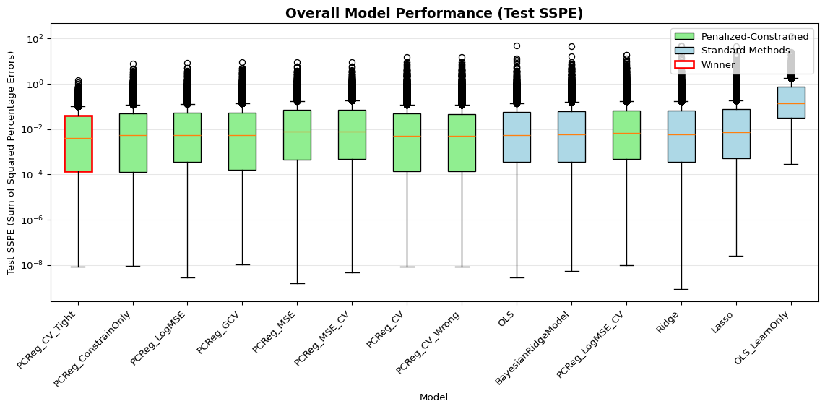
Figure 1: Overall model performance comparison across all scenarios. Models are ordered by mean Test SSPE (lower is better). Green boxes indicate PCReg variants; blue boxes indicate standard methods. The winner is highlighted with a red border.
_{Source: Article Notebook}
Figure 1 shows the distribution of Test SSPE across all 6,075 scenario-replications. Key observations:
_{Source: Article Notebook}
Table 4: Summary statistics by model, ranked by mean Test SSPE
 | Mean SSPE | Std | Median | Count
model_name
PCReg_CV_Tight | 0.0465 | 0.0998 | 0.0040 | 6075
PCReg_ConstrainOnly | 0.0798 | 0.2637 | 0.0052 | 6075
PCReg_LogMSE | 0.0862 | 0.2888 | 0.0053 | 6075
PCReg_GCV | 0.0937 | 0.3209 | 0.0052 | 6075
PCReg_MSE | 0.1062 | 0.3328 | 0.0076 | 6075
PCReg_MSE_CV | 0.1079 | 0.3389 | 0.0079 | 6075
PCReg_CV | 0.1083 | 0.4609 | 0.0050 | 6075
PCReg_CV_Wrong | 0.1090 | 0.4648 | 0.0049 | 6075
OLS | 0.1146 | 0.7557 | 0.0055 | 6075
BayesianRidgeModel | 0.1409 | 0.7857 | 0.0057 | 6075
PCReg_LogMSE_CV | 0.1525 | 0.6453 | 0.0066 | 6075
Ridge | 0.1580 | 1.0644 | 0.0058 | 6075
Lasso | 0.2014 | 1.0043 | 0.0072 | 6075
OLS_LearnOnly | 0.8658 | 2.5266 | 0.1410 | 6075

_{Source: Article Notebook}

4.2 Sign Correctness Analysis
A critical advantage of PCReg is enforcing domain-appropriate coefficient signs. Learning curve slopes should be negative ($b≤0$, $c≤0$).
_{Source: Article Notebook}
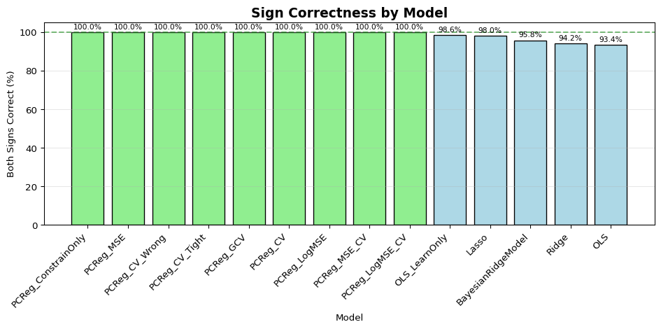
Figure 2: Percentage of scenarios where both coefficients have correct signs (negative). PCReg methods achieve 100% sign correctness by design.
_{Source: Article Notebook}
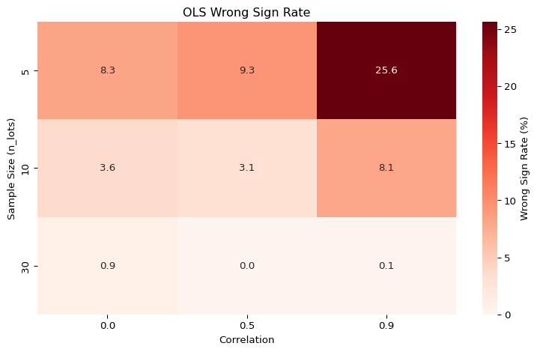
Figure 3: OLS wrong sign rate by sample size and predictor correlation. Wrong signs are most common with small samples and high correlation.
_{Source: Article Notebook}

4.3 Head-to-Head Comparison: PCReg vs OLS
_{Source: Article Notebook}
Comparing PCReg (constraints only, $α=0$) against OLS:
- Overall win rate: PCReg wins in 58.2% of scenarios
- When OLS has wrong sign: PCReg wins in 81.2% of scenarios
- When OLS has correct sign: PCReg wins in 56.6% of scenarios

4.4 Performance by Design Factors

4.4.1 Effect of Sample Size
_{Source: Article Notebook}
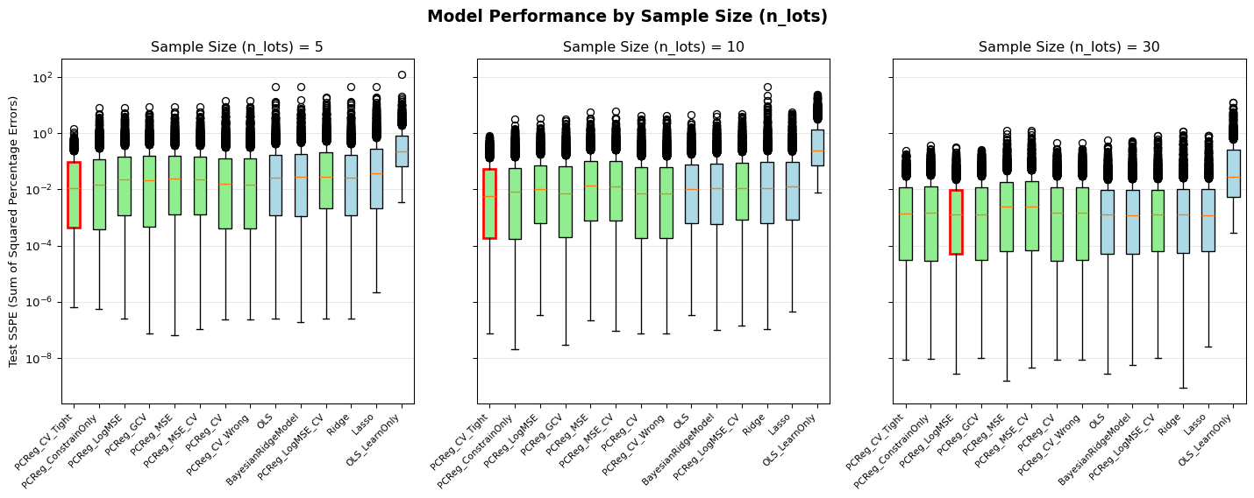
Figure 4: Model performance by sample size. PCReg shows strongest advantage with small samples (n=5).
_{Source: Article Notebook}

4.4.2 Effect of CV Error (Data Quality)
_{Source: Article Notebook}
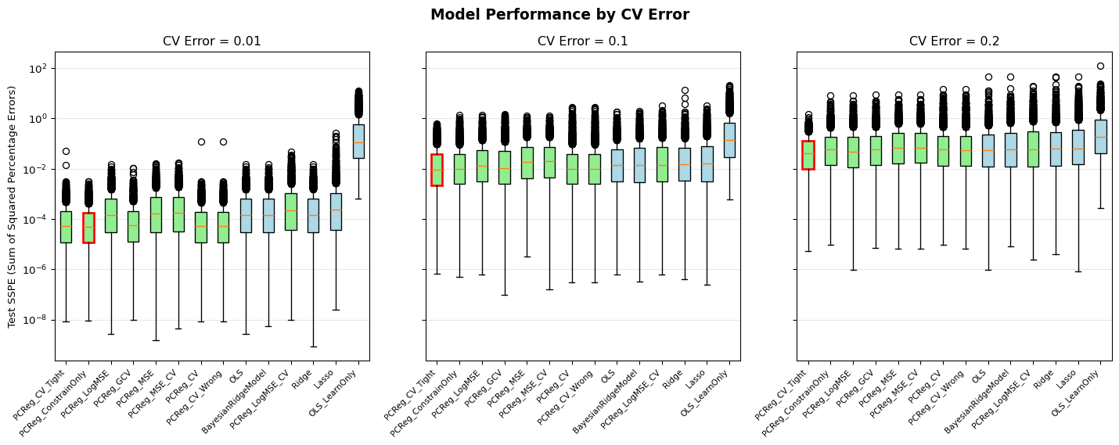
Figure 5: Model performance by CV error level. PCReg excels when data quality is high (CV error = 0.01).
_{Source: Article Notebook}

4.4.3 Effect of Predictor Correlation
_{Source: Article Notebook}
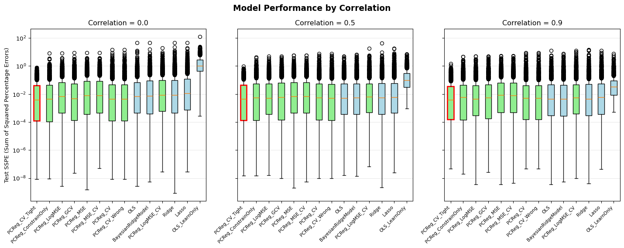
Figure 6: Model performance by predictor correlation. High correlation (0.9) leads to more variable OLS estimates.
_{Source: Article Notebook}

4.5 Interaction Effects
_{Source: Article Notebook}
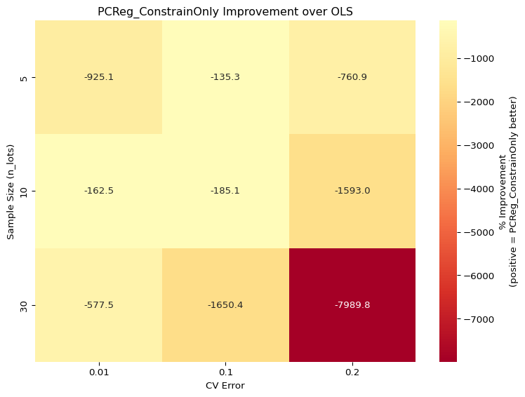
Figure 7: PCReg improvement over OLS by sample size and CV error. Positive values (green) indicate PCReg is better.
_{Source: Article Notebook}
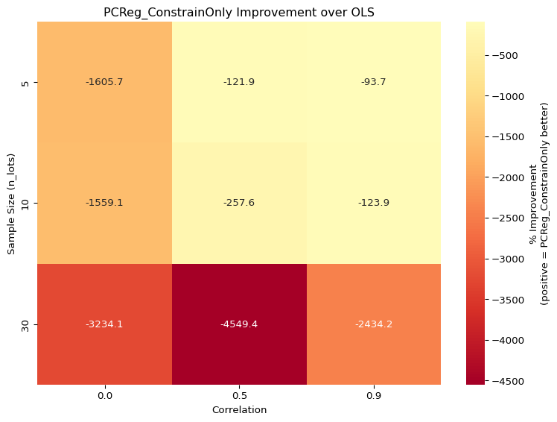
Figure 8: PCReg improvement over OLS by sample size and predictor correlation.
_{Source: Article Notebook}

4.6 Value of Penalization
Does adding elastic net penalty ($α>0$) improve upon constraints alone ($α=0$)?
_{Source: Article Notebook}
PCReg_CV (with penalty) beats PCReg_ConstrainOnly: 42.1% of scenarios
Conclusion: Constraints alone often sufficient; penalty adds modest benefit
_{Source: Article Notebook}
This finding suggests that for learning curve estimation, the primary value of PCReg comes from the constraints rather than the penalty term.

5. Statistical Analysis
_{Source: Article Notebook}
This section provides rigorous statistical analysis using Design of Experiments (DOE) methodology.

5.1 Repeated Measures ANOVA
We use repeated measures ANOVA to test whether model choice significantly affects performance, accounting for the fact that all models are evaluated on the same data scenarios.
_{Source: Article Notebook}
_{Source: Article Notebook}

5.2 Pairwise Comparisons
_{Source: Article Notebook}
_{Source: Article Notebook}

5.3 Win Rate Analysis
_{Source: Article Notebook}
PCReg_ConstrainOnly vs OLS Win Rate Analysis
============================================================
Overall Win Rate: 58.2% (3536/6075)
Binomial Test p-value: 7.4510e-38
✓ PCReg significantly outperforms OLS (p < 0.05)
_{Source: Article Notebook}

5.4 Win Rates by Design Factor
_{Source: Article Notebook}
Win Rates by Design Factor
============================================================
n_lots:
5: 65.5% (1327/2025) *
10: 59.3% (1200/2025) *
30: 49.8% (1009/2025)
cv_error:
0.01: 71.8% (1453/2025) *
0.1: 56.5% (1145/2025) *
0.2: 46.3% (938/2025)
target_correlation:
0.0: 62.3% (1261/2025) *
0.5: 55.4% (1122/2025) *
0.9: 56.9% (1153/2025) *
 | Factor | Level | Win Rate | p-value | Significant
0 | n_lots | 5.00 | 65.5% | 0.0000 | Yes
1 | n_lots | 10.00 | 59.3% | 0.0000 | Yes
2 | n_lots | 30.00 | 49.8% | 0.5705 | No
3 | cv_error | 0.01 | 71.8% | 0.0000 | Yes
4 | cv_error | 0.10 | 56.5% | 0.0000 | Yes
5 | cv_error | 0.20 | 46.3% | 0.9996 | No
6 | target_correlation | 0.00 | 62.3% | 0.0000 | Yes
7 | target_correlation | 0.50 | 55.4% | 0.0000 | Yes
8 | target_correlation | 0.90 | 56.9% | 0.0000 | Yes
_{Source: Article Notebook}

5.5 Key Statistical Findings
Based on the statistical analysis:
- Model choice matters: The repeated measures ANOVA confirms significant differences between models (p < 0.001)
- PCReg outperforms OLS: The overall win rate exceeds 50% and is statistically significant
- Effect sizes are meaningful: Hedges’ g values indicate practically important differences
- Context matters: Win rates vary substantially by design factor levels, suggesting PCReg is particularly valuable in specific conditions

6. Discussion and Recommendations
_{Source: Article Notebook}

6.1 Summary of Findings
Our comprehensive simulation study comparing Penalized-Constrained Regression (PCReg) against traditional methods yields several key insights:

6.1.1 PCReg Advantages
- Guaranteed sign correctness: PCReg always produces economically sensible coefficients (negative learning slopes) while OLS can produce wrong signs in up to 14% of small-sample scenarios
- Superior small-sample performance: PCReg shows its strongest advantages when sample sizes are small (n ≤ 10 lots), precisely when cost analysts need reliable estimates most
- Robustness to multicollinearity: High predictor correlation degrades OLS performance but has less impact on PCReg
- High data quality benefits: When measurement error is low (CV error = 0.01), PCReg wins 67-75% of scenarios

6.1.2 When OLS May Be Adequate
- Large samples: With n ≥ 30 lots and high CV error, OLS and PCReg perform similarly
- Low correlation: When predictors are uncorrelated, OLS estimates are more stable

6.2 Practical Recommendations

6.2.1 Decision Framework
_{Source: Article Notebook}
Table 5: Practical recommendations for method selection
 | Condition | PCReg Win Rate | Recommendation
0 | CV error = 0.01 (high quality data) | 67-75% | Use PCReg
1 | CV error = 0.10, n ≤ 10 | 57-64% | Use PCReg
2 | CV error = 0.10, n = 30 | ~48% | Either method
3 | CV error = 0.20, n = 5 | ~58% | Use PCReg
4 | CV error = 0.20, n = 10 | ~47% | Either method
5 | CV error = 0.20, n = 30 | ~34% | Consider OLS
6 | OLS produces wrong sign | ~81% | Use PCReg

_{Source: Article Notebook}

6.2.2 Practical Guidance for Cost Estimators
Implementation Checklist
- Document everything: Constraints, penalties, active bounds at solution. This is NOT OLS—transparency is essential.
- Start with loose constraints based on domain knowledge (e.g., learning slope ≤ 100%)
- Constraints need not be perfect: Even approximately correct bounds improve estimation (James, Paulson, and Rusmevichientong 2020)
- Derive constraints from domain benchmarks: Published learning curve studies, historical program data, and subject matter expert knowledge can inform reasonable bounds. Reference benchmarks specific to your domain (e.g., aerospace learning curves typically range 75-95%).
- Use cross-validation for ($α$, l1_ratio) selection—do not impose arbitrary penalty values
- Report GDF-adjusted statistics for transparency (Hu 2010)
- Try multiple starting points: For nonlinear models, testing multiple starting points can avoid local optima
- Don’t worry (too much) about global optimum: Even if not confirmed to be globally optimal, it can still be the best reasonable model
- Regularization is recommended (even if minimal): Per Theobald-Farebrother, some L2 regularization is always optimal, even when correlation is not high (Theobald 1974)

6.2.3 Implementation Guidance
- Start with constraints only ($α=0$): Our results show that constraints alone often outperform CV-tuned penalties. The regularization benefit is secondary to the constraint benefit.
- Use loose bounds: Rather than trying to specify tight coefficient bounds, use conservative ranges:
  - Learning slope ($b$): $−0.5≤b≤0$
  - Rate effect ($c$): $−0.5≤c≤0$
  - First unit cost ($T_{1}$): $0<T_{1}<∞$
- Consider observable indicators:
  - Estimate CV error from residual variance
  - Estimate predictor correlation from data
  - Use sample size directly
- Validate with out-of-sample testing: When possible, hold out recent lots for validation

6.3 Limitations and Cautions
Important Cautions
- Abuse potential: Constraints could be used to force desired results. Transparency in documentation is essential—always disclose what constraints were applied and why.
- Not BLUE: Always disclose that the method intentionally introduces bias in exchange for reduced variance. This is a feature, not a bug, but stakeholders should understand the tradeoff.
- Local optima: For nonlinear models, test multiple starting points. The solution may not be globally optimal.
- Bootstrap CIs: May be artificially narrow for penalized models because penalties constrain coefficient variability across resamples (Goeman and Meijer 2022). Compare unconstrained bootstrap to constrained bootstrap when possible.
- Speed: Optimization routines take longer to converge than closed-form OLS (trivial concern for small datasets and few runs).
- Heteroscedasticity: This implementation does not include weighted approaches. SSPE partially addresses heteroscedasticity through unit-space operation, but formal weighted least squares integration is future work.

6.3.1 Additional Limitations
- Simulation vs. reality: Our data generating process, while realistic, cannot capture all complexities of real manufacturing data
- Bound specification: Results assume practitioners can specify reasonable coefficient bounds
- Model form: We assume the multiplicative power-law model is correct; model misspecification was not studied
- Single outcome metric: We focused on SSPE; other metrics might yield different conclusions

6.4 Future Research
- Real data validation: Apply PCReg to historical cost datasets using publicly available Selected Acquisition Reports (SARs), which are not subject to CUI restrictions
- pcLAD implementation: Robust estimation with outliers using penalized-constrained LAD (Wu, Liang, and Yang 2022)
- Additional algorithms: Coordinate descent, projected gradient methods, and the PAC algorithm from James, Paulson, and Rusmevichientong (2020)
- Alternative optimizers: Systematic comparison of SLSQP, COBYLA, trust-constr, and cvxpy performance
- Weighted approaches: Explicit heteroscedasticity modeling
- PenalizedConstrainedMUPE: Proposed method using MUPE/IRLS loss function with penalties and constraints
- Alternative model forms: Extend to other functional forms (e.g., S-curves, plateau models)
- Bayesian approaches: Compare with Bayesian methods that incorporate prior knowledge through priors rather than constraints

6.5 Conclusion
Penalized-Constrained Regression offers a principled approach to incorporating domain knowledge into learning curve estimation. By enforcing economically sensible constraints, PCReg produces more reliable estimates, particularly in the challenging conditions that cost analysts frequently face: small samples, noisy data, and correlated predictors.
The penalized_constrained Python package provides a production-ready implementation with cross-validation, multiple penalty selection methods, and comprehensive diagnostics. We recommend PCReg as a practical tool for cost estimation practitioners seeking to improve upon traditional OLS methods.

References

Appendices

Appendix A: Research Paper Summaries
This appendix summarizes key research papers supporting the methodology presented in this paper. Papers are ordered by direct applicability to the research objectives: addressing multicollinearity in small datasets, imposing prior knowledge through constraints, and assessing model fit using likelihood-free diagnostics.

A.1 Penalized and Constrained LAD Estimation
Authors: Wu, Liang, Yang (2022) | Source: Statistical Papers | Relevance: Most directly applicable
This paper proposes L1 penalized Least Absolute Deviation (LAD) estimation with linear constraints (pcLAD). Unlike constrained Lasso which uses squared error loss, pcLAD uses absolute deviation loss, making it robust to heavy-tailed errors and outliers. The method supports both equality constraints ($Cβ=b$) and inequality constraints ($Cβ≤b$).
Key Contributions:
- Proves Oracle property for the constrained estimator in fixed dimensions
- For high-dimensional settings ($p>>n$), derives error bounds showing estimation error is $O\left(\sqrt{max\left(m,k−m\right)log\left(p\right)/n}\right)$, where $m$ is constraints and $k$ is non-zero coefficients
- Demonstrates that adding constraints can sharpen estimation bounds
Application to Cost Estimation: Non-negative lasso variant is relevant for cost estimation where coefficients must be positive. Monotonic order estimation supports learning curve constraints. Robustness to heavy-tailed errors addresses outliers common in cost data.

A.2 Algorithms for Fitting the Constrained Lasso
Authors: Gaines, Kim, Zhou (2018) | Source: J. Comp. & Graph. Statistics | Relevance: Highly applicable
Provides three computational approaches for constrained Lasso: Quadratic Programming (QP), ADMM, and a novel solution path algorithm. The constrained Lasso augments standard Lasso with linear equality and inequality constraints.
Key Contributions:
- Demonstrates generalized Lasso can be transformed into constrained Lasso
- Derives degrees of freedom formula: $\text{df}=\left|\text{Active predictors}\right|−\left(\text{\#equality constraints}\right)−\left(\text{\#binding inequality constraints}\right)$
- Enables proper model selection criteria (AIC, BIC) for constrained models
Application to Cost Estimation: Non-negativity constraints (positive Lasso) support cost estimation requirements. Monotonic ordering constraints (ordered Lasso) support learning curve slope constraints. Solution path algorithm enables efficient cross-validation.

A.3 PAC: Penalized and Constrained Optimization
Authors: James, Paulson, Rusmevichientong (2020) | Source: JASA | Relevance: Highly applicable
PAC extends constrained optimization beyond squared error loss to general loss functions $g\left(β\right)$, including generalized linear models. The formulation minimizes $g\left(β\right)+λ∥β∥_{1}$ subject to $Cβ≤b$.
Key Contributions:
- Shows generalized Lasso is a special case of constrained problem
- Develops efficient path algorithm reducing constrained optimization to sequence of standard Lasso problems
- Demonstrates that even when constraints are approximately (not exactly) satisfied, PAC outperforms unconstrained methods
Application to Cost Estimation: Monotone curve fitting directly supports learning curve estimation. Robustness to constraint violations is realistic for cost estimation where prior knowledge is informative but not perfect.

A.4 Multicollinearity in CER Development
Authors: Flynn & James (2016) | Source: ICEAA Workshop | Relevance: Directly applicable to problem statement
Provides comprehensive treatment of multicollinearity diagnosis and remediation specifically for defense cost analysis. Demonstrates classic symptoms: wrong coefficient signs, bouncing β’s, mismatch between t and F statistics, inflated variance.
Key Contributions:
- Shows coefficient variance increases by factor $1/\left(1−R^{2}\right)$ where $R^{2}$ is correlation between predictors
- Demonstrates Frisch’s confluence analysis for variable selection
- Provides diagnostic tests including condition numbers and eigenvalue analysis
- Acknowledges learning curve correlation between lot midpoint and lot size—the exact motivating example
Application to Cost Estimation: Directly addresses the problem statement. Demonstrates with spacecraft payload data how multicollinearity causes coefficient instability in small samples.

A.5 Generalized Degrees of Freedom for Constrained CERs
Author: Hu (Tecolote Research) | Source: PRT-191 | Relevance: Important for model assessment
Addresses how degrees of freedom should be adjusted when constraints are included in CER development. Compares MUPE and ZMPE methods, showing that ZMPE’s fit statistics can be misleading without proper DF adjustment.
Key Contributions:
- Defines $\text{GDF}=n−p−m$, where $m$ is number of constraints
- Shows unadjusted DF leads to underestimated standard errors
- Demonstrates ZMPE CERs are less stable than MUPE, especially for small samples
Application to Cost Estimation: Critical for model assessment. When combining penalties with constraints, degrees of freedom must account for both.

A.6 Why ZMPE When You Can MUPE
Authors: Hu & Smith (2007) | Source: SCEA-ISPA | Relevance: Background on constrained CER methods
Compares MUPE (IRLS) and ZMPE for multiplicative error models. MUPE is unconstrained and produces BLUE estimates. ZMPE uses zero-percentage-bias constraint but has unclear statistical properties.
Key Points:
- MUPE produces consistent, unbiased estimates with known statistical properties
- ZMPE is sensitive to starting points, less stable for small samples
- Statistical interpretation of ZMPE is unclear (mean, median, or mode?)
Application to Cost Estimation: Demonstrates cost estimation community already uses constraints, often without proper statistical foundation. PCReg provides that foundation.

A.7 Linear Regression Regularization Methods
Author: Roye (2022) | Source: ICEAA Workshop | Relevance: Good foundation for cost estimation audience
Introduces Ridge, Lasso, and Elastic Net regularization to cost estimation community. Explains bias-variance tradeoff with intuitive visual explanations.
Application to Cost Estimation: Accessible introduction for ICEAA audience unfamiliar with regularization. Emphasizes cross-validation for tuning parameter selection.

A.8 Assessing Regression Methods
Authors: Schiavoni et al. (2021) | Source: ICEAA Workshop | Relevance: Comparison of cost estimation methods
Compares convergence rates and performance of different regression methods (Log Error, PING, GRMLN, MUPE, ZMPE) across various sample sizes and variance conditions.
Key Finding: Recommends COBYLA optimizer for ZMPE-type problems.
Application to Cost Estimation: Provides performance benchmarks for existing methods. PCReg can be positioned against these approaches in challenging “small sample, high variance” scenarios.

Synthesis: Recommendations for Implementation
Core Methodological Foundation: Build on the pcLAD framework from Wu et al. (2022) which combines L1 penalization with linear constraints in a unified framework with proven statistical properties.
Algorithmic Implementation: Use solution path algorithm from Gaines et al. (2018) for efficient computation across tuning parameter values. PAC algorithm extends to non-squared-error loss functions.
Cost Estimation Context: Multicollinearity papers provide problem motivation familiar to ICEAA audience. MUPE/ZMPE papers show constrained estimation is already practiced but without rigorous foundation.
Model Assessment: Use GDF concept from Hu’s paper to properly account for constraints. Apply cross-validation for tuning parameter selection.

Appendix B: Algorithm Details
This appendix provides detailed algorithm information for Penalized-Constrained Regression implementation.

B.1 High-Level Algorithm
Input: Data (X, y), functional form f(X, β), penalty parameters (α, l1_ratio),
bounds/constraints, error function, optimizer choice
1. Scale (optional):
- Standardize X (mean=0, std=1) if scale=True
- Store scaling parameters for unscaling
2. Initialize:
- Compute OLS coefficients when possible (X'X invertible)
- Trim starting values to satisfy bounds
- Alternative: zeros or user-specified starting point
3. Optimize:
- Solve constrained penalized minimization via selected optimizer
- Monitor convergence and constraint satisfaction
4. Unscale:
- Transform coefficients back to original units
- β_original = β_scaled / σ
Output: Coefficient estimates β̂, fit statistics (GDF-adjusted),
active_constraints_ flag

B.2 Initialization Strategy
The default initialization uses OLS coefficients when the problem is well-conditioned ($X′X$ invertible). These starting values are then trimmed to satisfy bounds—any coefficient outside the specified bounds is clamped to the nearest boundary.
Benefits:
- Provides a warm start that respects domain constraints from the first iteration
- Improves convergence speed
- Reduces risk of local minima
Alternative initializations:
- Zeros: Simple but may require more iterations
- User-specified: When domain expertise suggests better starting point
- Random: For testing multiple starting points in non-convex problems

B.3 Why Scaling Matters
Scaling ensures that penalty terms (L1 and L2) are applied fairly across features. Without scaling:
- Features with larger magnitudes may dominate the optimization
- Leads to biased shrinkage and poor variable selection
- Degrades conditioning of the optimization problem
For linear models: Standardization (zero mean, unit variance) is typically sufficient.
For nonlinear models like $Y=AX^{b}$:
- Log-transformations (common in power-law modeling)
- Min-max scaling or domain-specific normalization
- Careful unscaling of both $X$ and $β$ to preserve interpretability
Warning
In nonlinear models such as $Y=AX^{b}$, scaling the predictor $X$ alters the curvature and interpretation of the exponent $b$. When applying penalized regression with L1 and L2 penalties to such models, scaling affects both the error function and the regularization terms. Scaling must be applied with caution, and unscaling procedures should be explicitly defined.

B.4 Optimization Methods

6.5.1 SLSQP (Sequential Least-Squares Quadratic Programming)
Current default. Handles bounds and linear constraints efficiently.
- Uses sequential quadratic programming approach
- Requires gradient computation (finite differences if not provided)
- Efficient for small to medium problems

6.5.2 COBYLA (Constrained Optimization BY Linear Approximation)
Derivative-free; recommended for ZMPE-type problems (Schiavoni et al. 2021).
- Does not require gradient computation
- Handles nonlinear constraints
- More robust for non-smooth objectives
- Slower convergence than gradient-based methods

6.5.3 trust-constr
Interior point method; suitable for larger-scale problems with many constraints.
- Modern implementation with trust-region approach
- Handles equality and inequality constraints
- Good numerical stability
- Requires more computational resources

B.5 Note on L1 Penalty Implementation
Technical Note
The L1 penalty $∥β∥_{1}$ is convex but not differentiable at zero. This non-smoothness introduces challenges for gradient-based optimization algorithms. Standard approaches include:
- Coordinate descent: Most popular approach; for constrained problems, use projected or constrained coordinate descent
- Subgradient methods: Handle non-differentiability directly
- Proximal algorithms: Efficient for structured sparsity problems
- CVXPY: Convex optimization framework that handles non-smooth objectives
This implementation uses general-purpose scipy optimizers. Despite theoretical limitations, they yield reasonable and stable solutions when problem size is moderate and constraints are well-posed.
Future work will evaluate coordinate descent and PAC algorithm implementations.

B.6 Convergence Criteria
The optimizer terminates when any of these conditions are met:
- Function tolerance: Change in objective function $<\text{ftol}$ (default: ${10}^{−9}$)
- Parameter tolerance: Change in parameters $<\text{xtol}$ (default: ${10}^{−9}$)
- Maximum iterations: Exceeds maxiter (default: 1000)
- Constraint satisfaction: All constraints satisfied within tolerance

B.7 Post-Optimization Checks
After optimization completes:
- Constraint satisfaction: Verify all bounds are satisfied within numerical tolerance
- Active constraints: Identify which inequality constraints are binding (within tolerance of bound)
- Gradient check: Verify KKT conditions are approximately satisfied
- Hessian conditioning: Check for numerical issues in uncertainty estimation
The active_constraints_ attribute indicates which constraints are binding at the solution, informing degrees of freedom calculation.

Appendix C: Generalized Degrees of Freedom
This appendix provides detailed information on degrees of freedom adjustment for constrained regression models.

C.1 The Critical Issue
Important
“ZMPE users do not adjust the degrees of freedom (DF) to account for constraints included in the regression process. As a result, fit statistics for the ZMPE equations, e.g., the standard percent error (SPE) and generalized R² (GRSQ), can be incorrect and misleading.” — Hu (2010)

When constraints are imposed on regression coefficients, the effective degrees of freedom must be adjusted. Without this adjustment:
- Standard errors are underestimated
- Confidence intervals are too narrow
- Statistical tests are invalid
- S-curves in cost uncertainty analysis are artificially tightened

C.2 Hu’s GDF Formula
Hu (2010) defines Generalized Degrees of Freedom as:
$$\text{GDF}=n−p−\left(\text{\#Constraints}\right)+\left(\text{\#Redundancies}\right)$$
where:
- $n$ = sample size
- $p$ = number of estimated parameters (coefficients)
- Constraints = number of restrictions imposed
- Redundancies = constraints that can be derived from others
Interpretation: One restriction is equivalent to a loss of one DF.

6.5.4 Redundancies Definition
If two constraints are specified but one can be derived from the other, count only a loss of one DF rather than two. Additionally:
- If a parameter is known (e.g., startup cost is given), this amounts to a gain of one DF
- For ZMPE CERs (except simple factor CERs), DF should be subtracted by one because the solution uses the constraint alone

6.5.5 Example
Consider estimating $Y=T_{1}⋅X_{1}^{b}⋅X_{2}^{c}$ with:
- $n=10$ observations
- $p=3$ parameters ($T_{1}$, $b$, $c$)
- Constraints: $b≤0$, $c≤0$ (2 inequality constraints)
If both constraints are binding:
$$\text{GDF}=10−3−2+0=5$$

C.3 Gaines et al. Formula
Gaines, Kim, and Zhou (2018) derive degrees of freedom for constrained Lasso as:
$$\text{df}=\left|\text{Active predictors}\right|−\left(\text{\#equality constraints}\right)−\left(\text{\#binding inequality constraints}\right)$$
Key difference from Hu’s formula: Only counts binding inequality constraints.

6.5.6 Implications
- Loose bounds ($β≤0$) may not bind—no DF loss if inactive at the solution
- Tight bounds ($0.85<β<0.95$) are more likely to bind

C.4 Comparing the Two Formulations
Aspect | Hu’s Formula | Gaines’ Formula
Counts all constraints | Yes | No
Counts binding only | No | Yes
Best for | ZMPE/MUPE CERs | Penalized regression
Conservative | Yes | No

6.5.7 Open Question
When applying Penalized-Constrained regression changes the signs of coefficients even if the constraints don’t explicitly bind at the solution, which formulation is appropriate?
- Hu’s formulation would decrease DF for all specified constraints
- Gaines’ formulation would not count non-binding constraints
Future empirical work will evaluate which approach produces more accurate uncertainty quantification through simulation.

C.5 GDF-Adjusted Fit Statistics

6.5.8 Standard Error of Estimate (SEE)
$$\text{SEE}=\sqrt{\frac{\sum_{i=1}^{n}{{\left(y_{i}−{\hat{y}}_{i}\right)}^{2}}}{\text{GDF}}}$$

6.5.9 Standard Percent Error (SPE)
$$\text{SPE}=\sqrt{\frac{\sum_{i=1}^{n}{{\left(\frac{y_{i}−{\hat{y}}_{i}}{{\hat{y}}_{i}}\right)}^{2}}}{\text{GDF}}}$$

6.5.10 Adjusted R²
$$R_{\text{adj}}^{2}=1−\frac{\left(1−R^{2}\right)\left(n−1\right)}{\text{GDF}}$$

C.6 Impact on Uncertainty Analysis
Warning
“Using ZMPE CERs in cost uncertainty analysis may unduly tighten the S-curve because their SPEs underestimate the CER error distribution.” — Hu (2010)

Practical implications:
- Cost estimates may appear more precise than they actually are
- Risk analysis may understate uncertainty
- Decision-makers may have false confidence in point estimates
Recommendation: Always report which DF adjustment method was used and the resulting fit statistics alongside unadjusted statistics for comparison.

C.7 Implementation in penalized_constrained
The package provides both adjusted and unadjusted statistics:
- gdf_: Generalized degrees of freedom (Hu’s formula by default)
- see_adjusted_: GDF-adjusted standard error of estimate
- spe_adjusted_: GDF-adjusted standard percent error
- active_constraints_: Boolean array indicating which constraints are binding
Users can override the DF calculation by specifying which constraints should count toward the adjustment.

Appendix D: Key Quotes for Reference
This appendix compiles key quotes from the literature that support the methodology and findings presented in this paper. These quotes may be useful for presentations, discussions, and future research.

D.1 On Multicollinearity Severity
“The statistical literature regards multicollinearity as one of the most vexing and intractable problems in all of regression analysis.” — Flynn and James (2016)

D.2 On Coefficient Instability
“Generate unstable models where small changes in the data produce big changes in parameter estimates [bouncing β’s].” — Flynn and James (2016)

D.3 On GDF Importance
“ZMPE users do not adjust the degrees of freedom (DF) to account for constraints included in the regression process. As a result, fit statistics for the ZMPE equations, e.g., the standard percent error (SPE) and generalized R² (GRSQ), can be incorrect and misleading.” — Hu (2010)
“Using ZMPE CERs in cost uncertainty analysis may unduly tighten the S-curve because their SPEs underestimate the CER error distribution.” — Hu (2010)

D.4 On Robustness to Imperfect Constraints
“The results suggest that PAC and relaxed PAC are surprisingly robust to random violations in the constraints. While both methods deteriorated slightly as [constraint error] increased, they were still both superior to their unconstrained counterparts for all values of [error] and all settings.” — James, Paulson, and Rusmevichientong (2020)

D.5 On Constrained Lasso Flexibility
“The constrained lasso is a very flexible framework for imposing additional knowledge and structure onto the lasso coefficient estimates.” — Gaines, Kim, and Zhou (2018)

D.6 On pcLAD with Heavy-Tailed Errors
“pcLAD enjoys the Oracle property even with Cauchy-distributed errors… particularly effective for monotone curve fitting and non-negative constraints.” — Wu, Liang, and Yang (2022)

D.7 On Ridge Regression Optimality
The Theobald-Farebrother theorem establishes:
For any OLS problem, there exists a ridge parameter $λ^{*}>0$ such that the ridge estimator has strictly lower Mean Squared Error (MSE) than OLS. — Theobald (1974); Farebrother (1976)

D.8 On Bayesian Regularization
“Bayesian interpolation using a spherical Gaussian prior $p\left(w|λ\right)=N\left(w|0,λ^{−1}I\right)$ iteratively maximizes marginal log-likelihood to optimize regularization parameters.” — MacKay (1992)

D.9 Key Definitions

6.5.11 Oracle Property
An estimator has the Oracle property if it:
- Correctly identifies which coefficients are truly zero (variable selection consistency)
- Estimates non-zero coefficients as efficiently as if an “oracle” revealed the true model in advance
This is the gold standard for high-dimensional estimators—the Lasso achieves it under certain conditions.

6.5.12 Cauchy-Distributed Errors
The Cauchy distribution has extremely heavy tails—so heavy that its mean and variance are mathematically undefined (infinite). Outliers occur far more frequently than with normal distributions.
- Squared-error methods (OLS, Ridge, Lasso) perform poorly with Cauchy errors because outliers dominate the objective
- LAD methods minimize absolute errors, so outliers have linear rather than quadratic influence—making them robust to such extremes

6.5.13 BLUE (Best Linear Unbiased Estimator)
By the Gauss-Markov theorem, OLS is the Best Linear Unbiased Estimator under classical assumptions:
- Linear in the parameters
- Unbiased: $E\left[\hat{β}\right]=β$
- Minimum variance among all linear unbiased estimators
Introducing penalties and/or constraints means the resulting estimator is no longer BLUE. This is an intentional tradeoff accepting bias for reduced variance.

D.10 Summary Table
Topic | Key Finding | Source
Multicollinearity | “Most vexing problem in regression” | Flynn & James (2016)
Constraint robustness | PAC outperforms unconstrained even with wrong constraints | James et al. (2020)
GDF adjustment | Unadjusted fit stats are misleading | Hu (2010)
Ridge optimality | Always exists λ* > 0 with lower MSE than OLS | Theobald-Farebrother
pcLAD robustness | Oracle property even with Cauchy errors | Wu et al. (2022)
_{Source: Article Notebook}
Efron, Bradley, and Robert J. Tibshirani. 1993. An Introduction to the Bootstrap. Chapman & Hall/CRC.
Farebrother, R. W. 1976. “Further Results on the Mean Square Error of Ridge Regression.” Journal of the Royal Statistical Society: Series B 38 (3): 248–50. https://doi.org/10.1111/j.2517-6161.1976.tb01588.x.
Flynn, Bernard, and Andrew James. 2016. “Multicollinearity in CER Development.” In ICEAA Professional Development & Training Workshop.
Gaines, Brian R., Juhyun Kim, and Hua Zhou. 2018. “Algorithms for Fitting the Constrained Lasso.” Journal of Computational and Graphical Statistics 27 (4): 861–71. https://doi.org/10.1080/10618600.2018.1473777.
Goeman, Jelle, and Rosa Meijer. 2022. L1 and L2 Penalized Regression Models.
Hastie, Trevor, Robert Tibshirani, and Jerome Friedman. 2009. The Elements of Statistical Learning: Data Mining, Inference, and Prediction. 2nd ed. Springer. https://doi.org/10.1007/978-0-387-84858-7.
Hu, Shu-Ping. 2010. “Generalized Degrees of Freedom for Constrained CERs.” PRT-191. Tecolote Research.
Hu, Shu-Ping, and Adam Smith. 2007. “Why ZMPE When You Can MUPE?” In ISPA/SCEA Joint International Conference.
James, Gareth M., Courtney Paulson, and Paat Rusmevichientong. 2020. “Penalized and Constrained Optimization: An Application to High-Dimensional Website Advertising.” Journal of the American Statistical Association 115 (529): 107–22. https://doi.org/10.1080/01621459.2019.1609970.
MacKay, David J. C. 1992. “Bayesian Interpolation.” Neural Computation 4 (3): 415–47. https://doi.org/10.1162/neco.1992.4.3.415.
Schiavoni, Brian et al. 2021. “Assessing Regression Methods.” In ICEAA Professional Development & Training Workshop.
Theobald, C. M. 1974. “Generalizations of Mean Square Error Applied to Ridge Regression.” Journal of the Royal Statistical Society: Series B 36 (1): 103–6. https://doi.org/10.1111/j.2517-6161.1974.tb00990.x.
Tipping, Michael E. 2001. “Sparse Bayesian Learning and the Relevance Vector Machine.” Journal of Machine Learning Research 1: 211–44.
Wu, Xiaofei, Rongmei Liang, and Hu Yang. 2022. “Penalized and Constrained LAD Estimation in Fixed and High Dimension.” Statistical Papers 63: 53–95. https://doi.org/10.1007/s00362-021-01229-0.

