Below image/lines are output by the following command

$ ps -ax -opid,uid,comm

uid 1000 is user:frank as shown below.

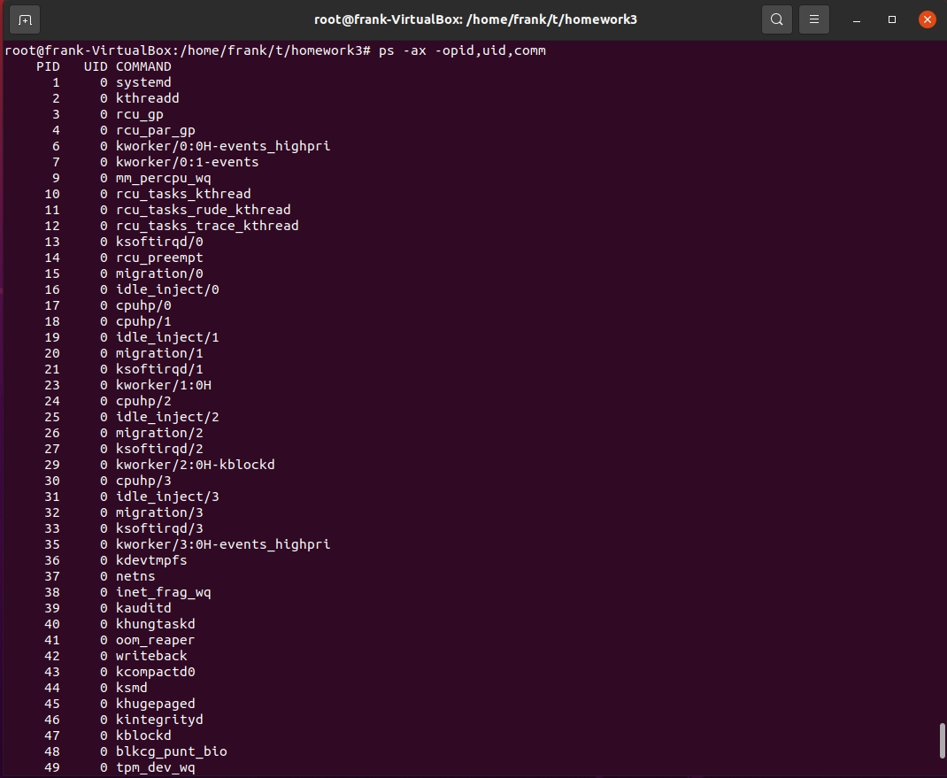

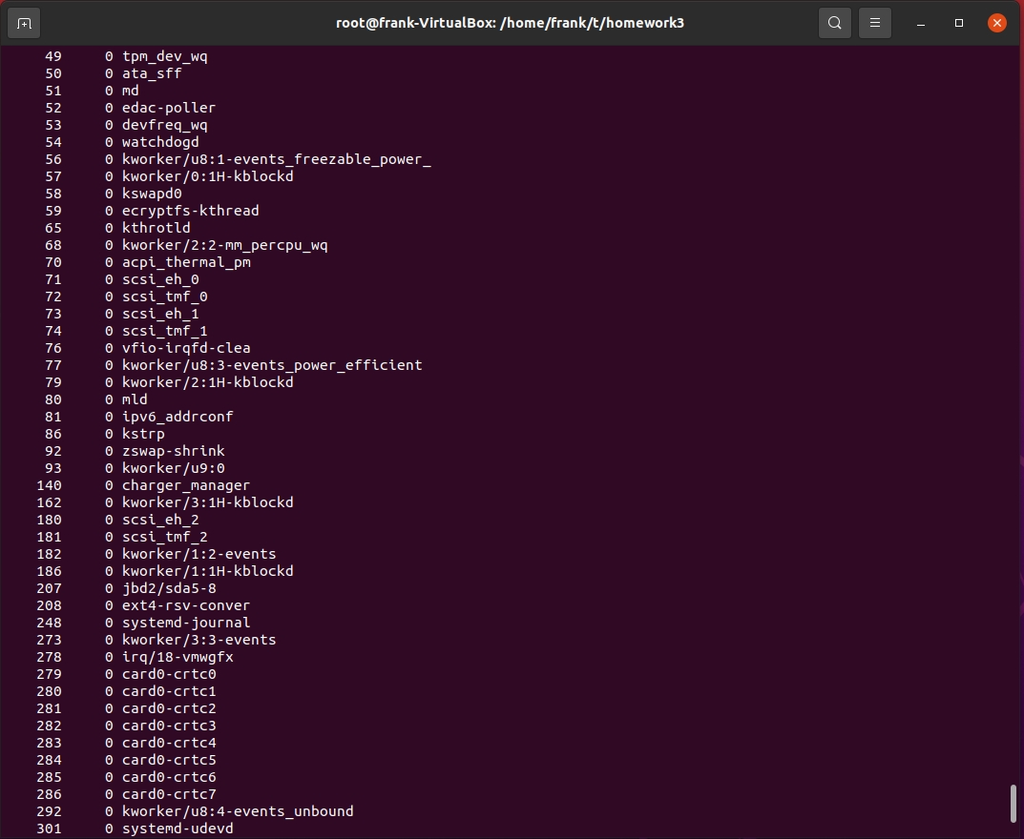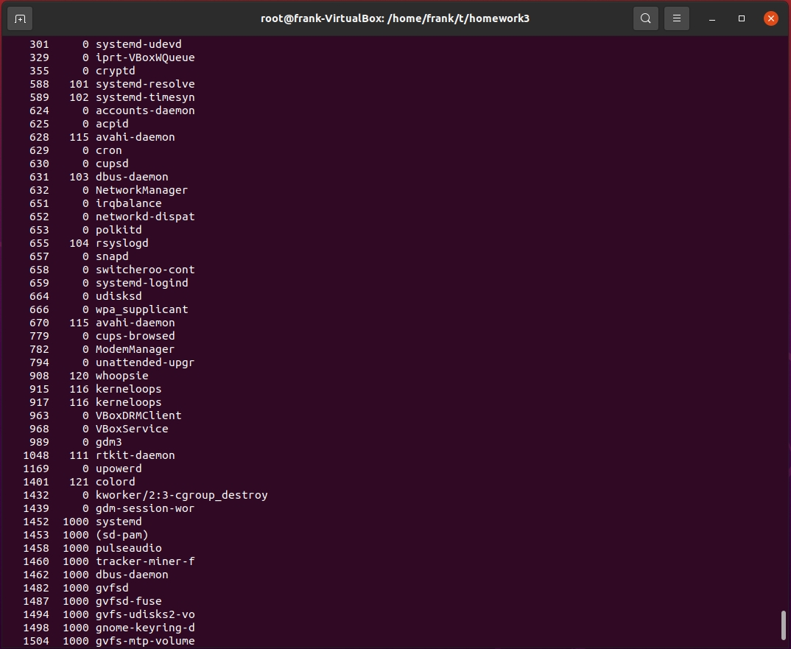

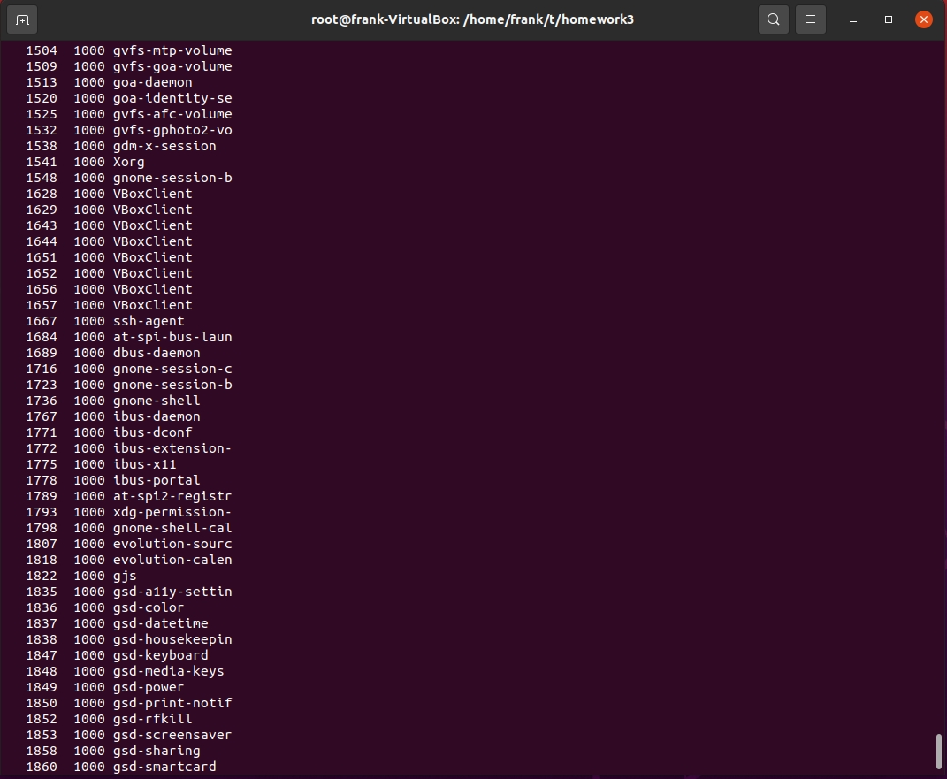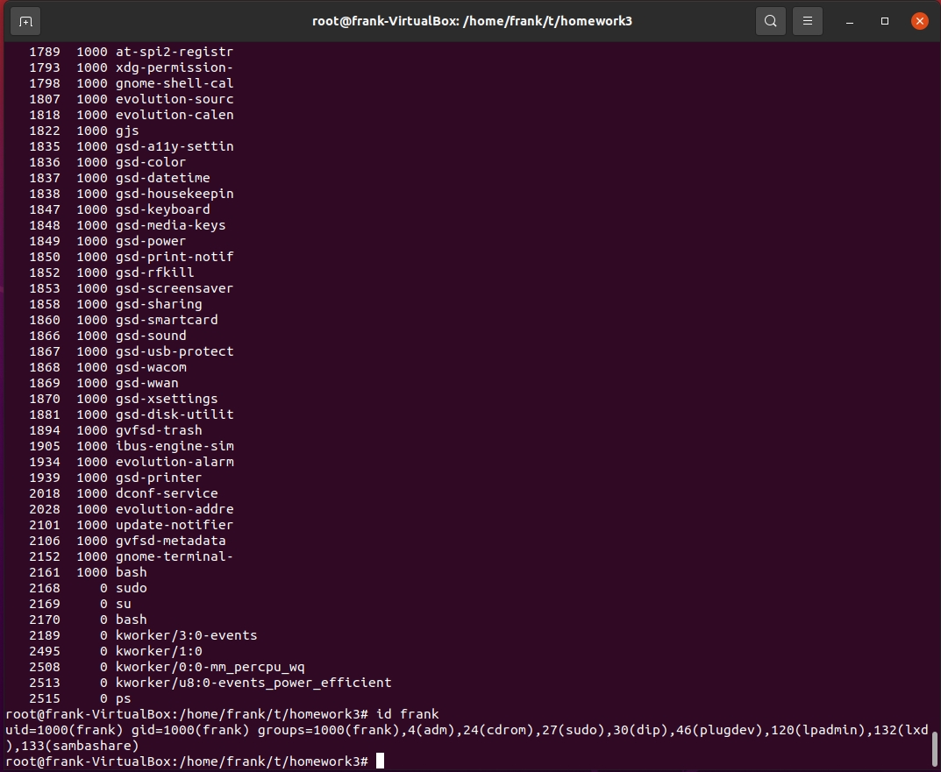

root@frank-VirtualBox:/home/frank/t/homework3# ps -ax -opid,uid,comm

PID UID COMMAND

1 0 systemd

2 0 kthreadd

3 0 rcu_gp

4 0 rcu_par_gp

6 0 kworker/0:0H-events_highpri

7 0 kworker/0:1-events

9 0 mm_percpu_wq

10 0 rcu_tasks_kthread

11 0 rcu_tasks_rude_kthread

12 0 rcu_tasks_trace_kthread

13 0 ksoftirqd/0

14 0 rcu_preempt

15 0 migration/0

16 0 idle_inject/0

17 0 cpuhp/0

18 0 cpuhp/1

19 0 idle_inject/1

20 0 migration/1

21 0 ksoftirqd/1

23 0 kworker/1:0H

24 0 cpuhp/2

25 0 idle_inject/2

26 0 migration/2

27 0 ksoftirqd/2

29 0 kworker/2:0H-kblockd

30 0 cpuhp/3

31 0 idle_inject/3

32 0 migration/3

33 0 ksoftirqd/3

35 0 kworker/3:0H-events_highpri

36 0 kdevtmpfs

37 0 netns

38 0 inet_frag_wq

39 0 kauditd

40 0 khungtaskd

41 0 oom_reaper

42 0 writeback

43 0 kcompactd0

44 0 ksmd

45 0 khugepaged

46 0 kintegrityd

47 0 kblockd

48 0 blkcg_punt_bio

49 0 tpm_dev_wq

50 0 ata_sff

51 0 md

52 0 edac-poller

53 0 devfreq_wq

54 0 watchdogd

56 0 kworker/u8:1-events_freezable_power_

57 0 kworker/0:1H-kblockd

58 0 kswapd0

59 0 ecryptfs-kthread

65 0 kthrotld

68 0 kworker/2:2-mm_percpu_wq

70 0 acpi_thermal_pm

71 0 scsi_eh_0

72 0 scsi_tmf_0

73 0 scsi_eh_1

74 0 scsi_tmf_1

76 0 vfio-irqfd-clea

77 0 kworker/u8:3-events_power_efficient

79 0 kworker/2:1H-kblockd

80 0 mld

81 0 ipv6_addrconf

86 0 kstrp

92 0 zswap-shrink

93 0 kworker/u9:0

140 0 charger_manager

162 0 kworker/3:1H-kblockd

180 0 scsi_eh_2

181 0 scsi_tmf_2

182 0 kworker/1:2-events

186 0 kworker/1:1H-kblockd

207 0 jbd2/sda5-8

208 0 ext4-rsv-conver

248 0 systemd-journal

273 0 kworker/3:3-events

278 0 irq/18-vmwgfx

279 0 card0-crtc0

280 0 card0-crtc1

281 0 card0-crtc2

282 0 card0-crtc3

283 0 card0-crtc4

284 0 card0-crtc5

285 0 card0-crtc6

286 0 card0-crtc7

292 0 kworker/u8:4-events_unbound

301 0 systemd-udevd

329 0 iprt-VBoxWQueue

355 0 cryptd

588 101 systemd-resolve

589 102 systemd-timesyn

624 0 accounts-daemon

625 0 acpid

628 115 avahi-daemon

629 0 cron

630 0 cupsd

631 103 dbus-daemon

632 0 NetworkManager

651 0 irqbalance

652 0 networkd-dispat

653 0 polkitd

655 104 rsyslogd

657 0 snapd

658 0 switcheroo-cont

659 0 systemd-logind

664 0 udisksd

666 0 wpa_supplicant

670 115 avahi-daemon

779 0 cups-browsed

782 0 ModemManager

794 0 unattended-upgr

908 120 whoopsie

915 116 kerneloops

917 116 kerneloops

963 0 VBoxDRMClient

968 0 VBoxService

989 0 gdm3

1048 111 rtkit-daemon

1169 0 upowerd

1401 121 colord

1432 0 kworker/2:3-cgroup_destroy

1439 0 gdm-session-wor

1452 1000 systemd

1453 1000 (sd-pam)

1458 1000 pulseaudio

1460 1000 tracker-miner-f

1462 1000 dbus-daemon

1482 1000 gvfsd

1487 1000 gvfsd-fuse

1494 1000 gvfs-udisks2-vo

1498 1000 gnome-keyring-d

1504 1000 gvfs-mtp-volume

1509 1000 gvfs-goa-volume

1513 1000 goa-daemon

1520 1000 goa-identity-se

1525 1000 gvfs-afc-volume

1532 1000 gvfs-gphoto2-vo

1538 1000 gdm-x-session

1541 1000 Xorg

1548 1000 gnome-session-b

1628 1000 VBoxClient

1629 1000 VBoxClient

1643 1000 VBoxClient

1644 1000 VBoxClient

1651 1000 VBoxClient

1652 1000 VBoxClient

1656 1000 VBoxClient

1657 1000 VBoxClient

1667 1000 ssh-agent

1684 1000 at-spi-bus-laun

1689 1000 dbus-daemon

1716 1000 gnome-session-c

1723 1000 gnome-session-b

1736 1000 gnome-shell

1767 1000 ibus-daemon

1771 1000 ibus-dconf

1772 1000 ibus-extension-

1775 1000 ibus-x11

1778 1000 ibus-portal

1789 1000 at-spi2-registr

1793 1000 xdg-permission-

1798 1000 gnome-shell-cal

1807 1000 evolution-sourc

1818 1000 evolution-calen

1822 1000 gjs

1835 1000 gsd-a11y-settin

1836 1000 gsd-color

1837 1000 gsd-datetime

1838 1000 gsd-housekeepin

1847 1000 gsd-keyboard

1848 1000 gsd-media-keys

1849 1000 gsd-power

1850 1000 gsd-print-notif

1852 1000 gsd-rfkill

1853 1000 gsd-screensaver

1858 1000 gsd-sharing

1860 1000 gsd-smartcard

1866 1000 gsd-sound

1867 1000 gsd-usb-protect

1868 1000 gsd-wacom

1869 1000 gsd-wwan

1870 1000 gsd-xsettings

1881 1000 gsd-disk-utilit

1894 1000 gvfsd-trash

1905 1000 ibus-engine-sim

1934 1000 evolution-alarm

1939 1000 gsd-printer

2018 1000 dconf-service

2028 1000 evolution-addre

2101 1000 update-notifier

2106 1000 gvfsd-metadata

2152 1000 gnome-terminal-

2161 1000 bash

2168 0 sudo

2169 0 su

2170 0 bash

2189 0 kworker/3:0-events

2495 0 kworker/1:0

2508 0 kworker/0:0-mm_percpu_wq

2513 0 kworker/u8:0-events_power_efficient

2515 0 ps

root@frank-VirtualBox:/home/frank/t/homework3# id frank

uid=1000(frank) gid=1000(frank) groups=1000(frank),4(adm),24(cdrom),27(sudo),30(dip),46(plugdev),120(lpadmin),132(lxd),133(sambashare)