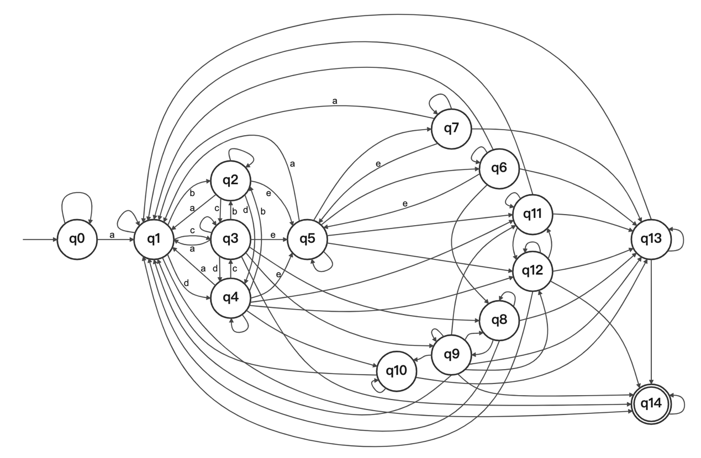

**S**

a,b,c,d,e,f,g,h,i,j,s,w

s

w

j

w

s

i

h

n

n

n

n

n

n

n

o

o

o

o

o

j

w

i

s

w

s

h

f

g

a

a

a

a

a

a