# Parallel gateway

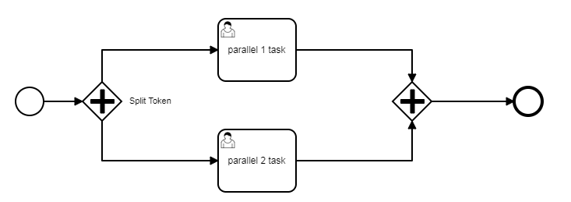

# Exclusive gateway

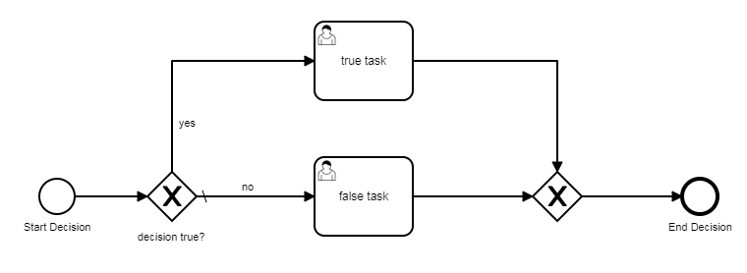

# Optional task

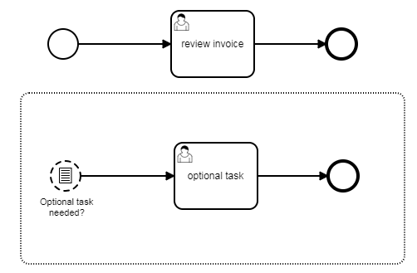

# Interrupting optional task

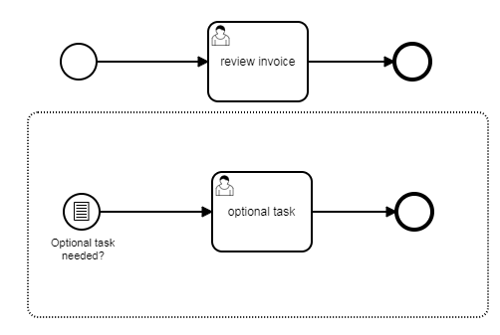

# On demand approval

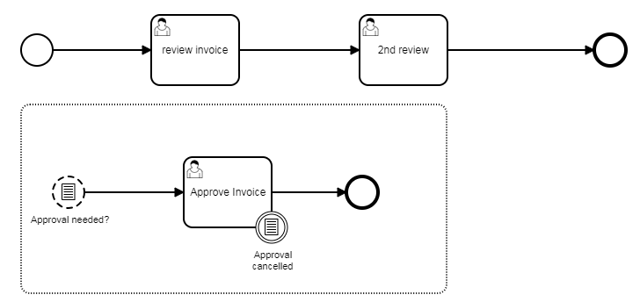

# Einrichtung java projekt und maven tomcat deplay

# Timer delay

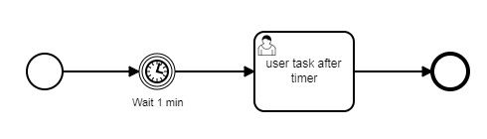

# Service task

