Read Me

Application: Wavebreak Media Payslip Exercise
Author: Frank Lenehan
Date: 02/03/2017

About:
This program is used to calculate an Australian payslip based on the 2012-2013 tax rates. It has been written using html to create the forms to display and control the interface with JavaScript to control the validation and calculation. CSS was also used for styling on this project.
How to use:
- Double click on payslip.html to open the application.
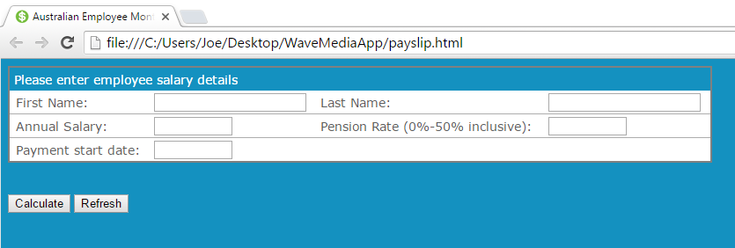
- Enter employee details and click Calculate
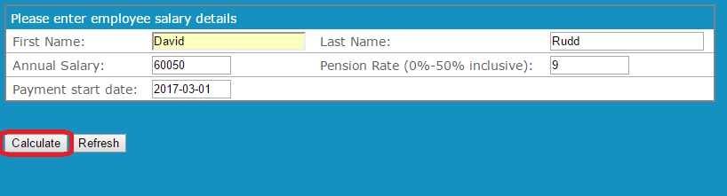

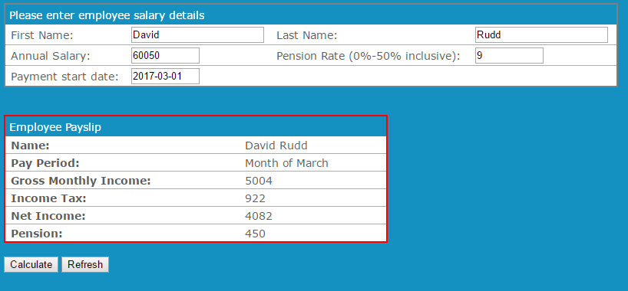
- Employee Payslip is then displayed for you to review.
- Click Refresh to clear data and start over.

