E-COMMERCE DATA ANALYTICS & BUSINESS INTELLIGENCE
End-to-End Marketplace Performance Analysis — Olist Real Dataset
Prepared by: Franklin Azevedo, Data Analyst | Core Stack: Python, Data Modeling, Advanced ETL, Business KPI Engineering
1. Project Overview & Objective
This portfolio document establishes a comprehensive technical breakdown of an end-to-end data analysis pipeline executed on the relational e-commerce database from Olist. The foundational objective of the core notebook architecture was to ingest, clean, manipulate, and model raw operational database tables to extract clear, high-level business intelligence performance metrics and trends that dictate enterprise decision-making.
2. Verified Enterprise Main KPIs
The programmatic aggregation scripts executed directly over the validated database generated the following production data foundations:
99,441 | 96,096 | R$ 16,008,872.12 | R$ 160.99
Total Orders | Total Customers | Total Revenue | Avg. Order Value
3. Macro Revenue Trend Analysis
Through systematic time-series aggregation, operational sales velocity was analyzed across a multi-year horizon. The analysis details sequential structural revenue scaling from late 2016 through mid-2018, mapping peak performance blocks and identifying critical cyclical seasonality patterns.
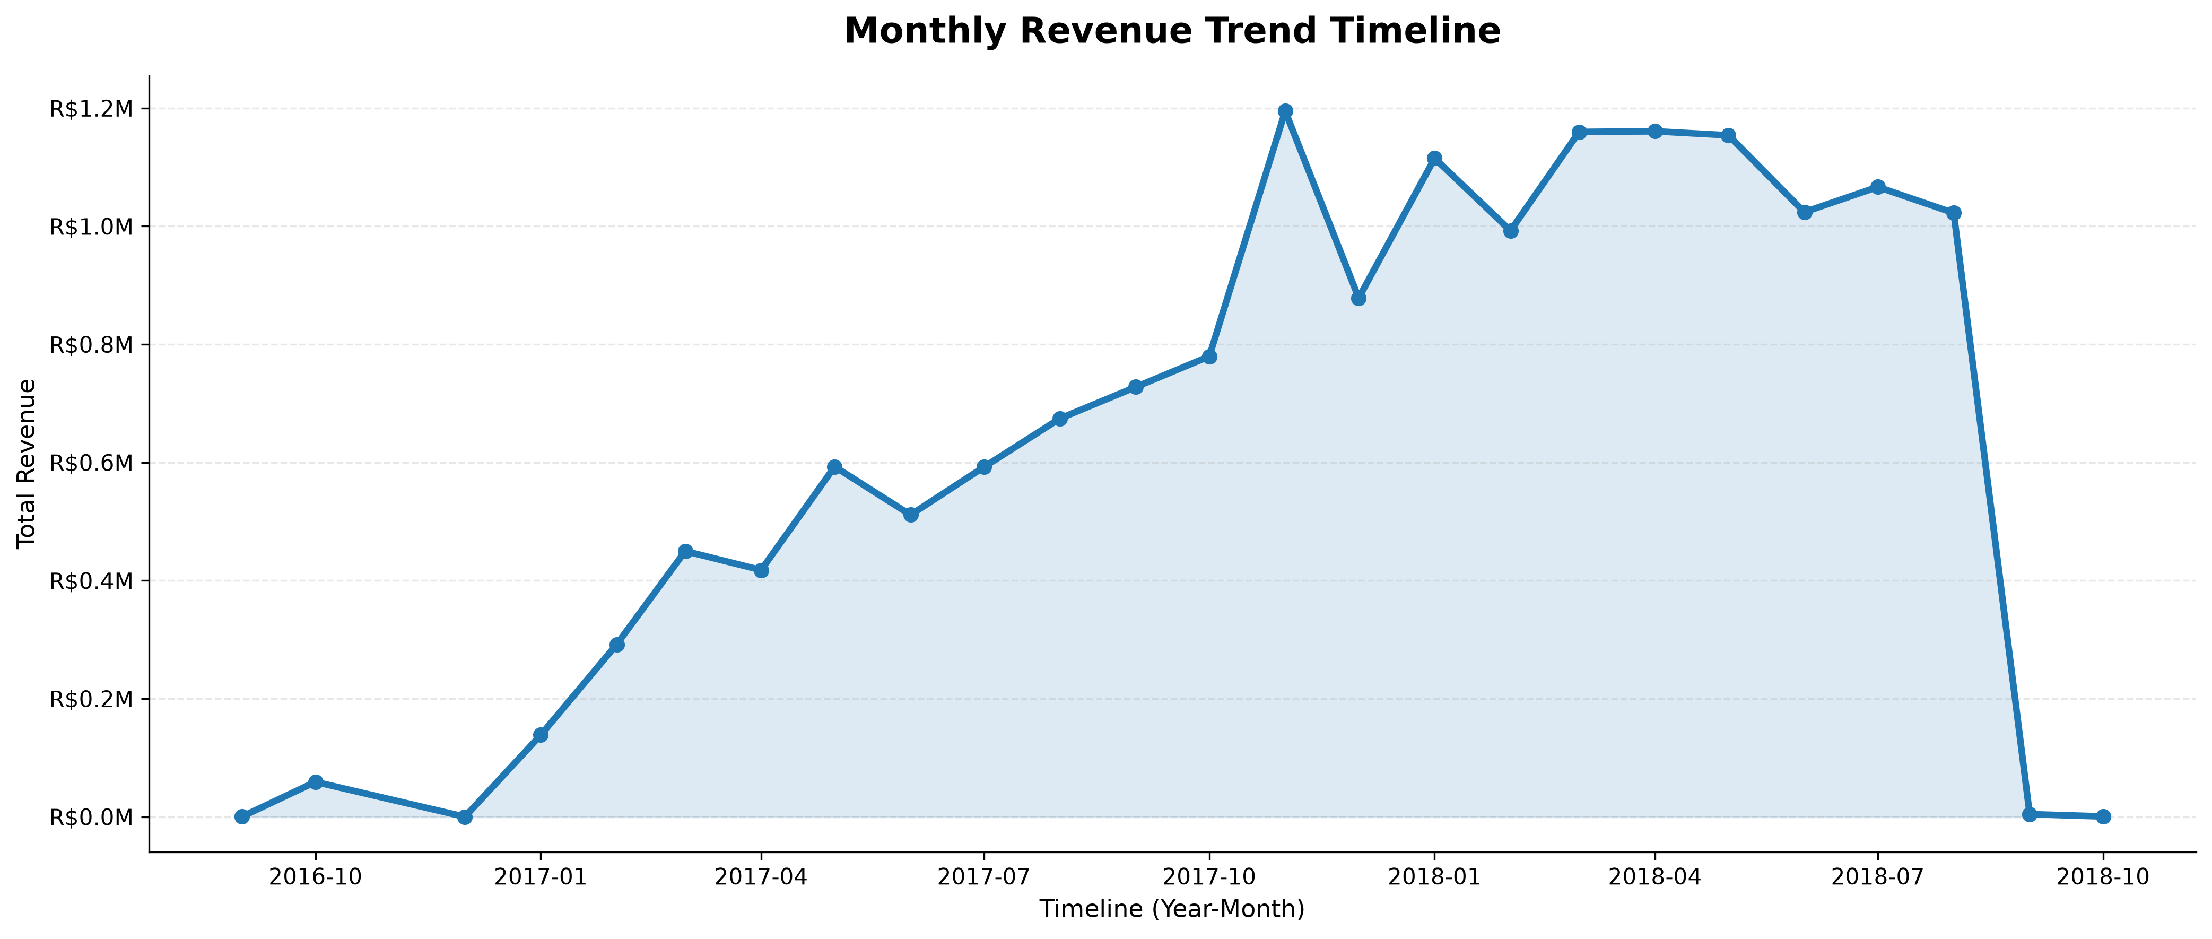
Figure 1: Longitudinal Monthly Gross Revenue Distribution Trend (Notebook Visual Output)
4. Geographic Performance Distribution
Regional market concentration was analyzed using localization mapping. Regional data grouping structures reveal that state-level distribution metrics are highly centralized within specific economic clusters, providing explicit commercial guidance for regional storage alignment and optimized shipping infrastructure.
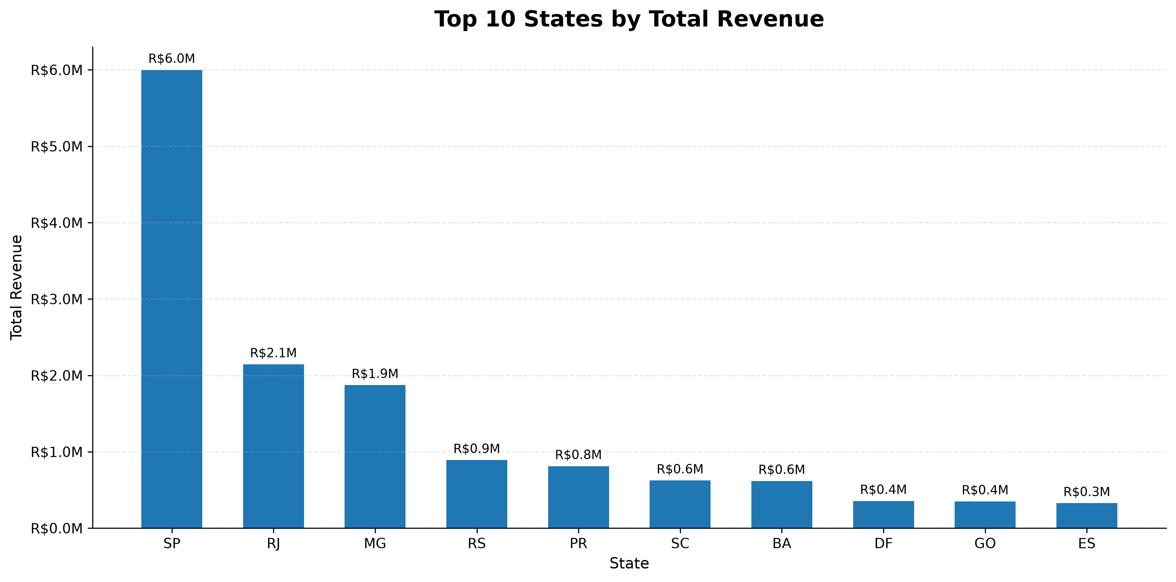
Figure 2: Regional Revenue Generation Analysis Mapping Top 10 Macro States
Geographic Discovery: The state of São Paulo (SP) represents the ultimate commercial hub, driving R$ 6.0M in gross transaction volume, followed sequentially by Rio de Janeiro (RJ) at R$ 2.1M and Minas Gerais (MG) at R$ 1.9M.
5. Product Category & Commercial Specialization
Granular category ranking models were constructed to evaluate inventory performance. High-volume consumer categories were separated from low-performing margins to assist procurement strategy.
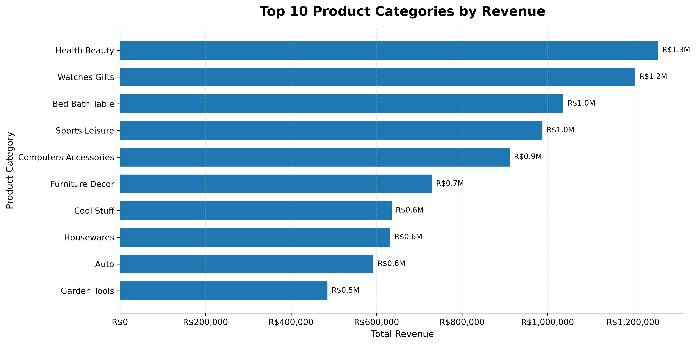
Figure 3: Categorical Revenue Concentration Ranking (Top 10 Performing Portfolios)
The data indicates that Health & Beauty (R$ 1.3M) and Watches & Gifts (R$ 1.2M) represent the primary revenue drivers for the marketplace framework, heavily dictating absolute corporate transaction health.
6. Transaction Behavior & Payment Preferences
To understand user checkout friction, transactional methods were evaluated by absolute volume metrics. This technical step measures checkout patterns to ensure payment Gateway optimization.
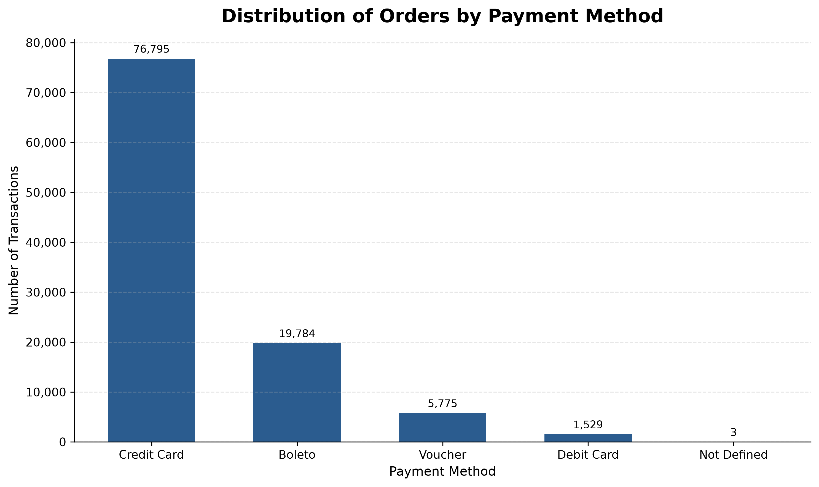
Figure 4: Quantitative Distribution of System Transactions by Selected Payment Gateway
Credit card utilization remains overwhelmingly dominant with 76,795 confirmed checkout instances, which significantly outlines consumer credit dependency inside the platform framework.
7. Technical Competency Summary
This data infrastructure implementation successfully demonstrates deep operational mastery over the entire analytics ecosystem: engineering raw relational structures, extracting precise data metrics, handling dense enterprise-level datasets, and visualizing key strategic indicators to generate immediate executive commercial value.

