**Comparative Assessment of RHEAS Maize Simulations against Crop Harvest Surveys for Zambia**

RHEAS model framework simulation was conducted for Zambia. The maize outputs were then compared to the preharvest crop surveys obtained from Zambia Statistics Agency website.

Pre-harvest and post-harvest surveys data were available for 12 and 5 years respectively. The model overestimated yields (metric tonnes per hectare). To address the issue, bias correction was performed. The results are shown in the table and the figure below.

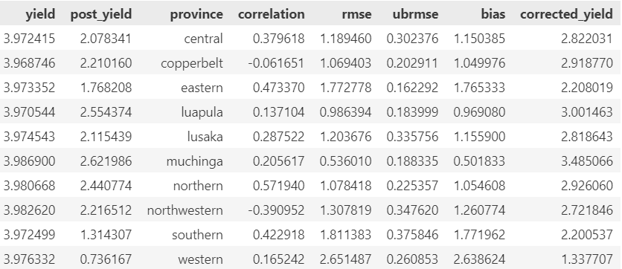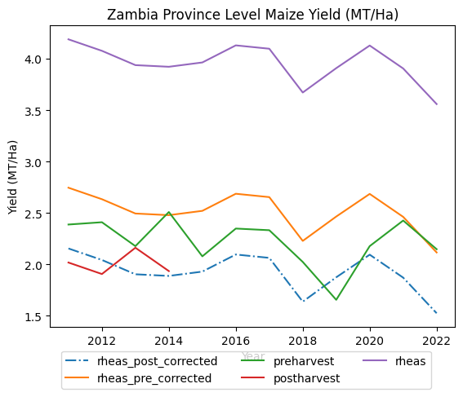

Results

|  |  |
| --- | --- |
| Code | Meaning |
| rheas_pre_corrected | Model results bias corrected with the preharvest crop surveys |
| rheas_post_corrected | Model results bias corrected with the postharvest crop surveys |
| preharvest | Preharvest maize survey data at provincial level |
| postharvest | Postharvest maize survey data at provincial level |
| RHEAS | Regional Hydrological Extremes and Assessment System |

The model bias corrected with the postharvest data performs better compared to when corrected with the preharvest data.

Conclusion

RHEAS crop model can be used to complement the crop survey activities.

The model needs appropriate datasets that include longer years of district level postharvest surveys, the areas of maize crop farming, maize specific seeds (cultivars) planted in each of the districts and other datasets for calibration.