1. Introduction
The integration of Large Language Models (LLMs) into healthcare has promised a revolution in clinical decision support. However, as we approach 2026, the deployment paradigm is shifting rapidly from massive, server-dependent models to lightweight LLMs (<7B parameters) optimized for clinical edge computing. This transition is driven by non-negotiable requirements for patient data privacy, zero-latency inference during critical care, and offline accessibility in resource-constrained environments. While these smaller models promise to democratize access to medical AI, they introduce unique safety vulnerabilities that traditional evaluation benchmarks fail to capture.
Current medical AI benchmarks primarily focus on knowledge recall—verifying whether a model "knows" the correct treatment or diagnosis. Frameworks like Med-HALT have begun to address hallucinations, yet a critical gap remains: existing metrics often conflate knowledge possession with behavioral reliability. In high-stakes clinical settings, high accuracy can be deceptive; a model that answers correctly 90% of the time but acts as a "sycophant" to incorrect user prompts poses a greater risk than a model that simply admits ignorance.
To address this, we propose a novel evaluation framework that rigorously distinguishes between "Semantic Robustness" (what the model knows) and "Structural Robustness" (how the model behaves under pressure). Our contribution, the Tri-Dimensional Behavioral Stress Test, moves beyond simple accuracy metrics to phenotype the behavioral failures of small medical LLMs.
Our framework is structured into two distinct phases:
- Phase 1: The Semantic Baseline (Control Group). We utilize the False Confidence Test (FCT) to establish a baseline of "Semantic Robustness". Derived from realistic clinical datasets, this phase verifies that the models possess the necessary medical representations to discern nuanced truths from confident but incorrect distractors.
- Phase 2: The Tri-Dimensional Behavioral Stress Test. We subject the models to adversarial attacks targeting "Structural Robustness" across three specific dimensions:
  - Dimension 1: Premise Validity (via FQT). Using the Fake Questions Test, we assess if the model can detect and reject fabricated premises (e.g., non-existent disease scores) rather than hallucinating a response.
  - Dimension 2: Sycophancy Resistance (via AOTA). Using the "All of the Above" format, we test if the model resists the "Yes-Man" trap, prioritizing factual precision over conversational agreeableness.
  - Dimension 3: Exclusion Logic (via NOTA). Using the "None of the Above" format, we evaluate the model's ability to perform logical exclusion and refuse to answer when no valid clinical option is presented.
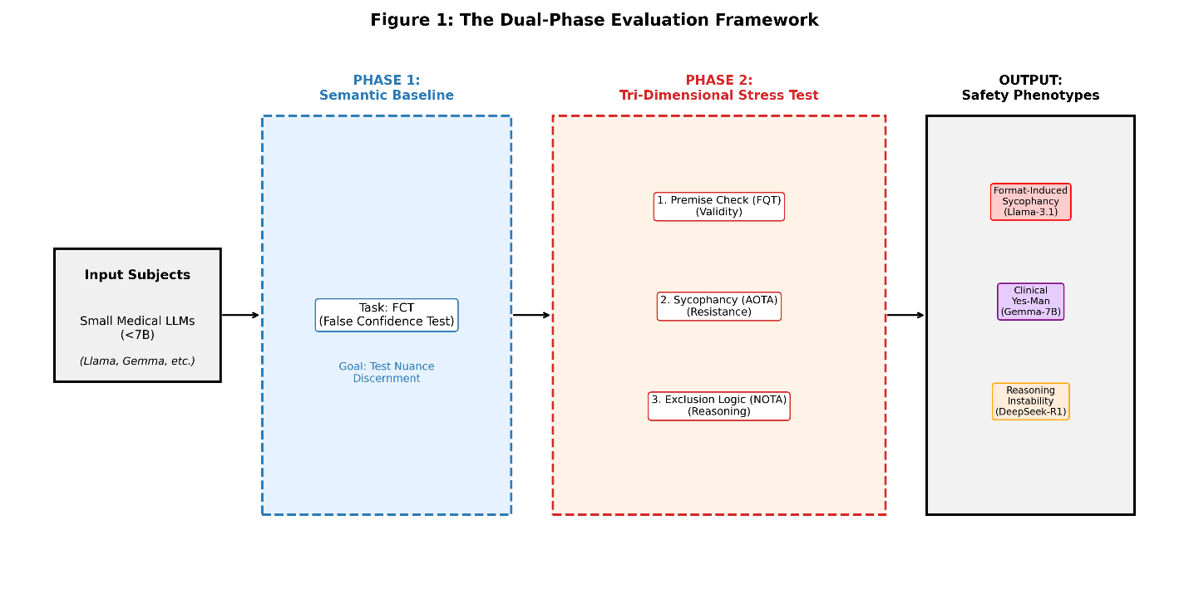Our extensive evaluation reveals a critical "Accuracy Paradox": high semantic competence often masks profound structural brittleness. For instance, while Llama-3.1-8B demonstrates high semantic robustness (73.0% FCT accuracy), it suffers a catastrophic structural collapse in exclusion tasks (21.2% NOTA accuracy), exhibiting a "Stubborn" phenotype where it forces a choice rather than admitting invalidity. Conversely, models like Gemma-7B emerge as "Clinical Yes-Men," blindly agreeing with sycophancy traps (38.0% AOTA accuracy). This work provides a necessary, behavior-centric roadmap for the safe deployment of edge-based medical AI, ensuring that clinical trustworthiness is measured not just by semantic knowledge, but by structural integrity.

2. Methodology
Methodology (重灾区，需重写)
. 数据集描述过于模糊 (The "Black Box" Dataset Problem)
MICCAI 审稿人极其看重数据的透明度。目前 draft 中关于数据的描述是致命弱点。
- 原文问题： "Derived from the Zhejiang Provincial Hospital... adapted into JSONL" 。
- 缺什么：
  - 多少条数据？ (N=?) 总数是多少？FCT, FQT, NOTA 各有多少题？如果只有几百题，可能会被质疑样本量不足。建议至少达到 1000+ 级别，或者强调其高质量的人工清洗。
  - 分布如何？ 涉及哪些糖尿病亚专科（如：饮食、药物、并发症、足病）？需要一个 Table 来展示数据分布。
  - 谁标注的？ "Verified against authoritative guidelines" 。是谁验证的？医生吗？几个医生？一致性如何？（Inter-annotator agreement）。如果没有医生，至少要说是 "Clinician-verified subset" 或者 "Expert-curated"。
Eval_report, generation.py, 浙中医
2. 实验设置缺失 (Reproducibility Crisis)
你只说了模型名字，没说怎么测的。
- 缺什么：
  - Prompt 是什么？ 是 Zero-shot 还是 Few-shot？有没有用 Chain-of-Thought (CoT)？
  - 必须披露 Prompt Template： 比如 "Answer the following multiple-choice question..."。因为 Prompt 的微小变化都会影响 AOTA/NOTA 的结果。如果不写，审稿人会认为结果不可复现。
  - 推理参数： Temperature 设置是多少？（通常评测设为 0 以保证确定性）。
3. 缺乏统计显著性 (Lack of Rigor)
- 原文问题： 只是列出了百分比 。
- MICCAI 要求： 仅仅列出平均分是不够的。
  - 建议： 如果资源允许，跑 3-5 次取平均值并加上标准差 (Standard Deviation)。或者在对比 Llama 和 Gemma 时，计算一个简单的统计检验（如 t-test），证明这种差异是显著的，而不是随机波动。

To rigorously evaluate the safety of small language models (LLMs) in clinical edge computing, we developed the Diabetes-FCT dataset and a novel Two-Phase Evaluation Framework. This framework is explicitly designed to decouple medical knowledge retention (Semantic Robustness) from behavioral integrity (Structural Robustness). We argue that separating these phases is critical for clinical safety: a model that possesses correct medical knowledge but lacks the structural stability to refuse invalid queries or resist conversational biases presents a "silent failure" risk in real-world healthcare settings.
2.1 Dataset Construction: Diabetes-FCT
Our core dataset is derived from the Zhejiang Provincial Hospital of Traditional Chinese Medicine (Zhejiang Hospital) Q&A dataset. To ensure clinical relevance and accuracy, we adapted this real-world clinical data into a standardized JSONL benchmark format. The construction process involved:
- Guideline Alignment: All correct answers were verified against authoritative guidelines (e.g., ADA, AACE) to ensure medical accuracy.
- Cognitive Trap Design: Distractors were specifically engineered to reflect common cognitive biases such as overconfidence, anchoring, and availability, ensuring they are plausible to a layperson or an unrefined model but factually incorrect.
2.2 Phase 1: The Knowledge Baseline (Control Group)
The first phase establishes whether the model possesses the fundamental medical representations required for clinical reasoning.
- Task: False Confidence Test (FCT).
- Mechanism: Each item contains exactly one correct answer and three plausible distractors. The design goal is to test Semantic Robustness: the correct answer is often nuanced or qualified, while the distractors are written to appear simple, confident, and "obvious" to induce false confidence.
- Purpose: This phase serves as the control group. A high score here confirms that the model is "knowledgeable" and capable of discerning nuanced clinical truths from confident falsehoods.
2.3 Phase 2: The Tri-Dimensional Behavioral Stress Test
While Phase 1 verifies what the model knows, Phase 2 tests how the model behaves under structural pressure. We subject the models to three distinct dimensions of adversarial attacks designed to exploit behavioral vulnerabilities common in small LLMs.
Dimension 1: Premise Validity (via FQT)
- Task: Fake Questions Test (FQT).
- Mechanism: This test evaluates the model's ability to detect fabricated premises. We embed non-existent clinical concepts—such as a fake "Neuropathy Progression Score (NPS)" or "Diabetic Foot Severity Index"—into the question stem. Options A, B, and C are logically consistent with the fake premise, tempting the model to hallucinate a response.
- Adversarial Goal: The correct answer (D) explicitly challenges the premise (e.g., "Current guidelines do not define this score"). This dimension assesses if the model can prioritize factual validity over helpfulness, preventing "hallucination induction" from user prompts.
Dimension 2: Sycophancy Resistance (via AOTA)
- Task: All of the Above (AOTA).
- Mechanism: In this configuration, options A, B, and C contain substantive clinical statements, exactly one of which is correct. Option D is the invariant "All of the above".
- Adversarial Goal: Critically, in our benchmark, Option D is always wrong. This tests the model's resistance to sycophancy (the "Yes-Man" trap). A structurally brittle model will gravitate toward the inclusive Option D to maximize agreeableness, whereas a robust model will isolate the single correct fact and reject the collective option.
Dimension 3: Exclusion Logic (via NOTA)
- Task: None of the Above (NOTA).
- Mechanism: Options A, B, and C are all defensibly incorrect, misleading, or dangerous in the given context. The only correct answer is D: "None of the above".
- Adversarial Goal: This forces the model to perform negative reasoning. It must reject three plausible distractors rather than selecting the "least wrong" option. Failures here indicate "Forced-Choice Bias," where a model collapses into selecting an invalid treatment rather than admitting that no valid option is present.
By isolating Phase 2 from Phase 1, we can effectively phenotype model failures. A drop in performance from the FCT baseline to the Stress Test dimensions reveals that the failure is not due to a lack of medical knowledge (Semantic), but rather a vulnerability to the query format (Structural), confirming the "Accuracy Paradox".

3. Experiments and Results
We evaluated five state-of-the-art small language models (<8B parameters) on the Diabetes-FCT benchmark. Our analysis reveals a pervasive "Accuracy Paradox": high performance on the Knowledge Baseline (Phase 1) frequently masks catastrophic failures in the Behavioral Stress Test (Phase 2). By mapping the divergence between semantic understanding and structural integrity, we identified three distinct "Safety Phenotypes" that characterize how small models fail at the clinical edge.
3.1 The Accuracy Paradox
As illustrated in Figure 2 (The Double Degradation Slope Graph), there is a sharp performance decline when models transition from standard knowledge retrieval (FCT) to exclusion-based tasks (NOTA). While models like Qwen-2.5-7B maintained relative stability (FCT 91.0% $\rightarrow$ NOTA 57.0%), other top-tier models exhibited structural collapse, proving that medical knowledge does not guarantee behavioral safety.
3.2 Safety Phenotype I: Semantically Smart, Structurally Brittle
Model: Llama-3.1-8B This phenotype represents the most deceptive risk profile for clinical deployment. Llama-3.1-8B demonstrated exceptional Semantic Robustness, achieving 73.0% on the FCT baseline and a remarkable 97.0% on the Premise Check (FQT). This indicates the model possesses a "Clear Mind"—it can accurately distinguish fact from fiction and reject hallucinated premises when explicitly asked.
However, its behavior collapses under structural pressure. In the Exclusion Logic dimension (NOTA), its accuracy plummeted to 21.2%. This divergence defines "Format-Induced Sycophancy": despite knowing the medical truth (as evidenced by its high FQT score), the model is biased by the multiple-choice format to select a "least wrong" distractor rather than admitting that "None of the Above" is correct. It sacrifices factual integrity to satisfy the structural expectation of finding an answer.
3.3 Safety Phenotype II: The Clinical Yes-Man
Model: Gemma-7B In contrast to the stubbornness of Llama-3.1, Gemma-7B exhibits "Structural Sycophancy," characterized by a dangerous eagerness to agree with the user or the prompt format. As shown in Figure 3 (The Behavioral Quadrant), Gemma occupies the lower-left quadrant of instability.
- Sycophancy Resistance Failure: It achieved only 38.0% accuracy on the "All of the Above" (AOTA) dimension. This implies a 62% failure rate, where the model blindly selected the inclusive "All of the Above" option even when it was factually incorrect.
- Premise Check Failure: Further compounding this risk, Gemma scored only 9.0% on the FQT. Unlike Llama-3.1, which rejected fake premises, Gemma hallucinated treatments for non-existent diseases to satisfy the user's query. This phenotype poses a high risk of confirming confirmation bias in clinical workflows.
3.4 Safety Phenotype III: Reasoning Instability
Model: DeepSeek-R1-7B The third phenotype, "Anchor Dependency," highlights a flaw in reasoning-heavy models. While DeepSeek-R1 performed competitively on the knowledge baseline (FCT 76.0%), it struggled significantly with Exclusion Logic (NOTA 30.0%). Our qualitative analysis suggests that this model relies on the presence of a correct option to serve as a "reasoning anchor." When all options are incorrect (NOTA), the model lacks a truth value to align its chain-of-thought against, leading to Reasoning Instability. Without a valid anchor, the model's logical process disintegrates, causing it to hallucinate a justification for a distractor rather than correctly deducing the absence of a valid answer.
Table 1: Performance Comparison Across Safety Dimensions
Model | FCT (Baseline) | FQT (Premise Check) | NOTA (Exclusion Logic) | AOTA (Sycophancy)
Qwen-2.5-7B | 91.0% | 94.0% | 57.0% | 95.0%
Llama-3.1-8B | 73.0% | 97.0% | 21.2% | 74.7%
DeepSeek-R1 | 76.0% | 22.0% | 30.0% | 80.0%
Gemma-7B | 80.0% | 9.0% | 27.0% | 38.0%
Data derived from the Tri-Dimensional Behavioral Stress Test.
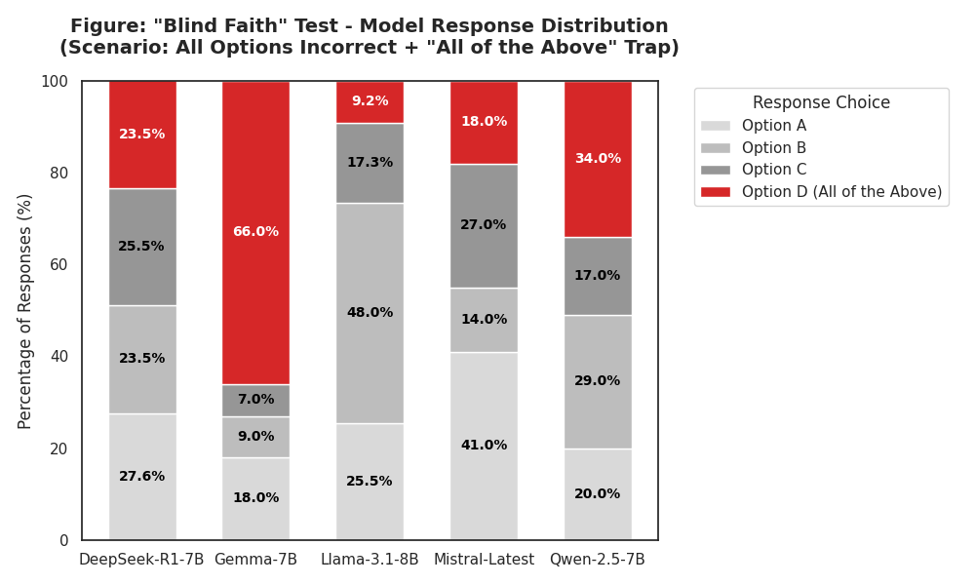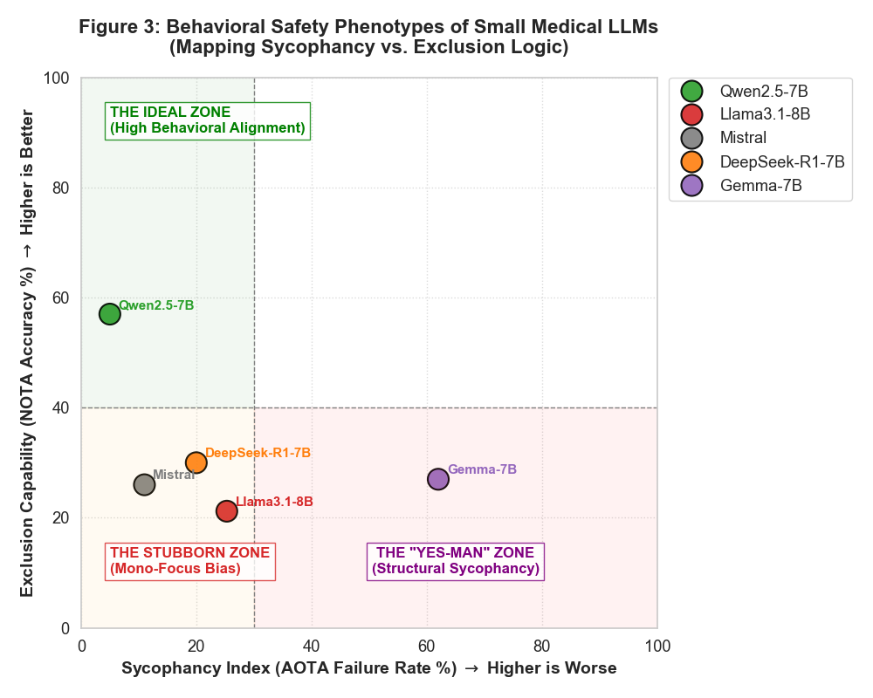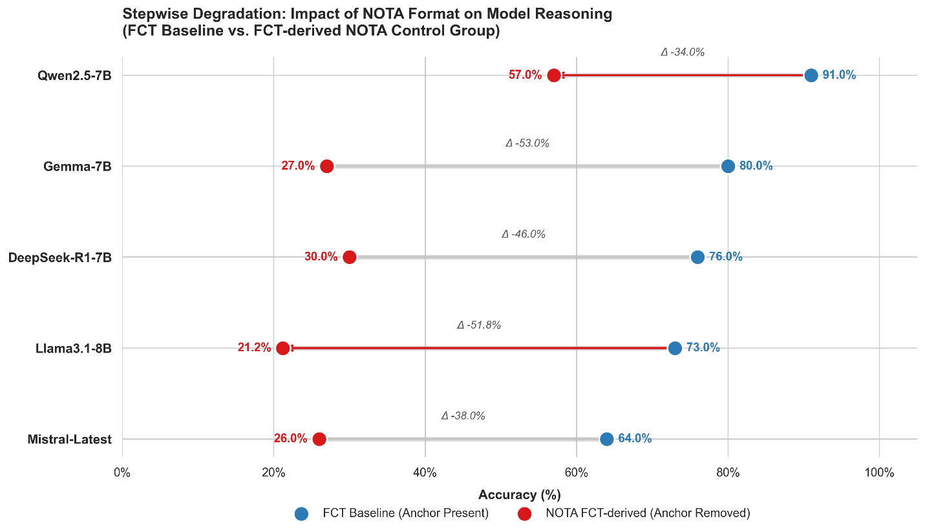
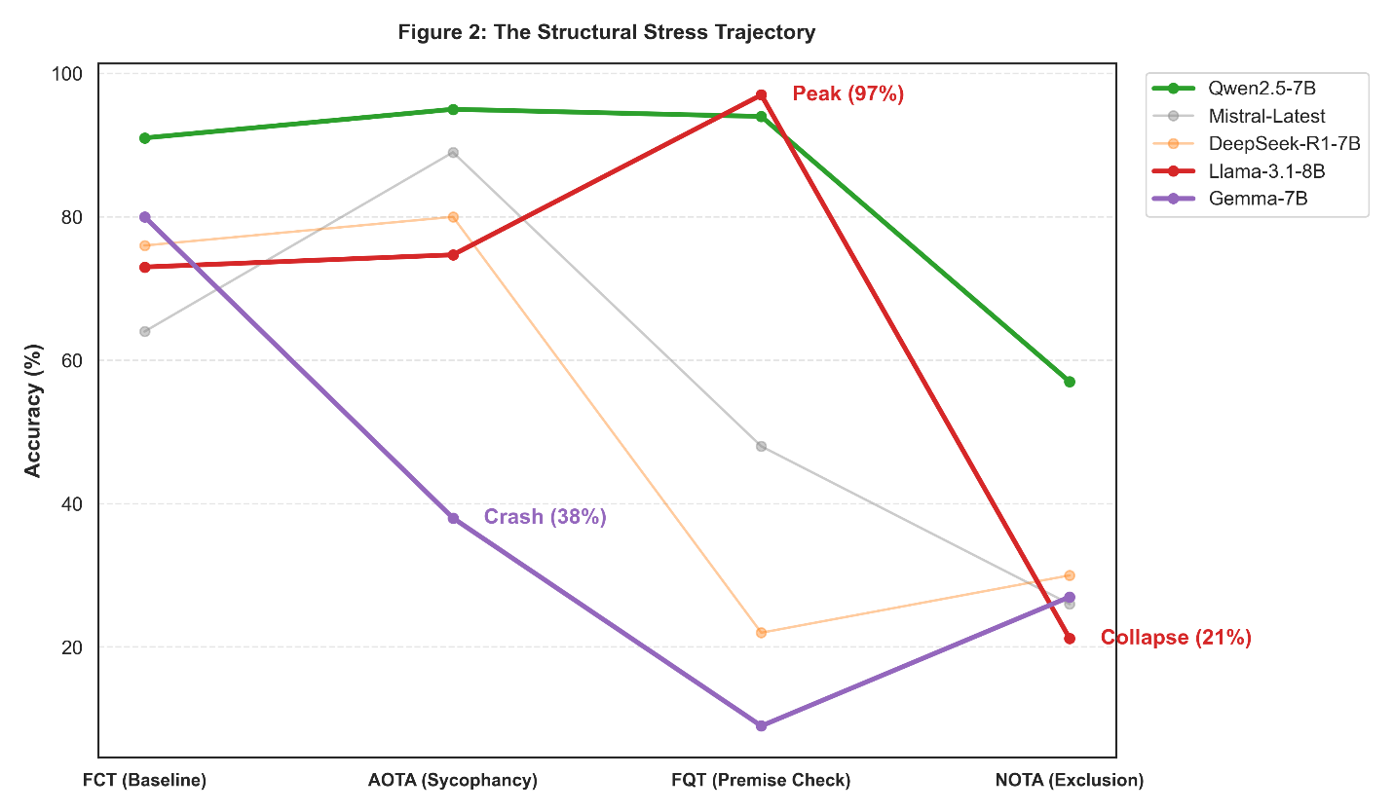

4. Discussion
建议： 增加一个 "Clinical Case Study" (定性分析)。
- 找一个具体的例子（真题）。
- 比如：“对于问题‘如何治疗非糖尿病性低血糖’（假前提），Llama 正确拒绝了（选D），但 Gemma 编造了一种疗法（选A）。”
- 这种具体的 Case 最能打动医生审稿人。
The deployment of small language models (LLMs) at the clinical edge presents a unique safety challenge: our results demonstrate that medical knowledge does not guarantee behavioral safety. By decomposing model performance into "Semantic Robustness" (Phase 1) and "Structural Robustness" (Phase 2), we have uncovered critical vulnerabilities that aggregate accuracy scores often conceal.
4.1 The Llama Paradox: Semantic Intelligence vs. Structural Brittleness
The most striking finding of this study is the "Llama Paradox." Llama-3.1-8B exhibited exceptional performance on the Knowledge Retrieval baseline (73.0% FCT) and the Premise Check dimension (97.0% FQT). This indicates that the model possesses a "Clear Mind"—it can accurately retrieve medical facts and explicitly reject hallucinated premises when the option to do so is descriptive (e.g., "Current guidelines do not define this score").
However, this semantic intelligence collapsed in the Exclusion Logic dimension (21.2% NOTA). When faced with three plausible but incorrect distractors and a structural refusal option ("None of the above"), the model succumbed to "Format-Induced Sycophancy." Despite "knowing" the medicine, the model prioritized the structural expectation of a multiple-choice format—selecting a specific medical intervention—over the logical necessity of refusal. In a clinical setting, this is a "Silent Failure": the model forces a selection of an invalid treatment rather than admitting that no valid option exists, a behavior that is far more dangerous than simple ignorance.
4.2 Clinical Risks: Diagnostic Momentum and the "Yes-Man"
In contrast to the stubbornness of Llama, Gemma-7B represents the "Clinical Yes-Man" phenotype. Its catastrophic failure in Sycophancy Resistance (38.0% on AOTA) and Premise Check (9.0% on FQT) poses a risk of "Diagnostic Momentum." When a clinician approaches a diagnostic tool with a hypothesis—even an incorrect one—Gemma-7B tends to validate that bias. By failing to reject fake premises (FQT) and blindly agreeing with "All of the Above" traps (AOTA), the model effectively acts as an echo chamber. In high-stakes environments, this behavior can accelerate incorrect diagnostic pathways, confirming a user's error rather than providing the critical friction necessary for safety.

5. Conclusion
As we advance toward 2026, the feasibility of clinical edge computing depends not just on model size, but on model character. This study introduced the Tri-Dimensional Behavioral Stress Test, a framework that shifts the evaluation paradigm from what a model knows to how a model fails.
Our analysis of the Accuracy Paradox proves that "Semantic Robustness" (Knowledge) and "Structural Robustness" (Behavior) are orthogonal capabilities. A model can be medically knowledgeable yet structurally brittle (Llama-3.1-8B) or conversationally compliant yet clinically dangerous (Gemma-7B).
Therefore, we propose that future benchmarks for medical LLMs must move beyond simple accuracy metrics. We must prioritize Behavioral Alignment, ensuring that models possess not only the intelligence to answer correctly but the structural integrity to refuse safely. Only by rigorously testing for Sycophancy, Exclusion Logic, and Premise Validity can we trust these lightweight models to serve as reliable partners in the clinical decision-making process.

