Franklin Harvey

CSCI 2270

Samantha Molnar

Assignment 4

Question 1: Inserting a node into a red-black tree and then deleting it does *not* necessarily result in the same tree. For instance in the following tree, I will add and then delete “65.”

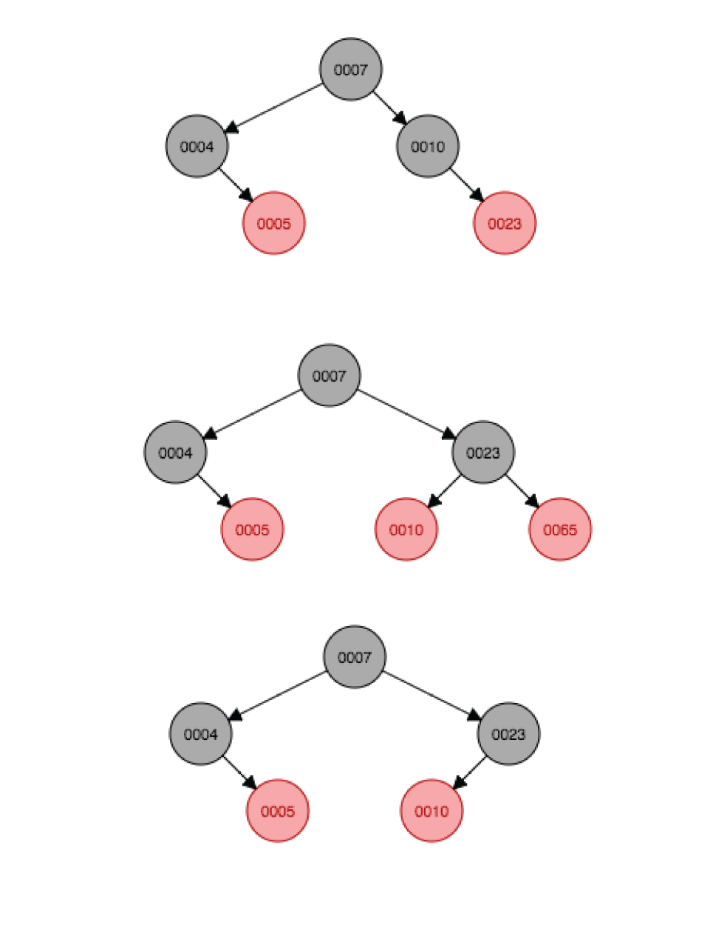

After it rotates on 23, and 65 is deleted, 10 is still a child of 23 (as opposed to 23 being a child of 10, as was originally). 7 remains the root. 10 and 23 get recolored.

Question 2: As before, deleting a node (with no children) and then adding it again will not necessarily result in the same red-black tree. For instance, delete the “1” in the following tree and adding it again has this effect:

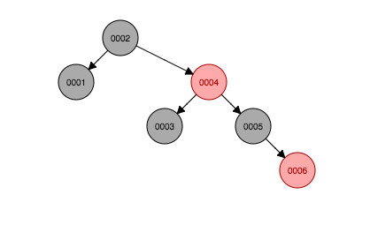 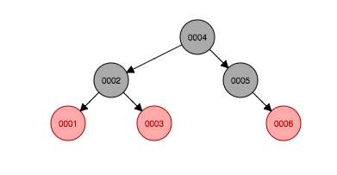

As 1 is deleted, 4 becomes the new root is recolored. 3 becomes a child of 2, and is also recolored. 1 becomes red. 2 goes from root to left child of 4.