Kewei Portfolio
A Digital Portfolio Website

Student Name: Kewei Wu
Student ID: 26141825
Module: CS5709 — Software Engineering Evolution
Module Leader: Dr. Salim Saay
University: University of Limerick
Date: September 2026

Table of Contents
1. Declaration and Transparency
2. Abstract
3. Discovery and Narrative Description
4. Iterative Project Plan
5. Tools and Techniques
6. Design Discussion
7. Code Listing
8. Innovation
9. Critique
10. Reflection
11. References

1. Declaration and Transparency

Generative AI Transparency Statement
AI Usage Level: 4 — AI Task Completion, Human Evaluation
Tool | Usage Level | Precise Usage
Joy AI (JoyCode) | Level 4 | Generated project scaffolding (Vite + React + TypeScript setup), directory structure, boilerplate component code, and CSS styling. All AI-generated code was reviewed and understood by the student.

2. Abstract
A portfolio website built with React, TypeScript, and Vite. It has nine pages, uses CSS Modules and CSS variables for styling, and includes a custom chat hook. Technologies are kept simple to stay lightweight. This report covers the discovery, design, implementation, and evaluation of the project.

3. Discovery and Narrative Description

3.1 Overview
The portfolio website serves as a professional digital presence. It provides visitors with information about the author's background, skills, and work through an intuitive navigation system.

3.2 Feature List
# | Feature | Page/Route | Phase | Description
1 | Home Page | / | 1 | Intro and feature cards
2 | About Me | /about | 1 | Personal background and interests
3 | Education | /education | 1 | Education and work timeline
4 | Professional Knowledge | /knowledge | 1 | Skills grouped by category
5 | Photo Gallery | /gallery | 1 | Photo grid of projects and events
6 | Video Gallery | /videos | 1 | Embedded YouTube videos
7 | Navigation Bar | — | 1 | Top navigation with active styling
8 | Client-side Routing | — | 1 | React Router page navigation
9 | CSS Styling | — | 1 | CSS Modules and theme variables
10 | Blog | /blog, /blog/:id | 2 | Articles with Markdown detail
11 | Instant Messaging | /messaging | 2 | Chat with auto-reply bot
12 | README | /readme | 2 | Project overview page
13 | Dark Mode | — | 2 | Auto dark/light theme switch
14 | Responsive Design | — | 2 | Mobile-friendly layout
15 | Error Handling | — | 2 | 404 page and Error Boundary

3.3 Narrative Description
The portfolio is developed in two phases. Phase 1 delivers the core structure: six static content pages (Home, About, Education, Knowledge, Gallery, Videos) plus the navigation bar, client-side routing, and CSS theming with CSS Modules and CSS Variables. Phase 2 adds interactive features — a Blog with Markdown rendering, an Instant Messaging page powered by a custom useChat hook, a README page, dark mode via prefers-color-scheme, responsive design, and error handling. This phased approach ensures a solid structural foundation before adding interactivity.

4. Iterative Project Plan

4.1 Phase 1 — Core Structure and Static Pages (Sep 15 – Oct 6)
Iteration | Duration | Deliverables
1.1 | Sep 15–28 | Project setup, routing, styling, Navbar, Home page
1.2 | Sep 29 – Oct 6 | About, Education, Knowledge, Gallery, Videos pages

4.2 Project Peer Review (Oct 6 – Oct 24)
Iteration | Duration | Deliverables
— | Oct 6–24 | Peer review of Phase 1

4.3 Phase 2 — Interactive Features and Polish (Oct 24 – Nov 14)
Iteration | Duration | Deliverables
2.1 | Oct 24 – Nov 7 | Blog, Messaging, README pages
2.2 | Nov 8–14 | Dark mode, responsive design, final polish

5. Tools and Techniques

5.1 Development Stack
Category | Tool / Technology | Version | Purpose
Framework | React | 19.2.8 | Build UI components
Language | TypeScript | 6.0.2 | Type checking
Build Tool | Vite | 8.3.0 | Dev server and bundling
Routing | React Router DOM | 7.18.4 | Page navigation
Markdown | react-markdown | 10.1.0 | Render blog content
Linting | ESLint | 10.10.0 | Code smell detection
Package Manager | npm | — | Install and run packages
Version Control | Git | — | Track code changes
Repository | GitHub | — | Host code remotely

5.2 Techniques
Technique | Application
CSS Modules | Scoped styling per component
CSS Custom Properties | Shared color and spacing variables
Custom React Hooks | Separate logic from UI (useChat)
Dark Mode | Auto theme switch via prefers-color-scheme
Static Data Separation | Data constants kept apart from rendering

6. Design Discussion

6.1 Architectural Overview
Entry (main.tsx → App.tsx) → Routing (BrowserRouter → Navbar + AppRouter) → Pages → Hooks (useChat) → Styles (CSS variables + CSS Modules).
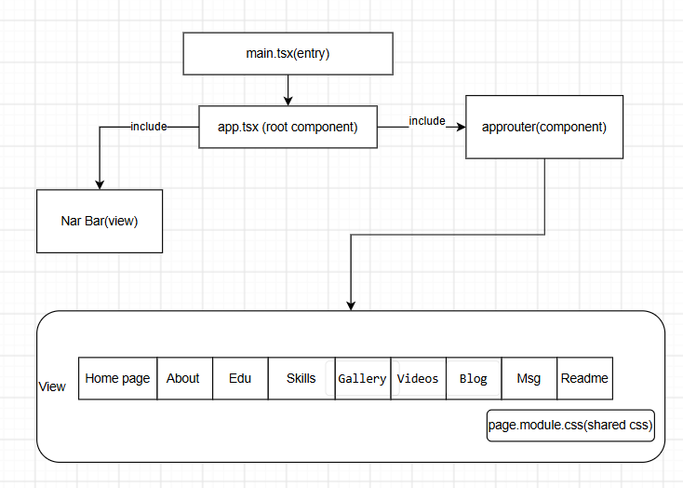

6.2 Component Diagram
Since this project is currently only in the frontend stage and quite simple, you can refer to the component diagram in 6.1 Architectural Overview.

6.3 Control Flow Diagram
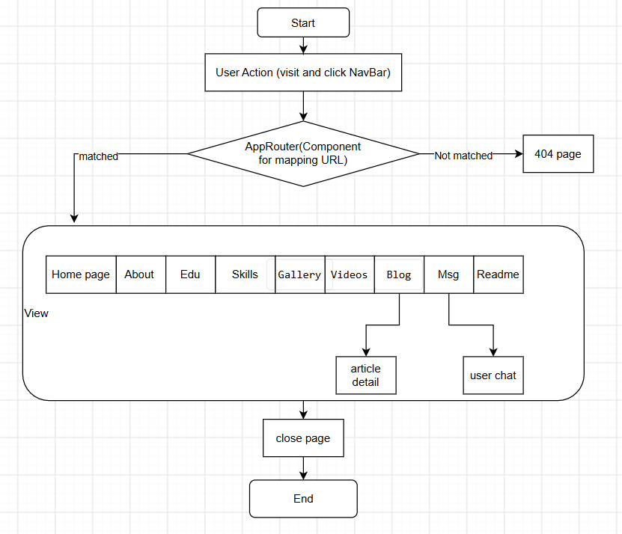

6.4 Design Decisions
1. CSS Variables in index.css: Shared theming and auto dark mode.
2. useChat Hook: Chat logic separated from UI.
3. Static Data Separation: Data constants kept apart from rendering.
4. react-markdown for Blog: Render rich text without a CMS.

7. Code Listing

7.1 GitHub Repository
https://github.com/franklinprivateuse-jpg/assignment

7.2 Project Structure
kewei-portfolio/
├── public/
│ ├── favicon.svg
│ └── icons.svg
├── src/
│ ├── app/
│ │ └── AppRouter.tsx # Route configuration
│ ├── assets/
│ │ ├── background_pricture.png
│ │ ├── hero.png
│ │ ├── react.svg
│ │ └── vite.svg
│ ├── components/
│ │ └── navbar/
│ │ ├── Navbar.tsx
│ │ └── Navbar.module.css
│ ├── hooks/
│ │ └── useChat.ts # Chat logic hook
│ ├── pages/
│ │ ├── page.module.css # Shared page layout
│ │ ├── about/
│ │ ├── blog/
│ │ │ ├── Blog.tsx
│ │ │ ├── BlogDetail.tsx
│ │ │ ├── types.ts
│ │ │ └── *.module.css
│ │ ├── education/
│ │ ├── gallery/
│ │ ├── home/
│ │ ├── knowledge/
│ │ ├── messaging/
│ │ ├── readme/
│ │ └── videos/
│ ├── App.tsx # Root component
│ ├── index.css # Global styles & CSS variables
│ └── main.tsx # Entry point
├── index.html
├── package.json
├── tsconfig.app.json
├── tsconfig.json
├── tsconfig.node.json
├── vite.config.ts
└── eslint.config.js

8. Innovation

8.1 Architecture Innovation
Page-based layout with co-located CSS Modules — no global state, clear separation, Markdown blog without a CMS.

9. Critique

9.1 Strengths
- Clean architecture: pages, components, hooks, and styles are separated.
- Shared CSS variables with auto dark mode.
- Custom Hook: useChat separates logic from UI.

9.2 Weaknesses
- No tests at all.
- No 404 page or Error Boundary.
- No mobile menu (Hamburger Menu) for navbar.

10. Reflection

10.1 Learning Outcomes
- Using CSS variables and CSS Modules for styling.
- Separating logic from UI with custom hooks.
- Page routing with React Router.

10.2 Challenges Faced
- Balancing features and quality in limited time.
- Too many navbar links for mobile screens.

11. References
[1] GeeksforGeeks (2025). Difference Between TypeScript and JavaScript. Available at: https://www.geeksforgeeks.org/typescript/difference-between-typescript-and-javascript/ (Accessed: September 2026).
[2] Mohanty, S. (2024). Difference Between Vite and Normal NPM. Available at: https://medium.com/@mailtosatyabratamohanty/difference-between-vite-and-normal-npm-2097c277beb0 (Accessed: September 2026).

