📺 AP Precalculus - Week 1 Session 1: Video Resources
Date: January 7, 2026 Topics: Right Triangle Trigonometry, Radians, Degree/Radian Conversion, Arc Length Teacher: Lyles

🎯 Learning Objectives
After watching these videos, you will be able to: - Apply SOH-CAH-TOA to find trigonometric ratios in right triangles - Understand radian measure as arc length divided by radius on the unit circle - Convert angle measures between degrees and radians - Calculate arc length using the formula s = rθ

📚 Required Viewing (Before Class)

1. Right Triangle Trigonometry - SOH CAH TOA
NancyPi: “Basic Trigonometry: Sin Cos Tan” 🎥 Watch Now: https://youtu.be/bSM7RNSbWhM ⏱️ Duration: ~10-12 minutes 📖 What You’ll Learn: - Definition of sine, cosine, and tangent - How to use SOH-CAH-TOA mnemonic - Step-by-step examples with right triangles - When to use each trig ratio
Best For: Preview before class, Homework help Watch This If: You need a refresher on trig ratios or don’t remember SOH-CAH-TOA
Thumbnail: 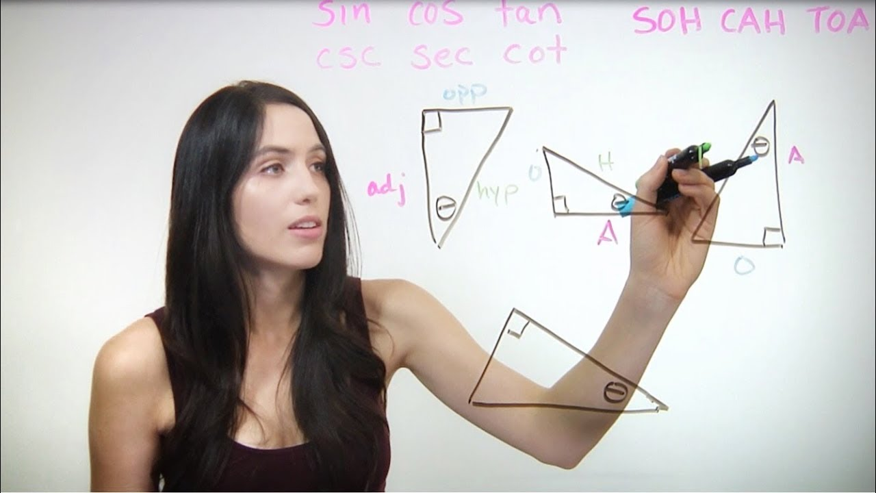

2. Understanding Radian Measure & Conversion
NancyPi: “Radians and Degrees” 🎥 Watch Now: https://youtu.be/l6hSY2Pcch0 ⏱️ Duration: ~8-12 minutes 📖 What You’ll Learn: - What is a radian? (arc length = radius) - Why we use radians in math - Visual demonstration with unit circle - Converting between radians and degrees
Best For: Preview before class Watch This If: The concept of radians is confusing or you need conversion practice
Thumbnail: 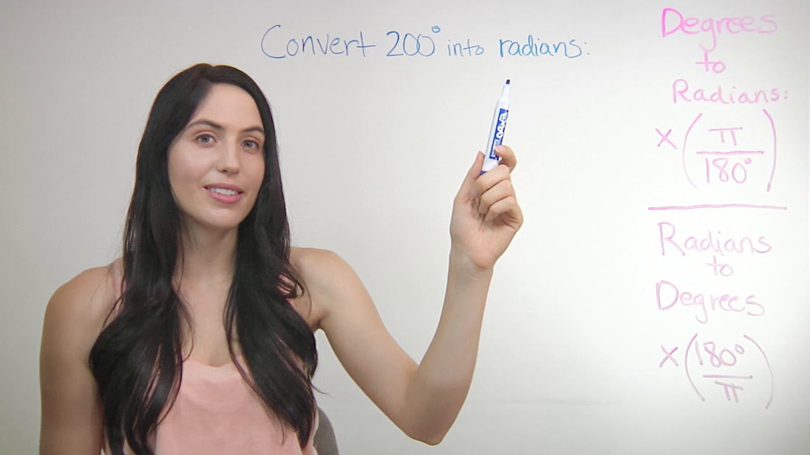

📝 Optional Review (After Class)

3. Solving Right Triangles
NancyPi: “Trigonometry: Solving Right Triangles… How?” 🎥 Watch Now: https://youtu.be/a5WQlcFTXyk ⏱️ Duration: ~10-15 minutes 📖 What You’ll Learn: - How to find missing sides using SOH-CAH-TOA - How to find missing angles - Complete worked examples - Common mistakes to avoid
Best For: Review after class, Homework help Watch This If: You need more practice solving complete triangles
Thumbnail: 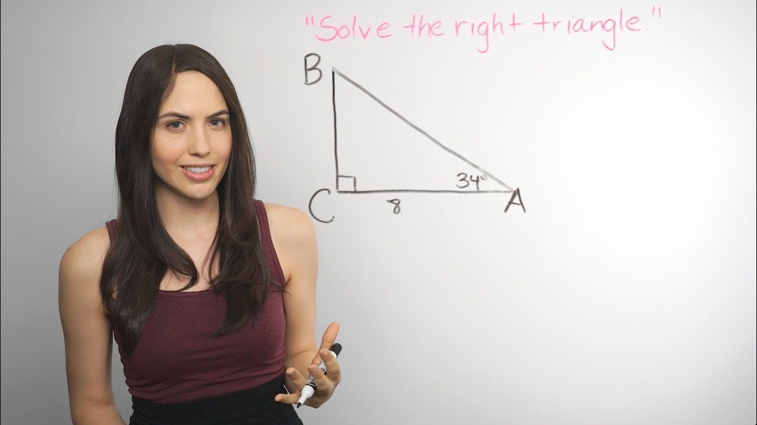

4. Additional Conversion Practice
Khan Academy: “Radians & Degrees” 🔍 How to Find: Search YouTube for: Khan Academy radians degrees conversion ⏱️ Duration: ~7-10 minutes 📖 What You’ll Learn: - Step-by-step conversion process - Practice problems with solutions - Common degree-to-radian values memorization - Why π radians = 180°
Best For: Review after class, Homework help Watch This If: You struggled with conversions in class
Direct Links: - Khan Academy Page: khanacademy.org/math/get-ready-for-precalculus/…/radians - YouTube Search: youtube.com/results?search_query=Khan+Academy+radians+degrees

4. Arc Length Formula
NancyPi: “Arc Length of a Circle Formula” 🔍 How to Find: Search YouTube for: NancyPi arc length formula ⏱️ Duration: ~10-15 minutes 📖 What You’ll Learn: - Derivation of s = rθ formula - How to apply arc length formula - Word problems with circular motion - Connection to radian measure
Best For: Review after class, Homework help Watch This If: Arc length problems are challenging
Direct Links: - Search: youtube.com/results?search_query=NancyPi+arc+length

5. Introduction to Radians (Alternative)
Khan Academy: “Intro to Radians” 🔍 How to Find: Search YouTube for: Khan Academy introduction to radians ⏱️ Duration: ~7-10 minutes 📖 What You’ll Learn: - Conceptual understanding of radians - Why radians are “natural” units - Unit circle with radian measures - Connection to arc length
Best For: Preview before class, Deeper understanding Watch This If: You want a different explanation of radian concept
Direct Links: - Khan Academy Page: khanacademy.org/math/trigonometry/…/v/introduction-to-radians - YouTube Search: youtube.com/results?search_query=Khan+Academy+intro+radians

💡 How to Use These Videos

Before Class (Preview)
✅ Watch Videos #1 and #2 (SOH-CAH-TOA and Radians) ✅ Take notes on key concepts ✅ Write down any questions for class ✅ Try the examples along with the video

After Class (Review)
✅ Watch Videos #3, #4, #5 if you need more practice ✅ Rewatch sections you found challenging ✅ Use timestamps to jump to specific topics ✅ Pause and try problems before seeing solutions

For Homework Help
✅ If stuck on a problem, find the relevant video ✅ Watch the worked example section ✅ Try your problem again ✅ Come to office hours if still stuck (7:30-8:00 AM, 3:30-4:00 PM)

🔗 Quick Reference: Creator Channels
Creator | YouTube Channel | Best For
NancyPi | youtube.com/@NancyPi | Clear step-by-step explanations, visual demonstrations
Khan Academy | youtube.com/@khanacademy | Conceptual understanding, practice problems
MathBFF | Older NancyPi content | Alternative explanations (same creator)

📱 Chromebook & Mobile Users
If video links don’t work in PDF preview: 1. Download this PDF to your device 2. Open in Adobe Acrobat or Google Classroom app 3. Or: Copy the YouTube search text and paste into YouTube.com 4. All videos are mobile-friendly and work on phones/tablets
Alternative Method: - Go directly to YouTube.com - Copy the search terms in quotes (e.g., NancyPi basic trigonometry) - Click the first result from NancyPi or Khan Academy

⚠️ Common Mistakes to Avoid
Based on these videos, watch out for:
❌ SOH-CAH-TOA Errors: - Confusing opposite and adjacent sides - Using wrong trig ratio for the given information - Forgetting to label triangle sides first
❌ Radian Conversion Errors: - Forgetting to multiply/divide by π when converting - Using the wrong conversion formula direction - Not simplifying radian answers (leave as fractions with π)
❌ Arc Length Errors: - Using degrees instead of radians in s = rθ - Forgetting to convert angle measure first - Mixing up radius and arc length

📧 Need More Help?
Office Hours: - Morning: 7:30-8:00 AM - Afternoon: 3:30-4:00 PM
Email: lyles@school.edu
Google Classroom: Post questions in “Week 1” stream
Khan Academy Account: Free practice problems and hints at khanacademy.org

📊 Exit Ticket Preview
To prepare for today’s exit ticket, make sure you can: 1. ✅ Find sin, cos, tan for a given right triangle 2. ✅ Convert 120° to radians 3. ✅ Convert 2π/3 to degrees 4. ✅ Calculate arc length given radius and central angle in radians
Mastery Goal: 3 out of 4 correct with work shown

Document Created: January 3, 2026 Generated By: @video-curator agent Format: Markdown (convert to PDF for distribution) For: Google Classroom upload

🔄 Updates & Additions
This video guide will be updated throughout the week. Check Google Classroom for: - Additional practice videos - Student-recommended resources - Clarification videos for common mistakes
Last Updated: January 3, 2026

