A Proposed Cross-platform Enrollment Management System with Integrated Data Analysis For ACLC Northbay Campus

A Research Project Proposal
Presented to the Faculty of the
Information and Communications Technology Program
AMA Computer Learning Center – Northbay Campus

In Partial Fulfilment
of the Requirements for the Strand
Information and Communications Technology
Barreto, Warren B.
Faa, Frank Nathan V.
Fernandez, Yhunice Kate G.
Maurera, Rizaldy Jose G.
Napiza, Ashley R.
Sabejon, Rafael C.
Santos, Jasraj D.

April, 2026

ENDORSEMENT FORM FOR PROPOSAL DEFENSE

TITLE OF RESEARCH: A Propose Cross-platform Enrollment Management System with Integrated Data Analysis For ACLC Northbay Campus

NAME OF PROPONENTS: Barreto, Warren B. Napiza, Ashley R.
Faa, Frank Nathan V. Sabejon, Rafael C.
Fernandez, Yhunice Kate G. Santos, Jasraj D.
Maurera, Rizaldy Jose G.

In Partial Fulfilment of the Requirements
for the Strand Information and Communications Technology
has been examined and is recommended for Proposal Defense.

ENDORSED BY:

MR. RONEL M. FARIOLEN
Research Project Adviser

APPROVED FOR PROPOSAL DEFENSE:

MRS. JOCELYN R. ISIDRO
Senior High School - Coordinator

NOTED BY:

MRS. EMILY L. QUINTANA
School Directress

APPROVAL SHEET

This research project proposal titled A Propose Cross-platform Enrollment Management System with Integrated Data Analysis For ACLC Northbay Campus, prepared and submitted by Barreto, Warren B. Faa, Frank Nathan V. Fernandez, Yhunice Kate G. Maurera Rizaldy Jose G. Napiza, Ashley B. Sabejon, Rafael C. Santos, Jasraj D. in partial fulfillment of the requirements for the Strand Information and Communications Technology, has been examined and is recommended for acceptance and approval.

MR. RONEL M. FARIOLEN
Capstone Project Adviser

Accepted and approved by the Capstone Project Review Panel
in partial fulfillment of the requirements for the Strand
Information and Communications Technology

<Panelist's Given Name MI. Family Name> <Panelist's Given Name MI. Family Name>
Panel Member Panel Member

<Panelist's Given Name MI. Family Name>
Lead Panelist

Noted:

MRS. JOCELYN R. ISIDRO MRS. EMILY L. QUINTANA
Senior High School – Coordinator School Directress

April, 2026

Acknowledgement

Table of Contents

Introduction of the Study

Background of the Study

Objectives

Statement of the Problem

Conceptual Framework

Hypothesis

Scope and Delimitation of the Study

Significance of the Study

Data Dictionary

Chapter 1

Introduction and Background of the Study

Introduction

Since the establishment of ACLC Northbay Campus in Tondo, it has primarily relied on manual, paper-based processes to handle enrollment tasks. These traditional practices are usually the main roots of inefficient and slow processes, prone to human errors, and provide an extra responsibility for the school administrator. In response to these long-standing and repetitious issues, studying and implementing an Enrollment System with integrated data analysis will create a significant impact in enhancing how technology can improve academic operations while maximizing the machinery capabilities and reliabilities of gathering datas digitally. This system also considers the challenges faced by non-technical facility officers, providing tooltips and user-friendly features to help them explore and use the program effectively. These are the internal problems that the school is facing today with our modern technology.

Aside from that, there are also external factors that make these problems more noticeable. Most educational institutions in our country rarely take advantage of the current technology. Which is why our education system barely makes any progress when it comes to cutting-edge methods. However, some universities like De La Salle University are already using digital systems for gathering school data. If ACLC Northbay continues to rely on old methods, it may get left behind while other schools move forward with recent tools that makes management more convenient.
Enrollment System (ES) will be the foundation of this issue since the system provides a digital solution capable of storing and displaying datas with the help of the database, enabling administrators and future enrollees to perform their duties efficiently, complete operations on time, and reduce the burden of repetitive work. Not only that, It is also capable of assigning the enrolled student into a specific section with an integrated auto-sectioning and auto-export of the sections’ class record. Through the use of this system, schools can minimize human errors, speed up administrative labor, improve records management across the faculty when it comes to enrollment, analyze and visualize data to extract insights and support decision-making, and display the benefits of automation in enhancing scalability and time management. Relying on this study will showcase ACLC Northbay Campus as a good role model and example for other schools, promoting innovation while showcasing the importance of technology in upgrading educational administration.

Background of the Study

Established in October 20, 1980, ACLC Northbay has been a cornerstone of quality education that is under AMA Education System. One of the oldest private schools founded by Dr. Amable R. Aguiluz V, who is widely recognized as the "Father of IT Education in the Philippines." Most Administrators in ACLC Northbay continues to rely on traditional methods to record student information via paperwork. While this method works, it often takes a lot of time and uses up a lot of paper and other resources that may lead to financial burden & mental health instability for the administrators especially when the paper works are piled up.

With the help of modern technology, these tasks can be done much faster, easier and more reliable. In a more specific perspective, automation of auto-sectioning and storage will have a huge impact when it comes to providing benefits in an education institution due to its capability to assign a student into a specific section with a gender-based feature and store student information, academic record and student documents which shows the strength of automation and storage. Due to those benefits, It is capable of driving away the path that leads to confusion and extra work for every school administrator.

In today’s timeline, private universities are already using digital systems to help manage, store and analyze enrollment records. These systems have proven to save time, lessen errors, and make academic management more organized. For ACLC Northbay, adapting to this kind of system is not only a sign of progress but also a way to make work easier for teachers and students who face challenges every day.
This study aims to create an Enrollment System with Data Analysis that will be the path in upgrading ACLC Northbay into a new level. Enrollment System (ES) will serve as a tool that automates the collection and distribution of student information management through the use of the latest technology. Which is why creating a web-based and school-friendly system, will gradually help the school by reducing human errors, save time, and improve coordination between administrators and future enrollees.

In order to validate the problems identified in this study, a survey was carried out among the students of ACLC Northbay Campus to understand how they personally experience the current manual enrollment process. Most of the respondents expressed that the current setup is physically exhausting, as having to go to school just to line up, fill out forms by hand, and submit physical copies of their requirements takes up a lot of their time and money. Several students also shared that not knowing whether their enrollment was accepted or still pending caused them unnecessary stress and anxiety. When asked about their openness to a digital solution, the majority welcomed the idea and expressed that being able to enroll online at any time would be far more convenient for them. These responses from the students themselves served as a strong confirmation that the problems identified in this study are real and are genuinely felt by the people the system is meant to serve.

Objectives
The primary objective of this study is to develop a cross-platform web-based enrollment system that eliminates the need for physical queuing and student transportation by allowing students to register and submit requirements online, while providing school administrators with automated data analysis tools to support informed decision-making.

- To develop a web-based and system-based enrollment website where students can register and upload requirements online, so they don't have to line up at school.

- To develop a secure and centralized student record management system that enables the registrar to efficiently store, retrieve, and manage enrollment data without risk of data loss.

- To provide Data Analysis (Charts/Graphs) for the School Administrator that automatically counts enrollees and shows trends (like the number of males vs. females students) to help in decision-making.

- To develop an Auto-Scheduling feature that captures and manages teacher assignments, room availability, and time slots to reduce manual scheduling conflicts.

- To implement a QR code attendance system that utilizes the system's existing student records to automate daily tracking and improve data integrity

Statement of the Problem
This study aims to address the inefficiencies, data redundancy, and lack of real-time reporting in the current manual enrollment setup of ACLC Northbay.

- What is the level of agreement of the student respondents on the problems encountered in the current manual enrollment process of ACLC Northbay Campus?

- Does the absence of a centralized digital record system cause difficulty for the registrar in storing, retrieving, and managing student enrollment data?

- Does the lack of a data analysis tool limit the ability of administrators to monitor enrollment progress and make informed decisions in real time?

- Does the manual sectioning, scheduling and encoding process contribute to administrative fatigue and human errors in class and faculty assignments?

- Does the manual recording of daily attendance through Excel files cause inefficiencies in tracking student presence?

Conceptual Framework

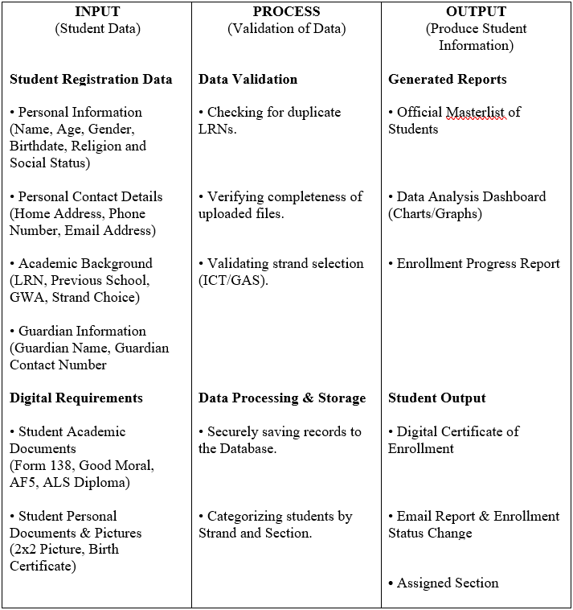

Hypothesis
This study and system hypothesizes the development of an efficient Cross-platform Enrollment system with integrated data analysis that is capable of replacing the traditional way of collecting student information like document keeping with the use of a web-based application. The system is expected to help school administrators in storing the school enrollment record and keeping the student informed to their sections. The Implementation of a web-based application will allow school personnel to easily access students' academic records which will greatly reduce the workload of school staffs.

Further on, staff productivity will increase, human errors will be minimized, record-keeping will be secured, and the overall efficiency of academic monitoring and reporting will improve significantly due to data analysis. Additionally, students and parents will benefit from the accurate feedback regarding the result of the result of the admission. Lastly, this study is foreseen to influence ACLC Northbay students to focus on implementing an innovative technology to reduce the physical burden of the students and greatly reduce the workloads of the administrators.

Scope and Delimitation
This study focuses on the design and development of a Cross-platform Enrollment Management System with Integrated Data Analysis For ACLC Northbay Campus. The current iteration of the system is deployed in a cloud-based Developer Environment (Free Tier) for testing and evaluation purposes. The institution should decide for full-scale implementation in the succeeding academic years, migrating to a commercial production tier (School Domain and Supabase Pro) will be required to handle heavy traffic and continuous deployment.

Scope of the Study

This section specifies the cover and inclusions of the research. This system COVERS the following specific functionalities:

- Online Student Registration: A public portal where students can input their demographic profile (Name, Age, Gender), educational background (LRN, Previous School), and contact details.

- Digital Requirement Submission: A feature allowing students to upload digital copies of necessary documents (Form 138, Birth Certificate, and Good Moral Character Certificate) for verification.

- Administrator Dashboard and Data Analysis: An overview of the database and analysis for the School Administrator that automatically generates visual analytics, including Enrollment Velocity, Total Enrollees, Graduates Revenue and Strand Distribution.
- Secure Student Database: A cloud-based database (Supabase) that securely stores student records, preventing data loss and allowing for easy retrieval via search filters (LRN/Name).

- QR Code Attendance Tracking: A feature that allows for the digital QR code recording of daily student attendance, providing a real-time log that can be exported for educational decision-making of the teachers.

- Auto-Scheduling: An automated tool that generates class schedules based on room availability and time slots, reducing the manual labor and "administrative fatigue" mentioned in the research.
Predictive Analytics: A data-driven forecasting module that uses a four-model ensemble — Ordinary Least Squares (OLS), Recency-Weighted OLS, Polynomial Regression, and Exponential Smoothing — to project future enrollment numbers, helping administrators anticipate enrollment spikes and allocate resources proactively.
Teacher Management Portal: A dedicated teacher dashboard that allows teachers to view their assigned schedules, manage daily attendance through QR code scanning, detect students with repeated absences via the Cutting Class Detector, generate exportable attendance reports, and receive announcements posted by the administrator.
Student Portal: A secure student account system where enrolled students can log in to view their enrollment status, section assignment, class schedule, and personal information.
Communication System: A real-time announcement board backed by Supabase that enables administrators to post announcements visible to teachers and students, improving information dissemination across the institution.
Activity Logs and Audit Trail: A comprehensive logging system that records all administrative actions within the system, providing accountability and traceability for enrollment decisions, section changes, and system configuration modifications.
Archive System: A historical record-keeping feature that captures a "snapshot" of enrollment data at the end of every school year, enabling administrators to view, compare, and restore data from previous academic periods for long-term planning and reporting.

Delimitations of the Study

This section specifies the boundaries and exclusions of the research. The following aspects are NOT included in the system:

- Exclusion of Grading & Learning Management: The system does not record quizzes, assignments, exam scores, or compute grades. It is strictly for the admission and enrollment phase only.

- No Website Payment: The system does not process transactions (credit card/GCash payments). It only strictly focuses on the submission of enrollment data and requirements.

- No Human Resource (HR) Functions: The system does not manage school staff payroll, employee performance evaluations, or staff personal records. While the system includes an Auto-Scheduling feature that assigns teachers to subjects and rooms, it does not extend to payroll processing or performance management.

- Cloud-Only Deployment: The system requires a stable internet connection and is not designed for offline or local-only server operation.

Significance of the Study
This research will provide benefits to the following groups: ‎
School Administrators - They gain full control over the enrollment process, including approving or declining student applications, managing sections, and exporting the official student masterlist. The data analytics dashboard provides real-time enrollment insights, while the archive feature stores historical enrollment records and gives access to website settings, schedules, and the chat system for long-term planning and school record-keeping.
Teachers – They benefit from the auto-scheduling feature, which eliminates manually distributed schedules. The QR Code Attendance system allows teachers to digitally monitor daily student presence and access the masterlist for their assigned sections.
Students - They benefit from a fully digital enrollment process, eliminating physical queuing, long lines, and in-person document submission, saving them time and money on transportation and printing.
Parents / Guardians - They are automatically notified when their child's attendance is recorded via QR Code, ensuring they are informed of their child's presence in school and building trust in school safety.
Future Researchers - This research serves as a reference for those looking to develop or improve similar systems, particularly enrollment platforms with integrated data analysis.
IT Administrators and School System Developers - This system serves as a model for how a project initially scoped as an enrollment system can organically evolve into a comprehensive school management platform. The modular architecture — with separate portals for students, administrators, and teachers — demonstrates best practices in scalable web application design that other institutions can replicate and customize.
Data Dictionary
Administrative labor - The physical and mental effort released by school staff to process enrollment forms, which this study aims to reduce through automation.
Cornerstone - Refers to the top of the highlight or essential foundation of education institutions when it comes to Information and Communication Technology (ICT).
Data Analysis - The feature of the proposed system that processes enrollment numbers to reveal progress and support administrative decisions.
Data encoders - The current, repetitive role of admission officers who must manually type student information from paper forms into the computer.
Data entry - The specific task of inputting student details, which the proposed system shifts from the staff to the students via online registration.
Data verifiers - The evolved, more efficient role of admission officers in the new system, where they simply check the accuracy of online submissions.
Enrollment System (ES) - The proposed web-based application designed to automate the registration, documentation, and record-keeping of ACLC Northbay.
Enrollment Tasks - The specific activities required to admit a student, including form filling, requirement submission, and grade validation.
Innovative technology - Refers to the modern digital tools, such as web development and predictive analytics, applied to upgrade the school's outdated processes.
Less techy admission officer - School personnel who may not have advanced computer skills, indication the need for a simple, easy-to-use interface.

Machine learning algorithms - The computational logic used within the system to analyze historical data and forecast future enrollment numbers, synonym for technology.
Machinery - Refers to the internal digital mechanism and logic of the system that processes student data automatically.
Manual Enrollment Tasks - The traditional activities, such as writing on logbooks and sorting papers, that currently cause delays in the admission process.
Manual, paper-based processes - The existing method at ACLC Northbay relying on physical documents, which results in data redundancy and storage issues.
Predictive Modeling - A statistical function in the dashboard that uses past data to predict how many students will enroll in specific strands for the next school year.
Repetitious issues - The present problems, such as long queues and lost files, that plague the school every semester due to the manual system.
School-Friendly - A design priority ensuring the system is intuitive and easy to navigate for students, parents, and non-technical staff.
Stand-alone application - Describes the proposed system as a dedicated platform focused specifically on enrollment functions, independent of other school software.
Traditional Methods - The conventional, pre-digital ways of handling admissions that require physical presence and handwriting.
Traditional Practices - The long-standing habits and workflows in the admission’s office that are now considered inefficient compared to digital solutions.
Activity Logs - A system feature that records every administrative action performed within the system, serving as an audit trail for accountability and system monitoring.
Archive System - A historical data management feature that captures snapshots of enrollment data at the end of each school year for long-term record-keeping and trend comparison.
Cutting Class Detector - An automated attendance analysis tool within the teacher portal that flags students with repeated absences or patterns of skipping classes.
Ensemble Model - A predictive analytics approach that combines multiple statistical models (OLS, Recency-Weighted OLS, Polynomial Regression, Exponential Smoothing) to produce more accurate enrollment forecasts.
Predictive Analytics - The system's forecasting capability that uses historical enrollment data and statistical models to project future student counts, helping administrators in strategic planning.
QR Code Attendance - A digital attendance tracking method where teachers scan student QR codes to record daily presence, replacing manual roll calls and Excel-based attendance sheets.
Rate Limiting - A security mechanism implemented using Upstash Redis that restricts login attempts to prevent brute-force attacks, protecting the admin and teacher portals.
Real-time Subscriptions - A feature powered by Supabase Realtime that allows the admin dashboard to instantly reflect changes without page refresh when new students enroll or data is modified.
Row Level Security (RLS) - A database-level security policy in Supabase that restricts data access based on user roles, ensuring that each portal can only access authorized data.
Teacher Portal - A dedicated web interface for teachers to manage attendance, view schedules, access student lists, receive announcements, and generate reports.
Turnstile - Cloudflare's bot protection mechanism integrated into the enrollment form to prevent automated spam submissions while maintaining a frictionless user experience.

Chapter 2

Review of Related Literature

Foreign Literature

Estimate undergraduate Student Enrollment in Courses by Re-purposing
Recommendation Tools
Khan, M. A. Z., et. al. (2024). ‎Resource distribution at university is challenging, as the management needs to allocate teachers, rooms, and other facilities according to the number of students in each course. In order to facilitate the aforementioned task, the research evaluated various machine learning approaches that rely on the past enrollment data to predict the number of students for each course in the next semester.

‎ The first step in this process was to implement a course recommendation model that would identify the subjects with the highest likelihood of selection by students, after which the researchers arrived at the student count based on this insight. The research concluded that their suggested method gives accurate and consistent results after experimenting with a variety of models including recommendation systems, time-series methods, and regression techniques.

Enhanced Student Admission Procedures at Universities Using Data Mining and Machine Learning Techniques
The research done on Foreign Literature from Saudi Arabia by Assiri, & Bashraheel, et al. (2024). indicates that conventional university admission methods, which are largely based on generalized cumulative scores (such as GPA and standardized test results), are not successful in predicting student success in all majors, thus, causing a high number of failures and dropouts. The scenario calls for a data-driven student placement system.

The first point in the paper is the use of Data Mining to demonstrate that the predictive power of admission features changes drastically from one major to another and also that it is very important to use the hidden details like the grades of high school courses. It also states that Machine Learning models were implemented to determine the suitable majors for students with the K-Nearest Neighbor (KNN) algorithm reaching 100% accuracy. The research concludes that ML models are indispensable in the creation of precise, skills-based admission criteria which thus, leads to a substantial increase in student enrollment and educational outcomes.

Materials and methods on digital enrollment system for educational institutions
Chamilco, & Pacheco, e.t.al (2023) Indicated that their literature revolves around the issues of enrollment delays and crowding at an educational institution which were addressed by the creation of a fully digital enrollment system. The researchers have undergone a four-phase development process for the system which includes: planning the system requirements, designing a simple and functional model, coding the system using appropriate programming languages, and testing it for errors.

The digital system has made the key enrollment tasks of student registration, record handling, and report generation more efficient. Consequently, the institution has been able to lessen the long queues, waiting time, and manual workload. Additionally, the system enabled remote collaboration between students and the institution, thus, ensuring quicker, more spacious, and fairer enrollment which was very necessary during the pandemic. This evidences the proposition that digital enrollment systems can considerably facilitate efficiency and accessibility in education.

Enrollment Appraisal Using Rule-Based Decision Support
Villaruz, R. J. G., & Diamante, R. A. (2024)) studied about Enrollment Appraisal Using Rule-Based Decision Support System. The study talks about creating a web-based system that helps schools check and approve student enrollment applications. The system uses a rule-based decision support system, where student information is reviewed based on set rules for enrollment. The system was divided into two sections.

One part was used by students to enter their information, while the other part handled the processing of the data in a secure way. The developers used the RAD method so they could make changes to the system as it was being built. The evaluation results showed that the system was easy to use and had acceptable security. Some users, however, pointed out issues with the layout and said that some instructions were not very clear. Even with these issues, the study showed that a rule-based system can help schools manage enrollment in a simpler and more organized manner.

A Practice in Enrollment Prediction with Markov Chain Models
Zhao, Y. & Otteson A. (2024) stated that the review is based on the described study, which aimed to determine the applicability of the Markov Chain models in the forecasting of the student enrollment of a university. In many schools, forecasting student enrollment is a significant predictive analysis that one needs in order to successfully run the schools. In many institutions, however, the process of forecasting student enrollment is not well explained. The authors of the study found that despite the uncertainty that had affected the educational sector, such as the COVID-19 pandemic, the difference between the allocated student population and the numbers projected with the help of the improved Markov Chain models ended up being less than 1%. Markov Chain models, thus, appear to be useful in the forecasting of student enrollments in institutions of higher learning in the future.

Local Literature

University Enrollment and Graduate Trends: Basis for Long-Term Development Plan
Guiamalon, Amad, and Dalamban (2025) emphasized that enrollment data should serve as a strategic asset rather than a mere static record. In their analysis of university trends from 2018 to 2025, they demonstrated how historical data can be utilized to forecast future student populations and identify fluctuations in specific academic programs.

They argued that without such data-driven insights, institutions struggle with resource allocation and long-term planning. This supports the current study’s proposition that an enrollment system must go beyond data entry; it must include predictive analytics to help administrators at ACLC Northbay anticipate enrollment spikes, allocate resources efficiently, and make informed decisions for upcoming academic terms.

Enhancing Academic Efficiency: A Comprehensive Online Enrollment System for College Students in Asbury College Incorporated
Aspa et al. (2025) emphasized that in the digital era, online enrollment systems play a crucial role in resolving the inefficiencies of traditional manual processes, such as long queues, repetitive procedures, and errors arising from illegible handwriting. Their study focused on developing an Online Enrollment System for Asbury College Incorporated to enhance operational efficiency, data accuracy, and user experience.

By implementing this platform, the researchers eliminated the need for physical forms, thereby streamlining procedures and offering a more accessible enrollment method. The results demonstrated that the system successfully minimized errors, reduced waiting times, and optimized administrative tasks, achieving an overall weighted mean score of 4.29, interpreted as “Excellent.”

Web-Based Enrollment System: An Evaluation
Ali‎, A. R (2022) This study assessed the effectiveness of the Online Enrollment System at Baliwasan Senior High School (Zamboanga City) during SY21, 22. A descriptive quantitative method was used to gather survey data through Google Forms from 11th and 12th graders. ‎ ‎The study demonstrated that respondents rated the Online Enrollment System as ‘Very Good’ in terms of use. In addition, there were no significant differences between 11th and 12th grade responses. Hence, it can be concluded that the system functions well; however, opportunities exist for further enhancement of the design and the user experience with the system.
Evaluating Satisfaction and Intention of Online Enrollment: A Case of a University in the Philippines
According to Berro and Waing (2025) Online Enrollment system is crucial to the expansion of the school population. Especially during the pandemic, online system have become essential when it comes to ensuring students’ education will be continued safely, prioritizing online enrollment and e-learning for institutions. Their study investigates students’ satisfaction and intention to use Caraga State University’s online enrollment. Additionally, their study conducted a quantitative research approach which utilizes Partial Least Squares Structural Equation Modeling (PLS-SEM) for data analysis.

Besides that, Berro and Waing (2025) evaluated the system by measuring Perceived Usefulness (PU), Perceived Ease of Use (PEOU), and Satisfaction (S) to determine students' Intention to Use (IU). The findings revealed a clear hierarchy of influence: while PEOU significantly enhanced both usefulness and satisfaction, it did not directly drive the intention to use. Instead, the study found that Perceived Usefulness was the pivotal factor, significantly influencing both satisfaction and intention. Consequently, the researchers concluded that while usability (ease of use) is necessary to make a system feel useful, it is the system's actual utility and the resulting user satisfaction that ultimately compel students to adopt it.

Enrollment Management System of Novaliches High School
Canizo M. et al. (2024) The researchers conducted a study to create an EMS (Enrollment Management System) for Senior High School at Novaliches High School located in the Quezon City, where the enrollment process had been done manually. The manual system led to considerable delays, long waiting lines, and also problems for the students, their guardians and the school employees. Therefore the researchers brought up an EMS that would make the admission and enrollment process smoother by providing an online platform.

The system's main goal was to automate the enrollment, track the students who have come, and monitor those who have completed or submitted school requirements so that the time saving and the load reduction of the administrative staff could be achieved. The study's focus was on the enrollment operations and the school employees, and it aimed at improving the overall productivity and efficiency of the school’s enrollment process.

The researchers acknowledged that the Enrollment Management System developed indeed served the school's requirements and efficiently tackled the problems that had been previously identified. The system was declared functional, effective, and ready for use, which was the reason why students and teachers were all pleased with it. The EMS not only managed to shorten the duration of enrollment processes and submission of requirements but also to upgrade the whole enrollment experience.

Synthesis of Related Review of Literature
The result among researchers is clear. Relying on manual enrollment is no longer sustainable. Studies by Chamilco and Pacheco (2023) and Canizo et al. (2024) agree that traditional methods are the main culprit behind long queues and administrative delays.
Aspa et al. (2025) take this further, explaining that digital systems don’t just speed things up—they also fix common human errors like illegible handwriting. Furthermore, Villaruz and Diamante (2024) point out that while security is crucial, moving to the web is the only way to truly organize student data efficiently.

But simply recording data isn’t enough anymore and schools need to understand it. Guiamalon et al. (2025) argue that enrollment data should be a strategic tool, a sentiment strongly backed by Khan et al. (2024) and Zhao and Otteson (2024), whose work proves that historical data can accurately predict future student counts. Assiri and Bashraheel (2024) also emphasize that using these analytics helps schools place students in the right courses better than generic scoring systems.

Finally, the success of any system depends on the people using it. Ali (2022) found that while digital systems function well, there is always room to improve the experience. Berro and Waing (2025) offer a crucial reminder, students won’t adopt a new system just because it’s easy to use; they will only embrace it if they perceive it as genuinely useful. This research combines these insights, aiming to build a system for ACLC Northbay that creates the efficiency demanded by Aspa and Canizo, while delivering the powerful analytics envisioned by Guiamalon and Khan.
Chapter 3

Research Methodology

Technical Background
This chapter presents a summary of the technologies currently used in developing A Proposed Cross-platform Enrollment Management System with Integrated Data Analysis For ACLC Northbay Campus, including the resources utilized, a Gantt Chart illustrating the project timeline, and the system's technical requirements.
Research Design
This study utilizes the developmental research design method in creating and evaluating the proposed Cross-platform Enrollment Management System with Integrated Data Analysis for ACLC Northbay Campus. Developmental research is appropriate because the study aims to design, develop, test, and assess a system that will improve the school's current manual enrollment process, administrative record-keeping, attendance monitoring, and data-driven decision-making capabilities.
According to Richey and Klein (2007), developmental research involves the systematic study of designing, developing, and evaluating instructional programs, processes, and products that must meet criteria of internal consistency and effectiveness. This design is well-suited for the current study because it encompasses the entire lifecycle of system creation — from identifying the problems of manual enrollment at ACLC Northbay, to designing and building the digital solution, and finally evaluating its acceptability through respondent feedback.
System Development Method
The study follows a hybrid development approach that combines the Rapid Application Development (RAD) methodology with Agile practices as the system development strategy. RAD is suitable because it emphasizes fast prototyping and iterative delivery over strict, sequential planning. Meanwhile, Agile practices — including continuous improvement, regular testing, and feedback from end-users — allow the researchers to make revisions and adjustments to the system whenever problems or additional requirements are identified. Through this hybrid approach, the researchers were able to rapidly expand the system beyond its original enrollment scope to include teacher management, QR-based attendance tracking, predictive analytics, and a comprehensive communication system.
The research process is divided into several phases:
Planning Phase
The researchers conducted interviews with the school administrators and registrar of ACLC Northbay Campus to identify the current problems in enrollment processing, record-keeping, scheduling, and attendance monitoring. Existing procedures, enrollment methods, and student concerns were observed and documented. The researchers identified the functional and non-functional requirements of the proposed system.
Design Phase
The researchers prepared the interface design, system flowchart, database structure, and webpage layout of the system. The design included portals for Students (enrollment wizard), Administrators (dashboard, applicants, sections, schedules, analytics, settings, archive, communication), and Teachers (schedule, attendance, cutting class detection, reports, announcements). The design phase ensured that the system is user-friendly, accessible, and mobile-responsive using a "Mobile-First" approach with Tailwind CSS.
Development Phase
The researchers developed the system using Next.js 16 (React Framework), TypeScript, Tailwind CSS 4, and Supabase as the backend. Features such as the five-step enrollment wizard, admin dashboard with real-time analytics, section management with auto-scheduling, QR code attendance tracking, predictive analytics using a four-model ensemble (OLS, Recency-Weighted OLS, Polynomial Regression, Exponential Smoothing), and a real-time communication system were integrated. The researchers continuously tested the developed features to ensure proper functionality.
Testing Phase
The researchers conducted system testing to determine if all features function properly. Testing included usability testing, compatibility testing across devices (desktop and mobile), functionality testing of all three portals, and security verification of Row Level Security (RLS) and rate limiting. Respondents and selected users evaluated the system based on ease of use, accessibility, convenience, and overall performance.
Evaluation Phase
The researchers distributed survey questionnaires to sixty (60) respondents to evaluate the effectiveness and acceptability of the proposed system. The collected data was analyzed using weighted mean and percentage formulas. The results determined whether the system successfully addresses the problems of manual enrollment, scheduling conflicts, inefficient attendance tracking, and lack of data-driven decision-making tools.

Technologies to be Used

The development of the Cross-platform Enrollment Management System with Integrated Data Analysis for ACLC Northbay Campus will require modern software technologies to ensure responsive design, secure data storage, and real-time analytics. The following technologies are proposed for the creation of the system:

1. Programming Languages & Frameworks
- Next.js (React Framework) – for developing the core web application, handling server-side rendering (SSR) for speed, and managing the routing between the student and admin portals.
- TypeScript – for ensuring type-safety in the code, reducing system errors, and improving the maintainability of the enrollment logic.
- Tailwind CSS – for designing a "Mobile-First" user interface, ensuring the system adapts seamlessly to smartphones, tablets, and desktops.
2. Database Management System
- Supabase (PostgreSQL) – to store massive amounts of student records, enrollment history, strand classifications, and system logs. This database allows for complex queries needed to filter students by strand (ICT/GAS) and status.
3. Data Processing & Visualization Tools
- Recharts Library – A composable charting library used to render the dynamic "Data Analysis" visualizations (Enrollment Velocity, Gender Distribution, and Strand Capacity).
- XLSX (SheetJS) – A library used to generate and export the "Masterlist" and "Enrollment Reports" into Microsoft Excel (.xlsx) or CSV formats for the Registrar's offline use.
- Date-fns – A lightweight library used for manipulating and formatting dates (e.g., calculating "Enrollment Velocity" based on the last 30 days).
- Supabase Realtime – to enable the "Live Dashboard" feature, allowing the Registrar to see new enrollees instantly without needing to refresh the page.
4. Email Notification Integration
- Brevo – A transactional email API service used to send automated notifications to students regarding their enrollment status and attendance record.
- Deno (Supabase Edge Functions) – A secure, server-side runtime used to execute the backend logic for sending emails. This ensures that email triggers happen quickly in the cloud without slowing down the main website performance.

5. Cloud Storage & Hosting
- Supabase Storage – to securely store digital copies of student requirements (Scanned PSA Birth Certificate, Form 138/Report Card, and Good Moral Certificate).
- Vercel – to host the web application on the cloud, making it accessible to students and staff via the internet 24/7.
6. Development Tools
- Cursor – the primary code editor used for programming and debugging the system.
- Git & GitHub – for version control, allowing the researchers to track changes in the code and collaborate efficiently.
- Google Chrome / Microsoft Edge – for testing the system’s responsiveness and compatibility across different web browsers.
7. Hardware Requirements
- Desktop Computer or Laptop – for the School Administrator and Registrar to access the main dashboard and manage student sections.
- Mobile Devices (Smartphones/Tablets) – for students to access the enrollment portal, fill out forms, and upload requirements remotely.
- Stable Internet Connection – required for the system to communicate with the cloud database and for users to access the website.

Calendar of Activities (Gantt Chart)
The activities are summarized in the Gantt Chart of activities and its duration of execution, wherein each month consists of four (4) weeks. Cells filled with yellow indicate the progress and blue indicates for completion.

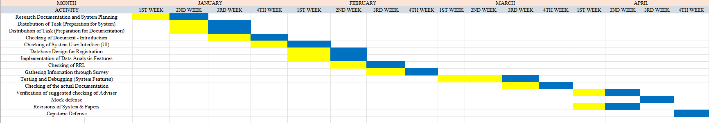

Budget Allocation

Items | Description | Price
Documents | Printing of Hard document papers, consultation forms, endorsement letter, and folder needed | Php. 1,350.00
Others | Transportation/Food | Php. 500.00
Total: |  | Php. 1,850.00
Table 1: Budget Allocation
Data Gathering Instruments
The primary data gathering instrument used in this study is a survey questionnaire. The questionnaire was designed to gather information regarding the problems encountered by students in the current manual enrollment process at ACLC Northbay Campus, as well as their openness to adopting a digital cross-platform enrollment system. The survey used a five-point Likert scale ranging from Strongly Agree (5) to Strongly Disagree (1) to measure the level of agreement of the respondents on each statement.
Aside from the survey questionnaire, the researchers also used interviews and observations as secondary data gathering instruments. Interviews with school administrators, the registrar, and selected teachers were conducted to gather information regarding the current enrollment process, record-keeping methods, scheduling concerns, and attendance monitoring challenges. Observation was also used to study the existing manual enrollment system and identify the common problems encountered in daily operations, including long queues, paper-based form processing, and the absence of real-time enrollment status updates for students.
Respondents of the Study
The respondents of the study consist of sixty (60) selected students from the Information and Communications Technology (ICT) strand of AMA Computer Learning Center – Northbay Campus. These respondents were chosen because they are directly affected by the current manual enrollment process and are the primary end-users of the proposed Cross-platform Enrollment Management System.
The respondents include students from the following age groups: seventeen (17) and below, eighteen to twenty (18–20) years old, twenty-one to twenty-five (21–25) years old, and twenty-six (26) and above. The majority of the respondents fall within the typical senior high school age range, which suggests familiarity with digital tools and technology.
The researchers used purposive sampling in selecting the respondents. Purposive sampling is appropriate because the study requires participants who have direct knowledge and experience regarding the current manual enrollment process of ACLC Northbay Campus. As ICT strand students, the respondents possess the technical literacy needed to meaningfully evaluate a digital enrollment system.
Statistical Treatment of Data
The data gathered from the survey questionnaires was analyzed using the weighted mean to determine the average responses of the respondents regarding the problems of the current manual enrollment process and their openness to the proposed digital system.
The formula for weighted mean is:
Weighted Mean = Σfx / N
Where:
Σfx = Total weighted score (sum of frequency × scale value)
N = Total number of respondents
Additionally, the percentage formula was used to determine the distribution of respondents by age and sex:
P = f / N × 100
Where:
P = Percentage
f = Frequency
N = Total number of respondents
The interpreted results determine whether the respondents Strongly Agree, Agree, Neither Agree nor Disagree, Disagree, or Strongly Disagree with each statement, based on the following scale:
5 (4.50 – 5.00) = Strongly Agree
4 (3.50 – 4.49) = Agree
3 (2.50 – 3.49) = Neither Agree nor Disagree
2 (1.50 – 2.49) = Disagree
1 (1.00 – 1.49) = Strongly Disagree

Requirements Analysis
This section focuses on the analysis conducted for the development “Cross-platform Enrollment Management System with Integrated Data Analysis for ACLC Northbay”. It includes the collection and evaluation of both functional and non-functional requirements, assessment of user needs, system performance, security measures, and integration capabilities, all aimed at ensuring the creation and implementation of a seamless, efficient, and secure enrollment system.

A. Who – People Involved
The following beneficiaries will interact with or benefit from the proposed system:
1. School Administrator
- Approve or decline student enrollment applications.
- Manage student sections and export the official student masterlist.
- Access the Data Analytics Dashboard to view real-time enrollment trends.
- Review historical enrollment records using the System Archive feature.
- Manage website settings, schedules, and the chat system.
- Maintain the cloud database, user accounts, and security settings.
2. Teachers
- View their automatically generated class schedules via the Auto-Scheduling feature.
- Use the QR Code Attendance system to digitally record and monitor daily student attendance.
- Access the student masterlist for their assigned sections.
3. Students
- Register online using their own devices (Mobile/Laptop) without visiting the campus.
- Upload digital requirements (PSA, Form 138) directly to the system.
- View their enrollment status (Pending, Accepted, or Declined) in real-time.
- Parents / Guardians
- Receive automatic arrival notifications when their child's attendance is recorded via QR Code.
- Stay informed of their child's assigned section.

B. What – Business Activity
The proposed system will support the following business activities:
- Online Student Registration: Filling out demographic forms via a web portal.
- Digital Document Submission: Uploading scanned copies of requirements securely.
- Automated Validation: The system instantly verifies data accuracy by blocking duplicate LRNs, ensuring all required fields are filled, and auto-filtering students by their chosen Strand (ICT/GAS).
- Data Visualization: Automatically converting raw student data into visual charts (Pie Charts, Bar Graphs) for administrative analysis.
- Section Management: Assigning students to specific sections based on slot availability and tracking section capacity limits.
- Auto-Scheduling: Automatically generating conflict-free class schedules based on teacher availability, room availability, and time slots.
- Arrival Notification: Automatically alerting parents or guardians via notification when their child's QR Code attendance is recorded."
- Data Exportation & Reporting: Generating and downloading the official student masterlist and enrollment analytics into offline formats (Microsoft Excel / .xlsx) for administrative records and printing.

C. Where – Environment of Operation
The system acts as a Cross-Platform Web Application, meaning it operates in two environments:
Client-Side (User Environment):
- Home: Students can enroll from the comfort of their homes using Smartphones or Laptops.
- School: Registrars and Administrators access the system via Desktop Computers in the administrative office.
Server-Side (Technical Environment):
- Cloud Hosting (Vercel): Where the website application is deployed and accessible via the internet.
- Cloud Database (Supabase): Where all student records, files, and analytics data are securely stored.

D. When – Timing of Operations
The system will operate during the following times:
- 24/7 Accessibility: Students can submit applications and upload requirements at any time, day or night.
- Business Hours Processing: The Registrar validates and approves applications during official school office hours.
- Real-time Analysis: The Dashboard updates instantly the moment a student successfully enrolls.
- Yearly Archiving: The system captures a "Snapshot" of the matrix at the end of every school year for historical record-keeping.
E. How – Current Procedures
Current Manual Procedure:
- Students are physically required to arrive in the school to obtain a registration form.
- Forms are filled out manually using pen and paper.
- The Registrar manually types names and details into an Excel file.
- Administrators manually count enrollees at the end of the month to check strand populations.
- Students must physically return to the school to ask if their application was accepted.
- Student application forms are passed out manually to the registrar.
Problems Identified:
- Physical arrival is required to obtain the registration form.
- Prone to common human errors
- Highly repetitive, time-consuming work that causes administrative fatigue and typing errors.
- Admin Personnel lack real-time data on enrollment velocity, delaying crucial decisions.
- Leaves students anxious and uninformed about their official enrollment status.
- Physical papers can be misplaced, damaged by water/fire, or lost.

Requirements Documentation
This document presents the Requirement Documentation for the proposed Enrollment Management System with Data Analysis. This section establishes the agreement between the School Registrar and the developers regarding what the software must do, how it will function, and what features it must contain.
Functional Requirements
These are the specific "features" we built into the code.
1.1 Access Control Module
- Secure and stable entry for the School Administrators and Registrar using email/password.
1.2 Online Registration Module
- Fields for the Student Information and Academic Information.
- Secure drag-and-drop zone for scanning PSA and Form 138 images.
- System automatically rejects if an LRN already exists.
1.3 Registrar Dashboard Module
- Interface to View, Approve, or Reject student applications.
- Ability to switch students into specific sections.
- Visual indicator if a section is full.

1.4 Data Analysis Module
- Enrollment Velocity Chart: Line graph showing how fast enrollment is growing day-by-day.
- Demographic Pie Chart: Visual breakdown of Male vs. Female enrollees.
- Strand Distribution: Bar graph comparing ICT vs. GAS population.
- Gender-Based Enrollees: Male and Female is separated to identify which gender is dominant.

1.5 Automated Notification Module
- Automatically sends an email to the student when their status changes to "Accepted."*
- Automatically sends an arrival notification to the parent or guardian when the student's QR Code attendance is recorded.
1.6 Auto-Scheduling Module
- Generates conflict-free class schedules based on teacher availability, room availability, and time slots.
- Eliminates manual schedule distribution and reduces administrative errors in class assignments."
1.7 Reporting & Archiving Module
- One-click download of student lists into Excel/CSV format.
- "Time Machine" feature to save and view data from previous school years.
1.8 Predictive Analytics Module
Four-model ensemble forecasting engine (OLS, Recency-Weighted OLS, Polynomial Regression, Exponential Smoothing) that predicts future enrollment counts based on historical data.
Interactive enrollment trend chart and market potential visualization for data-driven resource planning.
Simulation mode allowing administrators to test "what-if" scenarios by adjusting historical data points.
1.9 Teacher Portal Module
Dedicated teacher login with session-based authentication and rate-limited access.
Tabbed dashboard interface with Schedule, Attendance, Cutting Class Detector, Student Detail, Reports, Announcements, and Academic Calendar views.
QR code scanner (using jsQR library) for marking student attendance as Present, Late, Absent, or Excused, with manual fallback entry and real-time sync via Supabase.
1.10 Student Account Module
Secure student login portal where enrolled students can view their enrollment status, section assignment, and personal records.
Password setup and reset functionality for student accounts.
1.11 Communication Module
Real-time announcement board backed by Supabase for administrator-to-teacher and administrator-to-student communication.
1.12 Activity Logs Module
Comprehensive audit trail recording all administrative actions for accountability and system monitoring.
1.13 Security Module
Cloudflare Turnstile integration for bot protection on the enrollment form.
Upstash Redis-based rate limiting on admin and teacher login endpoints (10 requests/minute per IP).
Row Level Security (RLS) policies on all Supabase tables to enforce role-based data access.

Non-Functional Requirements
These describe "how well" the system performs.
Performance
- The website loads in under 5 seconds on mobile data (4G).
- The Admin Dashboard updates within milliseconds when a new student enrolls.
Security
- Row Level Security (RLS)
- Data Encryption
- AES-256 Encrypted Portal
User Experience
- User-Friendly Interface
- Tooltips are present for non-technical facility officers
- Mobile-Supported
Reliability
- Daily and Secured uptime
- Data Syncing and Integrity
Compatibility
- Mobile Devices
- Windows and Mac Computers
- Gadget that has access to Browsers

Design of Software, System, Product, and/or Processes

This study uses the Rapid Application Development (RAD) methodology for the creation of the Cross-platform Enrollment Management System with Integrated Data Analysis for ACLC Northbay Campus. The RAD approach was selected because it emphasizes fast prototyping and iterative delivery over strict, sequential planning. This flexibility allowed the researchers to make continuous adjustments and enhancements to the web-based system as it was being built. The development process is divided into four distinct phases.

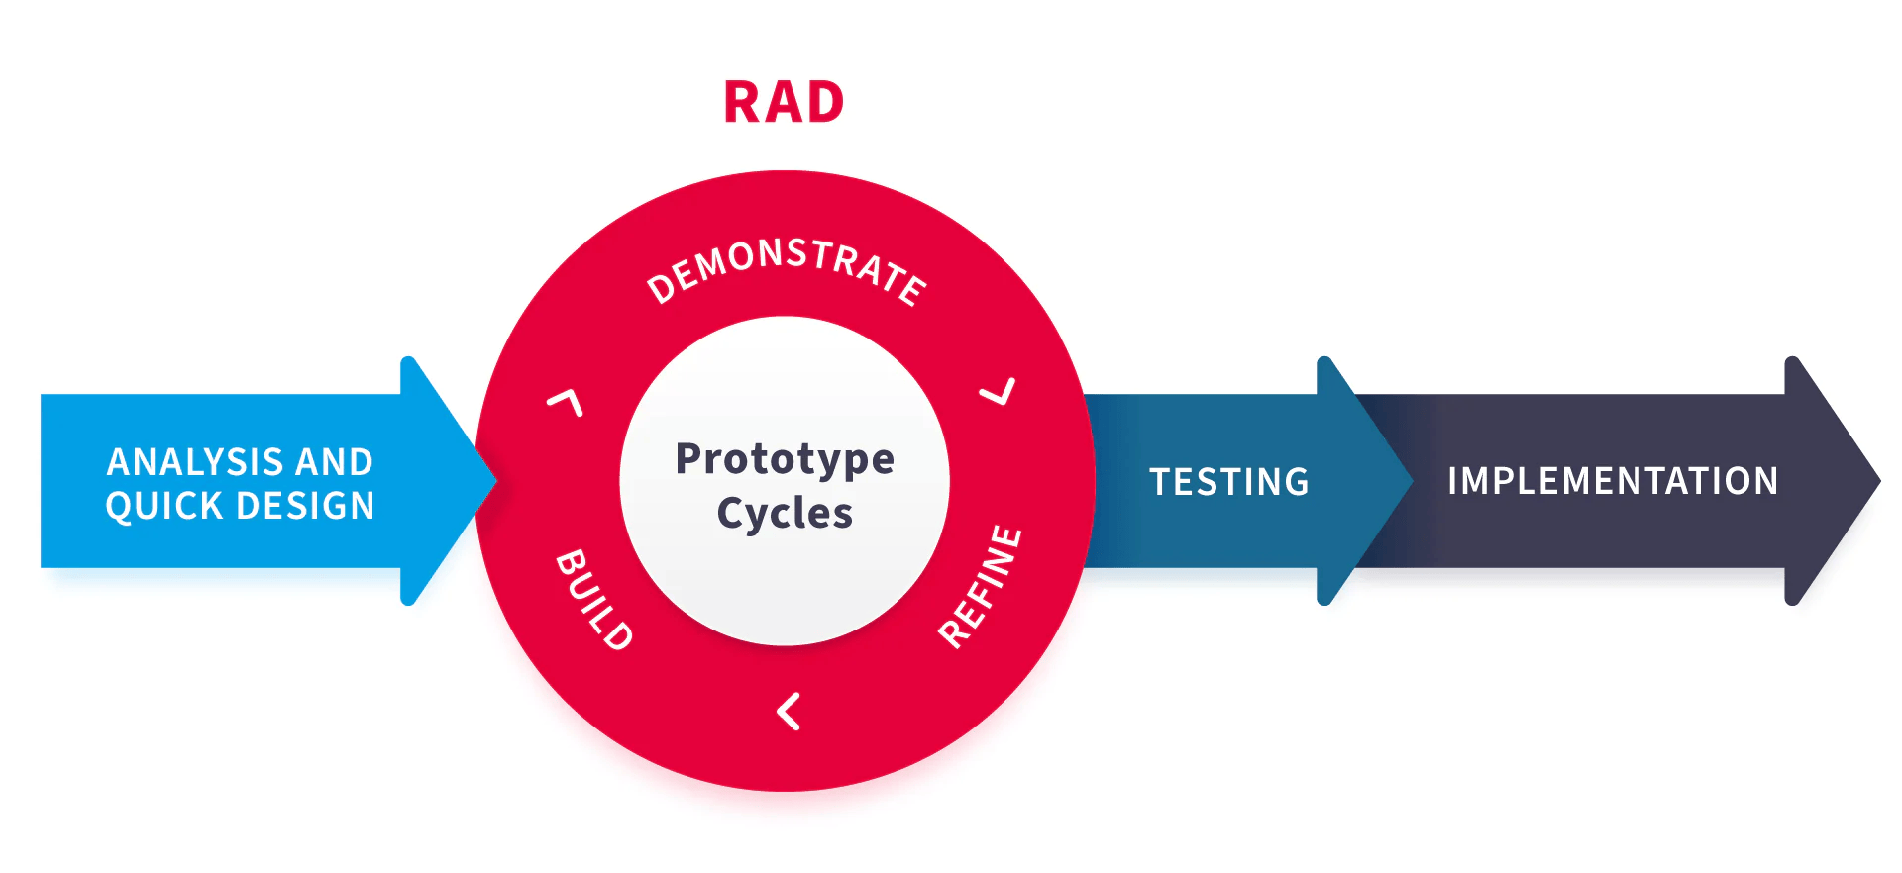

Phase I: Analysis and Quick Design
In this initial phase, the researchers identified the inefficiencies, data redundancy, and lack of real-time reporting related in the current manual, paper-based enrollment processes at ACLC Northbay. The core functional and non-functional requirements were established by evaluating the needs of the primary beneficiaries: the students, the School Registrar, and School Administrators. Once the requirements were clear, a "Mobile-First" user interface was quickly designed using Tailwind CSS so the application adapts perfectly to smartphones and desktops. Currently, the secure backend architecture was planned, outlining the use of Supabase (PostgreSQL) to handle the database management of student records and enrollment history.

Phase II: Prototype Cycles (Build, Demonstrate, Refine)
Instead of a single construction phase, this stage involved the continuous building, demonstrating, and refining of the system's core modules based on feedback. The core web application was developed using Next.js (React Framework) and TypeScript to ensure speed, type-safety, and maintainability. During these cycles, the system's analytical capabilities were constructed by integrating the Recharts Library to render dynamic visualizations. Automated email notification integrations were also built using the Brevo API and Deno edge functions to instantly inform students of their admission status. Through iterative prototyping, these modules were continually demonstrated to stakeholders and refined to ensure they met the project's objectives.

Phase III: Testing
Once the prototype cycles produced a stable version, the current iteration of the system was deployed into a cloud-based developer environment using Vercel for comprehensive testing and evaluation. During this phase, the system undergoes rigorous performance and security checks. The developers ensure the website loads efficiently and that all sensitive student data is securely protected via Row Level Security (RLS) and AES-256 encryption.

Phase IV: Implementation
The final phase focuses on the rollout of the evaluated system. This implementation phase ensures the system is highly functional, minimizes human errors, and effectively transitions the role of the admission officers from "data encoders" to "data verifiers" prior to any full-scale adoption by the institution.

Chapter 4

Presentation of Data and Results Discussion

This part of the study shows the data that was gathered and explains what the results mean. The researchers used statistical tools to properly analyze the responses and give clear interpretations based on what the respondents answered.
This chapter covers the findings of the study on the Proposed Cross-Platform Enrollment Management System with Integrated Data Analysis for ACLC Northbay Campus. A total of sixty (60) students from the Information and Communications Technology strand of AMA Computer Learning Center – Northbay took part in the survey as respondents.

Profile of the Respondents
Age
Table 4.1 shows how the respondents are distributed based on their age.
Table 4.1. Distribution of Respondents According to Age
Category | Frequency (f) | Percentage (%)
17 and Below | 27 | 45.0%
18 – 20 Years Old | 31 | 51.7%
21 – 25 Years Old | 1 | 1.7%
26 and Above | 1 | 1.7%
Total | 60 | 100%

Based on Table 4.1, most of the respondents were 18 to 20 years old, with thirty-one (31) or fifty-one point seven percent (51.7%) of the total. Twenty-seven (27) or forty-five percent (45.0%) were 17 and below. One (1) respondent, or one point seven percent (1.7%), was between 21 to 25 years old, and another one (1), or one point seven percent (1.7%), was 26 and above.
This shows that the respondents were mostly students in the typical senior high school age range. This is similar to the studies of Aspa et al. (2025) and Ali (2022), where their respondents were also mostly senior high school and college students of the same age. Since the respondents belong to a younger age group, they are already used to using phones and computers, which means they are likely to have no problem using a digital enrollment system once it is available.

Sex
Table 4.2 shows how the respondents are distributed based on their sex.
Table 4.2. Distribution of Respondents According to Sex
Category | Frequency (f) | Percentage (%)
Male | 33 | 55.0%
Female | 24 | 40.0%
Preferred Not to Indicate | 3 | 5.0%
Total | 60 | 100%

As shown in Table 4.2, thirty-three (33) or fifty-five percent (55.0%) of the respondents were male, twenty-four (24) or forty percent (40.0%) were female, and three (3) or five percent (5.0%) preferred not to indicate their sex.
This shows that more of the respondents were male. A similar pattern was also seen in the study of Canizo et al. (2024) at Novaliches High School, where male students also made up the larger portion of respondents in a senior high school setting. The researchers also allowed students to choose not to indicate their sex, so that everyone could answer the survey without feeling pressured.

Survey Results on the Proposed Cross-Platform Enrollment Management System
This section shows the answers of the sixty (60) student respondents to the survey questions about the current manual enrollment process and their thoughts on switching to a digital cross-platform enrollment system. The survey used a five-point Likert scale based on the scale below:
Scale of Values and Interpretation
Scale | Range | Verbal Interpretation
5 | 4.50 – 5.00 | Strongly Agree
4 | 3.50 – 4.49 | Agree
3 | 2.50 – 3.49 | Neither Agree nor Disagree
2 | 1.50 – 2.49 | Disagree
1 | 1.00 – 1.49 | Strongly Disagree

Table 4.3. Survey Results on the Proposed Cross-Platform Enrollment Management System
Statement | SA | A | N | D | SD | WM | Interpretation
1. I spend too much time standing in long lines just to enroll. | 15 | 26 | 12 | 6 | 1 | 3.80 | Agree
2. Physically traveling to school just to submit requirements is a waste of time and fare money. | 14 | 9 | 19 | 12 | 6 | 3.22 | Neither Agree nor Disagree
3. I find filling out handwritten forms tiring and prone to mistakes (e.g., erasures). | 14 | 24 | 11 | 5 | 6 | 3.58 | Agree
4. It is stressful when I do not know if my enrollment is accepted or still pending. | 24 | 16 | 13 | 4 | 3 | 3.90 | Agree
5. I sometimes forget or lose the physical list of requirements needed for enrollment. | 10 | 23 | 14 | 9 | 4 | 3.43 | Neither Agree nor Disagree
6. The manual process is confusing because I don't always know which window/desk to go to next. | 15 | 22 | 12 | 8 | 3 | 3.63 | Agree
7. The enrollment venue often gets crowded, hot, and uncomfortable. | 27 | 20 | 6 | 5 | 2 | 4.08 | Agree
8. Submitting physical photocopies of my Report Card/PSA is inconvenient and costs extra money. | 14 | 19 | 11 | 10 | 6 | 3.42 | Neither Agree nor Disagree
9. The manual enrollment schedule conflicts with my personal time or vacation. | 10 | 21 | 15 | 10 | 4 | 3.38 | Neither Agree nor Disagree
10. I would prefer to enroll online from home using my Mobile Phone or Desktop. | 24 | 18 | 9 | 5 | 3 | 3.87 | Agree
11. Taking a picture/scan of my requirements (PSA/Grades) and uploading them is easier than passing papers. | 23 | 19 | 12 | 5 | 1 | 3.97 | Agree
12. I feel safer knowing my student records are stored digitally and won't get lost. | 21 | 21 | 12 | 3 | 2 | 3.88 | Agree
13. I appreciate having 24/7 access to the system so I can enroll at my own convenience. | 20 | 28 | 9 | 3 | 0 | 4.08 | Agree
14. This system saves me money on transportation and printing/photocopying costs. | 24 | 25 | 7 | 3 | 1 | 4.13 | Agree
15. I strongly recommend replacing the old manual process with a digital cross-platform enrollment system. | 17 | 17 | 18 | 6 | 2 | 3.68 | Agree
Overall Weighted Mean |  |  |  |  |  | 3.74 | Agree

Statement 1: I spend too much time standing in long lines just to enroll.
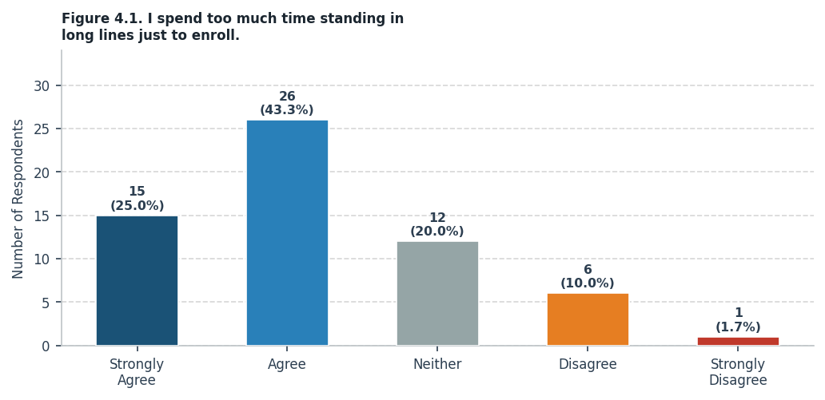
On the statement that students spend too much time standing in line just to enroll, 41 out of 60 respondents (68.3%) agreed or strongly agreed. The weighted mean is 3.80, which means the overall response is "Agree." Many students have personally experienced how slow and tiring the enrollment lines can get, and this result shows that it is a real and common problem at ACLC Northbay. This is supported by Chamilco and Pacheco (2023) and Canizo et al. (2024), both of whom found that long lines during enrollment were one of the main reasons why schools started looking into digital enrollment systems.

Statement 2: Physically traveling to school just to submit requirements is a waste of time and fare money.
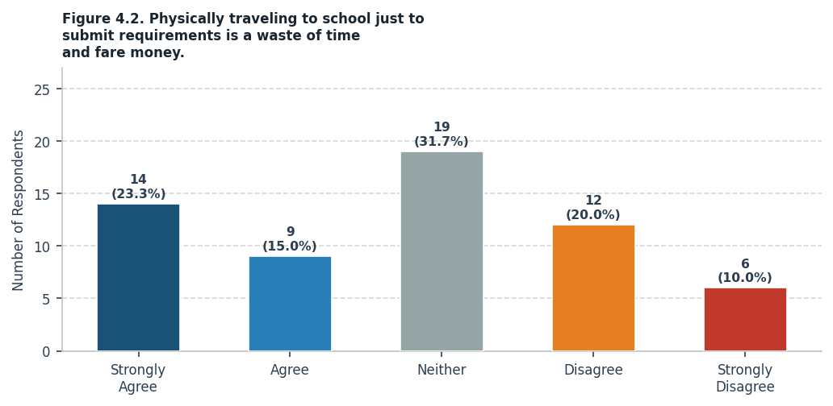
On the statement that going to school just to submit requirements wastes time and money on transportation, the weighted mean is 3.22, interpreted as "Neither Agree nor Disagree." A good number of students agreed that having to travel to school only to hand in papers is inconvenient, especially for those who live far away. Aspa et al. (2025) also pointed out that one of the biggest problems with manual enrollment is that it forces students to go through the same tiring steps over and over, which is why allowing students to submit requirements online is one of the main goals of this proposed system.

Statement 3: I find filling out handwritten forms tiring and prone to mistakes (e.g., erasures).
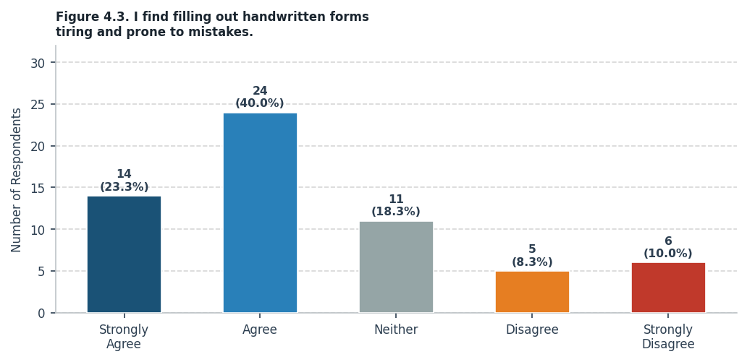
On the statement that filling out forms by hand is tiring and often leads to mistakes like erasures, 38 respondents (63.3%) agreed or strongly agreed, giving a weighted mean of 3.58, interpreted as "Agree." This means that students find the manual process of writing on paper forms not only exhausting but also prone to errors. Aspa et al. (2025) had the same observation in their study, where they noted that handwriting errors and messy forms were among the most common issues that their online enrollment system was able to fix.

Statement 4: It is stressful when I do not know if my enrollment is accepted or still pending.
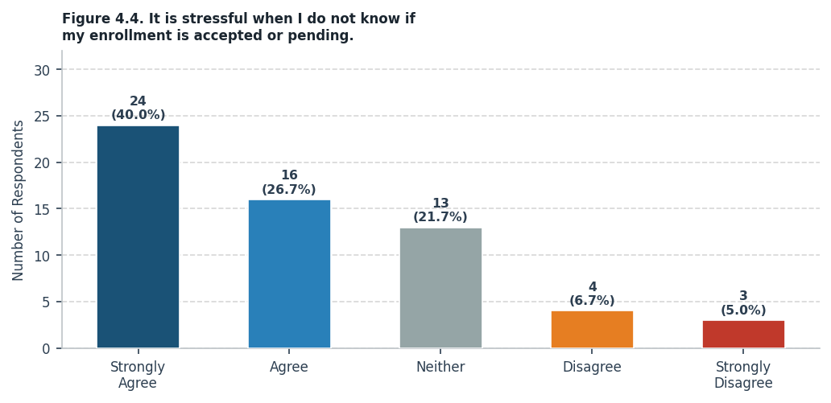
On the statement that not knowing whether enrollment has been accepted or is still pending causes stress, 40 respondents (66.7%) agreed, giving a weighted mean of 3.90, interpreted as "Agree." This shows that many students feel anxious when they have no way of checking their enrollment status. Berro and Waing (2025) explained that students are more satisfied with an enrollment system when it gives them useful and timely information, such as real-time updates on their application status, which is exactly what the proposed system aims to provide.

Statement 5: I sometimes forget or lose the physical list of requirements needed for enrollment.
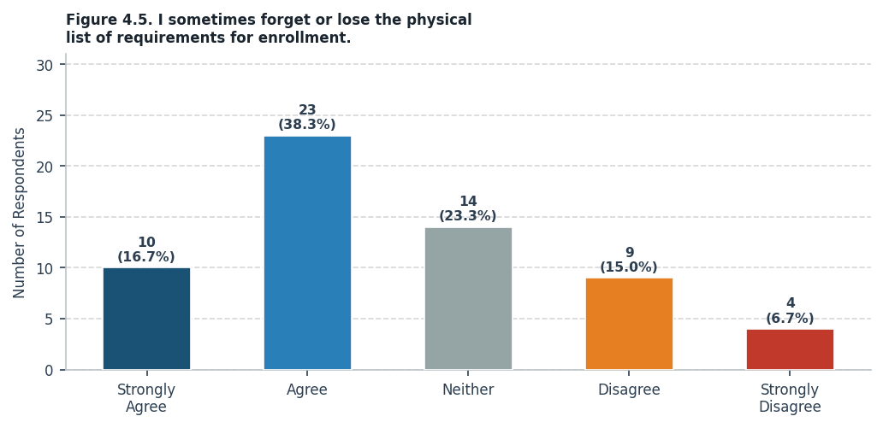
On the statement that students sometimes forget or lose the physical list of requirements for enrollment, the weighted mean is 3.43, interpreted as "Neither Agree nor Disagree." The results show that keeping track of all the needed documents in paper form is a problem that many students face. Canizo et al. (2024) also found this to be a recurring issue in manual enrollment systems, and they addressed it by building a digital tracking feature into their system, which is something that the proposed system for ACLC Northbay also plans to include.

Statement 6: The manual process is confusing because I don't always know which window/desk to go to next.
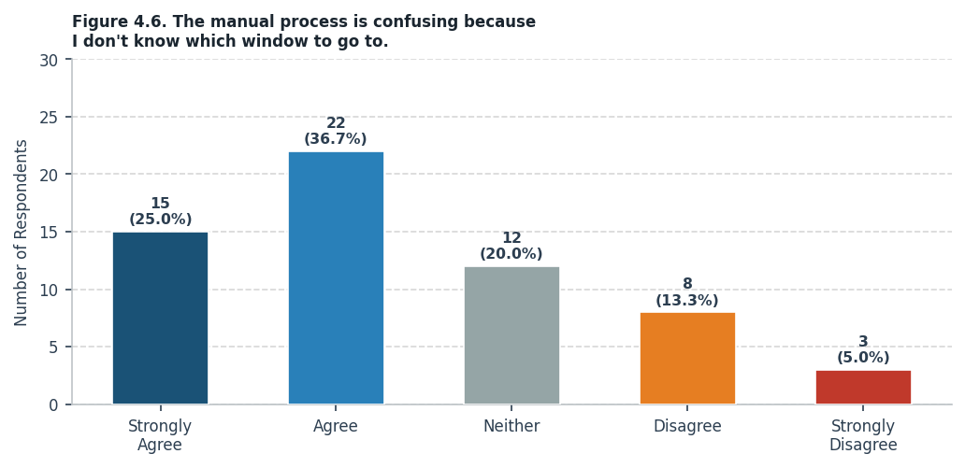
On the statement that the manual enrollment process is confusing because students do not always know which window or desk to go to, 37 respondents (61.7%) agreed, with a weighted mean of 3.63 interpreted as "Agree." This means a lot of students get confused about the steps they need to follow during enrollment. Villaruz and Diamante (2024) found that putting enrollment steps in a clear digital format made the whole process easier to understand and follow, which reduced confusion among students and made the experience less stressful.

Statement 7: The enrollment venue often gets crowded, hot, and uncomfortable.
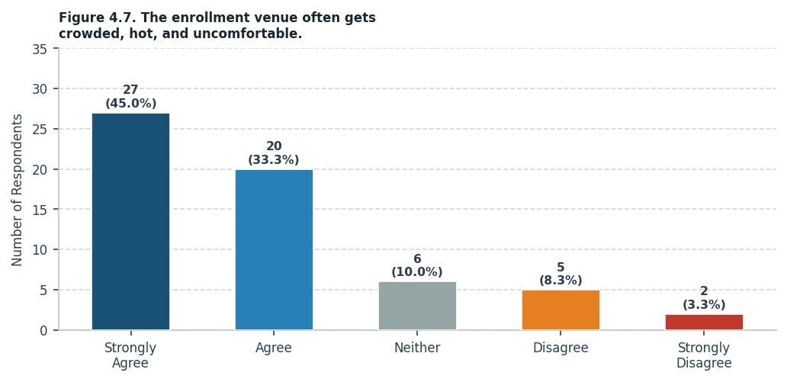
On the statement that the enrollment venue often gets crowded, hot, and uncomfortable, 47 respondents (78.3%) agreed or strongly agreed, with a weighted mean of 4.08, interpreted as "Agree." This is one of the stronger results in the survey, showing that students are very much bothered by the physical conditions during enrollment. Both Chamilco and Pacheco (2023) and Canizo et al. (2024) pointed out that overcrowding at enrollment venues was a major issue that was solved once students were allowed to register from home through a digital system.

Statement 8: Submitting physical photocopies of my Report Card/PSA is inconvenient and costs extra money.
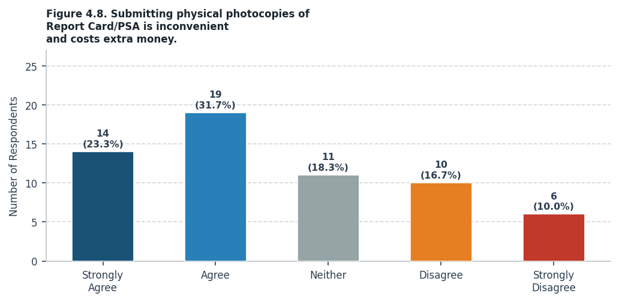
On the statement that submitting physical photocopies of documents like Report Cards and PSA is inconvenient and costs extra money, the weighted mean is 3.42, interpreted as "Neither Agree nor Disagree." Students agreed that having to print and photocopy documents every enrollment period adds up in cost and effort. Aspa et al. (2025) reported that their system removed the need for physical forms entirely, which helped reduce costs for students, and Canizo et al. (2024) also found that going digital made document submission easier and less of a burden overall.

Statement 9: The manual enrollment schedule conflicts with my personal time or vacation.
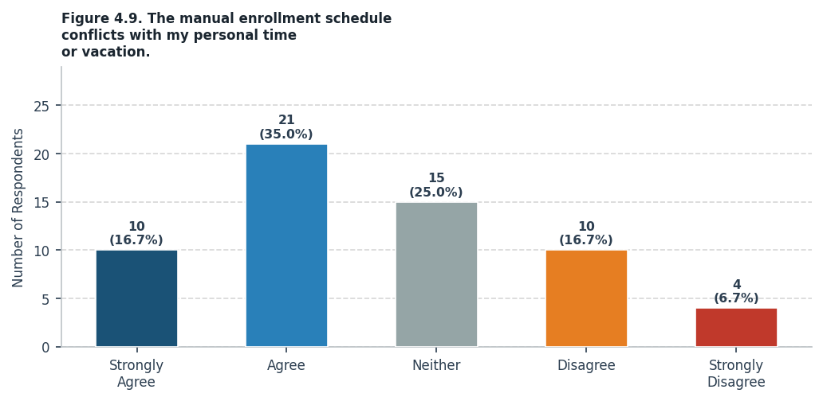
On the statement that the manual enrollment schedule sometimes conflicts with personal time or vacation, 31 respondents (51.7%) agreed, giving a weighted mean of 3.38 interpreted as "Neither Agree nor Disagree." This shows that the fixed schedule for manual enrollment does not always work for everyone. Chamilco and Pacheco (2023) noted that one of the biggest benefits of a digital enrollment system is that students can complete their enrollment from anywhere and at any time, which removes the problem of schedule conflicts altogether.

Statement 10: I would prefer to enroll online from home using my Mobile Phone or Desktop.
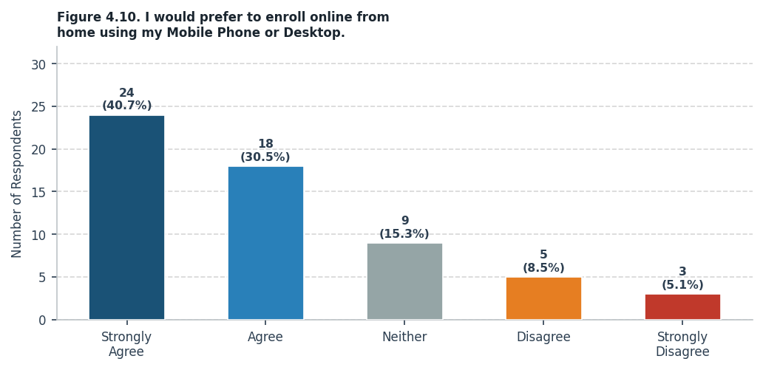
On the statement that students would prefer to enroll online from home using their phone or computer, 42 respondents (70.0%) agreed or strongly agreed, giving a weighted mean of 3.87 interpreted as "Agree." This is a clear sign that students want a more convenient way to enroll. Berro and Waing (2025) found that students are more willing to use an enrollment system when they see it as actually helpful and easy to access, while Ali (2022) found that senior high school students in Zamboanga rated their online enrollment system as "Very Good," showing that students in the Philippines are open to using digital enrollment tools.

Statement 11: Taking a picture/scan of my requirements (PSA/Grades) and uploading them is easier than passing papers.
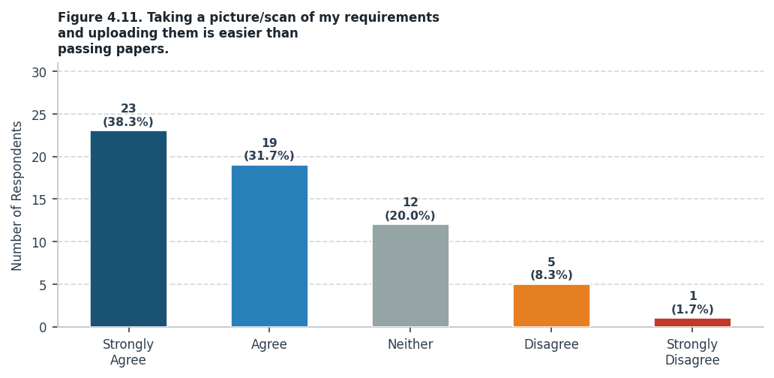
On the statement that taking a photo or scan of requirements and uploading them is easier than passing physical papers, 42 respondents (70.0%) agreed, giving a weighted mean of 3.97 interpreted as "Agree." Students clearly prefer uploading their documents digitally over submitting printed copies. Aspa et al. (2025) found the same thing in their study, where removing the need for physical forms was one of the most appreciated features of their system, which earned an overall weighted mean of 4.29 or "Excellent" from student evaluations.

Statement 12: I feel safer knowing my student records are stored digitally and won't get lost.
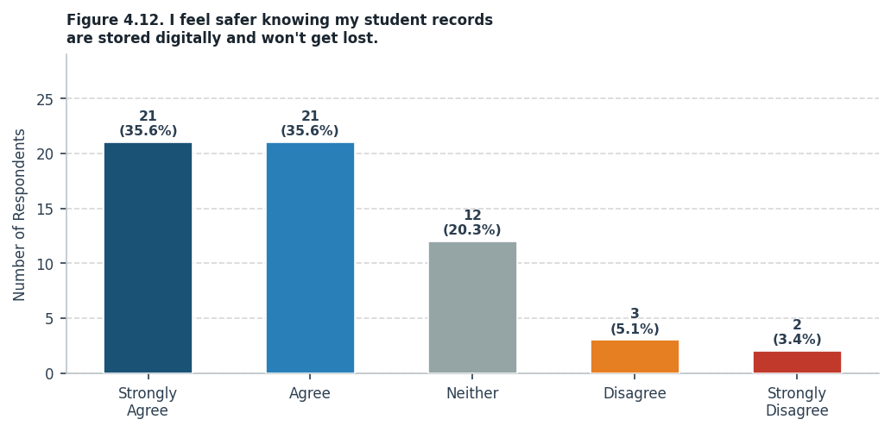
On the statement that students feel safer knowing their records are stored digitally and will not get lost, 42 respondents (70.0%) agreed, with a weighted mean of 3.88 interpreted as "Agree." This shows that students trust digital storage and feel more secure knowing their files are safe online. Villaruz and Diamante (2024) showed that a web-based enrollment system can meet acceptable security standards, while Canizo et al. (2024) pointed out that protecting student records from being lost or damaged was one of the key reasons why a digital system was needed.

Statement 13: I appreciate having 24/7 access to the system so I can enroll at my own convenience.
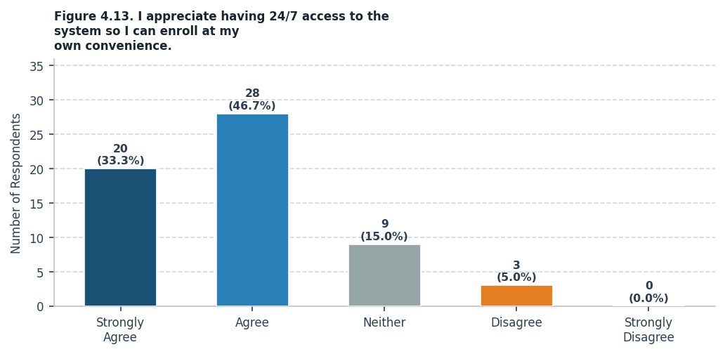
On the statement that having 24/7 access to the system so students can enroll at their own convenience is something they appreciate, 48 respondents (80.0%) agreed or strongly agreed, giving a weighted mean of 4.08 interpreted as "Agree." Students value the freedom to enroll whenever works best for them, not just during school hours. Berro and Waing (2025) said that being able to access an enrollment system anytime is a big factor in student satisfaction, and Chamilco and Pacheco (2023) also noted that 24/7 access was important for making enrollment fair and convenient for all students.

Statement 14: This system saves me money on transportation and printing/photocopying costs.
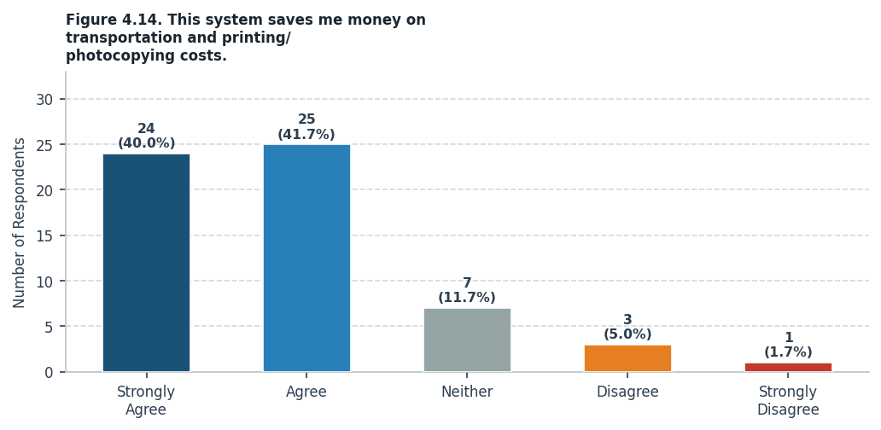
On the statement that the proposed system can save students money on transportation and printing costs, 49 respondents (81.7%) agreed, with a weighted mean of 4.13 interpreted as "Agree." Students recognized that switching to a digital enrollment system would help reduce their out-of-pocket expenses during enrollment. Aspa et al. (2025) made the same observation in their study, where students no longer had to travel to school or print documents after their online system was put in place, resulting in real savings that students directly benefited from.

Statement 15: I strongly recommend replacing the old manual process with a digital cross-platform enrollment system.
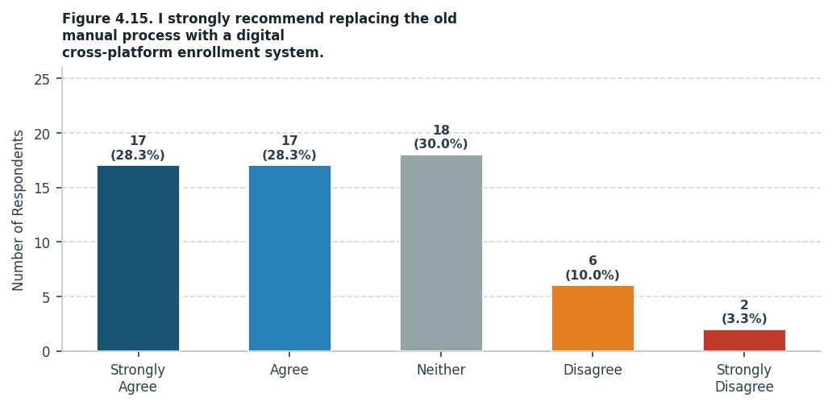
On the statement that students strongly recommend replacing the old manual process with a digital cross-platform enrollment system, 34 respondents (56.7%) agreed or strongly agreed, with a weighted mean of 3.68 interpreted as "Agree." While some students chose the neutral option, the overall lean of the responses still points toward support for going digital. This lines up with what Aspa et al. (2025), Canizo et al. (2024), and Ali (2022) all found in their own studies — that once students are introduced to digital enrollment, they tend to accept it and even prefer it over the old manual way.

Chapter 5
Summary, Conclusions, and Recommendations
Summary

A total of sixty (60) students from the Information and Communications Technology strand of AMA Computer Learning Center — Northbay Campus participated in this study as respondents. In terms of age, the majority of the respondents were 18 to 20 years old, accounting for fifty-one point seven percent (51.7%) of the total, followed by those aged 17 and below at forty-five percent (45.0%). Only one respondent (1.7%) fell under the 21–25 age range, and another one (1.7%) was 26 and above.
This indicates that most respondents belong to the typical senior high school age range, suggesting that they are already familiar with technology and are likely capable of using a digital enrollment system with ease. In terms of sex, thirty-three (33) or fifty-five percent (55.0%) of the respondents were male, twenty-four (24) or forty percent (40.0%) were female, and three (3) or five percent (5.0%) preferred not to indicate their sex, showing a slight male majority among the respondents though the distribution remains relatively balanced overall.

Regarding the survey results on the current manual enrollment process, the overall weighted mean of 3.74 is interpreted as "Agree," meaning that the respondents generally agree that the current manual enrollment process has real and recurring problems. Students commonly experienced long lines, physical travel just to submit requirements, stressful uncertainty about their enrollment status, and confusion about which steps to follow during the process. At the same time, the respondents also expressed strong openness to a digital solution, preferring to enroll online, upload documents digitally, and access the system anytime at their own convenience.
These findings are consistent with related studies. Aspa et al. (2025) obtained an overall weighted mean of 4.29, rated "Excellent," after students evaluated their online enrollment system, showing that students respond positively to digital solutions. Canizo et al. (2024) and Chamilco and Pacheco (2023) both found that transitioning away from manual enrollment improved the experience for both students and school staff. Berro and Waing (2025) further noted that students are more likely to embrace a system when it genuinely addresses their needs. All of these support the conclusion that developing the proposed Cross-Platform Enrollment Management System with Integrated Data Analysis for ACLC Northbay Campus is both necessary and highly supported by the students it is designed to serve.
Conclusions
Based on the findings of the study, the following conclusions are drawn:
1. The current manual enrollment process at ACLC Northbay Campus is widely recognized by students as inefficient and burdensome. With an overall weighted mean of 3.74 ("Agree"), the respondents confirmed that the manual system causes recurring problems such as long queues, physical travel requirements, handwriting errors, schedule conflicts, and uncertainty about enrollment status. These issues validate the need for a digital solution.
2. The proposed Cross-platform Enrollment Management System effectively addresses the identified problems by providing a fully digital enrollment process accessible from any device with an internet connection. The five-step enrollment wizard eliminates the need for physical queuing, while the real-time status tracking feature removes the anxiety caused by not knowing whether an application has been accepted or is still pending.
3. The system successfully goes beyond its original enrollment scope to serve as a comprehensive school management platform. The integration of features such as the Administrator Dashboard with real-time analytics, Predictive Analytics powered by a four-model ensemble (OLS, Recency-Weighted OLS, Polynomial Regression, and Exponential Smoothing), Auto-Scheduling, QR Code Attendance Tracking with Cutting Class Detection, Section Management, Activity Logs, Archive System, and a real-time Communication module demonstrates that the system has evolved into a tool that supports not only enrollment but also the day-to-day academic operations of the institution.
4. The respondents expressed strong openness to a digital enrollment system. The highest-rated statements include the preference for 24/7 system access (WM = 4.08), the cost savings from eliminating transportation and printing expenses (WM = 4.13), and the discomfort caused by crowded enrollment venues (WM = 4.08). These results indicate that students are not only willing but eager to adopt the proposed system.
5. The use of modern web technologies — Next.js 16, React 19, TypeScript, Tailwind CSS 4, and Supabase — ensures that the system is fast, secure, maintainable, and scalable. The cloud-based deployment on Vercel with Supabase as the backend guarantees 24/7 accessibility and data integrity through Row Level Security (RLS), AES-256 encryption, and Cloudflare Turnstile bot protection.
Therefore, the study concludes that the proposed Cross-platform Enrollment Management System with Integrated Data Analysis is both necessary and highly beneficial for ACLC Northbay Campus. The system provides an effective, efficient, and secure solution that modernizes enrollment operations while equipping administrators and teachers with powerful tools for data-driven decision-making and daily academic management.
Recommendations
Based on the findings and conclusions of the study, the researchers recommend the following:
1. Full-Scale Deployment: The institution should consider migrating the system from the current developer-tier cloud environment to a commercial production tier (custom school domain and Supabase Pro plan) to handle heavier traffic during peak enrollment periods and ensure continuous, reliable deployment for the entire student population.
2. Expand Respondent Coverage: Future evaluations of the system should include a broader respondent base beyond ICT strand students, including GAS strand students, parents/guardians, teachers, and school administrators, to gain a more comprehensive assessment of the system's acceptability and effectiveness across all user groups.
3. Integrate Online Payment: While the current system deliberately excludes payment processing, future iterations should explore the integration of online payment gateways (e.g., GCash, Maya) to allow students to complete tuition and fee payments directly within the enrollment portal, further reducing the need for physical visits to the campus.
4. Enhance Predictive Analytics: The existing four-model predictive ensemble should be expanded with additional historical data as the system accumulates enrollment records over multiple school years. This will improve the accuracy of enrollment forecasting and help administrators plan resource allocation more effectively.
5. Mobile Application Development: Although the current system is fully responsive on mobile browsers, developing a dedicated mobile application could further improve accessibility and user experience, particularly for the QR Code Attendance feature used by teachers and the enrollment status checking feature used by students.
6. Continuous User Training: The institution should conduct regular training sessions for school administrators and teachers to ensure they can fully utilize all features of the system, including the data analytics dashboard, predictive analytics, auto-scheduling, and the communication module.
7. Regular System Maintenance and Updates: The developers should implement a schedule for regular system updates, security patches, and feature enhancements based on ongoing user feedback and evolving institutional needs. The Activity Logs feature already built into the system can serve as a valuable audit trail for monitoring system usage and identifying areas for improvement.
8. Grading and Learning Management Integration: Future researchers may consider extending the system to include grading functionalities and learning management features, transforming it into a full-scale School Management Information System (SMIS) that covers the entire student lifecycle from enrollment to graduation.

References

Appendices

