A PROPOSED WEB-BASED WITH APPOINTMENT AND STAFF AVAILABILITY SYSTEM FOR JACK OF HEARTS NAILS AND BODY SPA

A Research Project Proposal
Presented to the Faculty of the
Information and Communications Technology Strand
AMA Computer Learning Center – Northbay Campus

In partial fulfilment of the requirements in
Inquires, Investigations, and Immersion

Austria, Jaira Mauriz E.
Frace, John Leynard A.
Mesana, Edison F.
Nillos, Danica Ashley G.
Orallo, Allyson Kim S.
Rafols, Jerry M.
Sepra, Rossana D.

Grade 12 – B

MR. RONEL M. FARIOLEN
Research Adviser

May 15, 2026
ENDORSEMENT FORM FOR PROPOSAL DEFENSE

TITLE OF RESEARCH: A Proposed Web-Based with Appointment and Staff Availability System for Jack of Hearts Nails and Body Spa

NAME OF PROPONENTS: Austria, Jaira Mauriz E.
Frace, John Leynard A.
Mesana, Edison F.
Nillos, Danica Ashley G.
Orallo, Allyson Kim S.
Rafols, Jerry M.
Sepra, Rossana D.

In Partial Fulfilment of the Requirements
for the Strand Information and Communications Technology
has been examined and is recommended for Proposal Defense.

ENDORSED BY:

MR. RONEL M. FARIOLEN
Research Project Adviser

APPROVED FOR PROPOSAL DEFENSE:

MR. RAFFY B. CABUTAJE MRS. JOCELYN R. ISIDRO
Research Coordinator Senior High School - Coordinator

NOTED BY:

MRS. EMILY L. QUINTANA
School Directress

APPROVAL SHEET

This research paper entitled, “A PROPOSED WEB-BASED WITH APPOINTMENT AND STAFF AVAILABILITY SYSTEM FOR JACK OF HEARTS NAILS AND BODY SPA”, prepared and submitted by Sepra, Rossana D., Frace, John Leynard A., Mesana, Edison F., Nillos, Danica Ashley G., Orallo, Allyson Kim S., Rafols, Jerry M., and Austria, Jaira Mauriz E., in partial fulfillment of the requirements for the subject Inquiries, Investigations, and Immersion (III), Senior High School, has been examined and recommended for approval and acceptance.

MR. RONEL M. FARIOLEN
Project Adviser

PANEL OF EXAMINERS
Approved by the Panel of Examiners on: _________________.

MR. HARVEY D. SIMODIO, LPT
Chairman, Panel of Examiners

MR. RICARDO B. BALDOVINO, LPT MR. SEAN DENZEL UNABIA
Panel Member Panel Member

MR. RAYMUND OPIZ, LPT MS. GLYDEL V. ALVAREZ, LPT
Panel Member Panel Member

APPROVED AND ACCEPTED

MR. RAFFY B. CABUTAJE MRS. JOCELYN R. ISIDRO
Research Coordinator Senior High School – Coordinator

MRS. EMILY L. QUINTANA
School Directress
Acknowledgement

We, the researchers, would like to thank the Almighty God for his guidance and blessings throughout the completion of this research project.
We are deeply grateful to Mr. Ronel M. Fariolen, our Research Project Adviser, for his invaluable guidance, patience, and support throughout the study. Our sincere thanks also go to Ms. Alyssa Mae Dela Cruz, our former Research Adviser, for her continuous encouragement and helpful advice in shaping our projects. Special appreciation is extended to John Leynard A. Frace, who played a key role in developing the web-based booking and reservation system that is the heart of this study. His technical skills and dedication greatly contributed to the project’s success.
We would also like to express our gratitude to Mrs. Jocelyn R. Isidro, Senior High School Coordinator, and Mrs. Emily L. Quintana, our School Directress, for their support, guidance, and approval, which greatly helped in the completion of this research.
We are thankful to our families for their constant support, guidance, and encouragement throughout this research.
Finally, we would like to thank all the members of our team for their hard work, cooperation, and dedication, which made this research project possible.

Table of Contents

Chapter 1
Introduction of the Study
Introduction
Many businesses in the beauty and wellness industry still use old ways of managing their daily work. They often rely on walk-in clients and handwritten records to keep track of their schedules. While this has been done for a long time, it often leads to problems like scheduling conflicts, long waiting times for customers, and difficulty in checking which staff members are free. These issues can make it hard for the business to run smoothly and can sometimes frustrate the customers. As technology improves, many businesses are moving toward digital solutions to fix these problems. An online system can make the appointment process much faster and more accurate. By using a digital tool, a business can easily see their schedule in real-time, avoid mistakes, and keep all client records in one safe place. To help solve these challenges, this study proposes the development of a web-based Appointment and Staff Availability System. This system will allow clients to schedule their visits online. By doing this, the spa can avoid scheduling conflicts and manage staff workloads better. Through this, the spa can provide better service, save time, and make the overall experience more convenient for both the staff and the clients.

Background of the Study
Jack of Hearts Nails and Body Spa was established on February 28, 2018, by Jack Quiambao Eumagie. It is located at 103 A. Mabini St., Maypajo, Caloocan City. The owner started the business because of his passion for beauty and wellness, which he shares with his family. Because the business became popular, he opened a second branch in Arpapa, Maypajo, Caloocan City. The spa is open from 12:00 PM to 12:00 midnight to give clients enough time to enjoy their services. The spa offers a wide variety of beauty and wellness treatments, including hand care, foot care, massage, facial care, paraffin waxing, eyelash extensions, and other related services.
Currently, the spa relies on manual methods to manage client visits and staff schedules. Because of this, the business faces challenges such as scheduling conflicts, where two clients are sometimes scheduled at the same time for the same staff member. Additionally, the manual process leads to long waiting times for customers and makes it difficult to keep track of client information and appointment history accurately.
To address these problems, this study proposes the development of a Web-Based Appointment and Staff Availability System. This system is designed to improve the appointment management process by providing a clear and accessible online platform. It allows clients to register and log in using Gmail, or a mobile phone number, ensuring secure access while simplifying account creation and keeping all client records in one place. Through the Home and About Us pages, clients are introduced to the spa’s background, vision, mission, and identity, while the Services page presents a complete list of treatments with descriptions and prices.
The Set Appointment feature enables clients to schedule appointments after selecting their preferred service and choosing available staff for a specific date and time, effectively eliminating the risk of double scheduling. Before finalizing, clients review all appointment details for accuracy, and once confirmed, the appointment is recorded in the system. Additionally, clients may access a personal account to manage their profiles, view appointment history, and monitor upcoming appointments. Features such as Contact and FAQ pages are also included to support communication and feedback.
By using this digital tool, the spa can improve its daily operations, reduce human errors, and ensure that both the staff and the clients have a better and more efficient experience.

Objectives
This study aims to support the improvement of appointment scheduling and staff management at Jack of Hearts Nails and Body Spa through the development of a Web-based Appointment and Staff Availability System. The objectives focus on addressing existing operational challenges, improving service coordination, and enhancing the overall management of appointments, staff performance, and client records.
- To develop a convenient online appointment process that allows clients to easily choose their preferred service, select their desired date and time, and pick an available staff member.
- To improve the staff management system by providing real-time visibility on staff availability.
- To provide a client account for managing personal information and appointment history to ensure accurate record-keeping.

Statement of the Problem
Despite the growing demand for beauty and wellness services, Jack of Hearts Nails and Body Spa continue to rely on manual appointment and staff scheduling processes. These traditional methods result in inefficiencies that affect both customers and management. This study seeks to identify and address the key problems related to appointment handling, staff monitoring, and record management.
- Does the current manual appointment process cause frequent scheduling conflicts and long waiting times that affect the overall efficiency of the spa's operations?
- Is the lack of real-time monitoring a significant obstacle in effectively tracking staff availability?
- Does the manual record-keeping method cause difficulties in accurately managing client accounts and appointment histories?

Conceptual Framework

OUTPUT

- Web-Based Booking and Staff Availability System

PROCESS

- System planning and webpage design

- Development of the web-based booking and staff availability system

- Creation and distribution of survey questionnaires

- Data collection analysis

- System testing and debugging

- Interpretation of results

INPUT

- Interview the owner

- Current booking and staff availability process

- Demographics profile of respondents (age, gender, device used)

- Responses from 50 randomly selected respondents

- Requirements for system development

Scope of the Study
This study focuses on the design, development, and evaluation of a Web-Based Appointment and Staff Availability System for Jack of Hearts Nails and Body Spa.
- The system allows clients to choose their preferred service, select their desired date and time, and pick an available staff member.
- The system provides real-time visibility on staff availability to help management and clients see which staff members are currently free or occupied.
- The system features a client account where users can manage their personal information and view their history of upcoming and completed appointments.
- The system features an approval process where appointments set by clients are marked as 'Pending' until confirmed by the admin, while also allowing clients to cancel their appointments through their accounts.
- Once an appointment is confirmed by the admin, the selected date, time, and staff member will automatically become unavailable to other clients to prevent scheduling conflicts.
- The system allows clients to delete their own accounts at any time, while the admin also has the authority to remove inactive or dummy accounts to maintain the integrity of the system's records.
- The system generates a digital appointment receipt that serves as official proof of a confirmed schedule, which clients must present upon arrival at the spa.
- The system requires users to log in using a Gmail account and password; upon successful login, new users must register their personal information, including full name, contact number, and Gmail address, for the admin's record-keeping.
- The system is accessible via web browsers on both desktop and mobile devices.

Delimitation of the Study
This study is limited to the operations of Jack of Hearts Nails and Body Spa and does not include other branches or businesses.
- The system does not handle online payments or any financial transactions.
- The system does not include chatbot support.
- The system does not support a downloadable PDF format for the appointment receipt; however, clients can view and take a screenshot of the receipt through their accounts as proof of appointment.
- The system does not send SMS or text alerts for the confirmed appointment receipt; clients must check their accounts for updates.
- The system does not include a 'Forgot Password' recovery feature or the sending of One-Time Passwords (OTP) via SMS or email; users must ensure the security of their login credentials.
- The system does not support authentication or login through other social media platforms (e.g., Facebook, Instagram) or via mobile number; it is strictly limited to Gmail account access only.

Hypothesis (Ho)
There is a significant improvement in the efficiency of appointment management, staff availability monitoring, and operational performance of Jack of Hearts Nails and Body Spa through the development of the proposed web-based system, which will provide a faster, more reliable, and seamless experience for both the management and its clients once approved and implemented.

Significance of the Study
This study is significant as it focuses on the development of a Web-Based Appointment and Staff Availability System for Jack of Hearts Nails and Body Spa to improve appointment scheduling, staff management, and service efficiency. The results of this study will be beneficial to the following:
To the Owner: This study helps the spa owner manage appointments more efficiently by reducing manual errors, scheduling conflicts, and long waiting times. It also supports better monitoring of daily operations and staff availability, leading to improved customer satisfaction and business growth.
To the Staff: This study benefits the staff by providing a clear schedule of appointments, helping them manage their time effectively. It also reduces double bookings and improves coordination through real-time availability tracking, resulting in a smoother and more reliable workflow.
To the Customers: This study benefits customers by offering a convenient and accessible online process. It allows them to select services, see available staff, and choose suitable schedules, leading to a more comfortable and satisfying service experience.
To Future Researchers: This study serves as a reference for future researchers who intend to develop or study web-based appointment and staff availability systems or similar applications in service-oriented businesses.

Data Dictionary
- About Us Page – Webpage section presenting the spa’s background, values, mission, and history to build client’s trust.
- Appointment Availability- Displays open service time slots, allowing real-time booking and preventing scheduling conflicts.
- Booking Confirmation- Digital notification sent to clients conforming a successfully scheduled appointment.
- Booking History- Record of all past and future appointments for a client, accessible through the personal dashboard.
- Client Profile- Personalized account containing client information, contact details, service preferences and booking records.
- Completed Appointment- Records of services already provided to clients for reference and reporting.
- Customer Engagement- Level of client interaction with the system, measured through bookings, feedback, and page visits.
- Customers Satisfaction- Measure of how well services and the system meet client expectations.
- Digital Receipt- Electronic proof of payment generated by the system, viewable in the dashboard and presentable at the store.
- FAQ (Frequently Asked Questions)- Sections providing answers to common questions about services, booking, or the system.
- Manual Transaction- Transaction processed manually by a person rather than automatically by the system.
- Payment Method- Options for clients to pay services, including Gcash, PayMaya, and Cash.
- Personal Dashboard- Customized interface showing upcoming appointments, booking history, and payment records.
- Real-Time Staff Availability- Displays which staff members are free at selected times to avoid double bookings.
- Scheduling System- Digital interface allowing clients to select services, preferred staff, and time slots efficiently.
- Services Selection- Process by which a client chooses a specific treatment or package before booking.
- Spa Services- Range of beauty and wellness treatments offered by the spa, including nails, waxing, massage, facial, and body care.
- Staff Selection- Allows client to choose a preferred staff member based on availability.
- User Authentication- Process of verifying a user’s identity before granting system access.
- Wellness Industry- Sector focused on improving physical, mental, and emotional well-being through health, fitness, beauty, and self-care services.

Chapter 2
Review of Related Literature

Foreign Literature
Yourecruit Real-Time Staff Availability Insights
As stated by Ondrej. (2024). real-time staff availability insights are essential for efficient scheduling and workforce management. The platform’s Work Tracker mobile app allows employees to manage their shifts, submit timesheets, and receive instant updates, improving both accuracy and communication. As noted by the company, these tools help reduce scheduling conflicts, enhance flexibility, and support higher employee satisfaction and retention.

Online Spa Appointment Booking System
As in to research Husna, T., Lahari, V., Ramakrishna, M., et al. (2022). The online spa reservation system is a web-based management application that enables scheduling for spa bookings. It connects clients, spas, and stylists within an online community, allowing users to explore, reserve, and cancel appointments with spas and stylists. Users can also leave and read reviews for both spas and individual stylists. Within the spa, you can showcase the stylists employed at the salon along with the services they provide. The system also enables you to book clients and view or print your schedule in an easily accessible format. It manages details about the spa, daily appointments, and generates various reports (such as employee payroll, product, and booking reports). Additionally, it oversees service management, billing, and employee information management. It tracks customer information, membership services, postpaid services, and daily transaction notifications. This system helps enhance the efficiency of spa operations.

Staff Scheduling for Demand-Responsive Services
In this study, Manik, D., and Raber, R. (2024). conducted a study on staff scheduling for demand-responsive services, where the number of staff required fluctuates depending on customer demand. The researchers proposed an optimization model that considers both staff availability and variable demand, allowing for real-time adjustments in scheduling. Their finding demonstrated that intelligent scheduling can reduce operational costs and improve service efficiency, proving the value of dynamic real-time availability systems in practice. This study directly supports the feasibility of implementing availability displays in industries requiring flexible staffing.

Era Beauty Spa Booking System
Based on the findings of Hamid, N., and Nawi, N. (2024), shows that manual spa booking can be slow and unorganized, so they created a web-based platform to make the whole process more modern. Their system gives clients an easy way to check services and book appointments online, while giving managers a dashboard to handle schedules and therapist assignments. By using features like automated alerts to remind customers, the study found that spas can reduce the number of "no-shows" and improve their overall productivity. Their findings prove that a digital booking system makes the business more efficient and provides a much better experience for the clients.

Enhancing Customer Experience and Satisfaction through Mobile-Based Salon and Spa Reservations on Android Platforms
As shown to the study of Permatasari, H., Purwanto, E., and Triyono, T. (2024), salons and spas in Indonesia really need to use digital systems to improve their business and give customers a better experience. They developed an Android-based app for a spa called Spaque Salon & Day Spa so that clients can easily book treatments and manage their appointments through their phones. Their tests showed that the system makes it much easier to handle schedules, track sales, and get feedback from customers. The study proves that switching to mobile technology helps small businesses become more organized and competitive in today's digital world.

Local Literature
The Advantages of Online Client Scheduling for Your Salon
In line with Zen, S. (2023). Explains that adopting an online scheduling system benefit both salon/spa owners and their clients. For businesses, it reduces administrative tasks by automating booking, record-keeping, and confirmation processes. For customers, it offers flexibility to book appointments anytime, even outside working hours, which improves convenience and loyalty. Features such as real-time availability and automated reminders also minimize no-shows. Collectively, these functions create smoother operations, help spas optimize staff time, and strengthen their competitive edge in a busy market.

Scissors And Mirrors Salon: Online Booking and Management System
In this work, Garcia, N., Orolfo, R., Toledo, J., et. al., (2024) developed a web-based booking and management platform for Scissors and Mirrors Salon in Bulacan. The system streamlined reservations, reduced scheduling errors, and lightened administrative work, making client bookings more convenient. The study shows how automation can improve operations and customer satisfaction in local salons.

A Cross-Platform Scheduling and Appointment Reservation System
According to Dela Fuente, M., Facunla, J., De Guzma, H., et. al., (2023) developed Project Clinik, a cross-platform scheduling and appointment reservation system intended to improve the efficiency of clinic operations and patient appointment management. The researchers employed the Software Development Life Cycle (SDLC) methodology in the system’s development, encompassing stages such as requirements analysis, system design, implementation, testing, and maintenance. A developmental research design was adopted, involving both information technology experts and end-users in the evaluation process. The system’s quality was assessed using the ISO 25010 software quality model, which includes criteria such as functionality, usability, reliability, performance efficiency, compatibility, security, maintainability, and portability.

Beautyhare: A Design of a Web-based Management System for Salon Services
Based on the study of Blancaflor, E., Lopez, M., Barrera, G., et al. (2024), it shows that many hair salons struggled during the pandemic, with some even seeing a 45% drop in their business. To help salons stay competitive and safe, the researchers developed a web portal called Beautyhare that allows shops to offer services both online and through home visits. This digital transformation helps salon owners reach more customers and manage their marketing better in the Philippine e-commerce market. Their study proves that using a web-based system makes it easier for salons to handle the challenges of the "new normal" while giving clients a much more convenient way to book services.

Vicky Salon: A Smart Salon Management System with Prescriptive and Descriptive Analytics for Enhanced Admin Side Experience
As stated in the study of Palaroan, P., Raymundo, L., Garay, L., et al. (2025), showed that many small beauty shops still struggle with manual booking and record-keeping, which often leads to errors like double-booked appointments. To solve this, they developed a web-based platform that automates scheduling and uses analytics to track sales trends and customer loyalty. Based on their evaluation using ISO standards, the system is easy to use and helps lessen human errors, proving that digital tools are a big help for small businesses to grow and manage their time better.

Chapter 3

Research Methodology

Technical Background
This chapter presents an overview of the technologies to be used in developing the Proposed Web-Based Booking and Staff Availability System for Jack of Hearts Nails and Body Spa. It includes the resources required for system development, a Gantt Chart that illustrates the project timeline and major activities, and the technical requirements necessary for the system’s implementation. The chapter also outlines the tools, software, and hardware needed to ensure the efficient operation and deployment of the system.

Research Design
This study will utilize the developmental research design method in creating and evaluating the proposed Web-Based Appointment and Staff Availability System for Jack of Hearts Nails and Body Spa. Developmental research is appropriate because the study aims to design, develop, test, and assess a system that will improve the spa’s current manual appointment and staff scheduling process.

System Development Method
The study will follow the Agile Methodology as the system development approach. Agile is suitable because it allows continuous improvement, regular testing, and feedback from the owner, staff, and possible users throughout the development process. Through Agile, the researchers can make revisions and adjustments to the system whenever problems or additional requirements are identified.
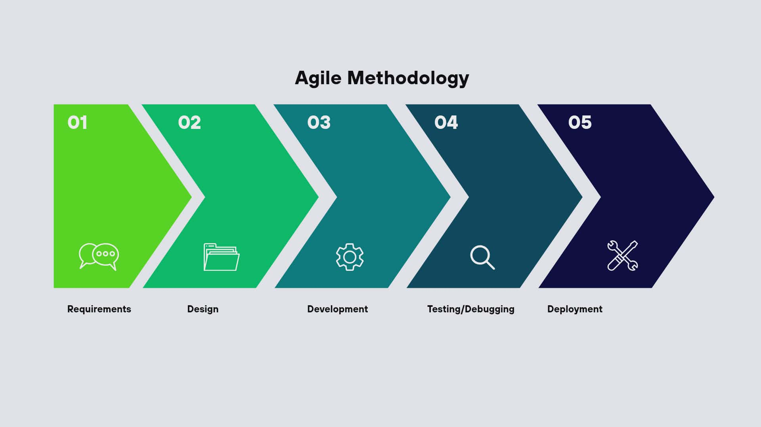

Figure 1: Agile Methodology

The research process will be divided into several phases:
- Planning Phase
- The researchers will conduct interviews with the owner of Jack of Hearts Nails and Body Spa to identify the current problems in appointment scheduling, staff monitoring, and record-keeping.
- Existing procedures, booking methods, and customer concerns will be observed and documented.
- The researchers will identify the functional and non-functional requirements of the proposed system.
- Design Phase
- The researchers will prepare the interface design, system flowchart, database structure, and webpage layout of the system.
- The design will include pages such as Home, About Us, Services, Appointment Booking, Staff Availability, Contact, FAQ, and Client Dashboard.
- The design phase will ensure that the system is user-friendly, accessible, and mobile-responsive.
- Development Phase
- The researchers will develop the system using appropriate programming languages, web technologies, and database tools.
- Features such as user registration and login, appointment booking, staff availability tracking, booking history, digital receipts, and admin approval will be integrated into the system.
- The researchers will continuously test the developed features to ensure proper functionality.
- Testing Phase
- The researchers will conduct system testing to determine if all features are functioning properly.
- Testing will include usability testing, compatibility testing, functionality testing, and error checking.
- Respondents and selected users will evaluate the system based on ease of use, accessibility, convenience, and overall performance.
- Evaluation Phase
- The researchers will distribute survey questionnaires to 50 respondents to evaluate the effectiveness and acceptability of the proposed system.
- The collected data will be analyzed using frequency counts and percentage formulas.
- The results will determine whether the system successfully addresses the problems of manual booking, staff scheduling conflicts, and inefficient record management.

Calendar of Activities
The Gantt chart illustrates the schedule of project activities and their execution over the months, with each month divided into four (4) weeks. The filled cells in brown represent the timeline and progress of each activity.
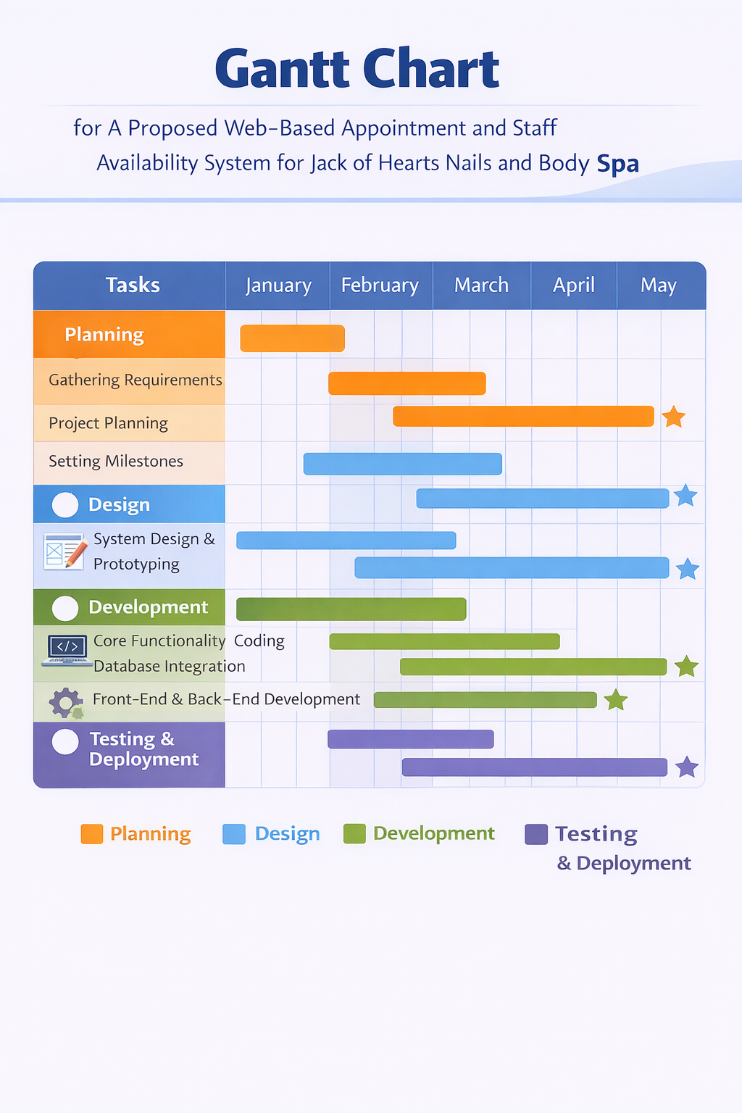

Figure 2: Gantt Chart
Budget Allocation

Items | Description | Price
Documents | Printing of hard document paper, consultation forms, folder, hard book bind. | Php. 3,500.00
Defense fee | Panelist’s food/Token | Php. 500.00
Others | Transportation | Php. 200.00
Total: |  | Php. 4,200.00
Table 1: Budget Allocation

Data Gathering Instruments
The primary data gathering instrument to be used in this study is a survey questionnaire. The questionnaire will be designed to gather information regarding the effectiveness, usability, reliability, and acceptability of the proposed Web-Based Appointment and Staff Availability System for Jack of Hearts Nails and Body Spa.
Aside from the survey questionnaire, the researchers will also use interviews and observations as secondary data gathering instruments. Interviews with the spa owner and staff will be conducted to gather information regarding the current appointment process, staff scheduling concerns, and customer service issues. Observation will also be used to study the existing manual booking system and identify the common problems encountered in daily operations.

Respondents of the Study
The respondents of the study will consist of fifty (50) selected individuals composed of spa clients, potential customers, and staff members of Jack of Hearts Nails and Body Spa. These respondents will be chosen because they are directly involved in the current appointment scheduling process and are the primary users of the proposed Web-Based Appointment and Staff Availability System.
The respondents will include:
- Thirty-five (35) spa clients or potential customers who frequently avail spa services and may use the online appointment feature of the proposed system.
- Ten (10) staff members who are responsible for handling appointments, monitoring staff availability, and managing client schedules.
- Five (5) management representatives, including the owner or supervisors, who oversee the overall operations of the spa.
The researchers will use purposive sampling in selecting the respondents. Purposive sampling is appropriate because the study requires participants who have direct knowledge and experience regarding the current appointment process and staff scheduling system of the spa.

Statistical Treatment of Data
The data gathered from the survey questionnaires will be analyzed using the weighted mean to determine the average responses of the respondents regarding the effectiveness and acceptability of the system.
The formula for weighted mean is:
Weighted Mean = Σfx / N
Where:
- Σfx = Total weighted score
- N = Total number of respondents
The interpreted results will determine whether the proposed system is highly acceptable, acceptable, moderately acceptable, or not acceptable based on the respondents’ evaluation.

Technologies to be Used
To develop and document the proposed Web-Based Booking and Staff Availability System, the proponents will utilize the following technologies:
Hardware:
- Laptop/Personal Computer - Used by team members who have access to it for coding the system, conducting research, and writing the research paper.
- Mobile Device/Cellphone - Used by team members who do not have laptops to assist in testing the system’s functionality, checking responsiveness, and contributing to the research documentation.
- Internet connection - Essential for accessing online resources, testing the web-based system, and collaborating among team members.
- External Storage Devices (e.g., USB, External Hard Drive) - Used for backing up files, research documents, and system-related data.
Both laptop and mobile devices will be used interchangeably depending on availability, ensuring that all proponents can contribute to the project and system regardless of the device they have.
Resources
Hardware Resources:
- Laptop
System Creator – For system development, database creation, and coding.
Leader – For inputting and correcting the research paper, and printing documents.
- Mobile Phones
Used by most members for research, online information gathering, and sharing ideas and tasks.
- Cash
Used by the member assigned to manage printing and upcoming expenses.
Software Resources
- Web Browsers (Google Chrome)
Used to access online research materials and test the web-based system.
- Google Docs / Microsoft Word
Used by the group to write, edit, and collaborate on the research paper.
- Online Comunication Tools
Used to coordinate tasks, share updates, and communicate between members.

Requirements Analysis
The proposed web-based Booking and Staff Availability System for Jack of Hearts Nails and Body Spa aims to improve the current manual appointment and staff scheduling processes. This section identifies the key requirements by examining who is involved, what activities are performed, where, and when they occur, and how the current procedures are carried out.

Requirements Documentation
The Requirements documentation establishes the features and functions of the proposed web-based Booking and Staff Availability System for Jack of Hearts Nails and Body Spa. This ensures that the system meets the needs of the owner, clients, staff, and the group developing it.

System Features
User Registration and Login
- Clients can register and log in using Gmail, Facebook, or mobile phone number.
- System creator ensured documentation of user flow for this feature.
Service Listing
- Displays all services offered by the spa (hand care, foot care, massage, facial care, paraffin waxing, eyelash extensions, etc.) with descriptions and prices.
- Contribution from all members in research helped gather accurate service information.
Booking
- Clients can select services, preferred staff, and available date/time.
- The system prevents double booking by checking staff availability.
- System creator developed and tested feature.
Client dashboard
- Clients can view upcoming and completed appointments, booking history, and profile information.
Staff Availability Management
- Admin or system automatically tracks staff schedules to avoid conflicts.
- System creator built this feature.
Informational Pages
- Home, About Us, Contact, Reviews, and FAQ pages that provide important information about the business and support communication with clients.
- Research contributions from all members helped provide accurate content.
Booking Confirmation
- Clients can review booking details before final submission.
- Digital receipt generated after confirmation.

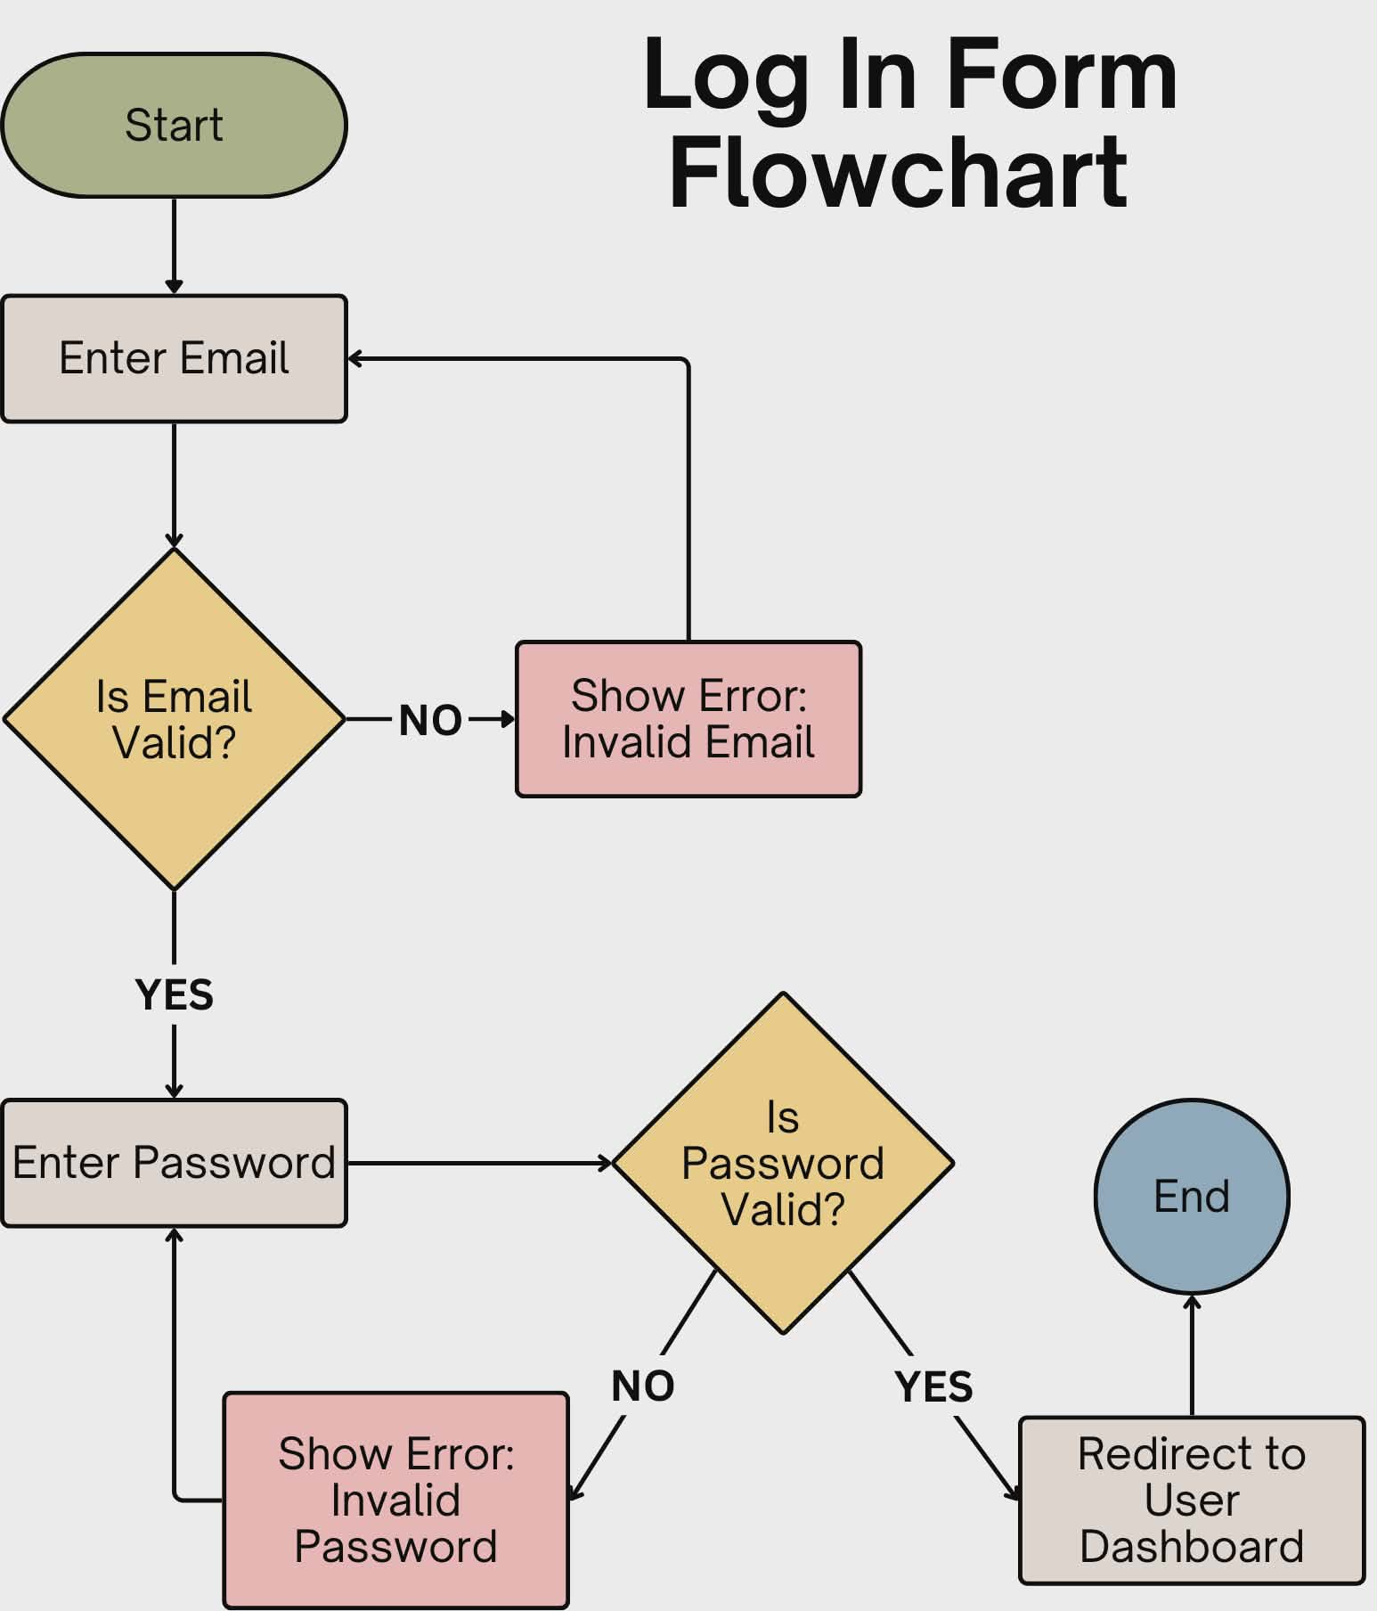

Figure 3: Login form Flowchart
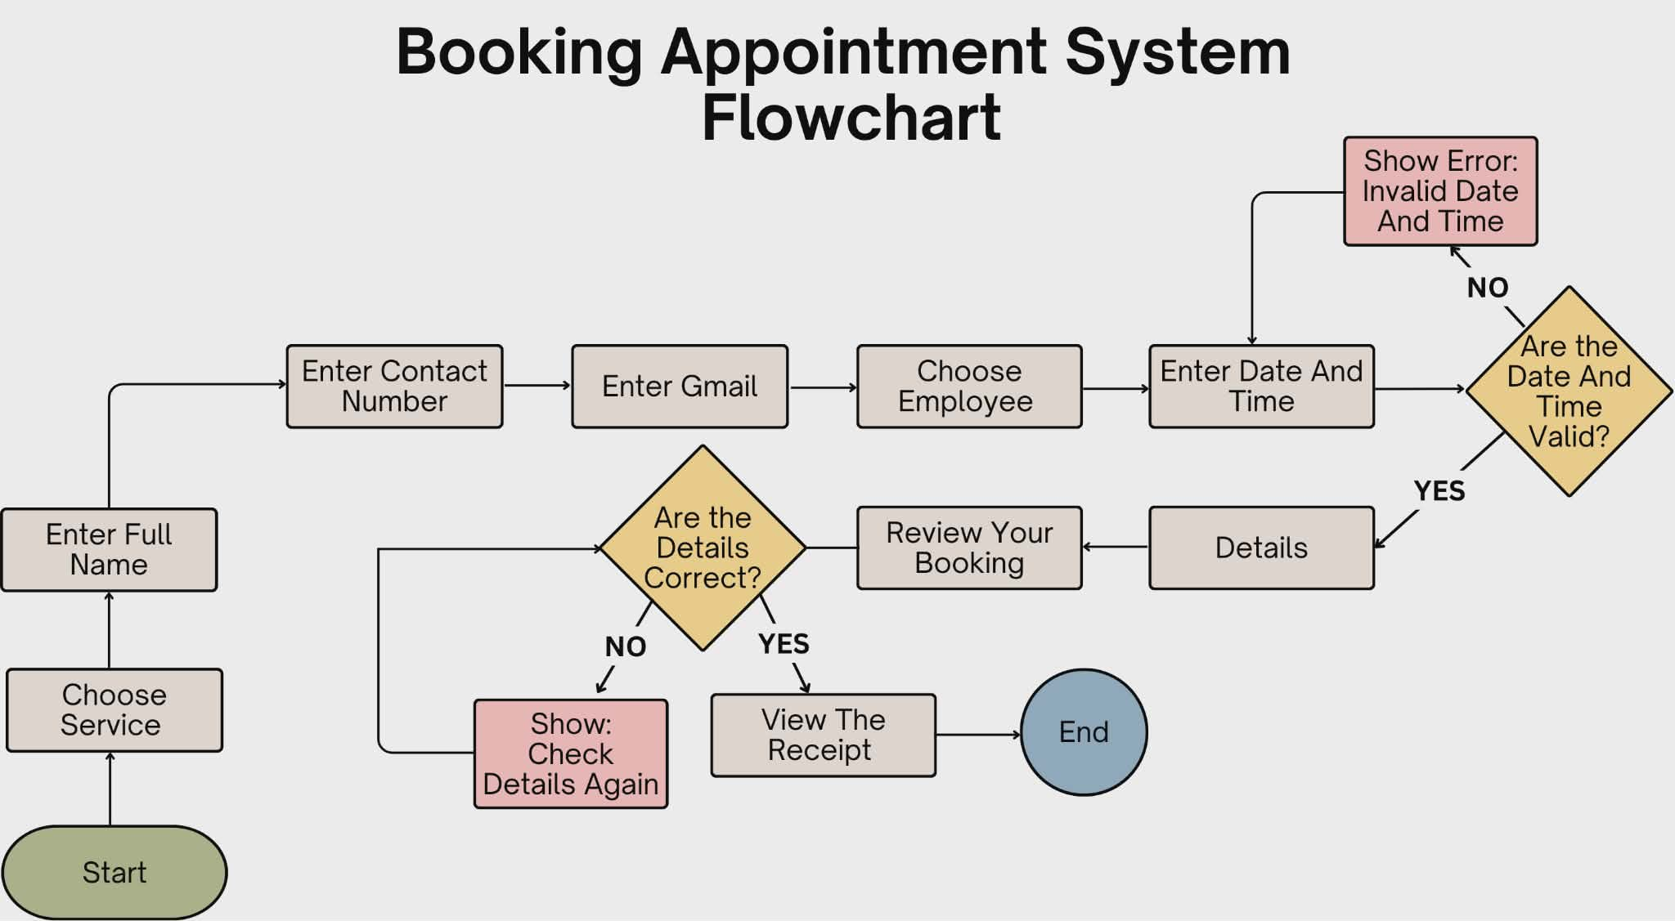

Figure 4: Booking Appointment Flowchart
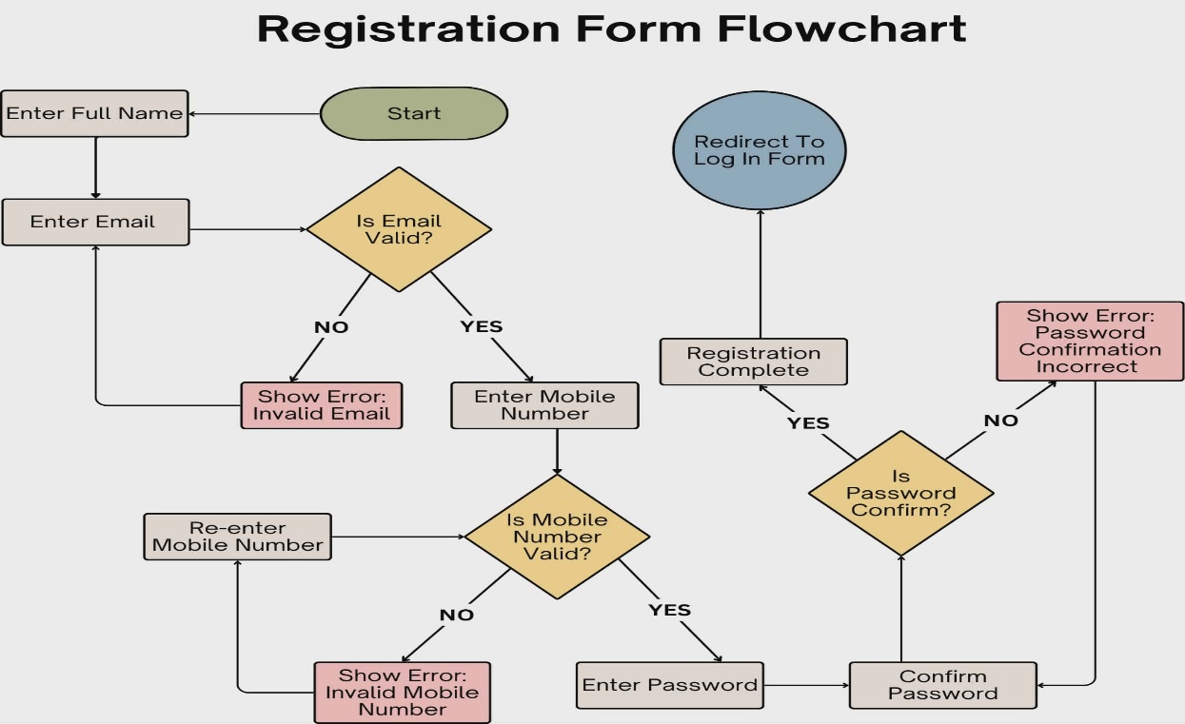

Figure 5: Registration Form Flowchart
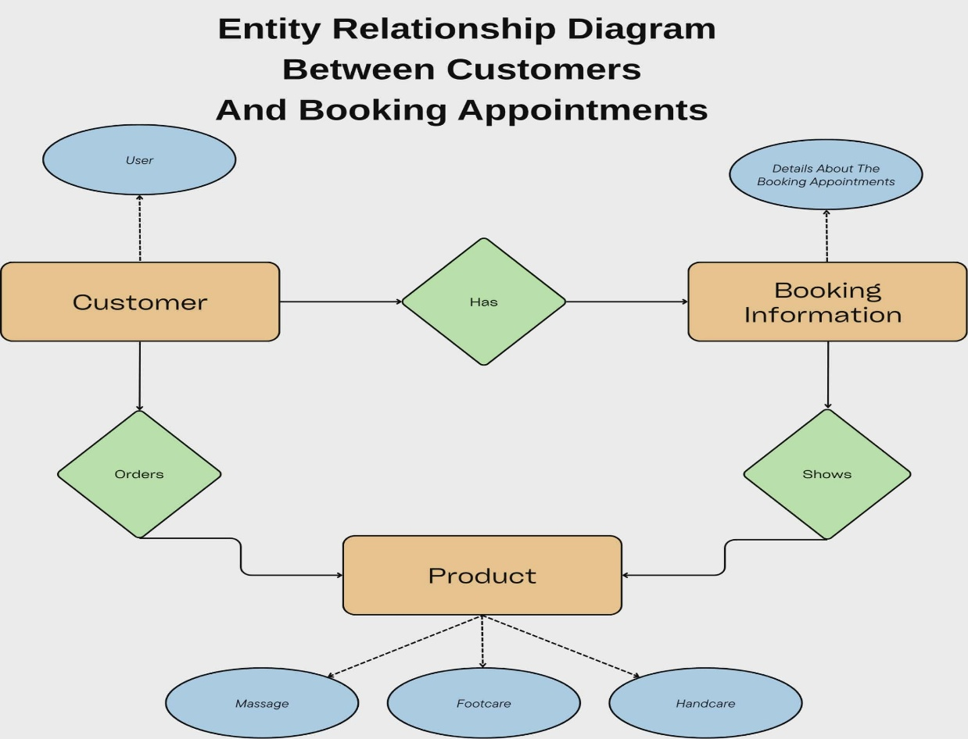

Figure 6: Entity Relationship Diagram
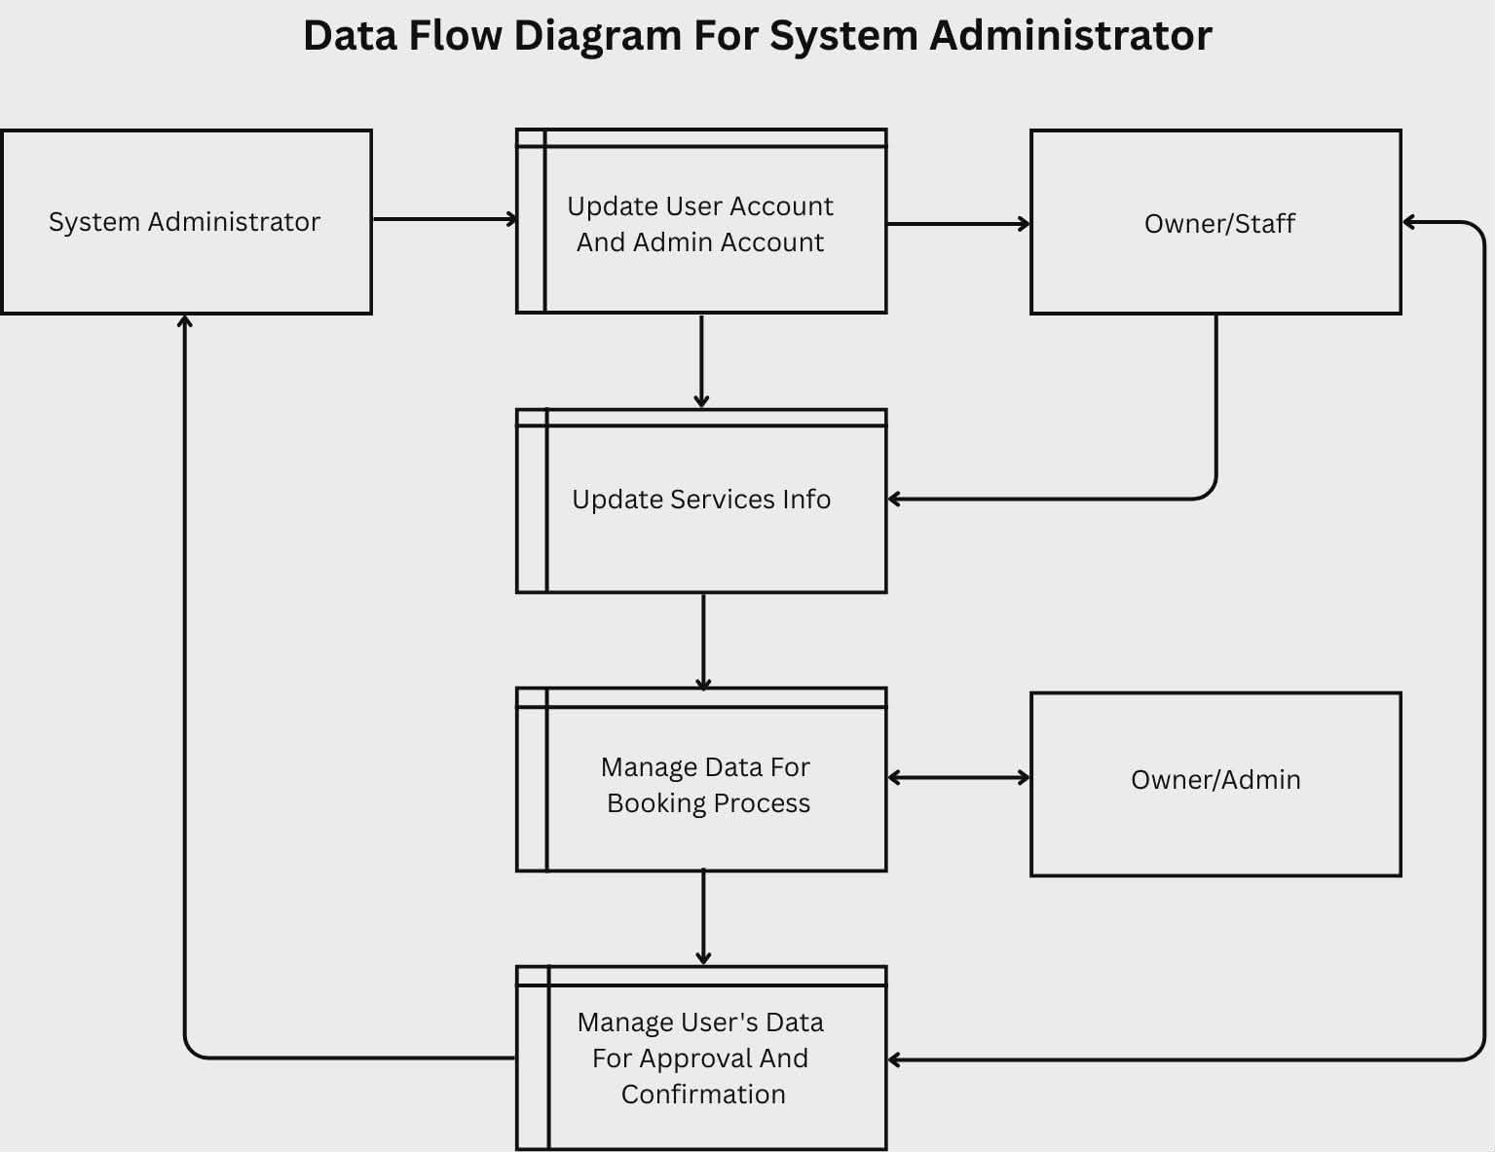

Figure 7: Data Flow Diagram

Chapter 4
Presentation of Data, Analysis, and Interpretation
Data Analysis
The data to be collected from the respondents will be computed using the following formula.

P = f/t x 100
P = percentage
F = frequency
T = total number of respondents
This formula is used to convert the counted responses into percentages for more easier interpretations and comparisons. by using this computation researchers can present more clearly about the overall trends and patterns in their responses

Data For Gender of Respondents
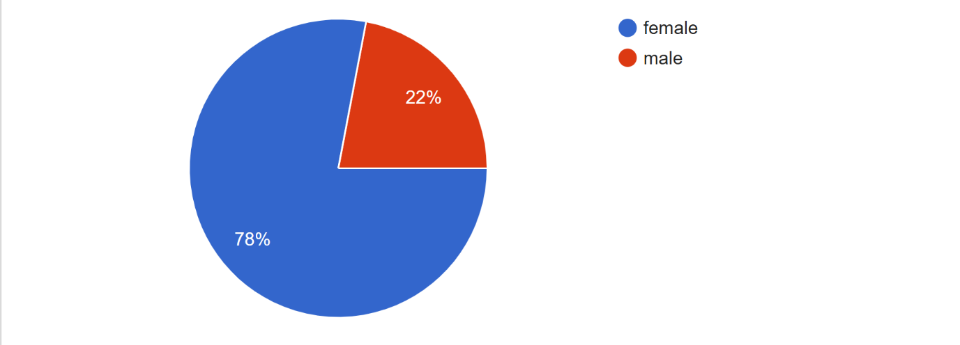
Gender of Respondents: The gender distribution consists of 78% (39) female and 22% (11) male.

Data For Age Group of Respondents
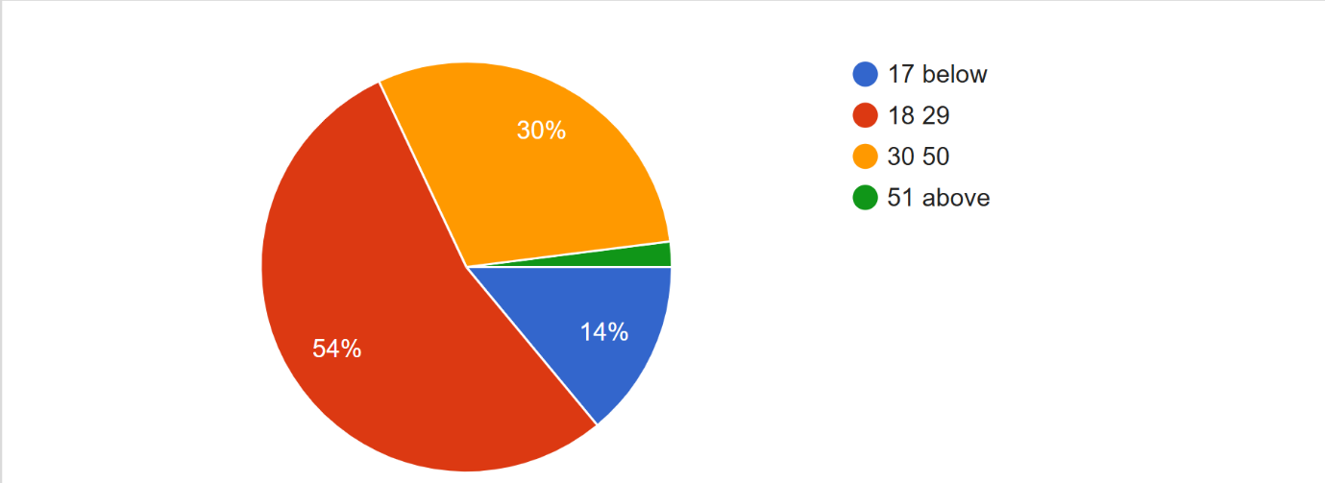
Ages of Respondents: The age demographics show 54% (27) are 18–29, 30% (15) are 30–50, 14% (7) are 17 or below, and 2% (1) are 51 or above.
Data For Q1
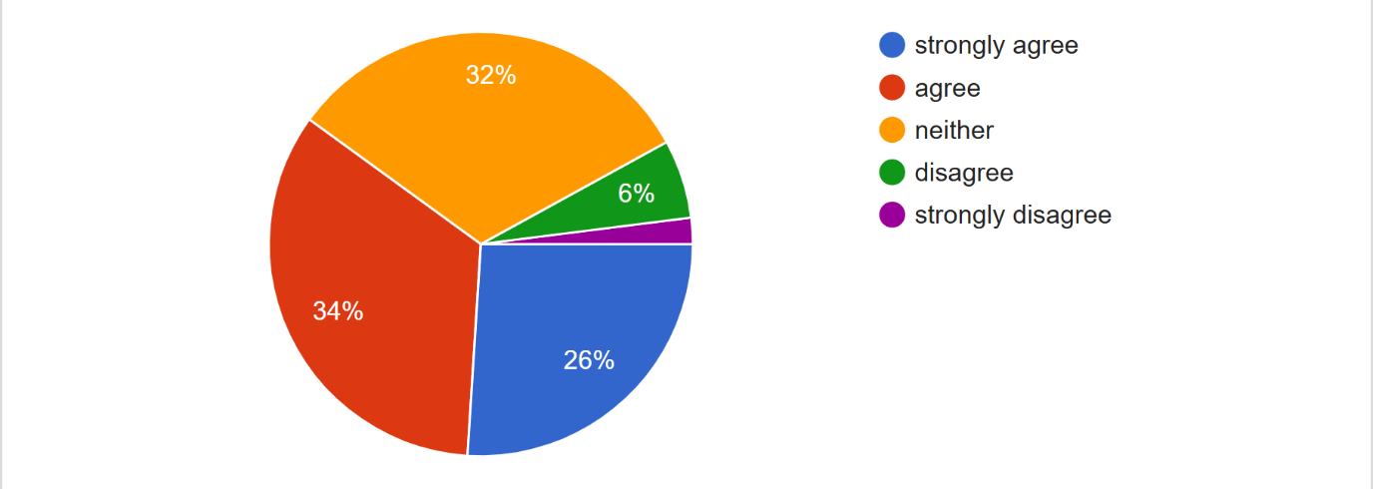Inability to book appointments outside business hours: For this concern, 34% (17) of respondents agree, 32% (16) feel neither agree nor disagree, 26% (13) strongly agree, 6% (3) disagree, and 2% (1) strongly disagree.

Data For Q2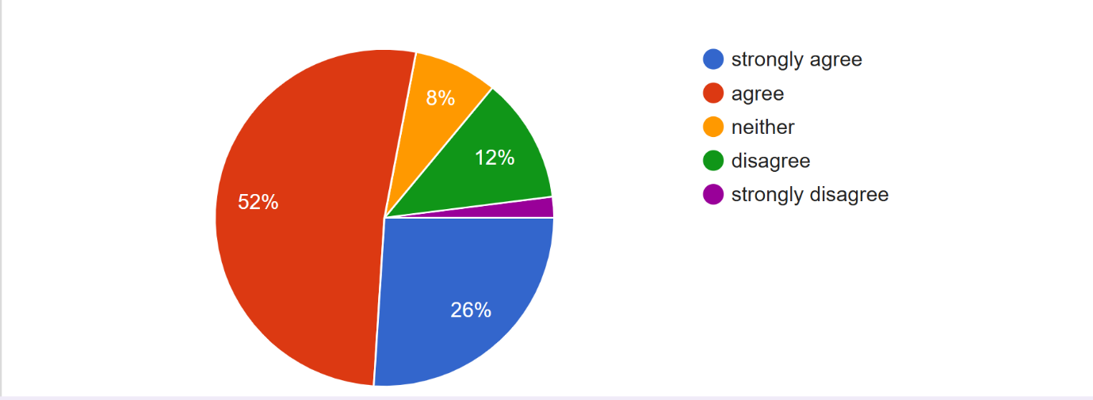
Relying on verbal communication for booking errors: Regarding verbal communication leading to errors, 52% (26) of respondents agree, 26% (13) strongly agree, 12% (6) disagree, 8% (4) feel neither agree nor disagree, and 2% (1) strongly disagree.

Data For Q3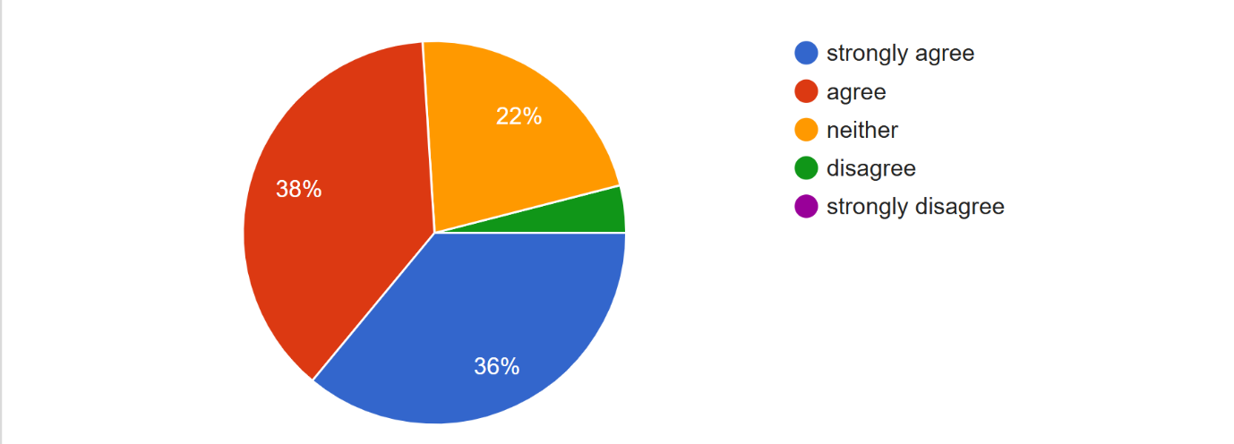

Difficulty requesting specific staff members: In terms of manual booking making it hard to request staff, 38% (19) agree, 36% (18) strongly agree, 22% (11) feel neither agree nor disagree, and 4% (2) disagree.

Data For Q4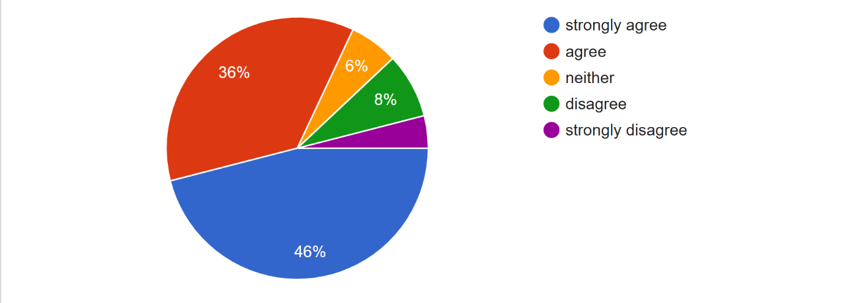
Need to call or visit to check availability: Regarding the burden of checking availability in person or by phone, 46% (23) strongly agree, 36% (18) agree, 8% (4) disagree, 6% (3) feel neither agree nor disagree, and 4% (2) strongly disagree

Data For Q5
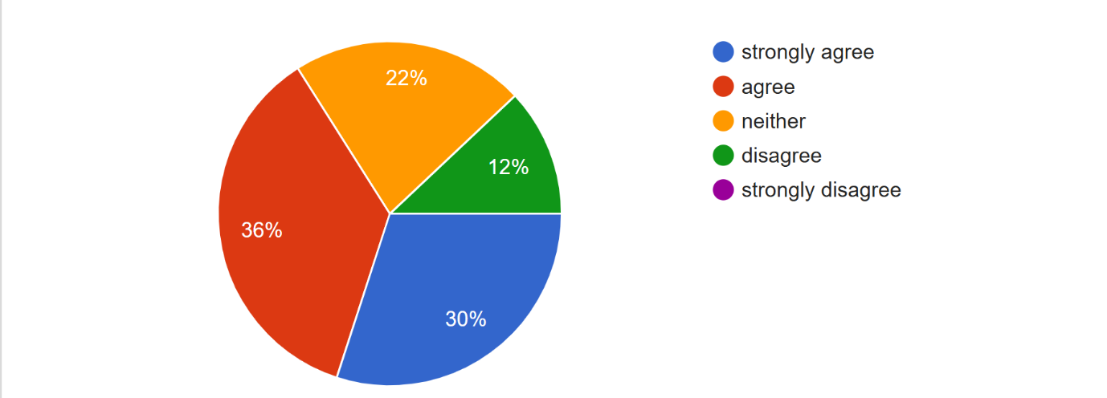 Uncertainty about schedule without written confirmation: For uncertainty due to lack of written confirmation, 36% (18) agree, 30% (15) strongly agree, 22% (11) feel neither agree nor disagree, and 12% (6) disagree.

Data For Q6

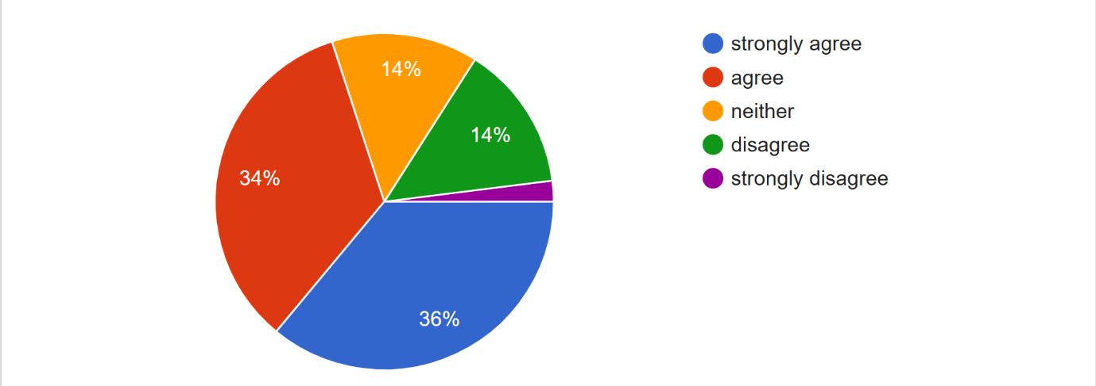
Logbooks resulting in double bookings: Concerning manual logbooks and accidental double bookings, 36% (18) strongly agree, 34% (17) agree, 14% (7) feel neither agree nor disagree, 14% (7) disagree, and 2% (1) strongly disagree.

Data For Q7

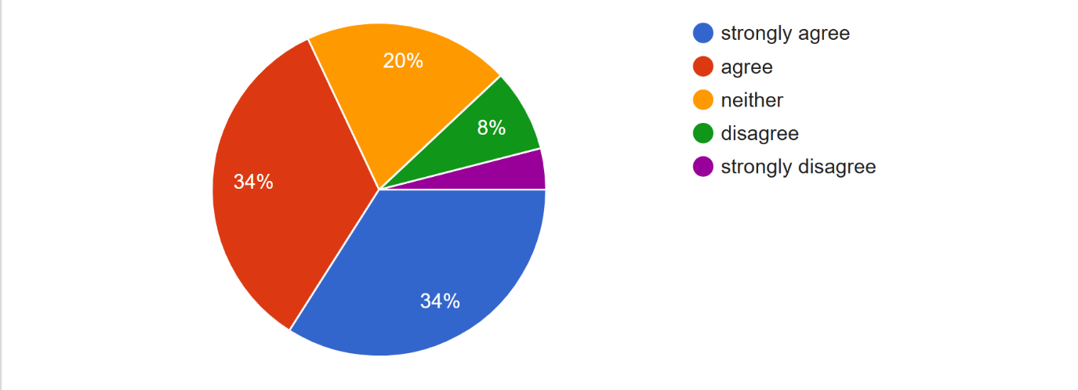
Complexity of managing staff shifts manually: For the complexity of manual shift management, 34% (17) strongly agree, 34% (17) agree, 20% (10) feel neither agree nor disagree, 8% (4) disagree, and 4% (2) strongly disagree.

Data For Q8
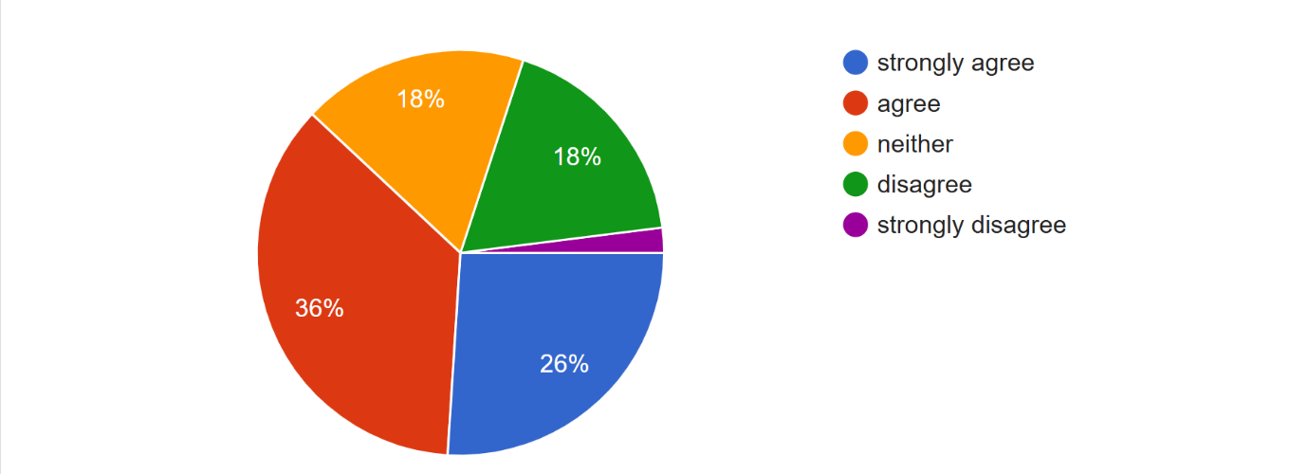

Difficulty tracking overbooked staff members: Regarding tracking overbooked staff, 36% (18) agree, 26% (13) strongly agree, 18% (9) feel neither agree nor disagree, 18% (9) disagree, and 2% (1) strongly disagree.

Data For Q9

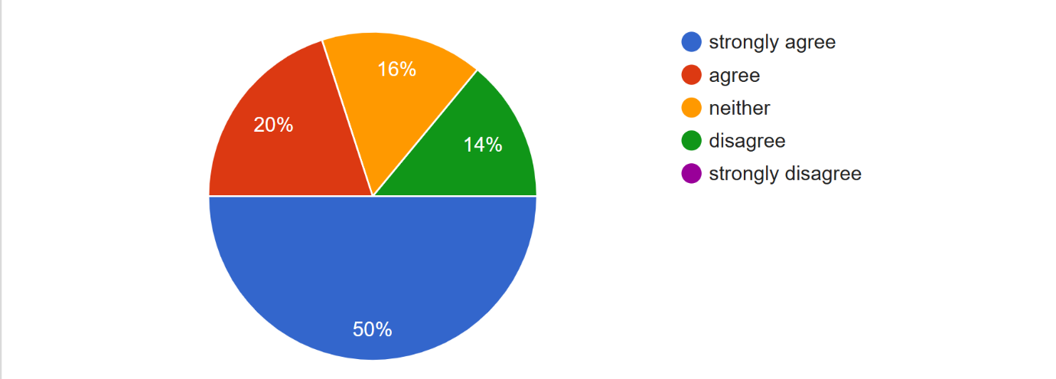
Legibility of handwritten notes on client preferences: Concerning the difficulty of reading handwritten client notes, 50% (25) strongly agree, 20% (10) agree, 16% (8) feel neither agree nor disagree, and 14% (7) disagree.

Data For Q10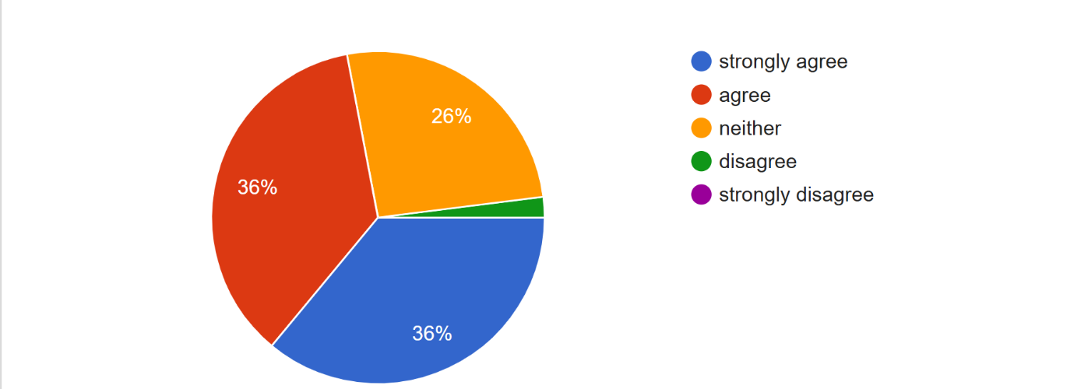
Time wasted manually coordinating staff timetables: In terms of time wasted on manual coordination, 36% (18) strongly agree, 36% (18) agree, 26% (13) feel neither agree nor disagree, and 2% (1) disagree.

Data For Q11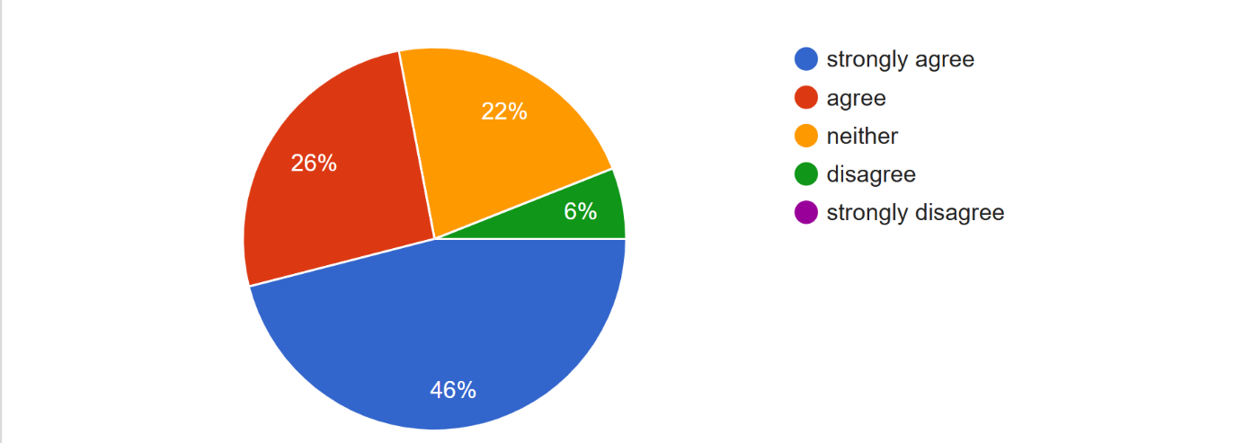
Inefficiency of searching physical filing systems: Regarding slow searches for client history, 46% (23) strongly agree, 26% (13) agree, 22% (11) feel neither agree nor disagree, and 6% (3) disagree.

Data For Q12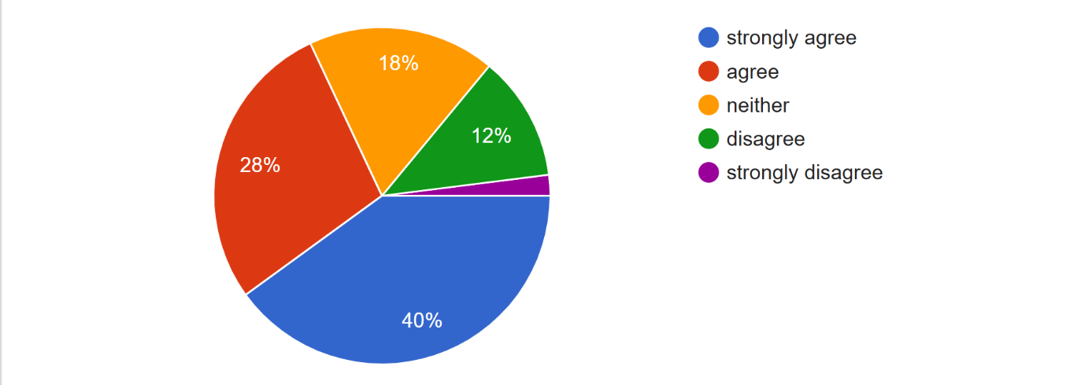Difficulty tracking peak hours with handwritten records: For tracking popular services and peak hours manually, 40% (20) strongly agree, 28% (14) agree, 18% (9) feel neither agree nor disagree, 12% (6) disagree, and 2% (1) strongly disagree.

Data For Q13
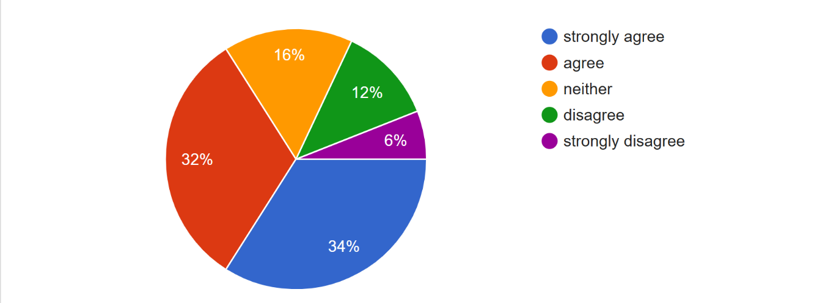
Errors in manual financial record keeping: Concerning financial errors from manual records, 34% (17) strongly agree, 32% (16) agree, 16% (8) feel neither agree nor disagree, 12% (6) disagree, and 6% (3) strongly disagree.

Data For Q14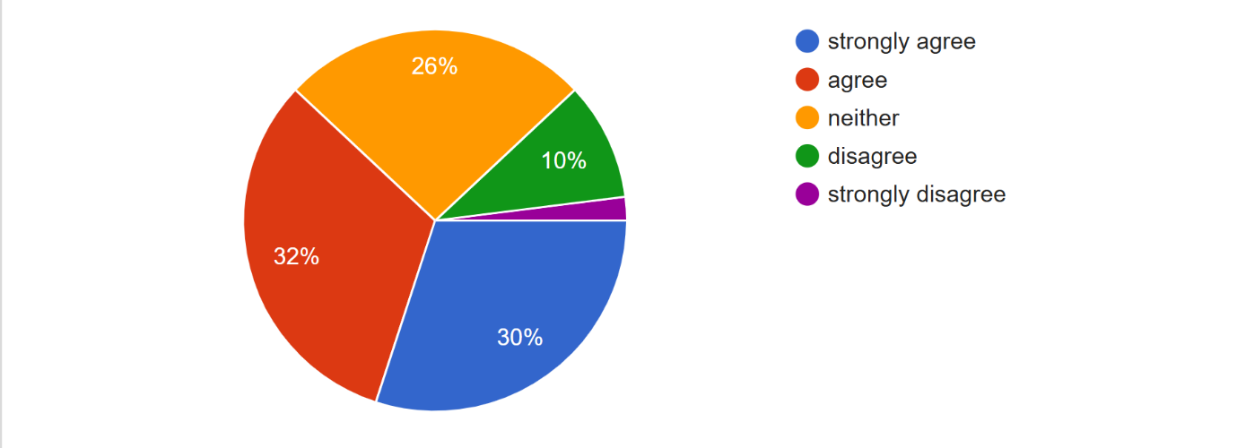
Data privacy risks for client contact information: Regarding the risk to personal data privacy, 32% (16) agree, 30% (15) strongly agree, 26% (13) feel neither agree nor disagree, 10% (5) disagree, and 2% (1) strongly disagree.

Data For Q15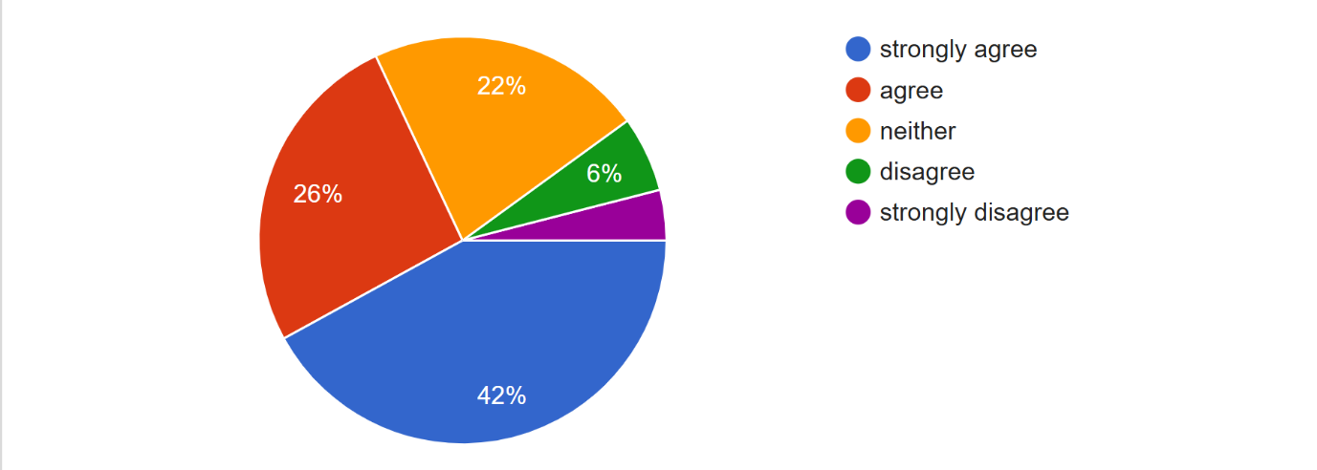
Manual paperwork hindering professionalism: For a cluttered workspace hindering professionalism, 42% (21) strongly agree, 26% (13) agree, 22% (11) feel neither agree nor disagree, 6% (3) disagree, and 4% (2) strongly disagree.

Chapter 5
Summary, Conclusion, and Recommendation

Summary of Findings
This study focused on the development of a Web-Based Booking and Staff Availability System for Jack of Hearts Nails and Body Spa to address the inefficiencies of manual booking processes. The data gathered from respondents revealed that most users belong to the younger age group (18–29) and frequently use mobile devices to access services, highlighting the importance of a mobile-friendly system. The results showed that a large percentage of respondents experienced difficulties with manual booking, such as scheduling conflicts, double bookings, and the need to visit or call the spa to check availability. Many respondents agreed that verbal communication often leads to errors, while handwritten records are difficult to manage and prone to mistakes. Additionally, the findings revealed that users highly value convenience, with many expressing the need for online booking, real-time staff availability, and written confirmations. Respondents also indicated that manual systems consume time, reduce efficiency, and affect professionalism. Overall, the collected data strongly supports the need for a digital solution that automates booking, improves record management, and enhances the overall customer experience.

Conclusion
Based on the findings of the study, it can be concluded that the current manual booking system used by Jack of Hearts Nails and Body Spa is inefficient and prone to errors. Issues such as double booking, difficulty in tracking staff availability, and lack of proper documentation significantly affect both customer satisfaction and business operations. The proposed web-based system provides an effective solution by offering features such as online booking, real-time staff availability, centralized records, and user-friendly navigation. These features directly address the identified problems and improve service efficiency. The results also indicate that users are highly receptive to digital solutions, especially those accessible via mobile devices. The high level of agreement among respondents regarding the challenges of manual processes confirms that implementing the proposed system will enhance convenience, reduce workload, and improve overall service quality. Therefore, the study concludes that the proposed system is beneficial and effective in improving booking management, operational efficiency, and customer satisfaction.

Recommendation
- Improve Service Descriptions: Revise and simplify service descriptions on the website to ensure clarity and better understanding for users. Adding visuals or examples can enhance user comprehension.
- Enhance Mobile Optimization: Since most users access the system through mobile devices, further improvements should be made to ensure faster loading time, responsive design, and smooth navigation across all devices.
- Implement Booking Confirmation System: Provide automatic confirmations and notifications to users to reduce uncertainty and improve trust in the system.
- Continuous Monitoring of Feedback: Regularly collect and analyze user feedback through surveys, reviews, and system interactions to identify issues and improve system performance.
- Future System Enhancements: Consider adding advanced features such as online payment integration, automated reminders, and analytics reports to further improve the system.
- Staff Training: Ensure that spa staff are properly trained to use the system efficiently for better coordination and service delivery.

References
Hamid, N. A. Z., & Mohd Nawi, N. (2025). Era Beauty Spa Booking System. Applied Information Technology and Computer Science, 6(1), 2231–2247.
Nandekar, P., & Singh, P. (2025). Design and Development of an Online Salon Booking and Management System. American Journal of Technology Advancement, 2(2025).
Choudhari, P., & Singh, N. (2025). A Web Based Solution for Efficient Salon Appointment Scheduling and Management. American Journal of Technology Advancement, 2(2025).
Alam, M. A., Khan, M. A., Khan, Y. H., Mallick, S., Zaid, M., & Sunil. (2024). CALMA: A Personalized Android-Based Salon Appointment Booking System. Presented at the 4th International Conference on ICT for Digital, Smart & Sustainable Development.
Starke, G. (2023). Shortcomings of ISO 25010. INNOQ.
ISO/IEC. (2023). ISO/IEC 25010: Systems and Software Quality Requirements and Evaluation (SQuaRE). arc42 Quality Model.
ByteAhead. (2022). Software Quality Standards – How and Why We Applied ISO 25010?
Moniruzzaman, A. B. M., & Hossain, S. A. (2013). Comparative Study on Agile Software Development Methodologies. arXiv.
Turk, D., France, R., & Rumpe, B. (2014). Assumptions Underlying Agile Software Development Processes. arXiv.
Soundararajan, S. (2011). A Methodology for Assessing Agile Software Development Approaches. arXiv.
Abrahamsson, P., Salo, O., Ronkainen, J., & Warsta, J. (2017). Agile Software Development Methods: Review and Analysis. arXiv.
ITPro. (2026). Agile Development Might Be 25 Years Old, but It Has Withstood the Test of Time – and There’s Still More to Come in the Age of AI.
Axios. (2017). Google Now Lets Users Book Salon, Spa Appointments Through Its Apps.
Reddit User Glamezy. (2023). Why Does a Business Need an Online Booking System? Reddit.
Reddit User Juliaching. (2024). Online Booking System: The Importance of Using It in the Salon. Reddit.
Reddit User Posbook1. (2020). Is Managing Salon Appointments Manually Costing You Customers? Reddit.
Reddit User. (2021). Online Booking System for Salons in WordPress? Reddit.
Reddit User Epistictechnologies. (2023). What Is the Agile Software Development Methodology? Reddit.
Reddit User Synsoftg. (2020). Why Agile? Why Software Development Companies Use This Methodology? Reddit.
Reddit User. (2023). Are Software Engineering and Agile Against Each Other? Reddit.

Appendices

Appendix A: Curriculum Vitae
Appendix B: Permission Letter to Conduct Data Gathering
Appendix C: Instrument
Appendix D: Proof to conduct Survey
Appendix E: Screenshot of System
Appendix F: Coding

