Chapter 3
Research Methodology
Technical Background
This chapter presents a summary of the technologies currently used in developing A Web-Based Point of Sale System to Enhance Customer Satisfaction for Boss K Sizzling, including the resources utilized, a Gantt Chart illustrating the project timeline, and the system's technical requirements.
Research Design
This study utilizes the developmental research design method in creating and evaluating the proposed Web-Based Point of Sale System to Enhance Customer Satisfaction for Boss K Sizzling. Developmental research is appropriate because the study aims to design, develop, test, and assess a system that will improve the eatery's current manual order-taking, billing, and kitchen communication process.
System Development Method
The study follows the Rapid Application Development (RAD) Methodology as the system development approach. RAD is suitable because it focuses on building the system quickly through close collaboration with the people who will actually use it. Instead of following a strict plan from start to finish, the team was able to make changes along the way based on real feedback from the owner and staff.
The research process was divided into four (4) phases:
Phase I: Requirements Planning
The researchers began by identifying the actual problems faced by Boss K Sizzling. Through direct conversations and on-site observation with the owner, cashier, and kitchen staff, the team documented daily challenges such as illegible handwritten slips, slow kitchen communication, and tedious manual tallying. From these findings, the team listed the functional and non-functional requirements for the system.
Phase II: User Design
This phase involved close collaboration between the team and the actual system users. Early prototypes were presented to the cashier and kitchen staff, and their feedback directly shaped the final interface. Any confusing or inconvenient feature was revised immediately until all stakeholders were comfortable with the design.
Phase III: Construction
With the approved design, the team developed the full system — the cashier's digital order interface, the real-time kitchen display, the automated billing calculator, and the owner's sales analysis dashboard. Each module was continuously tested and bugs were resolved before moving to the next feature.
Phase IV: Cutover
In the final phase, the completed system was deployed at Boss K Sizzling. All stations were configured and a hands-on walkthrough was conducted with the staff. The eatery officially transitioned from paper slips and manual billing to a faster, more organized digital operation.
Calendar of Activities
The Gantt Chart below illustrates the schedule of project activities and their execution over the months, with each month divided into four (4) weeks. Cells filled with yellow indicate activities currently in progress, while blue indicates completed activities.
Figure 2. Gantt Chart of Activities
Budget Allocation
Items | Description | Price
Documents | Printing of hard document papers, consultation forms, endorsement letter, and folder | Php. 3,100.00
Others | Transportation / Food | Php. 600.00
Total: |  | Php. 3,700.00
Table 1. Budget Allocation
Data Gathering Instruments
The primary data gathering instrument used in this study is a survey questionnaire designed to gather information from respondents regarding their experiences with the current manual ordering process at Boss K Sizzling and their perception of the proposed Web-Based Point of Sale System.
Aside from the survey questionnaire, the researchers also used interviews and observations as secondary instruments. Interviews with the owner, cashier, and kitchen staff gathered information about the current order-taking process and kitchen communication issues. Observation was used to study existing manual procedures and identify common daily operational problems.
Respondents of the Study
The respondents consist of fifty (50) selected individuals composed of regular customers, potential customers, and staff members of Boss K Sizzling, chosen because they are directly involved in or affected by the current manual ordering process.
The respondents include:
- Thirty-five (35) regular or potential customers who frequently dine at Boss K Sizzling and are directly affected by the current queue and ordering process.
- Ten (10) staff members, including cashiers and kitchen staff, who handle orders, process payments, and manage kitchen operations daily.
- Five (5) management representatives, including the owner or supervisors, who oversee overall daily operations.
The researchers used purposive sampling, which is appropriate because the study requires participants with direct knowledge and experience regarding the current ordering system and operational challenges of Boss K Sizzling.
Statistical Treatment of Data
The data gathered from the survey questionnaires were analyzed using the percentage formula and weighted mean to determine the frequency distribution and average level of agreement among respondents.
P = f/t × 100
Where: P = Percentage, f = Frequency, t = Total number of respondents
Weighted Mean = Σfx / N
Where: Σfx = Total weighted score, N = Total number of respondents
The interpreted results will determine the level of agreement among respondents using the following Likert Scale:
Scale | Range | Interpretation
5 | 4.20 – 5.00 | Strongly Agree
4 | 3.40 – 4.19 | Agree
3 | 2.60 – 3.39 | Neither Agree nor Disagree
2 | 1.80 – 2.59 | Disagree
1 | 1.00 – 1.79 | Strongly Disagree

Technologies to be Used
The development of the Web-Based Point of Sale System will require both hardware and software technologies to ensure accurate transaction recording, data storage, order-taking, and cashier-to-kitchen communication.
Hardware:
- Laptop/Personal Computer – Used for coding the system, research, and writing the paper.
- Mobile Device/Cellphone – Used for testing system functionality and checking responsiveness.
- Internet Connection – Essential for accessing online resources and testing the web-based system.
Resources
Hardware Resources:
Laptop
- System Creator – For system development, database creation, and coding.
- Leader – For typing, correcting the research paper, and printing documents.
Mobile Devices
- Used by most members for research, information gathering, and sharing tasks.
Cash
- Used by the member assigned to manage printing and upcoming expenses.
Software Resources:
1. Programming Language
- Next.js (React Framework) – Builds the main web application with fast loading and smooth navigation.
- TypeScript – Keeps the code clean and reliable, catching errors early.
2. Database Management System
- Supabase (PostgreSQL) – Stores order records and transaction history in a secure cloud-based environment.
3. Data Processing & Visualization Tools
- Recharts Library – Renders the dynamic Sales Analysis Dashboard with charts and graphs.
- Date-fns – Lightweight library for manipulating and formatting dates.
- Supabase Realtime – Enables live order updates for admins, cashiers, and kitchen staff.
4. Development Tools
- Visual Studio Code – Code editor for programming and system development.
- Git & GitHub – For version control and team collaboration.
- Google Chrome / Microsoft Edge / Brave – For testing system responsiveness and browser compatibility.
Requirements Analysis
This section covers the analysis for the development of the Web-Based Point of Sale System for Boss K Sizzling, including stakeholder roles, system operations, functional requirements, and identified problems with the current manual process.
A. Who – People Involved
1. Owner / Administrator
- Access the Sales Analysis Dashboard to view daily, weekly, and monthly revenue trends.
- Make informed decisions based on real-time charts (Best-Selling Items, Peak Hours, Revenue Totals).
- Review historical transaction data and audit sales records at any time.
2. Cashier
- Input customer orders and special instructions through the Digital Order Interface.
- Process cash payments and generate printed billing receipts for customers.
- Monitor order status and manage active transactions in real time.
3. Kitchen Staff
- Receive confirmed orders instantly through the Kitchen Display System.
- View order details including dish names, quantities, add-ons, and preparation instructions.
- Mark orders as completed to update the cashier and reduce wait times.
4. Customers
- Place orders with accurate, error-free billing through the digital counter interface.
- Receive a clear, printed receipt for every transaction.
- Experience faster service and reduced waiting times.
B. What – Business Activity
- Digital Order Taking – Cashier inputs customer orders through the POS interface.
- Kitchen Display Transmission – Confirmed orders sent instantly to the kitchen, replacing paper slips.
- Automated Billing Calculation – System computes total price, eliminating manual math and revenue leakage.
- Receipt Generation – System prints or displays an itemized bill upon payment completion.
- Sales Data Recording – Every completed transaction stored in the cloud database.
- Data Visualization & Reporting – Visual charts on daily revenue, peak hours, and best-selling items.
- Role-Based Access Control – Separate login portals for Owner and Cashier.
C. Where – Environment of Operation
- Counter / Cashier Station – Where the cashier uses the POS interface on a desktop or laptop.
- Kitchen Area – Where kitchen staff views orders on a dedicated display.
- Owner's Station – Where the business owner accesses the Admin Dashboard.
- Cloud Database (Supabase) – Where all transaction records are securely stored.
D. When – Timing of Operations
- Real-Time Order Processing – Orders transmitted to kitchen instantly upon cashier confirmation.
- Continuous Sales Tracking – Admin Dashboard updates automatically with each transaction.
- Weekly & Monthly Analysis – Historical data views for performance monitoring and planning.
E. How – Current Procedures
Current Manual Procedure:
- A customer verbally places their order at the counter.
- The cashier writes the order details on a paper slip by hand.
- The paper slip is physically handed to the kitchen staff.
- The cashier manually calculates the total using mental math or a basic calculator.
- At the end of the day, the owner manually tallies all paper receipts to compute total sales.
- Paper records are stored physically and are prone to loss or damage.
Problems Identified:
- Handwritten slips are difficult to read, causing kitchen mistakes.
- Manual calculation is prone to billing errors and revenue leakage.
- The physical handoff of paper slips slows down Turnaround Time (TAT) during peak hours.
- End-of-day auditing is time-consuming and exhausting for the owner.
- Paper records provide no real-time visibility into sales performance or best-selling items.
- Physical receipts can be lost, damaged, or manipulated, creating accountability risks.
Requirements Documentation
Functional Requirements
1.1 Access Control Module
- Secure login portal for Owner and Cashier using email/password credentials.
- Role-based permissions: Owner → analytics; Cashier → order interface only.
1.2 Digital Order Interface Module
- Cashier selects menu items, quantities, add-ons, and special instructions.
- System auto-computes subtotal and total with real-time price updates.
1.3 Kitchen Display Transmission Module
- Confirmed orders instantly sent to Kitchen Display without manual relay.
- Kitchen can mark orders as completed, triggering status update at cashier station.
1.4 Billing & Receipt Module
- System generates an itemized digital receipt upon payment confirmation.
- Supports printing of physical receipts and assigns a unique Order ID per transaction.
1.5 Sales Analysis Dashboard Module
- Daily Revenue Chart – Bar graph of total sales income per day.
- Peak Hours Graph – Line chart identifying the busiest business periods.
- Weekly and Monthly Reports – Summaries for performance monitoring and planning.
1.6 Reporting & Export Module
- One-click export of transaction sales reports into Excel/CSV format.
Non-Functional Requirements
Performance
- Order transmission to kitchen occurs in under 2 seconds.
- Admin Dashboard loads sales data within 3 seconds on a standard connection.
Security
- Role-based access control to prevent unauthorized data access.
- Encrypted data storage and secure cloud database with automatic backup.
User Experience
- Simple, intuitive interface requiring minimal training for cashier and kitchen staff.
- Mobile-responsive design accessible on tablets, laptops, and desktop computers.
Reliability & Compatibility
- High availability during all business operating hours with automatic data saving.
- Works on Windows and Mac via any modern web browser; compatible with tablet devices.
System Features
Order Management Interface
- Staff can input customer orders, quantities, add-ons, and special instructions in real-time.
Kitchen Display System
- Confirmed orders instantly transmitted to the kitchen display, replacing handwritten paper slips.
- Kitchen staff can mark orders as completed to update the cashier's live queue.
Automated Billing & Receipt Generation
- System auto-computes total order price and generates a unique Order ID per transaction.
- Supports printing of itemized physical receipts for customers.
Sales Analysis Dashboard
- Provides the owner with daily, weekly, and monthly visual reports on revenue, peak hours, and best-selling items.
Secure Role-Based Access Control
- Separate login portals for Owner (analytics) and Cashier (order-taking) to protect financial data.
Figures
The following figures illustrate the key system processes and data architecture of the proposed Web-Based Point of Sale System for Boss K Sizzling.

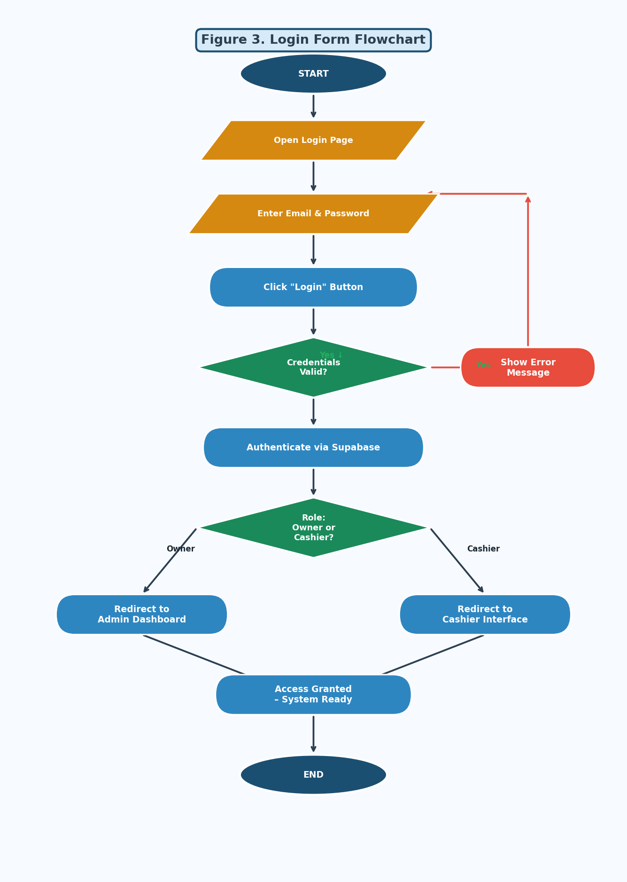
Figure 3. Login Form Flowchart

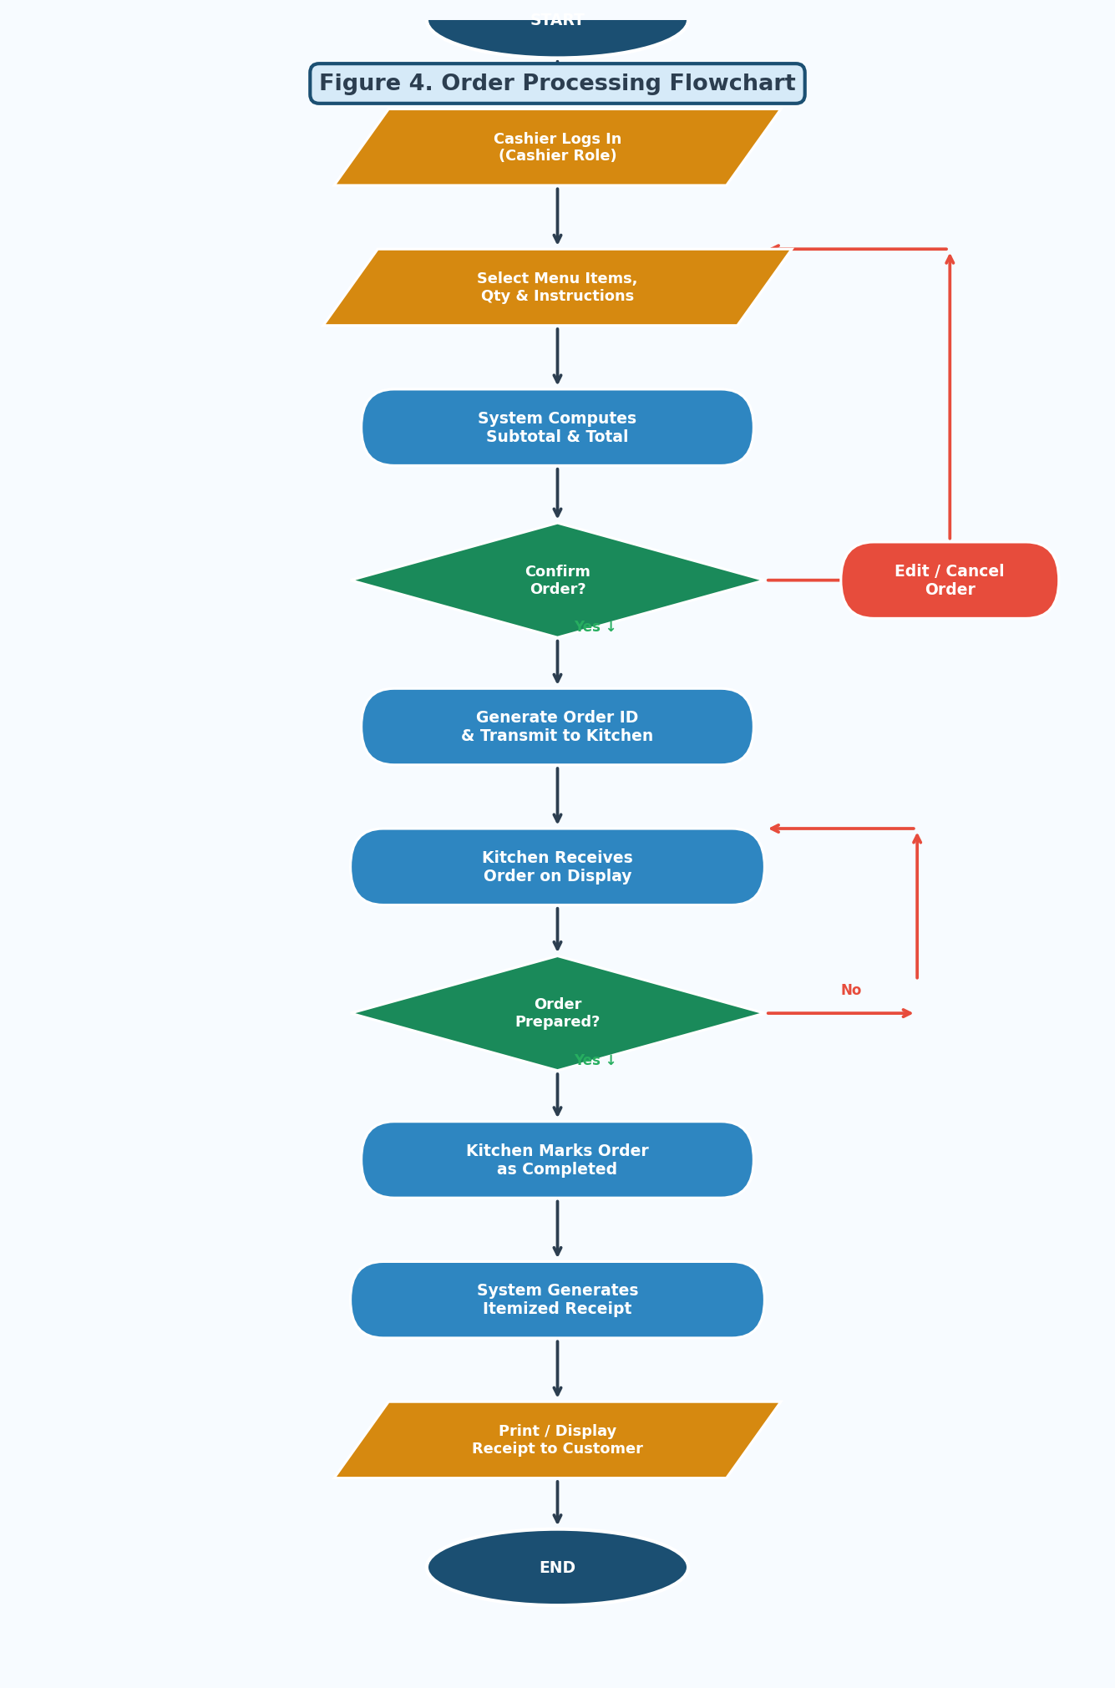
Figure 4. Order Processing Flowchart

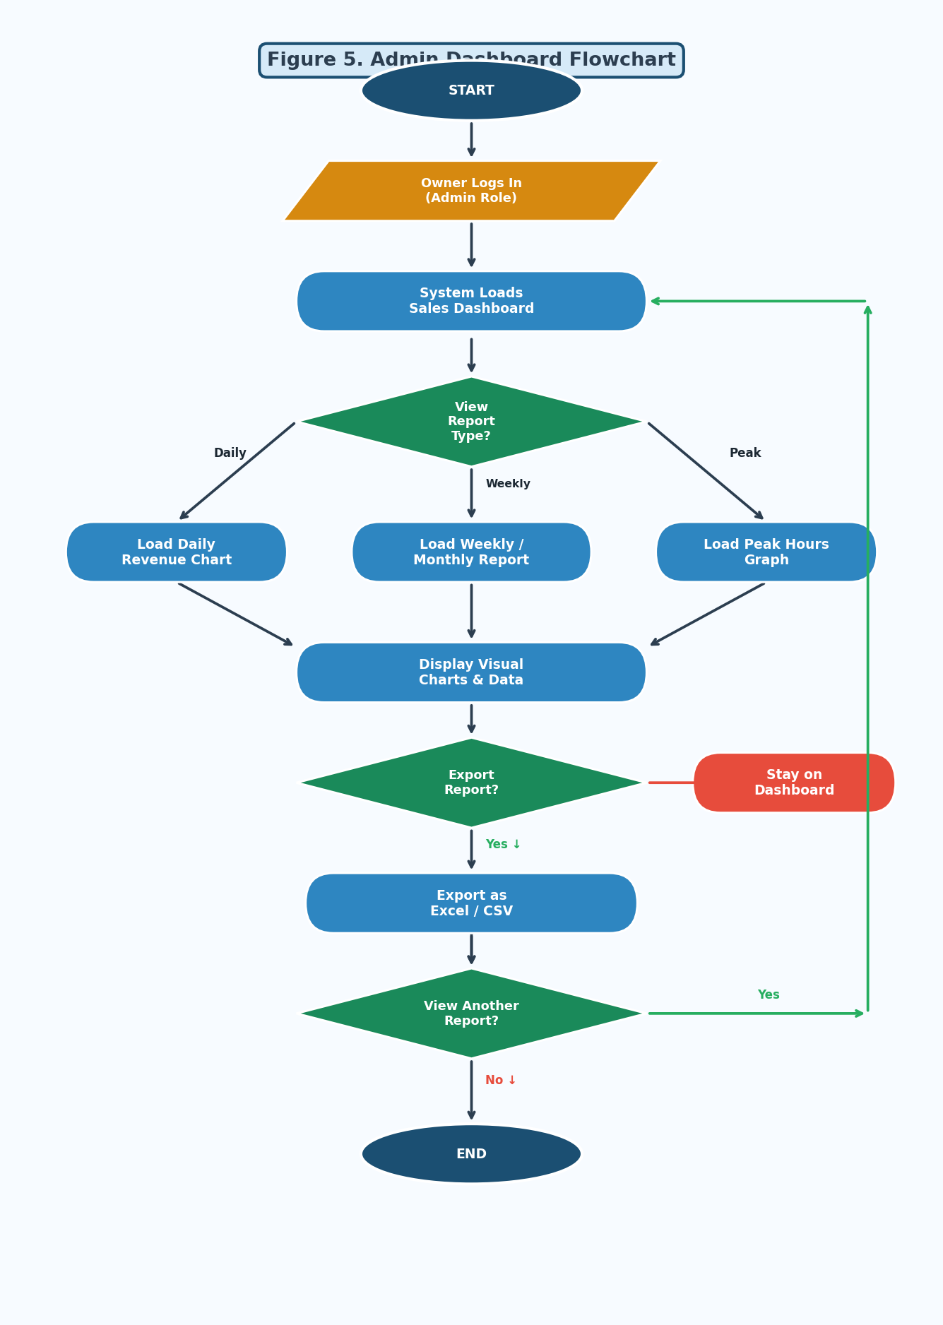
Figure 5. Admin Dashboard Flowchart

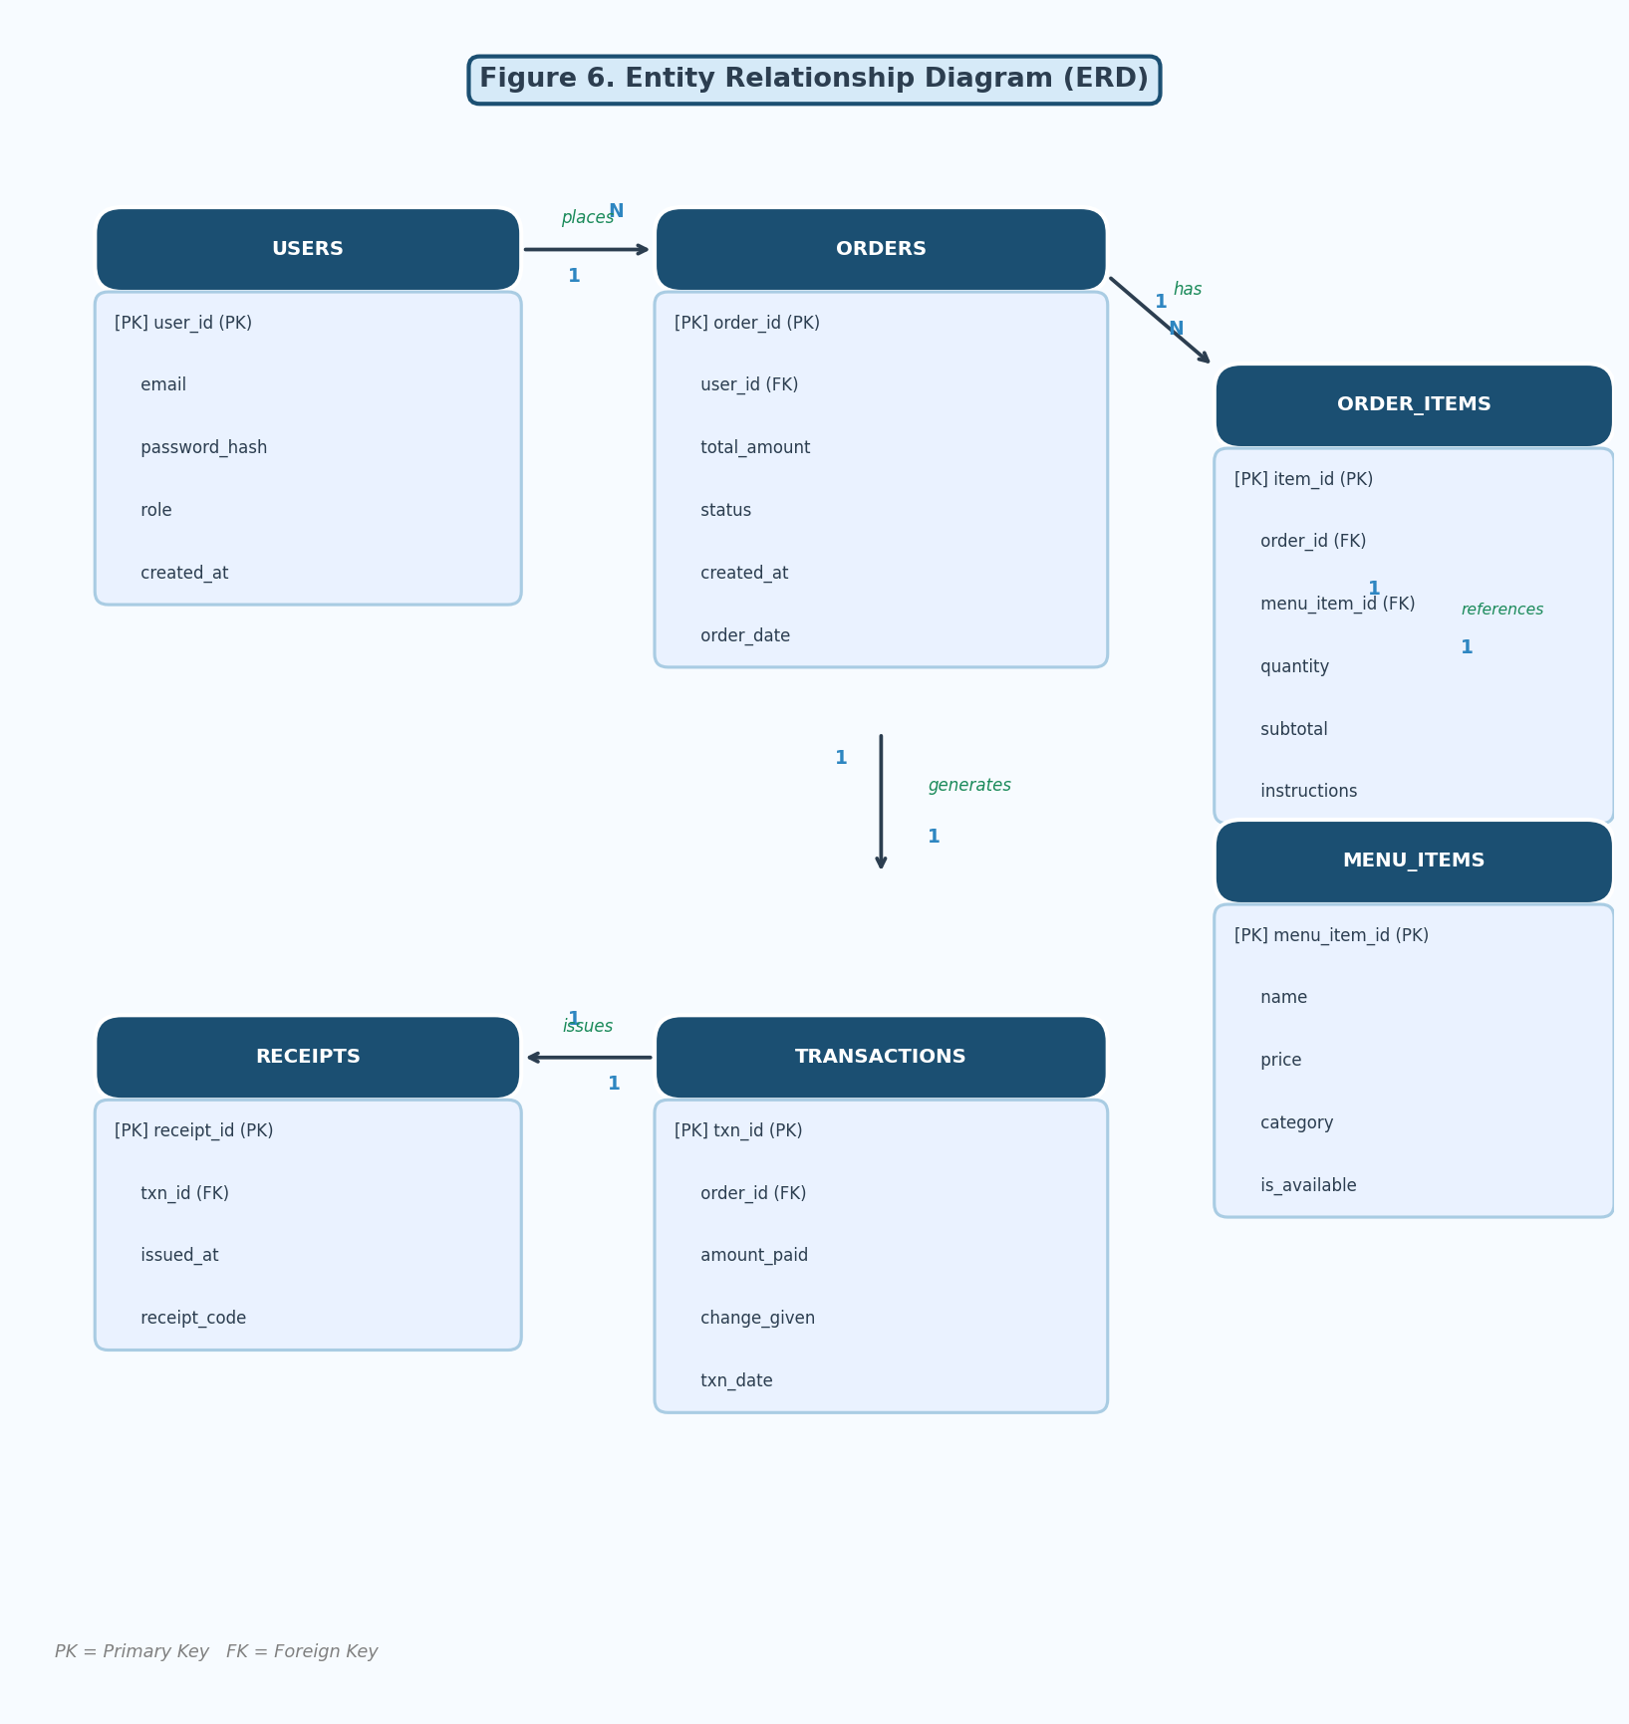
Figure 6. Entity Relationship Diagram (ERD)

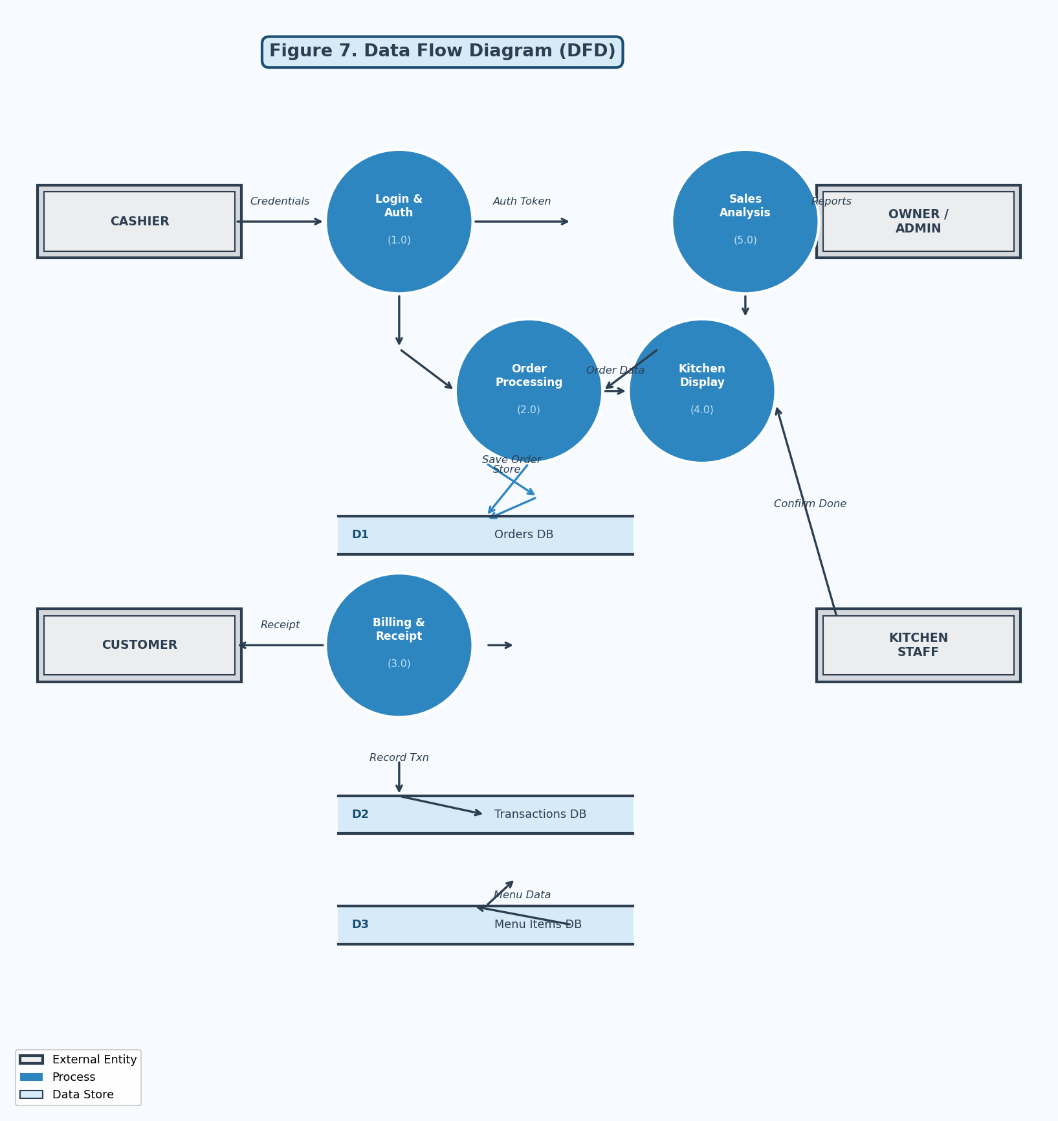
Figure 7. Data Flow Diagram (DFD)

Chapter 5
Summary, Conclusion, and Recommendation
Summary of Findings
This study focused on the development of a Web-Based Point of Sale System to Enhance Customer Satisfaction for Boss K Sizzling, a local eatery that has been operating on fully manual order-processing and billing methods since its establishment in 2019. The study aimed to identify the operational challenges caused by the current manual system and determine whether a digital POS solution would be accepted and seen as beneficial by the respondents.
A survey questionnaire composed of ten (10) Likert-scale statements was administered to fifty (50) respondents consisting of regular customers, potential customers, and staff members of Boss K Sizzling. Data were analyzed using percentage computation and weighted mean.
The findings revealed the following:
- The majority of respondents (44% strongly agree, 52% agree) confirmed that long queues are a consistent experience at Boss K Sizzling, with a Weighted Mean of 4.36 — interpreted as Strongly Agree.
- A significant number of respondents (44% strongly agree, 52% agree) indicated waiting a long time before placing orders, achieving the highest Weighted Mean of 4.40 across all statements.
- Respondents strongly agreed that food waiting time is longer than expected (WM = 4.32) and that the ordering process slows during busy hours (WM = 4.28), confirming operational inefficiencies in the current manual system.
- While 84% of respondents agreed staff manage customers efficiently during long lines, 8% disagreed (WM = 4.18, Agree), suggesting further improvement is possible with digital support.
- Respondents strongly agreed the dining area becomes crowded during peak hours (WM = 4.36) and that long queues negatively affect the overall dining experience (WM = 4.38).
- Despite the challenges, 94% of respondents agreed they would still choose Boss K Sizzling even with long lines (WM = 4.28, Strongly Agree), reflecting strong customer loyalty and a solid foundation for implementing improvements.
The overall weighted mean of 4.32 falls within the Strongly Agree range (4.20–5.00), indicating that respondents consistently recognized the operational issues caused by the manual process and affirmed the need for a Web-Based Point of Sale System.
Conclusion
Based on the findings, it is concluded that the current manual order-processing system at Boss K Sizzling is inefficient and negatively impacts customer satisfaction and daily operations. Long queues, slow ordering, and crowded peak-hour conditions are direct consequences of the absence of a digital system, further compounded by billing errors, revenue leakage, and staff exhaustion from handwritten slips and manual calculations.
The proposed Web-Based Point of Sale System directly addresses these problems through a digital order interface, real-time kitchen display transmission, automated billing, and a sales analysis dashboard. The overwhelmingly positive survey results — with an overall weighted mean of 4.32 (Strongly Agree) — confirm that respondents recognize the severity of existing problems and strongly support the system's implementation.
The strong customer loyalty reflected in the data (94% agreeing they would still patronize Boss K Sizzling despite long lines) demonstrates that the business has a solid customer base that can only grow stronger once service quality is enhanced through digital technology. The study therefore concludes that the proposed system is both necessary and beneficial for Boss K Sizzling, and its implementation will significantly improve order accuracy, reduce service time, eliminate manual billing errors, and enhance the overall dining experience.
Recommendation
Based on the summary of findings and conclusions, the researchers put forward the following recommendations:
- Full Implementation of the Web-Based POS System: The management is strongly encouraged to fully implement the proposed system at both the cashier station and kitchen display area to immediately reduce long queues and slow ordering.
- Staff Training and Orientation: Prior to full deployment, a thorough hands-on training session should be conducted for all cashiers and kitchen staff to ensure confidence and smooth transition.
- Continuous Monitoring of Customer Feedback: After deployment, management should regularly collect customer feedback through follow-up surveys to monitor satisfaction improvements and identify remaining issues.
- Regular System Maintenance and Updates: Periodic system reviews and updates are recommended — including digital menu updates, regular sales data reviews, and ensuring the cloud database remains secure and backed up.
- Integration of Additional Features in Future Versions: Future development should explore adding a customer loyalty/rewards program, a mobile-friendly ordering interface, and automated low-stock inventory alerts.
- Expansion to Other Local Food Businesses: Given the strong results, the researchers recommend similar Web-Based POS systems be developed for other small local food businesses in the community to support broader digital transformation of micro-enterprises.

