Chapter 4
Presentation of Data, Analysis, and Interpretation
Data Analysis
The data collected from the respondents were computed using the following formula:
P = f/t × 100
Where:
P = Percentage
f = Frequency
t = Total number of respondents
This formula is used to convert the counted responses into percentages for easier interpretation and comparison. By using this computation, researchers can more clearly present the overall trends and patterns in the respondents' answers.
Furthermore, the Weighted Mean formula was used to determine the average level of agreement:
Weighted Mean = Σfx / N
Where: Σfx = Total weighted score; N = Total number of respondents
Scale of Interpretation:
Scale | Range | Interpretation
5 | 4.20 – 5.00 | Strongly Agree
4 | 3.40 – 4.19 | Agree
3 | 2.60 – 3.39 | Neither Agree nor Disagree
2 | 1.80 – 2.59 | Disagree
1 | 1.00 – 1.79 | Strongly Disagree

Data For Gender of Respondents
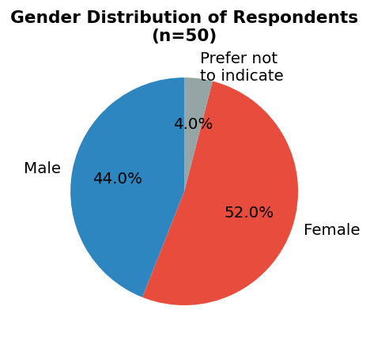
Figure 1. Gender Distribution of Respondents
Gender of Respondents: The gender distribution of the 50 respondents consists of 52% (26) female, 44% (22) male, and 4% (2) who preferred not to indicate their gender. The majority of respondents are female, suggesting that female customers are the primary patrons of Boss K Sizzling.
Data For Age Group of Respondents
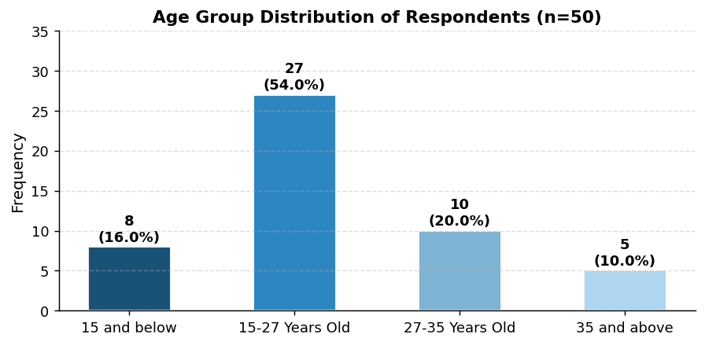
Figure 2. Age Group Distribution of Respondents
Age Group of Respondents: The age demographics show that 54% (27) of respondents are between 15–27 years old, 20% (10) are between 27–35 years old, 16% (8) are 15 years old and below, and 10% (5) are 35 years old and above. This indicates that the majority of customers are in the younger age bracket.
Data For Q1
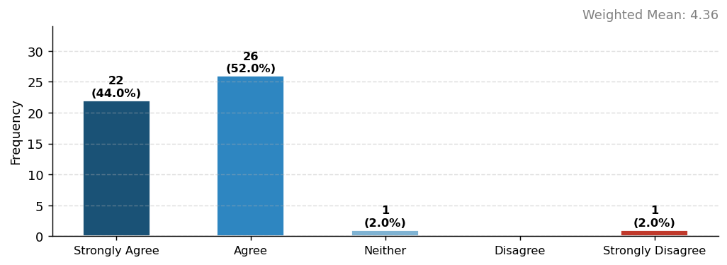
Figure 3. Survey Result for Question 1
Long Queue at Boss K Sizzling: Respondents strongly agree that the queue at Boss K Sizzling is usually long. With 44% (22) strongly agreeing and 52% (26) agreeing, the data shows that long lines are a common experience for customers, reinforcing the need for an efficient point of sale system to reduce waiting time.
Data For Q2
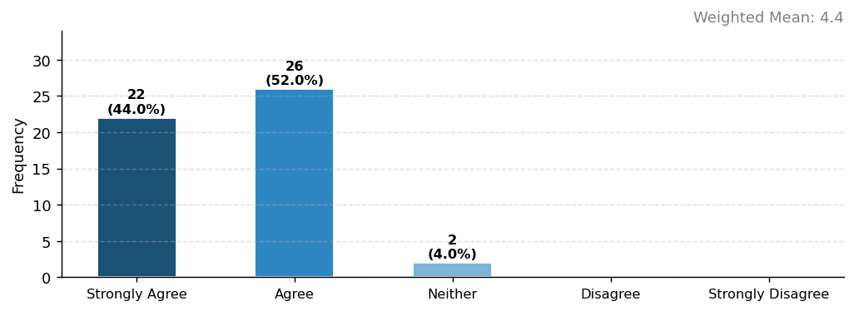
Figure 4. Survey Result for Question 2
Long Wait Before Placing an Order: The majority of respondents strongly agree that they wait a long time before placing their order. With 44% (22) strongly agreeing and 52% (26) agreeing, this highlights a significant bottleneck in the ordering process that a web-based POS system can address.
Data For Q3
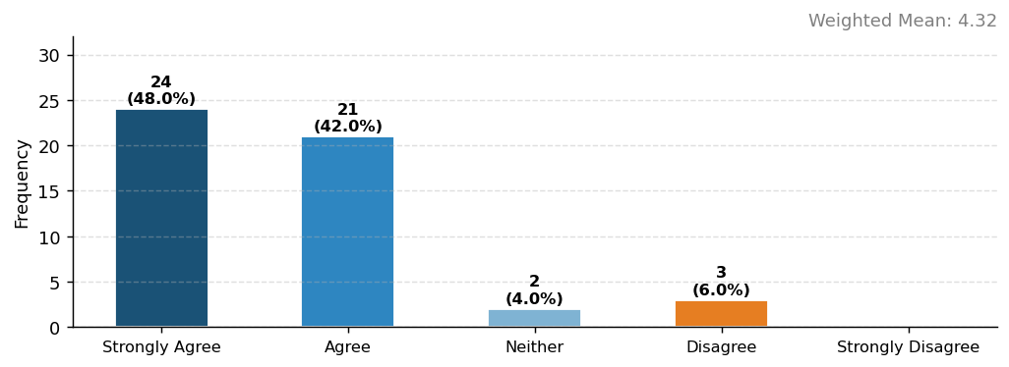
Figure 5. Survey Result for Question 3
Waiting Time for Food is Longer Than Expected: Respondents strongly agree that food waiting time exceeds expectations. With 48% (24) strongly agreeing and 42% (21) agreeing, this indicates that operational delays are notable, making system-based order processing a practical solution.
Data For Q4
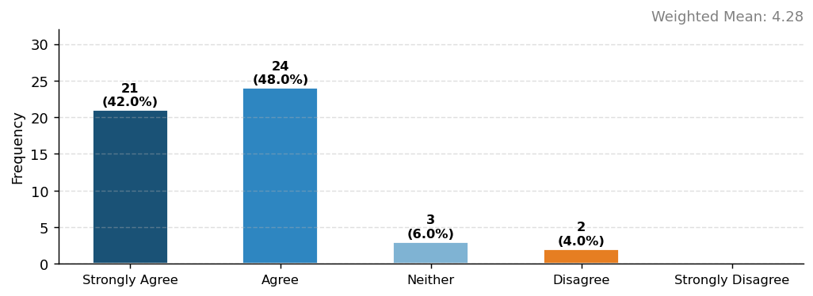
Figure 6. Survey Result for Question 4
Slow Ordering Process During Busy Hours: Respondents strongly agree that the ordering process slows down during peak hours. 42% (21) strongly agree and 48% (24) agree, confirming that the manual system struggles to keep up with high customer volume.
Data For Q5
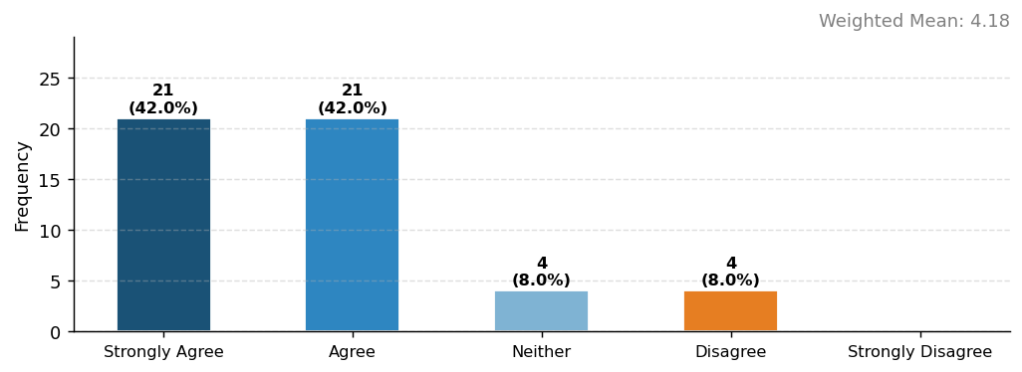
Figure 7. Survey Result for Question 5
Staff Efficiency During Long Lines: Respondents agree that staff manage customers efficiently even when the line is long. 42% (21) strongly agree and 42% (21) agree, though 8% (4) disagree, suggesting room for improvement with a digital support system.
Data For Q6
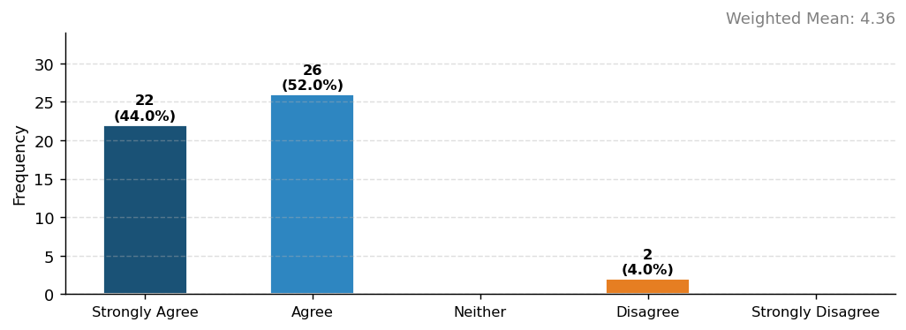
Figure 8. Survey Result for Question 6
Crowded Dining Area During Peak Hours: Respondents strongly agree that the dining area becomes crowded during peak hours. With 44% (22) strongly agreeing and 52% (26) agreeing, this validates the need for a system that helps manage customer flow and table turnover.
Data For Q7
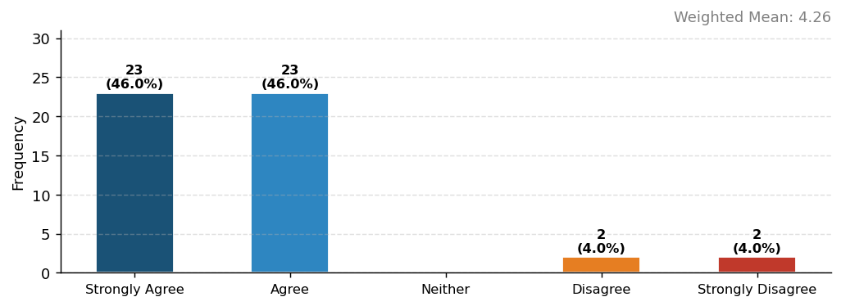
Figure 9. Survey Result for Question 7
Comfort While Waiting in Line: Respondents strongly agree that they feel comfortable while waiting in line. 46% (23) strongly agree and 46% (23) agree, suggesting that while physical comfort may be acceptable, operational efficiency can still be enhanced.
Data For Q8
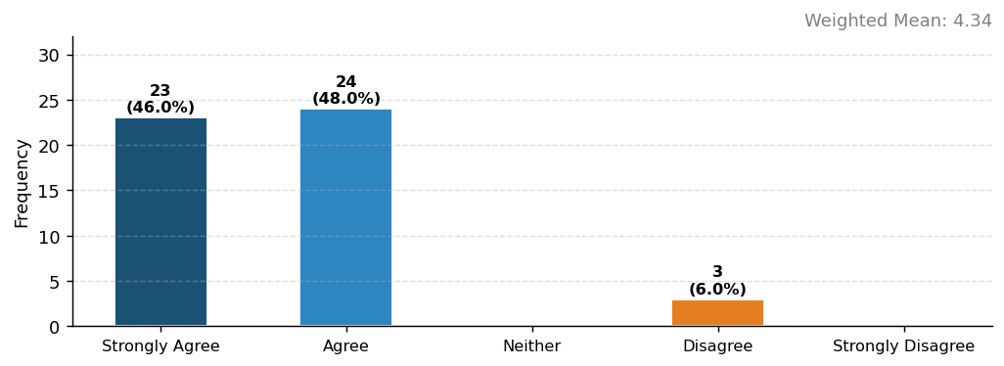
Figure 10. Survey Result for Question 8
Organized Service Despite High Volume: Respondents strongly agree that service remains organized even when many customers are present. 46% (23) strongly agree and 48% (24) agree, showing that staff maintain order but a digital system could further improve service consistency.
Data For Q9
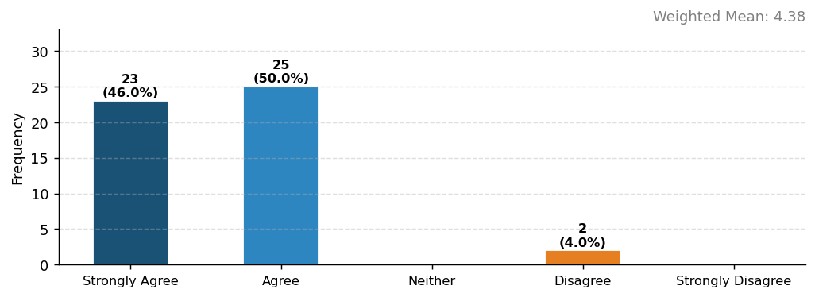
Figure 11. Survey Result for Question 9
Queue Affects Overall Dining Experience: Respondents strongly agree that long queues affect their overall dining experience. 46% (23) strongly agree and 50% (25) agree, emphasizing the importance of reducing wait times through a POS system to enhance customer satisfaction.
Data For Q10
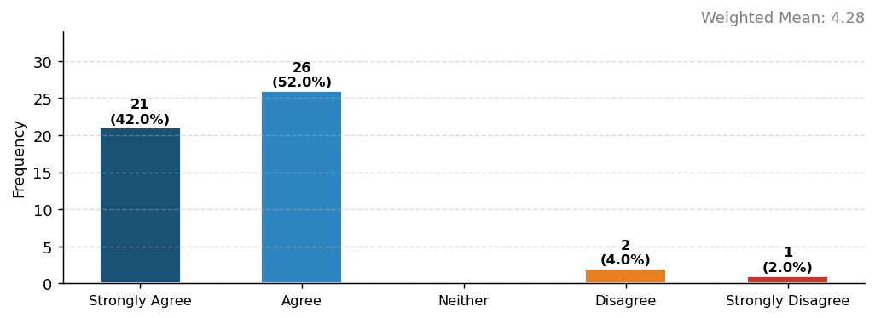
Figure 12. Survey Result for Question 10
Continued Patronage Despite Long Lines: Respondents strongly agree that they would still choose to eat at Boss K Sizzling despite long lines. 42% (21) strongly agree and 52% (26) agree, reflecting customer loyalty while also highlighting the potential for improved satisfaction through system implementation.

Summary of Survey Results
The table below presents the consolidated frequency, percentage, and weighted mean of all survey responses.
No. | Statement | SA | A | N | D | SD | WM | Interpretation
1 | The line or queue at Boss K Sizzling is usually long. | 22 | 26 | 1 | 0 | 1 | 4.36 | Strongly Agree
2 | I wait a long time before placing my order. | 22 | 26 | 2 | 0 | 0 | 4.4 | Strongly Agree
3 | The waiting time for food is longer than expected. | 24 | 21 | 2 | 3 | 0 | 4.32 | Strongly Agree
4 | The ordering process is slow during busy hours. | 21 | 24 | 3 | 2 | 0 | 4.28 | Strongly Agree
5 | The staff manage customers efficiently even when the line is long. | 21 | 21 | 4 | 4 | 0 | 4.18 | Agree
6 | The dining area becomes crowded during peak hours. | 22 | 26 | 0 | 2 | 0 | 4.36 | Strongly Agree
7 | I feel comfortable waiting in line at the restaurant. | 23 | 23 | 0 | 2 | 2 | 4.26 | Strongly Agree
8 | The service remains organized even when many customers are present. | 23 | 24 | 0 | 3 | 0 | 4.34 | Strongly Agree
9 | The long queue affects my overall dining experience. | 23 | 25 | 0 | 2 | 0 | 4.38 | Strongly Agree
10 | I would still choose to eat at Boss K Sizzling even if the line is long. | 21 | 26 | 0 | 2 | 1 | 4.28 | Strongly Agree
 | Overall Weighted Mean |  |  |  |  |  | 4.32 | Strongly Agree

The overall weighted mean of 4.32 falls under the Strongly Agree range (4.20–5.00), indicating that the majority of the 50 respondents consistently agreed with the statements regarding long queues, slow ordering, and crowding issues at Boss K Sizzling. This strongly supports the need for a Web-Based Point of Sale System to enhance customer satisfaction and streamline operations.

