**RADIO FREQUENCY REMOTE**

A SEMINAR PROJECT PRESENTED BY

NWANZE FRANKLIN CHUKA

2011364033

SUBMITTED TO THE DEPARTMENT OF ELECTRONIC AND COMPUTER ENGINEERING

NNAMDI AZIKIWE UNIVERSITY, AWKA

IN PARTIAL FULFILMENT FOR THE AWARD OF

BACHELOR IN ENGINEERING (B.ENG) DEGREE

IN ELECTRONIC AND COMPUTER ENGINEERING

MAY, 2016

SUPERVISOR: DR NNEBE

# CERTIFICATION

I hereby declare that this work was researched, written and compiled by me,

Nwanze Franklin Chuka, with registration number 2011364033 of Electronic and Computer Engineering, Nnamdi Azikiwe University, Awka.

……………………..

Nwanze Franklin. C

# APPROVAL PAGE

This is to certify that this seminar work has been approved and is sufficient in scope and content in accordance with the stipulated regulations as required in partial fulfillment for the award of Bachelor of Engineering (B.Eng.) Department of Electronic And Computer Engineering, Nnamdi Azikiwe University, Awka, Anambra State.

………………… …………………….

Engr Nnebe date

………………… …………………….

Prof C.C Okezie date

# DEDICATION

I dedicate this work to the Almighty God for his inspiration, mercy, protection and wisdom which is all that has kept me in every second of my five year stay in this University.

Table of Contents

CERTIFICATION 2

APPROVAL PAGE 3

DEDICATION 4

CHAPTER 1 7

1.0 Introduction 7

1.1 Radio Frequency Remote Control System 8

1.2 Related Works 9

CHAPTER 2 10

2.0 Brief History of radio frequency 10

2.1 Radio Frequency module TLP 433MHz (Transmitter) & RLP 433 MHz (Receiver) 12

2.1.1 Features of RF Module: 12

2.2 WORKING PRINCIPLES 13

2.3 WHY USE RADIO FREQUENCY FOR REMOTE CONTROLS? 14

2.4 THE IMPLEMENTATION 14

2.5 SOME ADVANCED FEATURES OF RADIO FREQUENCY REMOTE CONTROLS 16

2.5.1 Learning 16

2.5.2 Macro commands 17

2.5.3 PC connectivity 17

2.5.4 LCD screen 17

2.5.5 User interfaces 18

2.5.6 RF extenders 18

2.6 APPLICATIONS OF RADIO FREQUENCY REMOTE 19

CHAPTER 3 19

3.1 COMPARISON WITH INFRARED REMOTE CONTROL 19

3.1.1 Speed 19

3.1.2 Direction of propagation 20

3.1.3 Universality 20

References 21

# CHAPTER 1

## 1.0 Introduction

In recent times people have become very lazy that they find it difficult to even get up and switch their devices which are plugged to power. They would prefer to sit at a place and control their devices with a single remote and that led to the invention of remote controls. In developed countries home automation is a norm but developing countries like Nigeria are yet to adapt to this technology. Some of these remote controls work with infrared while others work with radio frequency. Each of these technologies has their own advantage as radio frequency remote controls are Omni-directional while infrared works based on line of sight.

## 1.1 Radio Frequency Remote Control System

Radio-frequency remote controls are very common. Car alarms, radio-controlled toys, and some garage doors have always used radio remotes, and the technology is starting to show up in other applications too. They are still rare in home-theater devices, but you will find RF remotes controlling certain satellite-TV receivers and high-end stereo systems. You'll also find Bluetooth-based remotes that control laptops and smart phones.

Instead of sending out light signals as in infrared, an RF remote transmits radio waves that correspond to the encoded binary command for the button you're pushing. A radio receiver on the controlled device receives the signal, decodes it and takes appropriate action. The major problem with RF remotes is the large number of radio signals flying through the air at any given time. Cell phones, walkie-talkies, Wi-Fi setups are all transmitting radio signals at varying frequencies. RF remotes address the interference issue by transmitting at specific radio frequencies and by embedding digital address codes in the radio signal. This lets the radio receiver on the intended device know when to respond to the signal and when to ignore it.

The greatest advantage to radio-frequency remotes is their range: They can transmit up to 100 feet from the receiver (the range for Bluetooth is shorter), and radio signals can go through walls. This benefit is why you'll now find IR/RF remotes for home-theater components. These remotes use RF-to-IR converters to extend the range of an infrared remote.

## 1.2 Related Works

A number of works have been done on remote controls most especially infrared (IR) remote controls. IR remote controls application can be seen in almost every electronic device used in homes and offices including televisions, decoders, compact disk, DVD’s etc. Radio frequency remotes finds it applications in toy cars, garage system etc. The two most common radio frequency module used for building these RF remote controls are TLP433/RLP433 and TLP315/RLP315. Each module has a transmitter/receiver pair operating at the same frequency.

Lots of works have been done on RF remotes with these modules interfaced with some IC’s called HT12-E (Encoder) and HT12-D (Decoder). However, using these IC’s limits the control the user have over these remote controls in the sense that the builder has no control over the data transferred from transmitter to receiver.

# CHAPTER 2

## 2.0 Brief History of radio frequency

Radio development began as "wireless telegraphy". Later radio history increasingly involved matters of broadcasting. The idea of wireless communication predates the discovery of "radio" with experiments in "wireless telegraphy" via inductive and capacitive induction and transmission through the ground, water, and even train tracks from the 1830s on. James Clerk Maxwell showed in theoretical and mathematical form in 1864 that electromagnetic waves could propagate through free space [1] [2]. It is likely that the first intentional transmission of a signal by means of electromagnetic waves was performed in an experiment by David Edward Hughes around 1880, although this was considered to be induction at the time. In 1888 Heinrich Rudolf Hertz was able to conclusively prove transmitted airborne electromagnetic waves in an experiment confirming Maxwell's theory of electromagnetism.

After the discovery of these "Hertzian waves" (it would take almost 20 years for the term "radio" to be universally adopted for this type of electromagnetic radiation)[3] many scientists and inventors experimented with wireless transmission, some trying to develop a system of communication, some intentionally using these new Hertzian waves, some not. Maxwell's theory showing that light and Hertzian electromagnetic waves were the same phenomenon at different wavelengths led "Maxwellian" scientist such as John Perry,Frederick Thomas Trouton and Alexander Trotter to assume they would be analogous to optical signaling[4][5] and the Serbian American engineer Nikola Tesla to consider them relatively useless for communication since "light" could not transmit further than line of sight.[6] In 1892 the physicist William Crookes wrote on the possibilities of wireless telegraphy based on Hertzian waves and in 1893 Tesla proposed a system for transmitting intelligence and wireless power using the earth as the medium. Others, such as Amos Dolbear, Sir Oliver Lodge, Reginald Fessenden, and Alexander Popov [[7]](https://en.wikipedia.org/wiki/History_of_radio#cite_note-invent2-11)  were involved in the development of components and theory involved with the transmission and reception of airborne electromagnetic waves for their own theoretical work or as a potential means of communication.

Over several years starting in 1894 the Italian inventor Guglielmo Marconi built the first complete, commercially successful wireless telegraphy system based on airborne Hertzian waves (radio transmission). Marconi demonstrated application of radio in military and marine communications and started a company for the development and propagation of radio communication services and equipment.

## 2.1 Radio Frequency module TLP 433MHz (Transmitter) & RLP 433 MHz (Receiver)

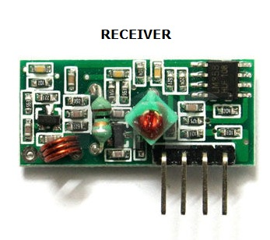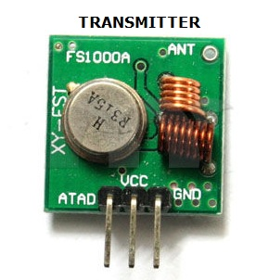Radio frequency modules are modules which operate at specific frequencies and come in pairs. They are digital modules which are triggered by a HIGH logic. The transmitter consists of three pins (1) VCC (2) GROUND (3) DATA-IN while the receiver consists of four pins (1) VCC (2) GROUND (3) DATA-OUT (2 PINS)

The transmitter draws no power when transmitting logic zero while fully suppressing the carrier frequency thus consume significantly low power in battery operation. When logic one is sent carrier is fully on to about 4.5mA with a 3volts power supply. The data is sent serially from the transmitter which is received by the tuned receiver. Transmitter and the receiver are duly interfaced to two microcontrollers for data transfer.

## 2.1.1 Features of RF Module:

* Receiver frequency 433MHz
* Receiver typical frequency 105Dbm
* Receiver supply current 3.5mA
* Low power consumption
* Receiver operating voltage 5v
* Transmitter frequency range 433.92MHz
* Transmitter supply voltage 3v~6v
* Transmitter output power 4v~12v

## 2.2 WORKING PRINCIPLES

The Transmitter is first connected to VCC and GND then signals are sent through the DATA-OUT pin (ATAD) by inputting logic HIGH. The signal is then transmitted through the 30cm antenna embedded on the module to the receiver. The receiver on reception of the transmitted signal sets the DATA-IN pin HIGH for the duration of time the transmitter sent the HIGH logic. At most, a transmission session can last one second when triggered by a HIGH before going LOW. The module use Amplitude Shift Keying Modulation to transmit and receive these digital Signals. The Transmitter and receiver modules are usually connected to an IC (HT12-D and HT 12-E) or a microcontroller which has the ability to process these digital signals either by manipulating the bits, synchronizing the transmitter and receiver and filtering noise. Using encoder and decoder IC handles the above processes very well but takes away the privilege the designer has over the type of data to be sent, how the data is to be processed, how the data will be displayed, the type of data to be transmitted, the block size and encoding technique.

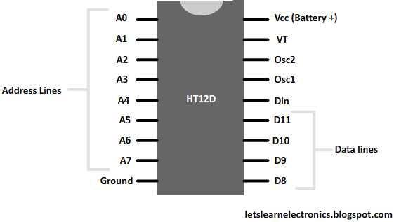It is up to the designer to do whatever he/she wants with the signals sent; he might decide to use it to switch on devices, control a robotic arm, trigger an alarm, display a message etc.

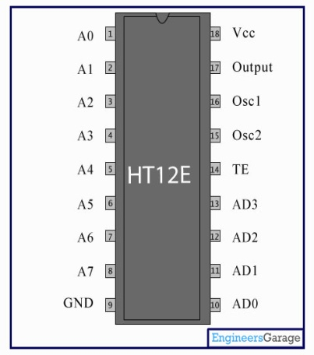

## 2.3 WHY USE RADIO FREQUENCY FOR REMOTE CONTROLS?

There are so many reasons why radio frequency is preferred and they include:

1. Objects do not restrict their propagation as they can bounce off objects, reflect, refract or scatter to get to their destination.
2. They can be radiated Omni directionally by use of appropriate antenna.
3. They travel far distances and offer better ranges.
4. They can be used in conjunction with RF repeaters for limitless transmission range.

## 2.4 THE IMPLEMENTATION

The proposed system provides solution to manual operation of devices through the use of radio frequency modules interfaced with micro controllers. The transmitter side is designed to transmit a particular data when a key is pressed. The data to be transmitted is first encoded using Manchester encoding technique before sending to the data-out pin of the TX module. The receiver part waits for a signal from the transmitter and on reception of this signal (start bit) gets ready for the reception of actual data from the transmitter.

A simple architecture of the system is shown below:

TRANSMITTER

MICROCONTROLLER

KEYPAD

RECEIVER

MICROCONTROLLER

OUTPUT

The Microcontroller used here is PIC16F877A which is a microchip product with forty pins; 32 I/O pins, internal Analog to Digital Converter and 4 memory banks. The Microcontroller contains a control program developed to implement the encoding/decoding, synchronization, transmission/reception, noise filtering and signal processing. The control program in the microcontroller can be illustrated using a flow chart as shown below:

Encode and Transmit Signal

Is transmission complete?

Is signal received?

Display transmitting channel on LCD

Decode and switch on appropriate device

YES

YES

YES

NO

NO

Initialize ports

Scan Keypad

Is any key pressed?

NO

## 

## 2.5 SOME ADVANCED FEATURES OF RADIO FREQUENCY REMOTE CONTROLS

### 2.5.1 Learning

Learning remote can receive and store codes transmitted by another remote control; it can then transmit those codes to control the device that understands them. For instance, let's say you have a receiver with its own preprogrammed remote, and you buy a new TV that comes with a universal learning remote. The learning remote can pick up the signals your receiver remote sends out and remember them so it can control your receiver, too. You don't need to input the command codes yourself -- a learning remote picks up and stores the signals another remote sends out. All learning remotes are considered universal remotes because they can control more than one device.

### 2.5.2 Macro commands

A macro is a series of commands that you program to occur sequentially at the push of a single button. These macros can be anything you want, such as an "activity command." You can set up a macro that lets you push one button to activate, in order, everything that needs to happen for you to watch a movie or listen to a CD. (Some remotes come with "activity commands" preprogrammed, and others let you download macros from the Internet.)

### 2.5.3 PC connectivity

There are remotes that connect to your PC via the USB port so you can install programming software and download command codes and personalized graphic icons (for remotes with LCD screens).

### 2.5.4 LCD screen

A remote-control LCD screen may simply display data, or it may be a touch screen that receives user input.

### 2.5.5 User interfaces

Most remotes still utilize the simple button-pushing method, but some have more high-tech manners of inputting commands. You'll find remotes that you operate via an LCD touch screen, a joystick (for directional commands) and even voice commands.

### 2.5.6 RF extenders

Some IR remotes can send out both IR and RF signals. The RF signals aren't meant to control RF devices (in fact, they can't control them). They're meant to extend the operating range of the IR remote control from about 30 feet to about 100 feet (give or take) and allow the signal to penetrate walls and glass cabinet enclosures. The remote automatically transmits both IR and RF signals for every command. When you hook up an RF-to-IR converter (sometimes included with IR/RF remotes, sometimes sold as add-ons) on the receiving end, it receives and converts the signal back into the infrared pulses the device can understand. Now you've got an IR remote that can increase the volume on your home-theater stereo from your bedroom upstairs.

Remote controls are steadily increasing the number of devices and functions they can manage. Some universal remotes intended for home-theater components can learn commands for wirelessly controlled lights, so they will not only start a movie at the push of a button, but they'll also dim the lights for you. Full home-automation systems let you use one remote control to manage lighting, alarm systems and entertainment components by way of a receiver wired directly into your home's electrical wiring. Chances are it won't be long before you have a single remote control to manage every electronic device in your life.

## 2.6 APPLICATIONS OF RADIO FREQUENCY REMOTE

1. Remote operated Robotic Vehicle
2. Remote controlled robotic arm

# 

# CHAPTER 3

In conclusion I will compare the efficiency and robustness of RF remote control and IR (Infrared) remote control.

## 3.1 COMPARISON WITH INFRARED REMOTE CONTROL

### 3.1.1 Speed

The RF remote operates at a frequency of 433MHz and by calculation V=F * λ gives us the speed at which the radio signals travel and since radio waves have bigger wavelength they have higher speed than infrared waves which operate in infrared region and have smaller wavelength. This speed is an advantage as lots of data can be transmitted over a short period of time.

### 3.1.2 Direction of propagation

As mentioned earlier, RF signals can penetrate walls and objects, bounce off surfaces and scatter to get to its destination but reverse is the case of infrared waves which operate based on line of sight such that any obstruction causes the signal not to get to its destination. The antennas used in RF have the ability to transmit Omni directionally.

### 

### 3.1.3 Universality

Most electronic devices use a single remote and as such each electronic device requires its own remote to be operated but with RF remotes a single remote can be used in conjunction with an RF extender to control all the electronic devices available. So the user only needs a single remote to save him/her the stress of carrying several remotes around.

### References

### [The Invention of Radio](http://inventors.about.com/od/rstartinventions/a/radio.htm) inventors.about.com/od/rstartinventions/a/radio.htm

1. [*"Maxwell"*](http://www.sparkmuseum.com/BOOK_MAXWELL.HTM).sparkmuseum.com.
2. ^ [Jump up to:***a***](https://en.wikipedia.org/wiki/History_of_radio#cite_ref-google.co.uk_3-0) [***b***](https://en.wikipedia.org/wiki/History_of_radio#cite_ref-google.co.uk_3-1) [*"Newton to Einstein: The Trail of Light"*](https://books.google.co.uk/books?id=5HVlBG_8nWIC&pg=PA122&dq=Maxwell+Predicts+Waves&hl=en&sa=X&ved=0CEgQ6AEwB2oVChMI6Zzl15KAxwIViEAUCh2ZAw1f#v=onepage&q=Maxwell%20Predicts%20Waves&f=false)*. Retrieved 11 December 2015*

### [*"22. Word Origins"*](http://earlyradiohistory.us/sec022.htm).earlyradiohistory.us

1. W. Bernard Carlson, Tesla: Inventor of the Electrical Age, page 125-126
2. [**Jump up^**](https://en.wikipedia.org/wiki/History_of_radio#cite_ref-6) Sungook Hong, Wireless: From Marconi's Black-box to the Audion, MIT Press, 2001, page 2
3. [*"Hertzian Waves (1901)"*](http://earlyradiohistory.us/1901hz.htm)*. Retrieved 2008-08-11*
4. Rybak, James P.[*"Alexander Popov: Russia's Radio Pioneer"*](https://web.archive.org/web/20140412051511/http:/www.ptti.ru/eng/forum/article2.html). Archived from[*the original*](http://www.ptti.ru/eng/forum/article2.html)on April 12, 2014.

https://en.wikipedia.org/wiki/History_of_radio

http://www.techstructions.com/2008/05/rf-remote-vs-ir-remote.html

https://www.audioholics.com/editorials/rf-remote-controls-is-it-time-for-you-to-step-up