Network Layer: logical communication between hosts
Transport Layer: logical communication between processes (services: connection-oriented data stream, reliability, flow control, multiplexing, congestion control, connection setup).
Multiplexing @ sender: handle data from multiple sockets, add transport header.
Demultiplexing @ receiver: use header info to deliver received segments to correct socket.
How demultiplexing works:
Host receives IP datagrams: each datagram source IP address, destination IP address, carries one transport-layer segment, source/destination port number.
UDP demultiplexing: SEND: socket=host-local port #, datagram=des IP addr, des port #; RECV: check des port #, direct to socket w/port #.
TCP demultiplexing: source IP addr & port #, des IP addr & port #.
UDP flaws: may be lost, delivered out-of order, no handshaking between snd/rcv; each UDP segment handled indp.
Why UDP? No connec. Establishment, small header size, no congestion control.
Checksum: detects errors in transmitted segment.
ACK: receiver “pkt OK” → sender NAK(neg ack): recv “pkt errors”→ sender → retransmission
Handling Duplicates: sender retransmits pkt if ACK/NAK corrupted → sender adds seq # to pkts → recv discards dup pkts
Pipelined Protocol: sender allows multiple, “in-flight”, yet-to-be-ack pkts (twp forms: go-back-N, selective repeat)
Go-back-N Selective Repeat
sender max = N unACK pkts max = N unACK pckts
receiver sends cummulative ACK sends individual ACK
(doesn't ACK pck if gap exists)
sender timer = oldest unACK pkt timer = on each unACK pkt
(when timer expires: retransmit all unACK pkts) (when timer expires: retransmit only that unACK pkt)
TCP seq # & ACKs:
seq # → byte stream “#” of first byte in segment's data(e.g seq=500, 100 bytes → next segment seq=600).
*instead of numbering segments, TCP numbers bytes of transmitted data & uses the # of the first data byte in a segment as that segment's sequence #.
ACK → seq of next byte expected from other side; cumulative ACK.
TCP Seq # & ACKS example:*
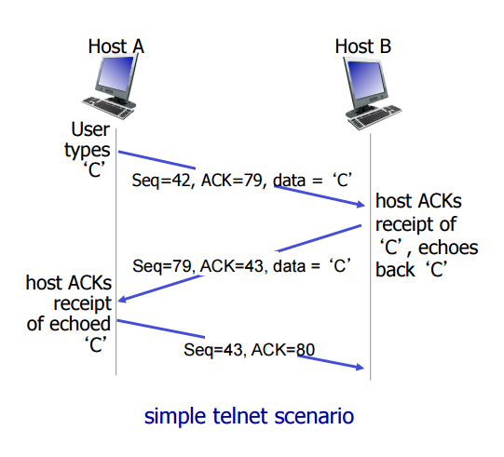
* Computing Timeout Intervals:
* Low Fluctuations, Steady graph:
* EstRTTnew = (1-α)*EstRTTold + α*SampleRTT
* where , α is usually 1/8 = 0.125.
*
* High Fluctuations (How to calculate deviations:):
* DevRTTnew = (1 - β) DevRTTold + β |SampleRTT – EstRTT|
* where, β is usually ¼ = 0.25.
*
* TimeoutInterval = EstRTT + 4*DevRTT
************************** “est RTT” “safety margin”
*when a segment timesout and is re-sent, timeout interval = 2 * timeout interval
*when 3 dupACK (indicating out of order), segment is re-sent, even if timer has not
expired, this is called FAST RETRANSMIT.
***************************************************************************************************
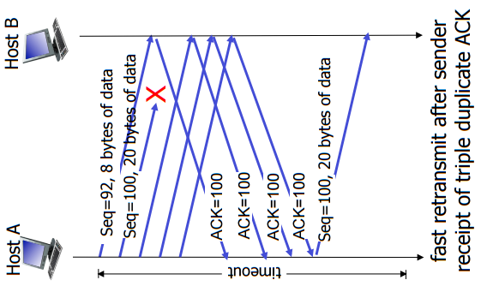
TCP Fast Retransmit
- time-out period long
- detect lost segments via 3 dupACKs
(if sender receives 3 dupAcks resend example →
segment w/smallest seq #, w/timing out)
Flow Control: endpoints in TCP prevent a fast sender from “overwhelming” a slow receiver. Each w/receive window sizes.
* Receiver controls sender, so sender won't overflow receiver's buffer by transmitting too much too fast.
Receive Window (rwnd): *rwnd Question (assume rwnd=0): How does recv tell sender
+ two hosts exchange rwnd size at beginning * to start sending again?
+ sender guarantees that diff between last seq # *Answer: sender sends tiny messages (1 byte each); recv then uses
& ACK sent never > rwnd * ACK messages for these to carry info about rwnd.
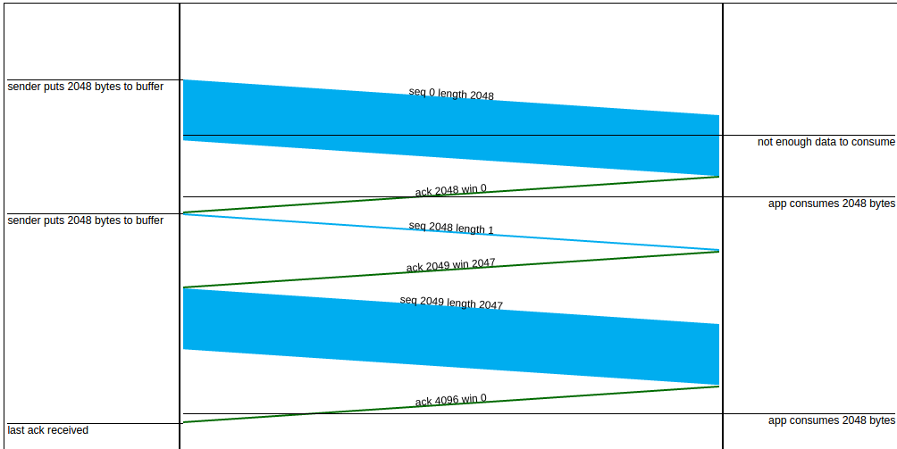
Principles of Congestion Control +”too many sources sending too much data too
fast for the network to handle”
+ manifestations:
- lost pkts (buffer overflow at routers)
- long delays (queuing in router buffers)
Causes of Congestion (from ex in book):
+ too many senders, too many receivers
+ one router, w/infinite buffers
+ output link capacity: R
+ no retransmission
Perfect knowledge scenario:
+ sender sends only when avail buffer
Known Loss Scenario w/out free buff space: TCP Slow Start
+ pkts can be lost, dropped @ router bc full buffers + when connection begins, inc rate
+ sender only resends if packet known to be lost expon until 1st loss event
Known Loss w/free buffer space: - init cwnd = 1 MSS
+packets can be lost, dropped at router bc full buffer - double cwnd every RTT
+sender only resends if packet known to be lost - done by incrementing cwnd per ACK reveived
Duplicates (realistic): - TCP Tahoe, cwnd = 1
+packets can be lost, dropped at router bc full buffer - TCP Reno, 3 dupACKs, cwnd=cwnd/2
+ sender times out permanently, sends 2 copies, delivers - Slow Start Treshold
Costs of congestion: ssthresh = cwnd/2
+more work (retrans) for given “goodput” *3 dupAcks = ssthresh=cwnd/2 +3
+unneeded retrans: link carries multiple copies of pkt* The rate of growth of cwnd is determined by another variable
- dec goodput * ssthresh, the slow-start threshhold. When the value of cwnd is
+when pkt dropped, any “upstream trans capacity used* than ssthresh, the size of the window grows exponentially
for that pkt was wasted! * (doubling). When cwnd exceeds ssthresh, the window size grows
TCP Congestion Control: add inc/mult dec * only linearly.
+sender inc trans rate (window size), until loss occurs
- additive inc: inc cwnd by 1 MSS every RTT until loss detected
- multiplicative dec: cut cwnd in half after loss
+Sending Rate: roughly: send cwnd bytes, wait RTT for ACKS,
then send more bytes ; rate = cwnd/ RTT (bytes/sec)
+Last byte sent/ACK <= cwnd
***********************************************************************
*Congestion control is different from flow control. It uses observations about network behavior to control the amount of data that is sent. A variable called the “congestion window” (cwnd) is set to the maximum number of bytes that can be transmitted at one time. The congestion window grows when acknowledgements are received in a timely way and shrinks when timeouts occur.
*Seq, length, and ACK fields in the TCP segment. When the receiver acknowledges a segment with seq and len, it send the ACK=seq + len, the number of the next byte expected. (NOTE: this happens only if all seqments up to seq have been received; if there are gaps, then the acknowledgement is for the last segment that was received with no preceding gaps.)

