Francisco Quezada

Lab 4

This work is mine unless otherwise cited.

1. [Make up your own UDP Checksum Problem]

Three 16-bit sum values:

a. 0101 0010 1001 1010
b. 0010 1010 0111 0001
c. 0001 0011 0111 0001

Calculation:

a. 0101 0010 1001 1010
b. + 0010 1010 0111 0001
--------------------------------
SUM: 0111 1100 1000 1011
c. + 0001 0011 0111 0001
--------------------------------
SUM: 1000 1111 1111 1100

FLIP: 0111 0000 0000 0011

CHECKSUM = 0111 0000 0000 0011

2.
(a) L/A = 2000 bits / 1E6 bits/secs = 2E-3 s = 2 millisecs x 2 hosts – 4 millisecs

(b) L/A = 1000 bits/1E6 bits/secs = 1E-3 s = 1 millisecs x 2 hosts = 2 millisecs

(c) L/A = 500 bits/1E6 bits/secs = 5E-4 s = 50 millisecs x 2 hosts x 2 rounds (each link with 500 bits) = 200 millisecs

3. [Sources of delay]

dend-end = N(dproc + dtrans +dprop)
dend-end = N(dtrans +dprop)
dtrans = L/R
dprop = d/s
Variables:

L = size of packet
R = transmission rate
d = distance
s = speed of light (the actual speed of light is 2..9E8m/s not 2E8 m/s; which is why I used 3E8 m/s)

packet Link 1 Link 2 Host

L 2000 bits
R 1 Mbps 1 Mbps
d 10 km 10 km
s 2E8 m/s 2E8 m/s

Link 1 transmission delay = L/R = 2000 bits / 1Mbps = (2000 bits) / (1E6 bits/s) = 0.002 seconds
Link 1 propagation delay = d/s = 10 km / 3E8 m/s = (10E3 m) / (3E8 m/s) = 0.000033 seconds
Link 2 transmission delay = L/R = 2000 bits / 1 Mbps = (2000 bits) / (1E6 bits/s) = 0.002 seconds
Link 2 propogation delay = d/s = 10 km / 3E8 m/s = (10E3 m) / (3E8 m/s) = 0.000033 seconds

Link 1 dend-end = dtrans + dprop = 0.002 s + 0.000033 s = 0.00203 s
Link 2 dend-end = dtrans + dprop = 0.002 s + 0.000033 s = 0.00203 s

Link 1 + Link 2 = 0.00203 s + 0.00203 s = 0.00406 s = 4.6 ms

4.

(a) 2 RT per three way handshake.

(B) 2 RT per three way handshake and there are 4 images so 8 RTT.

5.

Max throughput: A->D = 200 Mbps; B->E = 50 Mbps; C->F = 150 Mbps. Bottleneck is 50 Mbps.

6.

Traffic Intensity should be around 250 Kbps and the queuing delay is less than 1 making it slow but not as much.

7.
(a)

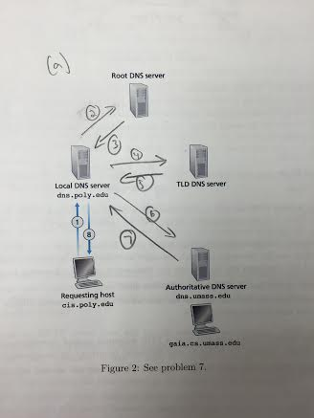

(b)
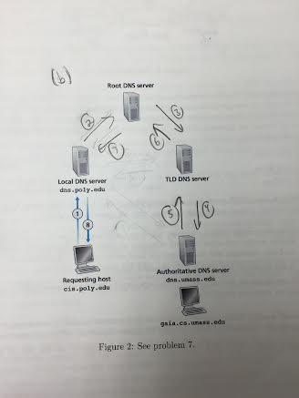

(c)
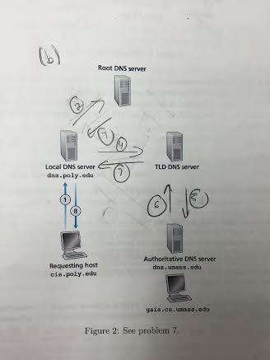
This is actually c...

