[1]

Procedure:

1. Went to Mozilla Firefox. Standby,

2. Open Wireshark, Edit → Preferences → Set to: “No”, “Time”, “Destination”, “Protocol”, “Length”, and “Info”.

3. Chose p4p1 ast the interface to capture.

4. Went to capture options and input capture filter as TCP.

5. Started Wireshark capture.

6. Went to stanford.edu, tsinghua.edu.cn, and ethz.ch and stopped the capture afterwords.

(a) in …lab6/ dir.

(b) ''

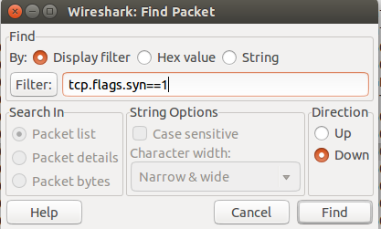
(c)

1030 0.000000000 141.195.226.133 171.67.215.200 TCP 74 60357 > http [SYN] Seq=0 Win=29200 Len=0 MSS=1460 SACK_PERM=1 TSval=436946 TSecr=0 WS=128

(d) done

(e) done

(f)

Procedure:

1. Cleared the Filter:... bar up top.

2. Went to Firefox → stanford.edu → Tools (in bar up top) → Web Developer → Inspector → Network (bar down below in source code) → Looked at first GET command → Looked at Remote Address (171.67.215.200; Port 80).

3. Went back to Wireshark → [CTRL] + [F} → Input [ip.src==171.67.215.200]

4. Looked for the first connection using [CTRL] + [N] and [CTRL] + [F]

1067 0.007327000 171.67.215.200 141.195.226.133 TCP 74 http > 60357 [SYN, ACK] Seq=0 Ack=1 Win=4140 Len=0 MSS=1380 TSval=1042799332 TSecr=436946 SACK_PERM=1

5. Right clicked → Conversation Filter → TCP

6. Screenshot → [SHIFT] + [PRTSCN] → saved in ...lab6/ dir.

(g)

Procedure:

1. Cleared the Filter:... bar up top.

2. Went to Firefox → www.tsinghua.edu.cn → Tools (in bar up top) → Web Developer → Inspector → Network (bar down below in source code) → Looked at first GET command → Looked at Remote Address (166.111.4.100; Port 80).

3. Went back to Wireshark → [CTRL] + [F} → Input [tcp.flags.syn==1 (because ip.src did not work as desired)]

4. Looked for the first connection using [CTRL] + [N] and [CTRL] + [F]

8411 0.000000000 141.195.226.133 166.111.4.100 TCP 74 42499 > http [SYN] Seq=0 Win=29200 Len=0 MSS=1460 SACK_PERM=1 TSval=439329 TSecr=0 WS=128

5. Right clicked → Conversation Filter → TCP

6. Screenshot → [SHIFT] + [PRTSCN] → saved in ...lab6/ dir.

[2]

