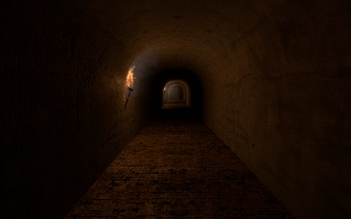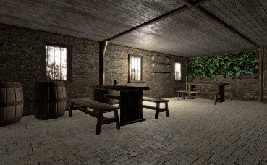 **Manual and instructions**

**Medieval Catacombs**

**V1.0**

Thank you for purchasing the Medieval catacombs pack!

**General information**

Prefabs are separated in folders based on their main categories. These are catacombs, props and upstairs folders. Every material supports PBR, they have all the textures assigned, each one is 2048x2048 resolution. *If you find some blurry during different light conditions, remove the heightmap from its respective slot.*

**Level building**

Though meshes line up as quick as they seem, this section here is very important to get the results you’ve seen in the web demo. Simply dragging the prefabs into the scene and duplicating them works well, but there are essential things you must be aware of. Once you get used to it, building a level is quick and easy.

In Translate mode (W), hold down V key for vertex snapping, and snap the prefab to the one next to it. Snapping points:

* **Catacomb pieces**
  + Corridors: They snap together on their bottom corners.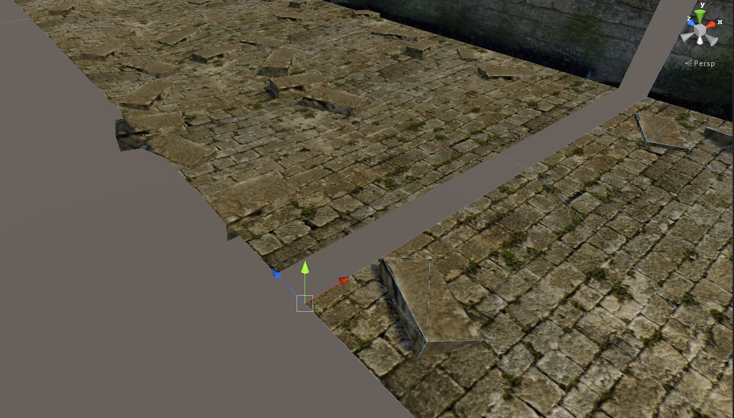
  + Tunnels: Middle vertex as shown here. (so it’s even on both sides)
  + 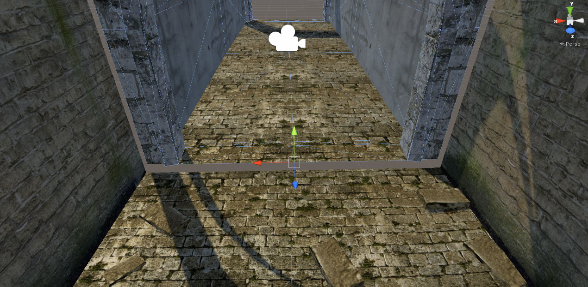
  + Corridor1 and 2 have a gap between: Corridor1’s floor is uneven while Corridor2 isn’t because they are intended to represent a different appearance – consider using a double door is necessary.
* **Upstairs room pieces**
  + Reference point when snapping is always the wall’s bottom corner (That’s the way to get a mathematically accurate room)
  + 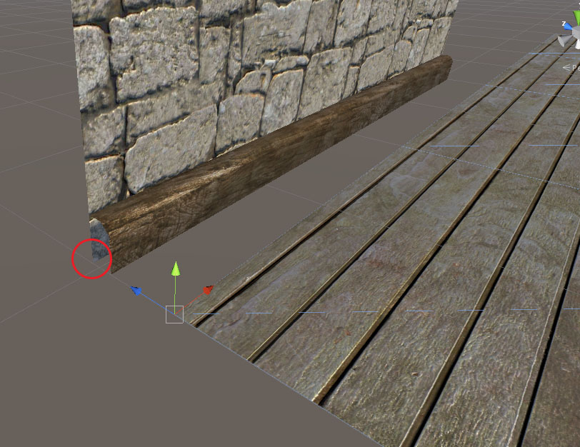

Once you get the catch of it, you can easily design corridors and rooms with different elevations and layout. All meshes are accurate and symmetrical, so you should have no trouble with it. ☺

**Editor extension**

Use the ‘Medieval Catacombs’ menu to open the custom editor. You’ll find 4 main tabs that can help your workflow.

1. **Collect**Any time the hierarchy view gets too crowded, use this menu to parent gameobjects as indicated on the buttons. They will then be sorted into groups nicely.
2. **Rendering**This option simply checks if your main camera uses HDR and render mode is depth only (it helps a lot in case you have little gaps somewhere)
3. **Batching**Very useful tool, always checks what gameobjects aren’t static in your scene, and can set them static for you by clicking the button. Doors are completely ignored, since they might want to be animated.
4. **Probes**Shows all light probes in the scene, lets you select them, or collectively toggle between baked/real time probe modes.

**Update log**

* 1.0 First release

***Updates****: There are plenty of planned updates to the project based on feedback from customers. You are one of them, so feel free to share your ideas and suggestions to expand the asset in the close future.*

*Should any question arose in regards with my product, please contact me at* [*gabromedia@gmail.com*](mailto:gabromedia@gmail.com)

Stay tuned for updates and new products! [www.facebook.com/gabromedia](http://www.facebook.com/gabromedia)

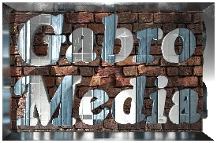

Happy level building!

Gabro Media Team 2015