下载ROM开发版，下载连接

<http://www1.miwifi.com/miwifi_download.html>

登陆小米路由器web界面刷ROM

开启SSH

<http://bbs.xiaomi.cn/t-9921071>

开启SSH后就可以SSH登陆你的路由器

创建一个目录

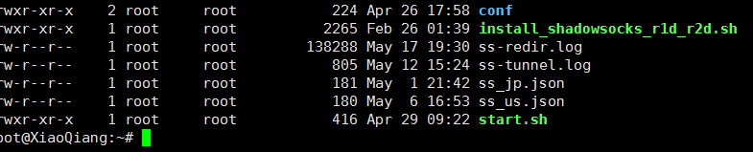

Start.Sh中的内容

mount -o remount ,rw /

ipset -N letitgo iphash

iptables -t nat -A PREROUTING -p tcp -m set --match-set letitgo dst -j REDIRECT --to-port 1082

killall ss-tunnel

killall ss-redir

nohup /usr/bin/ss-tunnel -b 0.0.0.0 -c /root/ss_us.json -l 53535 -L 8.8.8.8:53 -u > ss-tunnel.log 2>&1 &

nohup /usr/bin/ss-redir -c /root/ss_jp.json > ss-redir.log 2>&1 &

cp ./conf/ss.conf /tmp/etc/dnsmasq.d/

/etc/init.d/dnsmasq restart

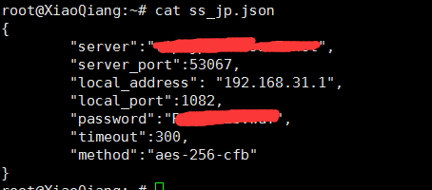

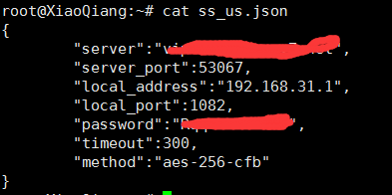

root@XiaoQiang:~/conf# cat ss.conf |grep google

server=/.googleadservices.com/127.0.0.1#53535

server=/.google-analytics.com/127.0.0.1#53535

server=/.googleapis.cn/127.0.0.1#53535

server=/.googleapis.com/127.0.0.1#53535

server=/.google.cn/127.0.0.1#53535

server=/.googlecode.com/127.0.0.1#53535

server=/.google.com/127.0.0.1#53535

server=/.googlecommerce.com/127.0.0.1#53535

server=/.googlelabs.com/127.0.0.1#53535

server=/.googlemail.com/127.0.0.1#53535

server=/.google.org/127.0.0.1#53535

server=/.googlesource.com/127.0.0.1#53535

server=/.googlesyndication.com/127.0.0.1#53535

server=/.googletagservices.com/127.0.0.1#53535

server=/.googleusercontent.com/127.0.0.1#53535

server=/.googlevideo.com/127.0.0.1#53535

server=/.googlezip.net/127.0.0.1#53535

ipset=/.googleadservices.com/letitgo

ipset=/.google-analytics.com/letitgo

ipset=/.googleapis.cn/letitgo

ipset=/.googleapis.com/letitgo

ipset=/.google.cn/letitgo

ipset=/.googlecode.com/letitgo

ipset=/.google.com/letitgo

ipset=/.googlecommerce.com/letitgo

ipset=/.googlelabs.com/letitgo

ipset=/.googlemail.com/letitgo

ipset=/.google.org/letitgo

ipset=/.googlesource.com/letitgo

ipset=/.googlesyndication.com/letitgo

ipset=/.googletagservices.com/letitgo

ipset=/.googleusercontent.com/letitgo

ipset=/.googlevideo.com/letitgo

ipset=/.googlezip.net/letitgo

vpn免费测试账号

<http://www.ishadowsocks.net/>

