作业1 知识工程与知识图谱

1. Consider the following RDF document:

<rdf:RDF

xmlns:rdf="http://www.w3.org/1999/02/22-rdf-syntax-ns#"

xmlns:rdfs="http://www.w3.org/2000/01/rdf-schema#"

xmlns:iswww="http://sw.edu/#"

>

<rdf:Description rdf:about="http://sw.edu/#germany">

<rdf:type rdf:resource="http://sw.edu/#country" />

</rdf:Description>

<rdf:Description rdf:about="http://sw.edu/#capital_of">

<rdf:type

rdf:resource="http://www.w3.org/1999/02/22-rdf-syntax-ns#Property"/>

<rdfs:domain rdf:resource="http://sw.edu/#city" />

<rdfs:range rdf:resource="http://sw.edu/#country" />

</rdf:Description>

<rdf:Description rdf:about="http://sw.edu/#country">

<rdf:type rdf:resource="http://www.w3.org/2000/01/rdf-schema#Class" />

<rdfs:label xml:lang="de">Land</rdfs:label>

</rdf:Description>

<rdf:Description rdf:about="http://sw.edu/#berlin">

<rdfs:label xml:lang="en">Berlin</rdfs:label>

<rdf:type rdf:resource="http://sw.edu/#city" />

<iswww:capital_of rdf:resource="http://sw.edu/#germany" />

</rdf:Description>

<rdf:Description rdf:about="http://sw.edu/#city">

<rdf:type rdf:resource="http://www.w3.org/2000/01/rdf-schema#Class" />

<rdfs:label xml:lang="de">Stadt</rdfs:label>

</rdf:Description>

</rdf:RDF>

Draw the graph representation of the above document.

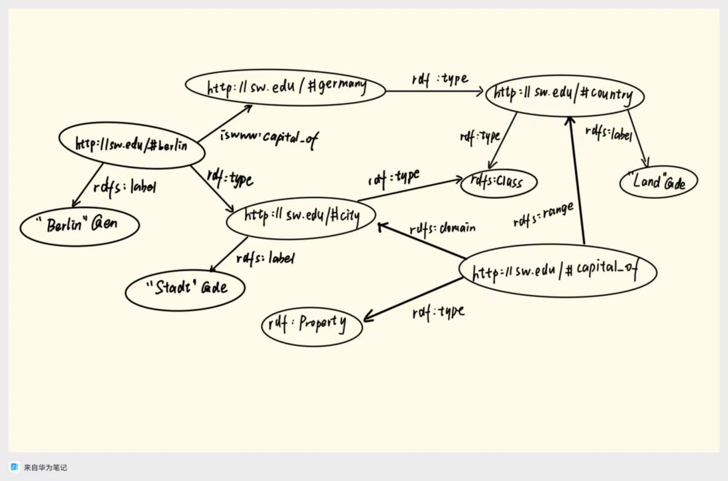

1. Translate the culinary-allergic example ontology as follows into RDF/XML syntax.

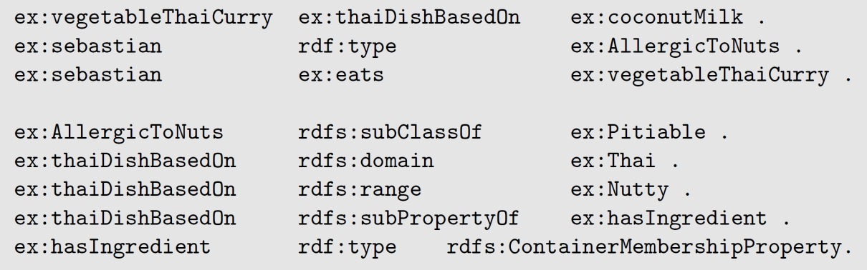

<rdf:RDF

xmlns:rdf="http://www.w3.org/1999/02/22-rdf-syntax-ns#"

xmlns:rdfs="http://www.w3.org/2000/01/rdf-schema#"

xmlns:ex="http://example.org/ns#"

>

<rdf:Description rdf:about="ex:vegetableThaiCurry">

<ex:thaiDishBasedOn rdf:resource="ex:coconutMilk"/>

</rdf:Description>

<rdf:Description rdf:about="ex:sebastian">

<rdf:type rdf:resource="ex:AllergicToNuts"/>

<ex:eats rdf:resource="ex:vegetableThaiCurry"/>

</rdf:Description>

<rdf:Description rdf:about="ex:AllergicToNuts">

<rdfs:subClassOf rdf:resource="ex:Pitiable"/>

</rdf:Description>

<rdf:Description rdf:about="ex:thaiDishBasedOn">

<rdfs:domain rdf:resource="ex:Thai"/>

<rdfs:range rdf:resource="ex:Nutty"/>

<rdfs:subPropertyOf rdf:resource="ex:hasIngredient"/>

</rdf:Description>

<rdf:Description rdf:about="ex:hasIngredient">

<rdf:type rdf:resource="http://www.w3.org/2000/01/rdf-schema#ContainerMembershipProperty"/>

</rdf:Description>

</rdf:RDF>

1. Decide whether the following propositions can be satisfactorily modeled in RDFS and, if so, give the corresponding RDF(S) specification:

• Every pizza is a meal.

• Pizzas always have at least two toppings.

• Every pizza from the class PizzaMargarita has a Tomato topping.

• Everything having a topping is a pizza.

• No pizza from the class PizzaMargarita has a topping from the class

Meat.

• “Having a topping” is a containedness relation.

1. 可以。 :Pizza rdfs:subClassOf :Meal.
2. 不可以。 RDFS不支持基数约束
3. 不可以。 RDFS无法强制要求每个实例必须拥有该属性，仅能声明关联关系。
4. 可以。 :hasTopping rdfs:domain :Pizza.
5. 不可以。 RDFS无法表达否定约束
6. 可以。 :hasTopping a rdf:Property.
7. As an example of an interpretation, this time with an infinite domain, consider the following vocabulary:

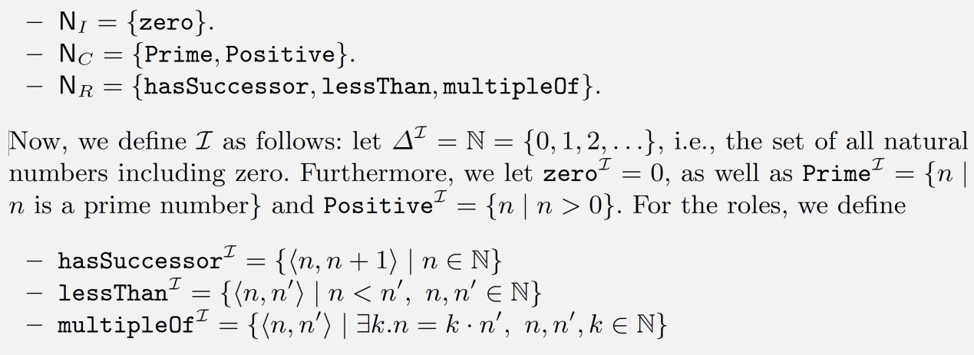

Describe (both verbally and formally) the extension of the following concepts with respect to the interpretation 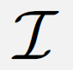 defined above

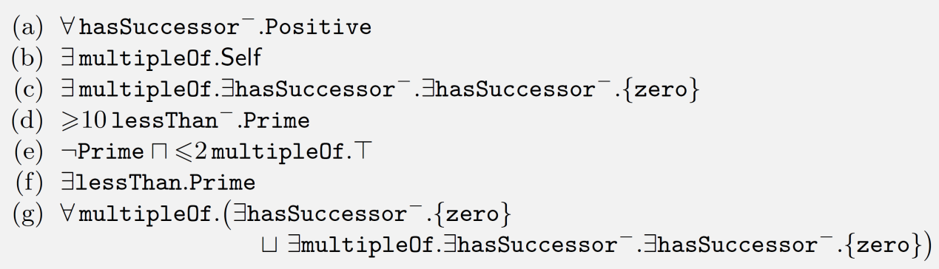

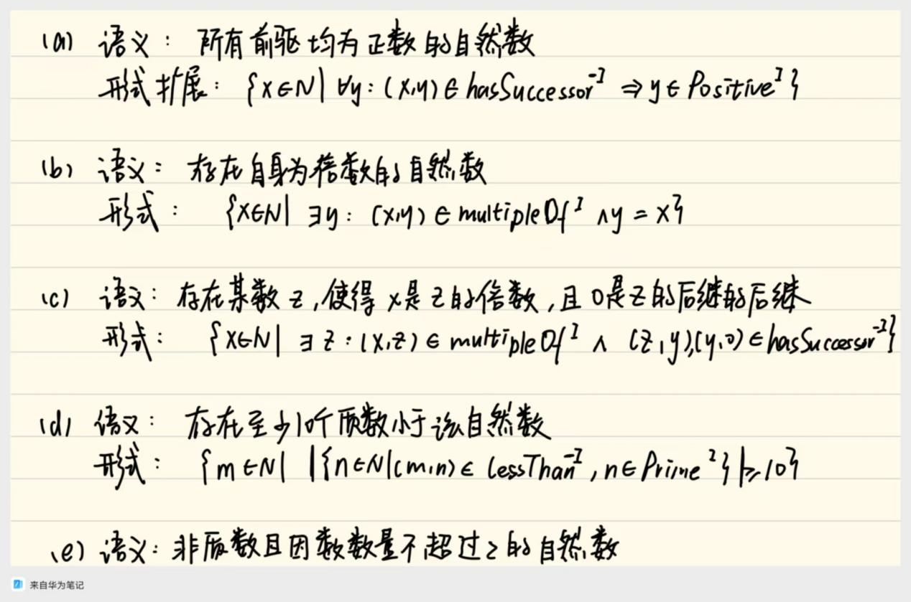

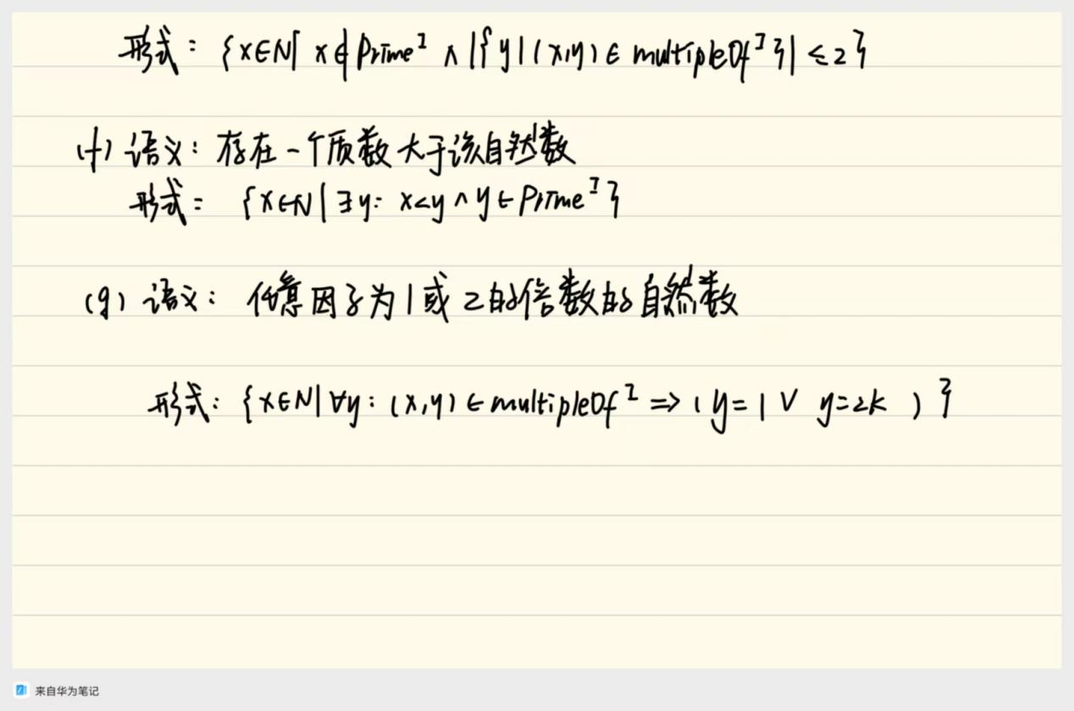

1. Decide whether the following axioms are satisfied by the interpretation  from Exercise 4.

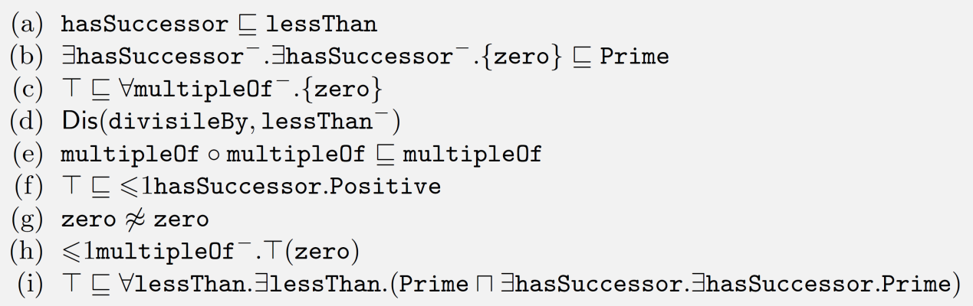

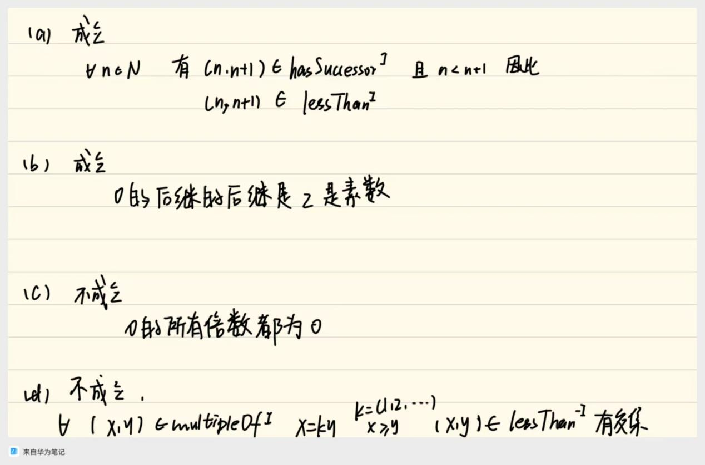

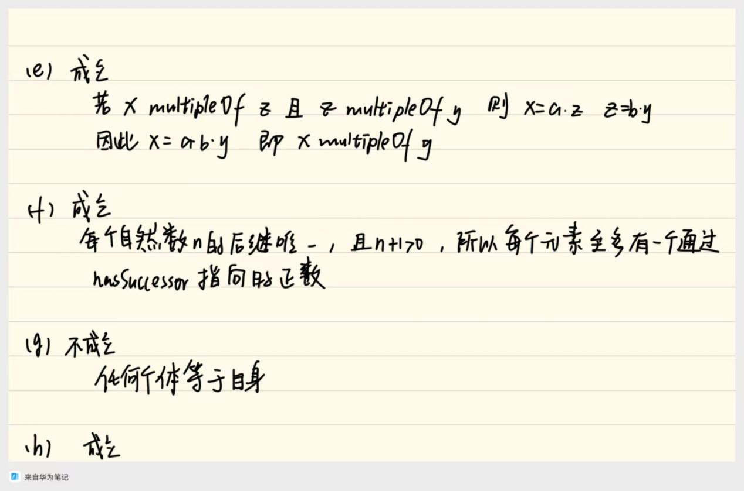

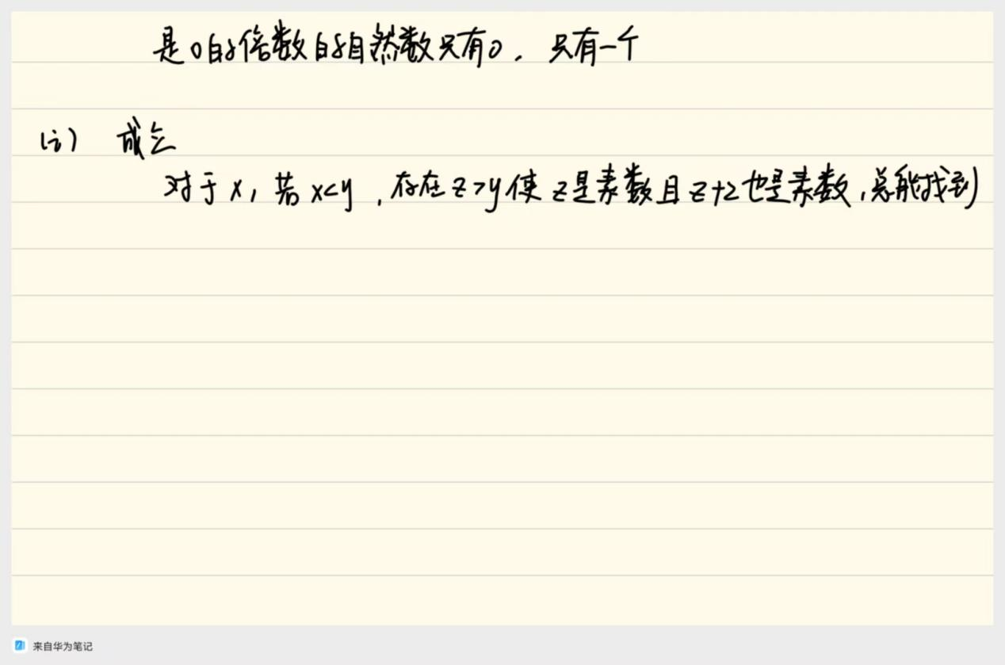

1. Show using the  tableaux algorithm that the following knowledge base is unsatisfiable.

