Week 01 Lab
Hello, I Exist.
Capability: Existence
Technology: Java · Maven · Spring Boot · HTTP · DevTools

Course | Web Programming (AI Native)
Project | MyBlog
Week | 01 — I Exist / Mission 01: Hello, I Exist.
Estimated Time | approximately 60 minutes (+ demo observation)

Student Name: __杨浩铭____________________________
Student ID: __25281E118____________________________
Date: _____10/9/2026_________________________

Contents
Table of contents — open in Word, right-click here, choose “Update Field”.

ABOUT THIS LAB MANUAL
This is your hands-on laboratory manual. You complete it during and after the teacher's live demonstration.
Source: lab.md (Week01 baseline — unchanged). This expanded manual adds an explicit overview, starting state, evidence map, and completion checklist; every task, bug exercise, and prompt from the baseline is preserved.
Companion files: mission.md (requirements) · assessment.md (how you are evaluated) · common-bugs.md (fixes) · ai-partner.md + prompts/ (AI collaboration) · reflection.md (closing questions).
Week06-pilot conventions applied: capability-shaped evidence, hypothesis-first AI loop, observable checkpoints.

1. Lab Overview
Field | This Lab
Weekly capability | Existence — MyBlog answers the Web for the first time
Core question | When I type a URL and press Enter — what actually happens?
Technology | Java 17+ · Maven · Spring Boot 3.x · embedded Tomcat · @RestController · @GetMapping · Browser DevTools
Starting state | Nothing — no project yet. You begin from zero.
Ending state | Running MyBlog app: GET /hello (personalized) + GET /me; you can explain the full request→response path
Time | ~60 min core + demo observation
Evidence | §10 — screenshots, DevTools conversation, written explanation, ai-log.md

What you are building
You
↓
Browser sends GET /hello
↓
Your Spring Boot application receives it
↓
Your Controller responds
↓
Browser shows: Hello, I Exist.

This is your first Web application — and the first heartbeat of your personal blog, MyBlog. Everything in the next 14 weeks (database, frontend, AI brain, knowledge assistant) grows from what you build today.

What proves success this week
The capability is existence + response. A bare "no error" is not proof. Your proof is the observable conversation:
Action: type http://localhost:8080/hello, press Enter
Observable: YOUR exact text appears in the browser
Verification: DevTools Network shows GET /hello → 200 OK → response body = your text
Evidence: screenshots + your own written explanation of the path (§10)

If you cannot explain how the text traveled from your return statement to the screen, the lab is not finished — even if it "works".

Estimated lab time
Section | Time
Environment check | 5 min
Create and explore project | 10 min
Write Controller and run | 10 min
Test in browser + DevTools | 5 min
AI exploration | 10 min
Debugging challenge | 10 min
Personalization | 10 min
Total | ~60 min

2. Starting Point & Environment Check
A missing tool is not your fault. A missing tool you ignored is a wasted hour.

Task 2.1 — Verify Java (JDK)
Open a terminal (in IDEA: View → Tool Windows → Terminal) and run:
java -version

Expected: openjdk version "17.x.x" or higher. If it fails or is below 17 — stop, raise your hand, or see common-bugs.md → JDK Problems.

Task 2.2 — Verify Maven
mvn -version

Expected: Apache Maven 3.x.x. If Maven is not installed separately, IntelliJ IDEA's bundled Maven is enough — the IDE uses it automatically.
注意：如果碰到如下错误信息，意味maven没有在系统中安装，可以单独安装，也可以将IDEA的maven添加到系统环境变量当中：
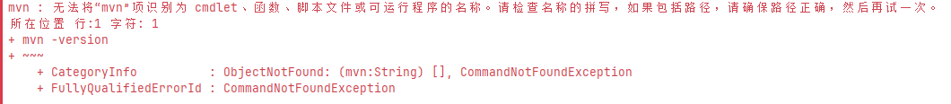

Task 2.3 — Verify IntelliJ IDEA and Internet
Open IDEA; confirm the Welcome screen or a project loads. The first Spring Boot project needs internet once (Maven downloads libraries, then caches them). Behind a proxy, configure it now — see common-bugs.md → Maven Download Problems.

Checkpoint — Environment
☐ java -version shows 17 or higher
☐ mvn -version shows 3.x (or IDEA bundled Maven confirmed)
☐ IntelliJ IDEA opens normally
☐ Internet connection works

EVIDENCE — capture this
[EVIDENCE: Environment summary — record your versions]
Java version: ______25.0.2__________
Maven version: ________________
IDEA version: _______2026.1.5_________
______________________________________________________________________________
______________________________________________________________________________

3. Create the Spring Boot Project

Task 3.1 — Generate the project
Two options; directly from the springboot official website or from IDEA locally, Option B preferred:
Option A — Spring Initializr (recommended):
1. Open https://start.spring.io
2. Configure exactly:
Project: Maven
Language: Java
Spring Boot: 3.x (latest stable)
Group: com.myblog
Artifact: myblog
Name: myblog
Description: My Personal Blog - Week 01
Package name: com.myblog
Packaging: Jar
Java: 17

3. Click ADD DEPENDENCIES → search Spring Web → select Spring Web
4. Click GENERATE — myblog.zip downloads
5. Extract it somewhere findable (Documents/myblog or Desktop/myblog)
6. IDEA → File → Open → the extracted folder → Trust Project
7. Wait for the import to finish (1–3 min; Maven is downloading dependencies — this is normal)
Option B — Inside IDEA: File → New Project → Spring Boot, same settings, add Spring Web, Create.
Expected structure in the project panel:
myblog/
├── pom.xml
└── src/main/
├── java/com/myblog/MyBlogApplication.java
└── resources/application.properties

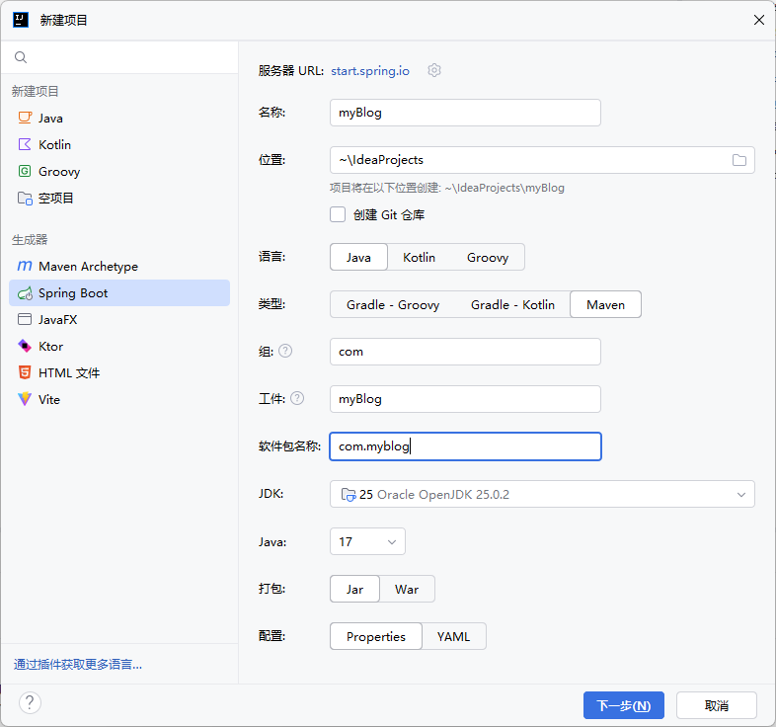
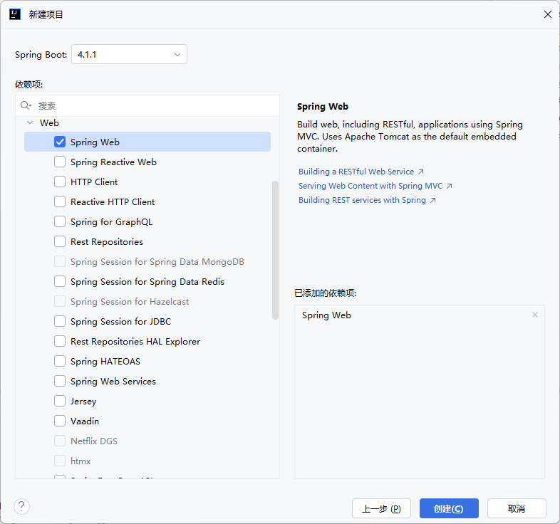

Task 3.2 — Understand what was generated
Do not skip this. Open pom.xml and find:
<dependencies>
<dependency>
<groupId>org.springframework.boot</groupId>
<artifactId>spring-boot-starter-web</artifactId>
</dependency>
</dependencies>

This one declaration is why your project can be a Web server: it brings Spring MVC (routing), embedded Tomcat (the server), and everything else Maven downloads for you.
Now open src/main/java/com/myblog/MyBlogApplication.java:
@SpringBootApplication
public class MyBlogApplication {
public static void main(String[] args) {
SpringApplication.run(MyBlogApplication.class, args);
}
}

- @SpringBootApplication — "start, scan for components, configure with defaults"
- SpringApplication.run(...) — launches the embedded Web server
- Without this file, nothing runs

Checkpoint — Answer before moving on
Write your answers; you will reuse them in reflection. You may ask AI to help — but read the answer and restate it in your own words.
1. What is the purpose of pom.xml?
Answer: __stores project information____________

2. What does @SpringBootApplication do?
Answer: __Auto configuration , component scan _________________________

3. What starts the Web server?
Answer: _________@SpringBootApplication__________________

Task 3.3 — Run the empty application
Verify the skeleton works before adding code:
1. Click the green Run button (▶) or press Shift + F10
2. Watch the console for:
Tomcat started on port(s): 8080 (http)
Started MyBlogApplication in X.XXX seconds

3. Open http://localhost:8080 in your browser
Expected result — a Whitelabel Error Page (404). This is not a problem. The server is alive; no Controller exists yet, so every path is unmapped. You just proved the server responds.
Symptom | Likely cause | Quick fix
Red errors immediately | Maven download incomplete | Re-run after full import
Port 8080 was already in use | Another process holds 8080 | Stop it, or change port
java: command not found | JDK not configured | File → Project Structure → SDK
Console freezes | Maven proxy needed | Configure Maven proxy

Details: common-bugs.md.

4. Build the Controller

Task 4.1 — Create the package and class
1. Project panel → navigate to src/main/java/com/myblog/
2. Right-click com.myblog → New → Package → name: controller
3. Right-click controller → New → Java Class → name: HelloController
An empty class appears:
package com.myblog.controller;

public class HelloController {

}

Task 4.2 — Write the GET /hello endpoint
Type the following by hand — do not copy-paste. Read each line as you type.
package com.myblog.controller;

import org.springframework.web.bind.annotation.GetMapping;
import org.springframework.web.bind.annotation.RestController;

@RestController
public class HelloController {

@GetMapping("/hello")
public String hello() {
return "Hello, I Exist.";
}
}

While you type — understand each line:
- @RestController — marks the class as a Web request handler; Spring Boot scans for it at startup. Without it, this class is invisible to the Web server.
- @GetMapping("/hello") — connects the URL path /hello to the method below. A browser's GET /hello finds and calls this method.
- return "Hello, I Exist."; — whatever the method returns becomes the HTTP response body. The browser receives this exact text.
When IDEA suggests imports (Alt + Enter / Option + Enter), accept them.

Checkpoint — Controller
☐ Package com.myblog.controller created
☐ HelloController.java exists inside it
☐ Code matches the listing above exactly (check typos)
☐ I typed it myself and can say what each annotation does

5. Test — and Watch the Conversation

Task 5.1 — Restart and request
1. Stop the app (red ⬛) if running, then Run (▶) again
2. Wait for Tomcat started on port(s): 8080 + Started MyBlogApplication
3. Browser → http://localhost:8080/hello → Enter
Expected result:
Hello, I Exist.

EVIDENCE — capture this
[EVIDENCE: Screenshot 01 — browser showing your /hello response]
Save as: 01-hello-response.png or paste it below
____________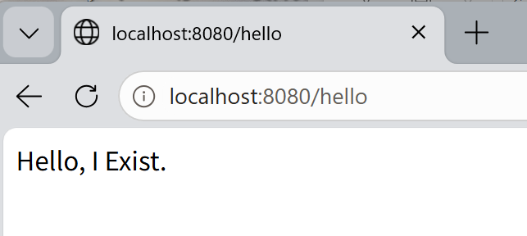__________________________________________________________________
______________________________________________________________________________

Task 5.2 — See the HTTP conversation in DevTools
1. Press F12 → Network tab
2. Refresh (F5) → click the hello request
3. Find each field:
Field | What you see | What it means
Request URL | http://localhost:8080/hello | The complete address your browser requested
Request Method | GET | The browser is asking for a resource
Status Code | 200 OK | The server found it and returned it
Response Body | Hello, I Exist. | The text your Controller returned

This is the week's evidence standard in action: the page on screen is the result; DevTools shows the conversation that carried it.
EVIDENCE — capture this
[EVIDENCE: Screenshot 03 — DevTools Network tab showing GET /hello, 200 OK]
Save as: 03-devtools-network.png
_____________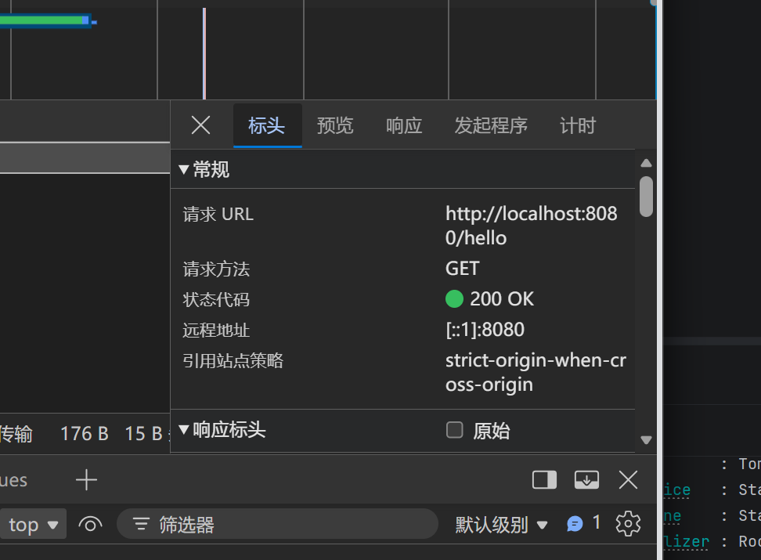_________________________________________________________________
______________________________________________________________________________

Task 5.3 — Trace the complete flow
Fill in each blank, then check with a classmate. Unsure → form a guess first, then ask AI.
1. I typed in the browser: http://localhost:__8080___/hello
2. The browser created an HTTP request: Method: ___GET__ Path: __/hello___
3. Tomcat received the request at port __8080___.
4. Spring Boot searched for a method with: @___GetMApping________("/hello")
5. It found: HelloController.hello()
6. The method returned: "_______Hello,I Exist.________"
7. Spring Boot wrapped it in an HTTP Response. Status: __200___ OK
8. The browser displayed: _______Hello, I Exist .________

6. AI Partner — Explain What You Built
AI is your tutor, not your copy machine. Rule of the course: if AI wrote it, you must be able to explain it.

The wrong way
Why doesn't my code work?

No context → generic answer → nothing learned.

The right way — copy this prompt and personalize it
AI PROMPT — copy, fill in the [brackets], verify the answer
I am a beginner learning Web Programming.

I just built my first Spring Boot Controller in Week 01 of my course.

Here is my code:

@RestController
public class HelloController {

@GetMapping("/hello")
public String hello() {
return "Hello, I Exist.";
}
}

Please explain:

1. What @RestController does and what happens if I remove it.
2. What @GetMapping("/hello") does and how it connects to the URL.
3. What happens step by step when a browser sends GET /hello to my app.
4. What the return value becomes in the HTTP response.
5. What String return type means, and when I might return something different.

Explain as if I have never seen Spring Boot before.
Keep each answer to 3-4 sentences.

What to do with AI's response
1. Read it fully before doing anything
2. Compare with what you observed — does it match what DevTools showed?
3. Write down one thing that surprised you
4. Test any claim — if AI says "removing @RestController causes a 404", try it (you will, in §7)

The AI collaboration cycle
Question → your hypothesis first → context-rich prompt
→ read the answer → compare with observation
→ test AI's claims → record what you learned

Record it
Create ai-log.md:
# AI Log — Week 01

## Session 1: Understanding HelloController

### My Prompt
[paste the prompt you used]

### AI's Response
[key points summarized — not copied wholesale]

### What I Verified
[what you tested; what matched your observation]

### What I Learned
[one sentence: what is clearer now?]

### What AI Got Wrong or Missed
[if anything — AI is not always correct]

7. Debugging Challenge — Break It, Then Fix It
Every developer breaks code. The skill is reading errors, not avoiding them.

Task 7.1 — Bug 1: Wrong path (produces 404)
Change only the mapping:
@GetMapping("/helloworld") // was: "/hello"

Restart → visit http://localhost:8080/hello → Whitelabel 404.
Before asking AI — think:
Question: Why is /hello returning 404?
My hypothesis: _____________Can’t find the path______________________
Then investigate with AI:
AI PROMPT — copy, fill in the [brackets], verify the answer
[PROMPT: Bug investigation — personalize the context, then verify the answer]
I am learning Spring Boot.

My application starts successfully.
The console shows: Tomcat started on port 8080.

But when I visit http://localhost:8080/hello,
I get a 404 Not Found error.

Here is my Controller:

@RestController
public class HelloController {

@GetMapping("/helloworld")
public String hello() {
return "Hello, I Exist.";
}
}

Expected behavior: /hello should return "Hello, I Exist."
Actual behavior: 404 error.

What is the most likely cause?
Why does this happen?
What should I check?

Read the answer. Was your hypothesis right? Fix it ("/helloworld" → "/hello"), restart, confirm.

Task 7.2 — Bug 2: Missing annotation (produces 404)
Remove @RestController from the class. Restart → visit /hello → another 404, but a different cause: the app starts normally, the path looks right, yet nothing handles it.
Why would removing @RestController cause a 404?
My hypothesis: _Cuz Spring Boot didn’t understand if HelloController is a request works on Web .__
Investigate the same way (context + expected + actual + code + question). Fix it — restore @RestController, restart, confirm.

What you learned
Observe the symptom → read the error → form a hypothesis
→ ask AI with context → apply the smallest fix
→ test and verify → understand why it worked

Do not skip the hypothesis. If you cannot form one, read the error again.

8. Make It Yours

Task 8.1 — Personalize /hello
@GetMapping("/hello")
public String hello() {
return "Hello, I am [Your Name]. I Exist.";
}

Ideas: "Hello, I am Wei. I love photography. I Exist." · "Hello, this is Lin. Computer Science is my journey." — no wrong answers, as long as it is yours.

Task 8.2 — Create GET /me
@GetMapping("/me")
public String me() {
return "I am [Your Name]. " +
"I study [Your Major]. " +
"I am interested in [Your Interest]. " +
"This is the beginning of my blog.";
}

Restart. Test both http://localhost:8080/hello and http://localhost:8080/me.
EVIDENCE — capture this
[EVIDENCE: Screenshot 02 — browser showing your /me response]
Save as: 02-me-response.png
________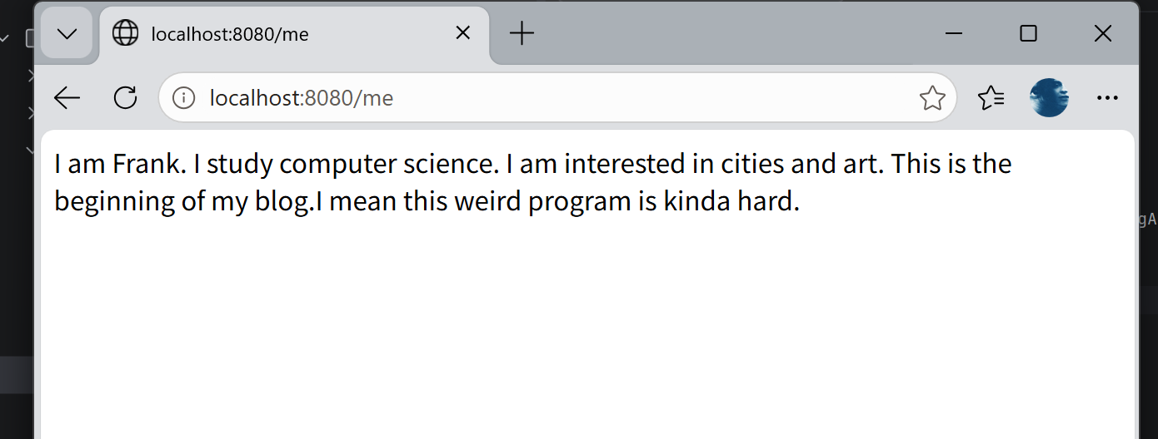______________________________________________________________________
______________________________________________________________________________

Think about this
Your /me endpoint is the first API of your personal blog. It will grow:
Week 01: GET /me → plain text introduction
Week 02: GET /me → JSON with multiple fields
Week 06: GET /posts → articles from a real database
Week 09: Vue frontend fetching your posts
Week 12: AI summarizing your writing
Week 15: a digital twin that understands who you are

This small endpoint is the seed.

9. Challenges

Required — explain the flow
Before submitting, complete this from memory:
When I type http://localhost:8080/hello and press Enter:
Step 1: My browser _____ sends an HTTP GET request to localhost port 8080 for path /hello__________
Step 2: The HTTP request contains _____ method GET, host localhost, path /hello__________
Step 3: Tomcat receives the request on port __8080___________
Step 4: Spring Boot finds the method annotated with ______ the method annotated with @GetMapping("/hello")_________
Step 5: The method returns ______ your personalized hello string_________
Step 6: The HTTP response has status _______200 OK________
Step 7: My browser displays ______s the returned text string
_________

Optional (choose any)
A — another endpoint:
@GetMapping("/about")
public String about() {
return "This is [Your Name]'s blog. Built with Spring Boot.";
}

B — current time:
import java.time.LocalDateTime;

@GetMapping("/time")
public String time() {
return "Server time: " + LocalDateTime.now().toString();
}

What changes each refresh?
The task i choose is C — personal identity API: design GET /me, GET /interest, GET /dream. Write the content yourself — no AI-generated personal text.
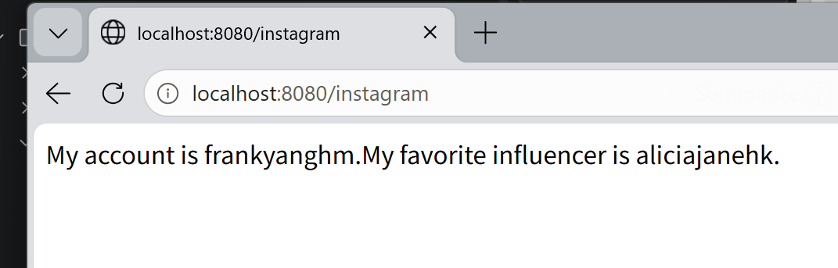
D — ask AI a design question:
AI PROMPT — copy, fill in the [brackets], verify the answer
[PROMPT: Design question — read the suggestions, then decide yourself]
I have a Spring Boot application with a GET /hello endpoint.
I want to add more endpoints to represent my personal identity.

What other endpoints might be useful for a personal blog backend?
Suggest 3 ideas with their URL path and expected response.

Keep the suggestions simple — this is Week 01 and I only know GET requests.

Read the suggestions, pick one, implement it yourself.

10. Evidence & Submission

The Week01 evidence map
Capability claim | Evidence that proves it
My server runs | Console lines: Tomcat on 8080 + Started
My server responds to the Web | 01-hello-response.png — your text in the browser
The HTTP conversation really happened | 03-devtools-network.png — GET /hello → 200 OK → body
My app has a personal voice | 02-me-response.png
I understand the path | Written explanation (below)
I collaborated with AI responsibly | ai-log.md

Required items
1. Source code — complete project; /hello and /me return personalized responses.
2. Screenshots
Filename | Content
01-hello-response.png | Browser showing /hello
02-me-response.png | Browser showing /me
03-devtools-network.png | DevTools Network, 200 OK

3. Written explanation (2–4 sentences, your words):
"What happens after I type http://localhost:8080/hello and press Enter?"
Must include: what the browser does · what Spring Boot does · what the Controller does · what arrives back.
4. AI collaboration record — ai-log.md with at least one complete entry (prompt · response summary · what you verified · what you learned).

Optional evidence
A hand-drawn flow diagram · a bug you hit and fixed · an extra endpoint and why · something AI got wrong.

11. Reflection
Five minutes. Write answers — they feed reflection.md.
Before / after:
When I typed a URL into a browser, I thought:
_________________________________________________

After this lab, I understand that:
Browser → _______ → Spring Boot → _______ → Browser
Still unclear:
The thing I am still not completely sure about:
_________________________________________________
AI's role:
AI helped me understand:
_________________________________________________
I verified this by:
_________________________________________________
Ownership test: close HelloController.java. Explain aloud: what @RestController means, what @GetMapping("/hello") means, what the return becomes. Can't? Open it and practice once more.

12. Completion Checklist
☐ Environment verified (java 17+, Maven, IDEA, internet)
☐ Project created via Initializr or IDEA with Spring Web
☐ I can explain pom.xml, @SpringBootApplication, and what starts the server
☐ HelloController typed by hand; /hello returns my text
☐ DevTools shows GET /hello → 200 OK → my response body
☐ Flow blanks (Task 5.3) filled and checked
☐ ai-log.md has at least one complete entry
☐ Bug 1 and Bug 2 broken, hypothesized, investigated, fixed
☐ /hello personalized; /me created; both screenshotted
☐ Required challenge (explain the flow) answered from memory
☐ Evidence map §10 complete: 3 screenshots + explanation + ai-log
☐ Reflection answers written

13. Bridge to Week02
Your application can speak — but only in single flat sentences.
If MyBlog can speak, how can it speak the language of the Web?
Next week: JSON responses · structured fields · your /me becomes machine-readable · a new /profile answers "who are you?" with structure, not one long string.
MyBlog has said its first word. Next, it learns to have a conversation.

Quick Reference

URL anatomy
http://localhost:8080/hello
│ │ │ │
│ │ │ └── Path → @GetMapping("/hello")
│ │ └─────── Port → Tomcat listens here
│ └────────────────── Host → "this machine"
└─────────────────────────── Protocol

Annotation cheat sheet
Annotation | Where | What it does
@SpringBootApplication | Main class | Start Spring Boot, scan for components
@RestController | Controller class | Mark as Web request handler
@GetMapping("/path") | Method | Connect GET /path to this method

HTTP status codes
Code | Meaning | When you see it
200 OK | Request succeeded | Endpoint exists and returned normally
404 Not Found | Path has no handler | Wrong path / missing @RestController
500 Internal Server Error | Something crashed | Read the console for the error

Common fix checklist
Application does not start:
→ java -version must be 17+
→ read the console's exact error

404 on /hello:
→ is @RestController present?
→ does the @GetMapping path match exactly?
→ did you restart after changes?

Maven download stuck:
→ check internet
→ see common-bugs.md

Detailed troubleshooting: `common-bugs.md` · Mission and evaluation: `mission.md`, `assessment.md` · AI templates: `prompts/`, `ai-partner.md`.

