Week 02 Lab
My Blog Has a Voice
Capability: Structured Voice
Technology: Java Object → JSON · Content-Type · Resource Naming

Course | Web Programming (AI Native)
Project | MyBlog
Week | 02 — I Speak / Mission 02: My Blog Has a Voice
Estimated Time | approximately 90–100 minutes

Student Name: __________杨浩铭____________________
Student ID: ___________25281E118___________________
Date: __________________16/9/2026____________

1. Lab Overview
Field | This Lab
Weekly capability | A Voice — MyBlog communicates structured information (JSON), not just output
Core question | How can my application express meaningful information?
Technology | Java data classes · @RestController returning objects · automatic Object→JSON (Jackson, beginner level) · Content-Type: application/json · resource naming · DevTools
Starting state | Your Week01 project: running app, GET /hello, plain-text GET /me
Ending state | Same project evolved: GET /profile returns JSON (≥3 fields); GET /me upgraded String→JSON; 3 bugs debugged with AI
Time | ~90–100 min in class (Bug 3 may finish as homework)
Evidence | §8 — JSON screenshots, Content-Type proof, AI debugging records, reflection

The transformation
Week 01: "Hello, I Exist." (one flat sentence)
↓
Week 02: { "name": "...", "owner": "...", "message": "..." } (a voice with parts)

Keep asking "Why does MyBlog need this?" before "How do I implement this?"
Full story: story.md · mission.md.

What proves success this week
The capability is structured communication. HTTP 200 alone is not proof — a plain String also returns 200 (you will demonstrate this yourself in Bug 1). Your proof is structure + content type:
Action: open GET /profile
Observable: browser shows { "name": ..., "owner": ..., "message": ... }
Verification: DevTools → Status 200 AND Content-Type: application/json;
JSON keys match your Java field names
Contrast: /hello (flat text) vs /profile (structured JSON) — same server
Evidence: §8 map — screenshots + AI records + before/after note

Estimated lab time
Section | Time
Mission intro + environment check | 5 min
L1A — Make MyBlog Speak (/profile) | 15 min
L1B — Upgrade Existing Endpoint (/me) | 10 min
L2A — Understand the Magic | 15 min
L2B — Debugging with AI (Bugs 1–2 in class) | 20–25 min
L3 — Make It Yours | 10 min
Deliverables + reflection | 5–10 min
Total (in class) | ~90–100 min

Time note: Bugs 1–2 are required in lab. Bug 3 is required for submission — finish in class if time allows; otherwise complete as homework with the same AI log format.

2. Starting Point & Environment Check
Keep this short — your tools already work from Week01. The important check is the starting state of the project, not the JDK.

Task 2.1 — Open your Week01 project
Open the Spring Boot project you built in Week01.
Do NOT create a brand-new unrelated project.
MyBlog is evolving. It is not restarting.

(Only if your teacher tells you to recover a lost project may you start fresh.)

Task 2.2 — Verify the baseline still runs
java -version

Expected: Java 17+. Then run the application and confirm the console shows Tomcat started on port(s): 8080 (http) and Started MyBlogApplication .... Open http://localhost:8080/hello — expected: your Week01 greeting.
If /hello does not work, fix Week01 first (weeks/week01/common-bugs.md). Do not build this week on a broken foundation.

Checkpoint — Starting state
☐ Week01 project opens in IDEA
☐ Application runs (Tomcat on 8080)
☐ GET /hello returns my Week01 response
☐ GET /me returns my Week01 plain-text introduction

EVIDENCE — capture this
[EVIDENCE: Starting state — record before changing anything]
Java version: _______25.0.2_______
GET /hello works: Yes
GET /me (text) says: ______I am Frank. I study computer science. I am interested in cities and art. This is the beginning of my blog.I mean this weird program is kinda hard._____

3. Level 1 — Make It Work
Level 1 has two parts, both required: 1A — Make MyBlog Speak (`/profile`) and 1B — Upgrade Existing Endpoint (`/me`).

3A. Make MyBlog Speak (GET /profile)
Goal: upgrade MyBlog from plain text to structured JSON at GET /profile.

Task 3A.1 — Why this matters (answer first)
Why is a JSON response more useful than a plain sentence when another system wants to read MyBlog's information?
My answer:
__________________JSON_is well-structured , which means it can be understood directly .____________________________________
Do not skip this. If you cannot answer yet, continue — but return after Level 2.

Task 3A.2 — Observe the current voice
Open http://localhost:8080/me (or /hello). DevTools: F12 → Network → refresh → click the request → inspect body and headers.
EVIDENCE — capture this
[EVIDENCE: Current voice — Week01 baseline observation]
URL I opened: _________localhost:8080/me___________
Response body: __________text__________
Content-Type (if visible):
_________text/html;charset=UTF-8___________________

Notice: readable — but still one block of text.

Task 3A.3 — Create the Java object for MyBlog's voice
Create src/main/java/com/myblog/model/BlogProfile.java (keep your own package style if different):
package com.myblog.model;

public class BlogProfile {

// These field names will become JSON keys
public String name;
public String owner;
public String message;
}

You are not decorating the project — you are deciding what MyBlog can say: name → who this application is · owner → who created it · message → what it wants to communicate.
Observation checkpoint:
1. What is BlogProfile?
Answer: ______________its a java model class__________________
2. If I later rename owner to author, what JSON key do I expect?
Answer: ______________the JSON key will automatically change from owner to author

Task 3A.4 — Return the object from the Controller
Open your Week01 Controller. Add:
@GetMapping("/profile")
public BlogProfile profile() {
BlogProfile blogProfile = new BlogProfile();
blogProfile.name = "MyBlog";
blogProfile.owner = "Your Name";
blogProfile.message = "Nice to meet you.";
return blogProfile;
}

Replace "Your Name" with your real name. Notice the return type: BlogProfile — not String. You are returning structured information, not a sentence.

Task 3A.5 — Run and observe the transformation
1. Restart the application
2. Open http://localhost:8080/profile — expected:
{
"name": "MyBlog",
"owner": "Your Name",
"message": "Nice to meet you."
}

3. DevTools → Network → click /profile → confirm: Status 200 and Content-Type includes application/json (ctrl+shift+I to open devTools or use browser optionsmore toolsDevTools)
EVIDENCE — capture this
[EVIDENCE: Screenshot — /profile JSON in the browser]
Also capture: DevTools showing Content-Type: application/json
_____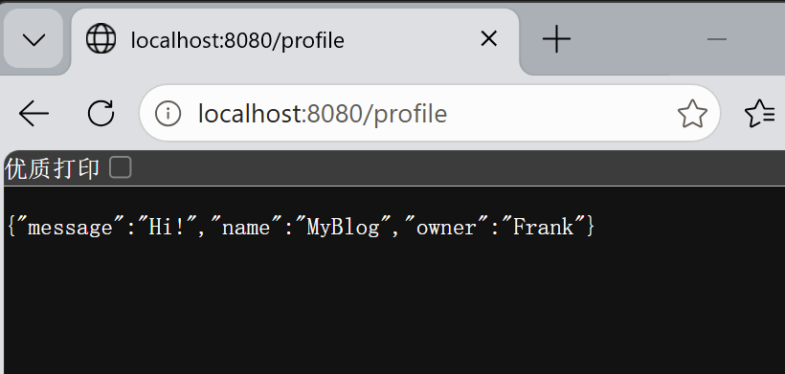____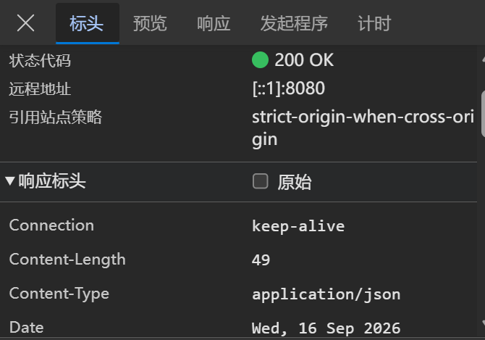_____________________________________________________________________
______________________________________________________________________________

Similar to this:
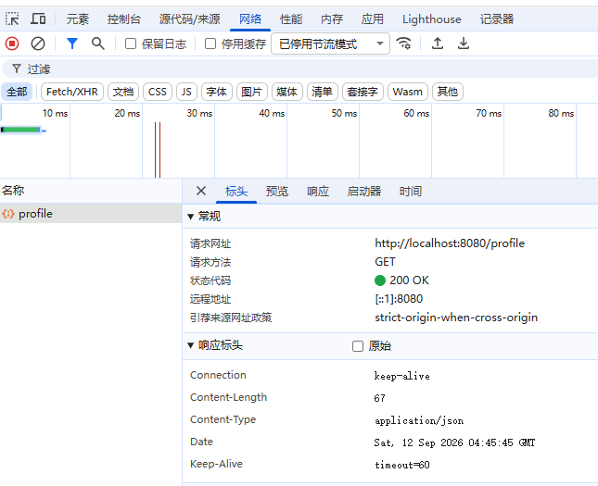

Checkpoint — Level 1A
☐ BlogProfile class created
☐ GET /profile returns JSON
☐ Browser shows name, owner, message
☐ DevTools shows application/json
☐ I did not only copy code — I observed the result

Pause and look. Say to yourself: I returned a Java object. The browser received JSON. Something converted my object into a Web message. That feeling is the center of Week02.

3B. Upgrade Existing Endpoint (GET /me)
Goal: upgrade GET /me from String to JSON — in the same project. Real systems evolve; if you rebuild from zero every week you are practicing tutorials, not software growth.

Task 3B.1 — Before / After
Before (your Week01 version):
@GetMapping("/me")
public String me() {
return "My name is MyBlog";
}

After — GET /me returns a JSON object:
{
"name": "MyBlog",
"owner": "Student"
}

Task 3B.2 — Create the response class
package com.myblog.model;

public class MeResponse {
public String name;
public String owner;
}

(You may add one more field in Level 3.)

Task 3B.3 — Upgrade the Controller method
@GetMapping("/me")
public MeResponse me() {
MeResponse meResponse = new MeResponse();
meResponse.name = "MyBlog";
meResponse.owner = "Your Name";
return meResponse;
}

Task 3B.4 — Compare before and after
Open http://localhost:8080/me. Record the transformation:
EVIDENCE — capture this
[EVIDENCE: Before/After — the upgrade in your own words]
Before (Week 01 style): ________________texts________________________________
After (Week 02 JSON): _________________JSON_______________________________
What feels different? __The response changed into structure data ._____________________________________

Keep GET /hello as plain text for a side-by-side comparison:
/hello → existence (plain text)
/me → personal voice (JSON)
/profile → structured profile (JSON)

Checkpoint — Level 1
☐ GET /profile returns JSON
☐ GET /me returns JSON
☐ I continued the Week01 project (no restart)
☐ I can explain why upgrading beats restarting
☐ MyBlog feels like one evolving application

4. Level 2 — Understand It
Two parts, both required: 2A — Understand the Magic, 2B — Debugging with AI.

4A. Understand the Magic
Goal: explain Java Object → Spring Boot → JSON Response.

Exploration questions (own words; AI as partner; final answers yours)
Question 1
I returned a Java object. Why did the browser receive JSON?
My answer:
_______When we return a Java object from a @RestController method, Spring MVC uses HttpMessageConverter. The Jackson library is included automatically in Spring Boot web starter. Jackson performs serialization: it reads the public fields of your Java object and converts the object into JSON text. Spring also sets the HTTP response header Content-Type: application/json, so the browser knows this is JSON data, not plain text._________________________________________
________________________________________________
Question 2
Who converted the object? (Hint: @RestController and Jackson at a beginner level — no framework internals.)
My answer:
______________________@Restcontroller and Jackson__________________________
________________________________________________
Question 3
What information is in the HTTP response? (DevTools: at least status code, Content-Type, response body.)
My answer:
__________________status code , content type , response body .______________________________
________________________________________________
Question 4
What is the difference between return "Hello, I Exist."; and return blogProfile;?
My answer:
__________one is texts while the other is structured data .___________________________
Question 5 — Resource naming
Why is /profile a better name than /getProfileData or /hello2? (Resource thinking, not full REST theory.)
My answer:
_____________________cuz it describe a resource , not an action___________________________
________________________________________________

Suggested AI prompts (ask only after seeing JSON in the browser)
AI PROMPT — copy, fill in the [brackets], verify the answer
I am building a Spring Boot personal blog called MyBlog.

I have a @RestController method that returns a Java object named BlogProfile.
The browser receives JSON.
I did not configure any JSON converter myself.

Please explain at a beginner level:
1. Why the Java object becomes JSON
2. What role @RestController plays
3. What Jackson is doing conceptually

Do not explain advanced Jackson configuration.

AI PROMPT — copy, fill in the [brackets], verify the answer
I opened DevTools for GET /profile.
The Content-Type is application/json.
Please explain what Content-Type means
and why it matters for Web communication.

After AI answers
What AI said that helped me:
________________step by step explain from java object to jackson , JSON , http .________________________________

What I verified myself in the browser:
______________________{"name":"MyBlog","owner":"Frank"}__________________________

What I can now explain without AI:
_Controller send the java object . it received by spring boot and changed into JSON . Finally being set to http content type ._______________________________________________

Checkpoint — Level 2A
☐ I can explain why a Java object became JSON
☐ I can name the beginner-level pieces involved
☐ I checked status code and Content-Type
☐ I can explain why /profile beats /getProfileData or /hello2
☐ I used AI to understand, not only to generate code

4B. Debugging with AI
Break things on purpose. Repair them with understanding. This is part of Understand It, not an optional extra.
In-class requirement: Bugs 1 and 2 (with an AI record each). Submission requirement: Bug 3 also — class if time allows, otherwise homework, same format.
For every bug, record: Problem → Hypothesis → AI Question → Solution → Learning.

AI debugging rules
1. Form a hypothesis before asking AI
2. Ask with context: expected result + actual result + code
3. Verify AI's suggestion in the browser
4. Write what you learned in your own words
Bad prompts: Give me the code. / Why doesn't this work?
Good pattern: Context + Expected + Actual + Code + Question

Task 4B.1 — Bug 1: Return String instead of Object
Temporarily change /profile:
@GetMapping("/profile")
public String profile() {
return "name=MyBlog, owner=Student, message=Hello";
}

Open the browser. Question: why is this not JSON communication? Even if the text looks organized to human eyes, why is it weaker than returning a Java object? (And notice: the status is still 200 — this is why 200 alone never proves this week's capability.)
Required AI question (adapt as you like):
AI PROMPT — copy, fill in the [brackets], verify the answer
[PROMPT: Bug 1 investigation — hypothesis first, then ask, then verify]
I am working on Spring Boot MyBlog Week 02.

I temporarily changed GET /profile to return a String:
"name=MyBlog, owner=Student, message=Hello"

I expected structured JSON communication.
Instead, the browser shows plain text.

Please explain at a beginner level:
1. Why returning a String is not the same as returning JSON
2. Why another program would struggle to read this response
3. What I should return instead, and why

Record:
Problem: ______________type writes String , not_JSON .
Hypothesis (before asking AI): ______the mistake type between string and JSON__________________________________________
AI Question (paste your prompt): ___check the screenshot .
1. What’s wrong?
2. How can I fix it so it returns JSON?
3. What will the Content-Type be after fixing?_____________________________________________
Solution: _If controller returns String, Spring treats it as plain text, Content-Type:text/plain.
Fix: Change method return type to BlogProfile, create BlogProfile object and return it.
After fix, Content-Type will be application/json.____
Learning: _____it needs to return java object.___________________________________________
Restore the object-returning version before continuing.

Task 4B.2 — Bug 2: Remove @RestController
Change @RestController → @Controller. Restart and open /profile.
Question: why does Spring not return the expected JSON response?
Required AI question:
AI PROMPT — copy, fill in the [brackets], verify the answer
[PROMPT: Bug 2 investigation — hypothesis first, then ask, then verify]
I am working on Spring Boot MyBlog Week 02.

My GET /profile method returns a BlogProfile object.
When the class uses @RestController, the browser shows JSON.
When I change @RestController to @Controller, the response is no longer the expected JSON.

Please explain at a beginner level:
1. What difference @RestController makes for the return value
2. Why @Controller alone does not give me the same JSON response
3. How I can verify the fix

Record:
Problem: ________Change the @RestController into @Controller .
Hypothesis (before asking AI): ______________idk...__________________________________
AI Question (paste your prompt): I changed @RestController to @Controller on my class. My /profile endpoint returns a Java object, but I do NOT get JSON in browser.
Explain the difference between @Controller and @RestController in Spring Boot. What annotation does @RestController combine?
Solution: ___________@RestController = @Controller + @ResponseBody.
@Controller only returns view. Without @ResponseBody, Spring will look for view page instead of converting object to JSON._____
Learning: ___________@RestController includes @ResponseBody. This tells Spring to turn returned object into HTTP response body.______
Restore @RestController immediately after the experiment.

Task 4B.3 — Bug 3: Wrong field name
When: in class if time remains after Bugs 1–2; otherwise required homework before submission (same AI log format).
Rename one Java field, e.g. message → note. Do not update your mental expectation. Open the browser and observe the JSON keys.
Question: why is the JSON structure different?
Required AI question:
AI PROMPT — copy, fill in the [brackets], verify the answer
[PROMPT: Bug 3 investigation — hypothesis first, then ask, then verify]
I am working on Spring Boot MyBlog Week 02.

My BlogProfile class originally had a field named message.
I renamed the Java field to note.
The JSON key also changed from "message" to "note".

Please explain at a beginner level:
1. Why the JSON key changed when I renamed the Java field
2. What this tells me about Object → JSON mapping
3. How I should choose field names when designing MyBlog's voice

Record:
Problem: ______renamed message into note .__________________________________________
Hypothesis (before asking AI): _______i still can’t predict what will happen... _______
AI Question (paste your prompt): ____have a Java model class BlogProfile with public fields. When I rename the field message to note, the JSON key changes automatically.
Why does Spring change JSON key name when I rename the class field? What tool does this conversion?____________________________________________
Solution: ___Jackson library scans your Java class public fields. It uses field name as JSON key. When you rename the field, JSON key changes._____
Learning:
Completed in: [ ] class [ 1] homework

Decide the final key — message or note — so the field name matches the meaning you want MyBlog to speak.

AI collaboration log
For each meaningful AI interaction in Level 2, keep in ai-log.md:
1. What I Asked: ________________________________________________
2. What AI Suggested: ________________________________________________
3. What I Used: ________________________________________________
4. What I Changed: ________________________________________________
5. What I Learned: ________________________________________________
6. What AI Got Wrong or Missed: ________________________________________________
Submission must include: Bugs 1–2 records (lab) · Bug 3 record (class or homework) · at least one Level 2A explanation interaction.

Checkpoint — Level 2
☐ I can explain Object → JSON mapping without reading notes
☐ I explained why /profile beats /getProfileData or /hello2
☐ I tested String vs Object (Bug 1)
☐ I tested @Controller vs @RestController (Bug 2)
☐ I observed field names becoming JSON keys (Bug 3 — class or homework)
☐ I asked AI for Bugs 1–2 in lab; Bug 3 recorded for submission
☐ I formed a hypothesis before each AI question
☐ I verified AI suggestions in the browser
☐ I recorded Problem / Hypothesis / AI Question / Solution / Learning

Only after 2A + Bugs 1–2 are complete, move to Level 3. (Finish Bug 3 before final submission if deferred.)

5. Level 3 — Make It Yours
Goal: personalize MyBlog's voice — after this level, MyBlog should sound like you. Structured communication is also identity practice: a profile full of meaningless fields is still empty.

Task 5.1 — Choose meaningful fields
Add personal information to /profile and/or /me. Candidates: favoriteQuote · introduction · vision · hobby · city · goal.
WARNING — forbidden pattern
❌ Avoid meaningless fields: a · test · asdf · field1

Ask yourself: if another system read only this JSON, would it know something true about me?
Optional AI design prompt (you decide what stays):
AI PROMPT — copy, fill in the [brackets], verify the answer
[PROMPT: Field design — AI suggests, you decide what stays]
I am designing a simple JSON profile for a personal blog.
I already have name, owner, and message.
Suggest 2 meaningful personal fields.
Keep it beginner-friendly.
No database. No nested objects.

Task 5.2 — Update classes and endpoints
Example direction for /me:
{
"name": "Alex",
"owner": "Alex",
"hobby": "Photography",
"vision": "Build my digital self",
"favoriteQuote": "Create something that responds."
}

Your fields can differ. What matters is that they are yours.

Task 5.3 — Read your voice aloud
Open the JSON in the browser. Read it as if MyBlog is speaking. Ask: does this sound like me? Does it feel generic? What one field would make it more honest? — then change one field based on that answer.

Checkpoint — Level 3
☐ JSON contains personal information
☐ Fields are meaningful, not random
☐ I can say: "MyBlog sounds like me."

6. Optional Extension
If you finish early, create GET /status:
{
"status": "alive",
"week": 2,
"ability": "I can speak."
}

Same Week02 idea. No new technology required.

7. Evidence & Submission

The Week02 evidence map
Capability claim | Evidence that proves it
MyBlog speaks in structure | Screenshot: /profile JSON with ≥3 fields in the browser
The Web recognizes it as JSON | DevTools screenshot: Content-Type: application/json (+ 200)
The project evolved (not restarted) | Before/after note for /me; Week01 endpoints still live
I understand the conversion | 2A answers + "Java object → JSON because…" in your words
I debug with a hypothesis-first AI loop | Bug 1–3 records in ai-log.md
MyBlog sounds like me | Personalized fields visible in JSON

Submit
1. Source code — the updated MyBlog project: BlogProfile (or equivalent), GET /profile, upgraded GET /me, personalized fields.
2. Screenshots — at minimum /profile returning JSON; recommended: DevTools showing Content-Type: application/json.
3. AI collaboration log — ai-log.md: one Level 2A explanation interaction · Bugs 1–2 debugging records (lab) · Bug 3 record (class or homework).
4. Reflection — answer "What did MyBlog learn this week?" and complete reflection.md (see homework.md for the full list). Minimum closing lines:
Before Week 02, my application only...
After Week 02, my application can...
The most important thing I understood is...
The thing I still want to understand better is...

8. Completion Checklist
☐ Starting state verified: Week01 project ran before I changed anything
☐ L1A: BlogProfile created; /profile returns JSON; DevTools shows application/json
☐ L1B: /me upgraded String → JSON in the SAME project
☐ L2A: Object → JSON + Content-Type + resource naming explained in my words
☐ L2B: Bug 1 and Bug 2 broken, hypothesized, AI-investigated, fixed, recorded
☐ L2B: Bug 3 recorded (class or homework) with the same format
☐ L3: personalized fields; MyBlog sounds like me
☐ Evidence map §7 complete
☐ ai-log.md + reflection.md complete
☐ I did NOT introduce database / Vue / service layer / POST

9. Technical Boundary Reminder
This lab stays inside Week02. Do not introduce:
WARNING — forbidden pattern
❌ Database / MySQL / JPA
❌ Vue
❌ IoC / DI / Service layer
❌ POST requests / @RequestBody
❌ Authentication

Feeling the urge to store data permanently? Good instinct — that is Week06 (Memory). This week is only about voice.

10. Bridge to Week03
MyBlog can speak now. But a voice needs an identity — a generic profile is still only a beginning:
{
"name": "MyBlog",
"owner": "Student",
"message": "Nice to meet you."
}

This is communication. It is not yet a full self.
Week 01: I Exist
Week 02: I Speak
Week 03: I Am Someone

Your application has a voice. Next, that voice begins to carry a real identity.
Detailed troubleshooting: `common-bugs.md` · Mission and evaluation: `mission.md`, `assessment.md` · AI templates: `prompts/`.

