Week 04 Lab
I Can Listen
Capability: Interaction
Technology: POST · @RequestBody · @PathVariable / @RequestParam · In-Memory List · HTTP Client

Course | Web Programming (AI Native)
Project | MyBlog
Week | 04 — I Can Listen / Mission 04: My Blog Can Listen
Estimated Time | approximately 65 minutes

Student Name: ______________________________
Student ID: ______________________________
Date: ______________________________

Contents
Table of contents — open in Word, right-click here, choose “Update Field”.

ABOUT THIS LAB MANUAL
This is your hands-on laboratory manual. Complete it during and after the teacher's live demonstration.
Source: lab.md (Week04 baseline — unchanged). This expanded manual adds an explicit overview, starting-state verification, evidence map, and completion checklist; the full Level 1 → 2 → 3 chain, all three bug exercises, the restart experiment, and all AI prompts from the baseline are preserved.
Companion files: mission.md (requirements) · assessment.md (evaluation) · common-bugs.md (fixes) · prompts/ (AI templates) · reflection.md, homework.md (submission).
Week06-pilot conventions applied: capability-shaped evidence, hypothesis-first AI loop, experience-before-explanation.

1. Lab Overview
Field | This Lab
Weekly capability | Interaction — MyBlog receives information from visitors and responds; heard messages can be retrieved
Core question | Can my application receive information from users?
Technology | POST · @RequestBody · @PathVariable · @RequestParam · in-memory List · HTTP client (Postman / Apifox / curl / IDEA HTTP)
Starting state | Your Week03 project: running app, rich GET /profile identity JSON, evolved GET /me
Ending state | Same project evolved: POST /messages accepts JSON, GET /messages + GET /messages/{id} retrieve what was heard, restart loss observed, 3 AI debug records
Time | ~65 min in class
Evidence | §7 — HTTP client evidence (POST + GET), restart observation, AI records, reflection

The transformation
Week 03: MyBlog speaks — every endpoint only *returns* information
↓
Week 04: MyBlog listens — a visitor's JSON arrives, is held, and can be read back

Keep asking "Why does MyBlog need this?" before "How do I implement this?"
Full story: story.md · mission.md.

What proves success this week
The capability is listening. A 200 OK on your POST is not proof — the server can return 200 without hearing anything. Your proof has two halves:
Half 1 — Heard: send { "content": "Hello, MyBlog" } via POST
→ the response carries your content
→ GET /messages later still shows it (listening accumulated)
Half 2 — Not yet remembered:
restart the application → GET /messages → empty
(heard ≠ remembered — that gap is Week06)

KEY IDEA
[KEY: A message you sent must be retrievable — retrieval proves listening.
And its disappearance after restart proves memory is still missing.
Both observations are required evidence this week.]

Estimated lab time
Section | Time
Intro + environment check | 5 min
Level 1 — Receive + retrieve | 25 min
Level 2 — Understand + AI debug + restart experiment | 20 min
Level 3 — Personalize | 10 min
Deliverables + reflection | 5 min
Total | ~65 min

2. Starting Point & Environment Check
This week adds one new tool to your kit: an HTTP client. The browser address bar can only send GET — it physically cannot send a JSON POST body.

Task 2.1 — Open your Week03 project
Open the Spring Boot project you have been growing since Week01.
Do NOT create a brand-new project.
MyBlog is evolving. It is not restarting.

Task 2.2 — Verify the baseline still runs
Run the application. Confirm http://localhost:8080/profile returns your Week03 identity JSON.
If /profile does not return your identity, fix Week03 first. Listening is built on top of identity — a blog that doesn't know who it is cannot meaningfully hear visitors.

Task 2.3 — Prepare your HTTP client
Have one ready before Level 1: Postman · Apifox · curl · IDEA HTTP — your choice.
# curl example (optional quick check that your client works):
curl http://localhost:8080/profile

Checkpoint — Starting state
☐ Week03 project opens in IDEA
☐ Application runs (Tomcat on 8080)
☐ GET /profile returns my identity JSON
☐ HTTP client is installed and can call GET /profile

EVIDENCE — capture this
[EVIDENCE: Starting state — record before changing anything]
GET /profile returns (short note): _{"blogName":"Frank's Blog","contact":"frankyanghm","interests":"maps&architecture","introduction":"Hi...","owner":"Frank","vision":"100% perfect work&life balance"}

HTTP client I will use: EDGE

3. Level 1 — Make It Work
Goal: POST receive + list/retrieve messages. By the end, a message you send can be read back.

Task 3.1 — Feel the gap
Before writing any code: try to "leave a message" using only what exists (GET endpoints).
Why GET is not enough:
__GET can only check the history , not creating new data request. ___
If you are unsure, that is fine — the demo showed the failure. Write your best guess now; revisit after Level 2.

Task 3.2 — Create MessageRequest
Create the input shape — the visitor's voice:
public class MessageRequest {
public String content;
}

(Place it beside your PersonalProfile, e.g. com.myblog.model. Optional personal fields like from or topic come later, in Level 3.)
Notice: this is Week03's DTO idea facing the other direction — a data shape for incoming communication.

Task 3.3 — Receive with POST
Add to your controller:
@PostMapping("/messages")
public MessageRequest create(@RequestBody MessageRequest request) {
// store and return

}

Note：You need to import the class MessageRequest And the annotation class RequestBody as well. The following two import statements should appear at the header:
import com.myblog.model.MessageRequest;
import org.springframework.web.bind.annotation.RequestBody;

Then send, using your HTTP client:
Method: POST
URL: http://localhost:8080/messages
Header: Content-Type: application/json
Body:

{
"content": "Hello, MyBlog"
}
Using the following command in windows command line:
curl -X POST http://localhost:8080/messages -H "Content-Type: application/json" -d "{\"content\": \"hello, MyBlog\"}"
See the Screenshot below:
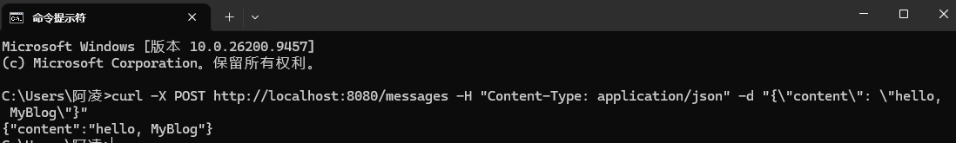
Expected result: the response includes the content you sent.
Verification: confirm the response body carries "Hello, MyBlog" — not an empty object, not null.
EVIDENCE — capture this
[EVIDENCE: HTTP client — POST /messages request + response]
Capture BOTH sides: method+URL+headers+body (request) and the JSON response.
Tool used: 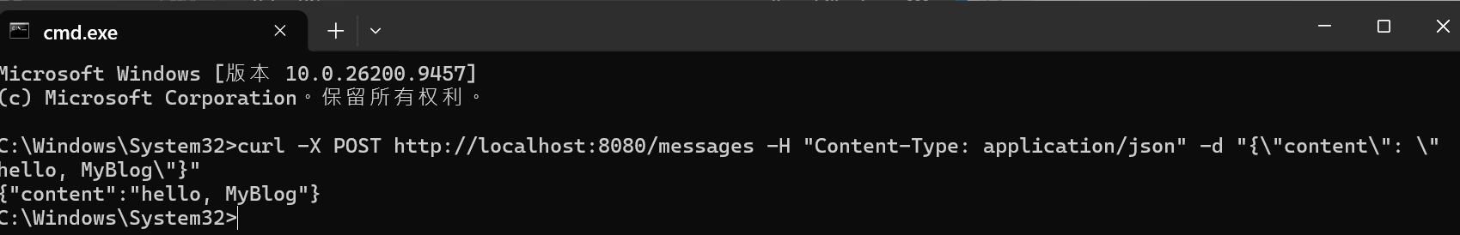

Sample Code：
@PostMapping("/messages")
public MessageRequest create(@RequestBody MessageRequest request) {
messages.add(request);
return request;
}

Task 3.4 — Temporary memory
Keep messages in a list, inside the controller (that is intentional this week):
private final List<MessageRequest> messages = new ArrayList<>();

On each POST, add the received request to the list. ("A list inside the Controller? Yes. The itch you feel is Week05's curriculum — write the itch down, don't fix it yet.")

Task 3.5 — Retrieve what was heard
Implement at least:
GET /messages
GET /messages/{id}

Optional:
GET /messages?keyword=hello

The accumulation check (Half 1 of this week's proof):
1. POST a first message ("Hello, MyBlog")
2. POST a second, different message
3. Open GET /messages in the browser (GET is browser-friendly) — both messages must appear
4. Open GET /messages/1 (or your indexing) — one specific message appears
EVIDENCE — capture this
[EVIDENCE: Screenshot — GET /messages showing BOTH messages sent earlier]
This is what proves listening accumulated. A POST 200 alone would not.
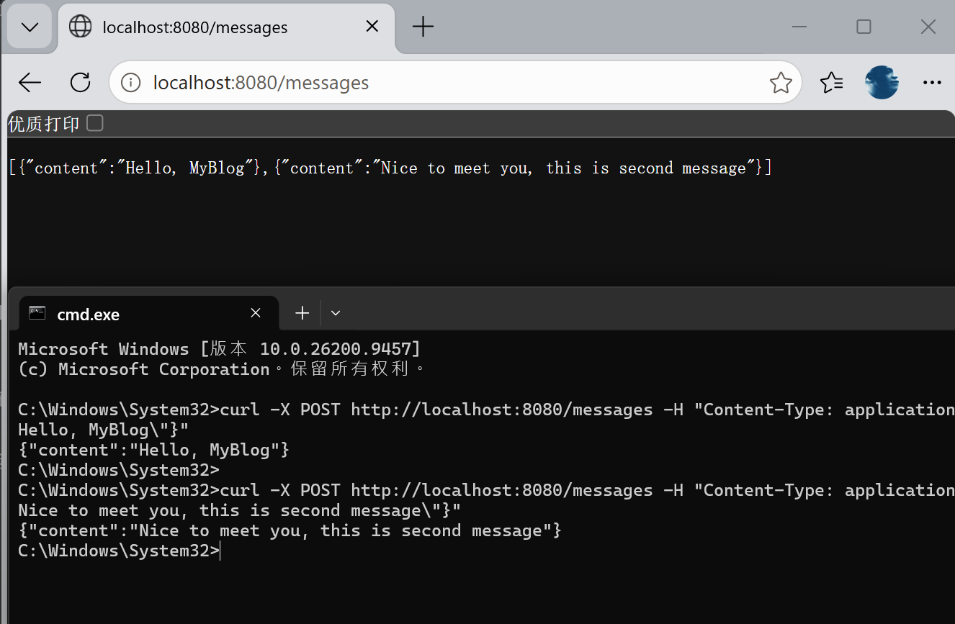

Sample Code:
// 1. 列出所有听到的消息
@GetMapping("/messages")
public List<MessageRequest> list() {
return messages;
}

// 2. 按位置取一条（@PathVariable：从 URL 路径里取参数）
@GetMapping("/messages/{index}")
public MessageRequest getOne(@PathVariable int index) {
return messages.get(index);
}

Checkpoint — Level 1
☐ POST accepts JSON body
☐ Received content appears in response
☐ GET can list messages
☐ PathVariable or RequestParam works
☐ HTTP client evidence saved

Pause and look. Say to yourself: a stranger's words entered my application, and I can read them back. That is the center of Week04.

4. Level 2 — Understand It
Goal: explain the binding, debug it with AI, and observe what restart destroys.

Task 4A.1 — Exploration questions (own words first)
1. What is the difference between request and response in your POST call?
2. Why use POST to leave a message?
3. Complete: "JSON became a Java object because…"
4. What happens after restart? Why?
My answers:
1. ____Clients send messages & Machine send messages____
2. _____Cause POST can send new data. _________________
3. ___Spring use Jackson to do this translate. ____
4. ___Every data will disappear. ____________

Task 4A.2 — AI explanation prompt
Ask only after your own answers exist:
AI PROMPT — copy, fill in the [brackets], verify the answer
[PROMPT: Understanding — @RequestBody and the reverse of Week02]
Explain @RequestBody for a beginner Spring Boot student.
Use MyBlog POST /messages as example.
No database. No security. No service layer.
Also explain how this is the reverse of returning JSON from a Java object.

Record:
What AI said that helped: @RequestBody reads JSON from the incoming HTTP request body and converts JSON → Java object (deserialization).
Returning a Java object from controller method does Java → JSON (serialization). They are reverse operations.
What I verified myself (client/browser): _Sent POST JSON via HTTP client; Spring filled my MessageRequest object. Without @RequestBody the object fields stay null.__

What I can explain without AI: _@RequestBody handles incoming JSON‑to‑Java conversion; returning POJO does Java‑to‑JSON output._

Task 4B — Debugging with AI (required)
Break things on purpose. Repair them with understanding. For each bug, record: Problem → Hypothesis → AI Question → Solution → Learning.
AI debugging rules: hypothesis before asking · ask with context (headers + body + code) · verify the fix in your HTTP client · write the learning in your own words.

Bug 1 — Wrong / missing Content-Type
Send the body without the JSON content type (or a wrong header). Observe failure/null.
AI PROMPT — copy, fill in the [brackets], verify the answer
[PROMPT: Bug 1 investigation — hypothesis first, then ask, then verify]
I POST to Spring Boot @RequestBody MessageRequest.
content is null / request fails.
Here is my request headers, body, and controller method.
Likely causes?

Record:
Problem: _POST send JSON, but content field becomes null. Forgot to set request header.__
Hypothesis (before asking AI): Spring cannot recognise incoming JSON without correct header, so cannot map values into Java fields.
AI Question (paste your prompt): I POST to Spring Boot @RequestBody MessageRequest. content is null / request fails. Here is my request headers, body, and controller method. Likely causes?
Solution: __Add request header Content‑Type: application/json_________
Learning: Spring relies on Content‑Type header to know incoming payload format. Missing header breaks JSON deserialization, even if body looks correct.

Restore the correct Content-Type: application/json before continuing.

Bug 2 — JSON key mismatch
Send {"text":"hello"} while the field is content. Observe null.
Question: the request returned 200 — so why is content null? (Another case where 200 alone proves nothing.)
AI PROMPT — copy, fill in the [brackets], verify the answer
[PROMPT: Bug 2 investigation — hypothesis first, then ask, then verify]
I POST JSON to Spring Boot @RequestBody MessageRequest.
The response is 200, but content is null.
My JSON body: {"text":"hello"} — my Java field: public String content;
Here are my request body and controller method.
Likely causes?

Record:
Problem: _HTTP status 200 OK, but content is null. Sent JSON {"text":"hello"}, Java field is named content._
Hypothesis (before asking AI): _JSON key name must exactly match Java public field name. Mismatched key leads to null value, even with 200 OK response._
AI Question (paste your prompt): __I POST JSON to Spring Boot @RequestBody MessageRequest. The response is 200, but content is null. My JSON body: {"text":"hello"} — my Java field: public String content; Here are my request body and controller method. Likely causes?__
Solution: _Change JSON key from "text" → "content", send {"content":"hello"}__
Learning: _Status code 200 OK does not guarantee correct business logic. JSON keys must match Java field names for automatic binding.__

Bug 3 — Wrong path or GET used by mistake
Call the POST URL with GET, or a wrong path. Observe the result and explain it.
AI PROMPT — copy, fill in the [brackets], verify the answer
[PROMPT: Bug 3 investigation — hypothesis first, then ask, then verify]
I called http://localhost:8080/messages with GET instead of POST
(or a wrong path). Here is the exact request I sent and the
status code / error I received.
Why did Spring Boot respond this way?
What does the error tell me about how it matches requests to methods?

Record:
Problem: Using GET to call POST‑only endpoint /messages, get error status.
Hypothesis (before asking AI): Spring matches request by URL path AND HTTP method. GET will not trigger @PostMapping controller function.
AI Question : I called http://localhost:8080/messages with GET instead of POST (or a wrong path). Here is the exact request I sent and the status code / error I received. Why did Spring Boot respond this way? What does the error tell me about how it matches requests to methods?
Solution: Use correct HTTP method POST when submitting new messages to @PostMapping("/messages").
Learning: Spring maps requests combining path + HTTP method. Mismatch of method causes no handler match error._

Task 4C — Restart experiment (Half 2 of this week's proof)
1. Create 2 messages (POST twice)
2. GET /messages — confirm both exist
3. Restart the application
4. GET /messages again
EVIDENCE — capture this
[EVIDENCE: Restart experiment — heard ≠ remembered]
Before restart, GET /messages showed: _Two messages: "Hello, MyBlog", "Nice to meet you"
After restart, GET /messages showed: _Empty square brackets [] (empty list, no messages)_
What disappeared? ____All messages____________________________
What does this teach about memory? Messages are stored in the controller’s in‑memory List. Application memory gets cleared every time the server restarts. In‑memory storage is temporary, it cannot save data permanently. Real persistent storage will come in Week06.__

The code didn't change. The server didn't crash. The messages lived in memory — and memory resets. Hold onto that feeling; it has a week number (06).

Checkpoint — Level 2
☐ I can explain request vs response
☐ I can explain @RequestBody
☐ I completed 3 AI debug records
☐ I observed restart data loss
☐ I noticed the Controller is getting crowded (save this feeling for Week05)

5. Level 3 — Make It Yours
Goal: personalize the listening experience — after this level, being heard by your MyBlog should feel different from a generic API demo.

Task 5.1 — Personalize the listening voice
Choose deliberately:
- response wording ("MyBlog heard you" → your voice)
- optional fields that fit your blog (from, topic, mood…)
- message topics related to your identity
Ask:
Does this feel like my MyBlog listening, or a generic API demo?
Remember Week03: your MyBlog knows who it is. It should hear in its own voice.

Task 5.2 — Optional AI critique
AI PROMPT — copy, fill in the [brackets], verify the answer
[PROMPT: Design critique — AI suggests, you decide what stays]
Here is my listening API design and sample response.
Does it feel personal to MyBlog identity?
Suggest 2 small improvements. Do not rewrite everything.

You decide what stays. Rejecting everything is valid — if you can say why.

Checkpoint — Level 3
☐ Listening response sounds like my MyBlog
☐ Fields/naming feel intentional

6. Optional Extension
Only after L1–L3 are complete (details: mission.md §9, challenge.md):
- DELETE one message by id (still in-memory)
- Add a from field to message identity
- Reject empty content with a clear JSON error message
Same Week04 technology. No database. No service layer requirement.

7. Evidence & Submission

The Week04 evidence map
Capability claim | Evidence that proves it
MyBlog receives a visitor's message | HTTP client capture: POST request (method, URL, Content-Type: application/json, body) + response carrying the content
Listening accumulated | Screenshot: GET /messages showing both messages sent earlier
I can listen selectively | GET /messages/{id} or ?keyword= result
I understand the binding | Level 2 answers + "JSON became a Java object because…" in your words
I debug with a hypothesis-first AI loop | Bug 1–3 records in your AI collaboration log
I know what memory would add | Restart experiment record (before/after + explanation)
The listening is mine | Personalized response wording visible in the response JSON

Submit
1. Source code — the continued MyBlog project: MessageRequest, POST /messages, in-memory list, GET /messages + GET /messages/{id}
2. HTTP client evidence — POST + GET (see evidence map)
3. AI collaboration log — Bug 1–3 records + at least one Level 2A explanation interaction
4. Reflection — "How is listening different from speaking?" (see reflection.md, homework.md)

8. Completion Checklist
☐ Starting state verified: Week03 project ran before I changed anything
☐ L1: MessageRequest created; POST /messages accepts JSON body
☐ L1: received content appears in the response
☐ L1: GET /messages lists what was heard; {id} or keyword works
☐ L1: HTTP client evidence saved (both sides of the POST)
☐ L2: request vs response + @RequestBody explained in my words
☐ L2: Bugs 1–3 recorded with Problem / Hypothesis / AI Question / Solution / Learning
☐ L2: restart experiment observed and explained
☐ L3: listening voice personalized
☐ Evidence map §7 complete
☐ AI log + reflection complete
☐ Continued Week03 project — no restart
☐ No Database / Service / Auth / Vue introduced

9. Technical Boundary Reminder
This lab stays inside Week04. Do not introduce:
WARNING — forbidden pattern
❌ Database / MySQL / JPA
❌ Service layer / IoC / DI
❌ Authentication
❌ Vue

Feeling two itches? Good — they are the curriculum:
The Controller is getting crowded → Week 05: I Have Structure
Heard messages vanish on restart → Week 06: I Remember

10. Bridge to Week05
MyBlog can listen. But look at your Controller honestly: how many endpoints live in it now? And look at your message list after a restart: where did everything go?
Week 04: I Can Listen
Week 05: I Have Structure
Week 06: I Remember

Your application can hear someone. Next, it needs a place to keep what it heard — and a cleaner home for all this listening.
Detailed troubleshooting: `common-bugs.md` · Mission and evaluation: `mission.md`, `assessment.md` · AI templates: `prompts/`.

