User Guide:

The default landing window:

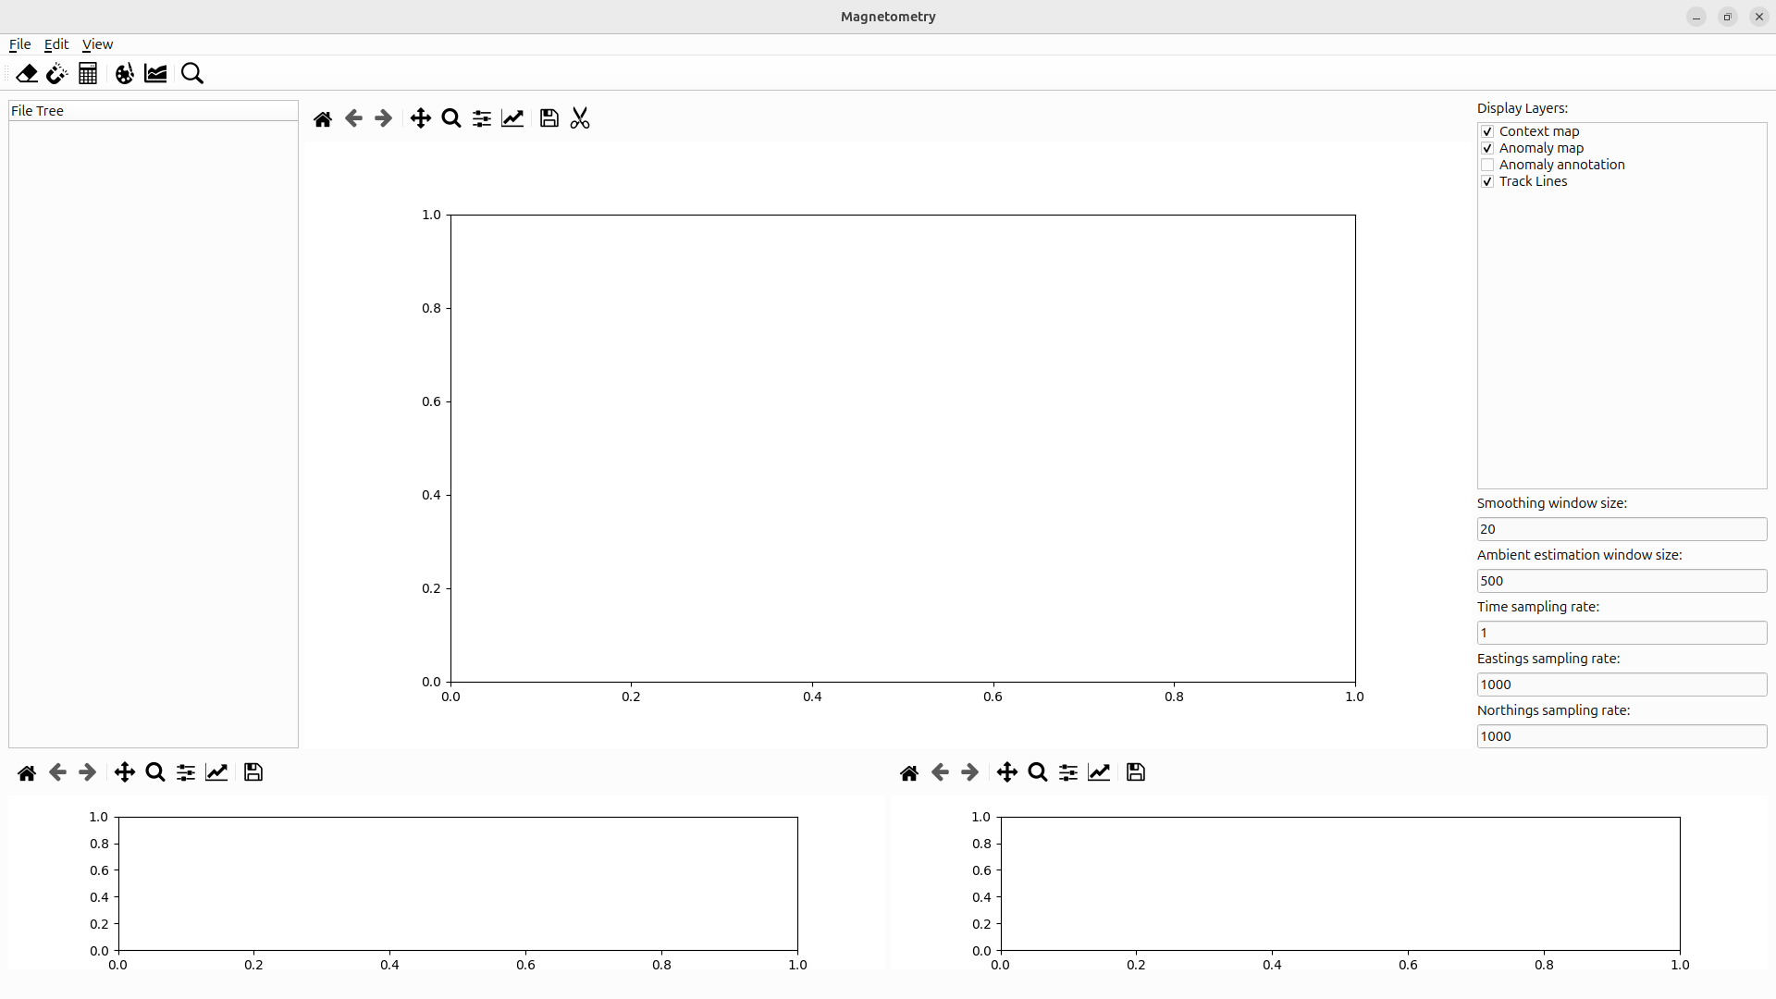

1. Importing data:

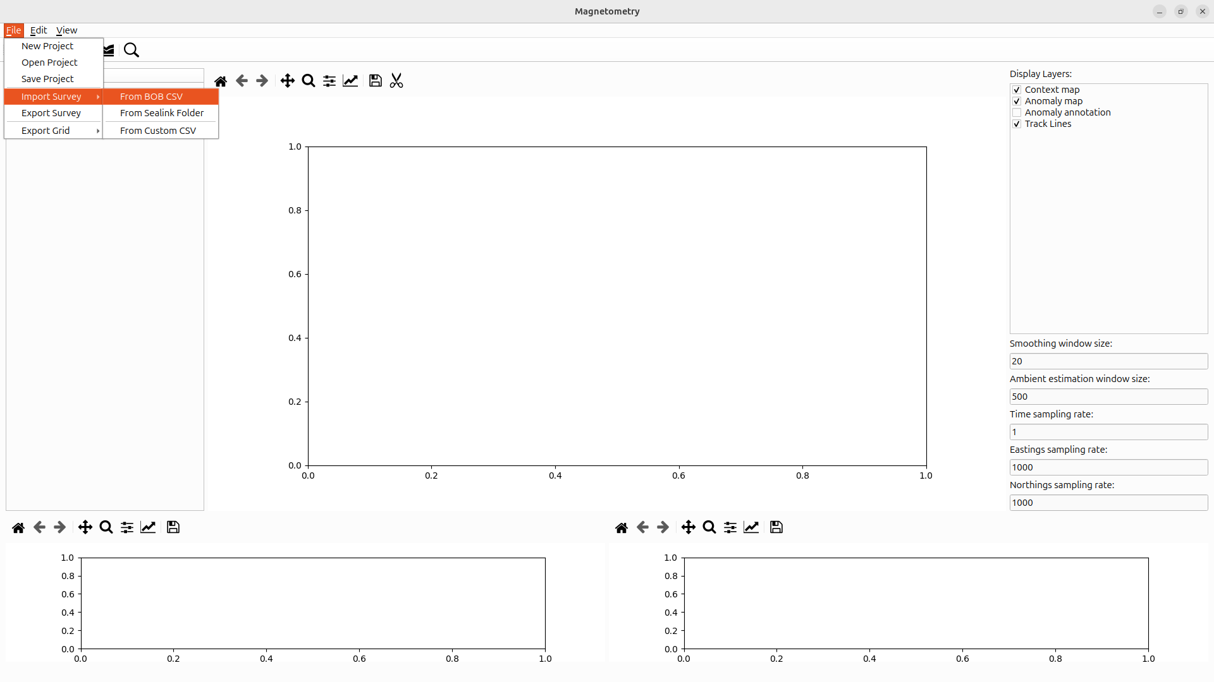

If the survey of interest is acquired using the Sealink acquisition software, it will be present as a folder containing several files within some of them are ending with .xyz.

This folder has to be selected by the opened file-dialog that spawns upon selecting the corresponding option in the dropdown menu.

If the survey has been acquired using the Bob acquisition software, it will be present as a large csv file. This file has to be selected by the opened file-dialog that spawns upon selecting the corresponding option in the dropdown menu.

Note that both option might take a couple of seconds depending on the file respectively folder size and will show on the left-hand file tree if successful imported.

Afterwards, a coarse cleaning of the imported data is possible through opening a dialog though the menubar.

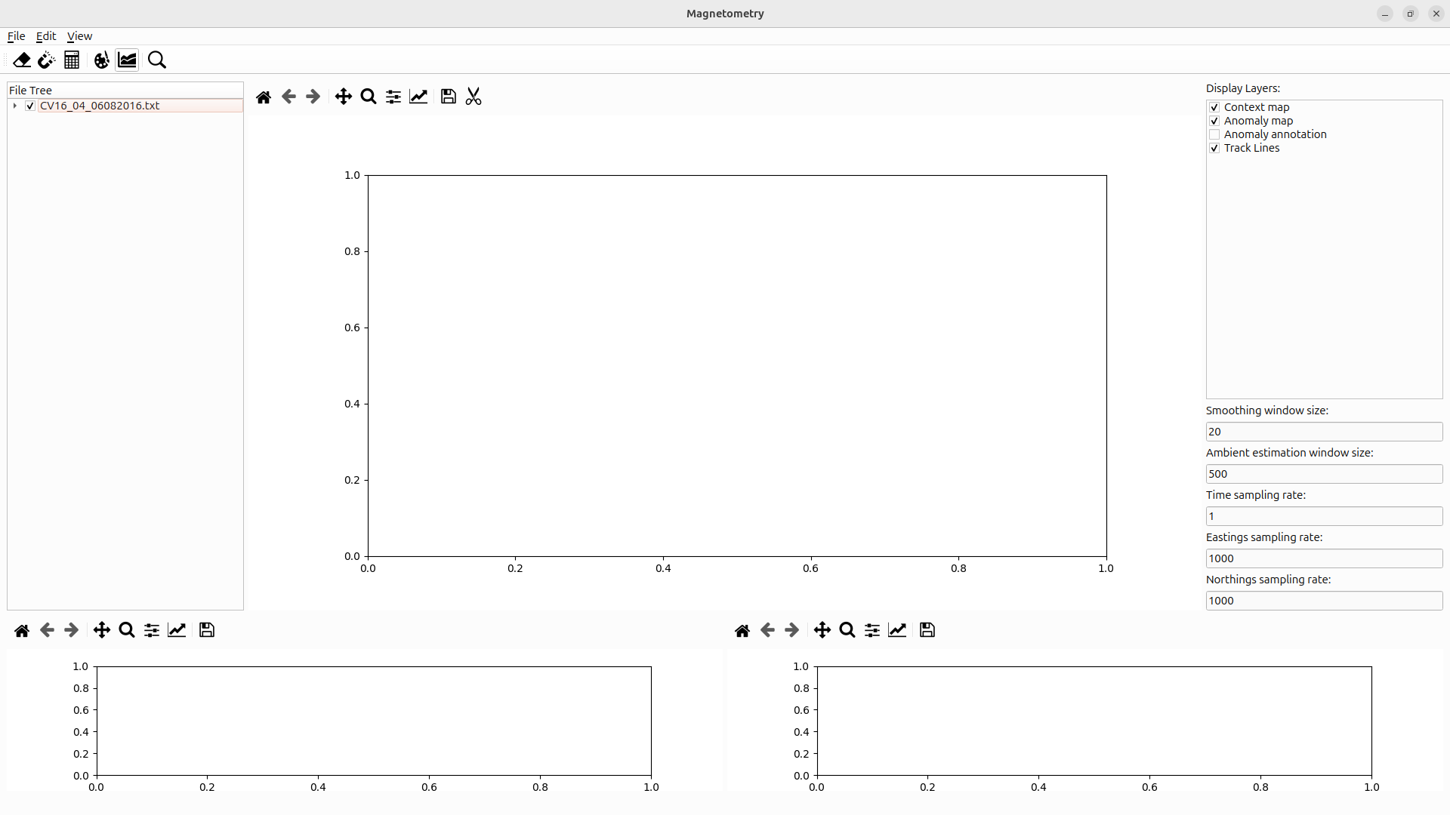

This dialog assumes a rough prior knowledge on the investigated area as well as on the measured magnetic field therein.

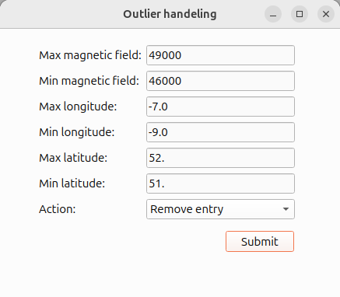

2. Timeseries processing:

Next, it is recommended to inspect the timeseries through the “timeseries”-window, which is open though the dropdown menu “view”.

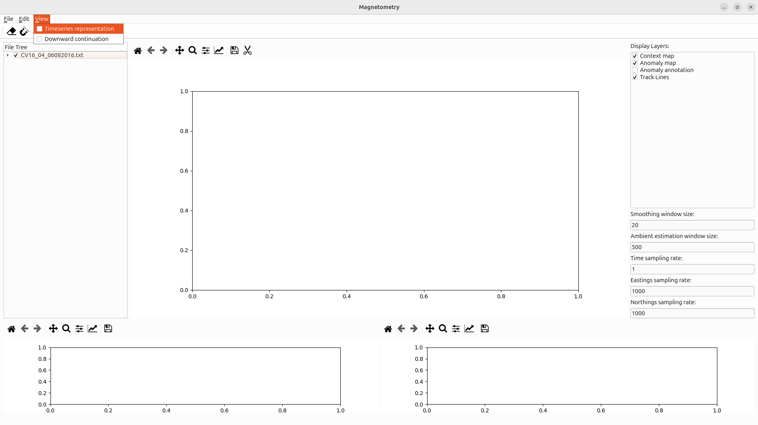

The “timesseries”- window features two key tools that is displaying the timeseries and manipulating it. The timeseries will be displayed by clicking on . This is also replicate on the main window and vise versa. Moreover, this operation internally smooth the timeseries and calculate the residuals as difference between the ambient field, estimated as slow running mean, and the current field, estimated as fast running mean. The window size of both means are preset upon preliminary work but might be adjusted by the user.

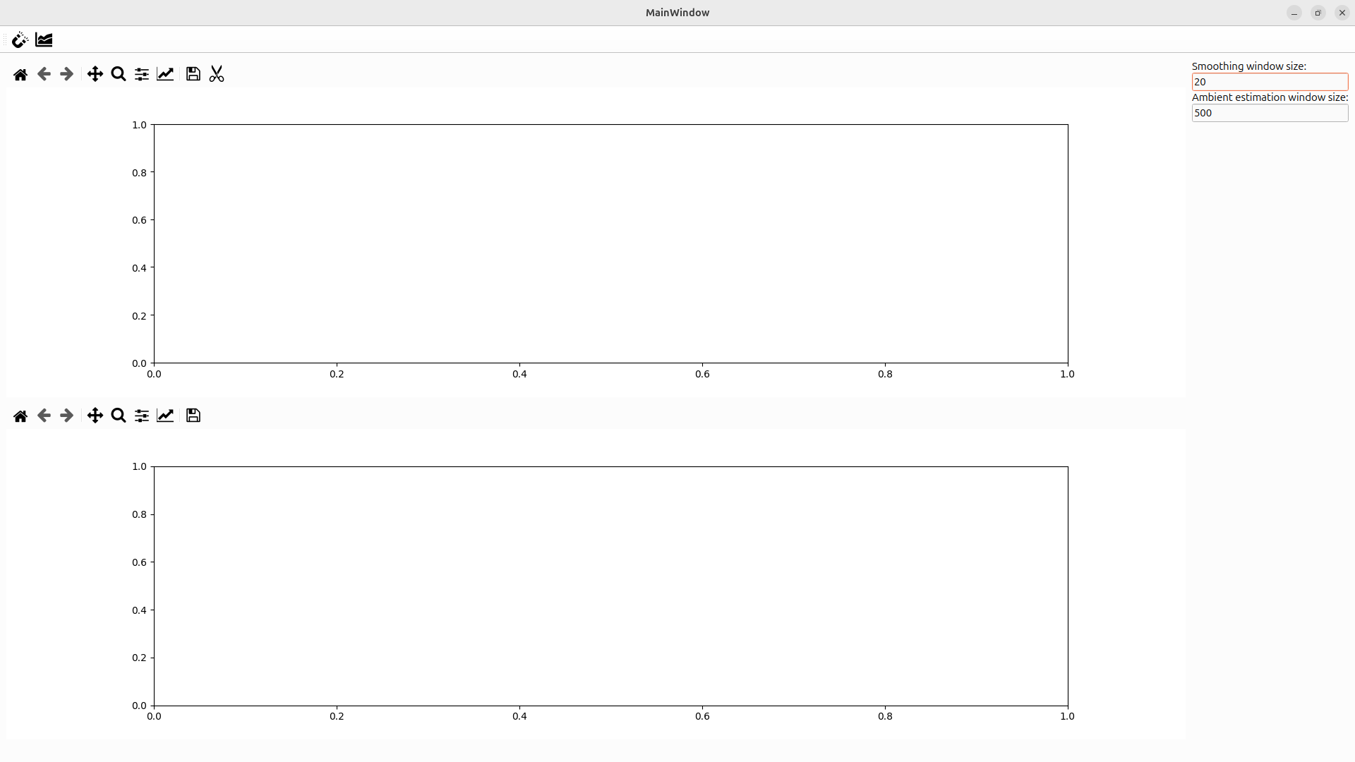

The scissor tool  allows the selection of an undesired interval in the time-series to be excluded.

The tool is activated by clicking on the corresponding icon. The boundaries of the red rectangle, defining the interval that is to be excluded, can be adjusted until the selection is confirmed by clicking again the scissor icon. In an final dialog the removal has to be confirmed by the user.

