NCTU Pattern Recognition, Homework 1

**Deadline: April 3, 23:55**

**Part. 1, Coding (60%)**:

In this coding assignment, you need to implement linear regression by using only NumPy, then train your implemented model using **Gradient Descent** by the provided dataset and test the performance with testing data. Find the sample code and data on the GitHub page

<https://github.com/NCTU-VRDL/CS_DCP3121/tree/master/HW1>

We suggest using the hyper-parameters below:

* Loss function: Mean Square Error
* Learning rate: 1e-4
* Number of training iteration: 100

**Please note that only NumPy can be used to implement your model, you will get no points by simply calling sklearn.linear_model.LinearRegression. Moreover, please train your regression model using Gradient Descent, not the closed-form solution.**

1. (15%) Plot the [learning curve](https://miro.medium.com/max/1718/1*69r3IZNMnWPngwzbeSTz_Q.png) of the training, you should find that loss decreases after a few iterations (x-axis=iteration, y-axis=loss, Matplotlib or other plot tools is available to use)

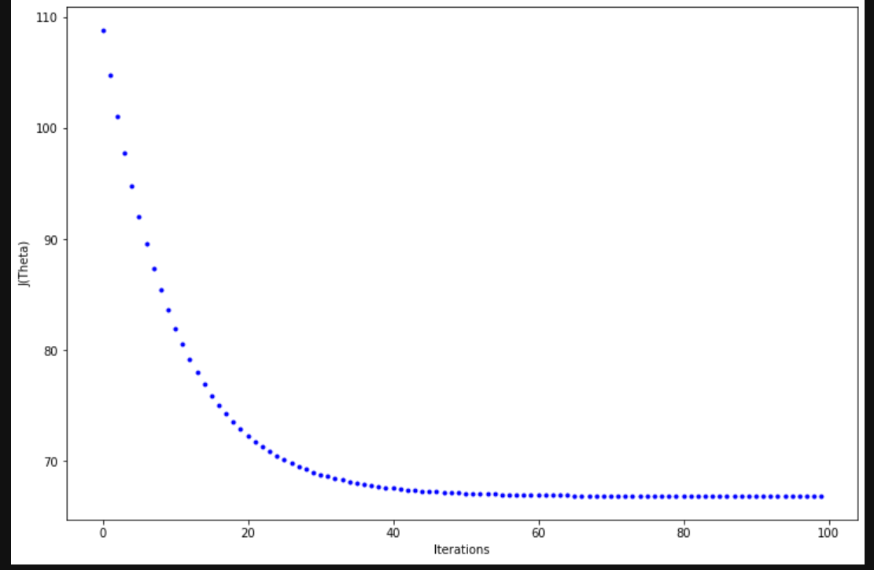

1. (15%) What’s the Mean Square Error of your prediction and ground truth (prediction=model(x_test), ground truth=y_test)

A:

MSE是prediction跟ground的差的平方和平均，所以是3.449*2/100=**0.06898**

(每一次跑會有點不一樣，因為一開始theta是隨機)

1. (15%) What’re the weights and intercepts of your linear model?

A:

Weights:0.784

Intercepts:0.815

(每一次跑會有點不一樣，因為一開始theta是隨機)

1. (10%) What’s the difference between Gradient Descent, Mini-Batch Gradient Descent, and Stochastic Gradient Descent?

A:三種方法主要的不同是在更新的頻率，gradient descent是一個iteration更新一次，mini-batch則是一個batch就更新一次，所以一個iteration總共會更新(n/batch size)次，Stochastic是一筆data就更新一次，所以一個iteration會更新n次。(n代表train_data的size)

1. (5%) All your codes should follow the [PEP8 coding style](https://www.python.org/dev/peps/pep-0008/) and with clear comments

**Part. 2, Questions (40%):**

1. (20%) Suppose that we have three colored boxes R (red), B (blue), and G (green). Box R contains 3 apples, 4 oranges, and 3 guavas, box B contains 2 apples, 0 orange, and 2 guavas, and box G contains 12 apples, 4 oranges, and 4 guavas. If a box is chosen at random with probabilities p(R)=0.2, p(B)=0.4, p(G)=0.4, and a piece of fruit is removed from the box (with equal probability of selecting any of the items in the box), then what is the probability of selecting guava? If we observe that the selected fruit is in fact an apple, what is the probability that it came from the blue box?
2. (20%) Using the definition ${var[f] = E[(f(x) - E[f(x)])}^{2}]$ show that $var[f(x)]$ satisfies ${var[f] = E[{f(x)}^{2}] - E[f(x)]}^{2}$

(這轉成word後就變這樣了)

