圖形識別HW2

0616095 曾敏峰

Part.1 Coding

1. mean vector of class 1: [2.47107265 1.97913899] mean vector of class 2: [1.82380675 3.03051876]
2. Within-class scatter matrix SW: [[140.40036447 -5.30881553] [ -5.30881553 138.14297637]]
3. Between-class scatter matrix SB: [[ 0.41895314 -0.68052227] [-0.68052227 1.10539942]]
4. Fisher’s linear discriminant: [[-0.00432865] [ 0.00744446]]
5. Accuracy of test-set 0.912
6. 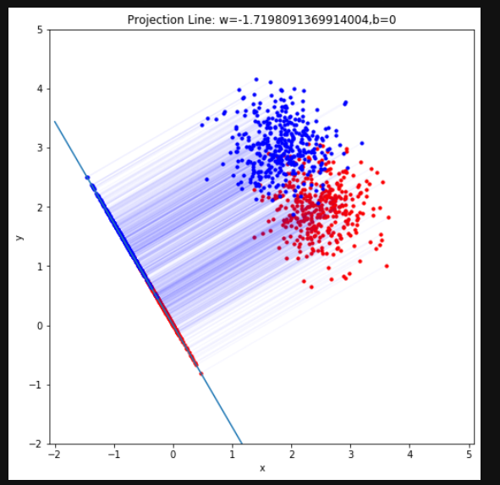

Part2.Questions

