圖形識別hw3

0616095 曾敏峰

Part 1

1. Gini of data is 0.4628099173553719

Entropy of data is 0.9456603046006402

1. Accuracy % of clf_depth3 is 0.9230769230769231

Accuracy % of clf_depth10 is 0.916083916083916

Accuracy % of clf_gini is 0.9230769230769231

Accuracy % of clf_entropy is 0.9370629370629371

1. 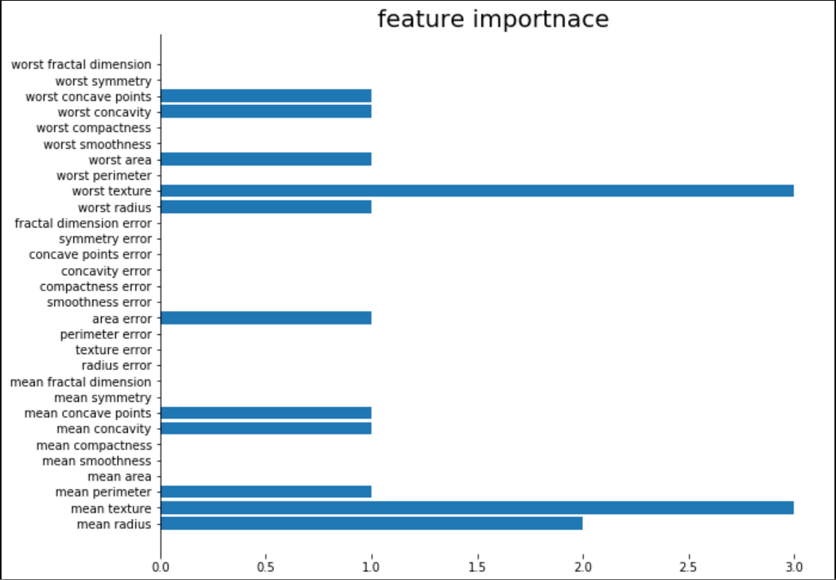
2. Accuracy % of clf_10tree is 0.9440559440559441

Accuracy % of clf_100tree is 0.951048951048951

Accuracy % of clf_all_features is 0.9230769230769231

Accuracy % of clf_random_features is 0.9370629370629371

Part 2

