圖形識別HW4

0616095 曾敏峰

Part 1

1. Split: 1, Training index: [ 1 2 3 4 5 7 8 9 10 11 14 15 16 17 18 19], Validation index: [ 0 6 12 13]

Split: 2, Training index: [ 0 2 3 4 5 6 8 11 12 13 14 15 16 17 18 19], Validation index: [ 1 7 9 10]

Split: 3, Training index: [ 0 1 2 4 6 7 8 9 10 11 12 13 14 15 17 18], Validation index: [ 3 5 16 19]

Split: 4, Training index: [ 0 1 2 3 4 5 6 7 9 10 12 13 16 17 18 19], Validation index: [ 8 11 14 15]

Split: 5, Training index: [ 0 1 3 5 6 7 8 9 10 11 12 13 14 15 16 19], Validation index: [ 2 4 17 18]

註:這每次會不一樣，因為是shuffle過的

2. {'C': 10, 'gamma': 0.001}

3. 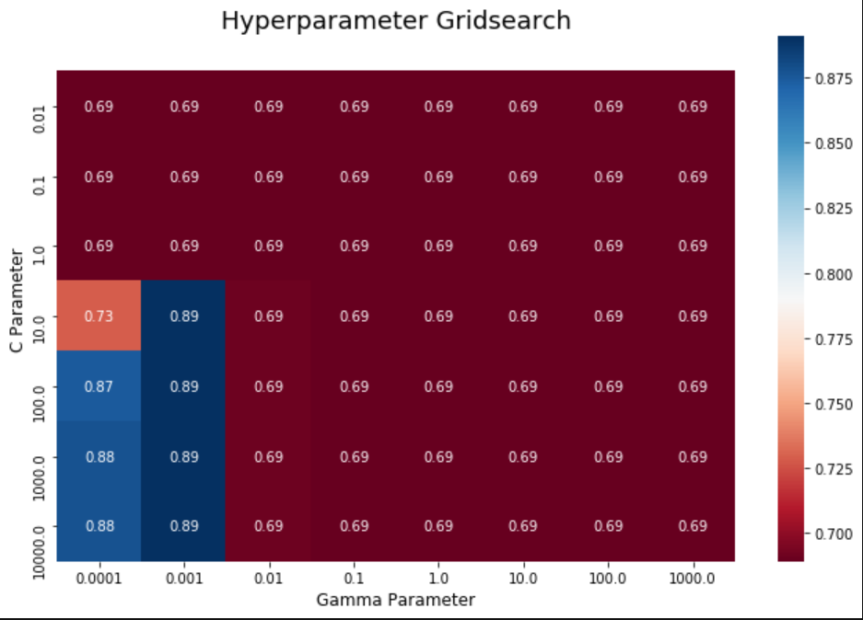

4. Accuracy score: 0.8958333333333334

5. {'C': 1000, 'gamma': 0.001}

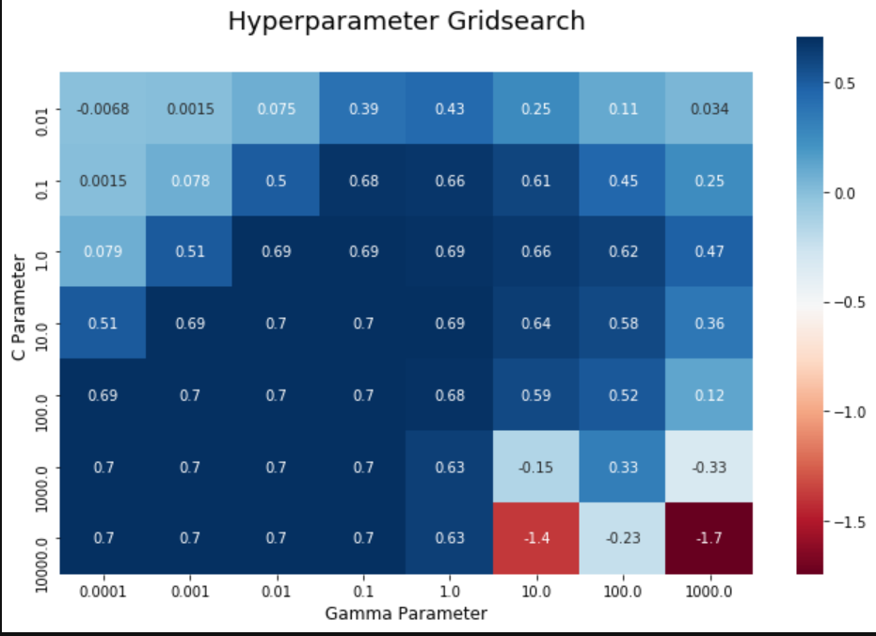

註: 這裡使用的score不是MSE，是SVR裡定義的score，score = 1-(u/v)

# u = ((y_true - y_pred) ** 2).sum()

# v = ((y_true - y_true.mean()) ** 2).sum().

# The best possible score is 1.0(when u is 0) and it can be negative (because the model can be arbitrarily worse).

Square error of Linear regression: 3.4339477869026385

Square error of SVM regresssion model: 3.6002184676788693

分析:這裡不管跑幾次都發現是Linear regression的MSE比較小

Part II

