Section 0

1. Question

Frank@DESKTOP-4I0TO51 MINGW64 ~/Desktop/CAP/Capgemini Training/project_dir (master)

* $ mkdir project_dir
* $ cd project_dir/

1. Question

Frank@DESKTOP-4I0TO51 MINGW64 ~/Desktop/CAP/Capgemini Training/project_dir (master)

* $ git init

Initialized empty Git repository in C:/Users/Frank/Desktop/CAP/Capgemini

Training/project_dir/.git/

1. Question

Frank@DESKTOP-4I0TO51 MINGW64 ~/Desktop/CAP/Capgemini Training/project_dir (master)

* $ touch index.html

1. Question

Frank@DESKTOP-4I0TO51 MINGW64 ~/Desktop/CAP/Capgemini Training/project_dir (master)

* $ git status

On branch master

No commits yet

Untracked files:

(use "git add <file>..." to include in what will be committed)

index.html

nothing added to commit but untracked files present (use "git add" to trac

k)

1. Question

Frank@DESKTOP-4I0TO51 MINGW64 ~/Desktop/CAP/Capgemini Training/project_dir (master)

* $ git add index.html

1. Question

Frank@DESKTOP-4I0TO51 MINGW64 ~/Desktop/CAP/Capgemini Training/project_dir (master)

* $ git add index.html

$ git commit -m 'initial commit'

[master (root-commit) 84b1e2e] initial commit

1 file changed, 0 insertions(+), 0 deletions(-)

create mode 100644 index.html

1. Question

Frank@DESKTOP-4I0TO51 MINGW64 ~/Desktop/CAP/Capgemini Training/project_dir (master)

* $ touch info.txt

1. Question

Frank@DESKTOP-4I0TO51 MINGW64 ~/Desktop/CAP/Capgemini Training/project_dir (master)

* $ git status

On branch master

Changes not staged for commit:

(use "git add <file>..." to update what will be committed)

(use "git restore <file>..." to discard changes in working directory)

modified: index.html

Untracked files:

(use "git add <file>..." to include in what will be committed)

info.txt

no changes added to commit (use "git add" and/or "git commit -a")

1. Question

Frank@DESKTOP-4I0TO51 MINGW64 ~/Desktop/CAP/Capgemini Training/project_dir (master)

* $ touch .gitignore
* And then type ‘*.txt’ in the .gitignore file

1. Question

Frank@DESKTOP-4I0TO51 MINGW64 ~/Desktop/CAP/Capgemini Training/project_dir (master)

* $ git status

On branch master

Changes not staged for commit:

(use "git add <file>..." to update what will be committed)

(use "git restore <file>..." to discard changes in working directory)

modified: index.html

Untracked files:

(use "git add <file>..." to include in what will be committed)

.gitignore

no changes added to commit (use "git add" and/or "git commit -a")

1. Question

Frank@DESKTOP-4I0TO51 MINGW64 ~/Desktop/CAP/Capgemini Training/project_dir (master)

* $ git commit -m 'second commit index.html changed'

[master 9dff0f3] second commit index.html changed

1 file changed, 8 insertions(+)

1. Question

Frank@DESKTOP-4I0TO51 MINGW64 ~/Desktop/CAP/Capgemini Training/project_dir (master)

* $ git log

commit 9dff0f39c2700a707206a963682f966b809f6868 (HEAD -> master)

Author: Ashish Frank <ashishfrank1234@gmail.com>

Date: Tue Jul 6 16:43:58 2021 +0530

second commit index.html changed

commit 84b1e2e67b1af8186d81864b235e79275c2d8596

Author: Ashish Frank <ashishfrank1234@gmail.com>

Date: Tue Jul 6 16:30:32 2021 +0530

initial commit

1. Question

Frank@DESKTOP-4I0TO51 MINGW64 ~/Desktop/CAP/Capgemini Training/project_dir (master)

* Made some changes in index.html

1. Question

Frank@DESKTOP-4I0TO51 MINGW64 ~/Desktop/CAP/Capgemini Training/project_dir (master)

* $ git checkout index.html

Updated 1 path from the index

1. Question

Frank@DESKTOP-4I0TO51 MINGW64 ~/Desktop/CAP/Capgemini Training/project_dir (master)

* Made some changes

1. Question

Frank@DESKTOP-4I0TO51 MINGW64 ~/Desktop/CAP/Capgemini Training/project_dir (master)

* $ git add index.html

1. Question

Frank@DESKTOP-4I0TO51 MINGW64 ~/Desktop/CAP/Capgemini Training/project_dir (master)

* $ git rm --cached index.html

rm 'index.html'

1. Question

Frank@DESKTOP-4I0TO51 MINGW64 ~/Desktop/CAP/Capgemini Training/project_dir (master)

* $ git config --global alias.my-add add

1. Question

Frank@DESKTOP-4I0TO51 MINGW64 ~/Desktop/CAP/Capgemini Training/project_dir (master)

* $ git my-add index.html
* $ git commit -m 'third commit'

[master 1bc8b5d] third commit

1 file changed, 1 insertion(+)

1. Question

Frank@DESKTOP-4I0TO51 MINGW64 ~/Desktop/CAP/Capgemini Training/project_dir (master)

* $ git reset --soft HEAD~1

Screenshot

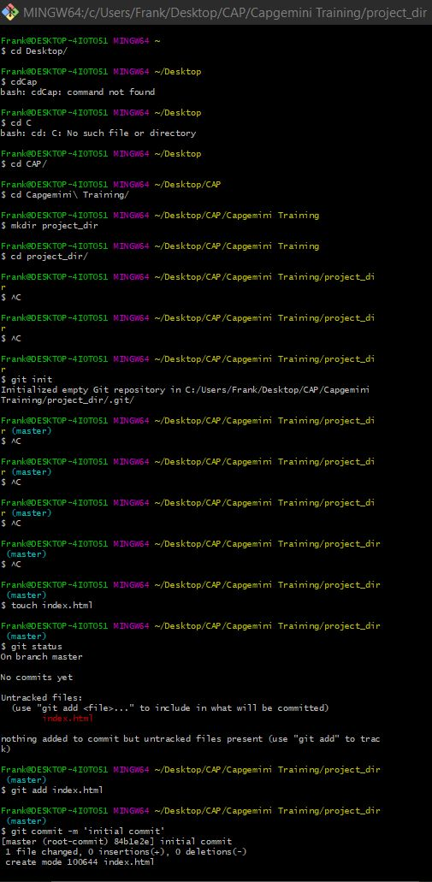

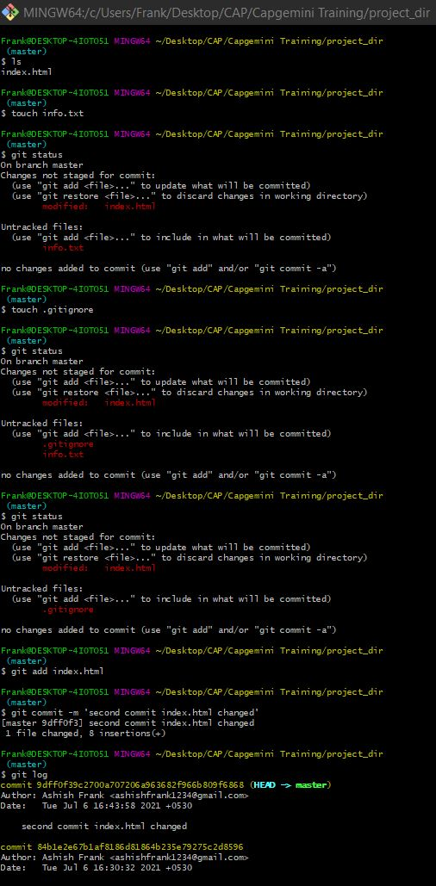

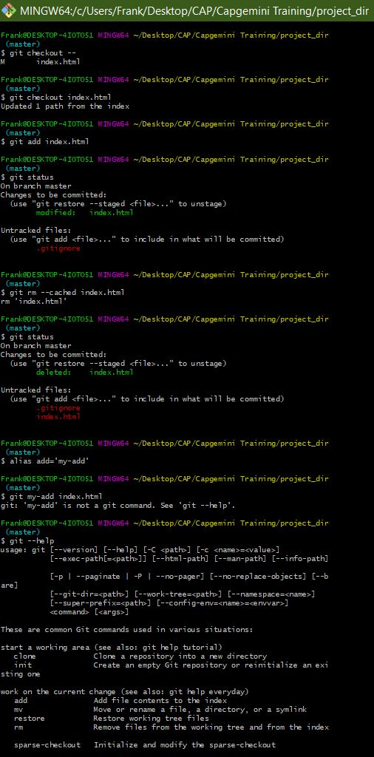

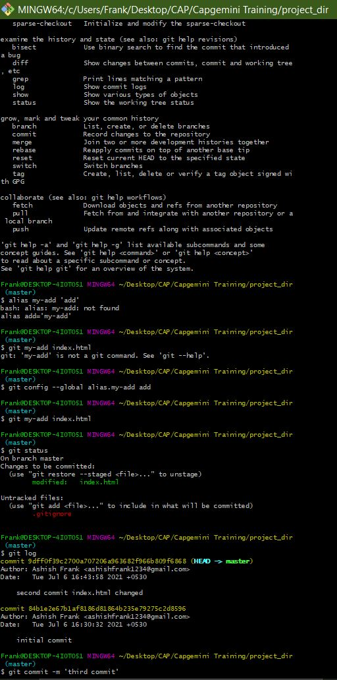

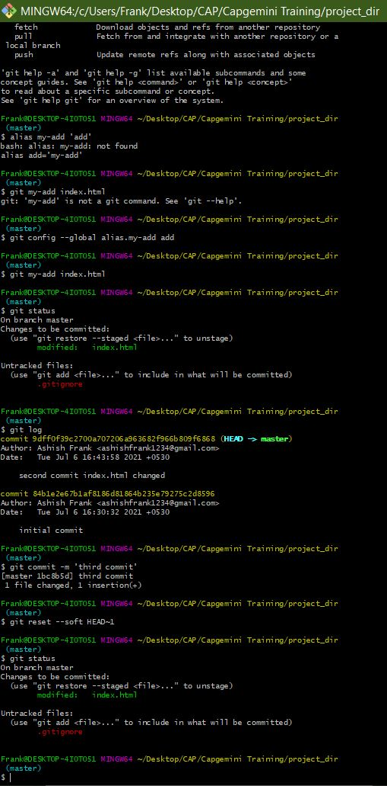

GIT BRANCHING

Section 1

1. Question

Frank@DESKTOP-4I0TO51 MINGW64 ~/Desktop/CAP/Capgemini Training/Assignments

* $ mkdir Assignments
* $ cd Assignments/

1. Question

Frank@DESKTOP-4I0TO51 MINGW64 ~/Desktop/CAP/Capgemini Training/Assignments

* $ touch README.txt

1. Question

Frank@DESKTOP-4I0TO51 MINGW64 ~/Desktop/CAP/Capgemini Training/Assignments (master)

* $ git commit -m 'initial commit'

[master (root-commit) ce5c251] initial commit

1 file changed, 1 insertion(+)

create mode 100644 README.txt

1. Question

Frank@DESKTOP-4I0TO51 MINGW64 ~/Desktop/CAP/Capgemini Training/Assignments (master)

* $ git branch html-assigments

1. Question

Frank@DESKTOP-4I0TO51 MINGW64 ~/Desktop/CAP/Capgemini Training/Assignments (master)

* $ git checkout html-assigments

Switched to branch 'html-assigments'

1. Question

Frank@DESKTOP-4I0TO51 MINGW64 ~/Desktop/CAP/Capgemini Training/Assignments (html-assigments)

* $ touch index1.html index2.html

1. Question

Frank@DESKTOP-4I0TO51 MINGW64 ~/Desktop/CAP/Capgemini Training/Assignments (html-assigments)

* $ git commit -m 'created index1.html and index2.html'

[html-assigments 96f03f0] created index1.html and index2.html

2 files changed, 0 insertions(+), 0 deletions(-)

create mode 100644 index1.html

create mode 100644 index2.html

1. Question

* Made minor changes in a few files from ‘html-assignments’ branch

1. Question

Frank@DESKTOP-4I0TO51 MINGW64 ~/Desktop/CAP/Capgemini Training/Assignments (html-assigments)

* $ git commit -m 'second commit after change in index1 and index2'

[html-assigments 0c77926] second commit after change in index1 and index

2

2 files changed, 2 insertions(+)

1. Question

Frank@DESKTOP-4I0TO51 MINGW64 ~/Desktop/CAP/Capgemini Training/Assignments (html-assigments)

* $ git checkout master

Switched to branch 'master'

1. Question

Frank@DESKTOP-4I0TO51 MINGW64 ~/Desktop/CAP/Capgemini Training/Assignments (master)

* $ git commit -m 'committing minor change in Readme'

[master 4fb3f06] committing minor change in Readme

1 file changed, 3 insertions(+), 1 deletion(-)

1. Question

Frank@DESKTOP-4I0TO51 MINGW64 ~/Desktop/CAP/Capgemini Training/Assignments (master)

* $ git checkout html-assigments

Switched to branch 'html-assigments'

1. Question

* Made minor changes to a few files in the ‘html-assignments’ branch

1. Question

Frank@DESKTOP-4I0TO51 MINGW64 ~/Desktop/CAP/Capgemini Training/Assignments (html-assigments)

* $ git commit -m 'commit to minor changes in index1 and index2'

[html-assigments 7899f25] commit to minor changes in index1 and index2

2 files changed, 4 insertions(+), 2 deletions(-)

1. Question

Frank@DESKTOP-4I0TO51 MINGW64 ~/Desktop/CAP/Capgemini Training/Assignments (html-assigments)

* $ git checkout master

Switched to branch 'master'

1. Question

Frank@DESKTOP-4I0TO51 MINGW64 ~/Desktop/CAP/Capgemini Training/Assignments (master)

* $ git merge html-assigments

Merge made by the 'recursive' strategy.

index1.html | 2 ++

index2.html | 2 ++

2 files changed, 4 insertions(+)

create mode 100644 index1.html

create mode 100644 index2.html

1. Question

Frank@DESKTOP-4I0TO51 MINGW64 ~/Desktop/CAP/Capgemini Training/Assignments (master)

* $ git branch -d html-assigments

Deleted branch html-assigments (was 7899f25).

Screenshot

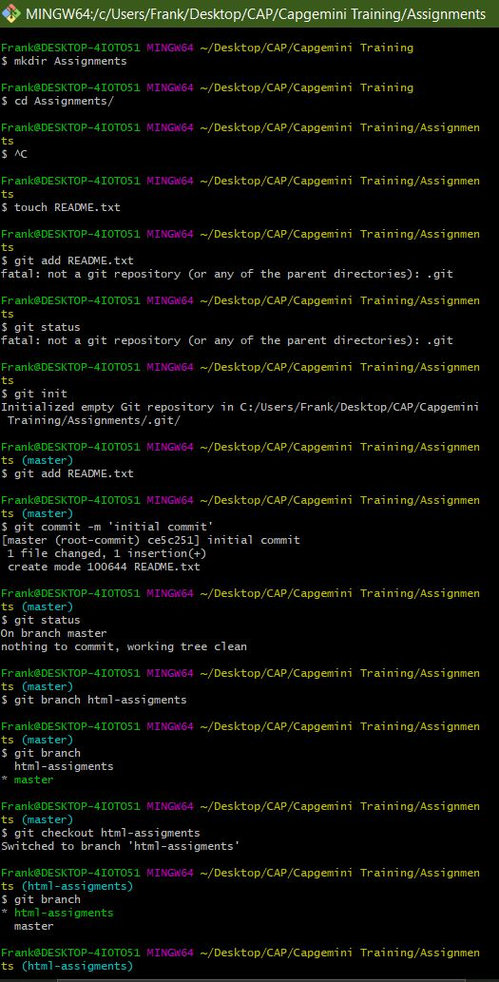

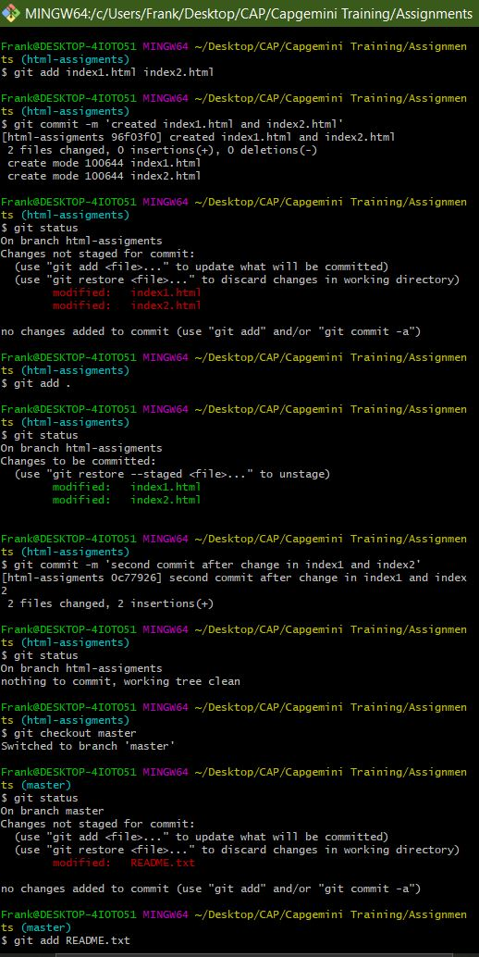

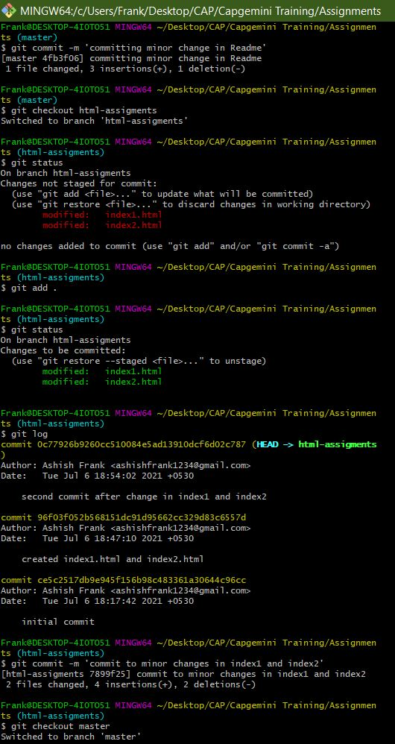

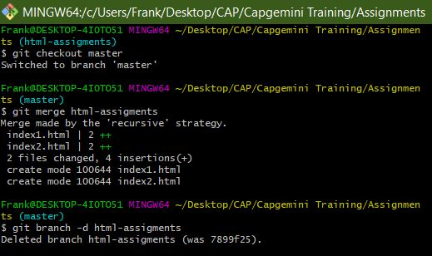

Section 2

1. Question

Frank@DESKTOP-4I0TO51 MINGW64 ~/Desktop/CAP/Capgemini Training/Assignments (master)

* $ git branch css-assigments

1. Question

Frank@DESKTOP-4I0TO51 MINGW64 ~/Desktop/CAP/Capgemini Training/Assignments (master)

* $ git checkout css-assigments

Switched to branch 'css-assigments'

1. Question

Frank@DESKTOP-4I0TO51 MINGW64 ~/Desktop/CAP/Capgemini Training/Assignments (css-assigments)

* $ touch styles1.css styles2.css

1. Question

Frank@DESKTOP-4I0TO51 MINGW64 ~/Desktop/CAP/Capgemini Training/Assignments (css-assigments)

* $ git commit -m 'created styles1.css and styles2.css'

[css-assigments 3e825ba] created styles1.css and styles2.css

2 files changed, 0 insertions(+), 0 deletions(-)

create mode 100644 styles1.css

create mode 100644 styles2.css

1. Question

* Made minor changes in line 1 in Readme.txt belonging to ‘css-assignments’ branch

1. Question

Frank@DESKTOP-4I0TO51 MINGW64 ~/Desktop/CAP/Capgemini Training/Assignments (css-assigments)

* $ git commit -m 'committing minor changes made in line 1 of Readme.txt'

[css-assigments b2a430b] committing minor changes made in line 1 of Read

me.txt

1 file changed, 1 insertion(+), 1 deletion(-)

1. Question

Frank@DESKTOP-4I0TO51 MINGW64 ~/Desktop/CAP/Capgemini Training/Assignments (css-assigments)

* $ git checkout master

Switched to branch 'master'

1. Question

Frank@DESKTOP-4I0TO51 MINGW64 ~/Desktop/CAP/Capgemini Training/Assignments (master)

* $ git commit -m 'committing minor changes made in line 3 of Readme.txt'

[master 5da77dd] committing minor changes made in line 3 of Readme.txt

1 file changed, 1 insertion(+), 1 deletion(-)

1. Question

Frank@DESKTOP-4I0TO51 MINGW64 ~/Desktop/CAP/Capgemini Training/Assignments (master)

* $ git checkout css-assigments

Switched to branch 'css-assigments'

1. Question

Frank@DESKTOP-4I0TO51 MINGW64 ~/Desktop/CAP/Capgemini Training/Assignments (css-assigments)

* Made minor changes in a few files belonging to the css-assignment branch

1. Question

Frank@DESKTOP-4I0TO51 MINGW64 ~/Desktop/CAP/Capgemini Training/Assignments (css-assigments)

* $ git commit -m 'committing changes made in styles1.css and styles2.css from the css-assignment branch'

[css-assigments 4c2ef6f] committing changes made in styles1.css and styl

es2.css from the css-assignment branch

2 files changed, 6 insertions(+)

1. Question

Frank@DESKTOP-4I0TO51 MINGW64 ~/Desktop/CAP/Capgemini Training/Assignments (css-assigments)

* $ git checkout master

Switched to branch 'master'

1. Question

Frank@DESKTOP-4I0TO51 MINGW64 ~/Desktop/CAP/Capgemini Training/Assignments (master)

* $ git merge css-assigments

Auto-merging README.txt

Merge made by the 'recursive' strategy.

README.txt | 2 +-

styles1.css | 3 +++

styles2.css | 3 +++

3 files changed, 7 insertions(+), 1 deletion(-)

create mode 100644 styles1.css

create mode 100644 styles2.css

1. Question

Frank@DESKTOP-4I0TO51 MINGW64 ~/Desktop/CAP/Capgemini Training/Assignments (master)

* $ git branch -d css-assigments

Deleted branch css-assigments (was 4c2ef6f).

Screenshot

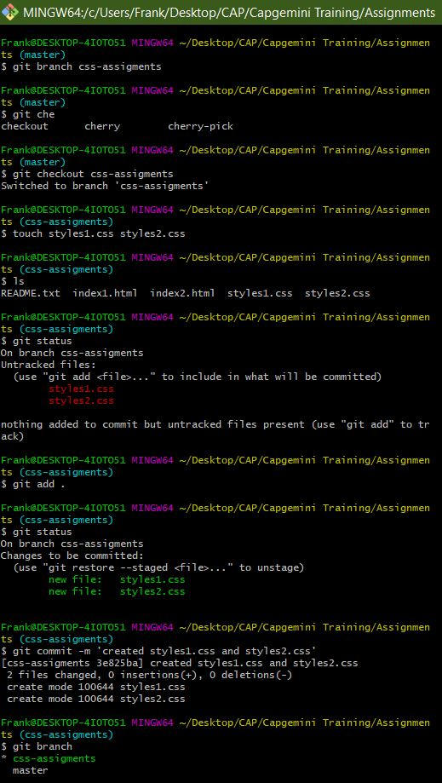

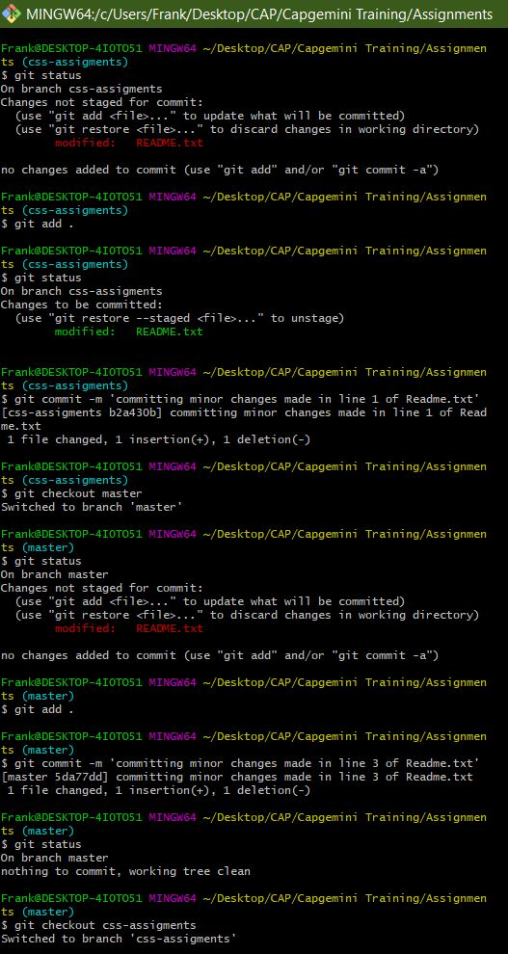

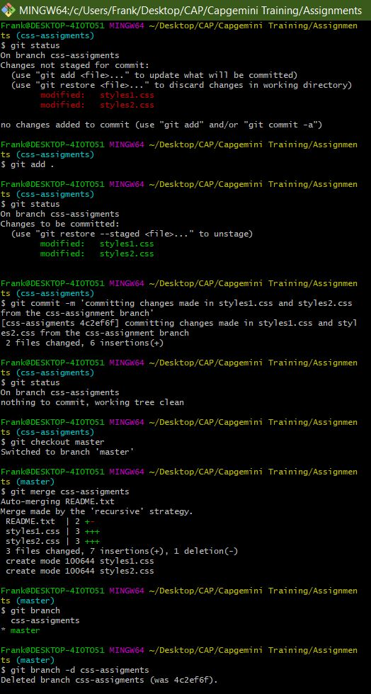

Section 3

1. Question

Frank@DESKTOP-4I0TO51 MINGW64 ~/Desktop/CAP/Capgemini Training/Assignments (master)

* $ git branch js-assignments

1. Question

Frank@DESKTOP-4I0TO51 MINGW64 ~/Desktop/CAP/Capgemini Training/Assignments (master)

* $ git checkout js-assignments

Switched to branch 'js-assignments'

1. Question

Frank@DESKTOP-4I0TO51 MINGW64 ~/Desktop/CAP/Capgemini Training/Assignments (js-assignments)

* $ touch app1.js app2.js

1. Question

Frank@DESKTOP-4I0TO51 MINGW64 ~/Desktop/CAP/Capgemini Training/Assignments (js-assignments)

* $ git commit -m 'created 2 new js files app1 and app2'

[js-assignments 90dea02] created 2 new js files app1 and app2

2 files changed, 0 insertions(+), 0 deletions(-)

create mode 100644 app1.js

create mode 100644 app2.js

1. Question

* Made minor changes in line 1 in Readme.txt belonging to ‘js-assignments’ branch

1. Question

Frank@DESKTOP-4I0TO51 MINGW64 ~/Desktop/CAP/Capgemini Training/Assignments (js-assignments)

* $ git commit -m 'committing change made in line 1 of Readme.txt from the js-assignment branch'

[js-assignments 082e08d] committing change made in line 1 of Readme.txt

from the js-assignment branch

1 file changed, 1 insertion(+), 1 deletion(-)

1. Question

Frank@DESKTOP-4I0TO51 MINGW64 ~/Desktop/CAP/Capgemini Training/Assignments (js-assignments)

* $ git checkout master

Switched to branch 'master'

1. Question

Frank@DESKTOP-4I0TO51 MINGW64 ~/Desktop/CAP/Capgemini Training/Assignments (master)

* $ git commit -m 'committing a minor change made in Readme from the master branch'

[master c4125ad] committing a minor change made in Readme from the master branch

1 file changed, 1 insertion(+), 1 deletion(-)

1. Question

Frank@DESKTOP-4I0TO51 MINGW64 ~/Desktop/CAP/Capgemini Training/Assignments (master)

* $ git checkout js-assignments

Switched to branch 'js-assignments'

1. Question

Frank@DESKTOP-4I0TO51 MINGW64 ~/Desktop/CAP/Capgemini Training/Assignments (js-assignments)

* Made minor changes in a few files belonging to the js-assignment branch

1. Question

Frank@DESKTOP-4I0TO51 MINGW64 ~/Desktop/CAP/Capgemini Training/Assignments (js-assignments)

* $ git commit -m 'committing changes made in app1.js and app2.js from the js-assignment branch'

[js-assignments 67420f1] committing changes made in app1.js and app2.js

from the js-assignment branch

1. files changed, 2 insertions(+)
2. Question

Frank@DESKTOP-4I0TO51 MINGW64 ~/Desktop/CAP/Capgemini Training/Assignments (js-assignments)

* $ git checkout master

Switched to branch 'master'

1. Question

Frank@DESKTOP-4I0TO51 MINGW64 ~/Desktop/CAP/Capgemini Training/Assignments (master|MERGING)

* $ git merge js-assignments

Auto-merging README.txt

CONFLICT (content): Merge conflict in README.txt

Automatic merge failed; fix conflicts and then commit the result.

1. Question

Frank@DESKTOP-4I0TO51 MINGW64 ~/Desktop/CAP/Capgemini Training/Assignments (master|MERGING)

* $ git branch -d css-assigments

Deleted branch css-assigments (was 4c2ef6f).

$ git branch -d js-assignments

error: The branch 'js-assignments' is not fully merged.

If you are sure you want to delete it, run 'git branch -D js-assignments

'.

* $ git branch -D js-assignments

Deleted branch js-assignments (was 67420f1).

Screenshot

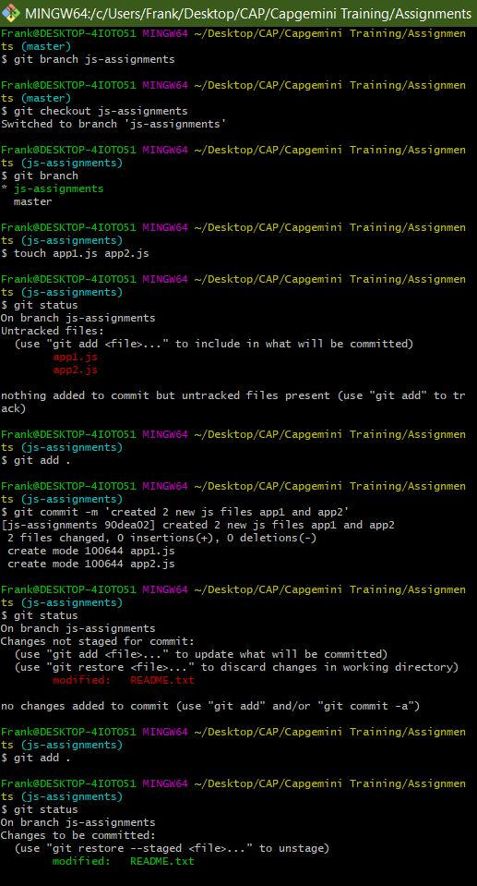

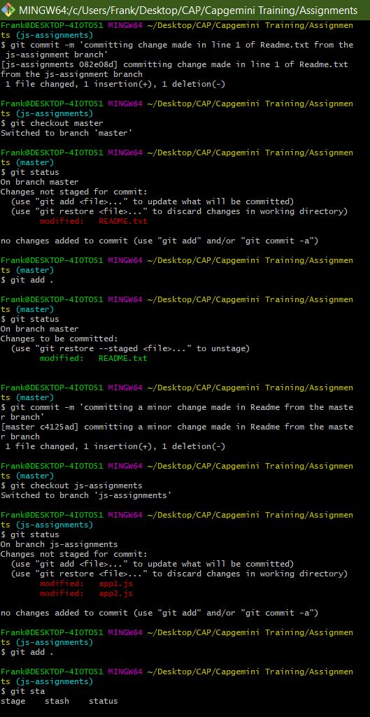

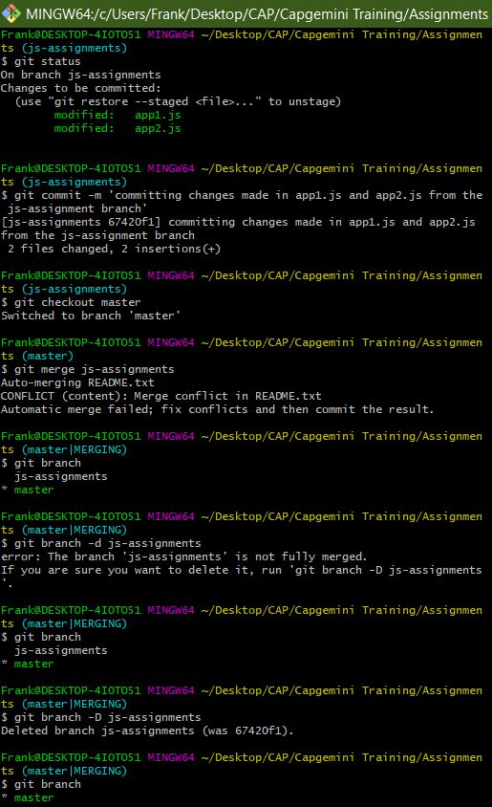

GIT REMOTING

Uploaded on the Git Repository at <https://github.com/frankuxur/freshersbatch-jun17>

Frank@DESKTOP-4I0TO51 MINGW64 ~/Desktop/CAP/Capgemini Training/Assignments (master|MERGING)

$ git remote add origin https://github.com/frankuxur/freshersbatch-jun17.git

Frank@DESKTOP-4I0TO51 MINGW64 ~/Desktop/CAP/Capgemini Training/Assignments (master|MERGING)

$ git remote

origin

Frank@DESKTOP-4I0TO51 MINGW64 ~/Desktop/CAP/Capgemini Training/Assignments (master|MERGING)

$ git push origin main

error: src refspec main does not match any

error: failed to push some refs to 'https://github.com/frankuxur/fresher

sbatch-jun17.git'

Frank@DESKTOP-4I0TO51 MINGW64 ~/Desktop/CAP/Capgemini Training/Assignments (master|MERGING)

$ git push

fatal: The current branch master has no upstream branch.

To push the current branch and set the remote as upstream, use

git push --set-upstream origin master

Frank@DESKTOP-4I0TO51 MINGW64 ~/Desktop/CAP/Capgemini Training/Assignments (master|MERGING)

$ git push --set-upstream origin master

Select an authentication method for 'https://github.com/':

1. Web browser (default)

2. Personal access token

option (enter for default): 1

info: please complete authentication in your browser...

Enumerating objects: 37, done.

Counting objects: 100% (37/37), done.

Delta compression using up to 8 threads

Compressing objects: 100% (28/28), done.

Writing objects: 100% (37/37), 3.37 KiB | 690.00 KiB/s, done.

Total 37 (delta 12), reused 0 (delta 0), pack-reused 0

remote: Resolving deltas: 100% (12/12), done.

To https://github.com/frankuxur/freshersbatch-jun17.git

* [new branch] master -> master

Branch 'master' set up to track remote branch 'master' from 'origin'.

Screenshot

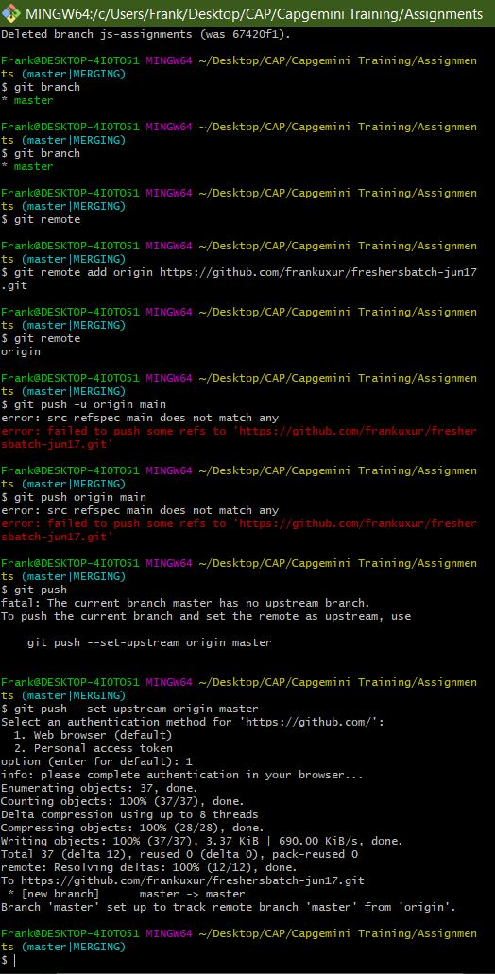

Section 4

Pushed project to remote repository using Eclipse GIT Plugin

Remote Repository: <https://github.com/frankuxur/trial>