**MongoDB – Aggregation Exercises**

**Atlanta Population**

1. **use db.zipcodes.find() to filter results to only the results where city is ATLANTA and state is GA.**

db.zipcodes.find({ city: "ATLANTA", state: "GA" })

1. **use db.zipcodes.aggregate with Smatch to do the same as above.**

db.zipcodes.aggregate([ { $match: { city: "ATLANTA", state: "GA" } } ])

1. **use Sgroup to count the number of zip codes in Atlanta.**

db.zipcodes.aggregate([ { $match: { city: "ATLANTA" } }, { $group: { _id: { city: "$city" }, count: { $sum: 1 } } } ])

1. **use Sgroup to find the total population in Atlanta.**

db.zipcodes.aggregate([ { $match: { city: "ATLANTA" } }, { $group: { _id: { city: "$city" }, population: { $sum: "$pop" } } } ])

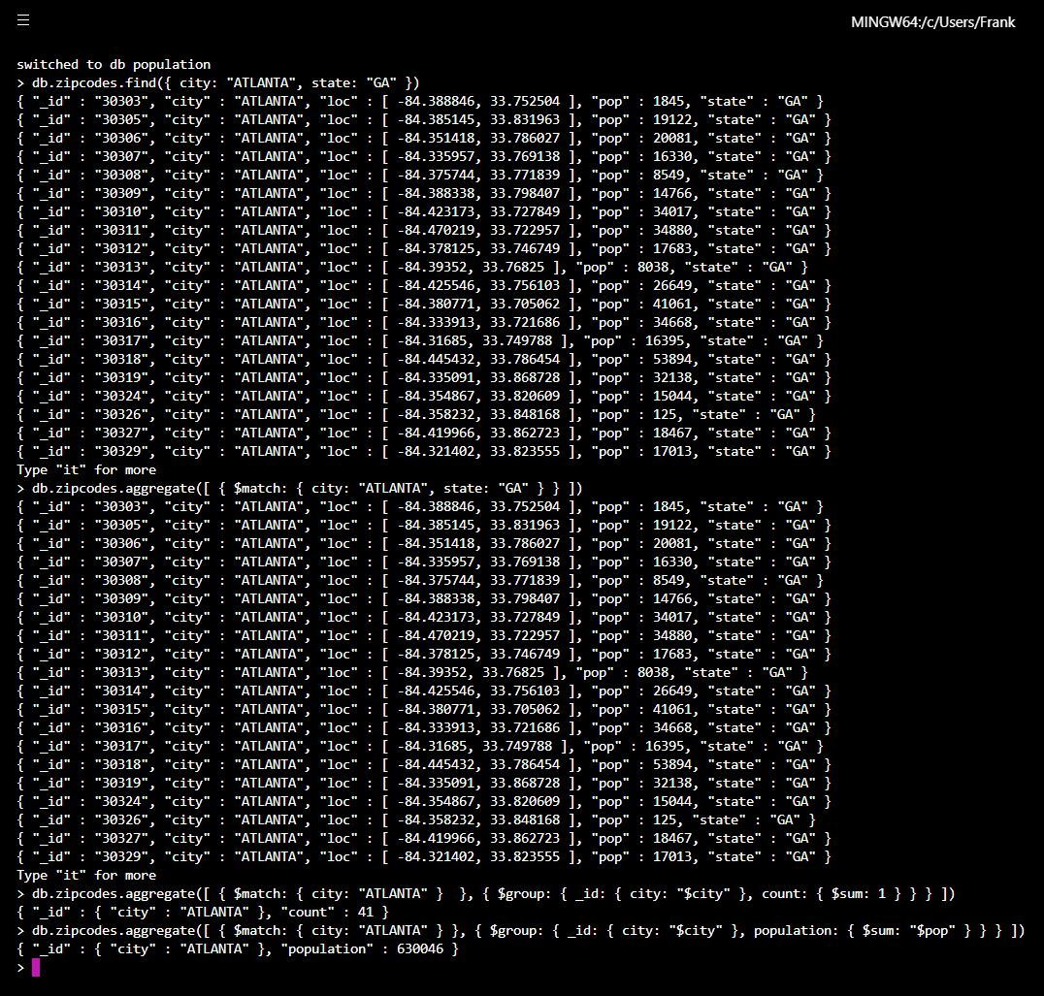

**Populations by State**

1. **use aggregate to calculate the total population for each state**

db.zipcodes.aggregate([

... { $group: {

... _id: "$state",

... population: { $sum: "$pop" }

... }

... },

... // { $sort: { population: -1 } },

... // { $limit: 3 }

... ])

1. **sort the results by population, highest first**

db.zipcodes.aggregate([

... { $group: {

... _id: "$state",

... population: { $sum: "$pop" }

... }

... },

... { $sort: { population: -1 } },

... // { $limit: 3 }

... ])

1. **limit the results to just the first 3 results. What are the top 3 states in population?**

db.zipcodes.aggregate([

... { $group: {

... _id: "$state",

... population: { $sum: "$pop" }

... }

... },

... { $sort: { population: -1 } },

... { $limit: 3 }

... ])

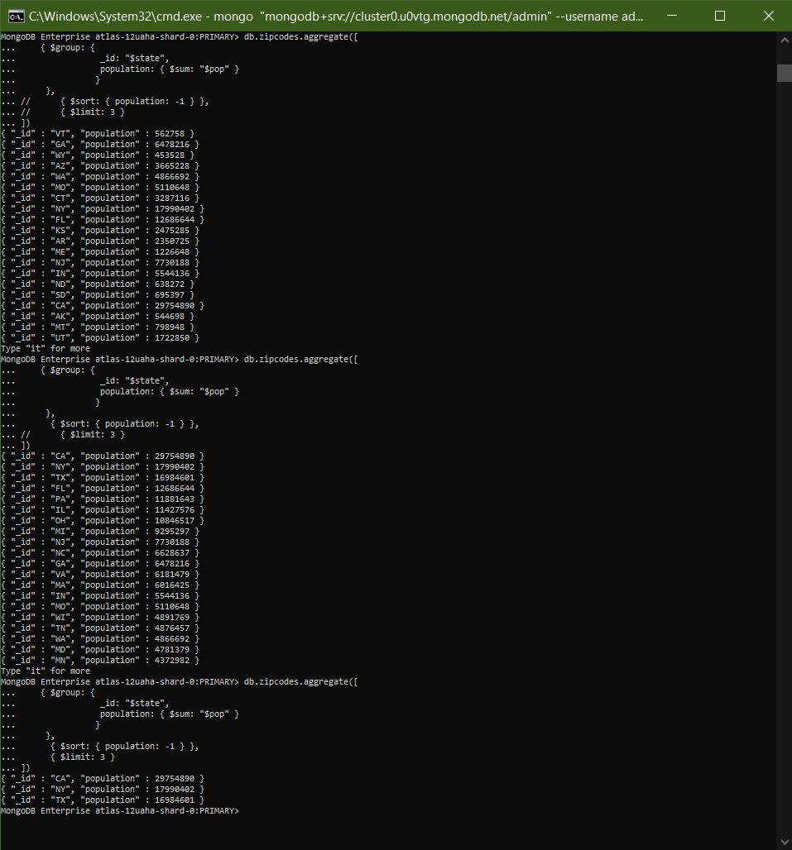

**Populations by City**

1. **use aggregate to calculate the total population for each city (you have to use city/state combination). You can use a combination for the id of the Sgroup: { city: 'Scity', state: 'Sstate')**

db.zipcodes.aggregate([

... { $group: {

... _id: { city: "$city", state: "$state"},

... population: { $sum: "$pop" }

... }

... },

... //{ $sort: { population: -1 } }

... ])

1. **sort the results by population, highest first**

db.zipcodes.aggregate([

... { $group: {

... _id: { city: "$city", state: "$state"},

... population: { $sum: "$pop" }

... }

... },

... { $sort: { population: -1 } }

... ])

1. **limit the results to just the first 3 results. What are the top 3 cities in population?**

db.zipcodes.aggregate([

... { $group: {

... _id: { city: "$city", state: "$state"},

... population: { $sum: "$pop" }

... }

... },

... { $sort: { population: -1 } },

... { $limit: 3 }

... ])

1. **What are the top 3 cities in population in Texas?**

db.zipcodes.aggregate([

... { $match: { state: "TX" } },

... { $group: {

... _id: { city: "$city", state: "$state"},

... population: { $sum: "$pop" }

... }

... },

... { $sort: { population: -1 } },

... ])

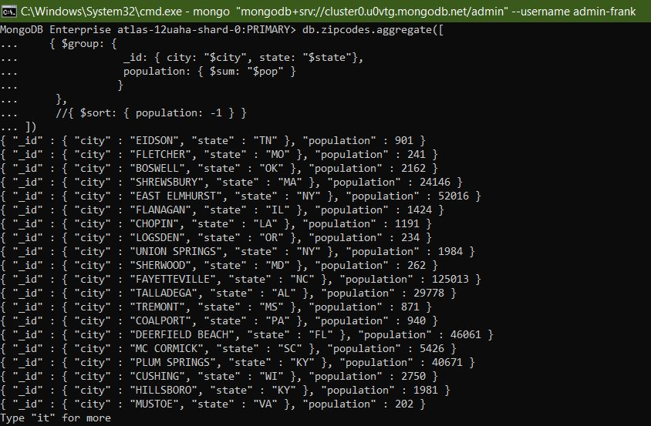

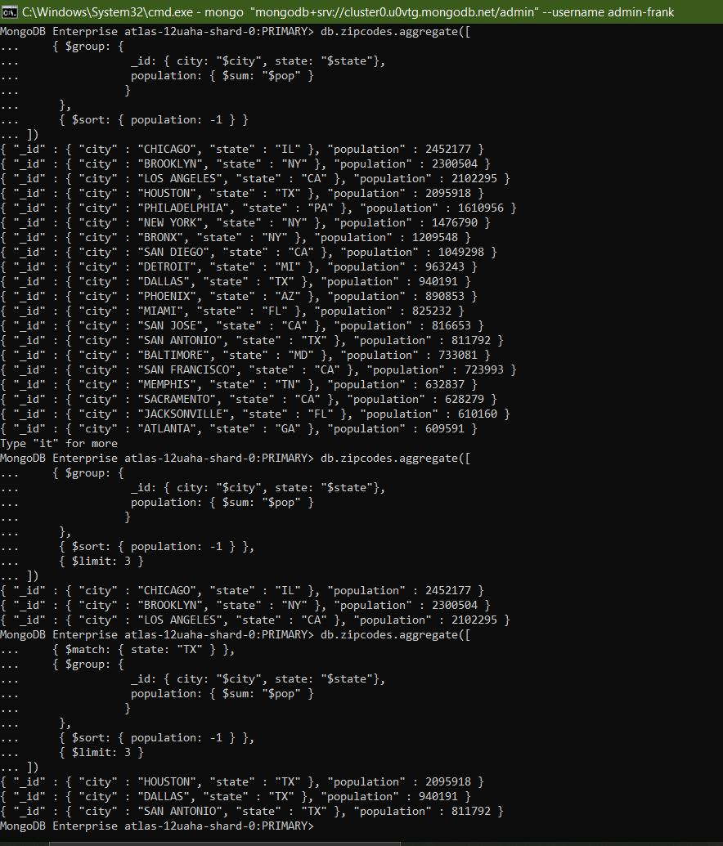

**Bonus**

1. **Write a query to get the average city population for each state.**

db.zipcodes.aggregate([

{ $group:

{ _id: { state: "$state" }, avgPop: { $avg: "$pop" } }

}

// { $sort: { avgPop: -1 } },

// { $limit: 3 }

])

1. **What are the top 3 states in terms of average city population?**

db.zipcodes.aggregate([

{ $group:

{ _id: { state: "$state" }, avgPop: { $avg: "$pop" } }

},

{ $sort: { avgPop: -1 } },

{ $limit: 3 }

])

