# Terms of trade in a partial equilibrium model

## Terms of trade and tariffs

Terms of trade are usually defined as the ratio of export prices to import prices. In the context of a partial equilibrium net-trade model where a country is either an exporter or an importer of the good in question, but not both, it’s a change in its terms of trade can be seen as the movement of the domestic prices relative to the world price.

Terms of trade effects arise when world prices are not given for the importer, but can change due to the importer’s actions. Import barriers, such as tariffs will tend to depress foreign prices while raising domestic prices. In that case the importer’s terms of trade are said to improve.

A simple textbook model illustrates this idea. It is inspired by the approach in chapter 8 of R. Feenstra and A. Taylor (2008), International Economics, Worth Publishers.

The figure below illustrates this: The tariff *t* drives a wedge between what Home consumers pay and what foreign producers receive by shifting export supply from X* to the tariff-ridden X*+t. The Home price increase from Pw to P*+t and the World market price falls from Pw to P*.

To measure the terms of trade the net-of tariff price received by foreign suppliers P* compared to the free trade price Pw. Multiplying this price differential by the amount of imports, one obtains a money measure of the terms of trade gains for Home (and the loss for foreign). If the Terms of Trade gain, the area *e* exceeds the dead weight loss (*b*+*d*) the Home country gains from the tariff..

The World, however, loses: it forgoes a foreign producer surplus (*e+f*) and the Home deadweight loss (*b*+*d*).

It should be noted that the possibility of ‘Home’ gaining with a tariff while the world is losing is a main reason for multilateral trade rules under the WTO.

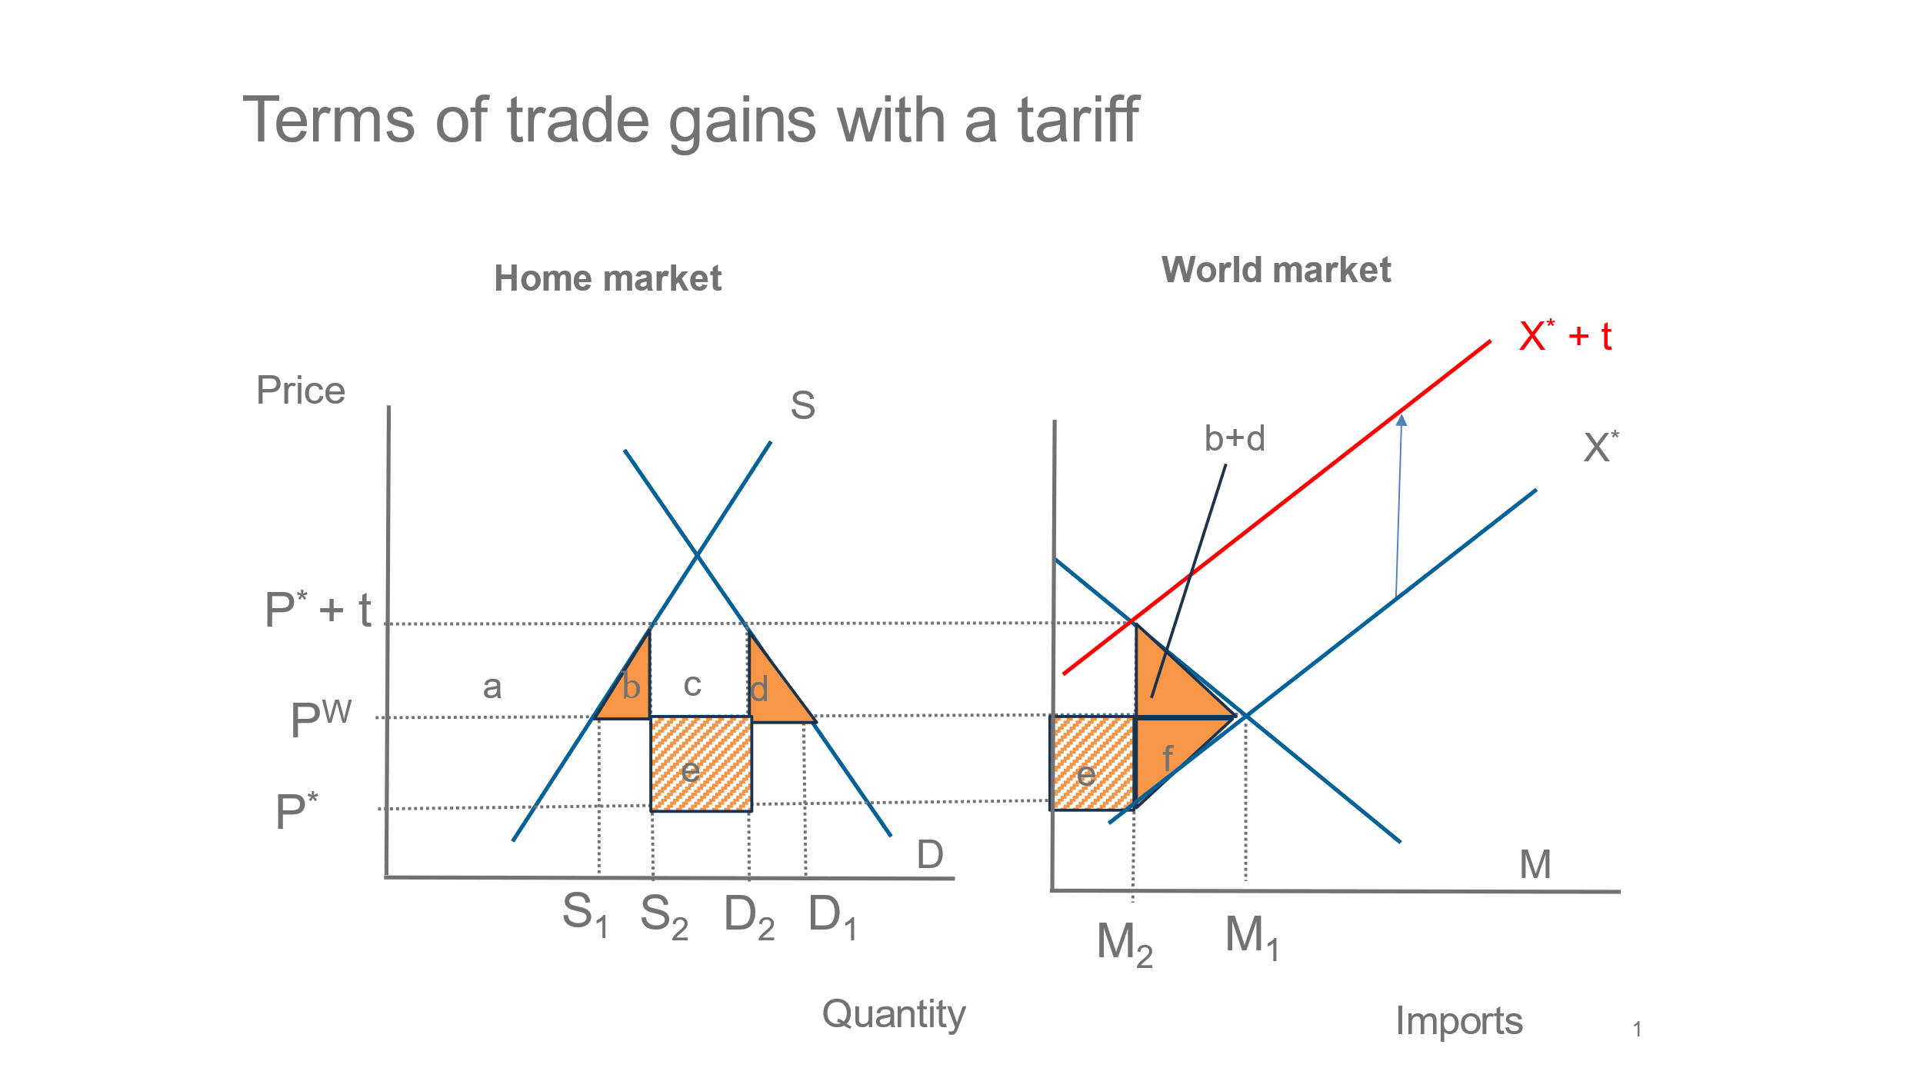

The tariff gives rise to various welfare effects:

**Home:**

Fall in consumer surplus: -(a+b+c+d)

Rise in producer surplus: +a

Rise government revenue: +(c+e)

----------------------------------------------

Net change: +**e** **–** **(b+d)**

**= Terms of Trade gain** – deadweight loss

**Foreign:**

Producer welfare loss: -f

Terms of Trade loss: -e

---------------------------------------------

Net change: -(e+f)

**World:**

Net world welfare loss: (b+d) + f

Home deadweight + foreign producer loss

## An optimal tariff

Which level of the tariff maximizes Home welfare? If the terms of trade rectangle (e ) is bigger than the sum of the 2 triangles (*b+d*) Home gains, but at some point the deadweight loss will exceed the Terms of Trade gain, and the net welfare gain diminishes.

The figure below illustrates this for a model that has linear demand a supply functions. Its parameters are: Home demand: constant -2.5, slope -15; Home supply: constant – 2.5, Slope 25; Foreign supply: constant -2, slope 25. In this case the optimal ad-valorem tariff is a s high as 42%.

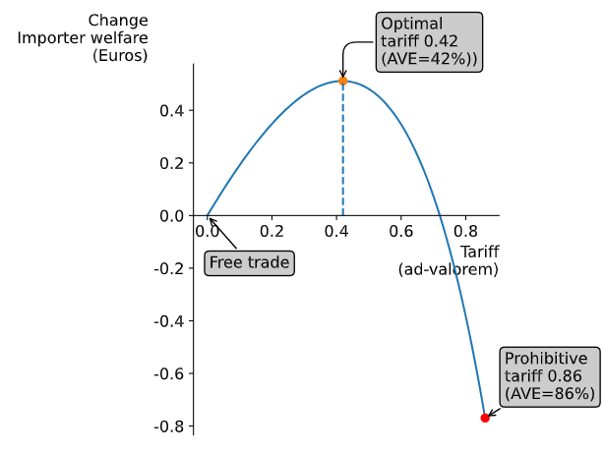

However, the different stakeholders in the economy are impacted differently . For consumers, the optimal tariff would be zero, for producers it would be as high as the prohibitive tariff 86% and for the government treasury it would be 52%.

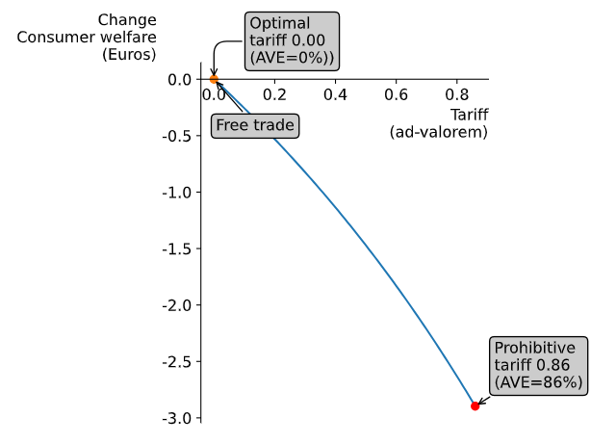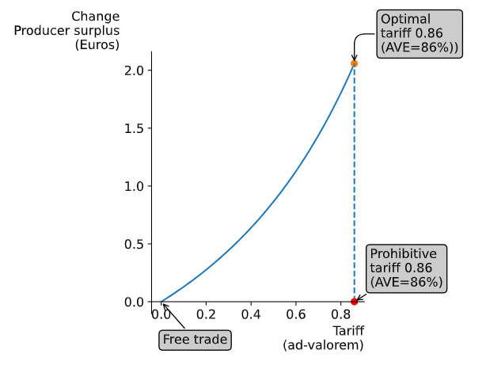

The common welfare measure adds up the three components to achieve an overall measure of change. However, society and the government imposing import tariffs may well weigh the different components differently. Assuming that more weight is put on consumer surplus, a bit less on producer surplus, and even less on revenue, with weights [0.44, 0.33, 0.22] the optimal tariff shrinks to and ad-valorem of 5%, and with a weighted welfare outcome of 0.00.