ggplot2: geom_violin vs. geom_boxplot vs. geom_density

library(datasets)  
library(ggplot2)  
  
summary(ToothGrowth)

## len supp dose   
## Min. : 4.2 OJ:30 Min. :0.50   
## 1st Qu.:13.1 VC:30 1st Qu.:0.50   
## Median :19.2 Median :1.00   
## Mean :18.8 Mean :1.17   
## 3rd Qu.:25.3 3rd Qu.:2.00   
## Max. :33.9 Max. :2.00

ggplot(data=ToothGrowth, aes(x=as.factor(dose), y=len, fill=dose)) +  
 geom_violin() +   
 facet_grid(. ~ supp) +   
 xlab("Dose (mg)") +  
 ylab("Tooth length (mm)") +  
 guides(fill=guide_legend(title="Dose")) +   
 ggtitle("Correlation of Tooth Length, \nDose, and Supplement Type")

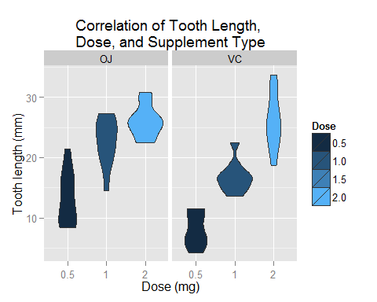

ggplot(data=ToothGrowth, aes(x=as.factor(dose), y=len, fill=dose)) +  
 geom_boxplot() +   
 facet_grid(. ~ supp) +   
 xlab("Dose (mg)") +  
 ylab("Tooth length (mm)") +  
 guides(fill=guide_legend(title="Dose")) +   
 ggtitle("Correlation of Tooth Length, \nDose, and Supplement Type")

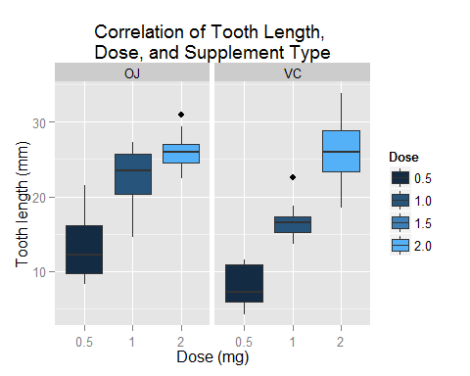

ggplot(ToothGrowth,aes(x=len, fill=dose)) +  
 geom_density() +   
 facet_grid(dose~supp) +  
 xlab("Tooth length (mm)") +  
 ylab("Density") +  
 guides(fill=guide_legend(title="Dose", reverse=TRUE)) +   
 ggtitle("Correlation of Tooth Length, \nDose, and Supplement Type") +   
 coord_flip()

